

LOCATION: Swansea | LLEOLIAD: abertawe
LEVEL 4 | LEFEL 4
EXAMINATION PERIOD | CYFNOD ARHOLIADAU
May 2022 | Mai 2022

MODULE CODE: ACDA4006
Electrical & Electronic Principles

TIME: 2 HOURS
answer all questions

Equipment or materials required – Calculator, Formulae Sheet
Adnoddau neu ddefnyddiau sydd eu hangen – Cyfrifiannell, Taflen Fformiwla

5 Questions
Total marks available = 50

ANSWER ALL QUESTIONS

- For the circuit shown in Fig Q1, given the following component values R1=100Ω, R2=500Ω, R3=300Ω, R4=150Ω, and R5=470Ω. If the battery terminal voltage is 15V, calculate:
  - The total circuit resistance
[4 Marks]
  - Write the current $I_{2}$ in terms of the currents $I_{1}$ and $I_{T}$
[2 Marks]
  - Write the current $I_{2}$ in terms of the currents $I_{3}$ and $I_{4}$
[2 Marks]
  - Total circuit current $I_{T}$
[2 Marks]
  - The value of current flowing $I_{5}$
[2 Marks]
  - Voltage across R3
[2 Marks]
  - Total power dissipated
[2 Marks]
  - Power dissipated by R1
[2 Marks]
  - Power dissipated by R3
[2 Marks]
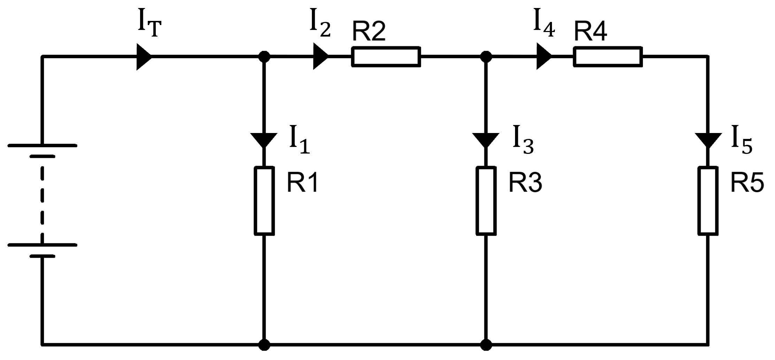
Fig Q1

  - Define the term “time constant” in relation to a RC circuit
[2 Marks]
  - For a RC circuit consisting of a 1kΩ resistance and a 47µF capacitance connected to a 24Vdc power supply: calculate the voltage on the capacitor at a time of 20ms after the supply was connected, assuming the capacitor had an initial charge of 0V.
[3 Marks]
  - For the circuit described in part b, plot a graph of charging current against time, for times between 0s and 235ms
[10 Marks]

- Design and sketch an LED circuit consisting of a 9V battery, an on-off switch and a resistor. Assuming the forward voltage across the LED is 2V and the current through the LED should be limited to a maximum of 20mA. Determine a suitable value of the resistor.
[5 Marks]

- An oscilloscope display shows the waveform in Fig Q4. The oscilloscope settings are shown in the box next to the waveform.

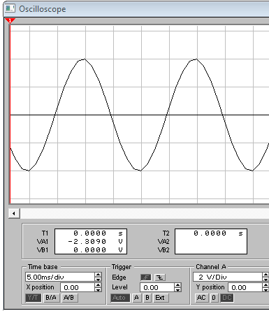
Oscilloscope settings

5 V/div
2 µs/div
Fig Q4

- Estimate the period of the waveform
[1 Mark]
- From the estimated period, determine its frequency
[1 Mark]
- Determine its peak to peak amplitude
[1 Mark]
- Determine the RMS value of the waveform
[2 Marks]

- For an AC voltage $V=50\sin\left(100πt+1.57\right)$, find the following quantities:
  - Peak value
[1 Mark]
  - RMS value
[1 Mark]
  - Frequency
[1 Mark]
  - Time period
[1 Mark]
  - Phase angle relative to $V=50\sin\left(100πt\right)$ and state if it is leading or lagging this waveform
[1 Mark]

Diwedd/End

Formulae Sheet
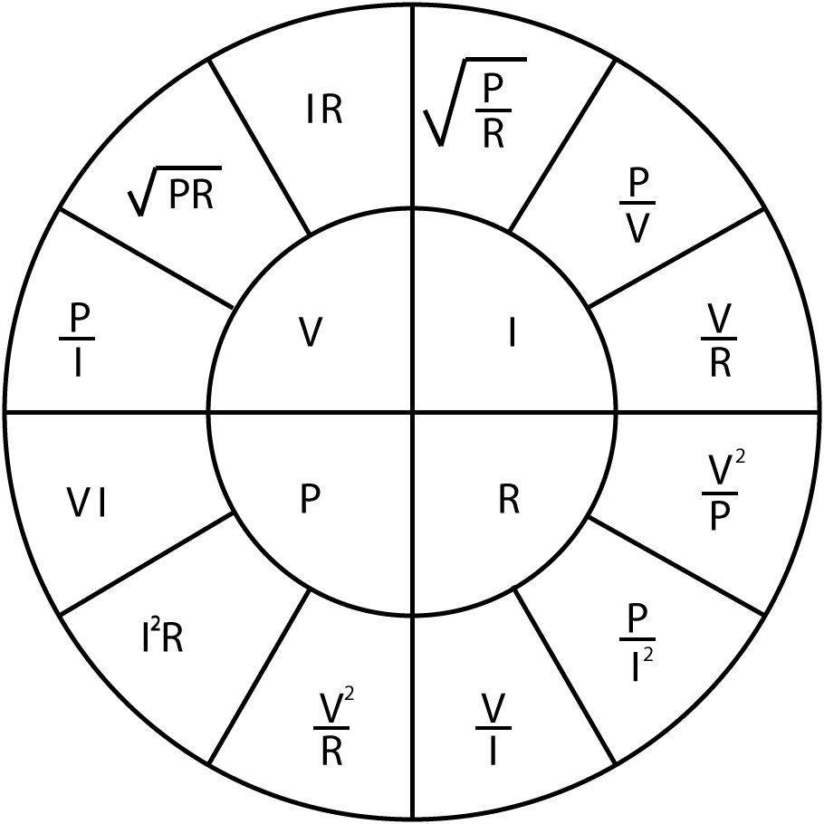 |  | $$R_{T}=R_{1}+R_{2}+…+R_{n}$$  $$\frac{1}{R_{T}}=\frac{1}{R_{1}}+\frac{1}{R_{2}}+…+\frac{1}{R_{n}}$$  $$\frac{1}{C_{T}}=\frac{1}{C_{1}}+\frac{1}{C_{2}}+…+\frac{1}{C_{n}}$$  $$C_{T}=C_{1}+C_{2}+…+C_{n}$$  $$L_{T}=L_{1}+L_{2}+…+L_{n}$$  $$\frac{1}{L_{T}}=\frac{1}{L_{1}}+\frac{1}{L_{2}}+…+\frac{1}{L_{n}}$$ | $$V_{Out}=V_{in}\frac{R_{B}}{R_{A}+R_{B}}$$  $$I=I_{in}\frac{R_{B}}{R_{A}+R_{B}}$$
$$X_{C}=\frac{1}{2πfC}$$
$$X_{C}=-j\frac{1}{ωC}$$

$$X_{L}=2πfL$$
$$X_{L}=jωL$$

$$Z=R+j\left(X_{L}-X_{C}\right)$$  $$\left|Z\right|=\sqrt{R^{2}+{\left(X_{L}-X_{C}\right)}^{2}}$$ | $$ω=2πf$$  $$X_{T}=X_{L}-X_{C}$$ | $$φ=\tan^{-1}{\frac{X_{T}}{R}}$$  $$pf=\cos{φ}$$ | $$f_{res}=\frac{1}{2π\sqrt{LC}}$$
$$V_{C}=V_{s}\left(1-e^{{-t}/τ}\right)$$  $$I_{C}=\frac{V}{R}\left(e^{{-t}/{RC}}\right)$$  $$V_{C}=V_{0}\left(e^{{-t}/τ}\right)$$  $$I_{C}=-\frac{V}{R}\left(e^{{-t}/{RC}}\right)$$  $$τ=RC$$ | $$τ=\frac{L}{R}$$  $$V_{L}=V\left(e^{{-Rt}/L}\right)$$  $$V_{L}=-V\left(e^{{-Rt}/L}\right)$$  $$I_{L}=\frac{V}{R}\left(1-e^{{-Rt}/L}\right)$$  $$I_{L}=\frac{V}{R}\left(e^{{-Rt}/L}\right)$$ | $$f=\frac{1}{2πRC}$$  $$A_{V}=20\log{\frac{V_{out}}{V_{in}}}$$  $$A_{P}=10\log{\frac{P_{out}}{P_{in}}}$$ | $$Q=\frac{X_{L}}{R}$$  $$Q=\frac{X_{C}}{R}$$  $$Q=\frac{f_{R}}{f_{U}-f_{L}}$$  $$Q=\frac{1}{R}\sqrt{\frac{L}{C}}$$
$$E=\frac{1}{2}CV^{2}$$
$$E=\frac{1}{2}LI^{2}$$
$$V_{B} \text{=}\frac{\text{RB2}}{\text{(}\text{RB}\text{1 + }\text{RB}\text{2)}}\text{×} V_{CC}$$  $$V_{E}=V_{B}-0.7$$  $$I_{C}=I_{E}$$  $$V_{C}=V_{CC}-\left(I_{C}×R_{C}\right)$$  $$Av=\frac{v_{c}}{v_{b}}$$  $$V_{E}=10\%V_{CC}$$  $$R_{IN}=\frac{1}{\frac{1}{{RB}_{1}}+\frac{1}{{RB}_{2}}+\frac{1}{\left(h_{FE}×R_{E}\right)}}$$  $$R_{OUT}=R_{C}$$  $$A_{V}≈-\frac{R_{C}}{R_{E}}$$ |  | $$V_{out}=-\frac{R2}{R1}×V_{in}$$  $$V_{out}=\left[1+\frac{R2}{R1}\right]×V_{in}$$  $$V_{out}=\frac{R2}{R1}×\left[V_{2}-V_{1}\right]$$  $$V_{out}=-\frac{R2}{R1}×\left[V_{1}+V_{2}\right]$$  $$V_{out}=-\left[\frac{R}{R1}×V_{1}+\frac{R}{R2}×V_{2}+…+\frac{R}{Rn}×V_{n}\right]$$

Detach this page and place in answer book

Student Number …………………………. Question Number ……………………….



