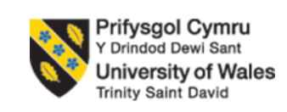
Programme Name: Master of Business Administration
Module Name & Code: Human Capital Management – LCMB7023
Assignment Title: Assessment component 1: Individual report – HR strategy
Lecturer: Anupam Mazumdar
Student Name: Vishal Sapkal
Student ID: 2521152
Word Count: 2500

Table of Contents
1. Introduction 2
2. Part 1: Option 2 – Building a Culture of Innovation & Future Work Practices 2
2.1 Current Culture and Work Practices in Tech Companies 2
2.2 Cultural Initiatives to Embed Innovation 3
2.3 Structural Initiatives for Innovation and Collaboration 5
2.4 Future of Work Model for Aether Innovations 6
2.5 Employee Motivation and Performance Impact 7
3. PART 2 – Reflective Learning 9
3.1 Reflection Using Gibbs Reflective Cycle 9
3.2 Future Professional Development and AI Adaptation 11
4. Conclusion 12
References 13

1. Introduction
This is a report on an integrated human capital strategy of Aether Innovations, which is a dynamic technology company experiencing decreasing growth, employee turnover, and unsatisfied customers. The findings put forth in the report suggest cultural, structural and future work projects to enhance innovation and employee performance. It also takes a look at personal learning and professional development with the help of a reflective framework.

2. Part 1: Option 2 – Building a Culture of Innovation & Future Work Practices

2.1 Current Culture and Work Practices in Tech Companies
Innovation, agility, and teamwork are the key pillars of the culture of technology companies that need to stay competitive in the fast-changing markets. Most of these top companies like Google and Microsoft embrace experimentation, quick learning and freedom of employees as a way of generating innovative problem solving and new products.
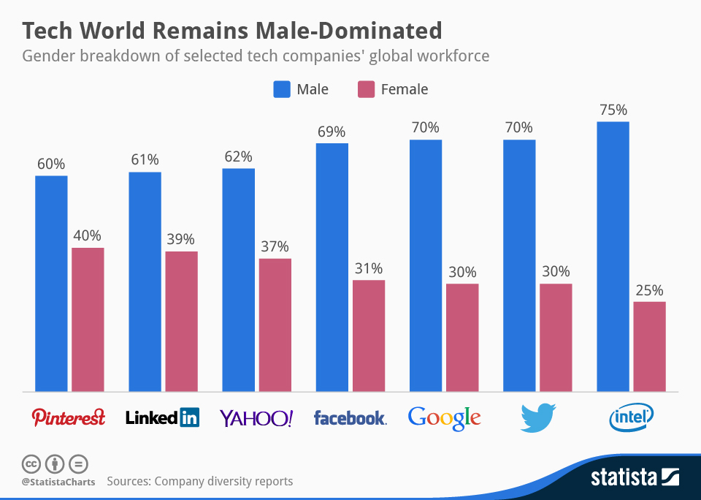
Figure 1: Tech World Remains Male-Dominated
(Source: Statista.com, 2026)
Diversity reports from Google, Yahoo, LinkedIn, Intel, Facebook, and Twitter show the tech industry is male-dominated, with women holding 52% of non-tech jobs at Yahoo but only 15% of tech roles and 23% of leadership positions, while at Google, women occupy 17% of tech jobs and 21% of leadership roles (Statista.com, 2026). Agile working environments are common in these organisations, with a team of people working within brief cycles of development, and responding rapidly to feedback that are given by customers.
An effective framework that can be used to explain these practices is the Organisational Culture Theory, which postulates that common values, behaviours and norms determine the performance and innovation of employees in a firm (Osei et al. 2023). Technology organisations have cultures that promote openness, sharing of knowledge and taking risks, as these cultures are likely to generate more innovative things.
Cross-functional collaboration and digital communication connect departments in modern tech firms, but gaps remain when culture, structure, and leadership are misaligned (Ahmad et al. 2023). In such organisations as Aether Innovations, creativity and employee engagement could be limited by poor communication channels, strict organisational hierarchy, or a lack of innovation support that would influence slower development and customer dissatisfaction.

2.2 Cultural Initiatives to Embed Innovation
To restore the culture of innovation and engagements at Aether Innovations, the organisation needs to introduce cultural programs that foster creativity, experimentation, and When it comes to knowledge sharing. A helpful strategy would include the implementation of innovation sprints and hackathons, during which employees can work in high intensity and create and prototype new ideas in a short duration (Opland et al. 2022). The activities encourage quick solutions to problems and make employees think outside the routine.
The other initiative is building intrapreneurship programs, which will enable the employees to present and spearhead internal innovations. These types of programmes will enable the employees to own ideas and make direct contributions towards organisational development. The collaboration and creativity can also be enhanced by encouraging the sharing of ideas among cross-departments by means of innovation forums, or in-house platforms, etc.
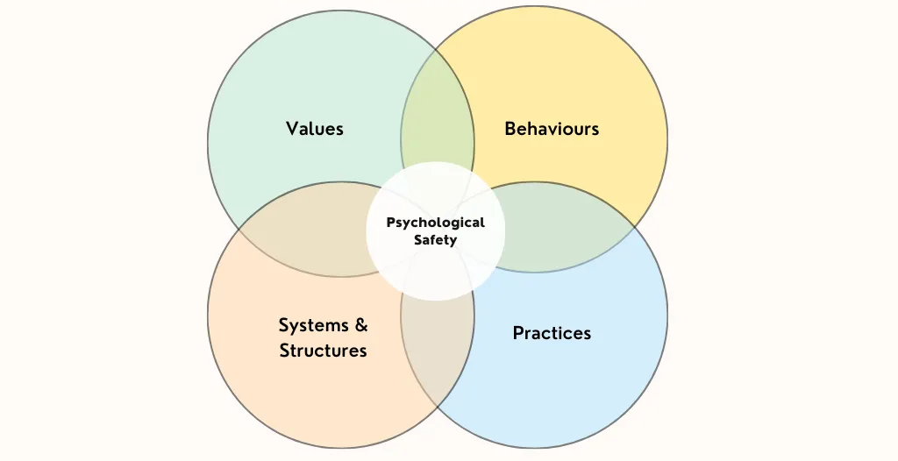
Figure 2: The Psychological Safety Theory
(Source: Self-developed)
It is also necessary to establish a psychological safety culture. Employees who feel secure to share ideas, challenge practices in place and take calculated risks without feeling their advancements may be criticised will give a greater chance of providing innovative solutions. The Psychological Safety Theory proposed by Amy Edmondson is a piece of evidence of this notion, as it is proposed that the team will work more efficiently when people feel free to discuss their opinions, learning how to correct their errors, trying new practices (Edmondson and Bransby, 2023).
Moreover, organisations ought to foster a culture of learning and experimentation through encouraging lifelong learning opportunities, training and knowledge-sharing seminars. Lastly, it is also possible to create incentive systems and reward systems that recognise innovative thoughts among employees to encourage them to share creative ideas.
Collectively, these cultural efforts will be able to enhance employee engagement, promote teamwork, and other organisational structures in which innovation is a key driver of long-term performance and competitiveness.

2.3 Structural Initiatives for Innovation and Collaboration
Together with the culture change, Aether Innovations will need to introduce the structural measures that are going to facilitate cooperation and innovation throughout the organisation. The formation of cross-functional project teams is one of the effective methods in which workers in various departments will work together towards a common goal. Cross-functional teams promote sharing of varied perspectives, quick problem solving and robust knowledge sharing as compared to traditional departmental structure, and are critical in innovation (Attah et al. 2024).
The other structural design is the agile squad design, where small teams that are autonomous handle certain projects or product features. The agile squads are more autonomous and flexible than traditional hierarchical teams that need management to pass before any decisions can be made (Gutiérrez et al. 2022). This enables decision making, adapting fast to any changes that happen on the market and continuous product and service improvement. To enhance this system, the creation of a flatter hierarchy in decision-making can help to dissipate bureaucracy and get the employees to offer more ideas freely.
Moreover, organisations can create innovation laboratories or idea incubators that can offer specific areas of experimentation and prototyping. These spaces promote innovation and taking risks, unlike the normal working conditions where an individual is under pressure to keep up with the operations of the day. Besides, digital collaboration tools could reinforce coordination among office-based and remote employees.
These structural initiatives are compatible with the Team-Based Organisational performance model that opines that structuring work within cooperative teams improves interaction, innovation, as well as the performance of the entire organisation (Barkova and Melnik, 2023). Changing the inflexible hierarchies to flexible and team-oriented systems would help Aether Innovations fast-track innovation processes and develop a more responsive and dynamic workplace.

2.4 Future of Work Model for Aether Innovations
Aether Innovations ought to introduce a hybrid work model, which involves working at home and the workplace to improve the level of collaboration and productivity. This will enable the employees to work at home half a week and visit the office where they can collaborate with members of the team, brainstorm, and develop projects. Work-life balance may be enhanced with the implementation of hybrid work and the building of solid team relationships (Ishak et al. 2025).
Next, the introduction of flexible work schedules should be considered in the organisation, which will result in the fact that workers can decide the amount of time they spend working on a specific project, depending on the requirements of the project and their individual patterns of work. Convenient times can be used to enhance job satisfaction and decrease burnout, especially in technology jobs that are more or less knowledge-oriented.
The digital collaboration tools utilised to support effective hybrid work also include a project management system, a shared communication platform and the cloud-based document system (Singh et al. 2024). Such tools allow the coordinated work of remote and in-office workers easily and contribute to real-time knowledge transfer.
Moreover, Aether Innovations will be able to arrange virtual workshops and showcases on innovations and brainstorming, during which the workers will be able to exchange ideas on the Internet and find solutions to complicated problems. Such meetings contribute to creativity even in distributed teams.
Good remote team leadership is also crucial. To keep the team officials motivated and accountable, the managers are encouraged to pay attention to clear communication and frequent feedback, as well as performance management based on the outcomes. By implementing this Future of Work model, Aether Innovations can become a flexible, collaborative, and innovation-driven workplace that fosters the health of the workers, as well as the efficiency of the organisation.

2.5 Employee Motivation and Performance Impact
The cultural and structural plans offered, along with a hybrid work model, will contribute greatly to the motivation of employees and the performance of the organisation at Aether Innovations. The level of engagement and commitment that the employees give improves when they are accorded more autonomy, collaboration prospects, and reward innovative ideas. The activities that stimulate knowledge sharing are also initiated, such as cross-functional teams, innovation sprints, and digital collaboration platforms, and employees are more likely to share ideas and come up with innovative solutions through the mentioned activities.
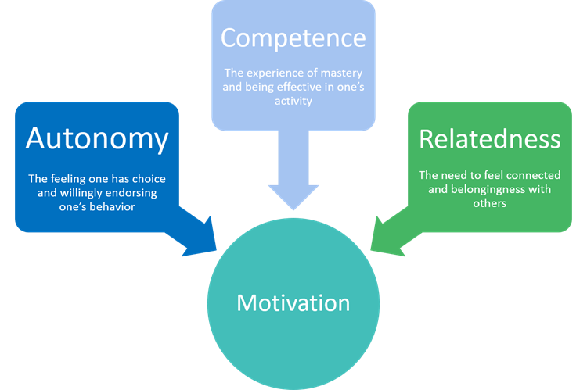
Figure 3: Self-Determination Theory
(Source: Self-developed)
This practice is justified by the Self-Determination Theory, which assumes that the higher the needs of employees are met in terms of autonomy, competence, and relatedness, the more motivated they will be (Gagné et al. 2022). Giving flexibility in work and an opportunity to experiment makes employees feel more powerful and competent in their positions.
Consequently, innovation output, problem-solving, and product development rates are also likely to be high in the organisation. Such improvements in the long run would be able to boost customer satisfaction and help improve overall organisational performance and competitive advantage in the long run.

3. PART 2 – Reflective Learning

3.1 Reflection Using Gibbs Reflective Cycle
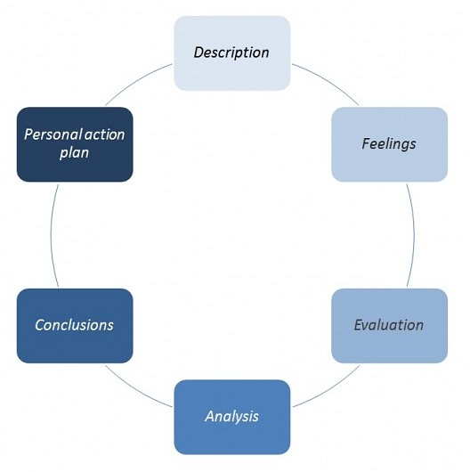
Figure 4: Gibbs Reflective Cycle
(Source: Self-developed)
Description
This HRM module enabled me to understand the role of management of human resources in organisational performance, innovation and employee engagement. Some of the important concepts in the module included those of organisational culture, talent management, leadership development and strategic HR practices. In terms of lectures, case studies and assignments, I was made to understand how HR strategies could be aligned to organisational objectives in order to achieve both employee results as well as business performance. Another important component of the learning was the analysis of real-life organisational problems and how HR theories could be used to come up with viable solutions. As an illustration, the formulation of a strategy to enhance innovation, motivation and teamwork in the organisations, assisted me in appreciating the strategic contribution of the HR professionals in contemporary organisations.
Feelings
Initially, at the first stages of the module, my perception of HR was limited to the administrative roles, including employee management and recruiting. As the module went on, however, I understood that HR has a much larger and more strategic involvement with organisations. I was especially interested to understand the role of the organisational culture and leadership in the fields of innovation and employee engagement. Knowing that people management and business success are associated gave me an insight into the roles played by HR in influencing organisational performance. Some of the theoretical concepts that I felt were complex, when applied in the practical scenarios, made me more confident and led to a better understanding of the concept.
Evaluation
The combination of theory and actual organisational experiences was one of the most important parts of the module. Learning about organisations culture, the motivation of employees and how work will be in the future made me realise that HR strategies determine the innovation and productivity. The use of group discussions and case-based analysis was especially useful since it allowed me to develop various opinions and implement theoretical frameworks on actual challenges. Also, the information regarding the effects of flexible workplace practices and online teamwork in contemporary organisations gave some ideas about the way working environments are changing. Such experiences assisted in developing my problem-solving skills and capabilities in critical thinking.
Analysis
The module showed that the HR theories can offer practical frames of understanding and resolving the organisational problems. As an illustration, motivation, organisational culture, and team collaboration theories can be used to explain the behaviour and performance of employees in organisations. Using these frameworks, the HR professionals can develop policies and practices that can increase employee engagement and productivity. As an example, learning the value of psychological safety and teamwork can assist organisations in developing an environment that fosters creativity and knowledge exchange. Likewise, strategic HR practices are planned to enhance the satisfaction of the employees by improving their skills, providing leadership assistance and flexible work schedules, besides facilitating organisational objectives (Hoichuk and Lyubomudrova, 2024). This discussion has emphasised the fact that, rather than being solely staff management, HR is also about influencing the organisational types of systems that facilitates long term performance.
Conclusion
On balance, this module has enabled me to realise the strategic role of HR management in contemporary organisations. I got to know that strong leadership, organisational culture, and good HR practices are critical in promoting innovation and enhancing the performance of employees. Stability. The module also indicated that HR professionals are very instrumental in ensuring that people management is aligned with business strategy. The knowledge has enhanced my desire to learn how organisations can instil cultures that endorse creativity, teamwork and continual enhancement.
Action Plan
I will keep enhancing my strategy and HR knowledge in future. I will read additional research papers and trade reports on human resource management and innovation in organisations. I will additionally work on my leadership, communication, and problem-solving skills, which are also necessary in the case of HR professionals. Moreover, having some practical experience working in HR related positions or conducting internships will assist me in implementing theoretical knowledge in the real-life scenario of the organisations. I plan to be more equipped to work in organisations that embrace innovation, employee growth, and sustainable performance by continually learning and acquiring these skills.

3.2 Future Professional Development and AI Adaptation
Artificial intelligence is rapidly spreading and is changing most areas of human resource management. Due to advanced AI technologies, some of the common HR functions, including data processing, job screening, and workforce analytics, can now be performed by AI. Although these innovations enhance efficiency and decrease the work of administrators, they also demand the modification of HR professionals and their new potential. Areas where AI is likely to transform the HR positions will be fewer to replace them and more to reorient their priorities to strategic management and human-centred tasks (Cappelli and Rogovsky, 2023).
In order to be acceptable in this dynamic environment, HR professionals should enrol their competencies that are hard to is duplicable by technology. Strategic thinking is an important tool that facilitates the practice of people management in line with organisational objectives. On the same note, emotional intelligence is vital in knowing the needs of the employees, conflict resolution, and the creation of healthy relations in the workplace (Sharma et al. 2024). Creativity and ethical decision-making are also becoming significant skills to have in seeking complex challenges in organisations and fair HR practices. Moreover, it requires good human leadership ability to lead the team, create trust and culture within organisations.
In addition to that, AI can also be used to assist in HR decision-making and not to substitute it (Cai et al. 2024). To illustrate, HR analytics can be used to process the data on employee performance and recognise workforce tendencies. Recruitment screening tools that are powered by AI can also help with the right hiring, and decision support systems can offer insights that will enable HR managers to make better strategic judgments. The ability to integrate technology with the distinctively human abilities will help HR professionals be useful assets to organisational success.

4. Conclusion
To sum up, the engagement, teamwork, and the overall performance of employees at Aether Innovations can be enhanced to a great extent by developing a robust innovation culture and providing favourable structural and working conditions. Another key point that is mentioned by the report is the necessity of continuous maturity and the cultivation of human-based abilities to stay a relevant and useful employee in an AI-based workplace and use technology as a support system.

References
Part 1
Ahmad, T., Boit, J. and Aakula, A., 2023. The role of cross-functional collaboration in digital transformation. Journal of Computational Intelligence and Robotics, 3(1), pp.205-42.
Attah, R.U., Garba, B.M.P., Gil-Ozoudeh, I. and Iwuanyanwu, O., 2024. Cross-functional team dynamics in technology management: a comprehensive review of efficiency and innovation enhancement. Eng Sci Technol J, 5(12), pp.3248-65.
Barkova, K. and Melnik, A., 2023. Organisational culture as factor of effectiveness in team building.
Edmondson, A.C. and Bransby, D.P., 2023. Psychological safety comes of age: Observed themes in an established literature. Annual review of organizational psychology and organizational behavior, 10(1), pp.55-78.
Gagné, M., Parker, S.K., Griffin, M.A., Dunlop, P.D., Knight, C., Klonek, F.E. and Parent-Rocheleau, X., 2022. Understanding and shaping the future of work with self-determination theory. Nature reviews psychology, 1(7), pp.378-392.
Gutiérrez, G., De Lena, M.T.G., Garzás, J. and Moguerza, J.M., 2022. Leadership styles in agile teams: An analysis based on experience. IEEE access, 10, pp.19232-19241.
Ishak, A.D., Entong, A.E., Entong, A. and Haris, A.T.L.P.L., 2025. Employees perception of work-life balance implementation in a hybrid work environment. Economics and Business Journal (ECBIS), 3(2), pp.207-214.
Opland, L.E., Smite, D. and Pappas, I., 2022. Facilitating Employee-Driven Digital Innovation Through the Use of Hackathons–A Case Study.
Osei, M.B., Papadopoulos, T., Acquaye, A. and Stamati, T., 2023. Improving sustainable supply chain performance through organisational culture: A competing values framework approach. Journal of Purchasing and Supply Management, 29(2), p.100821.
Singh, A.P., Rahi, P., Singh, I. and Yadav, V., 2024. Revolutionizing remote collaboration: a comprehensive review of cloud-based real-time platforms to secure teams. online] SNSFAIT, pp.120-129.
Statista.com (2026), “Tech World Remains Male-Dominated” Available at: https://www.statista.com/chart/2388/gender-breakdown-tech-companies/?srsltid=Af02mBOornsJtnK3JLTNQKPIsk-uDnrqsbNf2sfmk-rgeZBncZEeZO2Brh [Accessed on: 12.03.2026]
Part 2
Cai, F., Zhang, J. and Zhang, L., 2024. The impact of artificial intelligence replacing humans in making human resource management decisions on fairness: A case of resume screening. Sustainability, 16(9), p.3840.
Cappelli, P. and Rogovsky, N.G., 2023. Artificial intelligence in human resource management: a challenge for the human-centred agenda? (No. 95). ILO Working Paper.
Hoichuk, V. and Lyubomudrova, N., 2024. The impact of strategic human capital management on the competitiveness of an enterprise. Three Seas Economic Journal, 5(2), pp.1-6.
Sharma, P., Dhanta, R. and Sharma, A., 2024. Emotional intelligence and conflict resolution in the workplace. In Leveraging AI and emotional intelligence in contemporary business organizations (pp. 102-121). IGI Global Scientific Publishing.

