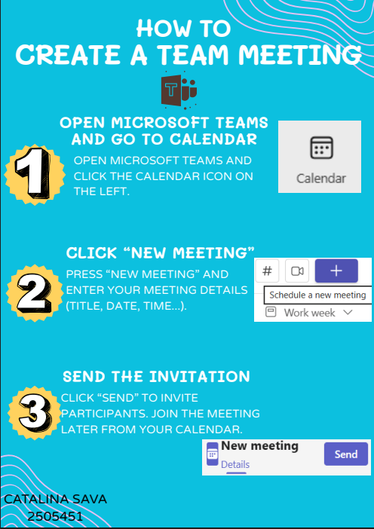
The graphic outlines three simple steps for creating a meeting in Microsoft Teams.
First, click the calendar icon on the left side of the Microsoft Teams app. You may view all of your meetings here and schedule new ones.
Second, locate the "New Meeting" icon and click it. The title, date, time, and people you wish to invite are all written here. To ensure that everyone is aware of the meeting's date and purpose, this step is crucial.
Third, save the meeting and send invites to the individuals you added by clicking the "Send" option. A notification to attend the meeting will be sent to them. You can attend the meeting directly from the calendar when it's time.
People may rapidly learn how to utilise Teams for meetings with the aid of this simple-to-understand poster. Even those who are not extremely tech-savvy can benefit from it because it covers only the essential topics and is written in plain language. By using this poster at work, employees may organise meetings on their own, which improves productivity. This poster explains how to utilise Microsoft Teams, a useful tool for online communication and collaboration.

