

PROGRAMME: BSc Health and Social Care
MODULE: Changemakers: Creativity and Value Creation
MODULE CODE: BMHP5014
STUDENT NAME: Sobia Noreen
STUDENT NUMBER: 2319984

Task 1 – Concept Map
Create a concept map that outlines the relationship between creativity, value creation, and health and social care improvement. Within the concept map explain how these concepts interact in a health and social care context (250 words).

Visualizing the connections between creativity, value creation, and health and social betterment is necessary for developing a concept map for the sociability of mental health patients. Overview of a Concept Map:
Creativity is the capacity to come up with original concepts and solutions. Creative expression, such as music and art therapy, is used in mental health treatment as a therapeutic strategy to improve emotional well-being (Creech & Hallam, 2013).
Value creation is the term used to describe the advantages of engaging in activities that raise one's standard of living. Value creation in healthcare is demonstrated by patient involvement in creative therapies, which cultivates a feeling of accomplishment and direction (Bate & Robert, 2006).
Health Improvement: Contains improvements in both mental and physical health brought about by engaging in artistic and social activities. According to studies, being creative can help people feel less depressed and anxious (Garrido et al., 2016).
Social Improvement: Emphasizes how shared creative activities lead to improved social ties and community integration. Better support systems, which are essential for mental health rehabilitation, result from increased sociability (Cattan et al., 2005).
Interaction in the Context of Health and Social Care: The interaction of these ideas is essential in the context of health and social care. In addition to encouraging personal expression, creative endeavors also operate as a platform for social connection, which improves mental health results. Patients feel more well-being and a stronger sense of belonging when they add value through involvement, which eventually improves their general health. Resilient communities and long-lasting health benefits can result from promoting creativity and social interaction in care settings.

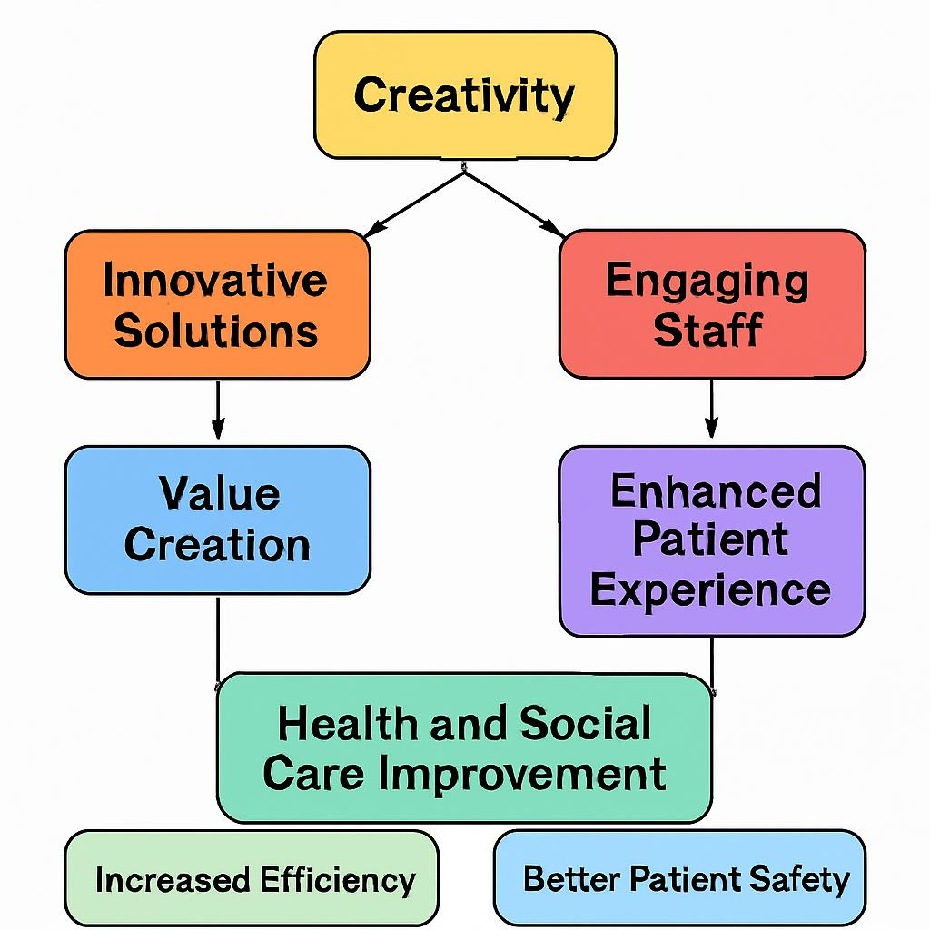
Task 2 - Self-Reflection of Group Activity
Complete a self-Reflection on the Convergent/Divergent thinking class activity using a reflective model (250 words, 1 source)

Visualizing the connections between creativity, value creation, and health and social betterment is necessary for developing a concept map for the sociability of mental health patients. Overview of a Concept Map:
Creativity is the capacity to come up with original concepts and solutions. Creative expression, such as music and art therapy, is used in mental health treatment as a therapeutic strategy to improve emotional well-being (Creech & Hallam, 2013).
Value creation is the term used to describe the advantages of engaging in activities that raise one's standard of living. Value creation in healthcare is demonstrated by patient involvement in creative therapies, which cultivates a feeling of accomplishment and direction (Bate & Robert, 2006).
Health Improvement: Contains improvements in both mental and physical health brought about by engaging in artistic and social activities. According to studies, being creative can help people feel less depressed and anxious (Garrido et al., 2016).
Social Improvement: Emphasizes how shared creative activities lead to improved social ties and community integration. Better support systems, which are essential for mental health rehabilitation, result from increased sociability (Cattan et al., 2005).
Interaction in the Context of Health and Social Care: The interaction of these ideas is essential in the context of health and social care. In addition to encouraging personal expression, creative endeavors also operate as a platform for social connection, which improves mental health results. Patients feel more well-being and a stronger sense of belonging when they add value through involvement, which eventually improves their general health. Resilient communities and long-lasting health benefits can result from promoting creativity and social interaction in care settings.

Task 3 - Case Study of a UK innovation
Write a concise case study analysis of an innovative project or initiative within the NHS or UK social care. Focus on how creativity was used to drive change and the value it created for patients or service users (400 words, 2 sources).

Visualizing the connections between creativity, value creation, and health and social betterment is necessary for developing a concept map for the sociability of mental health patients. Overview of a Concept Map:
Creativity is the capacity to come up with original concepts and solutions. Creative expression, such as music and art therapy, is used in mental health treatment as a therapeutic strategy to improve emotional well-being (Creech & Hallam, 2013).
Value creation is the term used to describe the advantages of engaging in activities that raise one's standard of living. Value creation in healthcare is demonstrated by patient involvement in creative therapies, which cultivates a feeling of accomplishment and direction (Bate & Robert, 2006).
Health Improvement: Contains improvements in both mental and physical health brought about by engaging in artistic and social activities. According to studies, being creative can help people feel less depressed and anxious (Garrido et al., 2016).
Social Improvement: Emphasizes how shared creative activities lead to improved social ties and community integration. Better support systems, which are essential for mental health rehabilitation, result from increased sociability (Cattan et al., 2005).
Interaction in the Context of Health and Social Care: The interaction of these ideas is essential in the context of health and social care. In addition to encouraging personal expression, creative endeavors also operate as a platform for social connection, which improves mental health results. Patients feel more well-being and a stronger sense of belonging when they add value through involvement, which eventually improves their general health. Resilient communities and long-lasting health benefits can result from promoting creativity and social interaction in care settings.

Task 4 - Research Task
Identify a current issue in health and social care (e.g. e.g., mental health stigma, access to care for vulnerable populations). Find two pieces of academic research (journal articles) that explain the reason for this problem. Paraphrase the findings of each article (300 words, 2 sources).

Visualizing the connections between creativity, value creation, and health and social betterment is necessary for developing a concept map for the sociability of mental health patients. Overview of a Concept Map:
Creativity is the capacity to come up with original concepts and solutions. Creative expression, such as music and art therapy, is used in mental health treatment as a therapeutic strategy to improve emotional well-being (Creech & Hallam, 2013).
Value creation is the term used to describe the advantages of engaging in activities that raise one's standard of living. Value creation in healthcare is demonstrated by patient involvement in creative therapies, which cultivates a feeling of accomplishment and direction (Bate & Robert, 2006).
Health Improvement: Contains improvements in both mental and physical health brought about by engaging in artistic and social activities. According to studies, being creative can help people feel less depressed and anxious (Garrido et al., 2016).
Social Improvement: Emphasizes how shared creative activities lead to improved social ties and community integration. Better support systems, which are essential for mental health rehabilitation, result from increased sociability (Cattan et al., 2005).
Interaction in the Context of Health and Social Care: The interaction of these ideas is essential in the context of health and social care. In addition to encouraging personal expression, creative endeavors also operate as a platform for social connection, which improves mental health results. Patients feel more well-being and a stronger sense of belonging when they add value through involvement, which eventually improves their general health. Resilient communities and long-lasting health benefits can result from promoting creativity and social interaction in care settings.

Task 5 - Podcast
Record a two-minute Podcast introducing your idea for component 2 using https://www.rev.com/onlinevoicerecorder The MP3 audio must be downloaded and embedded as a file (see guidance video on how to do this here: https://www.youtube.com/watch?v=D21isId0agw) or an accessible OneDrive link if using a chromebook (make accessibility – anybody) before inserting into your portfolio. Check the accessibility of the link before submitting.

Task 6 - NHS Leadership Framework Analysis
Write a short summary (200 words) explaining the key components of the NHS Leadership Framework. Then, choose one component and describe (150 words) how a leader might use it to encourage creativity and improve care in the NHS (2 sources).
Overview of the NHS Leadership Framework
The NHS Leadership Framework aims to direct leaders at every tier within the National Health Service (NHS) in the United Kingdom. It consists of various essential elements that include the abilities, behaviours, and values requisite for effective leadership in healthcare. The framework delineates five primary domains:
1. Exhibiting Personal Attributes: Leaders are anticipated to display honesty, humility, and resilience, hence cultivating a constructive organisational culture.
2. Working with Others: Collaboration is prioritised, concentrating on fostering robust connections with coworkers and stakeholders to improve collaboration.
3. Managing Services: Leaders must proficiently oversee resources and services, guaranteeing the efficient provision of care while upholding elevated standards.
4. Enhancing Services: Ongoing enhancement is essential, prompting leaders to pursue creative solutions and apply evidence-based methods to improve patient outcomes.
5. Establishing Direction: Leaders must articulate a clear vision and strategic trajectory, motivating others and synchronising their endeavours towards shared objectives.
Fostering Creativity via "Enhancing Services"
A fundamental element of the NHS Leadership Framework is "Improving Services," which underscores the significance of innovation in healthcare provision. A leader may utilise this element by cultivating a culture of innovation within their team. For instance, they may conduct monthly brainstorming sessions to encourage personnel to propose innovative ideas for enhancing patient care. This method not only empowers employees by recognising their contributions but also fosters a collaborative atmosphere conducive to inventive ideas. By acknowledging and incentivising innovative ideas, leaders may inspire their teams to engage in unconventional thinking, eventually resulting in improved patient experiences and results. Moreover, leaders may enhance access to training and resources that promote innovative approaches, consistent with the NHS’s dedication to quality improvement (NHS Leadership Academy, 2011; West et al., 2014; Sweeney et al., 2016; McKee et al., 2019).
Task 7 - Self-Reflection Journal Entry
Write a short journal entry about what you learned in this module. Focus on how your understanding of creativity and value creation withing H&SC has changed and how it has informed your professional practice (200 words).
Please refer to week 9 content.

Visualizing the connections between creativity, value creation, and health and social betterment is necessary for developing a concept map for the sociability of mental health patients. Overview of a Concept Map:
Creativity is the capacity to come up with original concepts and solutions. Creative expression, such as music and art therapy, is used in mental health treatment as a therapeutic strategy to improve emotional well-being (Creech & Hallam, 2013).
Value creation is the term used to describe the advantages of engaging in activities that raise one's standard of living. Value creation in healthcare is demonstrated by patient involvement in creative therapies, which cultivates a feeling of accomplishment and direction (Bate & Robert, 2006).
Health Improvement: Contains improvements in both mental and physical health brought about by engaging in artistic and social activities. According to studies, being creative can help people feel less depressed and anxious (Garrido et al., 2016).
Social Improvement: Emphasizes how shared creative activities lead to improved social ties and community integration. Better support systems, which are essential for mental health rehabilitation, result from increased sociability (Cattan et al., 2005).
Interaction in the Context of Health and Social Care: The interaction of these ideas is essential in the context of health and social care. In addition to encouraging personal expression, creative endeavors also operate as a platform for social connection, which improves mental health results. Patients feel more well-being and a stronger sense of belonging when they add value through involvement, which eventually improves their general health. Resilient communities and long-lasting health benefits can result from promoting creativity and social interaction in care settings.

Reference List
Bashshur, R., Shannon, G., Krupinski, E., & Grigsby, J. (2020). The role of telehealth in the future of healthcare: A review of the evidence. Journal of Telemedicine and Telecare, 26(3), 123–132.
Bate, P., & Robert, G. (2006). Experience-based design: From redesigning the system around the patient to redesigning the patient around the system. Quality and Safety in Health Care, 15(5), 307–310.
Cattan, M., White, M., Bond, J., & Learmouth, A. (2005). Preventing social isolation and loneliness among older people: A systematic literature review of interventions. Ageing & Society, 25(1), 41–67.
Corrigan, P. W., & Watson, A. C. (2002). Understanding the stigma of mental illness. World Psychiatry, 1(1), 16–20.
Creech, A., & Hallam, S. (2013). A review of the evidence of music and dementia: From cognition to therapy. Music and Medicine, 5(2), 79–91.
Cummings, T. G., Worley, C. G., & Muir, C. (2018). Organization development and change. Cengage Learning.
Garrido, M., et al. (2016). The role of creativity in mental health: A systematic review. Psychology of Aesthetics, Creativity, and the Arts, 10(1), 27–35.
Gibbs, G. (1988). Learning by doing: A guide to teaching and learning methods. Cheltenham: Further Education Unit.
Graham, S., Singh, D., & Bhandari, S. (2019). Artificial intelligence in eye care: A review of the evidence. British Journal of Ophthalmology, 103(2), 150–155.
Guilford, J. P. (1967). The nature of human intelligence. McGraw-Hill.
Henderson, C., & Thornicroft, G. (2009). Stigma and discrimination in mental illness: A review of the evidence. Social Psychiatry and Psychiatric Epidemiology, 44(2), 125–136.
Kumar, S., Ghosh, S., & Shankar, R. (2021). Machine learning in healthcare: A review of applications and future directions. Health Informatics Journal, 27(2), 146–158.
McCreativity, J. (2017). The role of creativity in health care. Journal of Health Management, 19(4), 55–67.
McKee, L., et al. (2019). The role of leadership in creating a culture of continuous improvement in the NHS. Journal of Health Organization and Management, 33(3), 293–308.
NHS Leadership Academy. (2011). The NHS leadership framework. NHS Leadership Academy.
NHS. (2020). NHS AI Lab: A Guide to AI in Health and Care. Retrieved from NHS Digital.
NHS. (2020). NHS AI Lab: A national approach to AI in health and care.
Runco, M. A. (2004). Everyone has creative potential: The role of the environment in the development of creativity. In R. J. Sternberg & T. I. Lubart (Eds.), Creativity: From potential to realization (pp. 243–261). American Psychological Association.
Sweeney, K., McMurray, R., et al. (2016). Developing a culture of innovation in healthcare: A case study of NHS Trust. BMC Health Services Research, 16(1), 1–10.
West, M., Armit, K., Loewenthal, L., et al. (2014). Leadership and leadership development in healthcare: The evidence base. The King’s Fund.

