Digital Marketing (LCMB7010)

Student name: Sudarshan Sunil Alande
Student Number: 2220282
Lecturer: Dr. Jayalakshmi Gopalkrishnan
Word Count: 4616
Submission Date: 29th August 2023

TABLE OF CONTENT
Sr. No. | Title | Page No.
1 | Introduction  - Background of HP company  - HP History  - HP Mission, Vision and Values | 3
2 | PART I:  The Organizational Strategies | 5
3 | PESTLE Analysis of HP in the UK Market | 7
4 | Consumer Insights of the UK Market | 10
5 | - POEM Model  - Customer Lifecycle Management  - RACE Framework | 11
6 | Buyer Personas | 16
7 | Competitive Analysis HP | 18
8 | Micro Environmental Analysis | 20
9 | PART II:  Digital Marketing Strategies | 22
10 | - SMART Objectives  - TOWS Framework  - Digital Marketing Strategy Framework | 24
11 | - Marketing Tactics and Tools  - Digital Communications Tools | 31
12 | HP Key Metrics and KPIs | 33
13 | HP Cost of Strategy | 35
14 | Conclusion and Recommendations | 36
15 | References | 37

DIGITAL MARKETING ASSIGNMENT – HP Company

Introduction

Today's Internet era has opened up a plethora of business opportunities. Using social media, one may simply reach out to existing clients and get new ones, as well as share a private birthday photo. It's incredible how fast and effortlessly digital media can share knowledge and help businesses flourish.

HP Logo (Source: dxc)
The term "digital marketing" refers to the targeted, quantified, and interactive marketing of goods or services that employs digital technology to find viewers, convert them to customers, and retain consumers. The research focuses on HP's worldwide digital marketing strategy and offers insights into the company's successful global digital development. It is the study oh HP Company and all the information related such as Brand strategy, Brand story, Mission, Vision and Values, etc. Along with that, Micro Environmental and PESTLE Analysis and consumer insights of the UK market.
Undertaking the competitor analysis of UK market, the report also analyze the target market with the help of buyer personas, customer journey, Digital Marketing plan and critical analysis of each factor. Also, the report aims to develop a Digital Marketing Strategy by identifying SMART objectives and KPI followed by the current situation of the company.

Background of HP Company
One of the most well-known technological corporations is Hewlett Packard. Bill Hewlett and David Packard started it in 1939, however largely for the manufacture of measuring equipment. It is now one of the major producers of laptops, desktop computers, printers, and many more products. However, only exist as a single business. Instead, it currently consists of a number of businesses that each specialize in a distinct area, such as Hewlett Packard Enterprise, which focuses on business solutions and analytical data products. (Hannah Ward, 16th May, 2023)
History
When the Hewlett-Packard Company (HP) was introduced in the year 1939, the world was in a very different era.
HP's history has paralleled the rise of Silicon Valley and the rise of home computing. Home computers and printers were more affordable to the ordinary customer thanks to HP's inventions, and the company's success fueled a wave of electronics companies in Santa Clara County, California. Everyone wanted to gather at HP's neighborhood. (HP.com, 2019)
HP Vision, Mission and Values:
"To make what we make," reads HP's motto. They utilize to demonstrate their ingenuity is "to invent and reinvent." What does that signify, though? They want you to think that HP can contribute to the advancement of technology, so you won't have to worry since they'll be by your side at every turn.
On its website, HP does not have an official mission statement. However, HP hints that the goal is "we are committed to reinventing and innovating your digital life."
The vision of HP is to develop technology that enhances the lives of every individual, business, and community on the planet. (Visionary, 2023)

PART 1
Organizational Analysis and its current Digital Strategy
Organizational Strategy:
The dedication of HP to innovation and research & development is one of its main advantages. The business has a long history of making investments in emerging technology and creating state-of-the-art goods and services. Because of this, HP has been able to preserve its leadership position in the technology sector and its competitive advantage in a market that is continually changing.
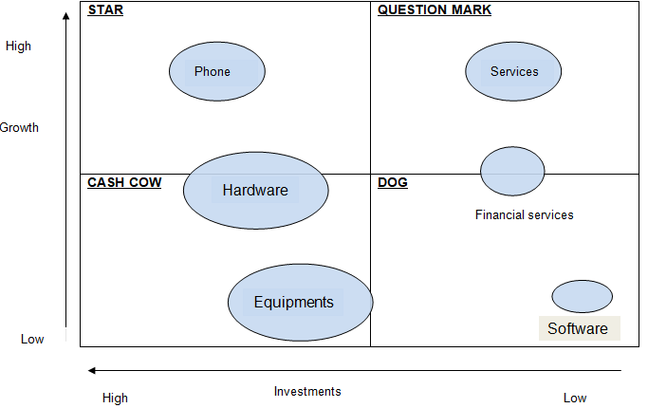
HP Corporate Level Strategy (Ivy Panda, 2019)
HP's broad distribution network and worldwide reach are further assets. The business operates in more than 170 nations and has alliances with many of the biggest technology merchants and distributors on the planet. This makes it possible for HP to promote its goods and services globally and reach a wide variety of customers.
According to Forbes, HP was listed at position 80 on the Global 2000 list and at number 31 among the World's Most Valuable Brands. Even if HP is currently a market leader in the field of global technology providers and has a notable success story to its credit, the corporation still has a ways to go.
In conclusion, HP is a significant participant in the technology sector and is well known for its cutting-edge goods and services, worldwide presence, and dedication to sustainability and social responsibility. (Bart Leby, 2023)

PESTLE Analysis of HP in the UK Market:

PESTEL study, in addition to competing pressures, provides significant information about operational challenges HP Inc. may encounter in the overall macro environment. For example, even if a sector has a strong growth trajectory and high profitability, HP Inc. will not gain from it if the political environment is volatile.

PESTLE Diagram (Source: Business to you)
Political Factors:
- The government of the United Kingdom is one of those governments that would be not just consistent but also successful if it operated properly in all of these areas.
- The United Kingdom's political structure combines parliamentary democracy and a constitutional monarchy, with the monarch serving as head of state and the prime minister as head of government.
- Brexit had an impact on the United Kingdom because many people believed that the country would become economically affluent and that there would be lots of employment opportunities as a result of the country's departure from the EU.

Economic Factors:
- Because the UK market is so diverse, all firms including HP have an equal chance to develop and expand there.
- The inflation rate in the UK is 7.9% according to the data of Office for National Statistics which is an unfavorable factor for HP.
- The prosperity of the UK economy is running completely by diversity. Because the market is so diverse, every business has an equal opportunity to develop and flourish. As long as there is a market for it and it adds value to the customers' lives. (Ahsan Ali Shaw, 2019)
Social Factors:
- The British educational system is unique in that it is regularly updated with the most recent material each year. Degrees gained via the British educational system are recognized globally.
- A society's way of life and culture impact organizational culture in a certain context. When developing a marketing message for clients, marketers at HP Inc.'s Diversified Computer Systems business must analyze the populace's common views and attitudes.
- Social factor for HP in the UK also includes Demographics and skill of level of the population, entrepreneurship skills in the society, educational level, etc.
Technological Factors:
- Britain is one of the most technologically advanced countries in the world. Both financial and technical institutions thrive in London. The cutting-edge technology infrastructure of the United Kingdom provides entrepreneurs with several commercial prospects. (Joe David, 2023)
- HP, being a technology behemoth, is heavily influenced by technical factors. The rapid advancement of technology has exacerbated HP's issues.
- The UK economy is significantly influenced by the technology sector.
Legal Factors:
- There are multiple data protection and privacy regulations in different nations because as technology advances, it becomes increasingly crucial to protect our data when entering a new market.
- HP must follow the data regulations of the respective country; for example, several countries, including China, the EU, and India, want to store their data there. It is critical to follow consumer protection regulations in countries such as the United States, the European Union, the United Kingdom, and India.
- The history of democracy in the United Kingdom is long and glorious. It has a cutting-edge judicial system and a strong tradition of upholding civil liberties. It is a global leader in terms of civil liberties and human rights.
Environmental Factors:
- After announcing that it had recycled one billion items, HP increased its objectives year after year. HP routinely ranked top in a variety of environmental sustainability metrics as a consequence of these measures.
- The company issues a Global Responsibility Report that focuses on how HP utilizes its products and services to assist people all around the world.

Consumer Insights of the UK Market:
The act of analyzing and extrapolating consumer information, habits, and comments to generate conclusions that may be used to enhance product development and customer service is known as consumer insight. Insights are the reasons behind customer needs and requirements that may be used to boost features, create new products, and improve consumer advantages. The goal of acquiring customer insights is to reconcile a company's economic aims with the desires of its consumers. (Scott Sachs)
HP Amplify Data Insights, aims to transform data analytics into insightful information from HP, partners, and other sources. Together, these insights equip HP's partners to succeed—even as client behaviors change as the astounding digital revolution plays out all across the world. Partners that have HP Amplify Data Insights at the center of their operations will be able to generate fresh ideas, guide innovation, and foresee client requirements. (HP Press)
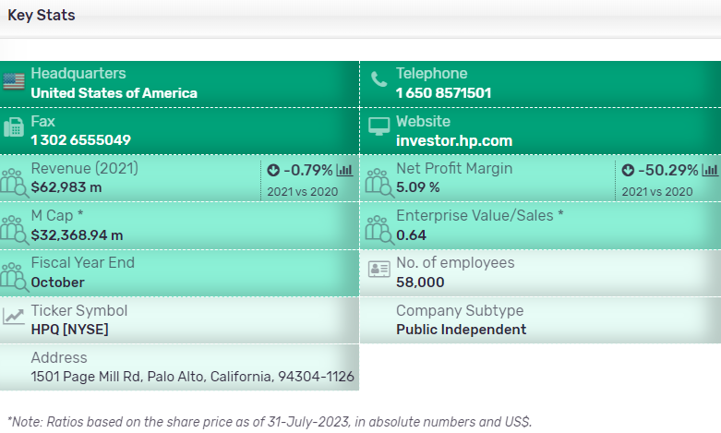
HP Key Statistics (Source- Marketline, 31st July, 2023)
The business generated sales of (US Dollars) US$62,983 million for the fiscal year that ended in October 2022 (FY2022), a 0.8% decrease from FY2021. In comparison to a 12% operating margin in FY2021, the company's operating margin in FY2022 was 7.4%. In FY2022, the company's net margin was 5.1%, down from 10.2% in FY2021. The company reported revenues of US$12,913 million for the second quarter that ended in April 2023, a 6.6% decrease from the previous quarter. (Marketline, 31st July)
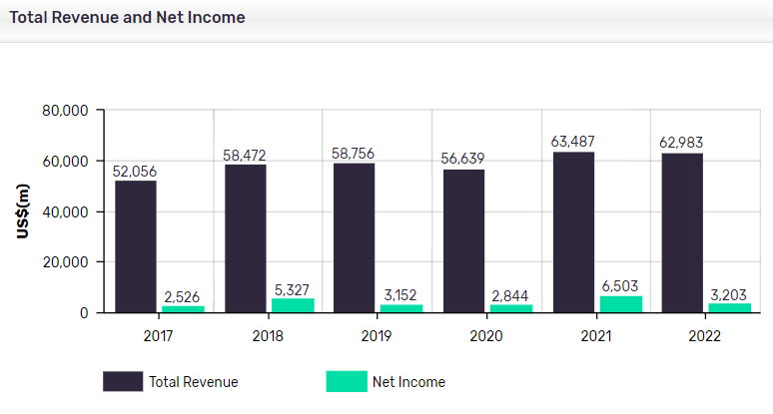
HP Total Revenue and Net Income (Source: Marketline, 2023)

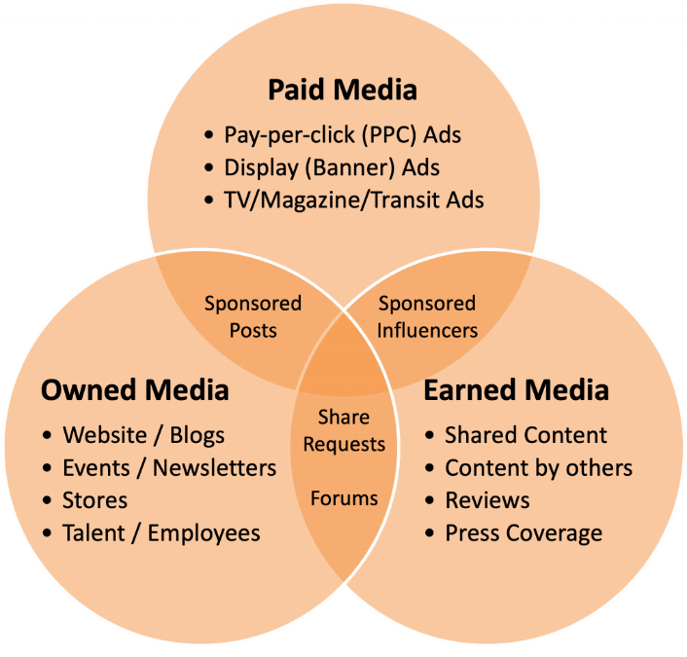
POEM Model:
POEM Model (Source- Opentext)
POEM is an abbreviation for paid, owned, and earned media. While not a novel concept, POEM is an essential component of any digital marketing approach. POEM can help you build and implement an online advertising plan and processes that will help you generate higher-quality leads and achieve better results.
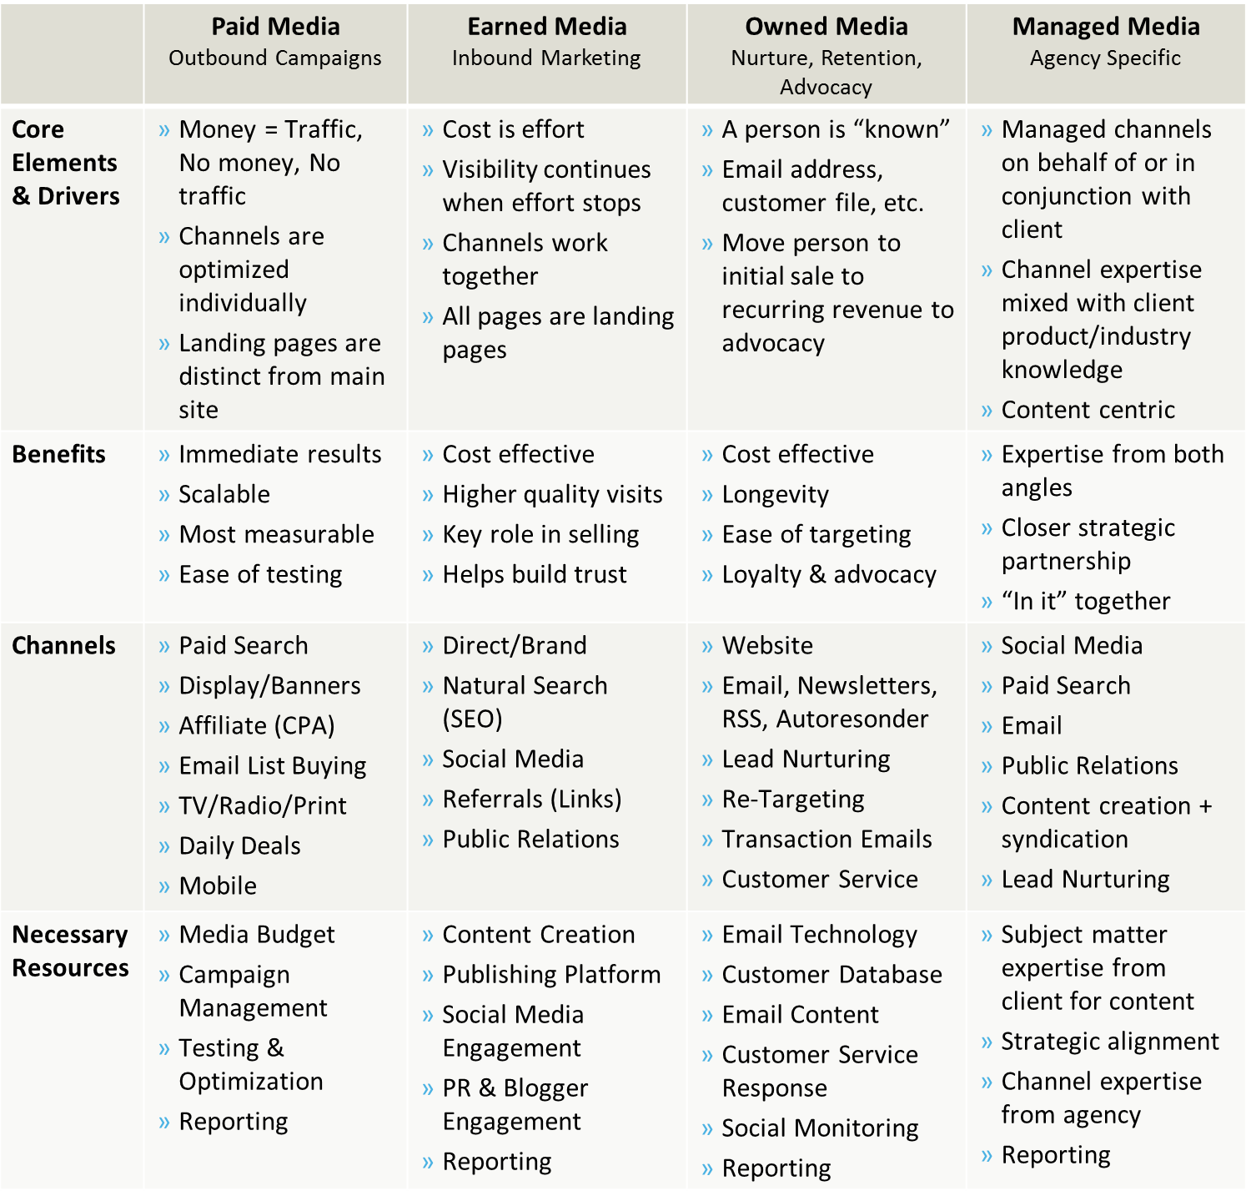
Customer Acquisition Model of POEM (Source- Scott, 2013)

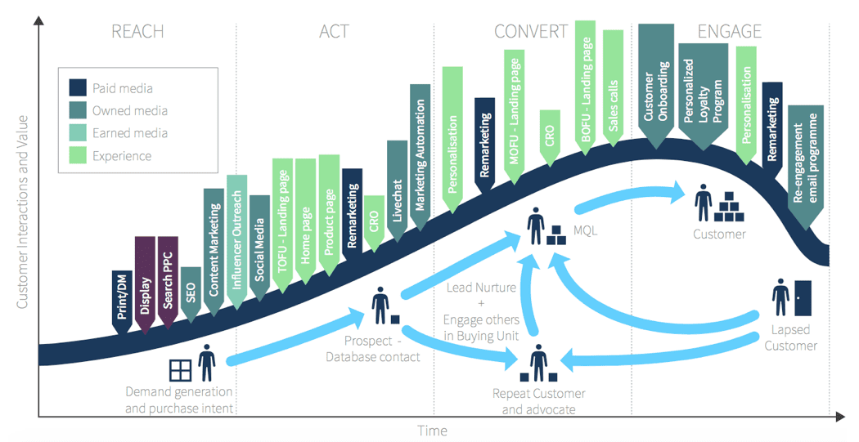
Customer Lifecycle Management
Customer Lifecycle Marketing Model (Source- Dave Chaffey, 2023)
Creating a managed communications or contact strategy that prioritizes and integrates the whole spectrum of marketing communications channels and experiences to aid prospects and customers on their journey to purchase by employing methods such as appealing personalized message and re-targeting. (Dave Chaffey, 2023)
According to the adage, "all customers are not created equal." Some are definitely more valuable than others and provide a steady stream of lucrative cash, but others are not worth the effort of attracting or retaining. Then there are the many client types in the center. According to HP ES, when a firm progresses through the different stages of the customer life cycle, it must match the particular expectations and preferences of each of these client groups. As a result, each company must strike a delicate balance in its business operations: reduce the cost of acquiring, keeping, and recognizing its most valuable clients while promoting their overall experience from Marketing to Sales to Customer Service to create loyal and satisfied patrons and advocates. (Nov 2018)

RACE Model Framework:
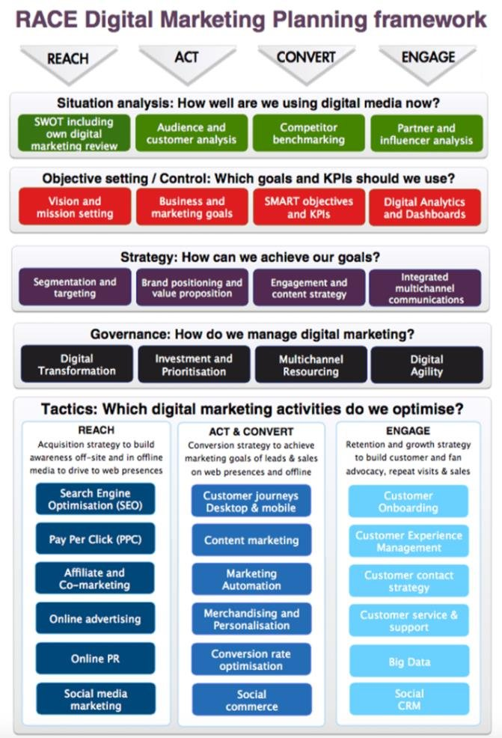
RACE Digital Marketing Framework (Source: Dave Chaffey, 2020)
RACE consists of four stages or internet marketing activities designed to help businesses engage their clients throughout the customer lifecycle. The Plan also includes an initial phase in which the overall integrated digital strategy, objective formulation, and governance are developed, as well as funds for "digital transformation." (Dave Chaffey, 2022)
Reach: Reach is the process of developing brand recognition and exposure on other websites and in offline media in order to attract people to your main site, microsites, or social media accounts.
Act: The fundamental purpose of Act is to generate online leads that can then be nurtured along the "path-to-purchase." When site visitors or prospects first come at your website or social network presence, it is all about encouraging them to take the next step, the next Action in their customer journey.
Convert: Because RACE is a multichannel or Omni channel marketing approach, this stage focuses solely on conversion to sale, whether online or offline.
Engage: Creating a long-term connection with first-time purchasers in order to generate customer loyalty as repeat purchases through messages on your site, social presence, email, and direct encounters in order to increase customer lifetime value.

BUYER PERSONAS
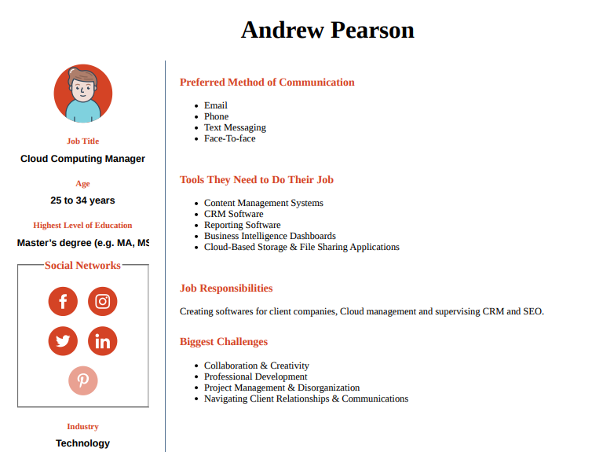
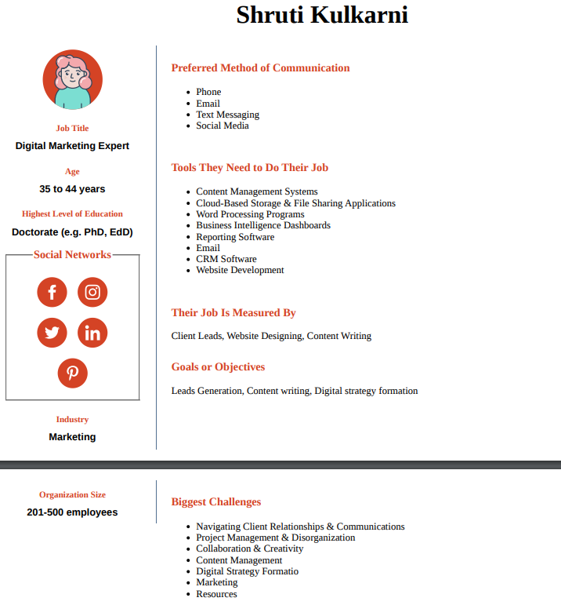
Competitive Analysis:
When compared to its competitors, Hp Inc reported a -21.69% year on year revenue reduction in the first quarter of 2023, which was faster than the -0.76% overall decrease recorded by Hp Inc's competitors in the same quarter. (CSI Market)
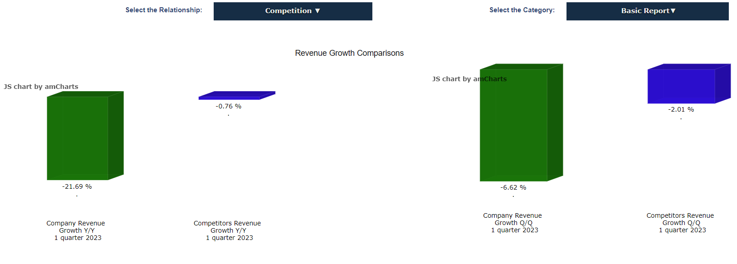

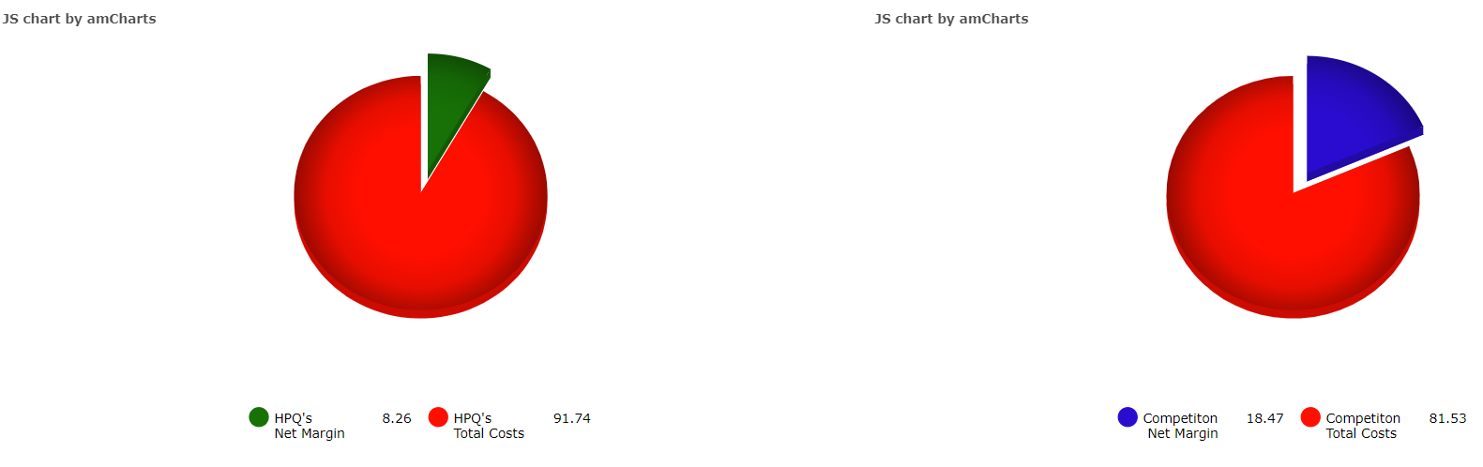
Revenue Growth Comparison HP Inc. and Competitors (Source: CSI Market)
In every aspect of our business, HP face fierce competition. HP competes primarily on the basis of technology, performance, price, quality, dependability, brand, reputation, distribution, product range and ease of use, account relationships, customer training, service and support, security, availability of application software, and internet infrastructure offerings.
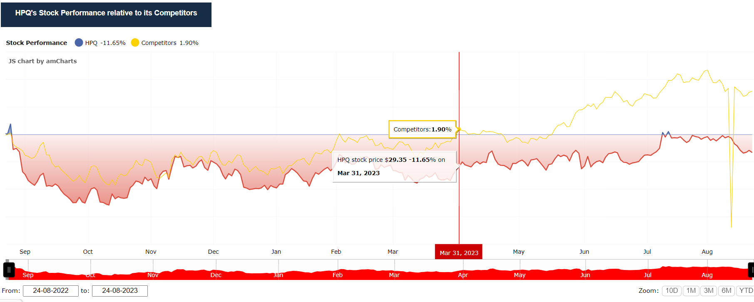
HPQ’s Stock Performance relative to its Competitors (Source- CSI Market)
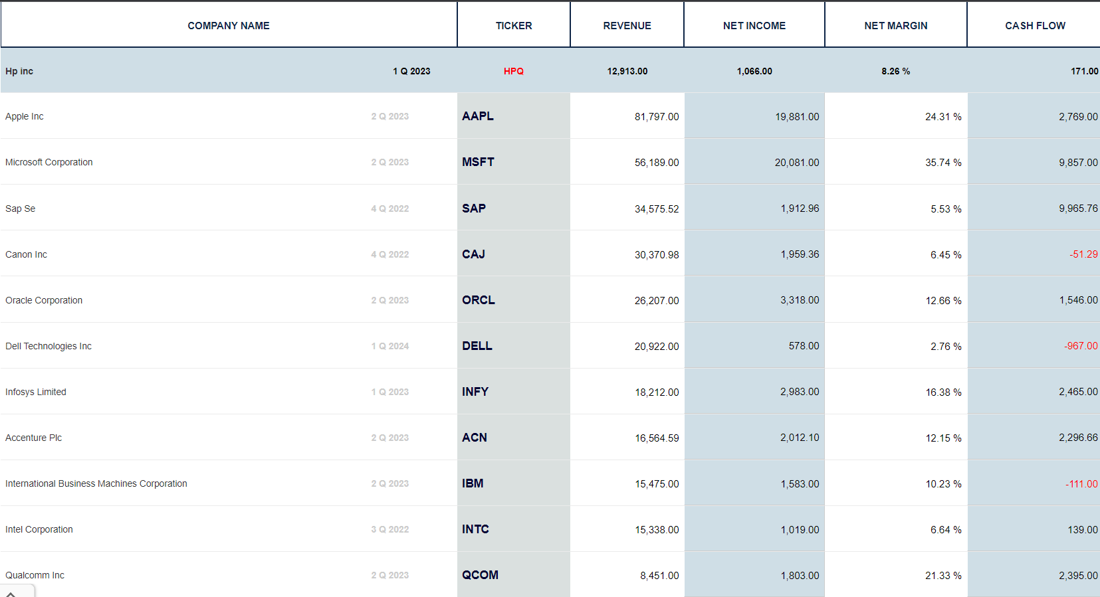
HP Inc. and Competitors Quarterly Revenue (Source: CSI Market)
The better you understand HP competition, the more likely it is that you will use it as a position in your portfolios. From the standpoint of an individual investor, HP's competitive research might encompass a wide variety of criteria. Some of them will be more important than others, depending on your personality as an investor and how you respond to market volatility. However, if you are committing to a long-term investing strategy, comparing the fundamental indicator across HP's competitors over multiple years is one of the greatest methods to assess its investment potential. (Macro Axis)

Micro Environmental Analysis
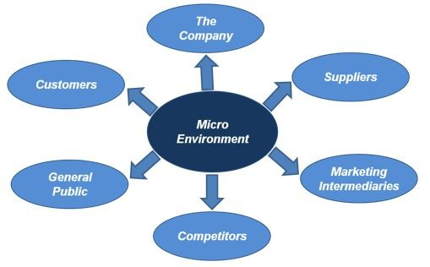
Micro Environmental Factors (Source- Bobin Philip, 2019)
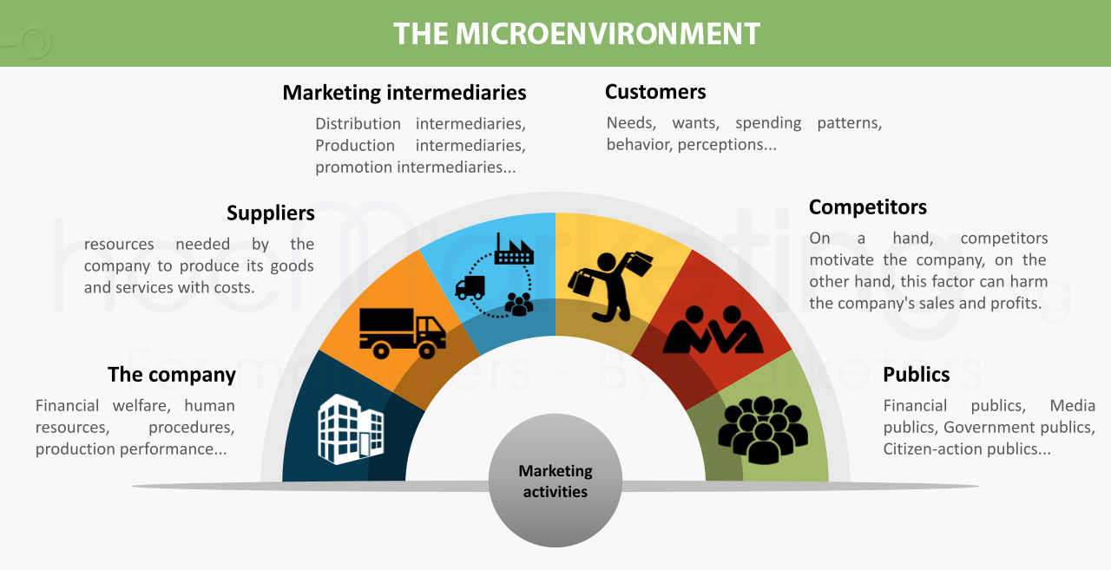
Factors affecting micro environment (Source: Diem My, 2020)
HP's Office of Strategy and Technology has four key functions: managing the company's $3.6 billion R&D investment, building the company's global technical community, leading strategy and corporate development initiatives, and undertaking global corporate marketing operations. This site houses HP Labs, HP's research department. HP Labs, which was created in 1966, is in charge of developing novel technologies and generating income opportunities that go beyond HP's current aims. Memory spot chip is an example of cutting-edge HP Lab technology. Furthermore, HP Idea Lab provides an online platform for early-stage ideas to encourage open feedback from customers and the development community.
PART II: HP Digital Marketing Strategy
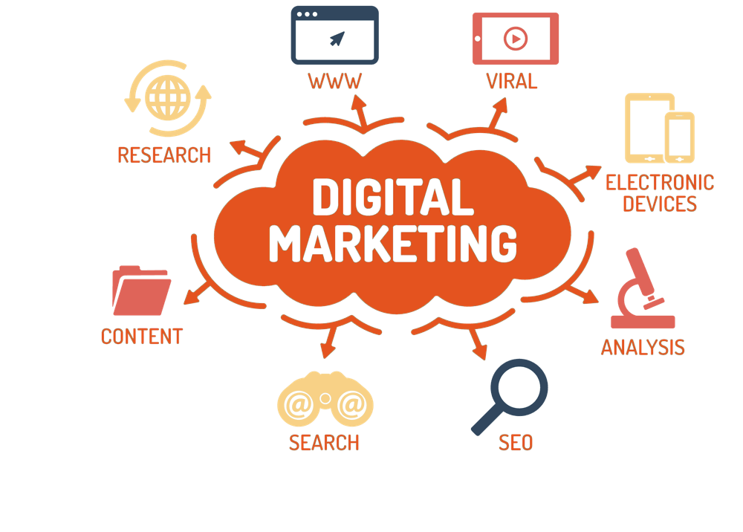
Digital Marketing Platforms (Source: Digital Webdia, 2019)
HP employs 360 branding in their marketing mix to boost brand identification. HP advertises across a range of channels, including billboards, television, newspapers, magazines, and internet. HP's One Voice marketing effort tries to promote the notion that the firm is a one-stop shop for all software and hardware needs. The campaign's online and outdoor advertising were both seamlessly integrated. In addition, HP has a program that allows you to trade in old items for new ones. In addition to typical discounts, HP from time to time offers certain services for free in order to promote HP. HP has previously sponsored Formula One and Premier League Club. (Arnab Chakraborty, Prithviraj Roy, Pritam Paul, Girish Srinivasan, February 7, 2011)
HP has been spending extensively in digital channels at the vanguard of this digital transition to boost demand, engage consumers, and provide technical help. HP's e-marketing initiatives may be summarized using the three "Cs" of the e-marketing ecosystem:
- To effectively generate leads, community focuses on involving consumers and increasing knowledge of HP goods and services.
- Material focuses on the element of providing clients with personalized, relevant material and improving user experience.
There are several levers accessible to expand the internet business. These levers consist of:
- directing traffic by directing users to relevant information,
- boosting conversion by providing pertinent items at suitable pricing points;
- cross-sell and up-sell to broaden the scope of the basket and boost margins; and
- Boosting client interaction to foster loyalty and repeat business.
HP uses a variety of analytics tools to promote online sales. This has shown to be helpful in three key areas:
- Increasing the efficacy of an online business through increasing quality visitors, analyzing marketing performance, and planning inventory
- proactive consumer involvement to spot opportunities and provide the appropriate items to the right customers
- improved profitability of digital media investments through wise budget distribution across marketing channel

The Marketing Technology Landscape (Source: Chiefmartec)
SMART Objectives:
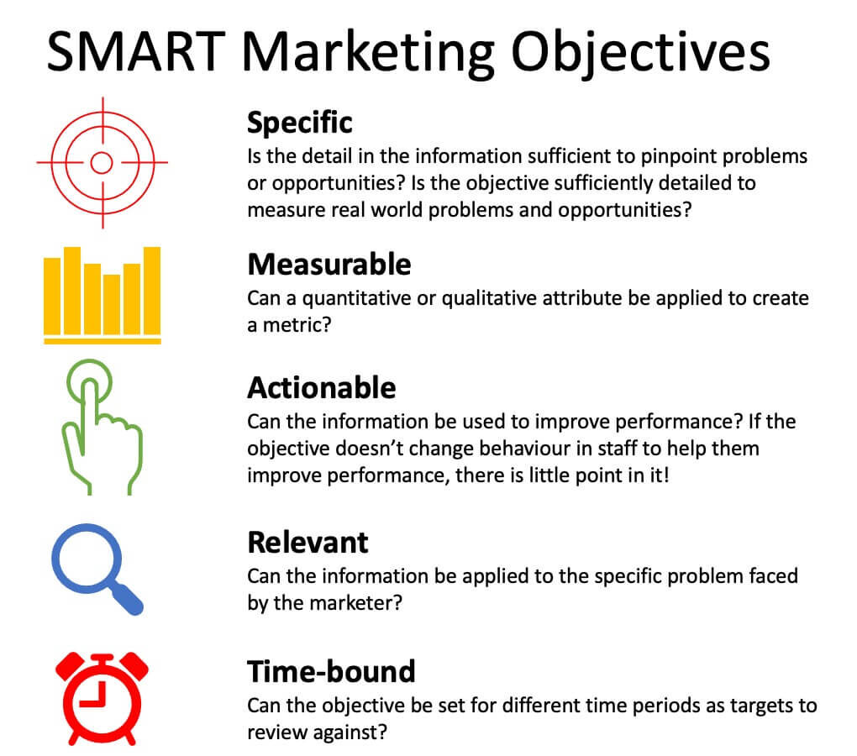
Smart Marketing Objectives (Source: Dave Chaffey, 2022)
Specific: HP's objectives are all plain and obvious. This assists employees and supervisors in managing and staying focused on the goals and objectives that must be met. Concurrently, well stated objectives assist managers in determining skill development and training requirements within their departments.
Measurable: HP's goals are also quantifiable. This means that all goals' progress may be tracked. This is critical for HP since it allows them to fulfill deadlines. Goals become more measurable by including quantitative criteria for tracking progress and goal achievement.
Actionable: The objective should be reachable in such a way that it remains achievable even when employees' talents are pushed and tested. HP's objectives are feasible because they challenge employees beyond their comfort zones while remaining attainable.
Relevant: HP's goals are also attainable since they are acceptable. This shows that HP sets goals while keeping organizational resources and restrictions at the forefront in order to achieve them efficiently and on schedule.
Time-bound: HP goals are also time-bound in the sense that they have a beginning and an end date. The timing of the target helps HP create a sense of urgency among employees and keeps them motivated to attain the goal. (George, 2020)

TOWS Analysis
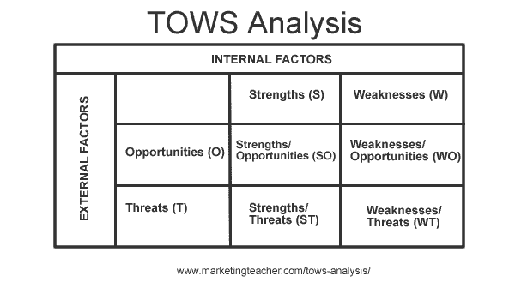
TOWS Framework (Source- Tim Friesner, 2017)
Strengths-Opportunities (SO):
- Speed of production on HP computers and accessories has been increased.
- HP also provides fasted delivery of their products and services in the market.
- HP Inc. focus on customer fulfilment to enhance the level of customer satisfaction.
Strengths-Threats (ST):
- HP has a very good and strong distribution channel.
- The main threat of HP is that the competitors are using similar channels.
- To get over this HP could diversify the methods of distribution to gain the competitive advantage.
Weakness- Opportunities (WO):
- HP sometimes has minor issues within product testing which could be improved by working on it efficiently and effectively.
- HP may also make the funding available for their staff in Research and Development department to have better and improved quality of work.
Weakness-Threat (WT)
- HP manufacturing locations are limited and too remote which can cause delay in distribution and delivery.
- HP competitors can have their outlets and distribution channels in prime location which can affect the revenue.(Andrew Wallbridge, 2022)

Despite the fact that HP is experiencing various issues, including bankruptcy, decreasing client demand, and growing challenges in its printer industry, the firm has maintained its performance level by increasing its focus on innovation.
There are various market prospects for HP, including new technology, managed services, and an economic uptick, which were all mentioned.
Currency changes in different nations, growing expenses, and more competition are the dangers it confronts in the market.

Framework for Digital Marketing Strategy:
A digital strategy identifies an organization's key projects for future digital technology investment to make a firm more competitive through digitization of operations and a review of its business model. It covers a wide range of topics, including how digital technology may help businesses achieve their objectives. (Dave Chaffey, 2023)
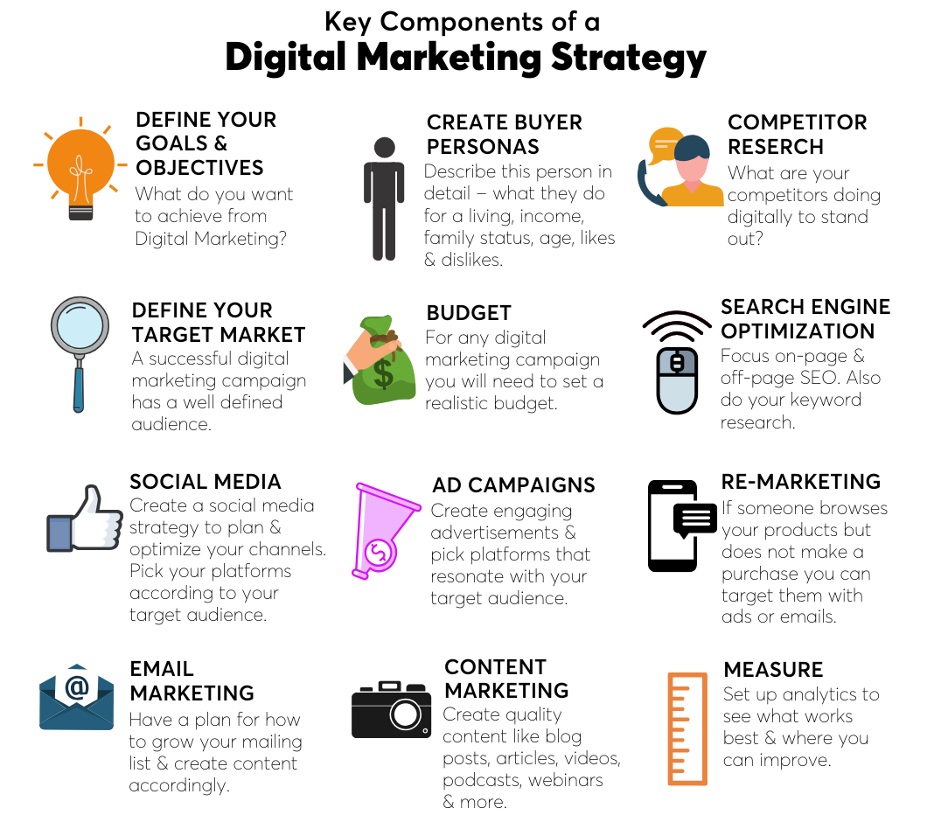
Key Components of Digital Marketing Strategy (Source: Boldxcollective)

HP Social Media Marketing:
More than 80% of buyers buy something after seeing it on social media. The power of social media is very unexpected, particularly in three key areas: connection, engagement, and consumer data. Businesses may now more easily evaluate consumer behavior and influence consumers behind the scenes of purchases thanks to social media.
HP is present on social media platforms such as Instagram, Twitter, TikTok, and Facebook. HP has 4.5 million Facebook followers, 1.2 million Instagram followers, and 1.1 million Twitter followers.
HP SEO Strategies:
The quantity of clients that visit a company's website is significantly influenced by Search Engine Optimization (SEO) strategies. As a consequence, the company obtains new customers, keeps old ones, and expands its market share. As seen in the graph, the company obtains around 2.8M clients from organic search, showing that the organization utilizes a large number of phrases.
E-com Strategies:
HP is a very informational-oriented website where you may learn a lot about today's technologies. They do not sell their items on their website, but you may get product information such as specifications and pricing.
Mobile Applications:
HP has officially released 5 to 6 applications for both Android and iOS. In terms of downloads and star ratings, the most popular apps are HP Smart and HP Print Service Plugin. You may use HP Smart to print, scan, and transfer data from your PC to your HP printer. With capabilities like Print Anywhere and Mobile Fax, HP Smart makes it simple to get started and keeps you going!
HP Content Marketing Strategies:
HP has been active on social media platforms, particularly Facebook and Instagram. The content is based on information on its new product launches, marketing campaigns, and so on. Their press announcement is based on a safety advise, financials, and changes to the firm structure, among other things. The press release is primarily aimed at investors. (Aditya Shastri, 2022)

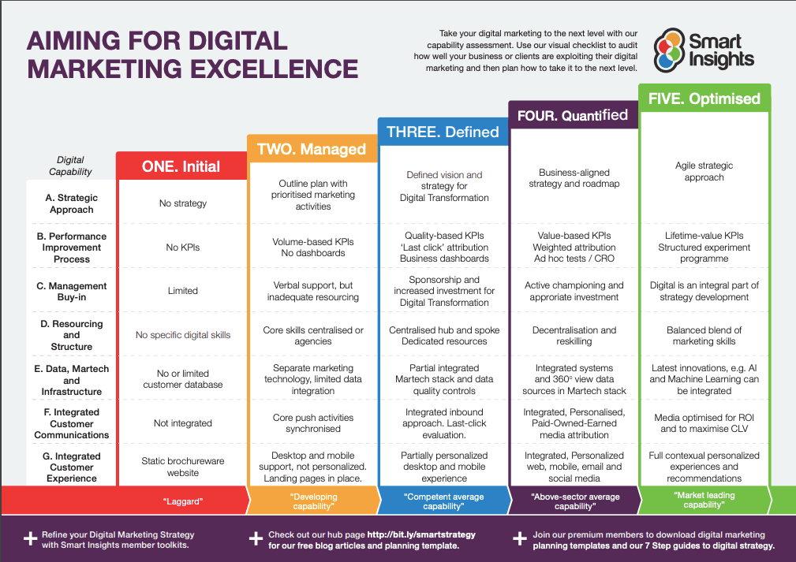
Structure of a plan for Digital Marketing Strategy (Source- Smart Insights)
HP is committed to addressing high-frequency employee concerns, such as methodically automating and streamlining repetitive operations, offering access to best-in-class workplace gadgets and tools, and encouraging digital methods of working. Every day, they effectively enable the workforce to accomplish what they do best. (Ampily Vijay, 2022)
The core aim of any digital transformation is to allow quicker innovation, more agility, seamless experiences, and integrated processes, resulting in superior business results and higher customer satisfaction at significantly reduced cost curves—in other words, faster, better, and cheaper. This will be a multi-year endeavor. If HP can reinforce the foundation with a standardized, reusable set of "digital building blocks" spanning experiences, insights, and processes in a year or two and have delivered on the growth strategy that will be a huge step forward.

Marketing Tactics and Tools:
Tactical marketing tools are the activities you take to implement your marketing strategy and achieve your objectives. When you create or manufacture a product or service, you design it with certain people in mind who are likely to need and use it in mind, and then you invent a way to inform and distribute it to them. That is the essence of marketing. Tactics are developed in response to strategies or approaches. Each of your marketing Ps (product, price, location, and promotion) should have its own set of tactics. Investigate your customers to determine the most effective techniques to deploy. (Karen S. Johnson)
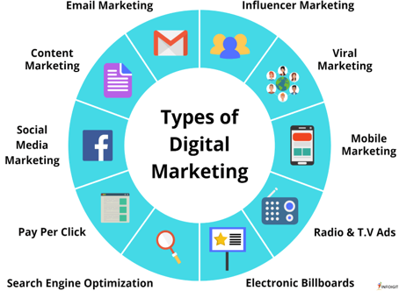
Digital Marketing Tools (Source: Cubes Project)
HP has prioritized brand development and advertising its products and services through multiple channels. The company's advertising efforts have emphasized the goods' quality, inventiveness, and dependability, as well as their cost and ease of use. HP has also emphasized the adaptability of its products, demonstrating how they can be used for both personal and corporate reasons.
HP's marketing strategy evaluates the brand using a marketing mix technique that incorporates the four Ps. Marketing tactics include product innovation, price strategy, and promotion planning. These commercial methods contribute to the brand's commercial success based on the HP marketing mix. The HP marketing strategy assists the brand/company in meeting its business goals and objectives while establishing a competitive market position.

Digital Communication tools:
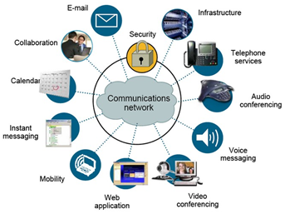
Digital Communications Tools (Source: P. Barmashe. 2021)
Digital communication refers to any type of communication that makes use of technology. There are several channels of communication available. Email, phone conversations, video conferencing, and other forms of instant messaging, such as SMS and web chats, are all examples. Blogs, podcasts, and videos are all forms of digital communication. (Limecall)
The HP Dynamic Marketing solution comprises a fully integrated software platform that integrates to almost all marketing repositories and apps. Handle all aspects of document generation and multi-channel distribution, from customizing on-demand letters to fully automating procedures and intelligently integrating papers into workflow and review processes. HP Dynamic Marketing, which is designed to fit into any marketing structure, links CRM and business intelligence platforms and provides completely tailored materials that expedite consumer decision processes while improving preference.

HP Key Metrics and KPIs:
HP owns and rents properties all around the world. They are taking steps to minimize greenhouse gas (GHG) emissions, energy usage, water use, and trash creation at our 159 facilities throughout all the countries.
- Employees who are diverse, equitable, and inclusive- Around 508,001 workers globally drive HP's innovation, bringing unique views and a growth mentality to develop game-changing technology and revolutionary solutions. We are dedicated to creating a diverse and inclusive environment that attracts, keeps, and advances outstanding people. Diversity, equality, and inclusion (DEI) are business imperatives at HP.
- Emissions of greenhouse gases- the energy needed to power our facilities accounts for the majority of our GHG emissions from operations. GHG emissions are measured and reported in tons (or tones) of CO2e (or carbon dioxide equivalent).
- GHG emissions intensity- describes our operations' energy efficiency performance. CO2e emissions are measured in tones per million US dollars of net sales.
- Water use is measured and reported in cubic meters (m3).
- Waste generation- Waste generation is measured and reported in tones. (HP Sustainability)
KPI:
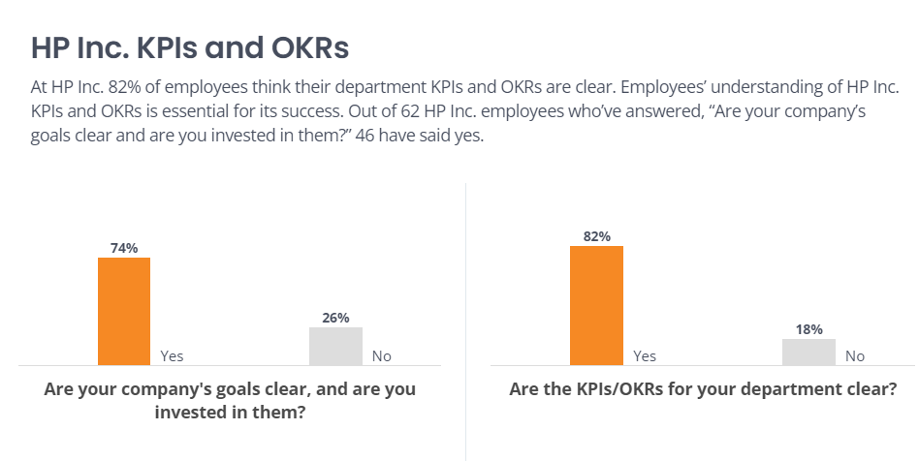
HP Inc. KPIs and OKRs (Source: Comparably)
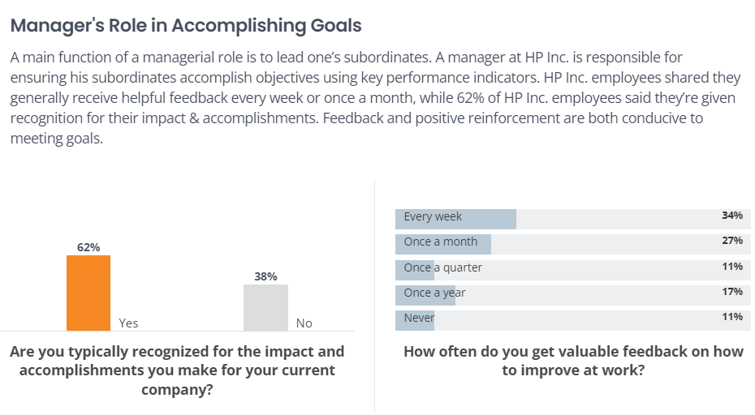
Internal HP Inc KPI (Staff and Managers) (Source: Comparably)
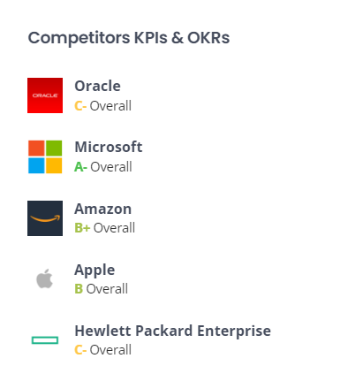
HP competitor’s KPI and OKRs (Source: Comparably

HP Cost of Strategy Estimation:
HP Inc. (NYSE: HPQ) presented a multi-year strategic and financial value development strategy, with non-GAAP diluted net earnings per share of $3.25 to $3.65 predicted by 2022. HP's market leadership and track record of execution across Personal Systems, Print, and 3D Printing & Digital Manufacturing, as well as disciplined and sustained cost actions and a new $16 billion capital return program from fiscal 2020 to fiscal 2022, support this significant expected earnings growth. (HP Press)
HP aims to produce the following value under this value development strategy:
- $4.7 billion to $5.1 billion in non-GAAP operating profit in fiscal 2022;
- $10.7 billion to $11.7 billion in total free cash flow from fiscal 2020 to fiscal 2022;
- $1.2 billion in structural cost savings in fiscal 2022, with a flow-through of $650 million to non-GAAP operating profit. (Palo Alto, 2020)(California)
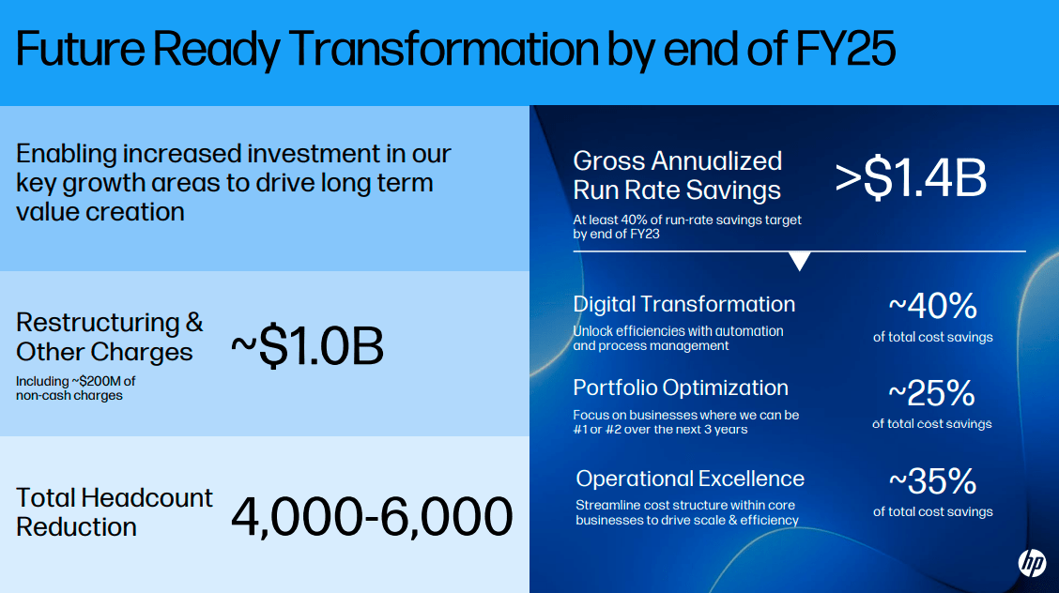
Future cost of strategy Estimation (Michele Pagliaro, 2022)

Conclusion and Recommendations:
HP competes with other big firms on several levels, including technical innovation, product portfolio depth, network and IT infrastructures, source accessibility, branding, distribution channels, and maintaining the talent pool from which HP may draw. HP constantly modifies the cost of its products and services in order to remain competitive.
Numerous firms with a lengthy track record, such as IBM, Samsung, and many more, compete with HP in various product or service categories. The market is overcrowded with a plethora of big and small firms, such as MNCs, which take up each of their market shares while also making it difficult for enterprises to thrive in a marketplace that delivers items and services in restricted time periods. The market for each section of a corporation like HP is vast, and HP frequently has to compete with its OEM partners in many industry sectors.
HP offers a variety of solutions designed to meet the needs of both individual customers and businesses. HP supports the requirements of organizations ranging from small and medium-sized industries to private corporations and government agencies.
However, there are some areas where HP's approach to digital marketing may be improved. The organization has the opportunity to increase its use of data and analytics to better understand customer behavior and preferences, and the design and functioning of the website might be more user-friendly, particularly on mobile devices.
In general, HP's digital marketing strategy has increased customer engagement and income, particularly through email and social media marketing campaigns. HP must continuously coming up with new ideas and enhancing its digital marketing approach in order to continue growth and success as the digital environment changes. By staying current with trends and utilizing new technologies, HP may position itself as a pioneer in the world of technology.

References:

Aditya Shastri, Sep 23, 2022, Extensive Marketing Strategy of HP- With detailed overview, information retrieved on 21st August, 2023, https://iide.co/case-studies/marketing-strategy-of-hp/

Ahsan Ali Shaw, Marketing Tutor, Pestle analysis of UK, information retrieved on 1st August, 2023, https://www.marketingtutor.net/pestle-analysis-of-uk/

Ampily Vijay, 28th July, 2022, Becoming a first digital company, HP garage, information retrieved on 25th August, 2023, https://garage.hp.com/us/en/business/digital-transformation-hp-ampily-vijay.html

Andrew Wallbridge, November 17, 2022, The Tows Matrix- A guide for leaders and managers, information retrieved on 20th August, 2023, https://www.tsw.co.uk/blog/leadership-and-management/the-tows-matrix/

Arnab Chakraborty, Prithviraj Roy, Pritam Paul, Girish Srinivasan, HP’s World Class e-marketing business, February 7, 2011, information retrieved on 31st July, 2023, https://pubsonline.informs.org/do/10.1287/LYTX.2011.01.04/full/

Bart Leby, Strategic Analysis of HP: The business strategy of HP, information retrieved on 30th July, 2023, https://www.bartleby.com/essay/Strategic-Analysis-Of-Hp-The-Business-Strategy-FCCZMWXLNR

Bobin Philip, November 12, 2019, Micro and Macro environment factors to be analyzed for companies, information retrieved on 23rd August, 2023, https://www.linkedin.com/pulse/micro-macro-environment-factors-analyzed-companies-bobin-philip/

Bold x Collective, Digital Strategy, key components, image retrieved on 20th August, 2023, https://www.boldxcollective.com/insights-blog/12-ways-to-optimize-your-digital-strategy-for-results

CSI Market, HP Inc. competitive report, information retrieved on 23rd August, 2023, https://csimarket.com/stocks/compet_glance.php?code=HPQ

Cubes Project, Digital Marketing Tools, information retrieved on 22nd August, 2023, https://cubesproject.eu/topic/topic-1-digital-marketing-tools/

Dave Chaffey, 29th Nov, 2022, How to define SMART marketing objectives, information retrieved on 16th August, 2023, https://www.smartinsights.com/goal-setting-evaluation/goals-kpis/define-smart-marketing-objectives/

Dave Chaffey, February 9, 2023, Digital Insights, information retrieved on 20th August, 2023, https://www.davechaffey.com/digital-marketing-glossary/digital-strategy/

Dave Chaffey, May 2023, What is customer lifecycle marketing? , Smart insights, information retrieved on 6th August, 2023, https://www.smartinsights.com/ecommerce/web-personalisation/what-is-lifecycle-marketing/

Dave Chaffey, The Marketing technology landscape, Information retrieved on 23rd August, 2023, chiefmartec.com

Diem My, 06th August, 2020, What is Microenvironment? Actors and Examples, Hoc marketing, information retrieved on 20th August, 2023, https://en.hocmarketing.org/what-is-microenvironment-actors-and-examples

Digital Webdia, September 24, 2019, Best Digital Marketing Services in Sundernagar HP, information retrieved on 20th August, 2023, https://digitalwebdia.com/digital-marketing-in-sundernagar-hp/

Dr. Dave Chaffey, 13th January, 2022, RACE Marketing Model, Digital Insights, information retrieved on 9th August, 2023, https://www.davechaffey.com/digital-marketing-glossary/race-marketing-planning-model/

George, March 10, 2020, Components of Objectives, information retrieved on 17th August, 2023, https://www.essay48.com/12627-HP-Mission-Vision

Hannah Ward, 26th May, 2023, Hewlett Packard — Complete Guide: History, Products, Founding, and more, information retrieved on 29th July, 2023, https://history-computer.com/hewlett-packard-history/

HP (Hewlett-Packard) Mission and Vision Statements Analysis, information retrieved on 29th July, 2023, https://mission-statement.com/hp/

HP Inc Summary, Marketline, 31st July, 2023, information retrieved on 1st August, 2023, https://advantage-marketline-com.ezproxy.uwtsd.ac.uk/Company/Summary/hewlett_packard_company

HP KPI Metrics, KPIs and OKRs, HP Inc. Comparably, information retrieved on 25th August, 2023, https://www.comparably.com/companies/hp/kpi-okr

HP Logo, Image, retrieved on 29th July, 2023, https://dxc.com/us/en/about-us/partner-ecosystem/hp

HP Making it Better, Success Story, information retrieved on 29th July, 2023, https://images.successstory.com/adminimg/image_uploads/content_images/meg-whitman-photo-v2-1940x1268_1463565957.jpg

HP Mission Statement & Vision Statement with Core Values, Visionary Business person, information retrieved on 29th July, 2023, https://visionarybusinessperson.com/hp-mission-statement/?expand_article=1

HP Sustainability, 17th Jul, 2023, What are the key indicators that HP measures its Operations performance against and how are those metrics defined?, information retrieved on 25th August, 2023, https://sustainability.ext.hp.com/en/support/solutions/articles/35000064532-what-are-the-key-indicators-that-hp-measures-its-operations-performance-against-and-how-are-those-met

HP, The history of HP, September 1, 2019, information retrieved on 29th July, 2023, https://www.hp.com/us-en/shop/tech-takes/history-of-hp

Image, Poem Model, foundations in Digital Marketing, Open Text, and information retrieved on 5th August, 2023, https://opentextbc.ca/foundationsdigitalmarketing/chapter/introduction-to-digital-marketing/

Ivy Panda, HP Corporate Level Strategy, 20th December, 2019, information retrieved on 03rd August, 2023, https://ivypanda.com/essays/hp-corporate-level-strategy/

Joe David, Pestle Analysis of the UK (Country Profile), 2023, information retrieved on 01st August, 2023, https://www.howandwhat.net/pestel-analysis-uk/\

Karen S. Johnson, Tactical Marketing Tools, information retrieved on 22nd August, 2023, https://smallbusiness.chron.com/tactical-marketing-tools-60573.html
Lars De Bruin, Scanning the Environment PESTLE Analysis, September 18, 2016, information retrieved on 31st July, 2023, image, https://www.business-to-you.com/scanning-the-environment-pestel-analysis/

Loan Matei Purcarea, The connection between Digital Marketing and Relevant Public Relations. The Brand Building Role of Digital Communication, July 2020, information retrieved on 07th August, 2023, Research gate, https://www.researchgate.net/figure/Figure-no1-RACE-Digital-Marketing-Planning-framework-Source-Chaffey-D-2020-What_fig1_343162869

Macro Axis, HP Competitors, Information retrieved on 23rd August, 2023, https://www.macroaxis.com/competition/HPQ

MBA Skool, Hewlett Packard (HP) Marketing Strategy & Marketing Mix (4Ps), information retrieved on 30th July, 2023, https://www.mbaskool.com/marketing-mix/products/17114-hp.html#:~:text=The%20promotional%20and%20advertising%20strategy,magazines%2C%20website%2C%20billboards%20etc.

Michele Pagliaro, Dec 20, 2022, HP Inc., How to speed up and be future ready, information retrieved on 25th Aug, 2023, https://seekingalpha.com/article/4565463-hp-inc-speed-up-future-ready

Palo Alto, California, February 24, 2020, press HP, information retrieved on 25th August, 2023, https://press.hp.com/us/en/press-releases/2020/hp-strategic-and-financial-value-plan.html

Pbarmashe, 10th January, 2021, Digital Communication and Collaborations Tools, information retrieved on 23rd August, 2023, https://scientificresearch.in/digital-communication-and-collaborations-tools-for-workplace/

Press hp, HP Amplify Data Insights Summary Final, Page no. 1, information retrieved on 2nd August 2023, https://press.hp.com/content/dam/sites/garage-press/press/press-kits/2021/2021-hp-reinvent/HP%20Amplify%20Data%20Insights%20Summary%20Final.pdf
Scott Sachs, Tech Target, Customer experience management, Customer insights, information retrieved on 2nd August, 2023, https://www.techtarget.com/searchcustomerexperience/definition/customer-insight-consumer-insight

Scott, February 20, 2013, Poem Customer Acquisition Model, Digital Marketing Coach, Consultant, Consigliere, Brand Digital, information retrieved on 5th August, 2023, https://branddigital.net/strategy-leadership/p-o-e-m-customer-acquisition-model/

The Brand Hopper, History, Financials And Marketing Strategies Of HP, 30th March, 2023, information retrieved on 1st August, https://thebrandhopper.com/2023/03/30/history-financials-and-marketing-strategies-of-hp/#:~:text=Innovation%20and%20digital%20transformation%3A%20HP,the%20needs%20of%20its%20customers.

Tim Friesner, April 27, 2017, All Marketing Index, Marketing Strategy, TOWS Analysis, Marketing Teacher, image retrieved on 18th August, 2023, https://www.marketingteacher.com/tows-analysis/

UK Essays, November 2018, Customer Lifecycle Case Study: Toyota and HP, information retrieved on 6th August 2023, https://www.ukessays.com/essays/marketing/following-customers-lifecycle-toyota-and-hp-cases-marketing-essay.php?vref=1

