


Computer Forensics (CF)

Lab 7

Wales Institute of Science and Art
Applied Computing
I.Q Building, Room 205
Swansea
SA1 8EW

Lecturer: Assoc. Professor Carlene Campbell
Email: carlene.campbell@uwtsd.ac.uk
Website: https://www.knowledgewithprofit.com

EXT4 File System Analysis
You are a junior digital forensic analyst working for Apex Innovations. The company suspects that an employee may have copied confidential project files to a USB drive before leaving the company.
You have been provided with a forensic image:
- File Name: LAB06.img
- MD5: ae182fd2dcb4eefe5f0e865ec9df8dcf
Your task is to analyze the disk image and determine:
- Whether confidential files were accessed
- Whether files were copied to external media
- Whether there is evidence of attempted data exfiltration

Your Role
You are a forensic investigator with authorized access to the disk image. Your task is to identify digital evidence, analyze file metadata, compute and compare hashes of the evidence files and document your findings.

Instructions for the Lab Exercise

Part 1: Preparation
- Download the LAB06.img file from the OneDrive evidence folder LAB06.img to your computer (step 2 below) or directly onto your Ubuntu VM by launching Firefox within Ubuntu, sign into your OneDrive from the browser and download the LAB06.img
- As the evidence file is in a folder that’s outside the Ubuntu forensic VM, it requires the VirtualBox Guest Additions to be installed and group membership to be added.
NOTE: You may skip this step if you have already completed this in the previous lab and are using the same Ubuntu forensic VM.
To do this, follow the steps below:
  - In the VM window menu, go to Devices → Insert Guest Additions CD Image…
  - To check if it is mounted, run
ls /media/$USER
You should see something like VBox_GAs_* (where * indicates the version)
  - Go into the mounted directory and run the installer.
cd /media/$USER/VBox_GAs_* (replace * with the version on your VM)
sudo ./VBoxLinuxAdditions.run
  - Add your user to the vboxsf group.
sudo usermod -aG vboxsf $USER
  - Reboot the Ubuntu forensic VM.
  - To verify if you have the necessary permissions, run
groups
You should see vboxsf in the list.
- Power off the Ubuntu forensic VM. Right-click on the Ubuntu forensic VM and navigate to Settings → Shared Folders.
- Click on the “Add new shared folder” icon and set the following:
  - Folder path = Path to the folder where you downloaded the IMG file.
  - Folder Name = evidence
  - Select “Read-only” (This is important to maintain forensic integrity!)
  - Select “Auto-mount”
  - Click OK in the folder share window.
  - Click OK on the main Settings window.
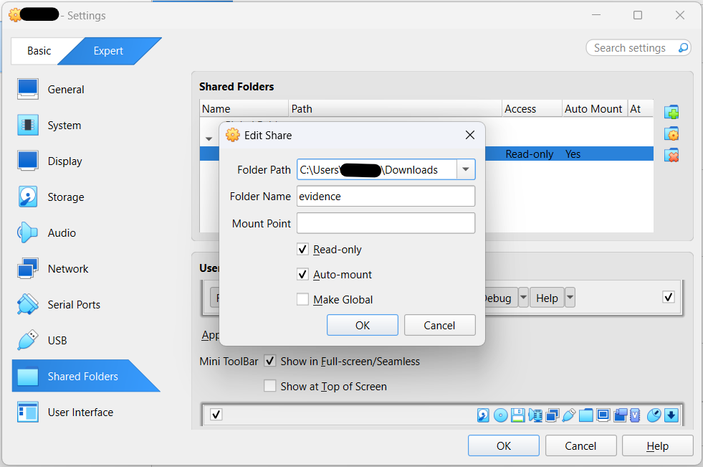
- Power on the Ubuntu forensic VM.
- Check if the shared folder with the LAB05.img file is mounted in the Ubuntu forensic VM.
ls /media
You should see the folder sf_evidence in the list. Further, check if the LAB05.img file is accessible in the shared folder with the appropriate permissions.
ls -ltr /media/sf_evidence | grep LAB06.img
You should see something like this:

Part 2: Verify Evidence Integrity
- Validate if the MD5 hash of the disk image file matches the given hash value. This might take a while as the computation of hashes depends on the size of the file and availability of compute and memory resources. To check the progress while performing the hash computation, run:
pv /media/sf_evidence/LAB06.img | md5sum
NOTE: If pv command in not working, you can use the following commands to install the required tools. However, you can skip these commands if you have already done this in the previous lab and are using the same Ubuntu forensic VM.
sudo nmcli networking on
sudo apt install pv binutils
sudo nmcli networking off
- Record the result in your lab notes.

Part 3: EXT4 Analysis Using Sleuth Kit
- Identify disk partitions.
mmls /media/sf_evidence/LAB06.img
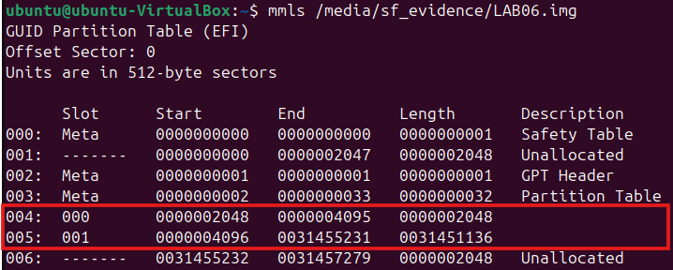
- Record the EXT4 offset. In the above screenshot, the disk partitions show 2 EXT4 partitions with a blank description – one indicating the default EFI / Boot partition (smaller) and the other indicating the actual data disk partition. The offset number is the value of the Start sector for the partition – in this case, 2048 for the Boot partition and 4096 for the actual Linux EXT4 partition. To verify this, run
fsstat -o 2048 /media/sf_evidence/LAB06.img
fsstat -o 4096 /media/sf_evidence/LAB06.img
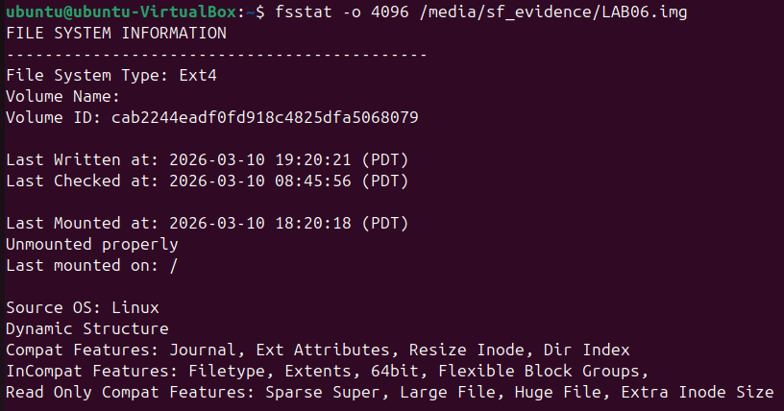
- To list the contents of the disk, run
fls -o 4096 /media/sf_evidence/LAB06.img
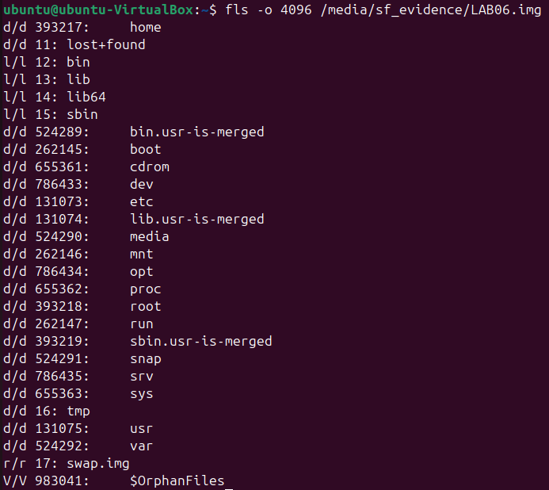
Note the directories named home, etc, media, and var, where:
  - d/d indicates that they are Directories
  - 393217, 131073, 524290, and 524292 are the inode numbers of the directories respectively
You may learn more about the Linux file system, directory structure, and the their purpose from https://refspecs.linuxfoundation.org/FHS_3.0/fhs/ch03.html
- Create a folder named extracted for extracting the evidence files from the disk image. (NOTE: You may skip this step if the directory was already created in the previous lab and you are using the same Ubuntu forensic VM.)
mkdir -p extracted
- To explore the contents of the home directory, run
fls -o 4096 /media/sf_evidence/LAB06.img 393217
The directory apex inside the home directory indicates the account name of the Linux workstation.
fls -o 4096 /media/sf_evidence/LAB06.img 426732
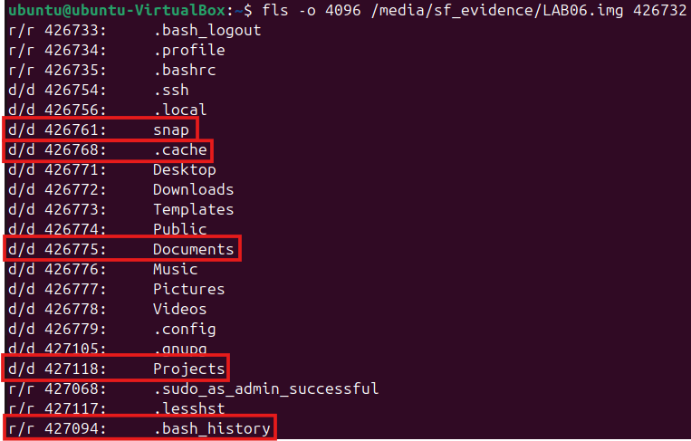
For this exercise, files and directories of interest are marked in the image above. Hidden files or directories begin with a dot (.).
- Note down the inode numbers for each directory and file you discover in a list or table format for easy reference during further analysis.
- The .bash_history file located at /home/apex/.bash_history contains a history of all commands run by the user, including copying files, creating archives, or mounting USB devices.
To extract a copy of the contents of this file for further analysis, run
icat -o 4096 /media/sf_evidence/LAB06.img 427094 > extracted/Export_Apex_Bash_History.txt
cat extracted/ Export_Apex_Bash_History.txt
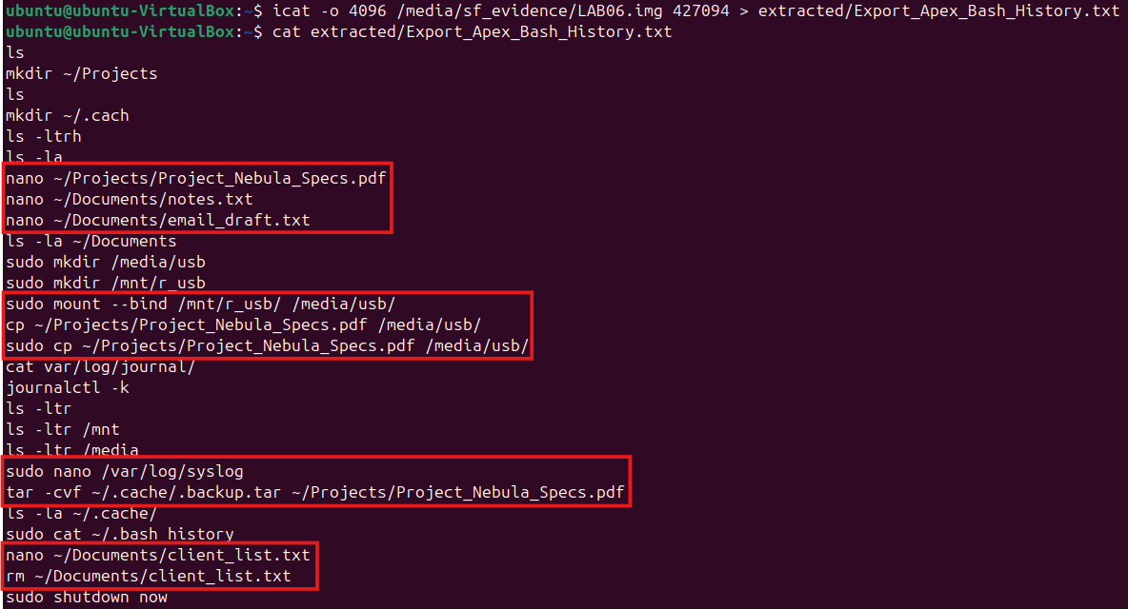
Files and directories of interest can be identified from the highlighted commands in the .bash_history file as shown in the image above for further analysis.
- To explore the contents of the /home/apex/Projects directory, run
fls -o 4096 /media/sf_evidence/LAB06.img 426768
You will find a PDF file which possibly contains confidential project specifications.
  - Analyze metadata for the original PDF file with the istat command.
istat -o 4096 /media/sf_evidence/LAB06.img 427128
  - For further analysis, extract file contents and create a copy of evidence files on your forensic VM using the icat command.
icat -o 4096 /media/sf_evidence/LAB06.img 427128 > extracted/Export_Project_Nebula_Specs.pdf
cat extracted/Export_Project_Nebula_Specs.pdf
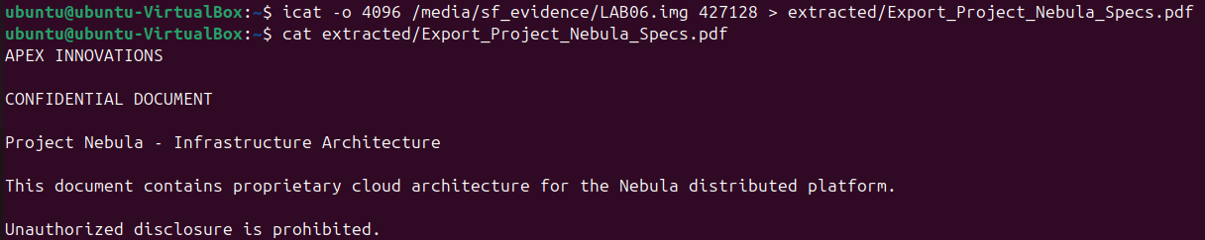
- To explore the contents of the /home/apex/Documents directory, run
fls -o 4096 /media/sf_evidence/LAB06.img 426775
You will find a hidden notes file and an email draft.
  - Analyze and compare the metadata for both the TXT files with the istat command.
istat -o 4096 /media/sf_evidence/LAB06.img 427129
istat -o 4096 /media/sf_evidence/LAB06.img 427067
  - For further analysis, extract contents of both files and create copies of evidence files on your forensic VM using the icat command.
icat -o 4096 /media/sf_evidence/LAB06.img 427129 > extracted/Export_Notes.txt
cat extracted/Export_Notes.txt
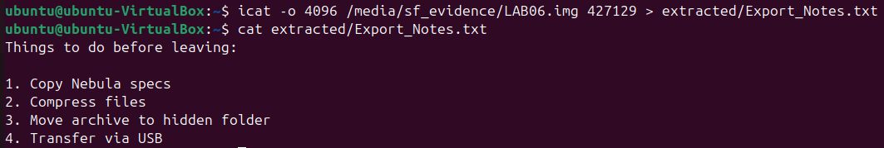
icat -o 4096 /media/sf_evidence/LAB06.img 427067 > extracted/Export_Email_Draft.txt
cat extracted/Export_Email_Draft.txt
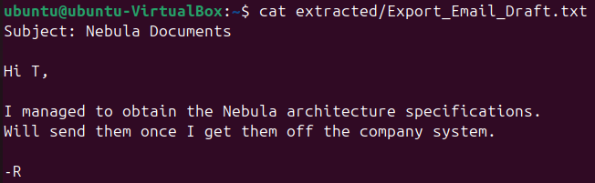
- To find the /var/log/syslog file and search for evidence of files copied to a USB drive, run
fls -r -o 4096 /media/sf_evidence/LAB06.img 524292 | grep syslog
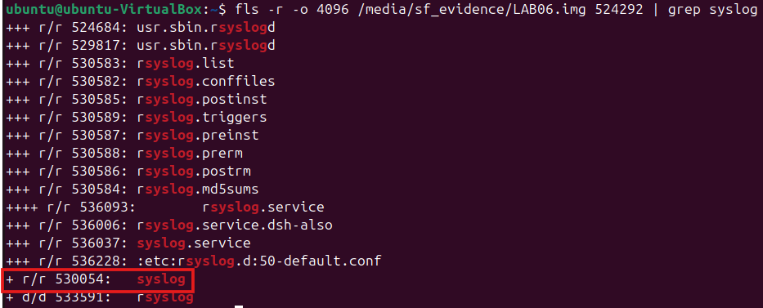
  - Analyze metadata for the syslog file with the istat command.
istat -o 4096 /media/sf_evidence/LAB06.img 530054
  - For further analysis, extract file contents and create a copy of evidence files on your forensic VM using the icat command.
icat -o 4096 /media/sf_evidence/LAB06.img 530054 > extracted/Export_Apex_Syslog.txt
cat extracted/Export_Apex_Syslog.txt | grep usb
Look for the above entries in the syslog file to confirm the USB device was connected and note the timestamps to get clearer evidence.
cat extracted/Export_Apex_Syslog.txt | grep 2026-03-11T07:16
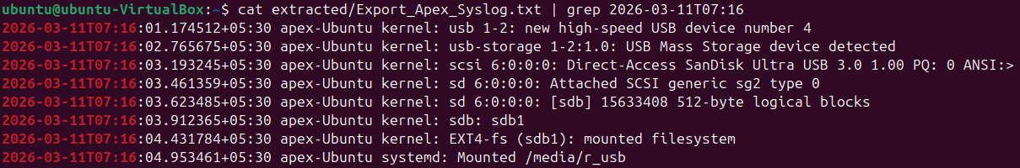
- To explore the contents of the /home/apex/.cache directory, run
fls -o 4096 /media/sf_evidence/LAB06.img 426768
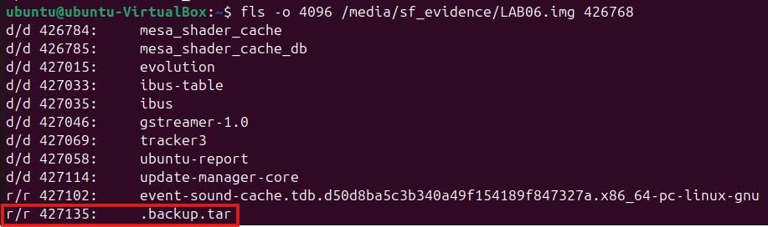
You will find a TAR file which possibly contains a copy of the confidential project specifications archived for exfiltration.
  - Analyze metadata for the file with the istat command.
istat -o 4096 /media/sf_evidence/LAB06.img 427135
  - For further analysis, extract file contents and create a copy of evidence files on your forensic VM using the icat command.
icat -o 4096 /media/sf_evidence/LAB06.img 427135 > extracted/Export_Backup.tar
mkdir -p extracted/Export_Backup
tar -xvf extracted/Export_Backup.tar -C extracted/Export_Backup
cat extracted/Export_Backup/home/apex/Projects/Project_Nebula_Specs.pdf
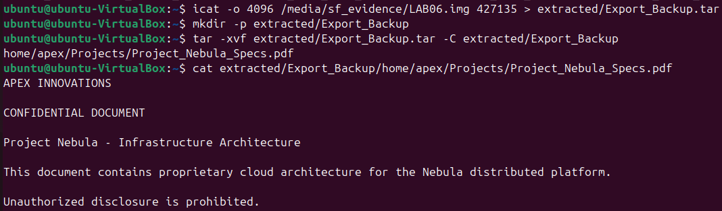
You will notice that this is the same file as the original PDF file, i.e. Export_Project_Nebula_Specs.pdf extracted in Step 16 from the Projects directory.
You can now verify the exfiltration attempt by identifying if both files are the same by comparing their hashes using the hashdeep command and their metadata by comparing the outputs of the istat commands.
- To explore /home/apex/snap/firefox/common/.mozilla/firefox/vjqbi9cb.default, run
fls -o 4096 /media/sf_evidence/LAB06.img 426761
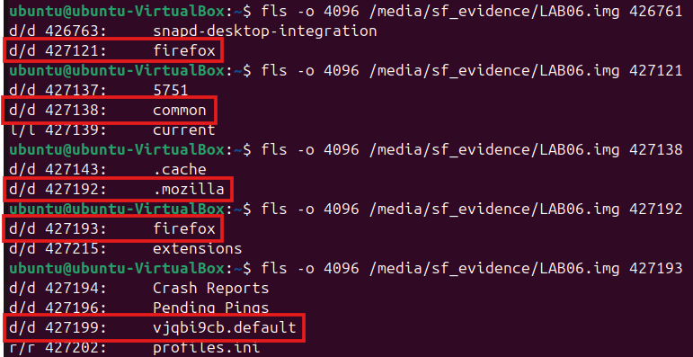
Follow the sequence of commands in the image above to find the default folder with browsing history, bookmarks, cache, etc. from Mozilla Firefox. The browsing history and bookmarks are stored in the places.sqlite database file. To search for this file, run
fls -o 4096 /media/sf_evidence/LAB06.img 427199 | grep places.sqlite
You may also explore the default folder with inode 427199 for other web browsing related artifacts.
  - Analyze metadata for the sqlite file with the istat command.
istat -o 4096 /media/sf_evidence/LAB06.img 427263
  - To view the contents of this sqlite database file, you need to install the sqlite3 package. To do this, run
sudo nmcli networking on
sudo apt install sqlite3
sudo nmcli networking off
  - For further analysis, extract file contents and create a copy of evidence files on your forensic VM using the icat command.
icat -o 4096 /media/sf_evidence/LAB06.img 427263 > extracted/Export_places.sqlite
sqlite3 extracted/Export_places.sqlite
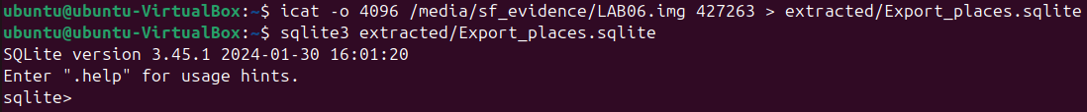
  - Inside the sqlite console, to view the list of tables in the database, run
.tables
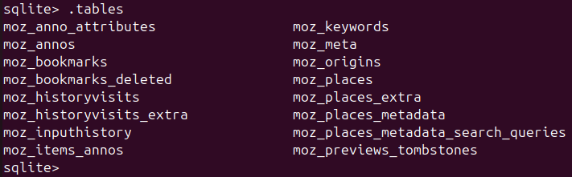
  - To view the browsing history, run
SELECT url, title FROM moz_places;
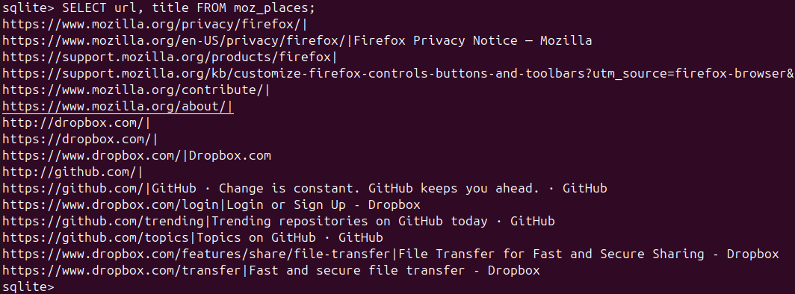
  - To view the website visit times, run
SELECT url, last_visit_date FROM moz_places;
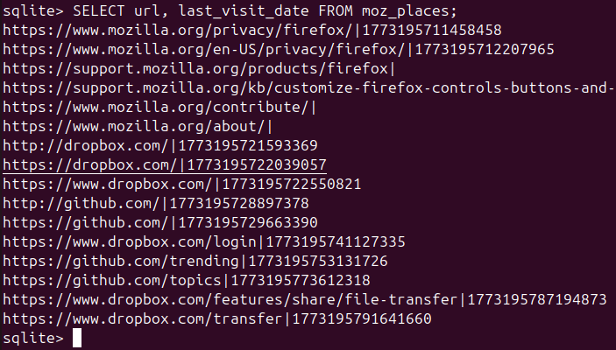
Firefox stores timestamps in microseconds since Unix epoch. You can convert these to regular timestamps using any free online Unix Epoch Time Converter.
  - The browsing history and times show that the user visited file sharing services such as Dropbox and Github. This suggests the user may have been researching ways to transfer files externally for copying the confidential document.

Part 4: GUI Analysis (Autopsy)
- Open Autopsy
autopsy
- Create a New Case. Provide the case name as LAB06. Set the base directory as /home/<your_user>
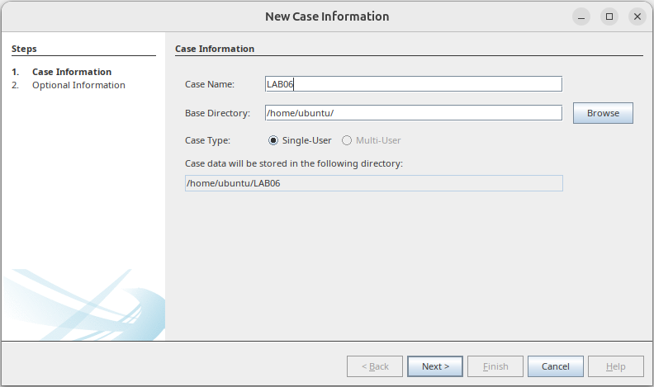
- To add the data source, follow the steps below:
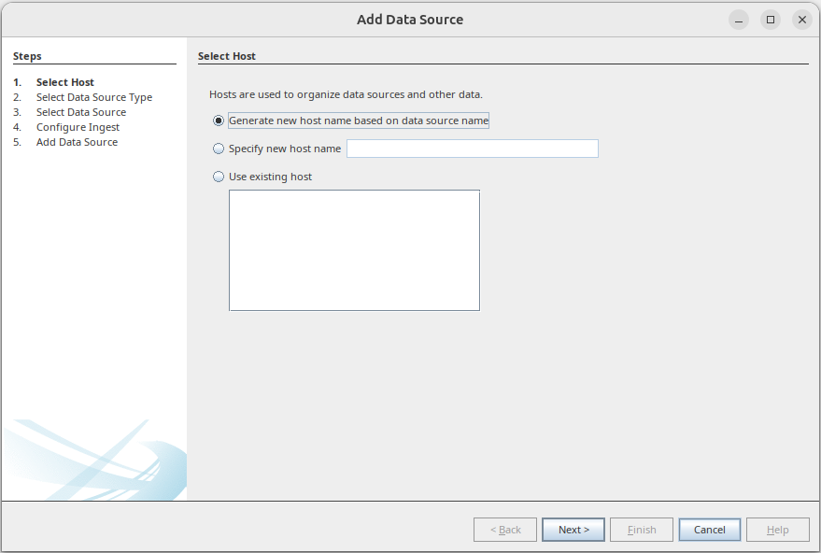
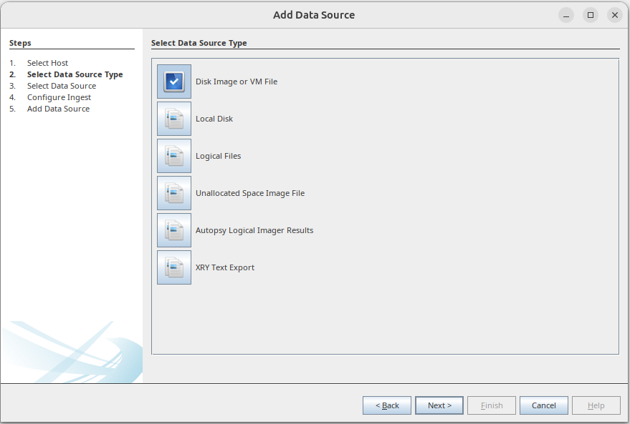
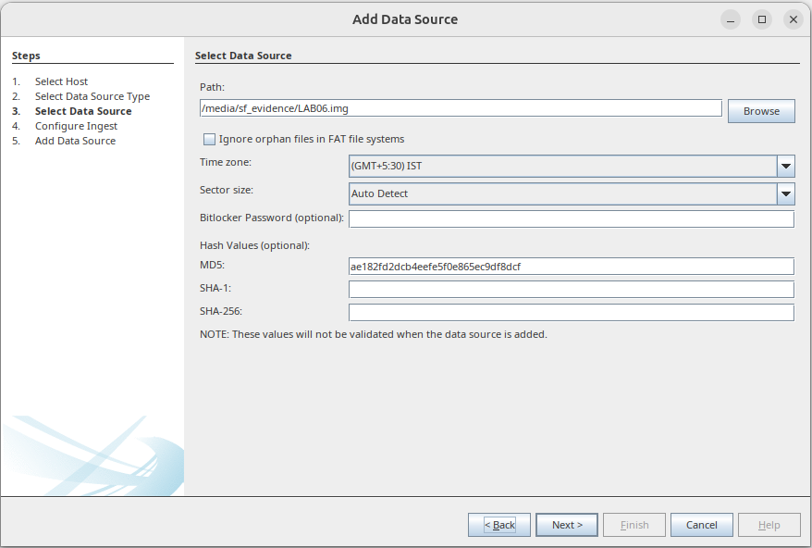
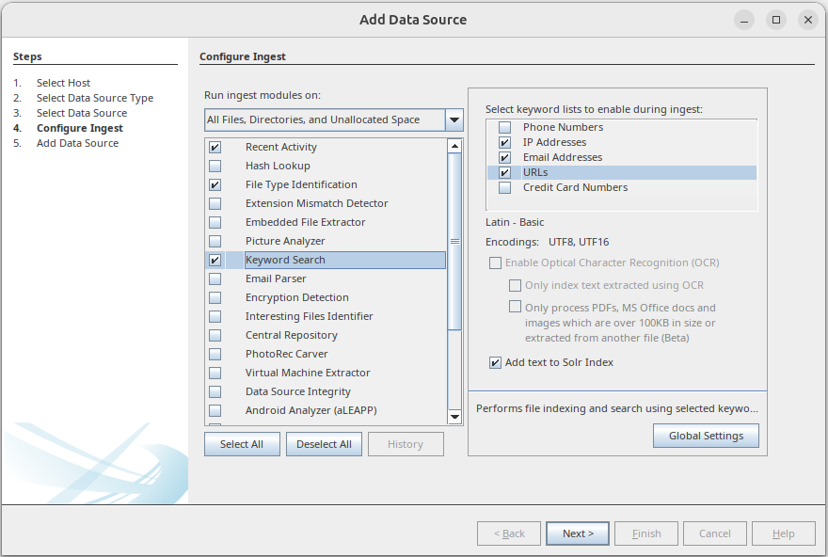
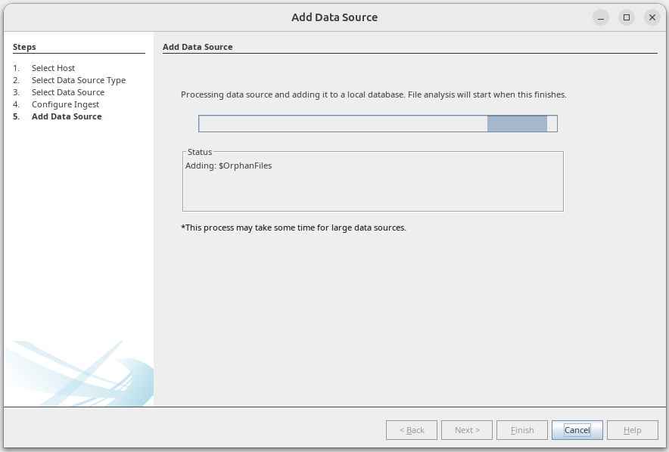
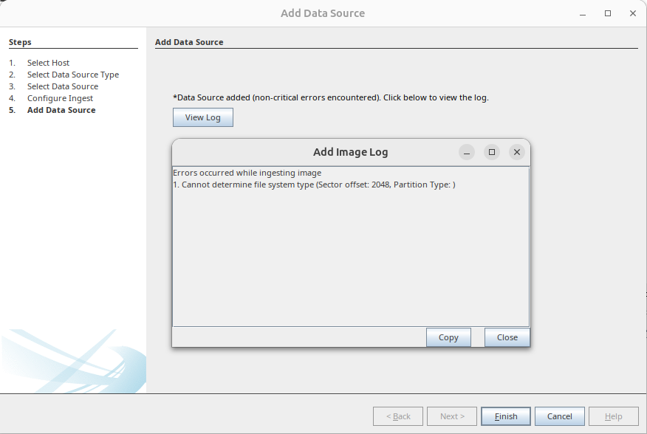
You may ignore the errors as shown in the above image, if any.
- Once the data source is added in Autopsy, you can explore Deleted Files, Recent Documents, Hidden Files, Web History, and Timeline View.
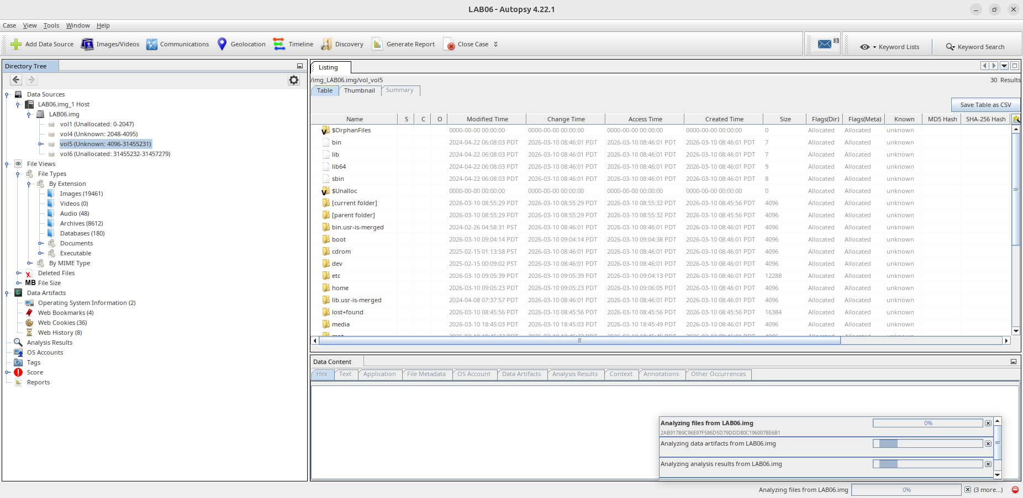
You must look for the following:
  - Evidence of file staging (export)
  - Evidence of USB usage
  - Evidence of web browsing
  - Evidence of clearing tracks
  - Timeline reconstruction
  - Conclusion (Was data exfiltrated?)

Deliverables
Case report with the following sections, indicating a complete chronological timeline of events:
- Evidence Identified
- Findings
- Interpretation
- Limitations
- Conclusion

Lab Analysis
Analyse and document the results of this lab exercise.
Task: Using https://tryhackme.com/ website

- Once you have signup go to learn and do one of the Forensics free lab

- Choosing any of the Hands-on activities by going into the Learn menu and search for a Forensics lab of your choice.

- To select a free walk through task, select
  - Go to Walkthroughs as shown below

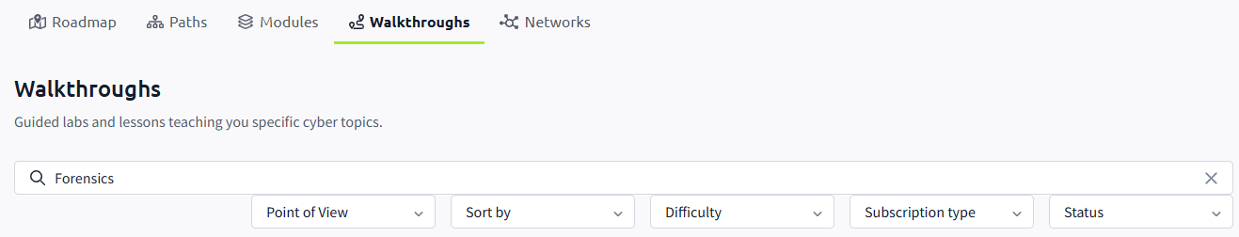
  - Type Forensics
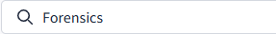
  - In the drop-down menus below the search, select the following in red circle:

  - Choose any of the free walkthrough exercises and give it a go. If you have not done the “Intro to Digital Forensics”, start with that one.
  - Now try to find a lab on how to convert an E01 image file to a dd image file and vice versa.
  - Or choose a forensics lab of your choice.

There are many other similar sites. If you are using a different one, please share it with the class. Do any of the free walkthrough exercise but the option is yours if you want to subscribe (pay).

