Josh Naylor

Name of the Team: Team NOS
Team Members
Student Name | Student ID
James Frew | 2108660
Daniels zelinskis | 2104718
ALEX TZAFOS | 2104846
Josh Naylor | 2114259

Team Evaluation (Self Evaluate your Team)
 | Student 1 | Student 2 |  | Student 3 |  | Student 4
Student 1 | 5 |  | 5 |  | 5 |  | 5
Student 2 | 2 |  | 3 |  | 2 |  | 2
Student 3 | 4 |  | 5 |  | 4 |  | 5
Student 4 | 3 |  | 4 |  | 3 |  | 4
Rate your Teams Contribution with a scale of 1 to 5 (1 No Contribution and 5 Excellent Contribution)
Add your comments on Team Evaluation: (Justify your evaluation)
Student 3: He did a good amount of work.
Student 4: I could have done more work than.
Student 2: He could have been in class more.
Student 1: He did the most work out of all of us.

Table of Contents
II. Task 1: Managing and Maintaining Network Resources Using Network Policy and Security Practices 2
III. Task 2: Routing and Packet Filtering Within Core TCP/IP Services and Critical Failover/Redundancy Practices 20

Task 1: Managing and Maintaining Network Resources Using Network Policy and Security Practices

Understanding NTFS and Share Permissions

NTFS
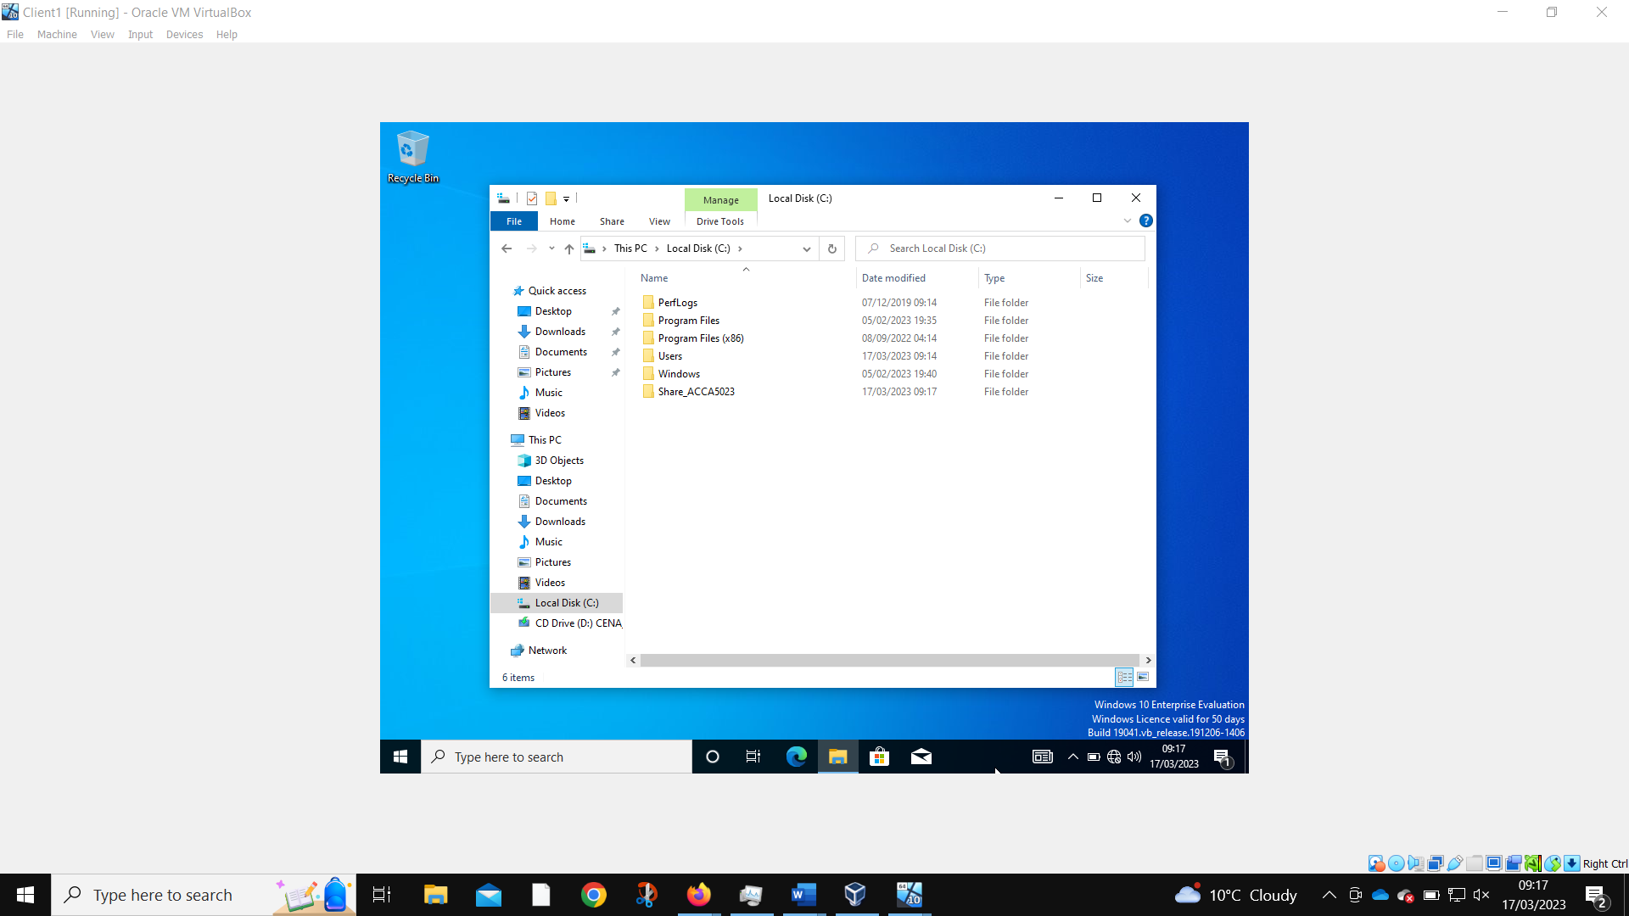 The folder that will be used for sharing files is created
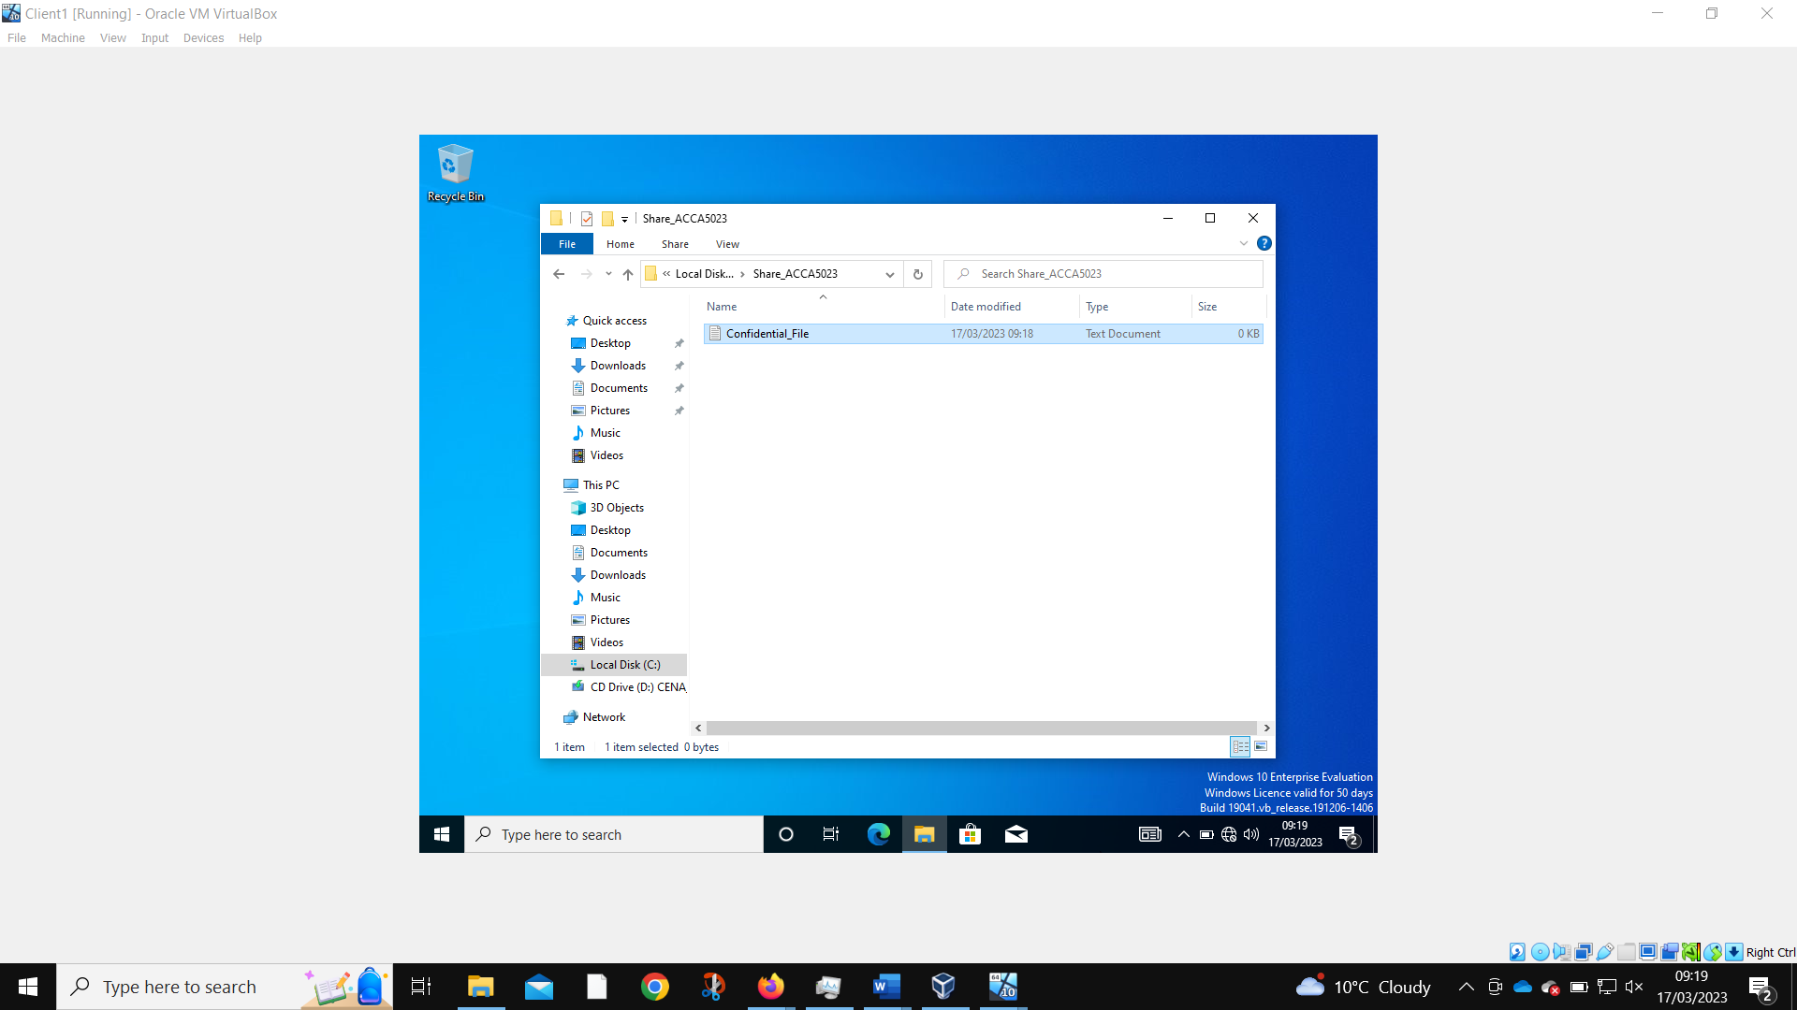
A “confidential” file is created inside this folder
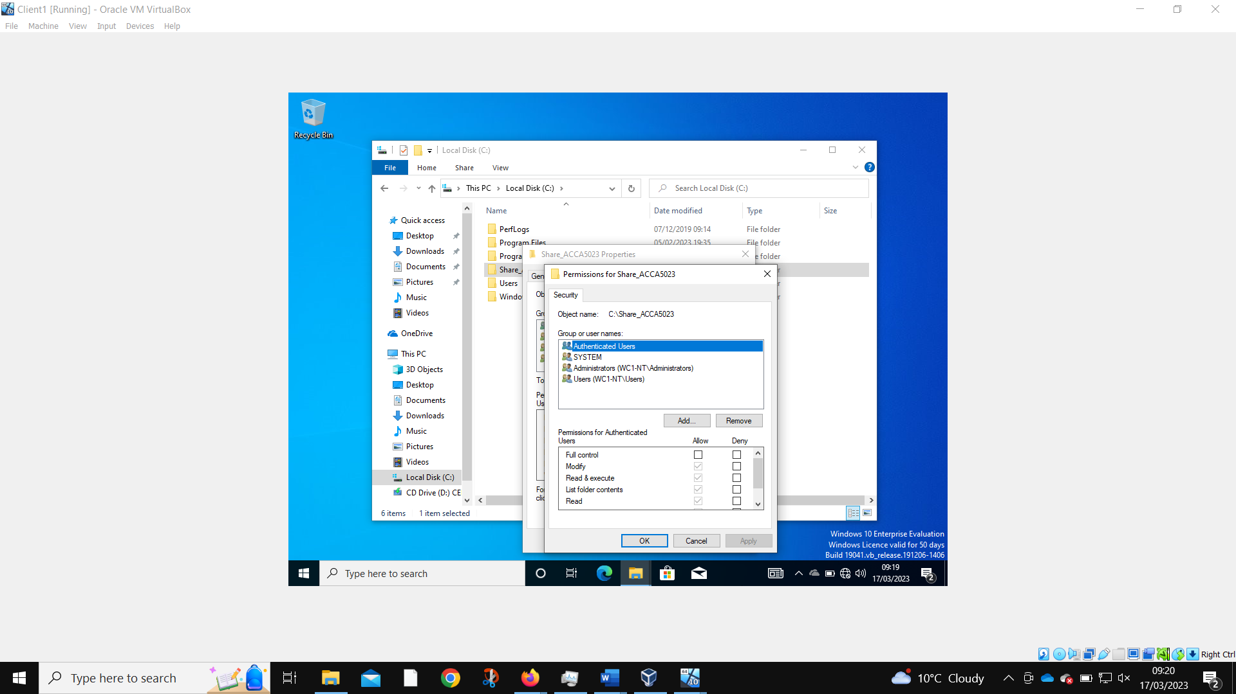
This is a list of the default users that have access to the file.
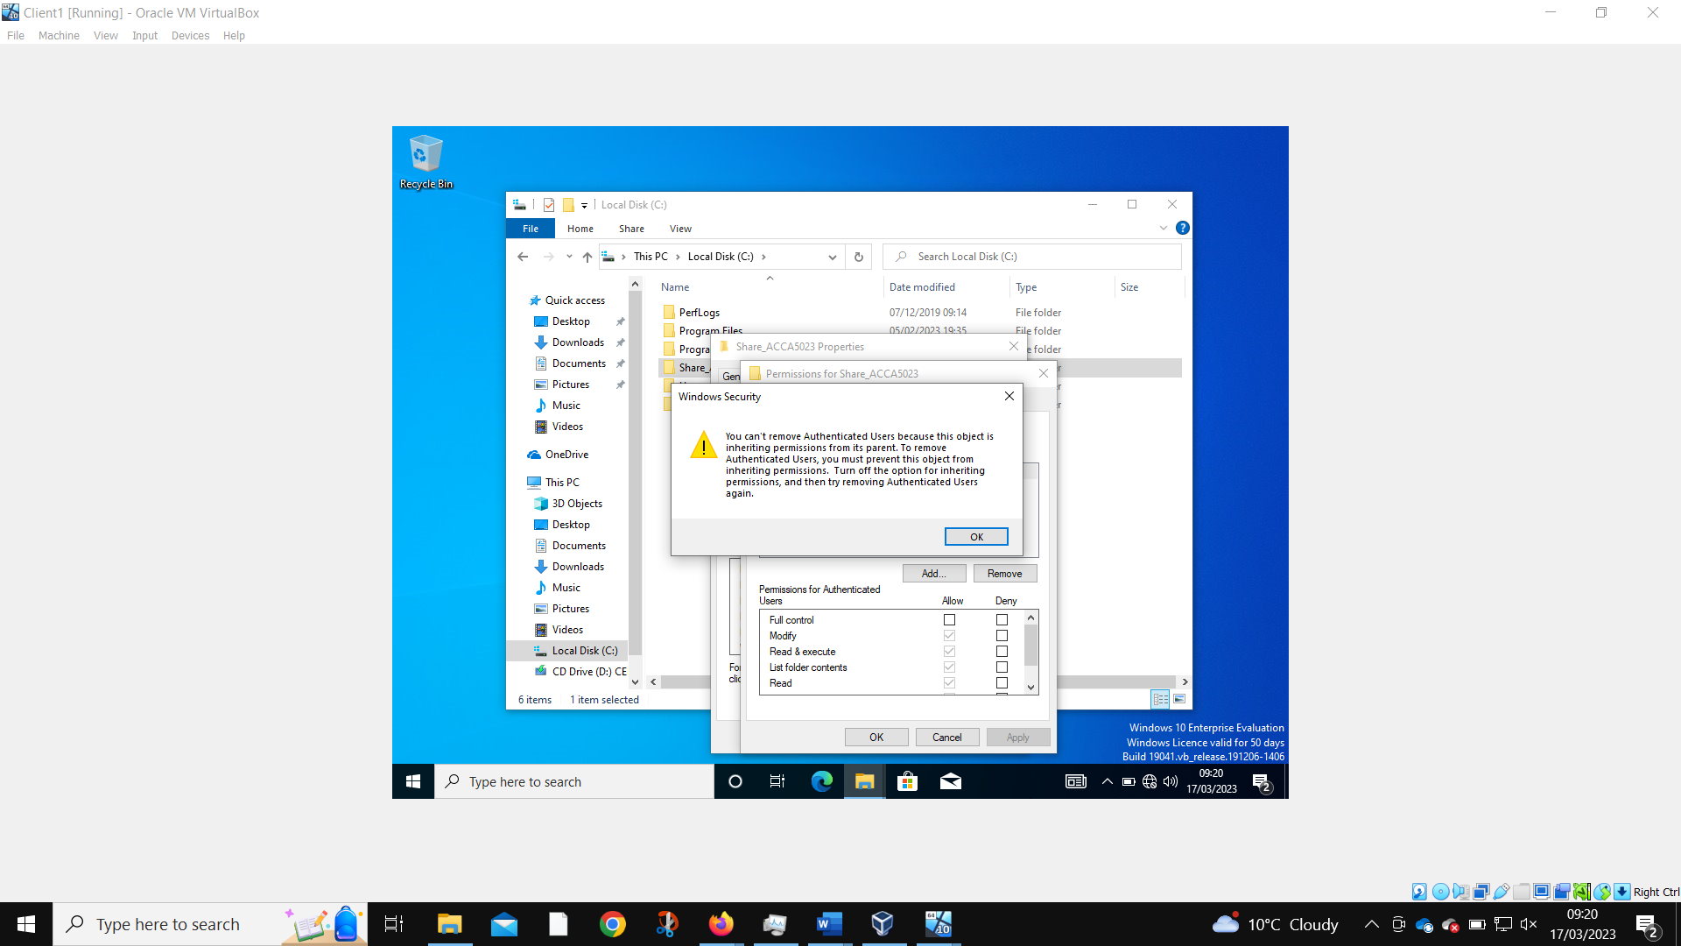
When trying to remove the Authenticated Users’ permissions, we first must remove inherited permissions.
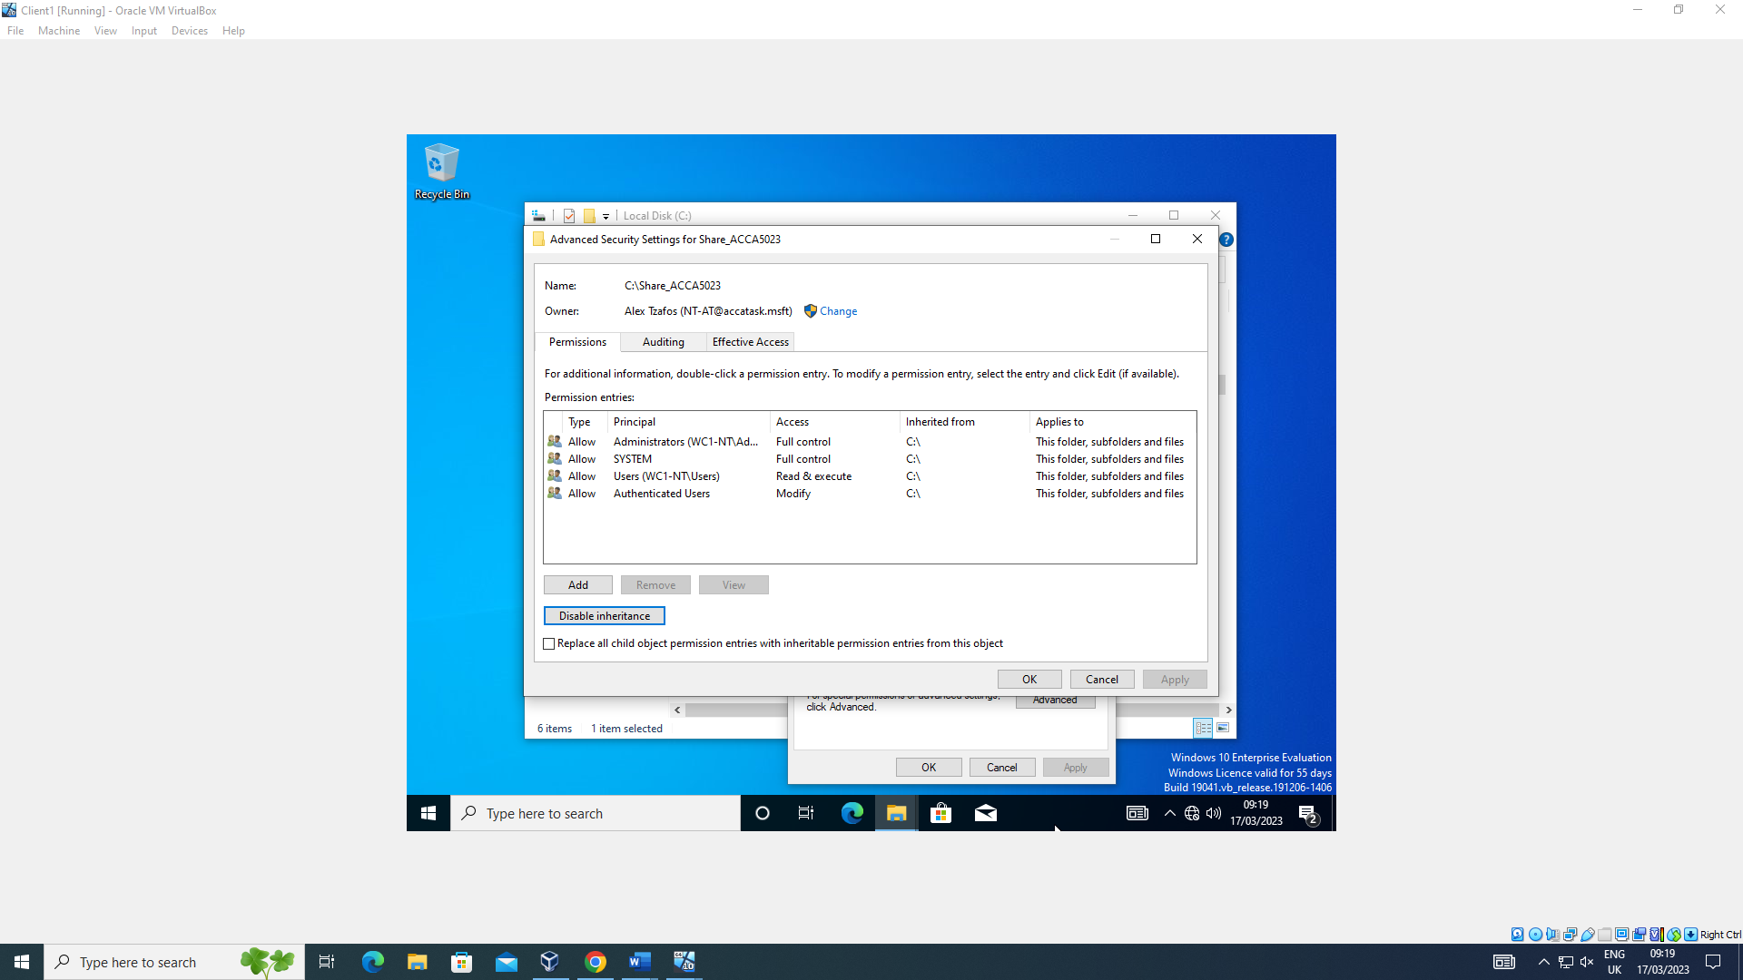
Using the advanced security settings, we can turn off the file’s inheritance.
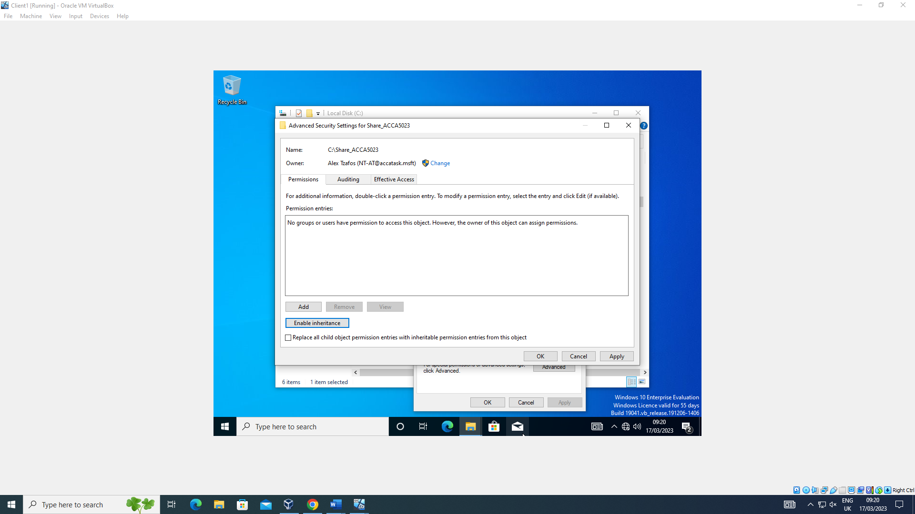
Which allows the removal of inherited user permissions on the folder?
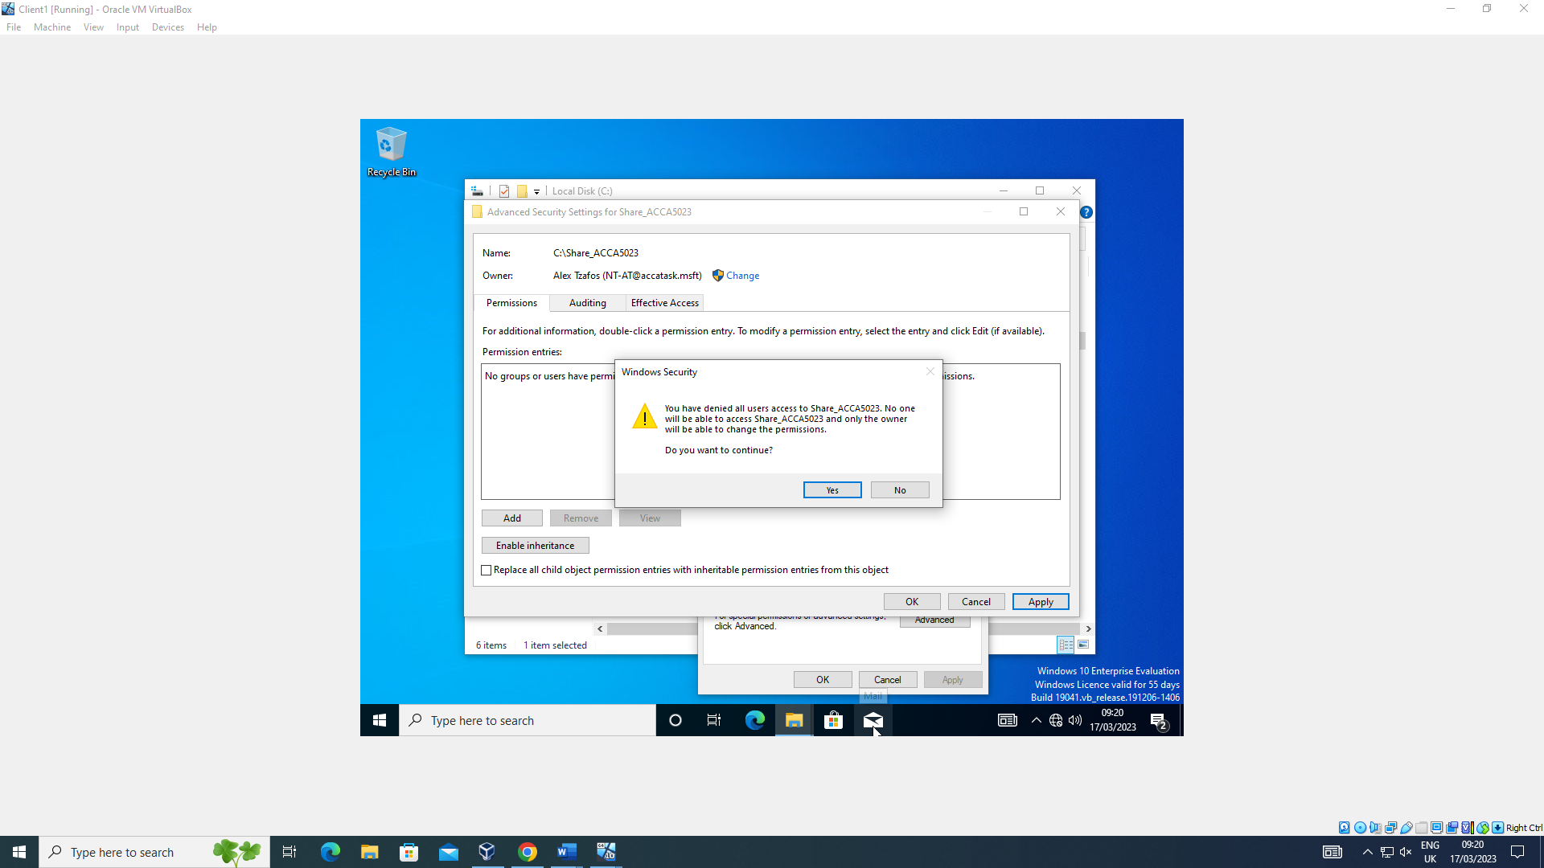
This prevents all but the folder owner from accessing it.
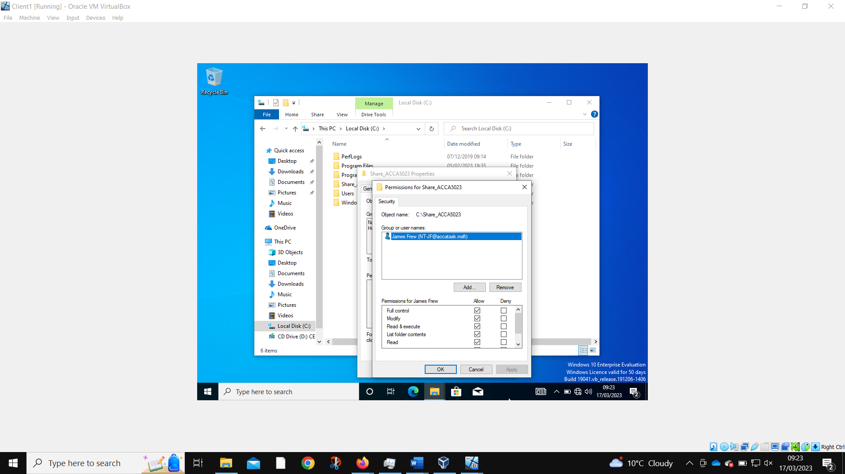
The desired account is added to the permissions list with full control allowed.
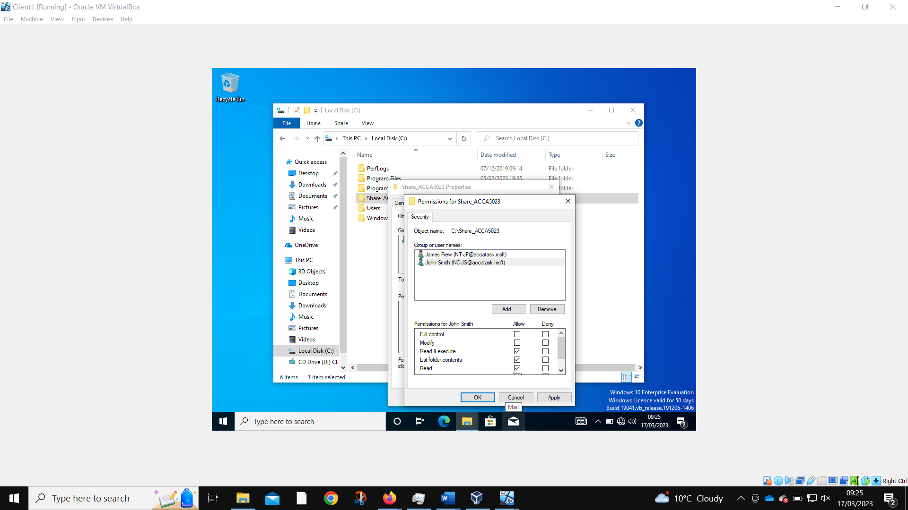
Another user can be added to the folder, but with fewer permissions.

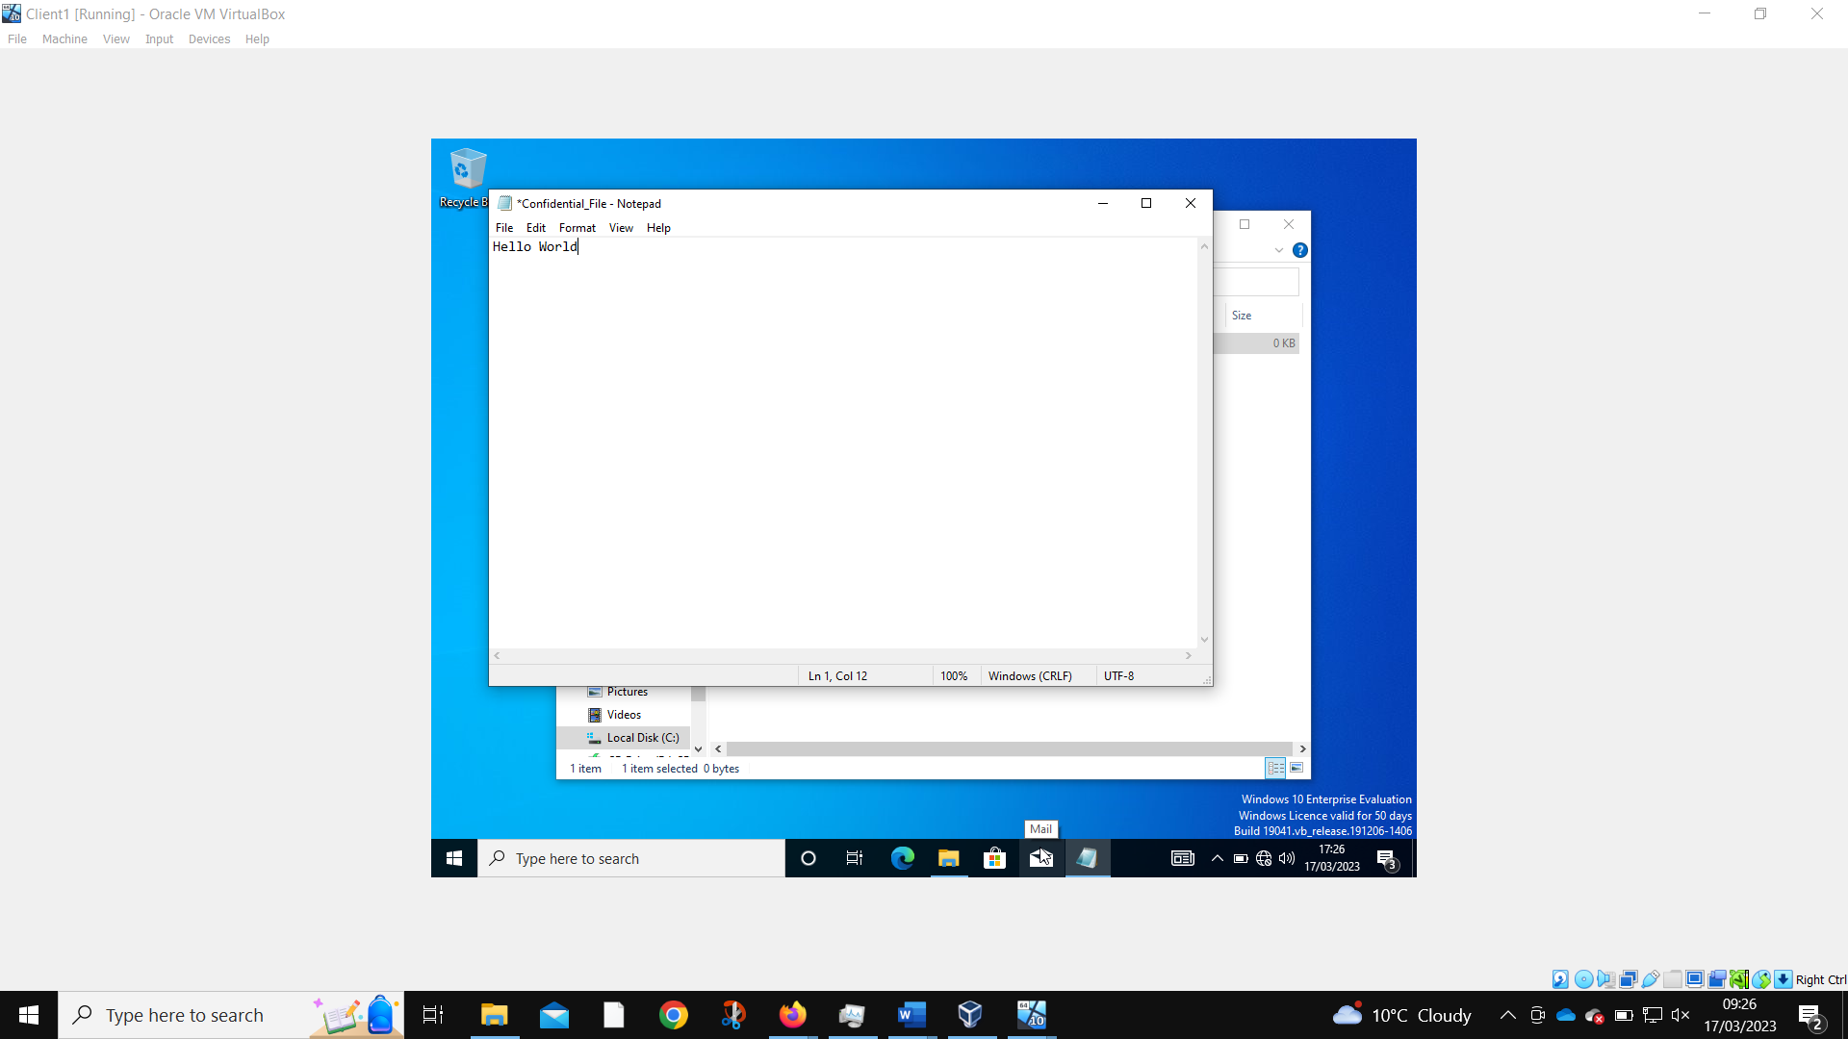
Only the admin account can now edit the file.
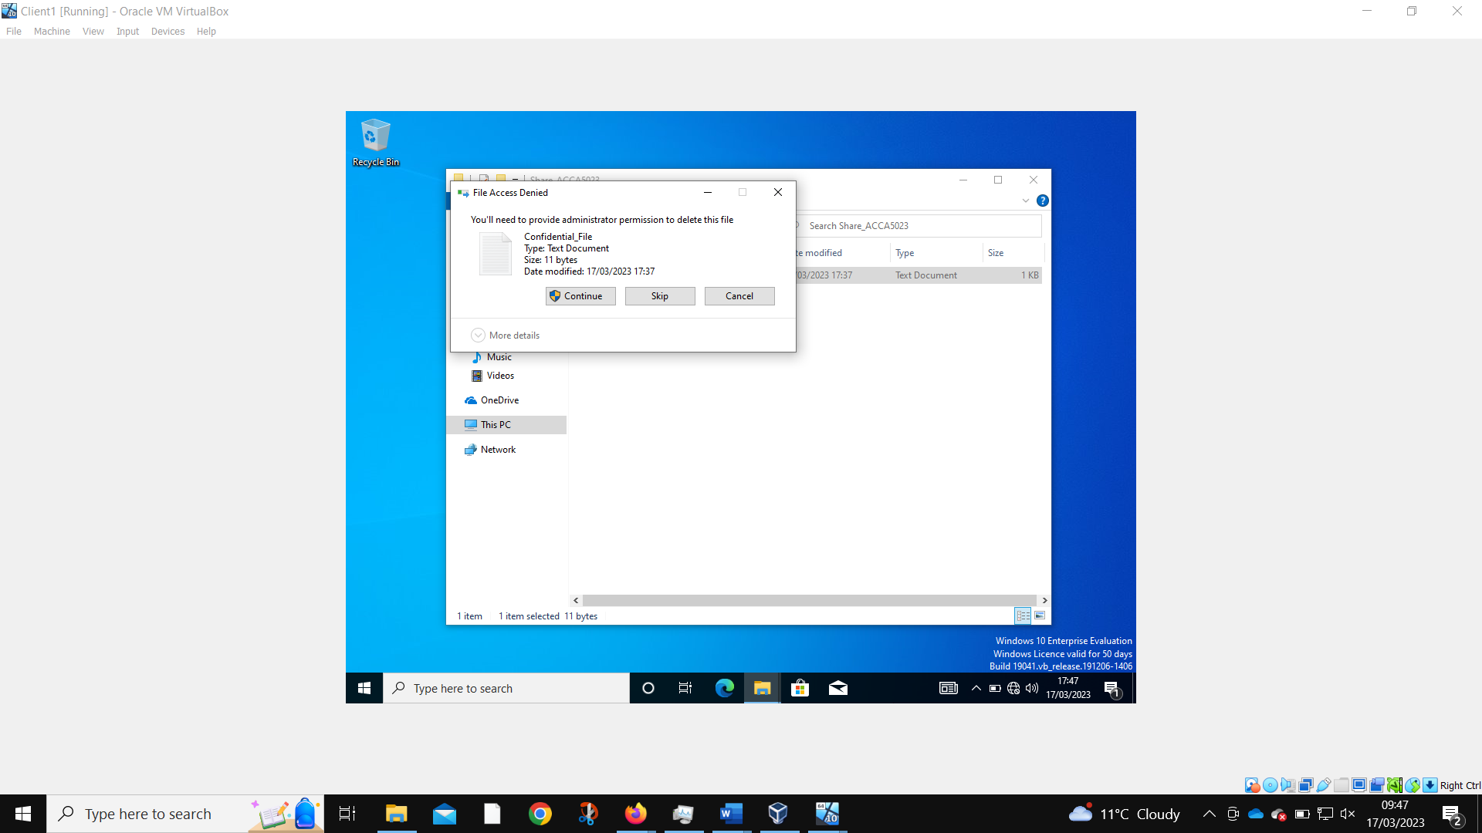
When the non-admin tries, they are required to give proper authentication.

Share Permissions
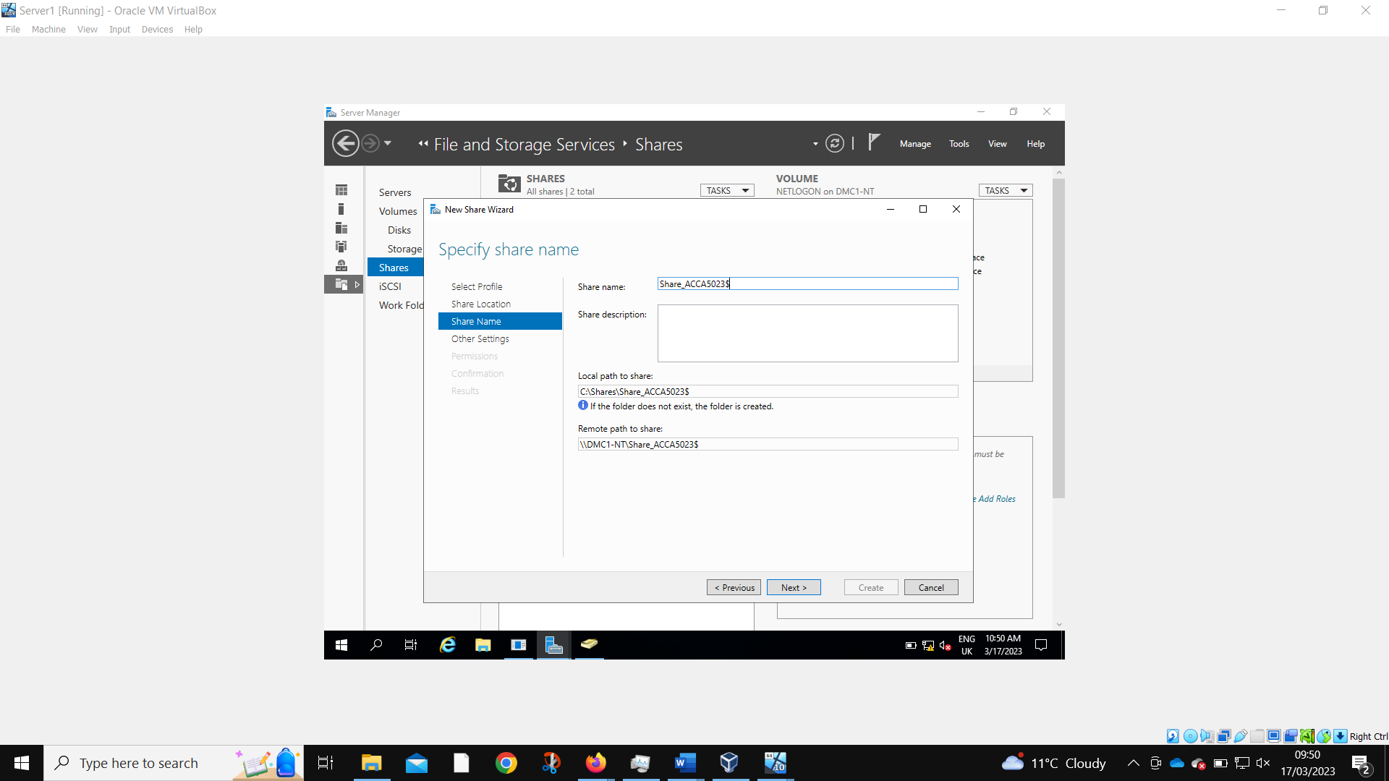
Share permissions are created on Server 1. The remote path name in the worksheet was wrong so has been corrected here.
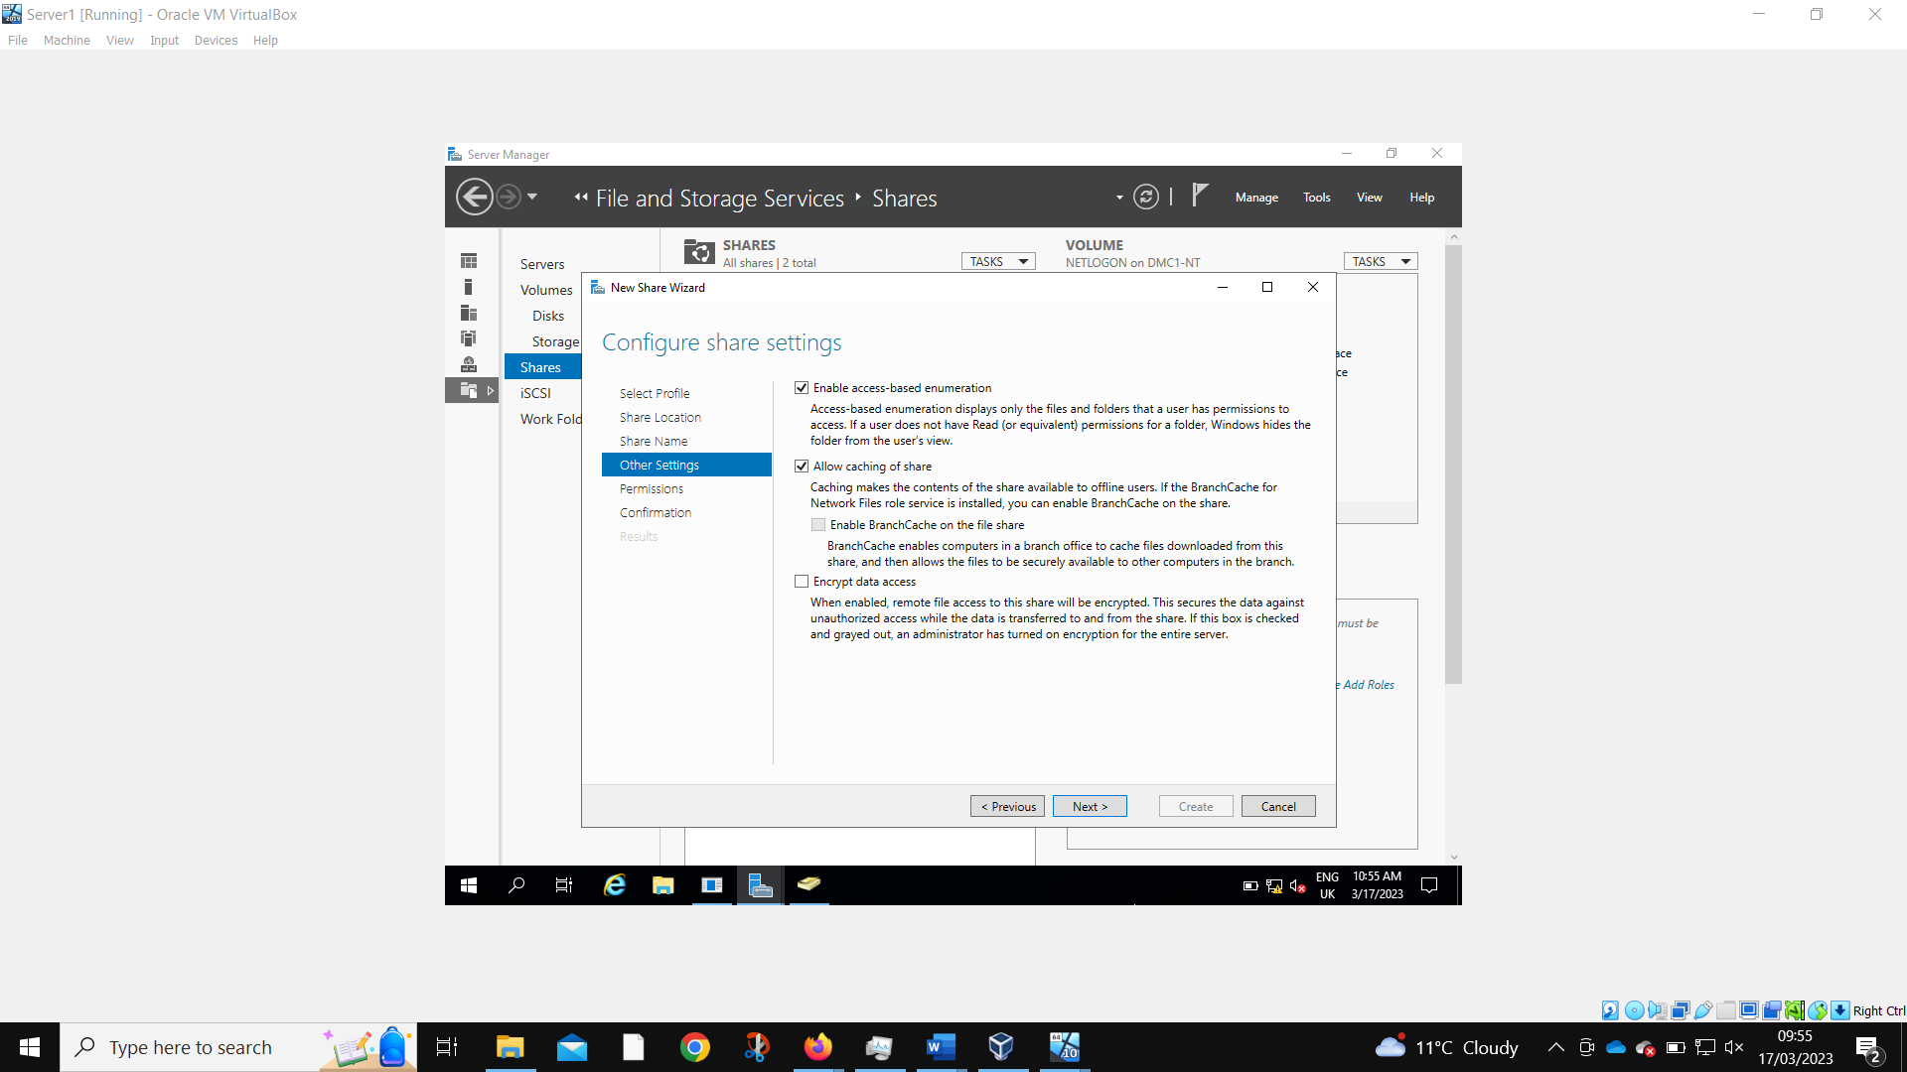
These settings will only show a user file that they have access to, and cache those files so they can still be accessed when offline.

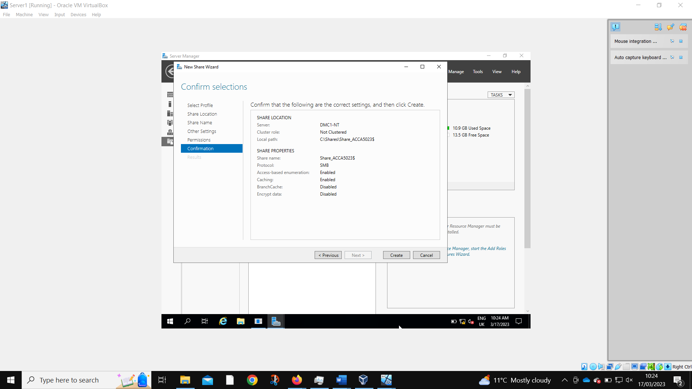
Confirmation of the desired settings.
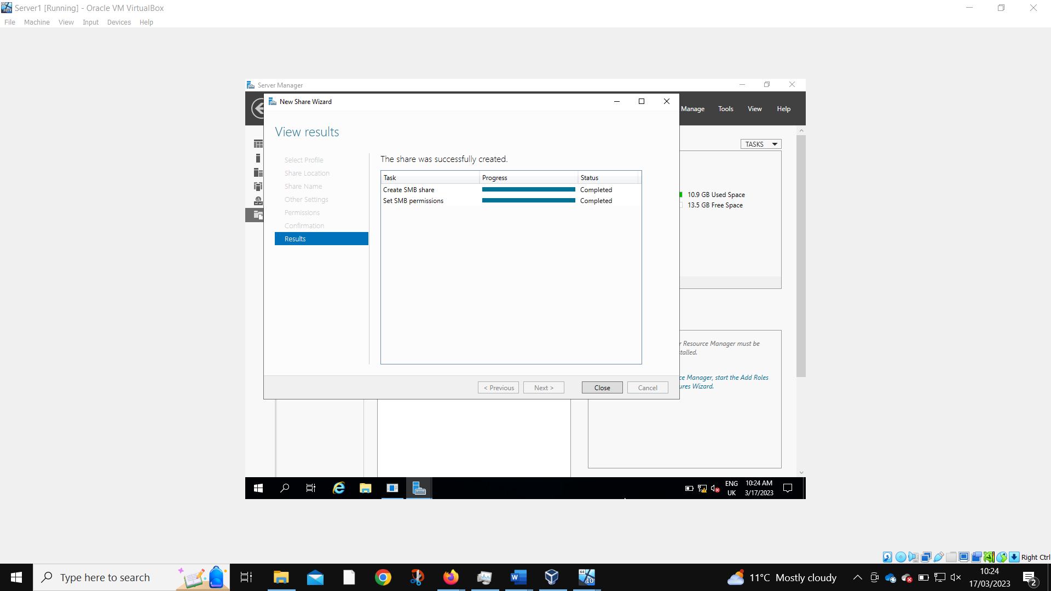
Share successfully created.

Accessing the file share/server over the network
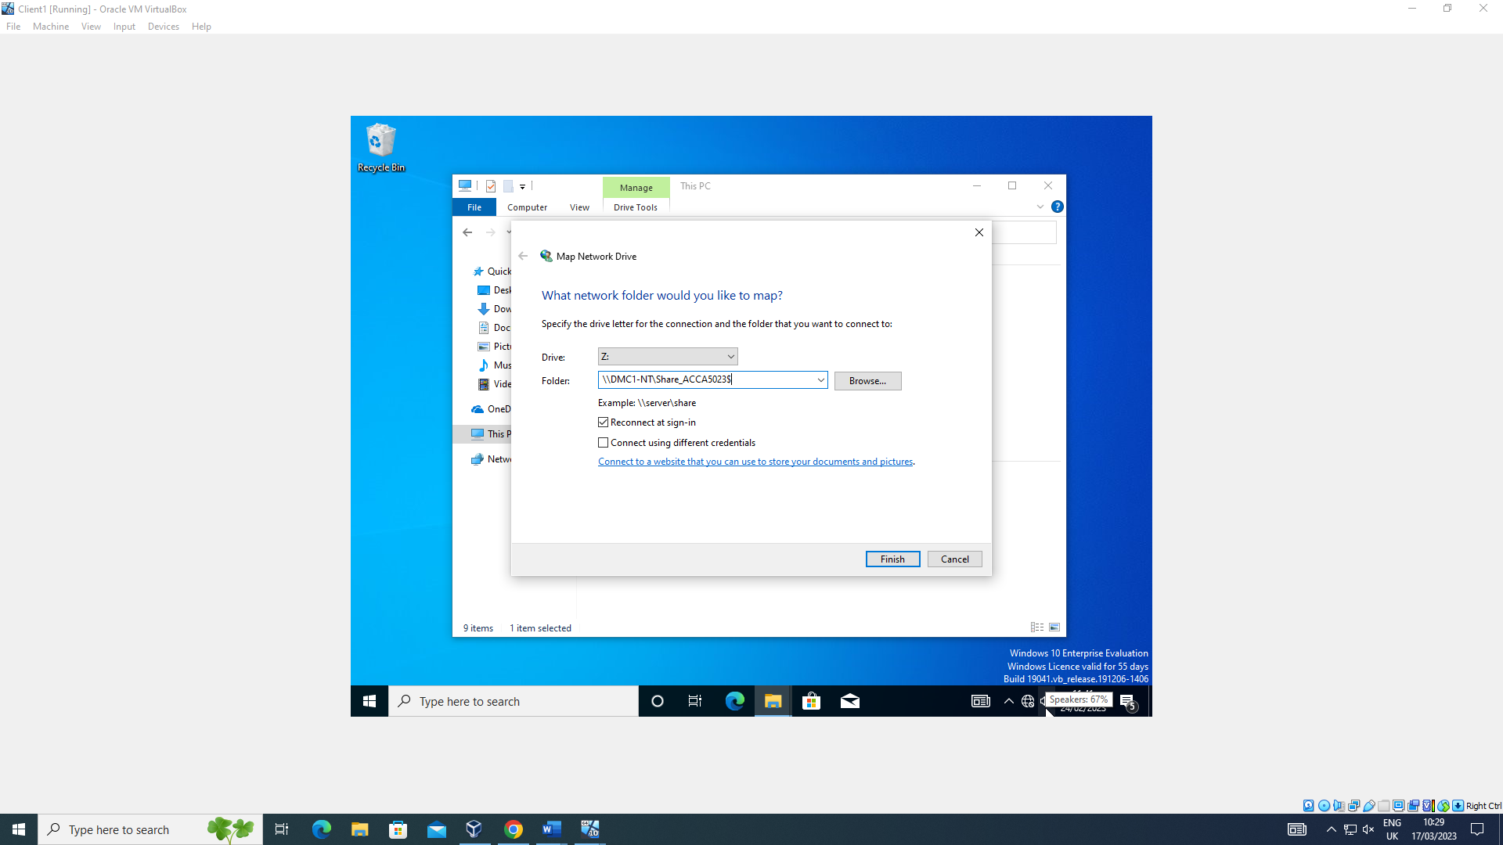
Mapping the network drive is required to access the share folder.
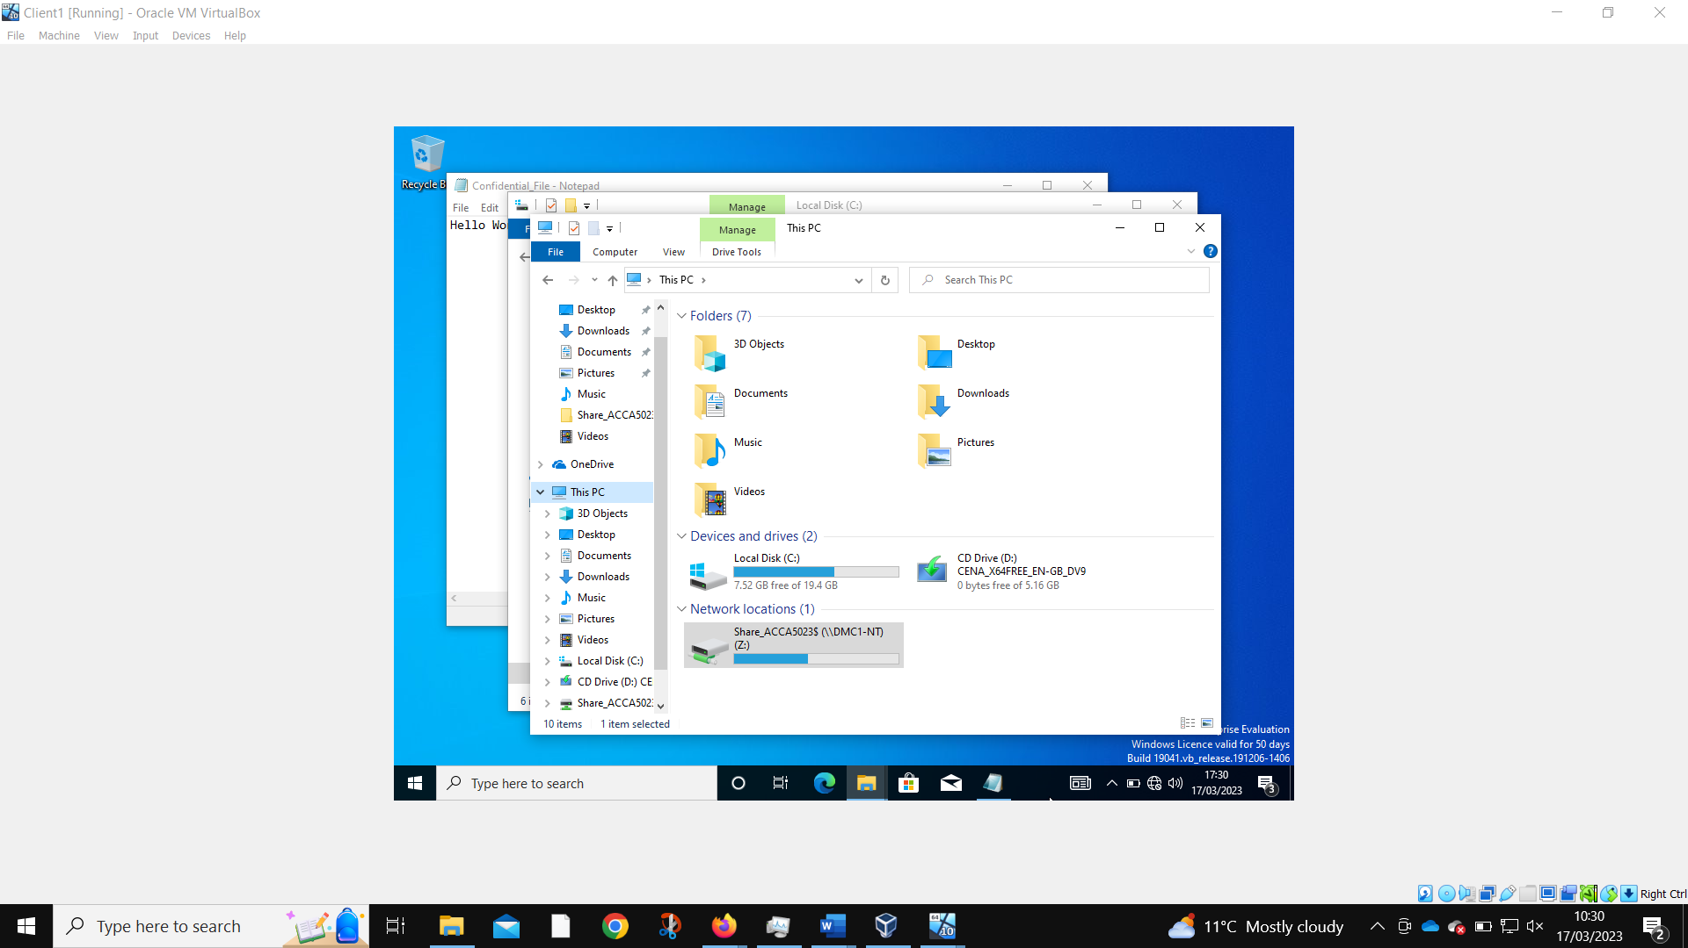
The share folder is now present on this local machine.
Utilizing Group Policy Management Console to better facilitate network object management.
Configuring User Environment and Computer Environment, ‘Network Group Policy Objects’

Moderating Access to the Control Panel
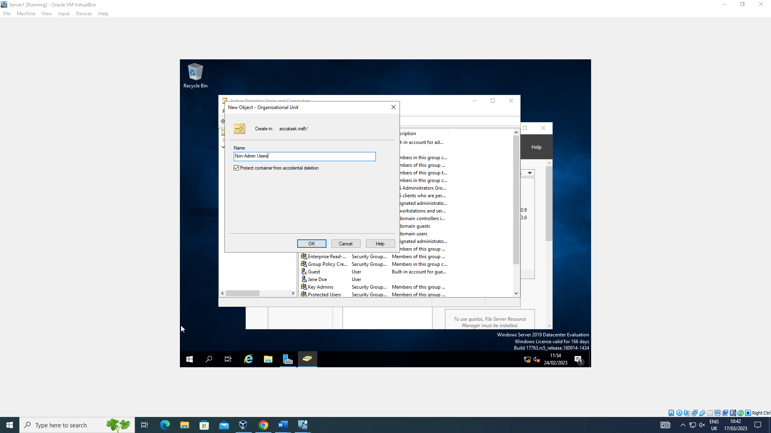
A new non-admin users organizational unit object is created to set group policies.
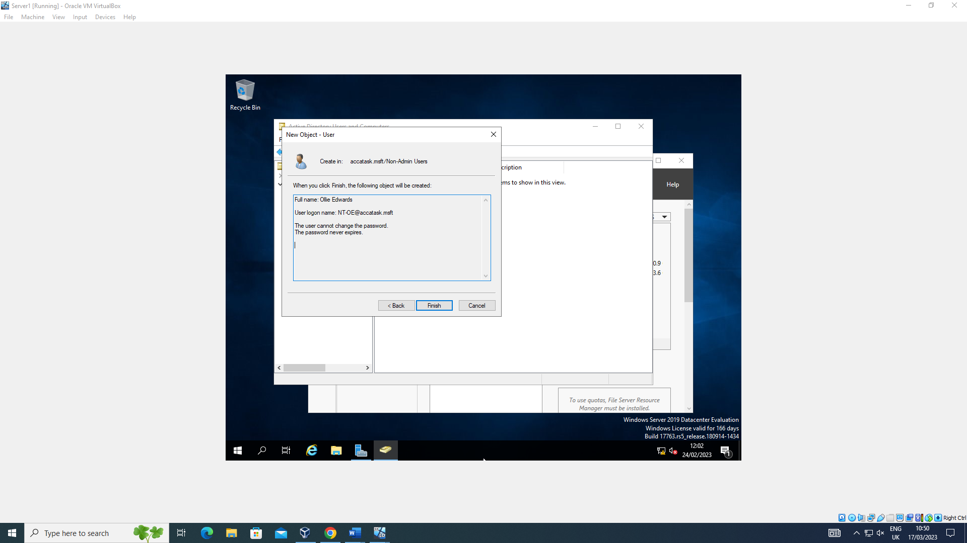
A new user is created to test the working functionality of the policy.
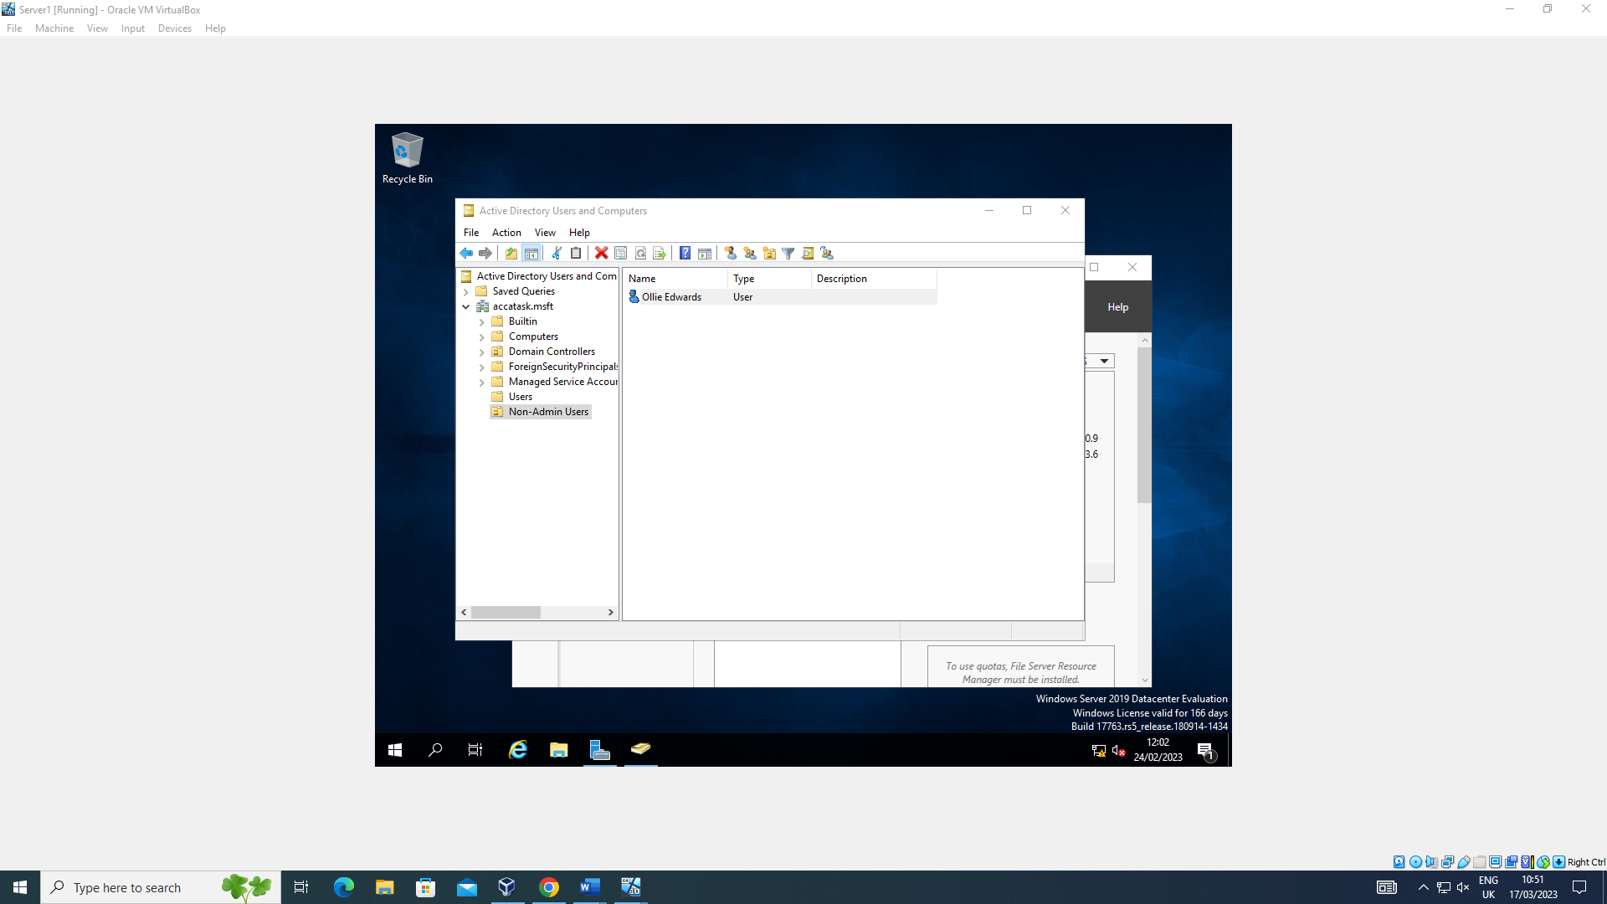
This user resides inside the newly created folder.
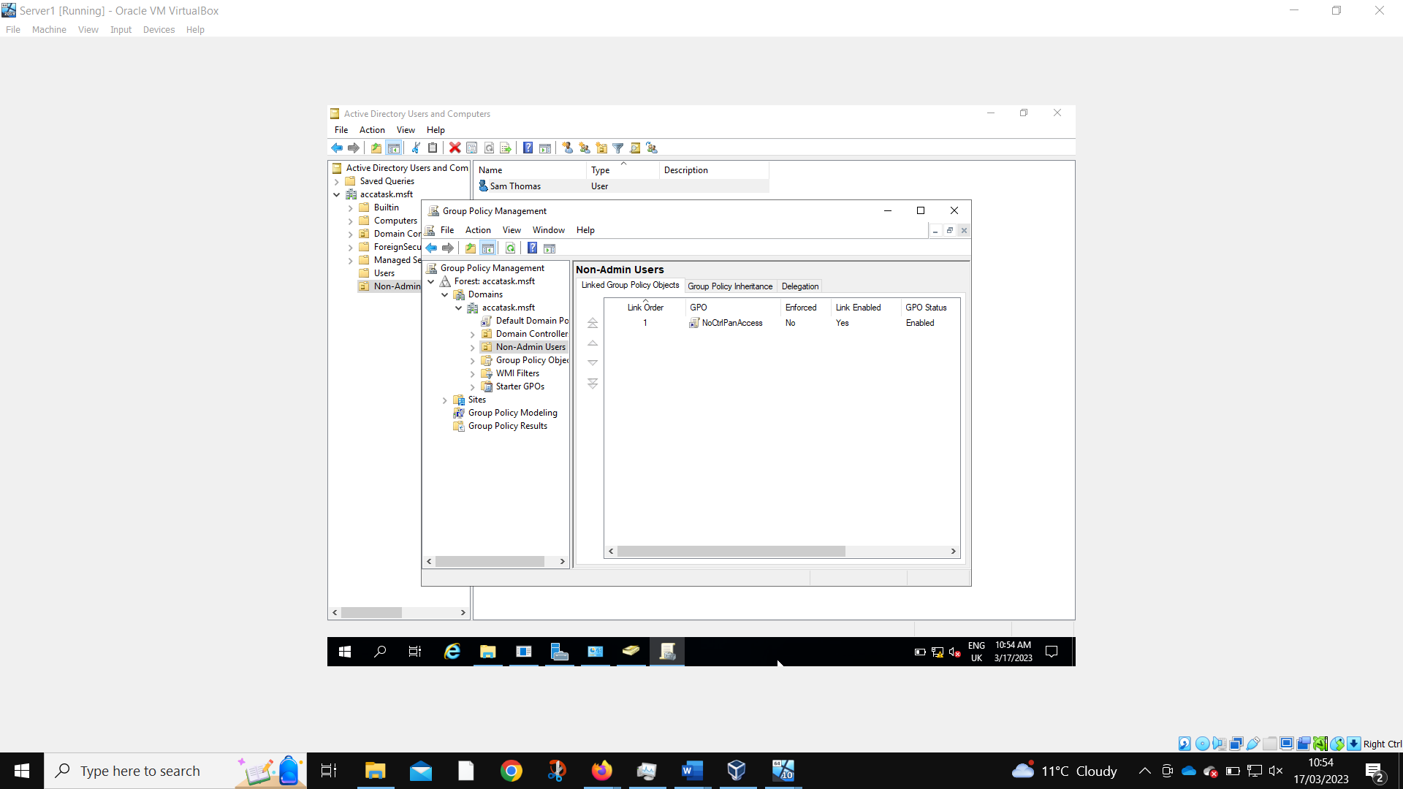
A new GPO is created to prevent access to the control panel.
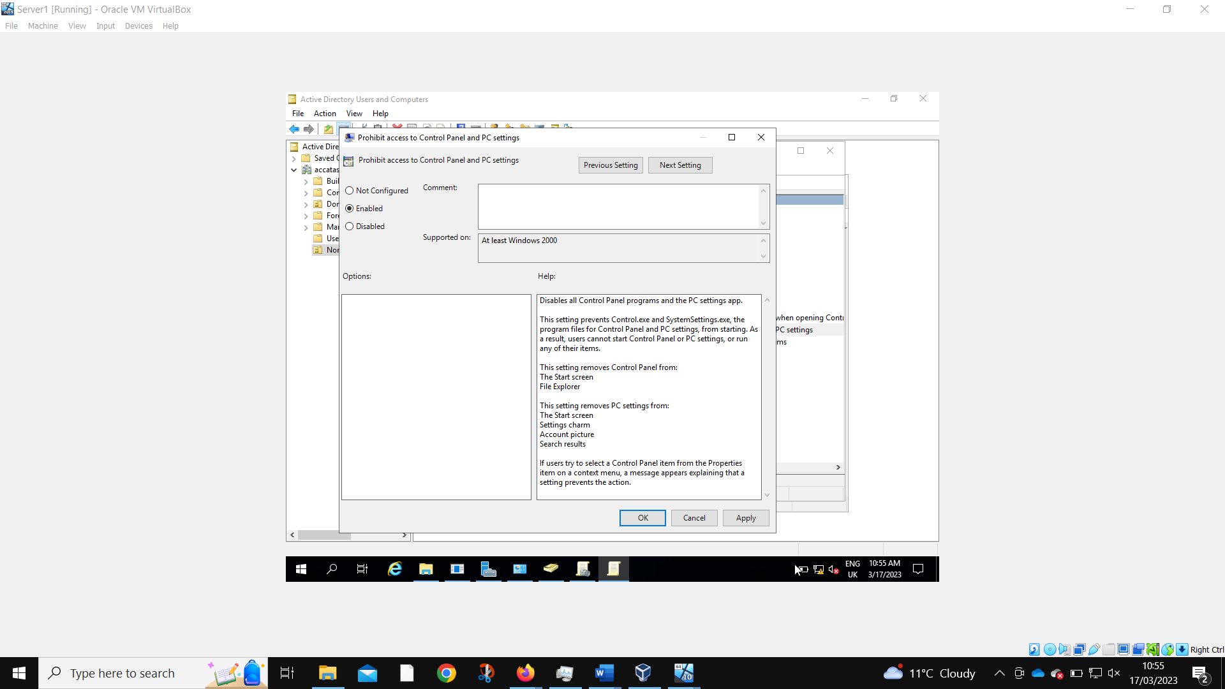
As is configured to do so.
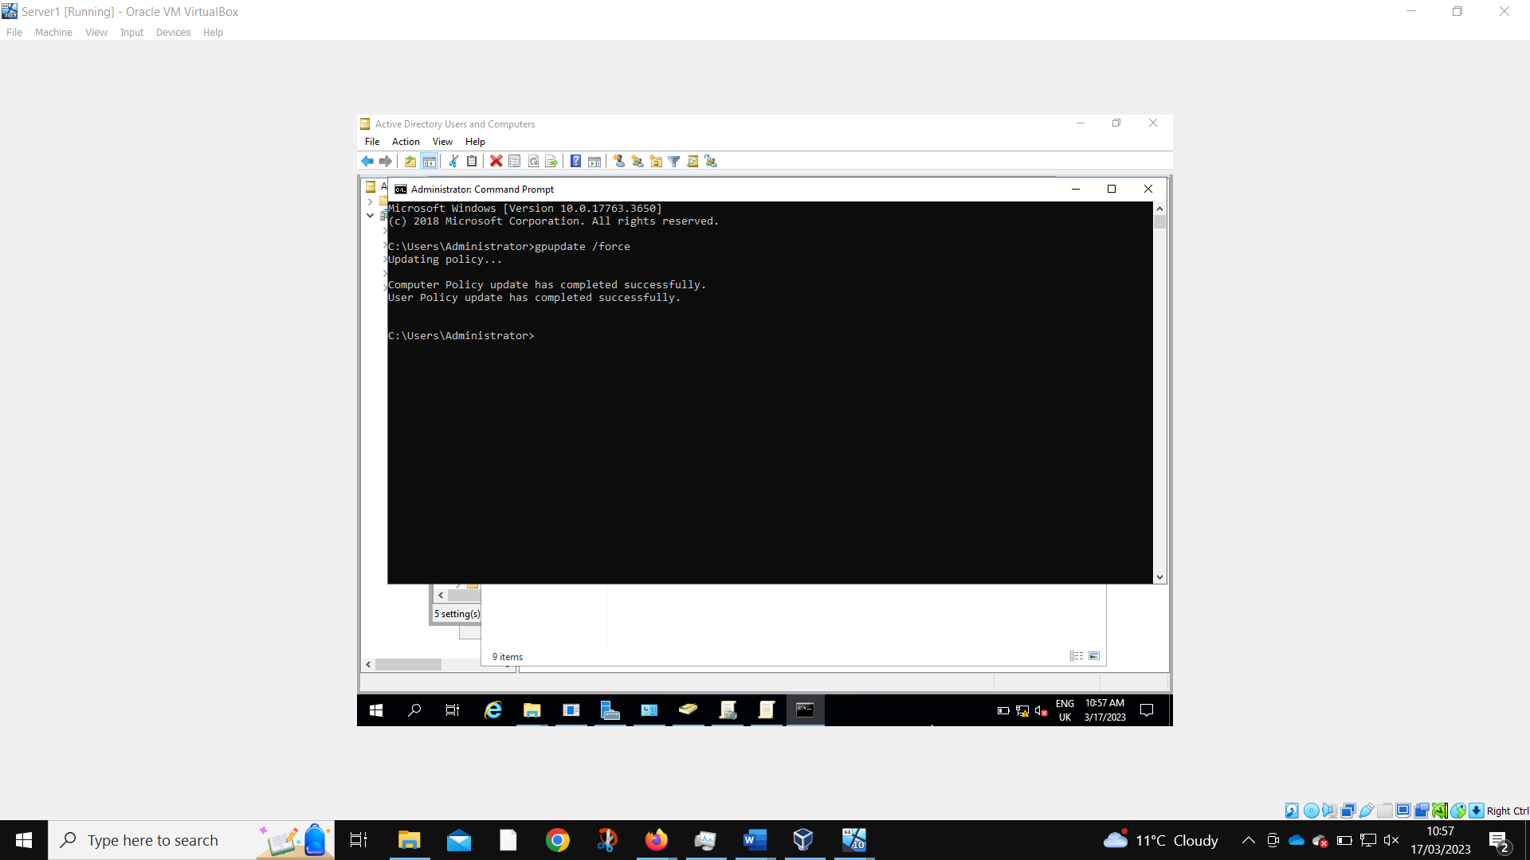
The server must force gpupdate to get the new policy working.
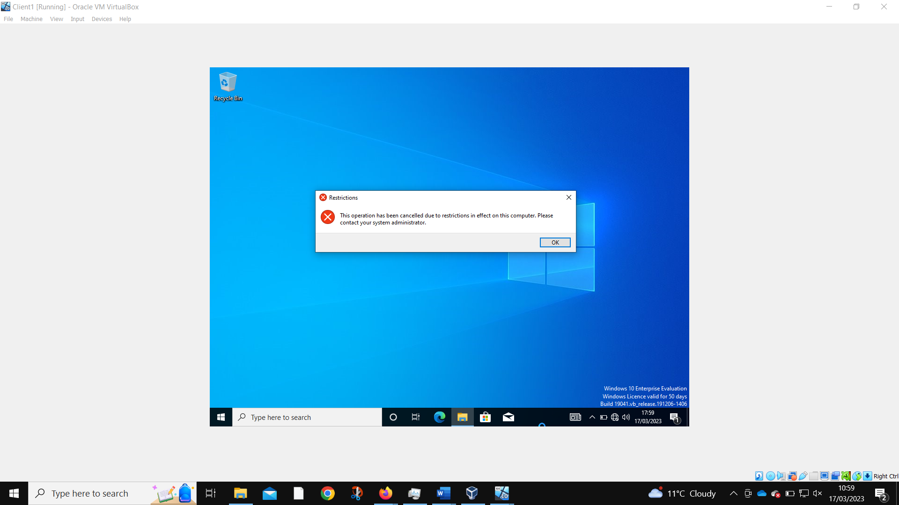
When logged in as the new user, they are no longer able to access the control panel?

Removing Access to the Command Prompt
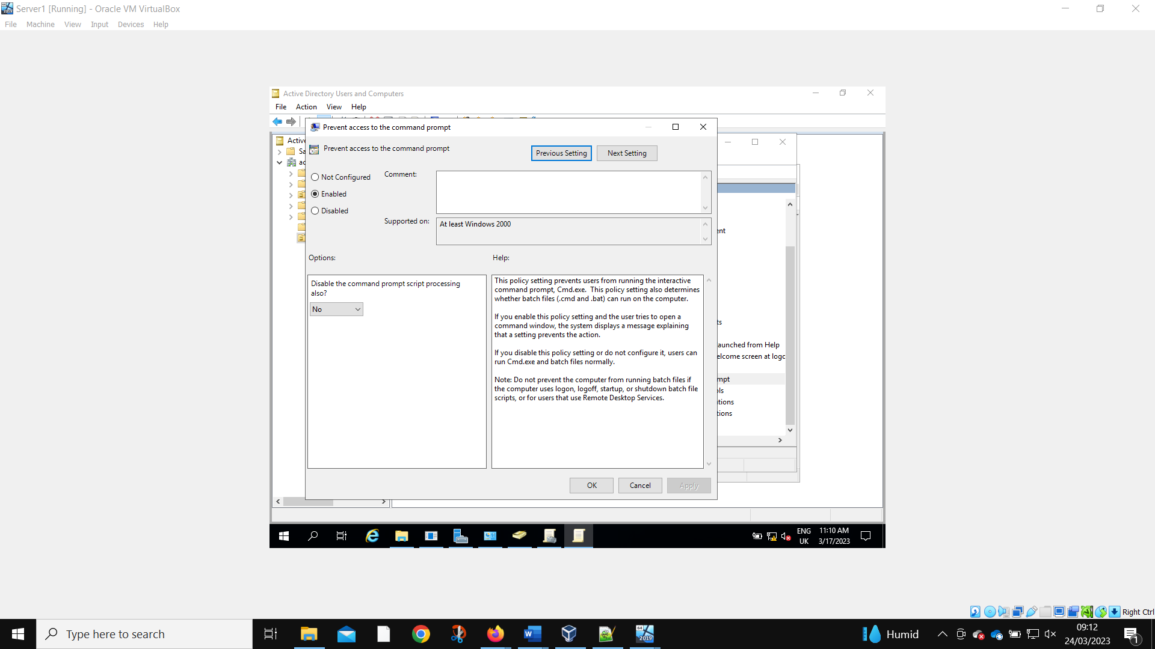
The same process is conducted, with a new GPO made to prevent access to command prompt.
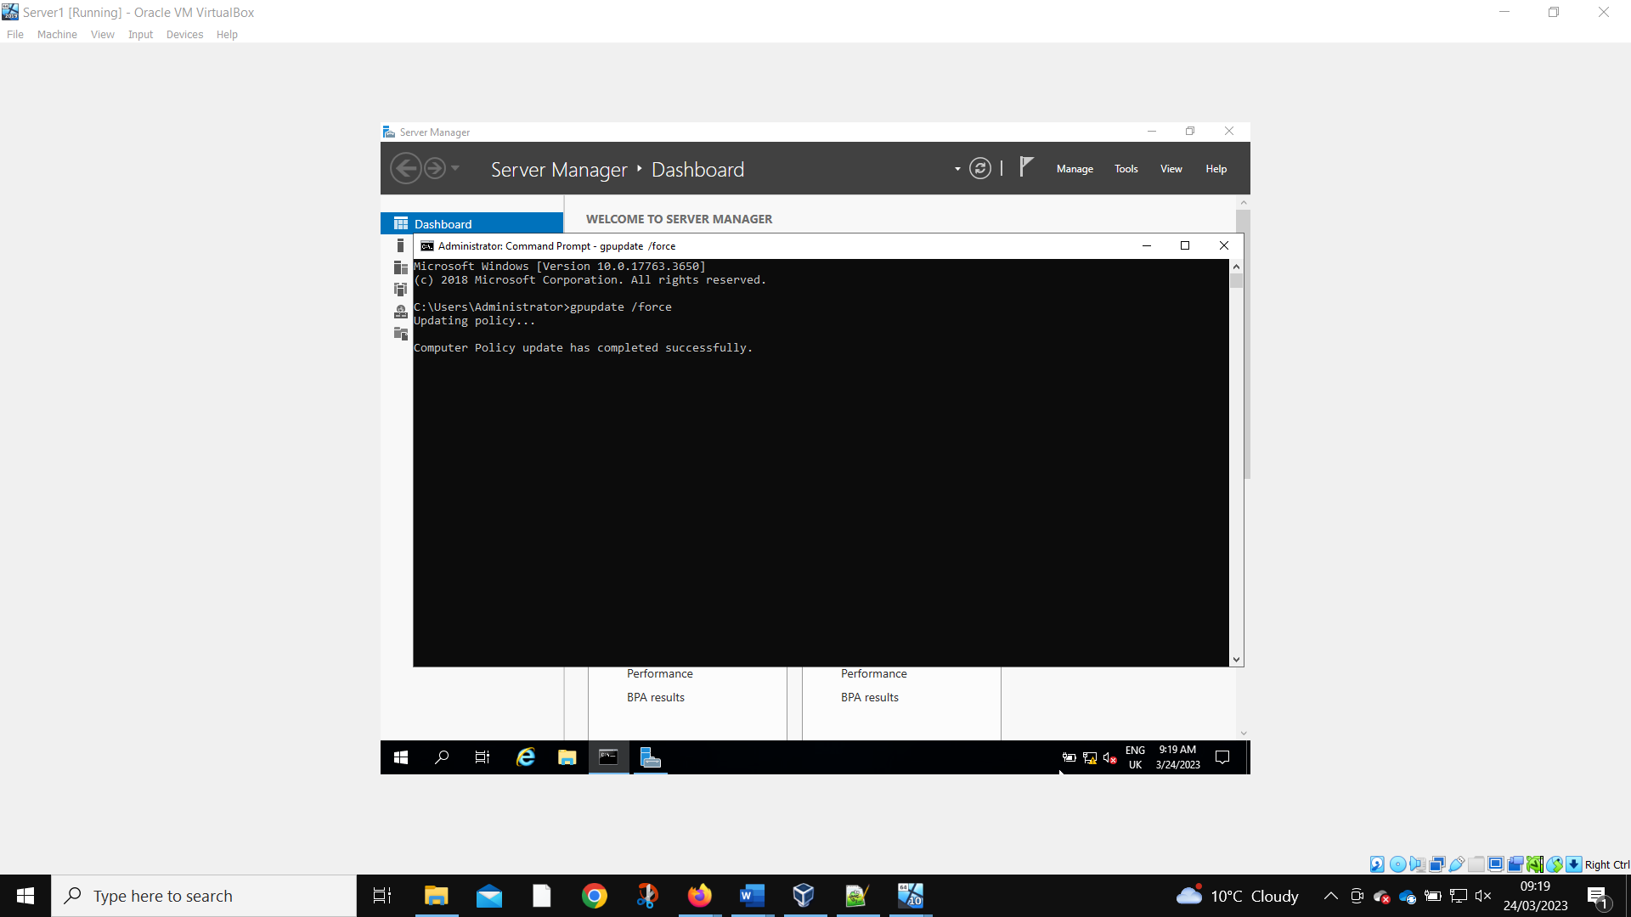
Force gpupdate is needed again.
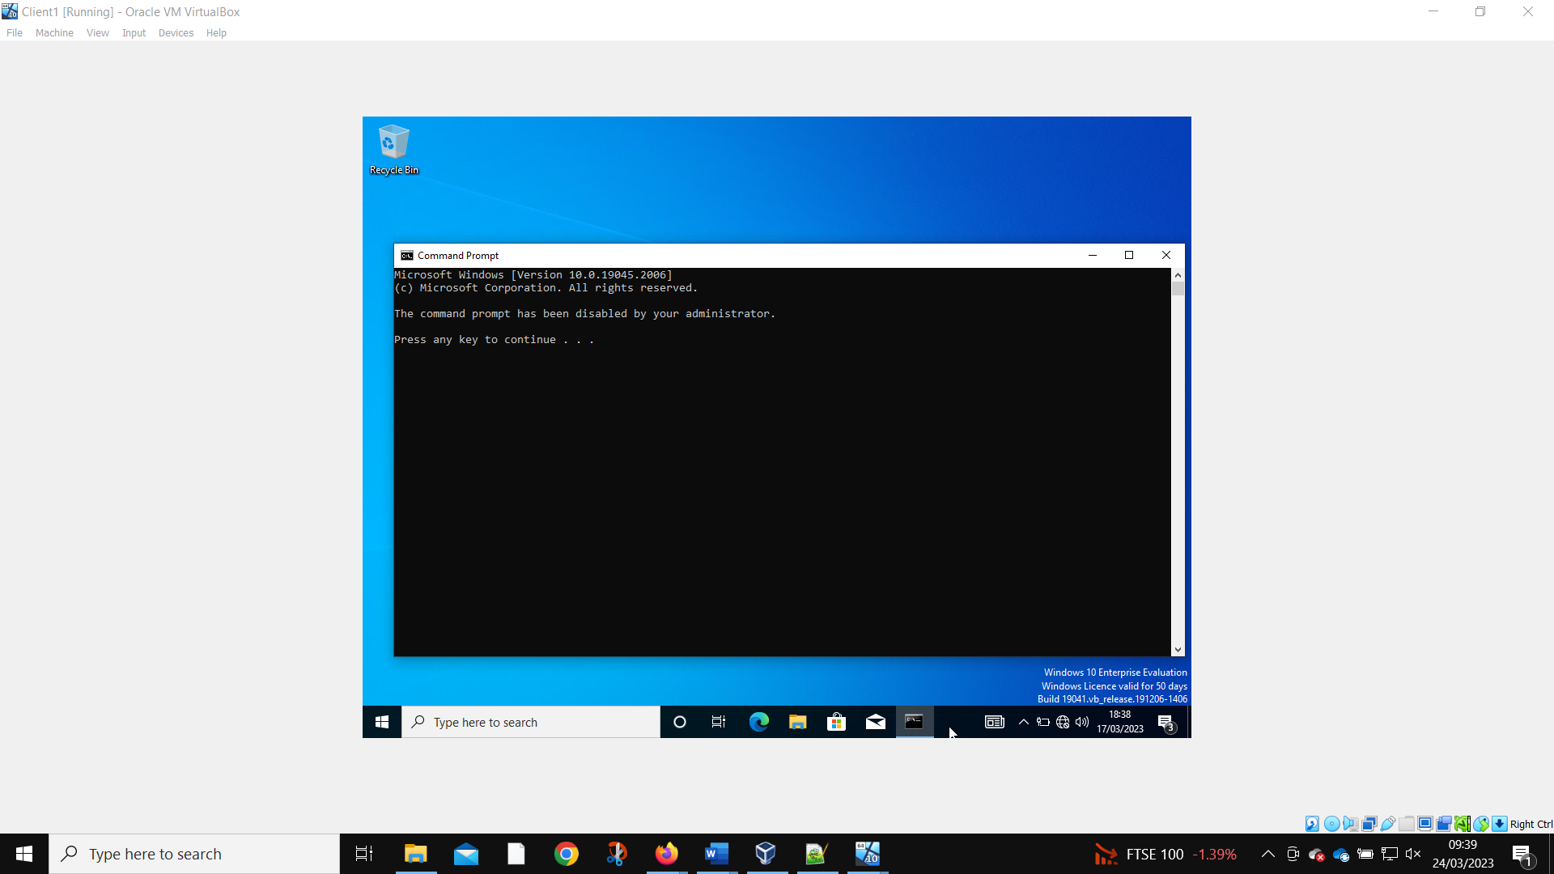
The new user is no longer able to use the command prompt.

Restricting Access to Removable Media Drives
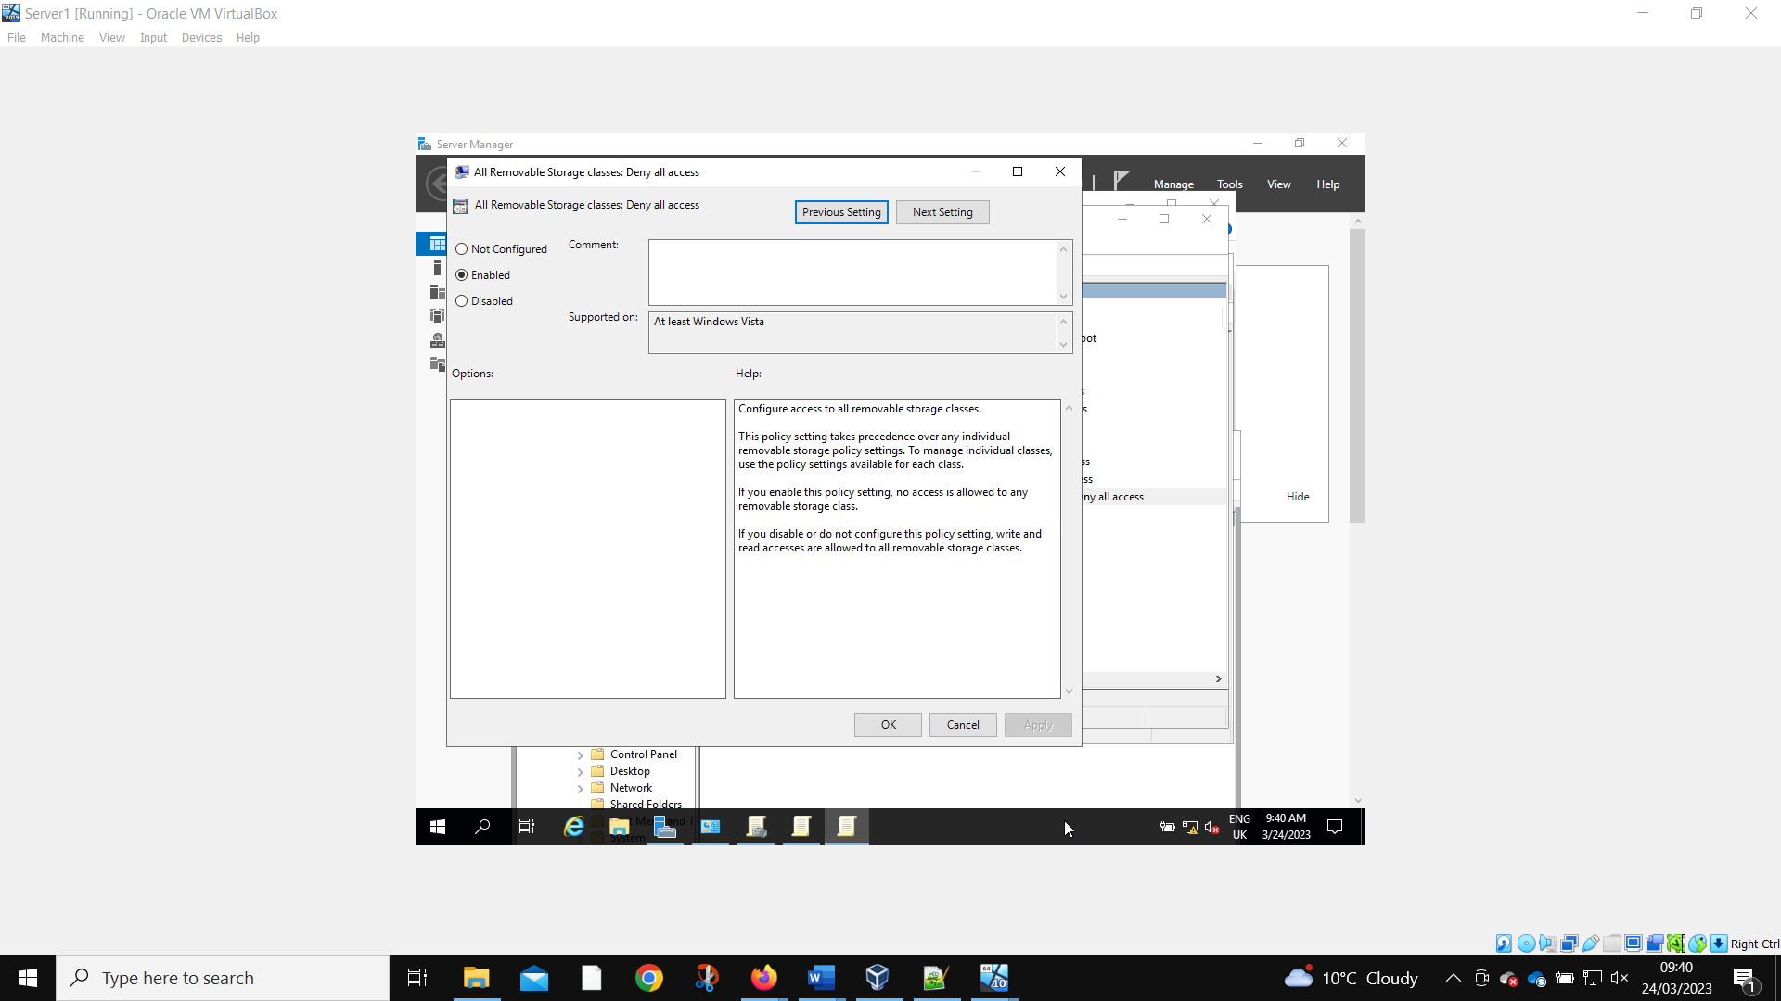
Another GPO is made to prevent the use of removable storage devices. This is unable to feasibly be tested using the current setup of VirtualBox.

Restricting Software Installs
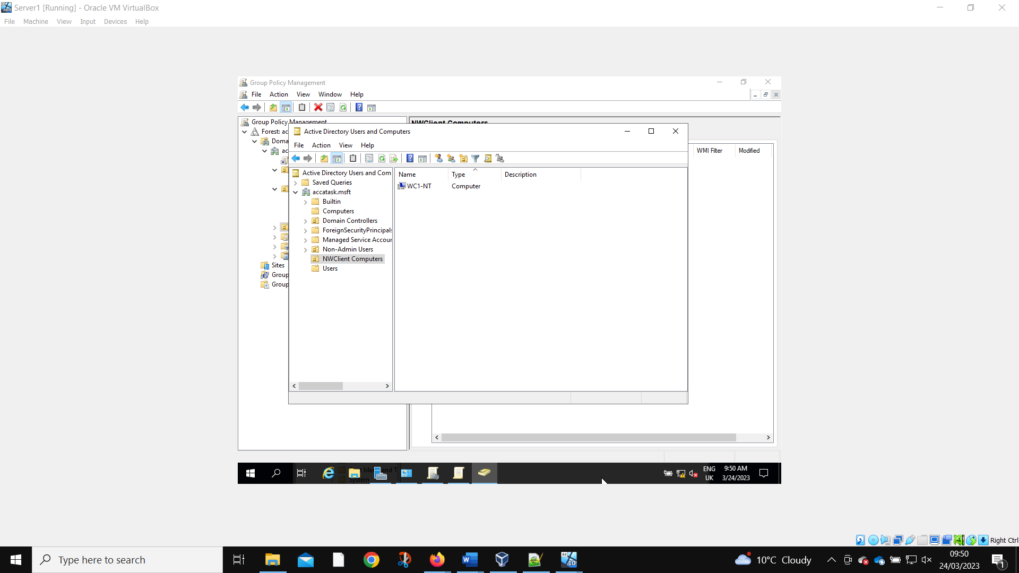
A new organizational unit is created to prevent specific computers from being able to install software.
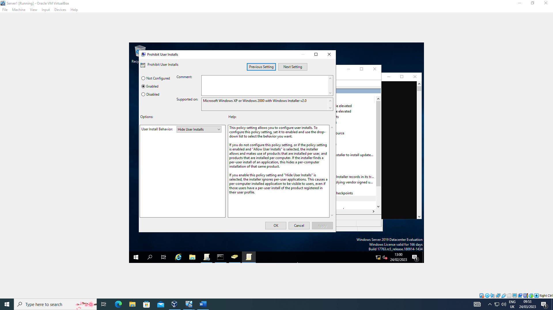
The rules are configured.
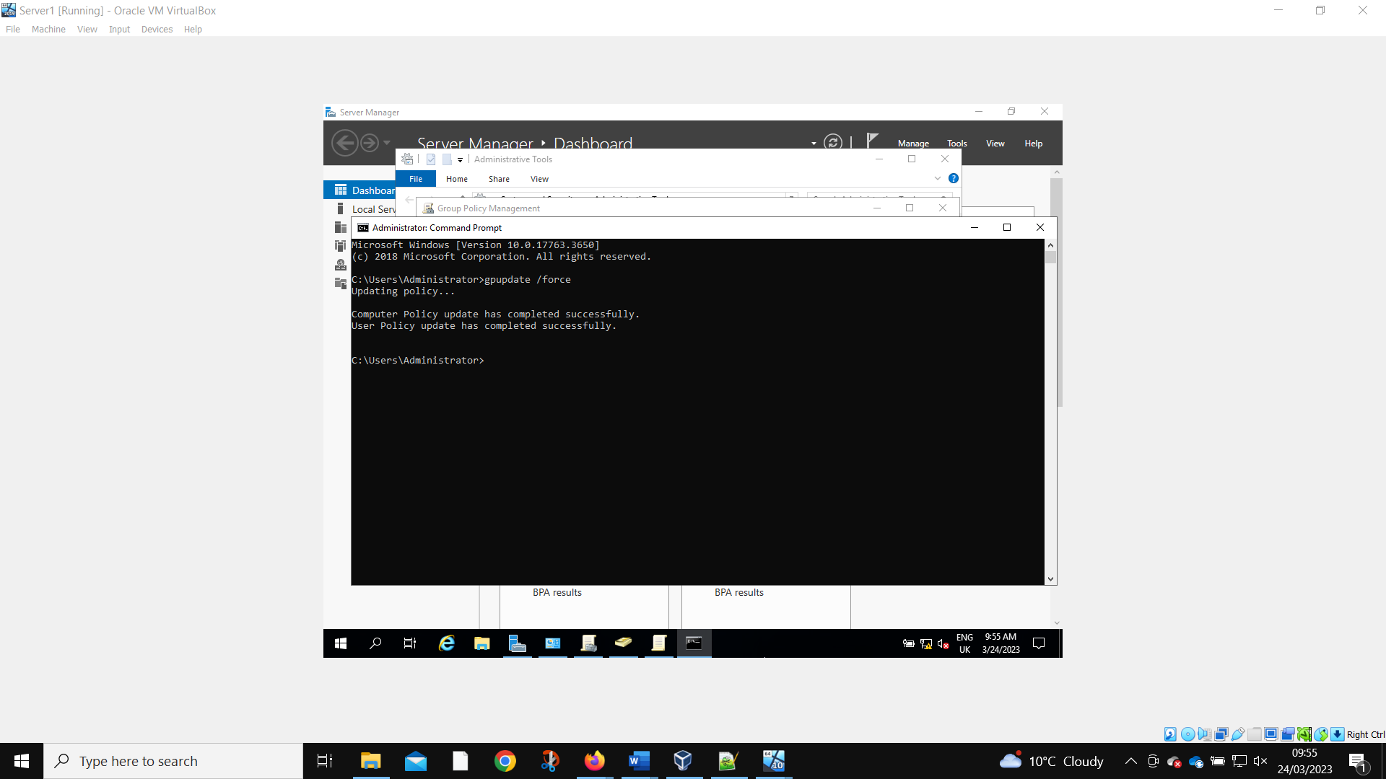
Force gpupdate is performed.
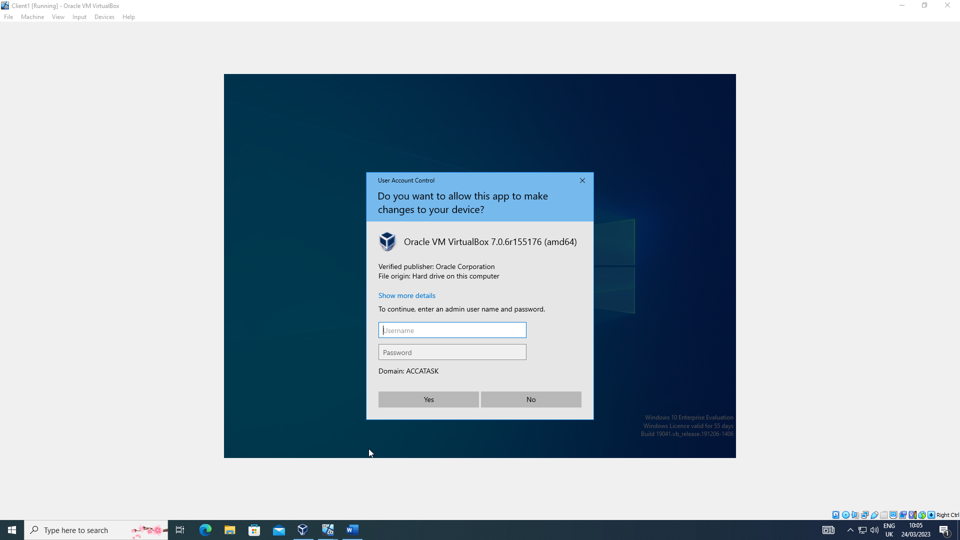
And the new user now requires admin privileges to install software on Client 1.

Enforcing Password Policy in the ‘accatask.msft’ domain
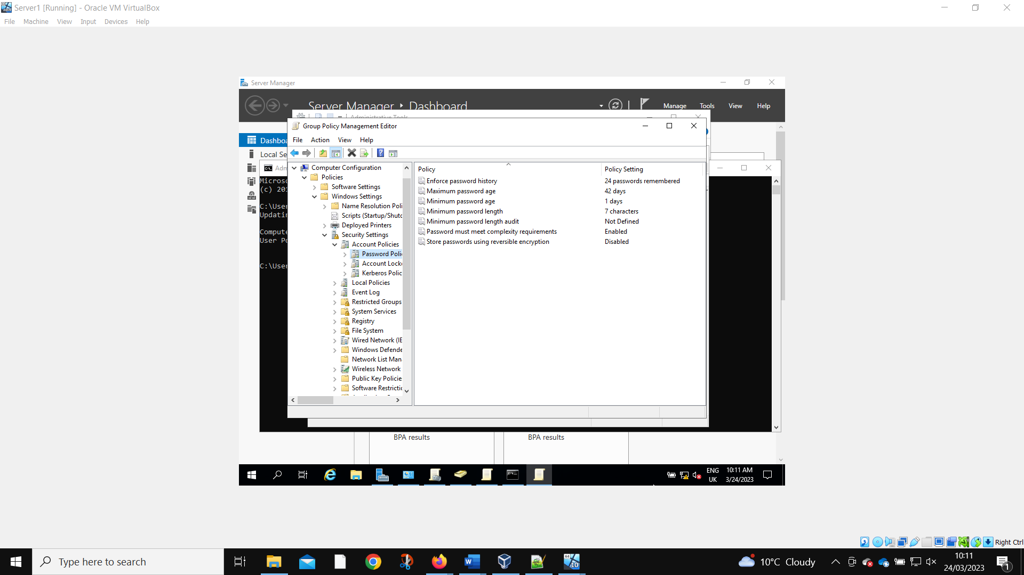
The default password polices.
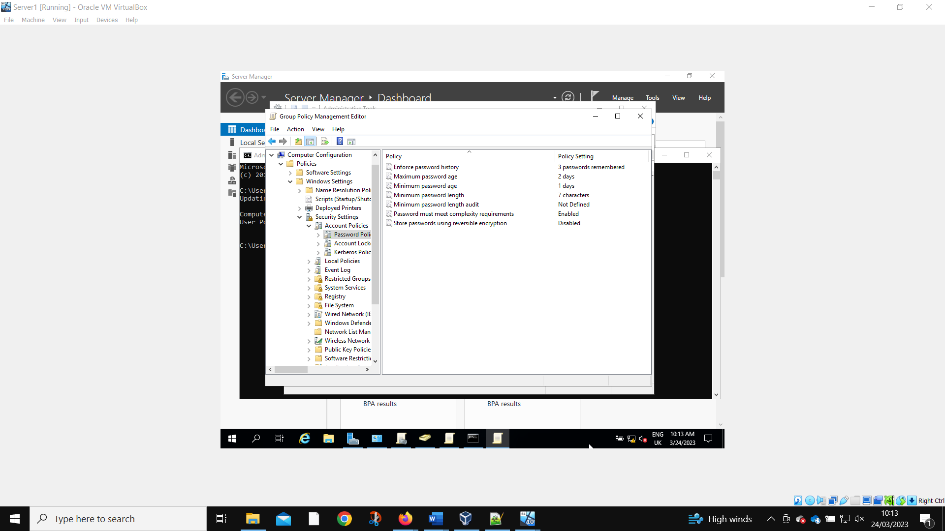Are changed to reflect the requirements.
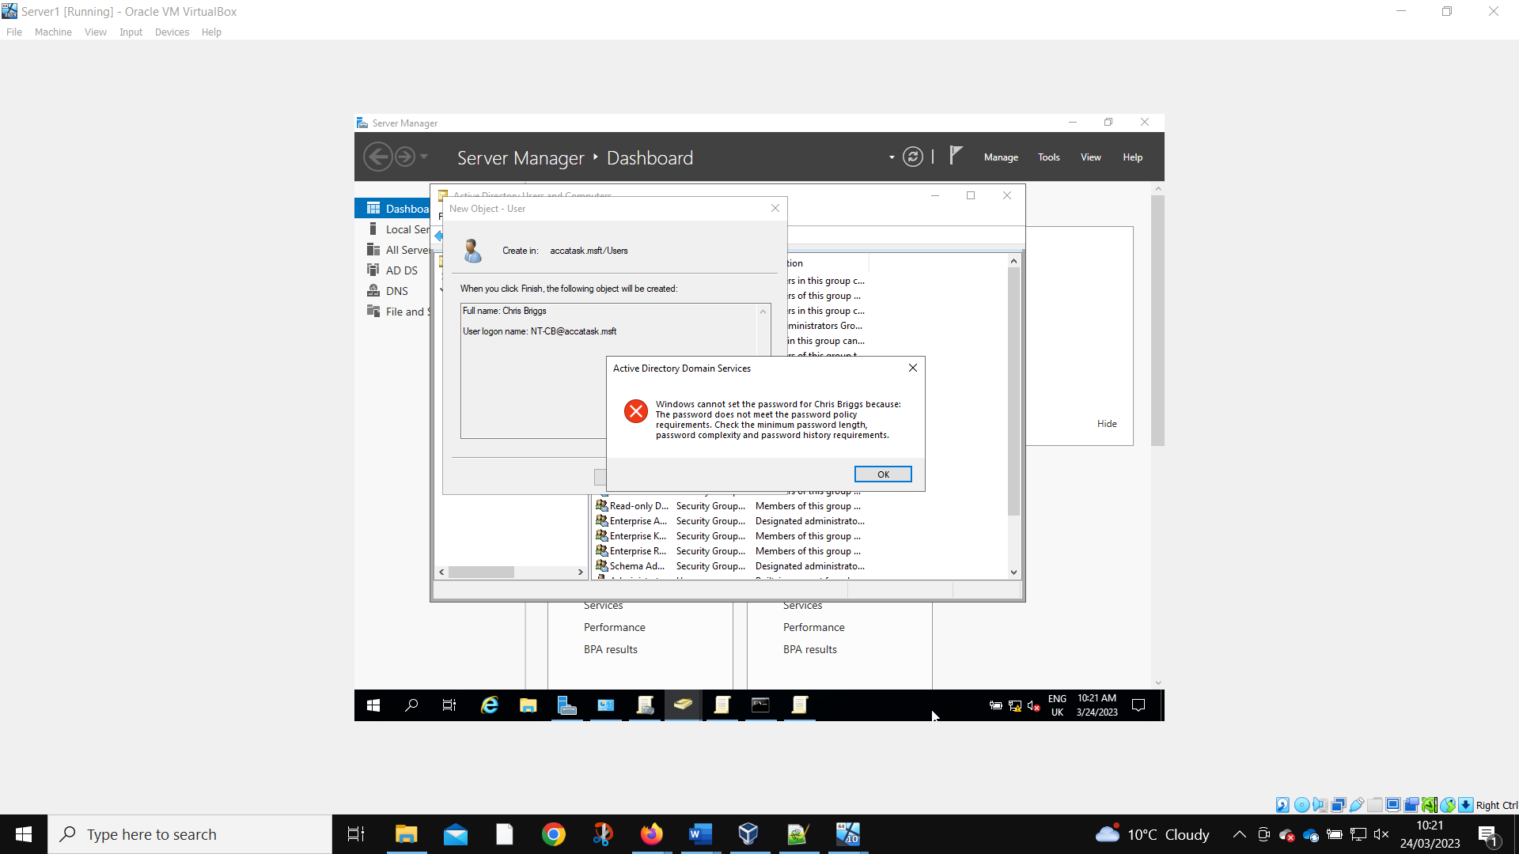
When a new user is created, they are prevented from using a password that does not meet the requirements.

Task 2: Routing and Packet Filtering Within Core TCP/IP Services and Critical Failover/Redundancy Practices

Utilizing ARP and Routing Tables
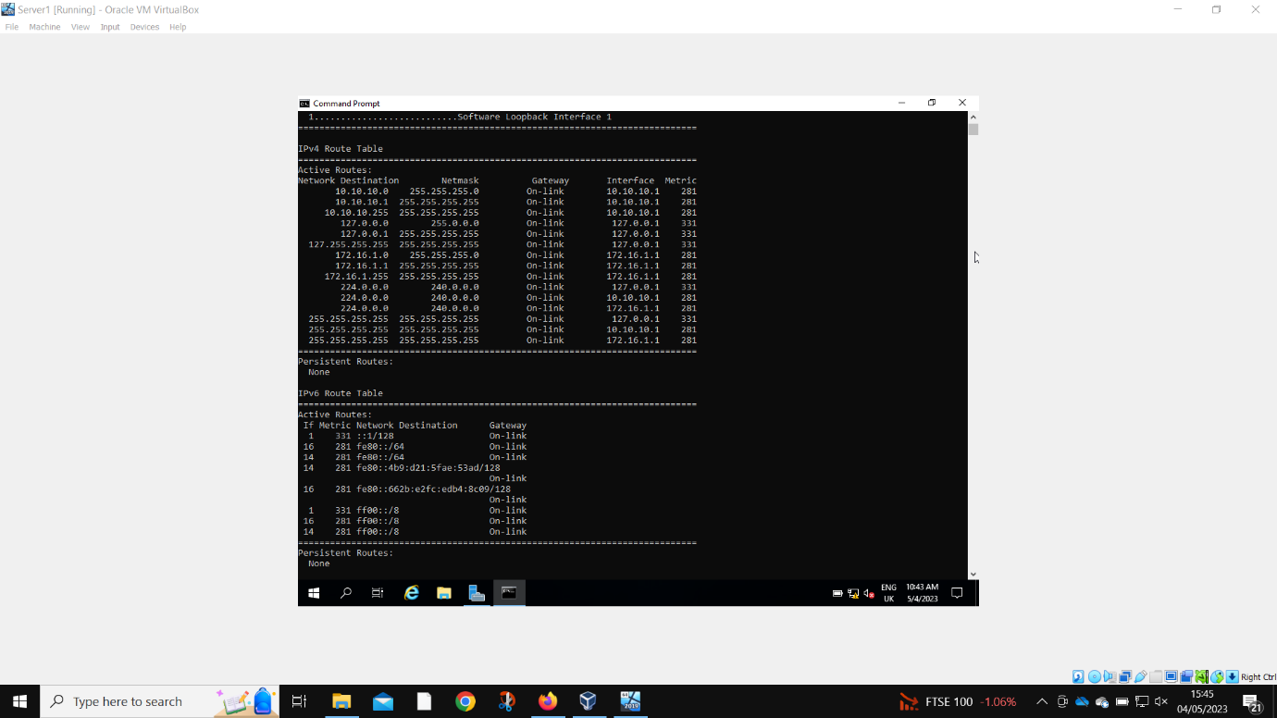
Running the route print command to find all the networks that are connected to Server 1.

Deploy Core Services (FTP Server)
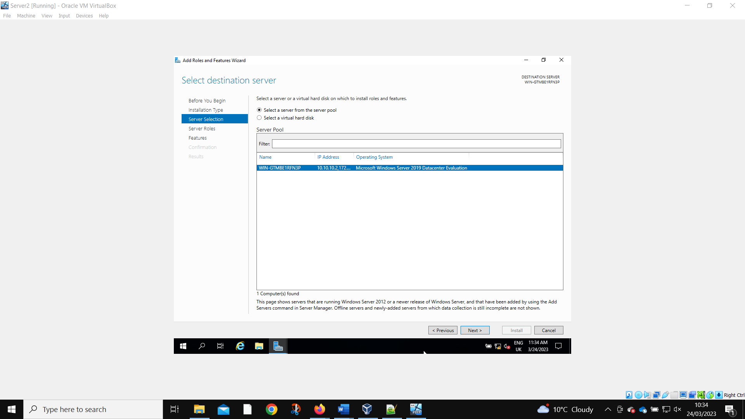
Installing the FTP server to the correct location.
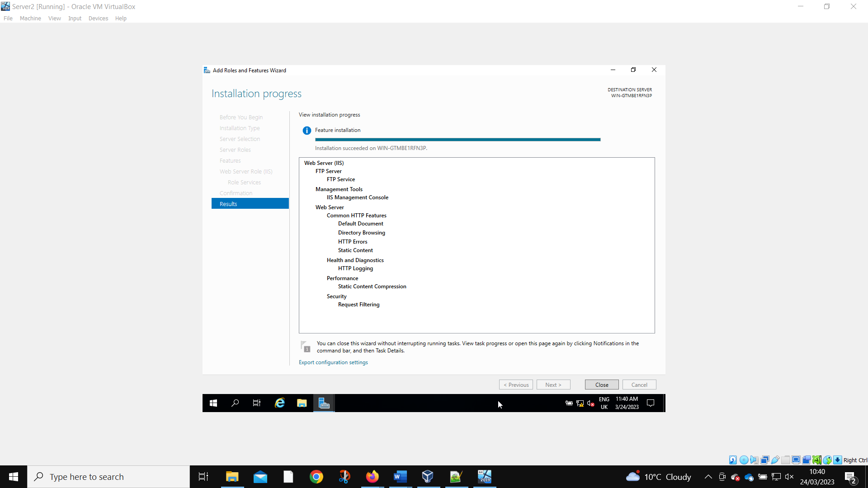
Confirmation of correct installation.
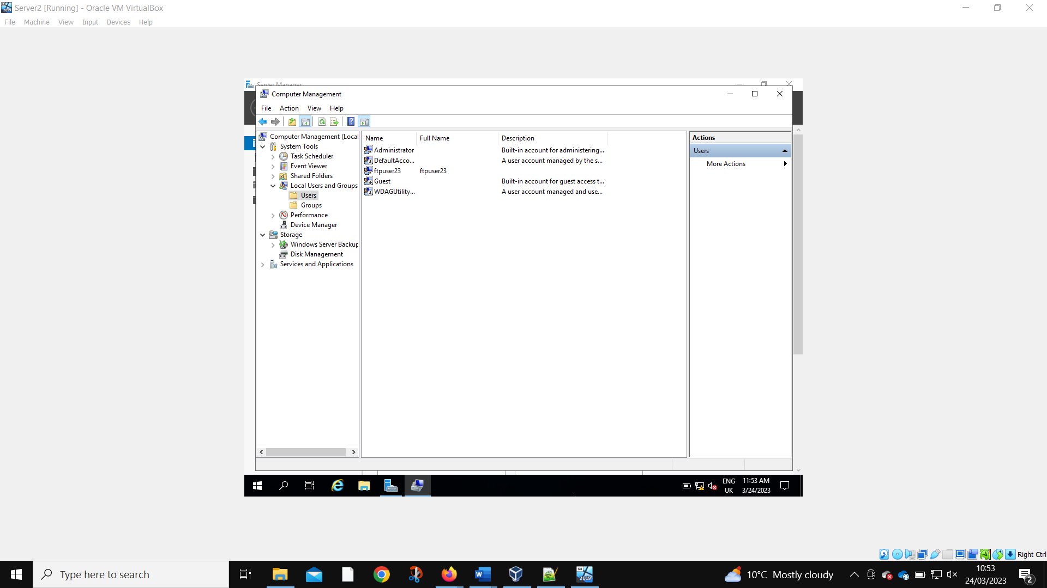
The local test account ftpuser23 is created to test the functionality of the FTP server.
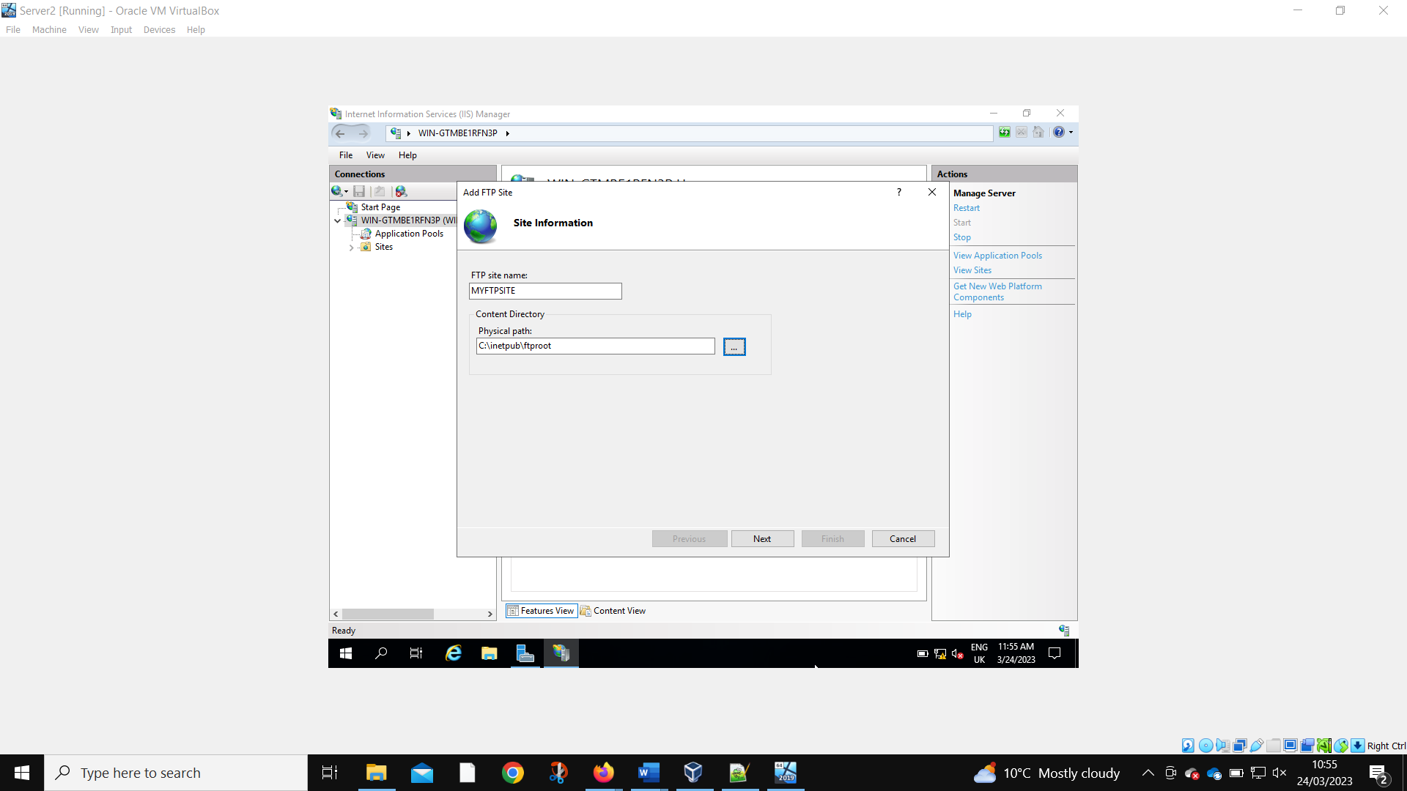
The physical path for the FTP site is set.
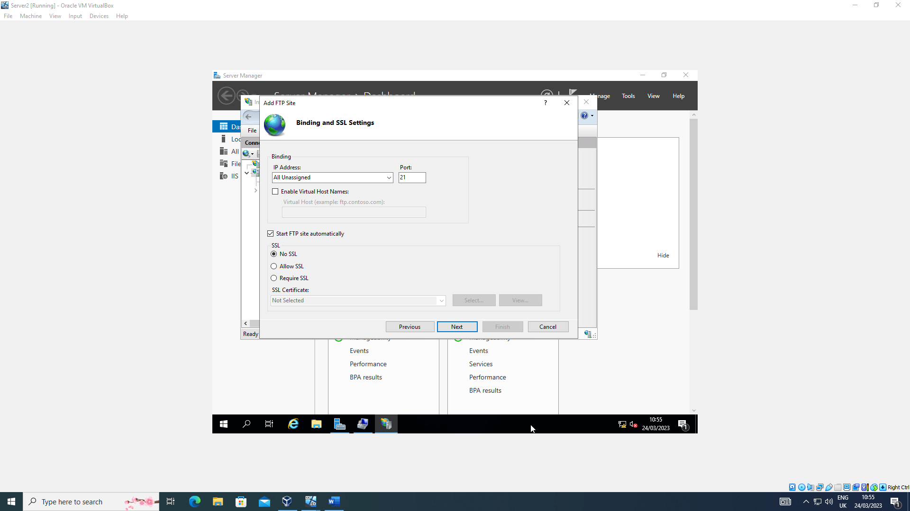
Then the port number is bound along with disabling SSL.
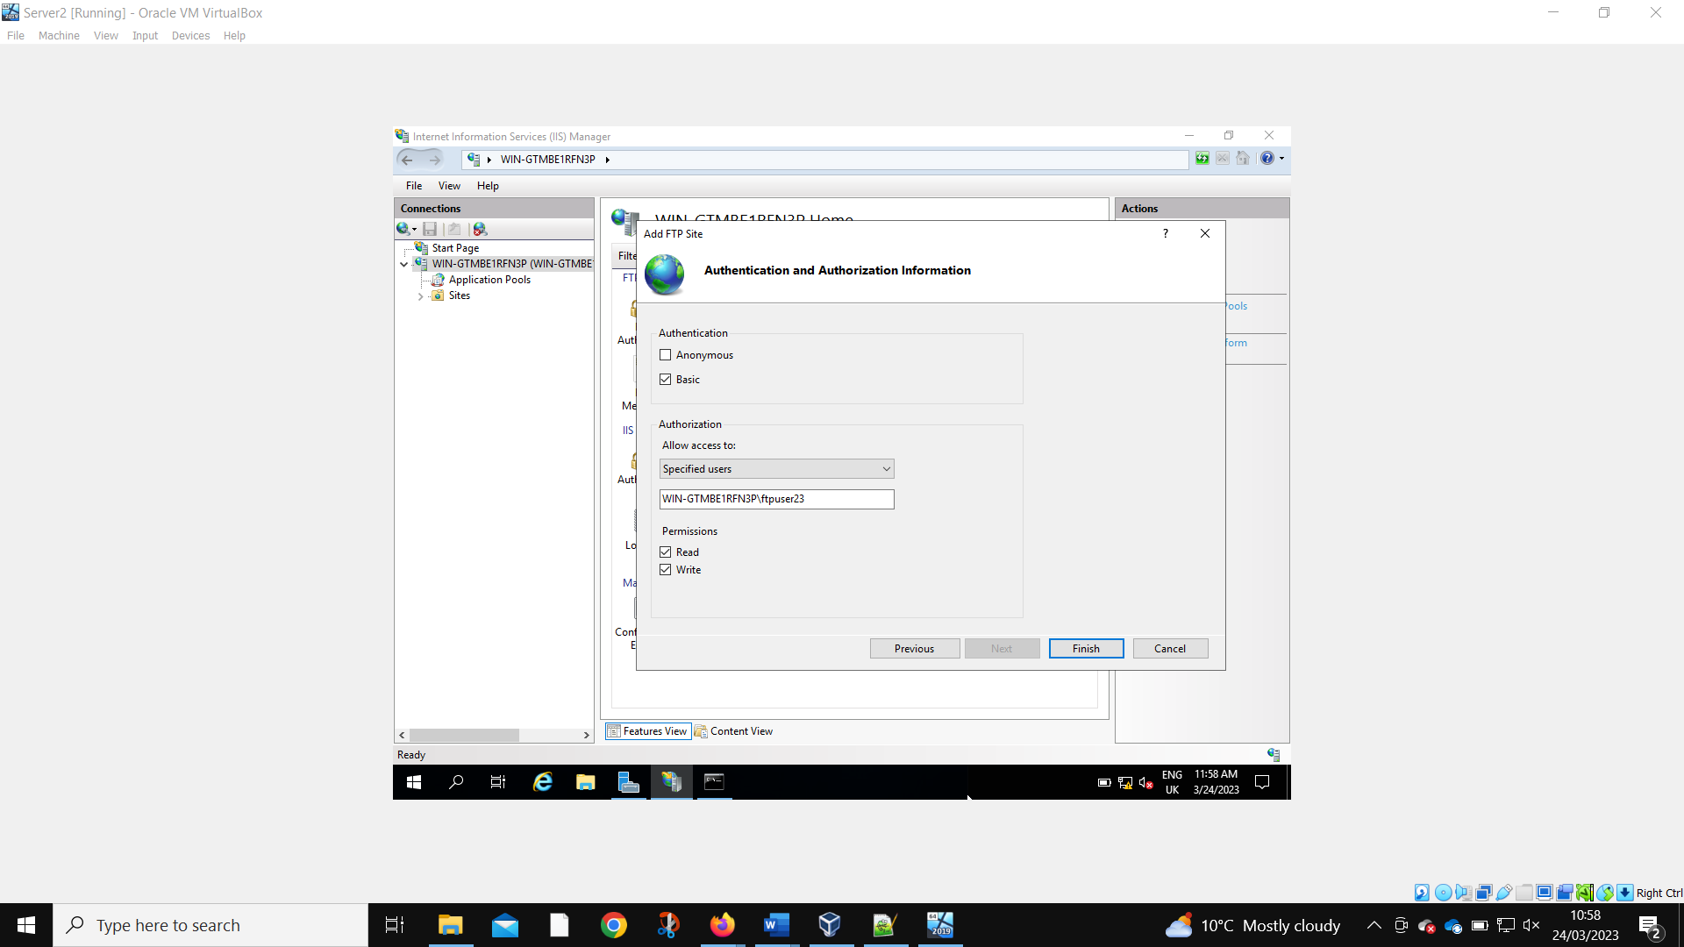
The Read Write privileges are set.
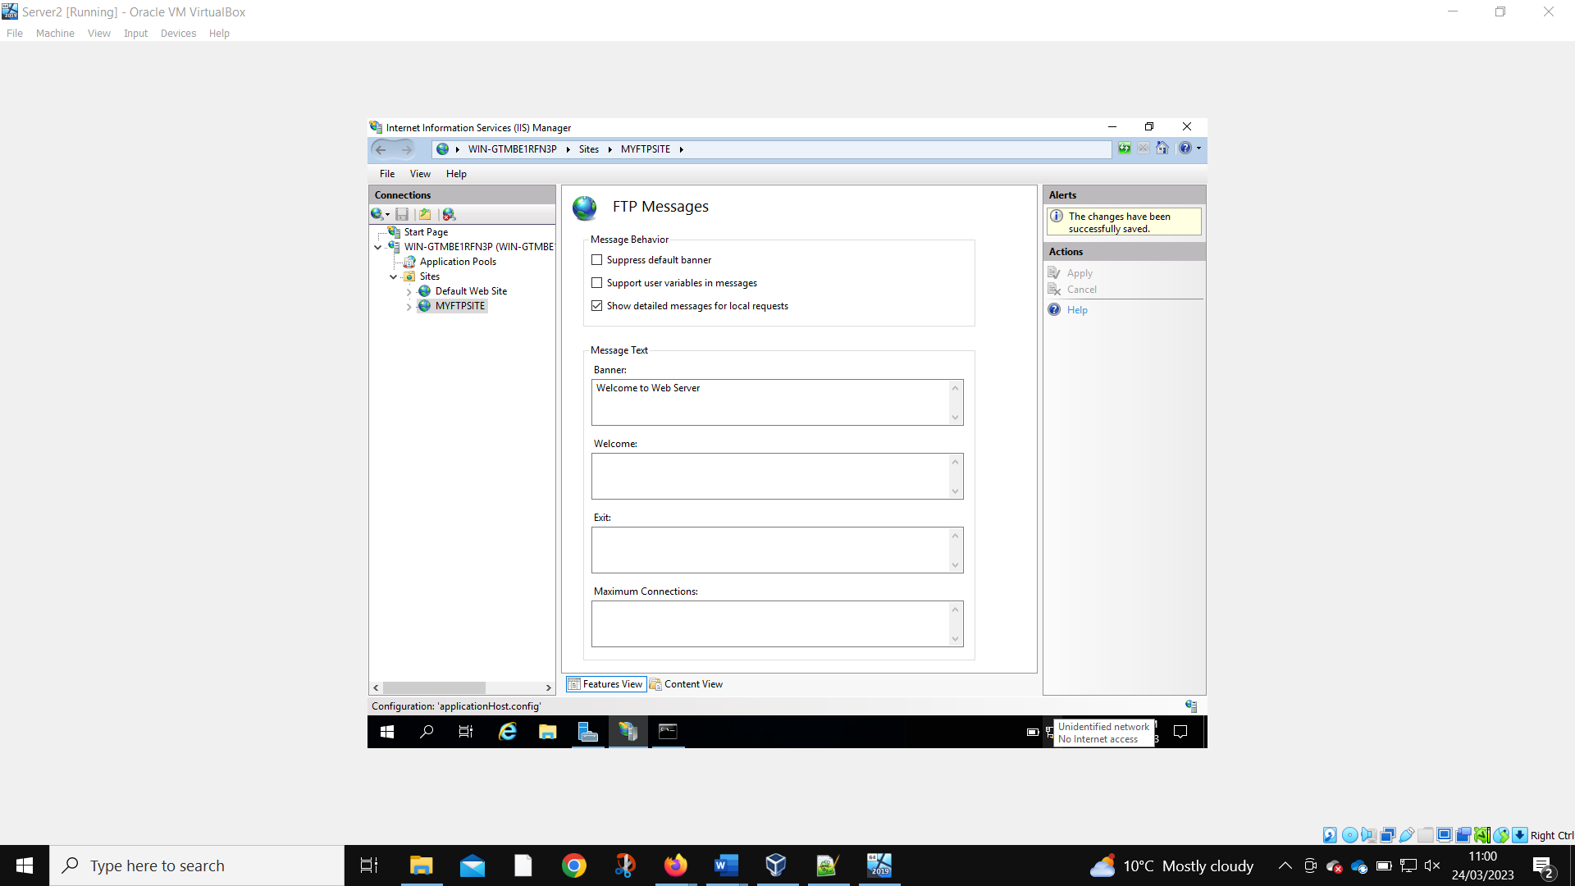
Confirmation of the FTP site being created.
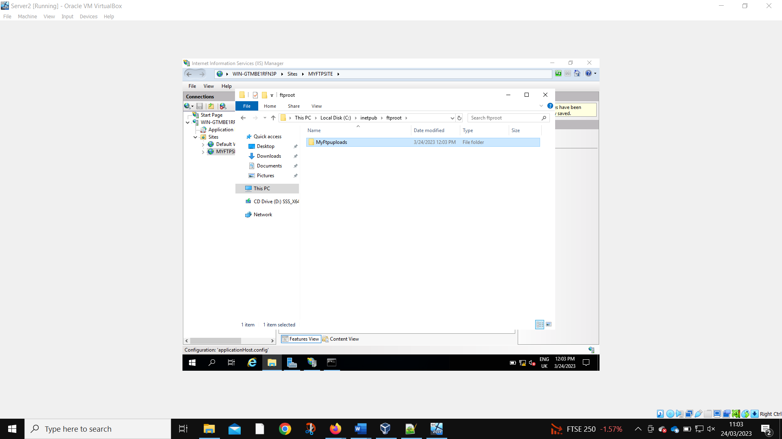
A folder is created to test sharing.
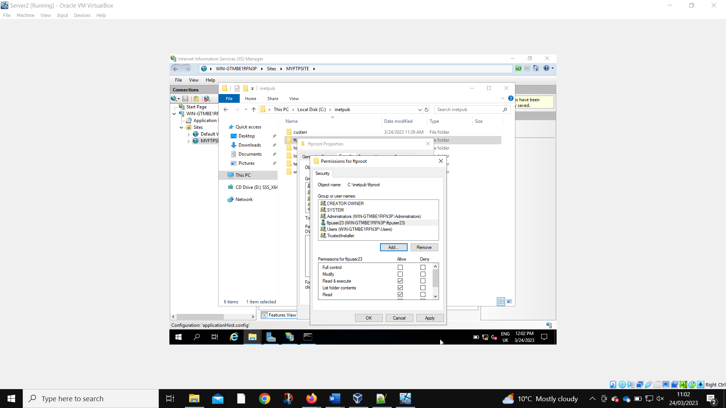
The folder permissions are being set to allow the local user to access the folder.

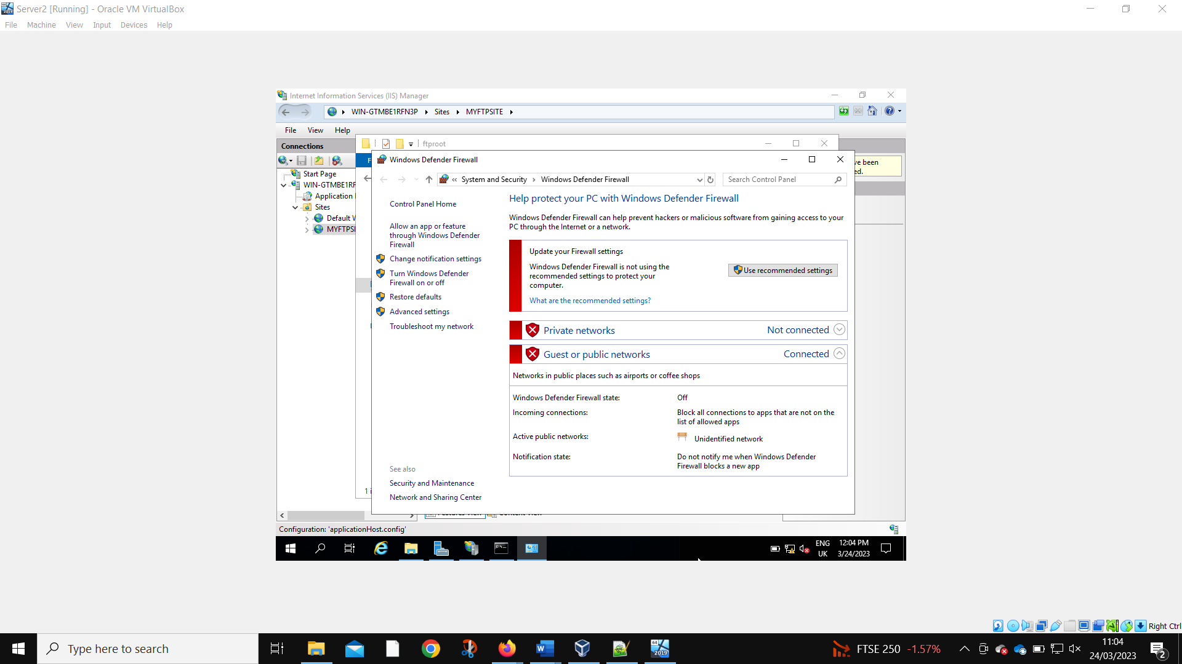
All the firewalls on Server 2 must be disabled for the FTP to work properly.
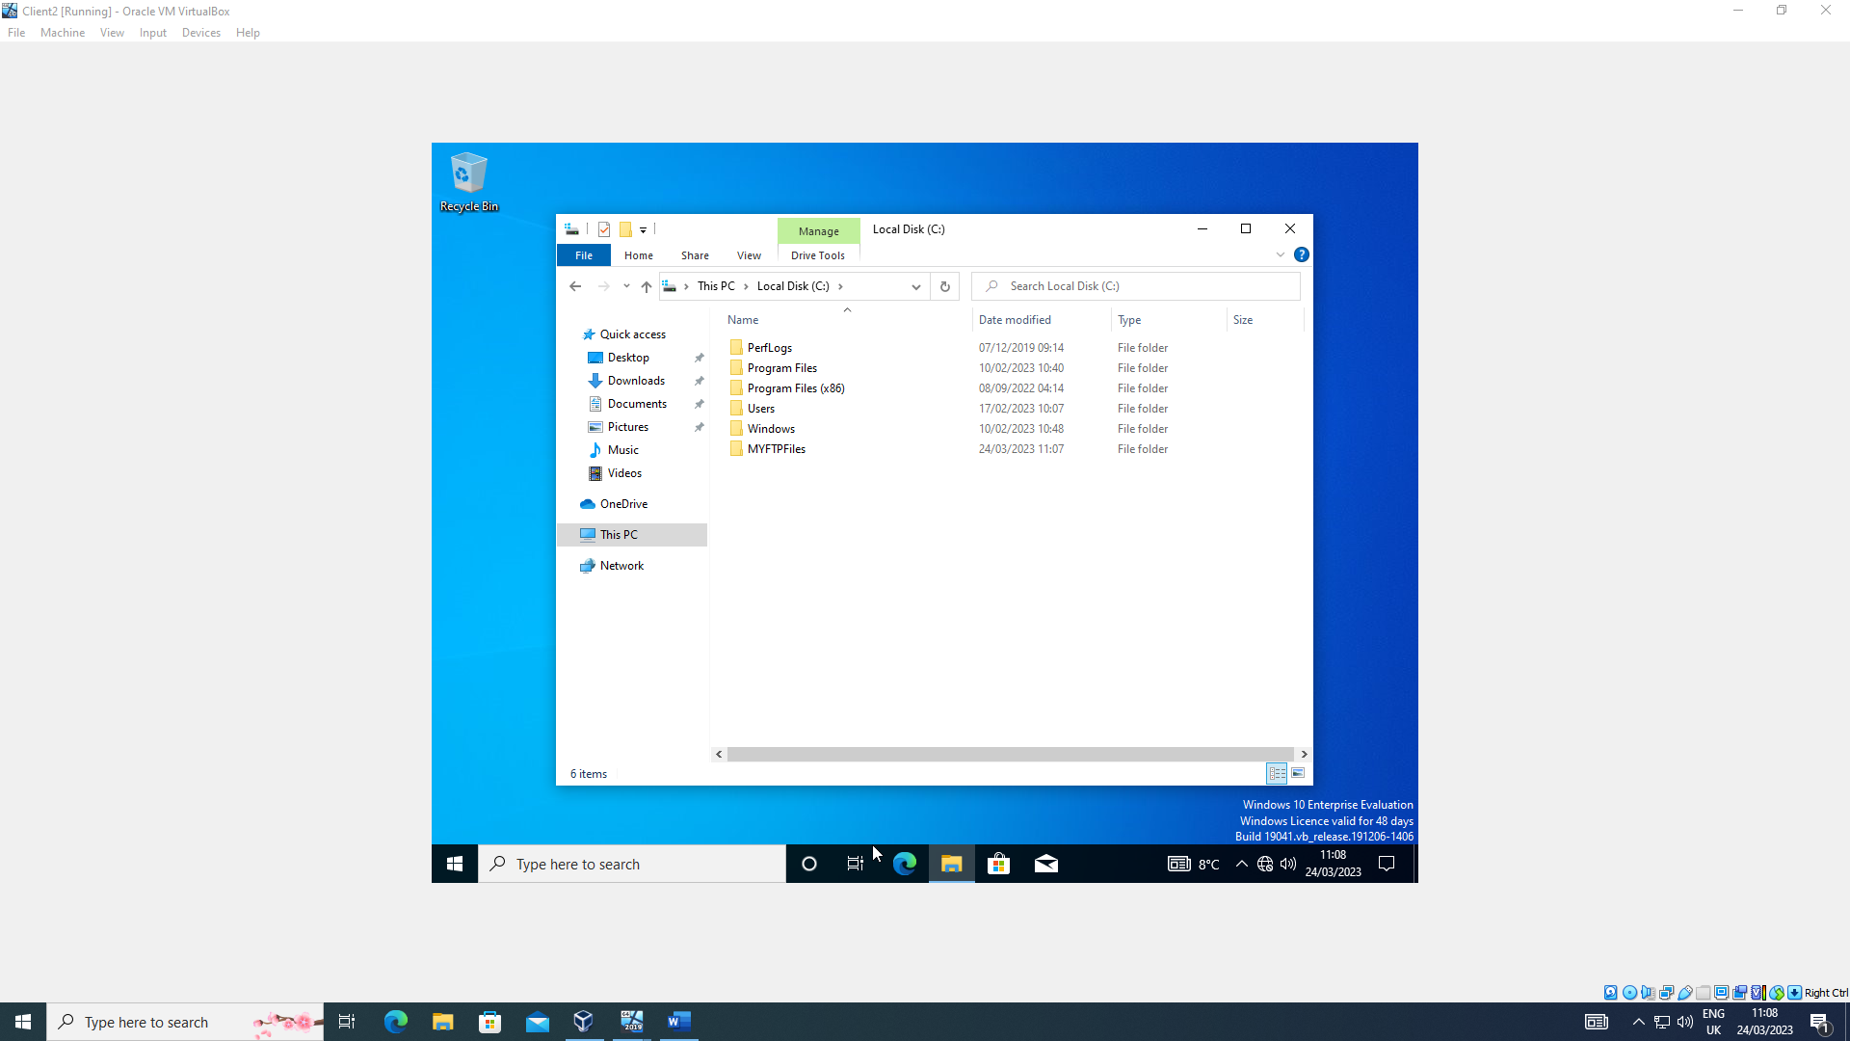
The administrator on Client 2 creates a folder to link to the FTP folder.
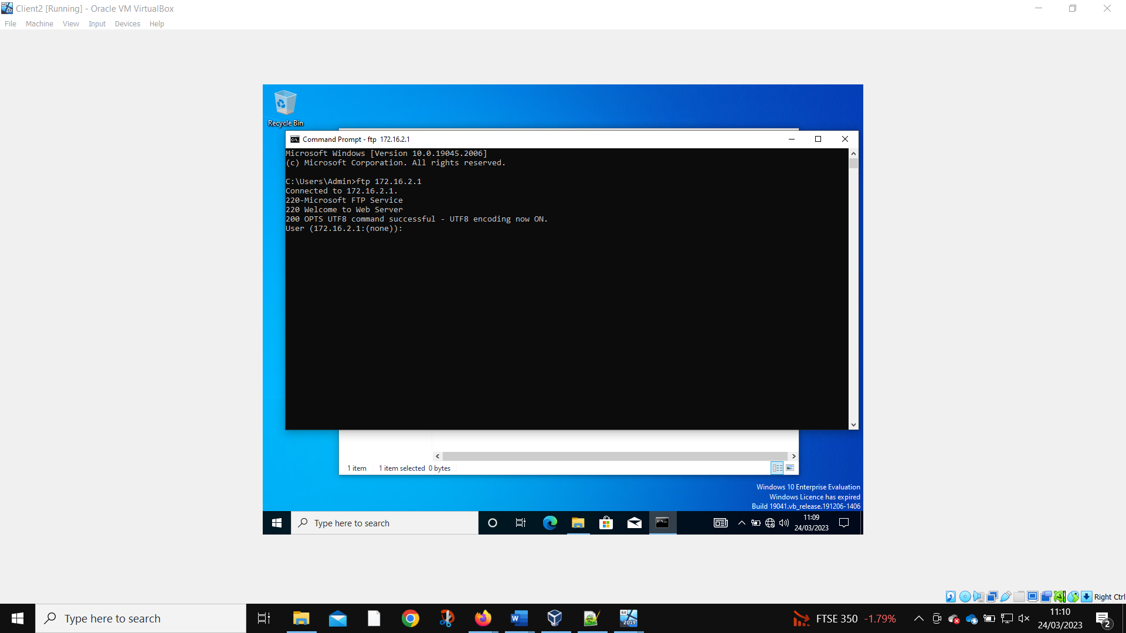
Client 2 can access the FTP server.
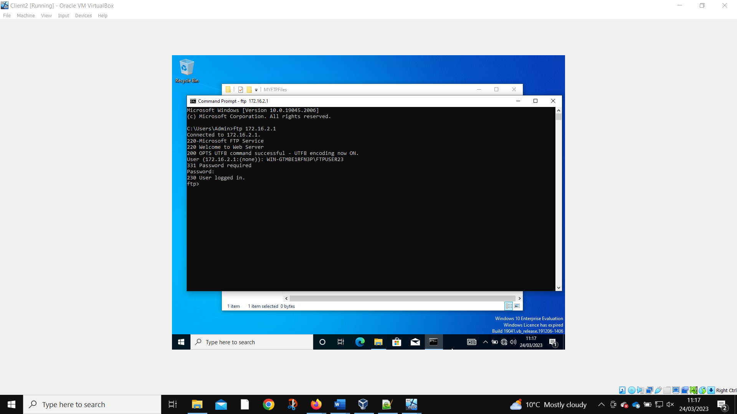
The admin can log into the local FTP account on Client 2.

Installing and Configuring the Routing and Remote Access Service
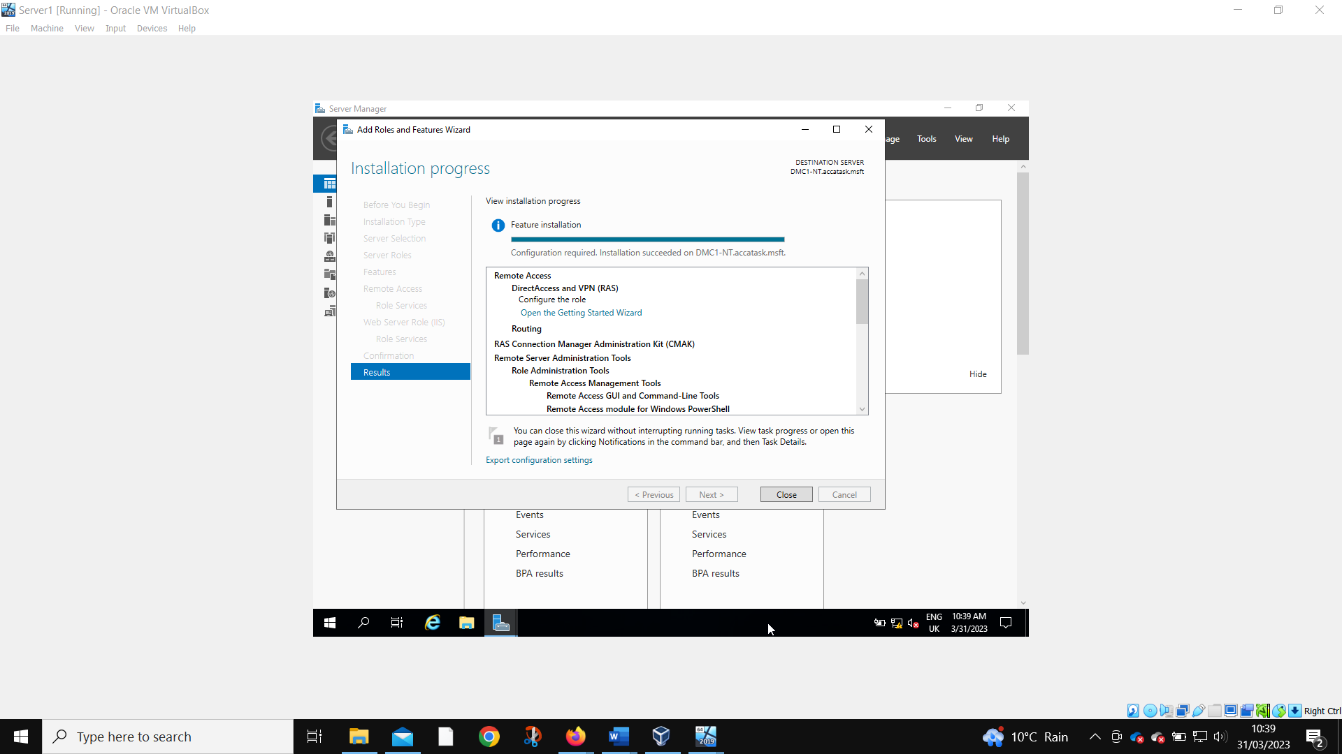
The routing and remote access is installed on Server 1.
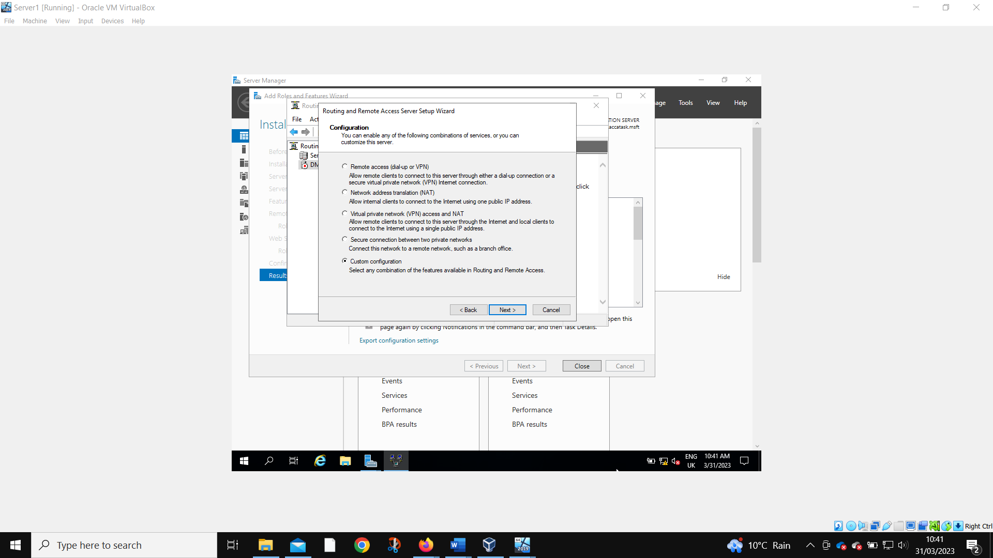
A custom configuration is needed.
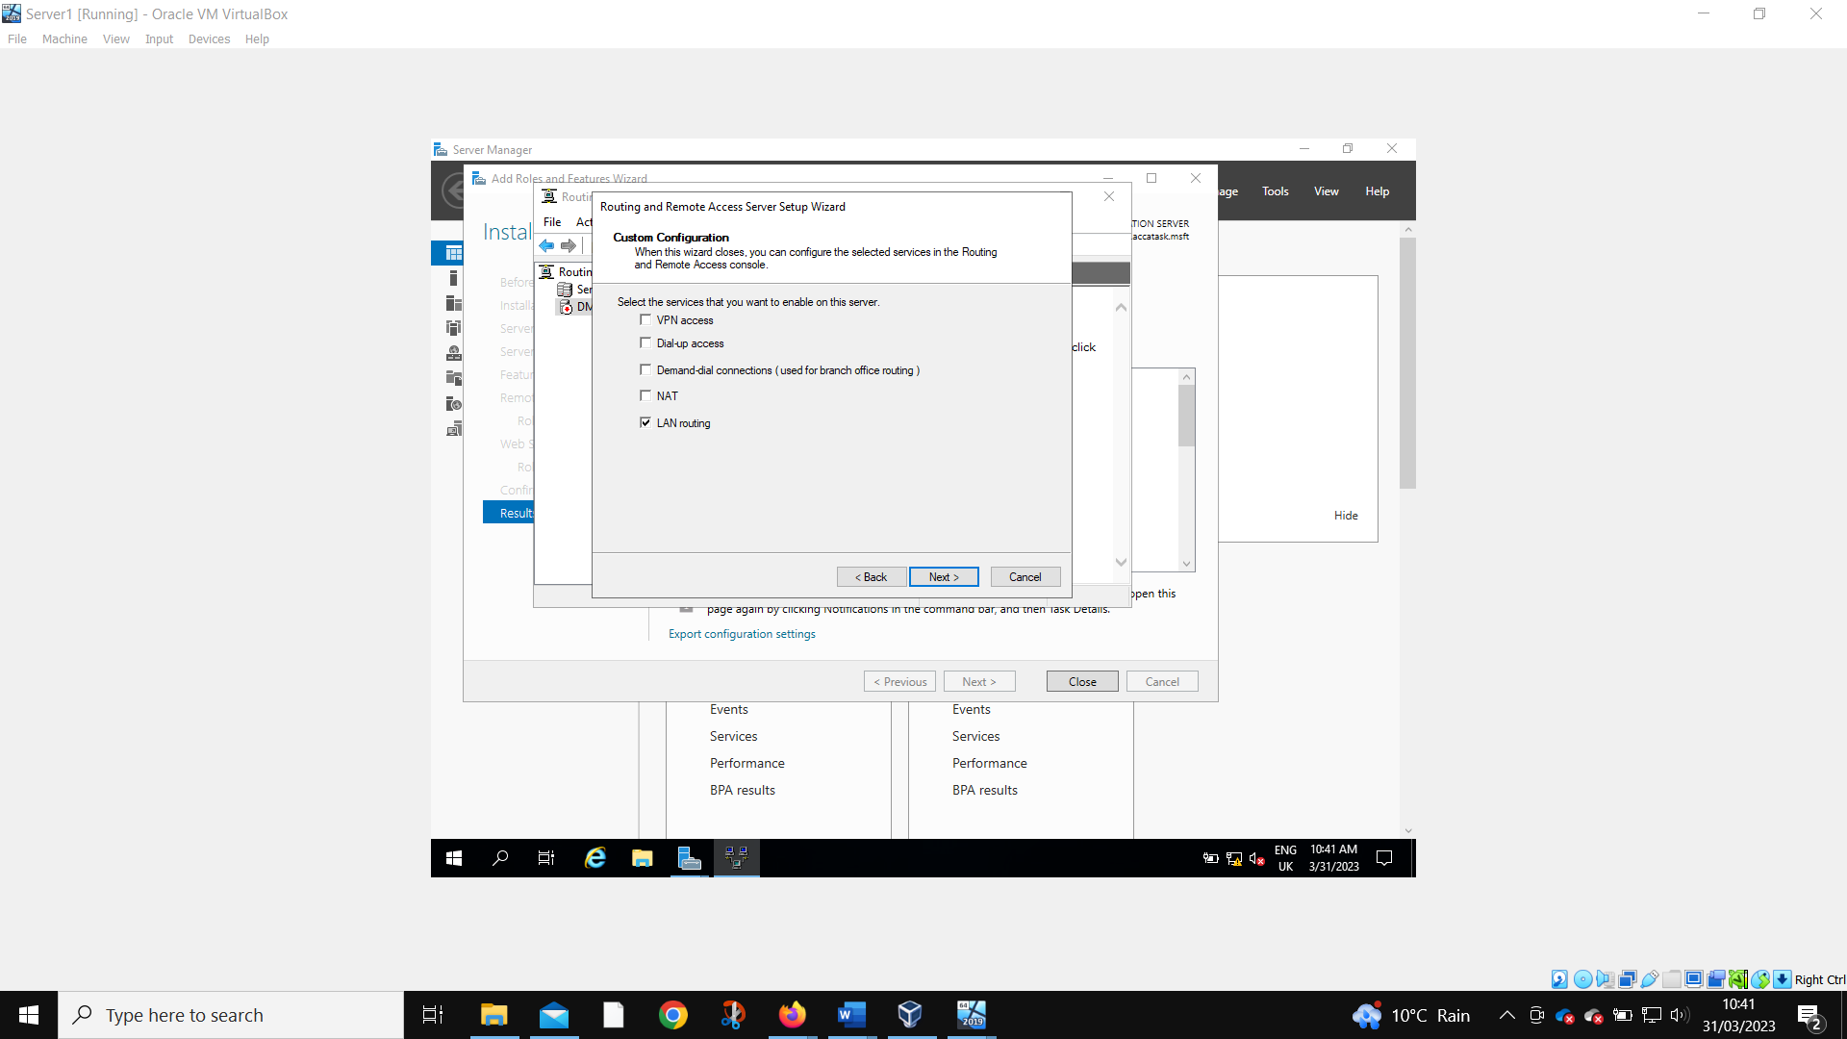
The configuration is set for LAN routing.

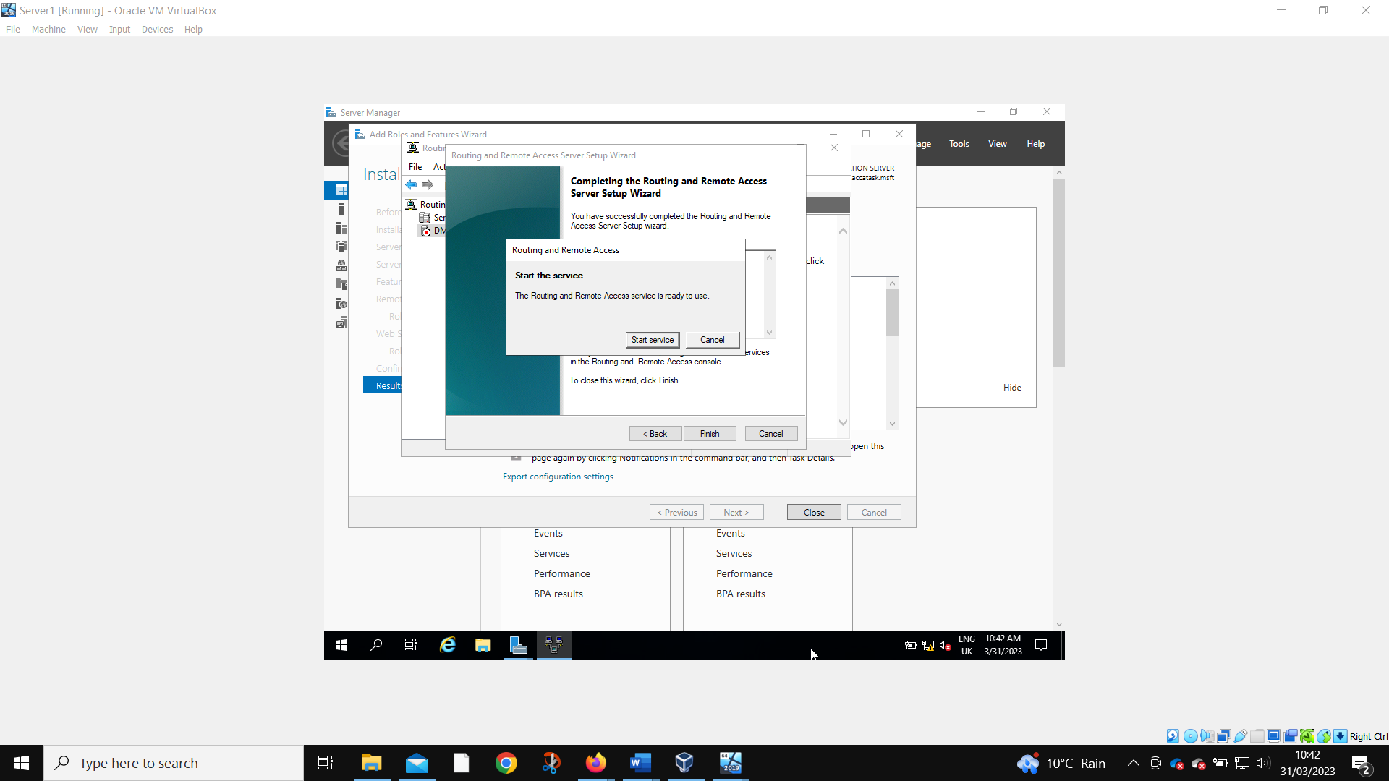
When the service has been successfully installed, it is started.
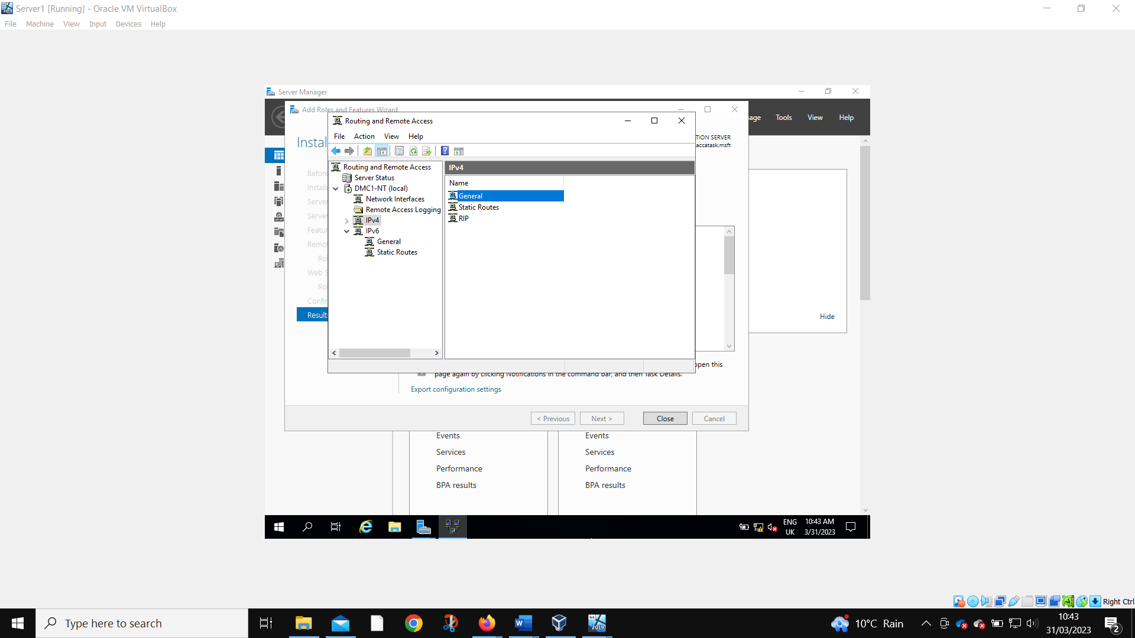
The RIP V2 is selected.
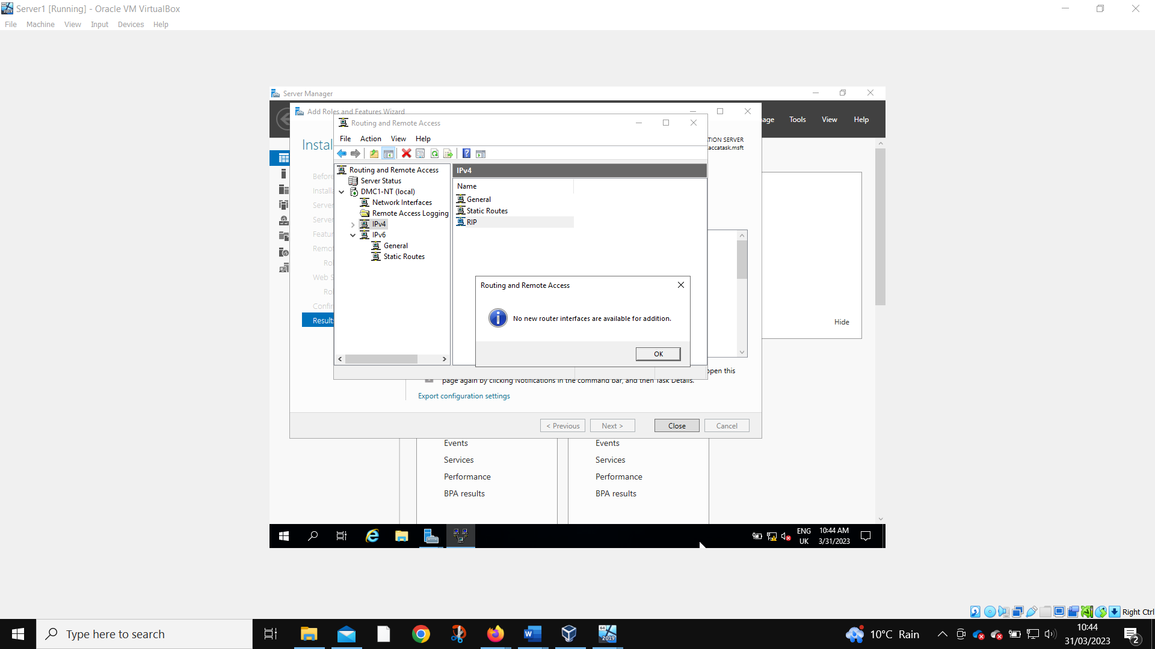
All available network interfaces – PublicNet and PrivateNet1 – are added to the routing protocol.
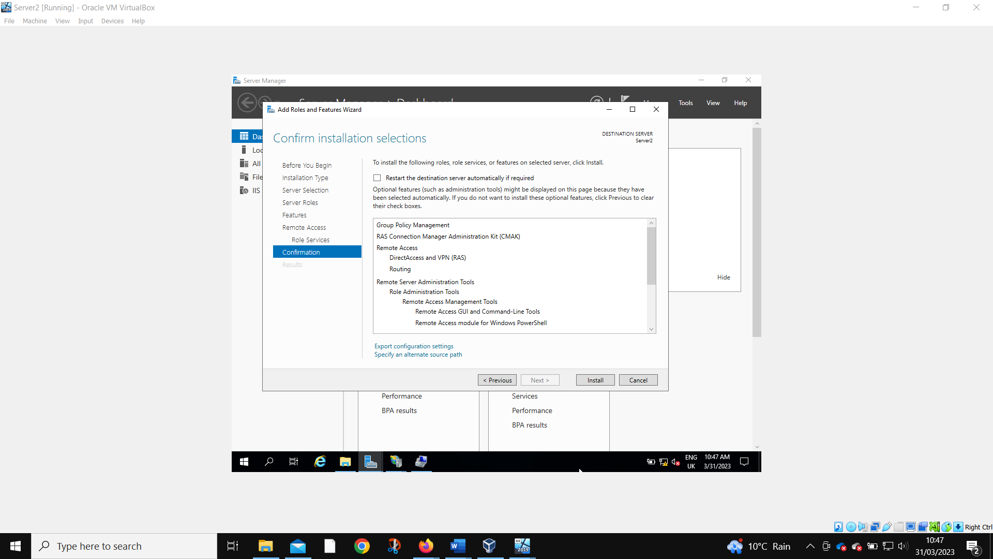
The steps are repeated on Server 2
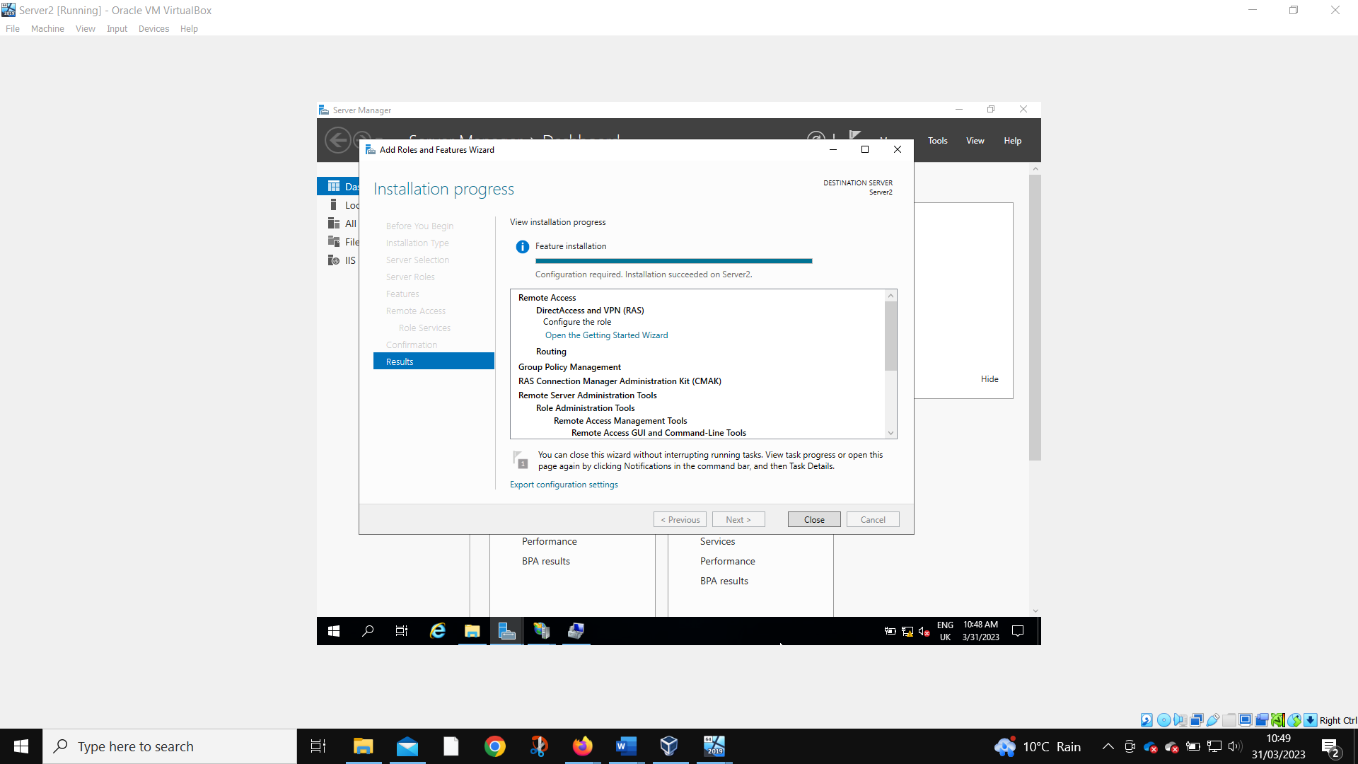
Installation confirmed.
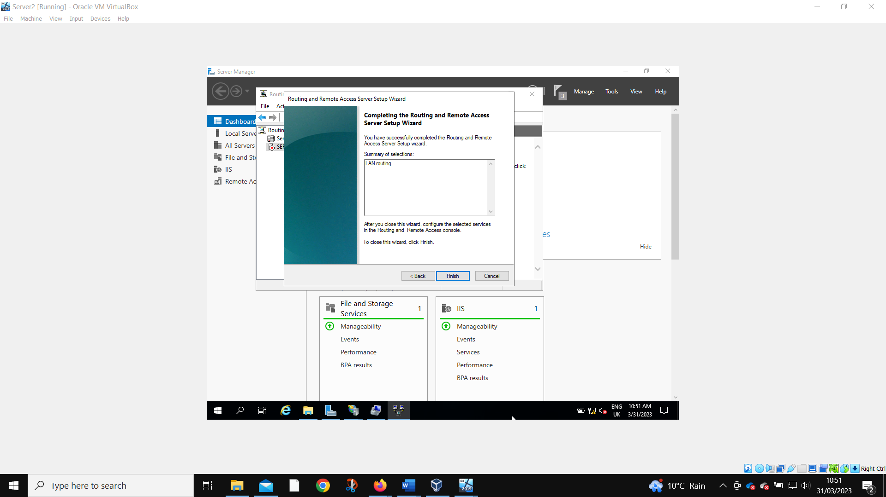
Installation successful.
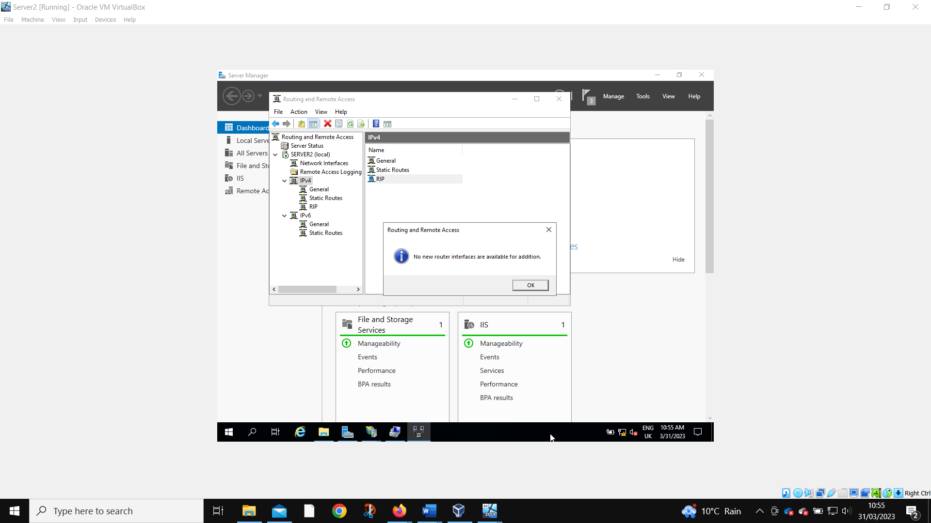
All network interfaces were added.
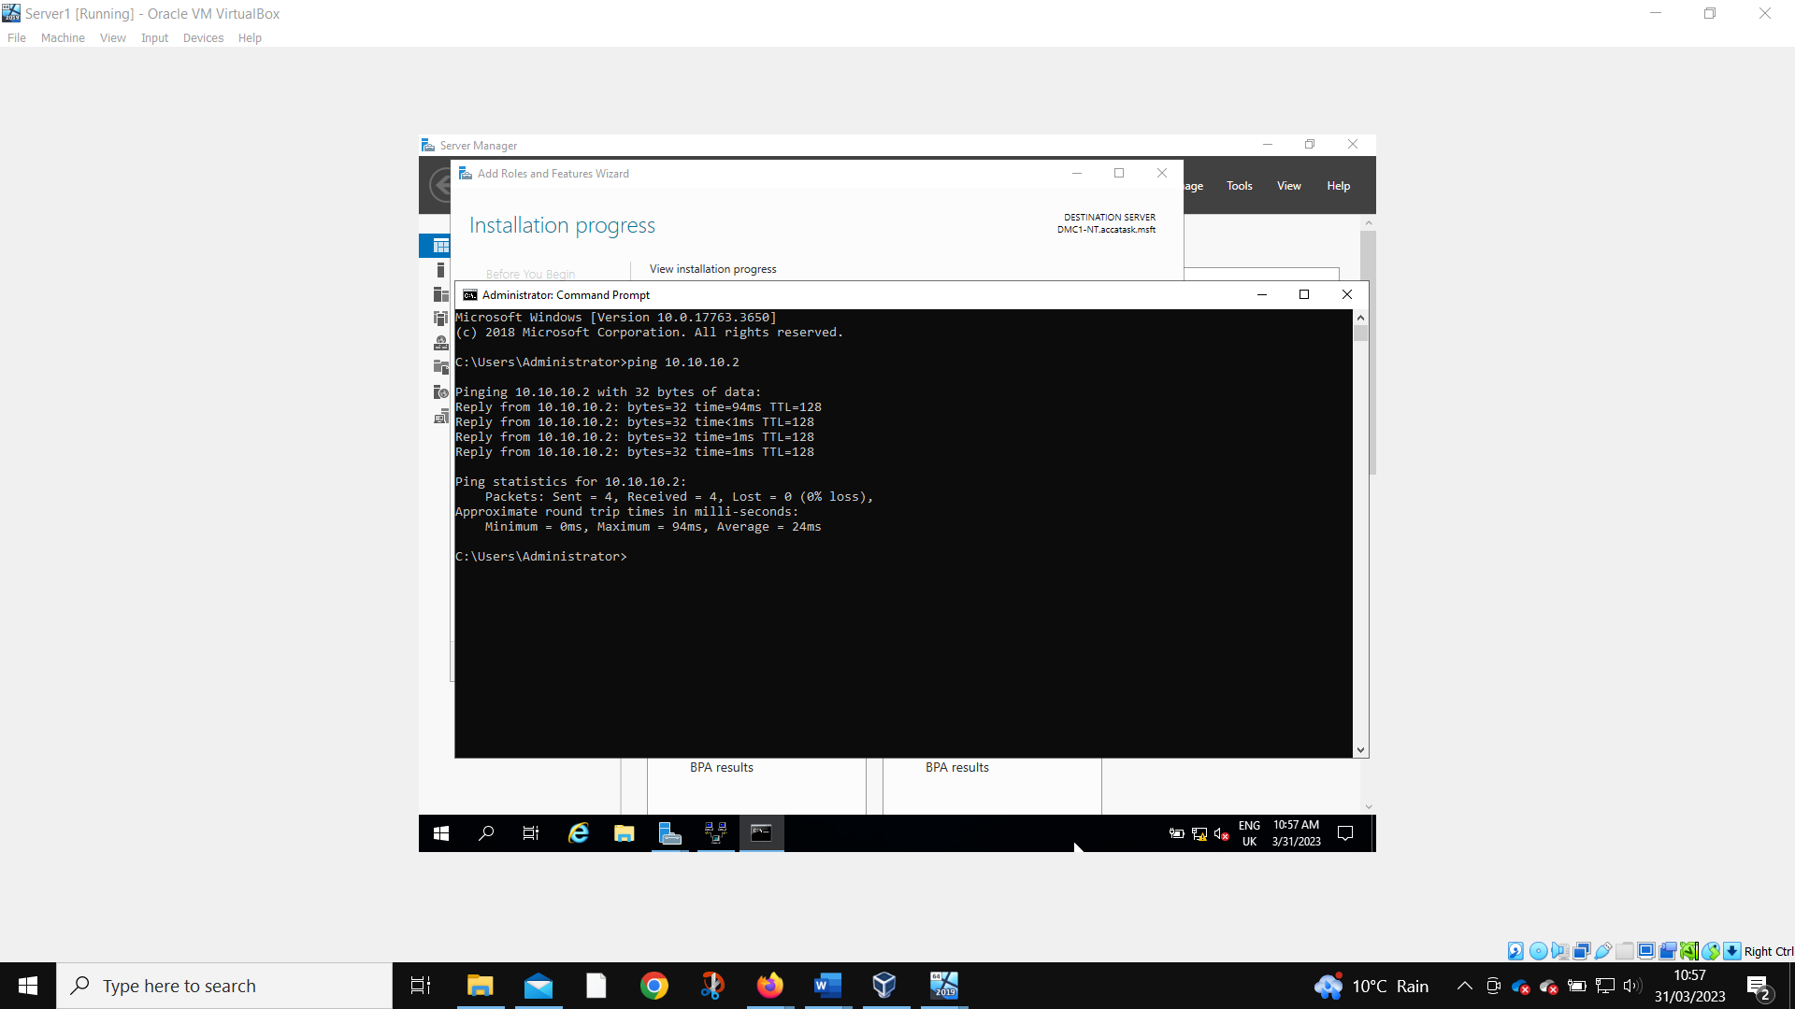
Server 1 is still able to ping the PublicNet IP of Server 2. This means that the servers are connected correctly.
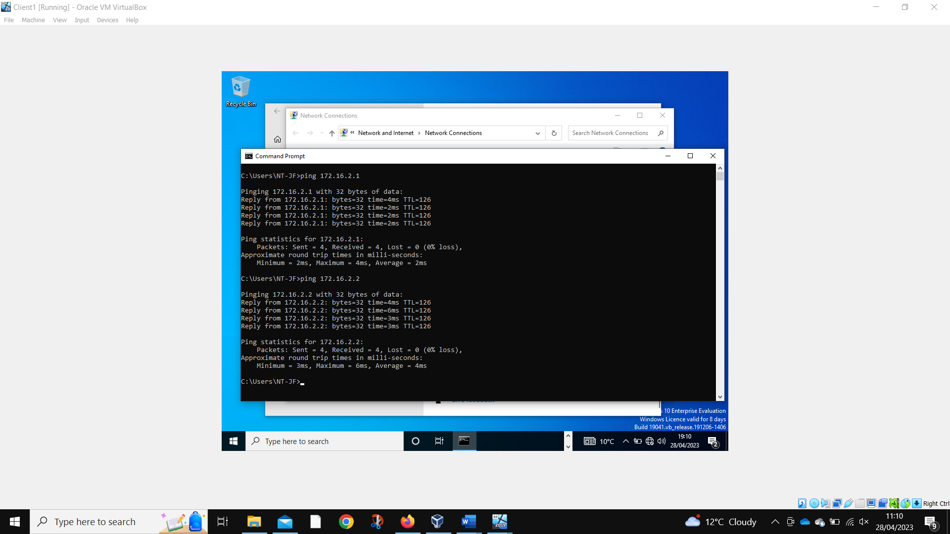
Client 1 can ping both Server 2 and Client 2.
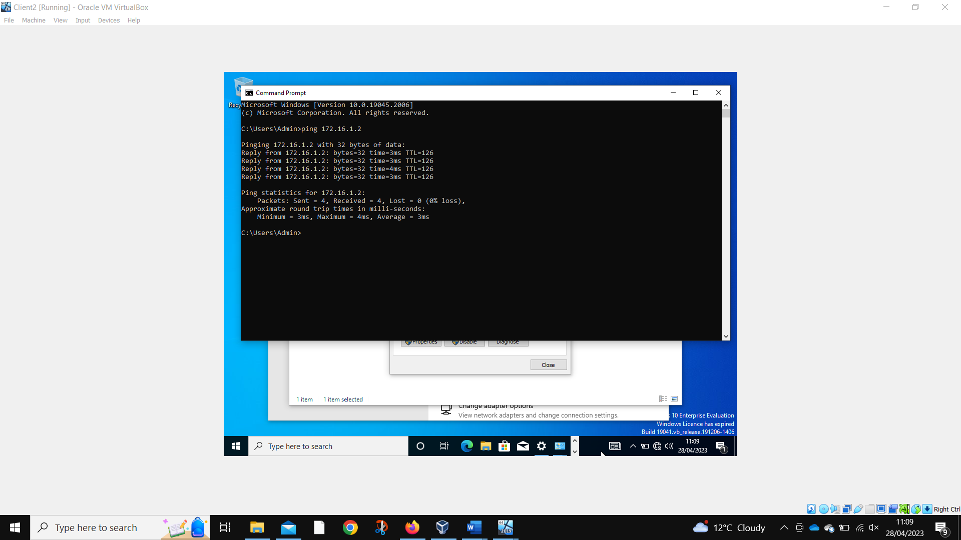
Client 2 can ping Client 1.

IP Packet Filtering
Stopping ‘anyone’ in PrivateNet1 from Pinging the Router Firewall Service
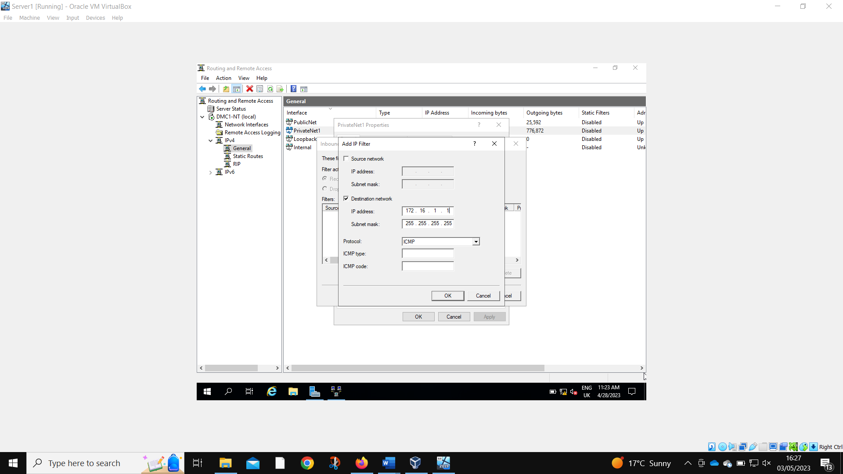
Everyone in PrivateNet 1 is prevented from pinging the router firewall.
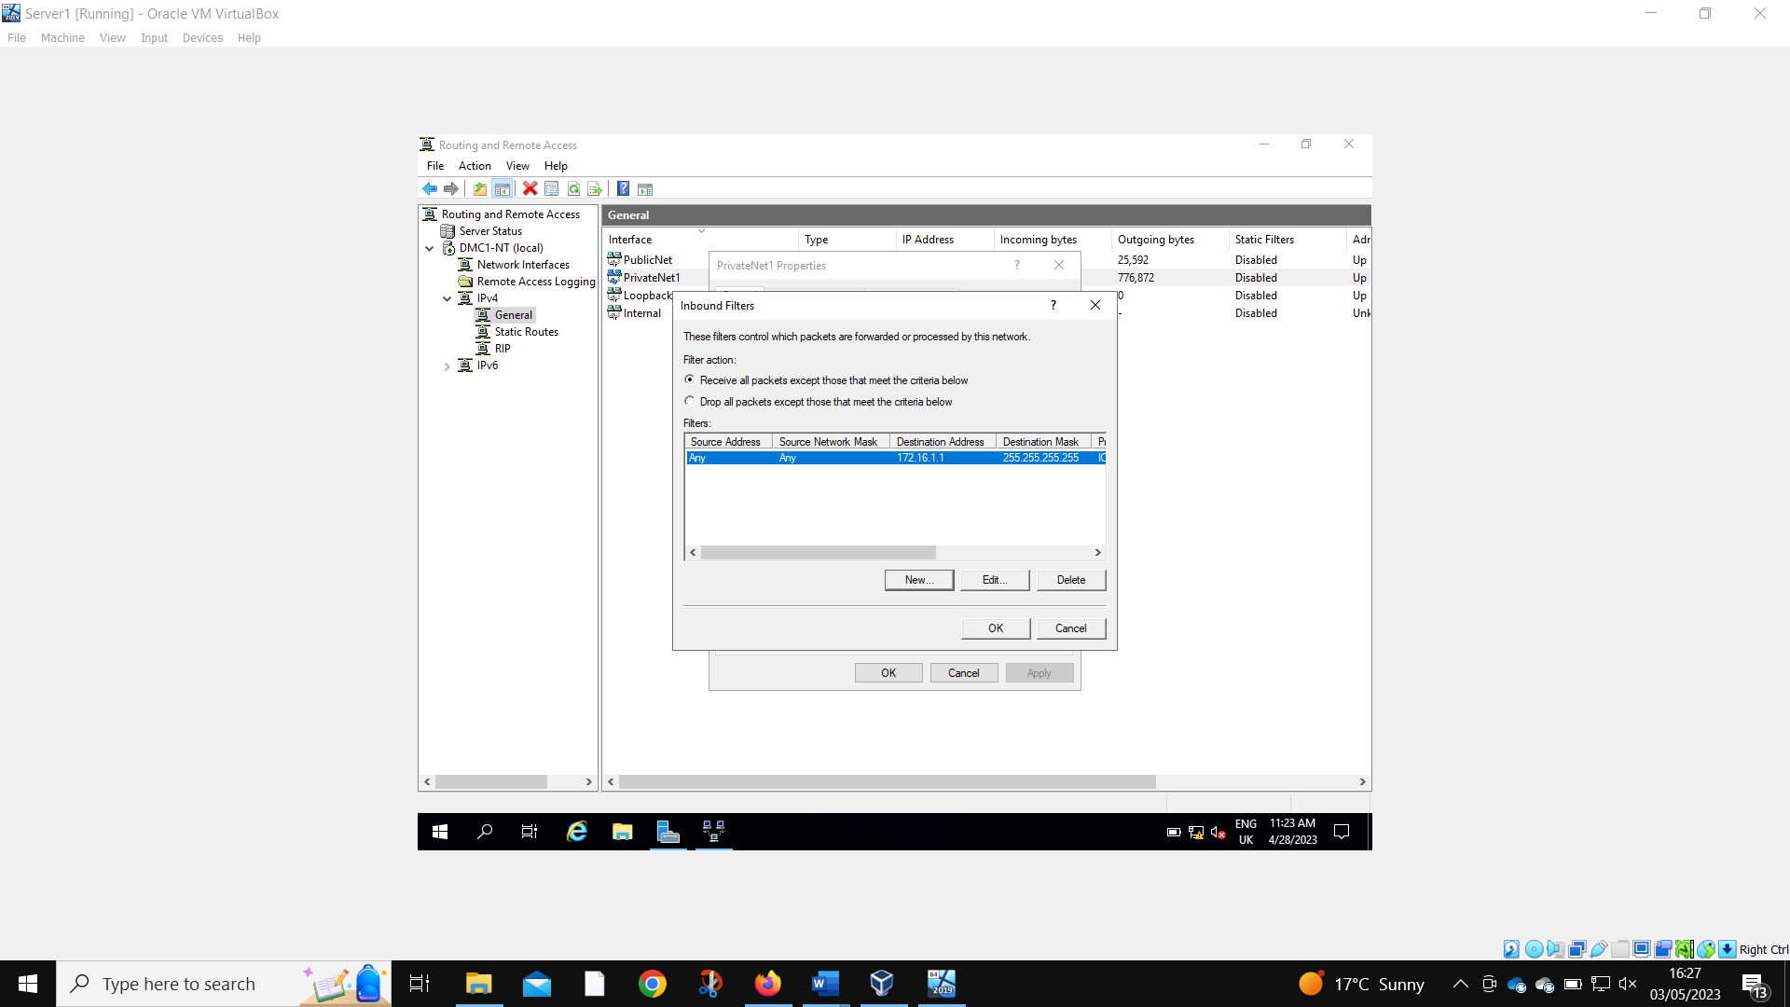
PrivateNet1 is set to receive all packets expect those that meet the criteria below. This allows other functions to continue – only pinging the server is prevented.
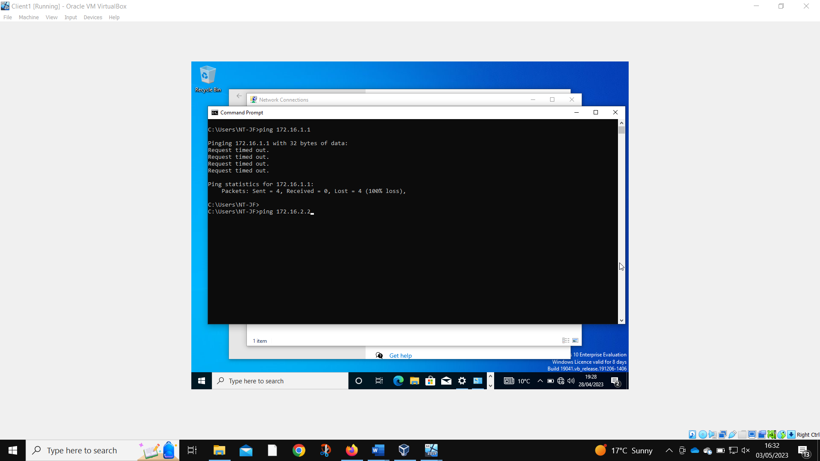
Client1 is unable to ping server.

Filter 2: Restrict Access to FTP Service running on Server2 to only hosts in PrivateNet2.
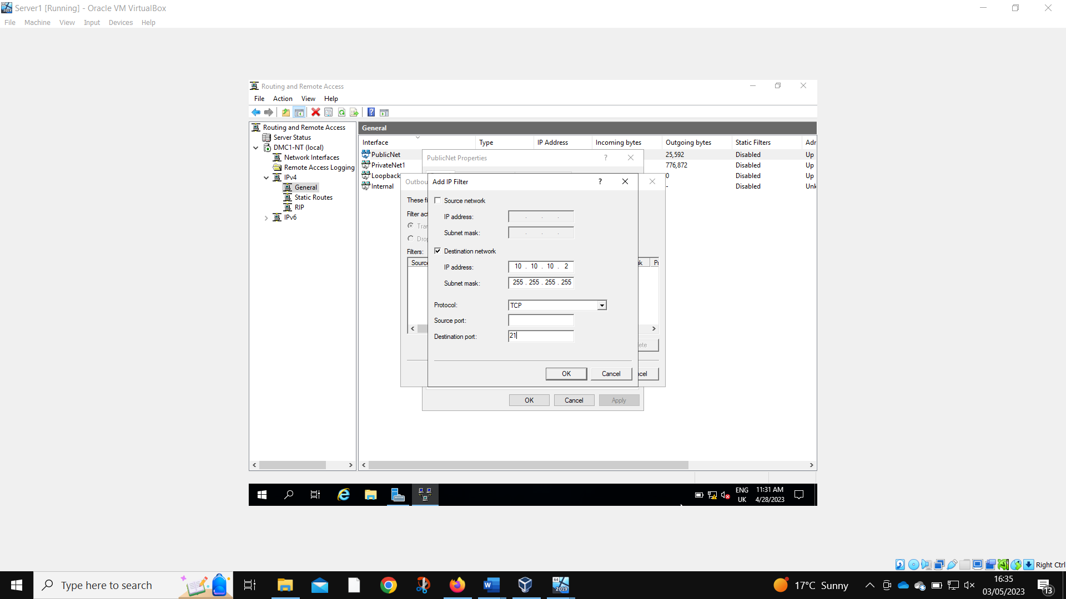
Anyone outside of PrivateNet2 is prevented from using the FTP service on Server2.
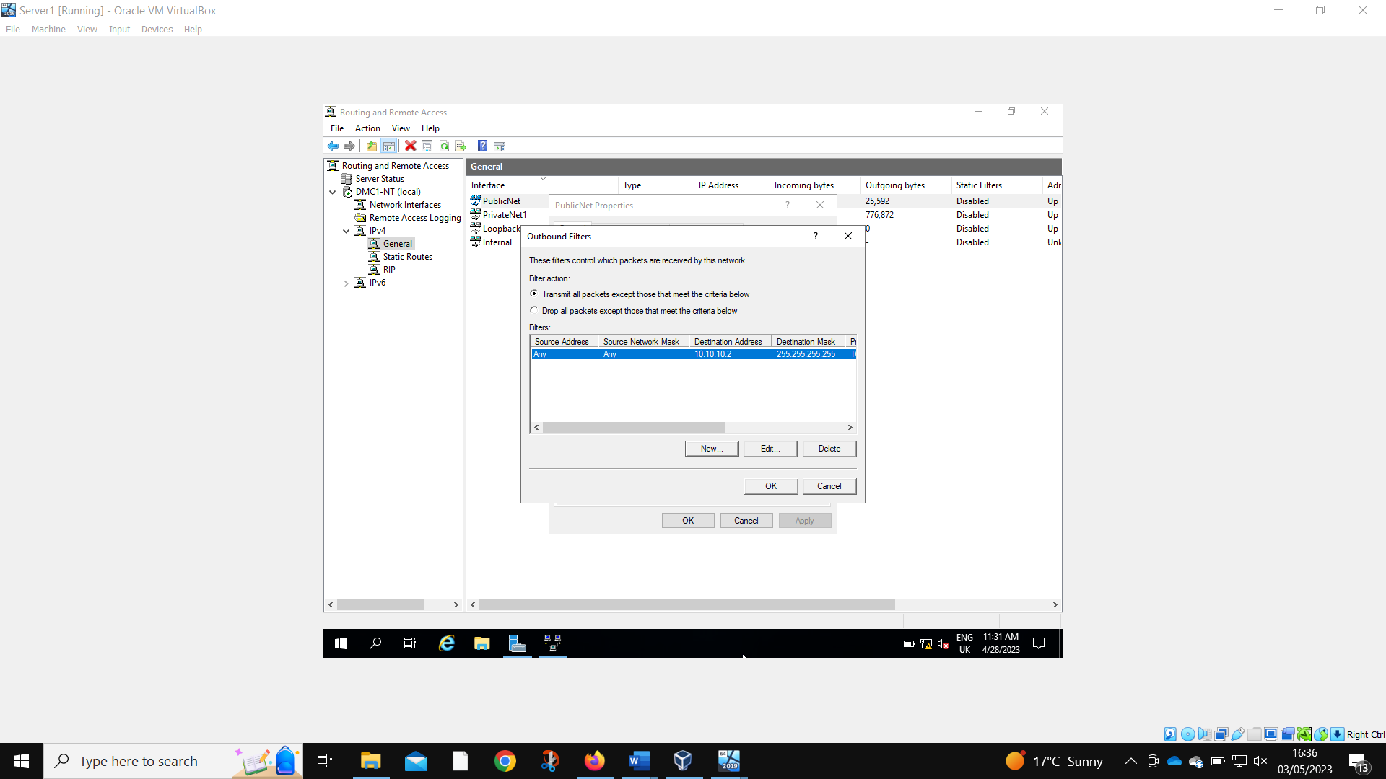
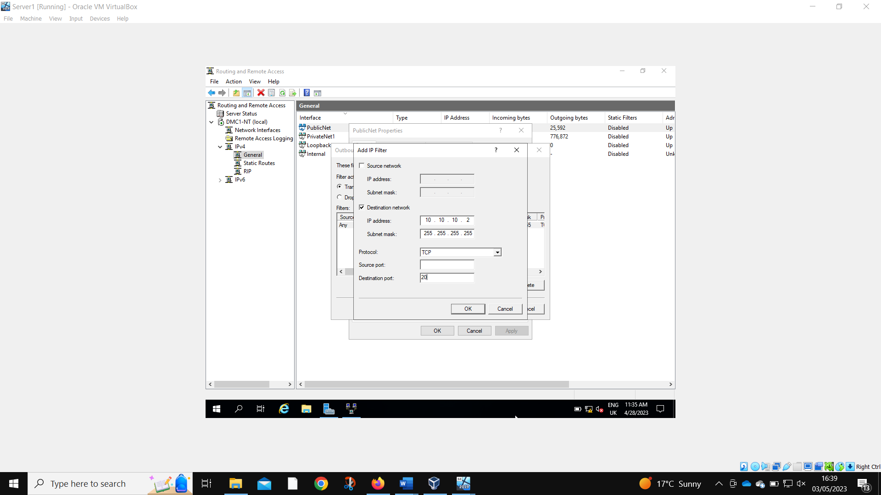
Port 20 and 21 had to be set.
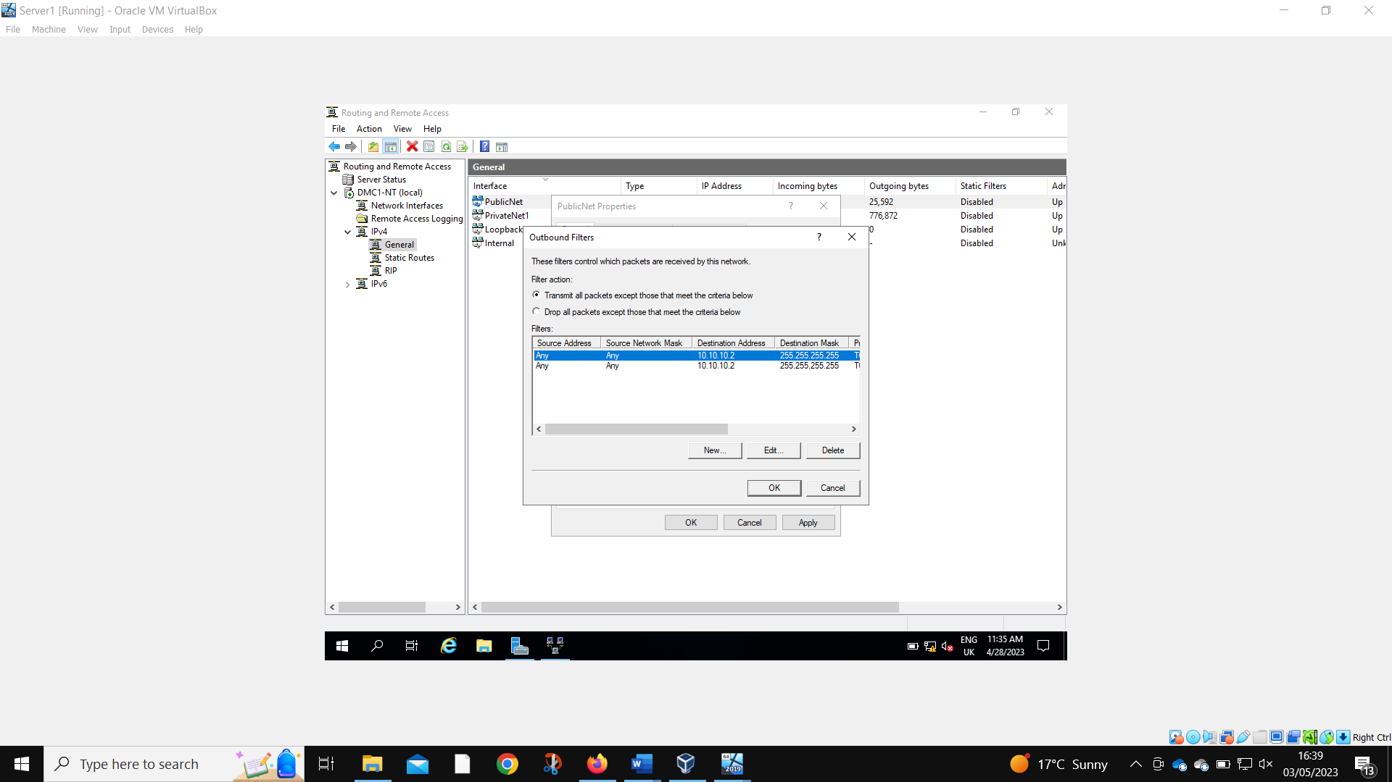
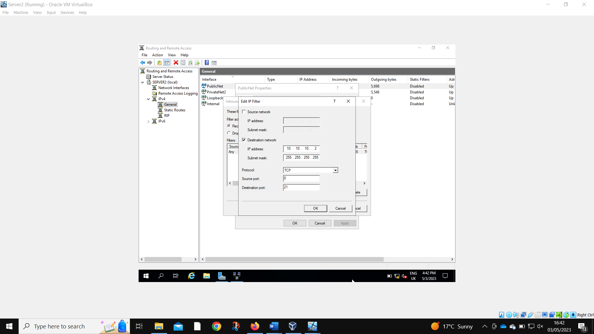
Port 21 is also blocked as an inbound on Server2.
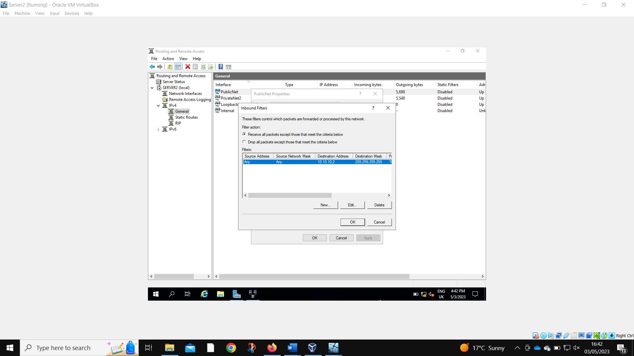
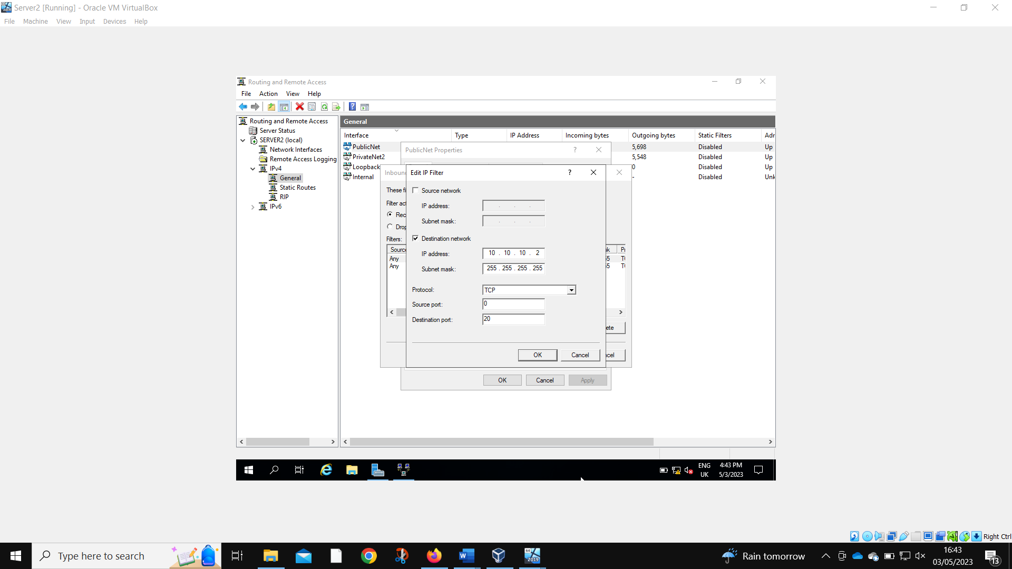
As is port 20.
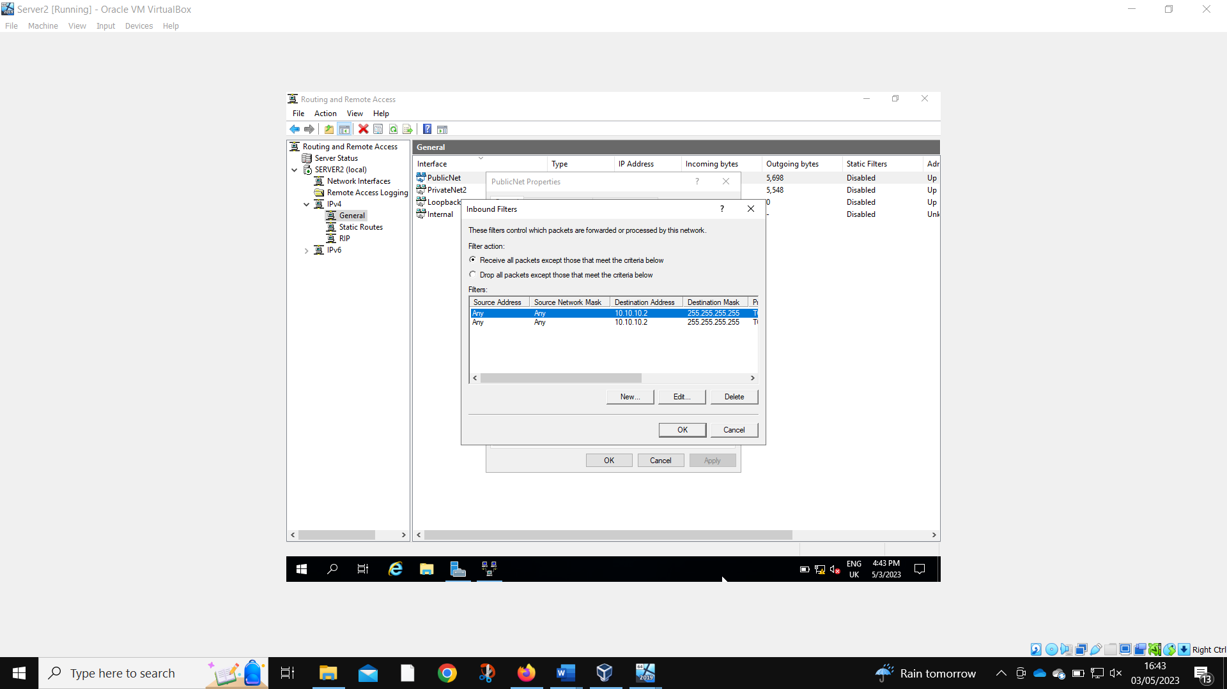
Client 1 is unable to log into the FTP service.

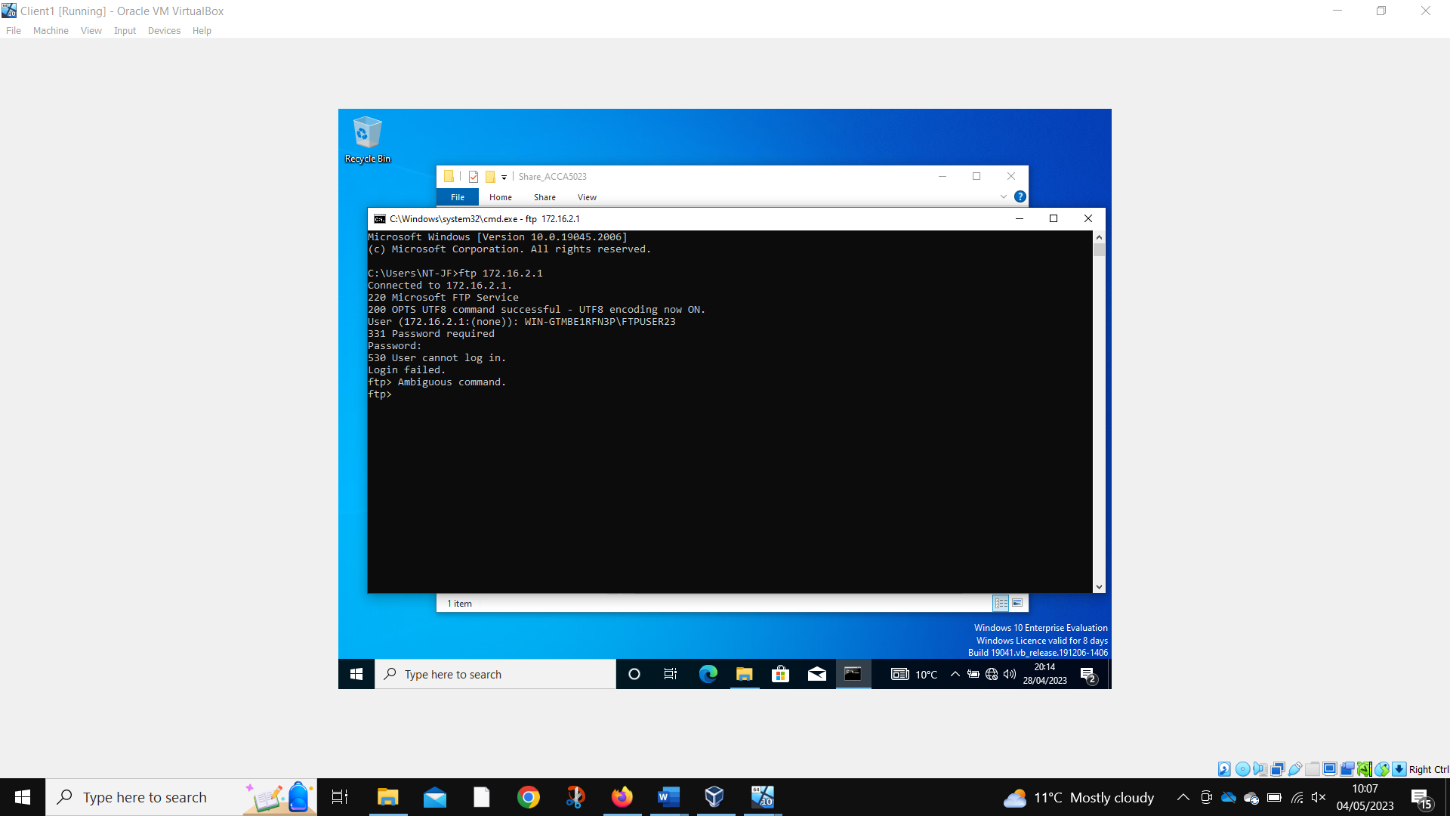

Task 3
- It is very important to have security on a Small network as you need to make sure you have security like you can have a VPN to protect you from the different viruses on the home office as they can be very dangerous if not taken care of on the home office as it is such a small network it can do more damage than a bigger one as it would be able to destroy everything but if it was larger it wouldn’t get out of the first computer on that network. “A VPN creates a secure tunnel between a user's computer and the VPN server, which hides their online activity and location.” [1]. You can also use antivirus software on your personal computer as you can you this to stop more virus as this will stop them from multiple different apps and services as like with the VPN it will just stop the viruses and the other data from the internet but the AV will stop anything else that will get through “Antivirus products work by detecting, quarantining and/or deleting malicious code, to prevent malware from causing damage to your device.”[2]. If you can do it would make it so much easier to not allow your family or any other person to use your work computer for home tasks as they could mess up the computer by going on a game so it wouldn’t work and then you would be stuck when you couldn’t do the work, you need to do. “Treat your work-issued laptop, mobile device and sensitive data as if you were sitting in a physical office location,” [3]. If you can use need to use a central work storage site like cloud storage so you have your work backed up.

2.
The role of a failure over cluster is “to increase the availability and scalability of clustered roles” [8]. This will work with other computers to make this happen as they will be connected by physical cables and by the same software. The basic concept is that when one of the servers will fail there is a backup system so nothing will ever stop working and they will probably not even know. This would be most relevant with the storage side of the servers like when different computer around the servers is using the same document as they will keep needing to edit it or even if they are using the VMs as it would be very bad if they are not shut down properly as they would keep charging the company. This would be very beneficial if they are using the VMs with a lot of data going through them as the customer and the company will benefit from not having any downtime from not being able to access the VM or document. “The clustered servers can collectively improve the availability and scalability of applications and services.” [9]. A failover cluster must have at least two nodes in the network (in these terms the servers are called nodes) to make sure they can connect to each other so if one goes down it go the other one. if the failure happens then the data will be transferred on to the other node so it will be seamless. The biggest roles of this system will be the online transaction processing as this has a high availability as you don’t what someone missing out on a purchase because they can’t use it straight away. Another one would be the disaster recovery as they will need to move to another part of the country or even another country as the disaster can be that big it will need it. “These clusters provide geographic replication so if a server in one location goes down, data will still be available on failover servers at other sites.” [10]. If you are deploying this feature, then you will need a lot of money as most liking you will have more than two servers and then you will need to a some to always look after it so it will never go bad. You will also need to buy the software for the whole of the nodes. In the high availability cluster, you will need to pay more as well as you it the servers will keep looking at each to check if they are okay and to see if they need to move the data over so if one of the nodes fail it will do everything automatically. The other cluster is continuous, and this is less impressive as it might have some downtime and they might lose some data as it isn’t always looking at the other servers.

- When you have such a big company you will have lots of different network sites where different people can access the sites so you will have to make sure that everything is secure where everyone is access it. This policy will give you an understanding on how the whole network will give you access from different sites. Throughout the different sites the best topology in the network would be star as this would go to each computer and if any of the wires break the other computer will still work not like some of the rest. “As a consequence, if a node that isn't the central node goes down then the network will remain up” [4]. The best layout of the room would be each table would get as switch and then they would all connect and go to the server from each room as this would help if there was ever a problem as you could narrow it down to the certain spot the problem would be. Then you could connect the sites together and then it will be one big network as when it comes to upgrading the system as you can easily add a different site to the network by just connecting it to the normally network that already on the network. “Topology is defined by the network hardware, ability to extend the network and manner it is managed” [5]. The security risks of having such a large network can very big as you must be on such high alert when you are setting the passwords and security measures as if you get one thing wrong with it the whole network can go down it can be that bad. That is why if you even get the people who work on the network, they will be background checked and they will have to swipe their card or thumb print if they even do anything on the network as this will leave a paper trail so they can see where it went wrong, and they can blame them. “The certainty one has in identifying someone else derives from the security of the credential itself.” [6]. If they ever get notified of a threat on a network, they can access the network from anywhere they will have Wi-Fi so they can shut it down so they can’t access the files on the network and can do any more damage than they already have. They will have a mass amount of people fixing and looking at the data from the team is very important as they will have to fix the problems on the network so they will have to be very smart to fix the problems that will happen as they will have to fix them quick or the user will not be impressed as they need to do their work but the security comes first even if they are trying

to get it without the security active. “Protecting IT infrastructure, edge devices, networks, and data.” [7]

- We had a few mistakes with the different tasks as we couldn’t get the computer to work with the screenshots and we got it to work in the end. We also had the computer where we couldn’t load up the computer as the boot disk was in the computer so it was going to that disk before it could boot but there was nothing important on the disk, so it wasn’t going to work but we managed to get the disk out and now it is working. We it came to working on the assignment I think I could have done more with it as I have given a few screenshots for the assignment but Alex and James it most of the screenshots on the task so get the most credit. It took a long time to fix the problems that we had as we had a few weeks break while doing it and that didn’t help as we all forgot what we need to do some that took roughly 1 hour to see what we can do and where we can start. If I was to do it again, I think we should just keep going through the break.

References

[1]
https://www.fortinet.com/resources/cyberglossary/are-vpns-safe#:~:text=A%20VPN%20creates%20a%20secure,from%20tracking%20their%20browsing%20activity.

[2]
https://www.ncsc.gov.uk/guidance/what-is-an-antivirus-product#

[3]
https://www.businessnewsdaily.com/9372-secure-home-office.html

[4]
https://www.comparitech.com/net-admin/network-topologies-advantages-disadvantages/#:~:text=Star%20topologies%20are%20most%20commonly,the%20network%20will%20remain%20up.

[5]
https://grapholite.com/Diagrams/NetworkLayouts#:~:text=Topology%20is%20physical%20layout%20of,and%20manner%20it%20is%20managed.

[6]
https://ingroupe.com/insights/key-features-modern-identity-card/#:~:text=The%20goal%20of%20an%20identity,security%20of%20the%20credential%20itself.

[7]
https://www.simplilearn.com/it-security-professionals-key-roles-responsibilities-article#:~:text=At%20a%20mile%2Dhigh%20level,monitoring%20and%20reacting%20to%20attacks.

[8]
https://learn.microsoft.com/en-us/windows-server/failover-clustering/failover-clustering-overview

[9], [10]
https://www.techtarget.com/searchwindowsserver/definition/failover-cluster

