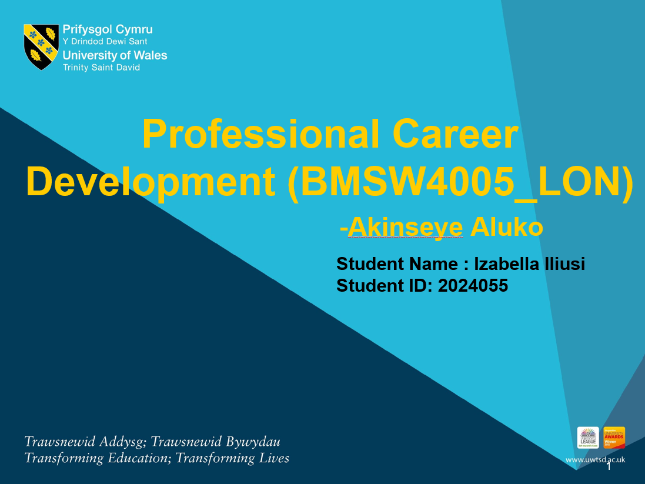

Table of Contents
Report
Introduction
Kolb’s Reflective Cycle
Recruitment and Selection
Conclusion
Role Play
Interview
References
Report
Executive Summary
Kolb’s reflective cycle has been used in this report section to understand the interview section. This report has showcased all the necessary steps of Kolb’s cycle and that has made me clearly understand how the interview process has gone, and how it can help to develop the skills of the people.

Introduction
Kolb's Reflective Cycle is one of the assessments that is formulated based on reflective interpretations and was eventually to evaluate the personal development inside itself, which will be done through four experiments. According to the report's reflective section, judgement tests, organisational skills, knowledge test type, and personal growth are the four assessments that indicate the real usefulness of personal development. To understand the learning experience, Kolb's reflective cycle is used, and the procedure involved reviewing, analysing, and assessing the total experience. In Kolb's reflective cycle, assessing consists of four steps: concrete experience, reflective observation, active experimentation, and abstract conception.

Kolb’s Reflective Cycle
Concrete Experience
Managing an organisation and handling a team is a great opportunity as well as a responsibility for me. I have experienced certain growth and development in my skills as I have learnt how to manage the works at small and local enterprises. I have experience with creative works as I am optimistic about my knowledge of marketing. The making of promotional banners, articles, pamphlets and banners helped me to understand the market demand and valuation. I have learned to make the PPT presentation which helped me to demonstrate my abilities. It is necessary to state that being a marketing executive, an individual is always required to be a creative individual, who helps to grab the opportunities that are available within the market at right time. Marketing activities require a high level of working abilities and the activities to grab the attention of the consumers with quick succession. I believe that the skill that I have within me related to my creativity will help me to get success in my marketing career. In terms of Cabin crew management, I have experienced difficult situations such as working outside for a longer period, managing a large group of people and my experience in customer services. I have network security and management skills that can assist me in determining the issues with internet marketing. To preserve consistency, I can critically examine data and look for new information depending on my perspective. I have some experience with banner making, blog writing and presentation. My most successful talent is concentrating on social media and increasing web activity for professional reasons.
Reflective Observation
As a marketing manager, my data capabilities are mostly focused on social media and digital marketing areas. In terms of digital competencies, I have the key talent of presentation planning when evaluating the perfect platform for Instagram posts, according to the investigation. I am well convinced of the significance of utilising the most updated technology devices and arrangements to assess the industry stability and acceptability of the market. In my recent abilities, I can articulate my opinions and presentation to improve my performance. I have a strong understanding of how to properly save important information for a prolonged period. I can alter and reinterpret existing information and market strategies to make things interesting and provide the best service. I am completely focused on the most recent industry trends and requests to provide a better online marketing consequence for the firm. I have improved my communication abilities, which enables me to gain a better understanding of my business. I can assist the organisation to develop its digital expertise by using my present abilities. I might explore the current techniques such as tools like Twitter and Instagram and privacy surveillance to manage the confidentiality of the users to expand my capability over content analysis and managing. Along with my technical attributes, I have other skills like effective communication skills, and organisation skills, and these two skills are also highly necessary for the marketing career as this communication skill is necessary to win over the emotions of the consumers, and organisation skills of an individual help the individual to keep the entire team together. Working as a marketing manager I need to win over my consumers successfully, along with that I need to perform win over the team members successfully as well. In this regards my skills are well suited for the job. I can also add here that I have another trait in me that would help me to get success in the marketing industry is my reading skill. With the help of this skill, I can be able to keep myself up to date with all the necessary changes that are going on in this current market. Following the social media promotions by the other organisations to reading all the journals, articles, magazines that are related to marketing information can help to stay up to date about the current market. Another approach that can help me to beat the other candidates in this interview season is my previous experience, where I have gained the experience of presenting anything with confidence. Being a marketing individual, it becomes necessary for an individual to showcase any presentation whether it is related to the product or related to the organisation’s strategy to the client with confidence. Here, in this situation, I have the special traits, where I have my skills of giving a presentation, and that will provide me with an added advantage.
Abstract Conceptualisation
I can use my talents as a strong business manager to help companies to expand and improve their market. It is clear that my abilities are strong, and so I can locate them as per my preferences. Thus, by using presentation skills to write meaningful and polite blogs and banners, firm productivity can be maintained. The procedure may be more structured if they used online marketing with proper strategies. The varying nature of customer service and customer relations might result in my career. I can also state the communication skill along with the presentation skill can be the combination of two such skills that will help me in future to become a successful marketing manager as these two skills will help to win the client for my organisation, keep my team motivated, and engaged, and along with that, it will help me to win the consumers of the organisation as well successfully.
Active Experimentation
Areas of Improvement | Actions to be taken
Customer Services | According to my overview, it is important to manage the customers as a marketing individual as well as it is the most important responsibility for the job role. To improve more of my customer services, I need to develop knowledge upon observing them and understanding their demands. Every customer is different and their needs are also different. I can handle customer services, but to maintain excellence, I need to work hard on my skills. For that matter, I need to develop my management skills and build my knowledge upon their process.
Group Management | Managing the work of an individual or a small number of people is easy, but being in a 100 personal group and managing their work is somehow complicated. I have learnt to make presentations and product demonstrations. Although it is also required to maintain the sustainability and consistency of the work. I need to be more precise about my management skills and rather need to go through all of my management course exercises, to sum up, the process. As I have effective communication skills; henceforth, if I learn to improve my leadership approach, it would help me enhance my group management activities.
Organisational Management | Organisational management needs a lot of skills such as well bound communication, presentation skills, abilities to control the team and process and strategic planning. Although I can develop presentation skills and have knowledge of marketing, it is essential for me to brush up on my skills more frequently. It is important to consider the internal environment of the organisation and change the patterns according to the business and customers. While dealing with any new client, I became a bit nervous which affects my overall performance and my confidence. I need to read more over the topics and procedures to meet the requirements and fulfil the objectives of the projects.

Recruitment and Selection
Reflective writing is a type of analytical piece of writing in which the writer analytically describes the real-time situation, past event, experience or imaginary event etc. this can be written during the event or after the end of the event. This is a mix of description and analysis which will provide in-depth insights into the event to the reader (KarinBjerkvik, 2019).
In this reflective report, I am going to express my reflection on the two interview sessions.
Interview 1:
From the first interview session, I can say that the interviewee seems to be pretty confident while answering the questions. If I am going to analyse the style of questions prepared by the interviewer, I can say that the questions are mixed with both the open-ended questions and the close-ended questions. As per my knowledge of open and close-ended questions I can say that mostly the interviewer wants to get the idea of the subject knowledge of the candidate. He is provoking the candidate to get an idea about his previous work experience by asking about his inspiration and why he should get selected for this job role. The interviewer patiently heard each one of the long questions to get an in-depth idea of the candidate before boarding him for the next interview session or selecting him for the job position. From scanning the answer of the interviewee, I can say that the interviewee has both the subject knowledge and experience which is making him the best candidate for the job role.
Interview 2:
While skimming the interview questions and the answers, I have realized that the interviewee is pretty vocal about her experiences and knowledge in front of the interviewer. The interviewer is making some excellent choices of questions while interviewing the candidates. These amalgamations of both the theoretical questions along with the hypothetical situation wise questions will bring the best candidate out of slots. The interviewer by giving the hypothetical questions wants to test the quick reflection of the candidate. I can say that this particular candidate excels in the interview because she was very quick to answer those hypothetical questions. The interviewer patiently heard each one of the long questions and her experiences to get an in-depth idea of the candidate before selecting her for the job role. I feel that not only the interviewer was patient enough but the interviewee also patiently replied to each of the questions with suitable answers. By reading the last answer where the interviewee gave herself 8 marks out of 10 on the scale of customer service along with providing an example, I feel that this candidate can control the situation while keeping her mind calm and making some great arrangements by using her brain. I can also sense that this candidate has the best idea of customer service which make her suitable for the job.

Conclusion
Kolb's Reflective Cycle is one of the assessments that was formulated based on reflective interpretations and was eventually to evaluate the personal development inside itself, which has been done through four experiments. According to the report's reflective section, judgement tests, organisational skills, knowledge test type, and personal growth are the four assessments that indicate the real usefulness of personal development. To understand the learning experience, Kolb's reflective cycle was used, and the procedure involved reviewing, analysing, and assessing the total experience. In Kolb's reflective cycle, assessing consists of four steps: concrete experience, reflective observation, active experimentation, and abstract conception.
Appendix:

Role Play
The interview is a type of formal conversation in which one person is asking questions while the other one is answering to convey his or her feelings, prior knowledge, information etc (Damayanthi, 2019). In an interview session, the person who is asking the questions or regulating the interview session is called INTERVIEWER (Bull, 2018). On the other hand, the person who is giving the answers in the interview is called INTERVIEWEE (Ajoge, 2020). The interview can be taken place via various mediums like Face to Face interviews, virtual interviews, and interviews over call etc according to the preferences of the company or the interviewer. In the Covid 19 situation, most of the interviews were taken place via virtual interview sessions. In every scenario, the purpose of the interview session for any company is to remain the same i.e. to select the best candidate for the company out of multiple numbers of candidates (Gordon, 2020). For an effective interview round, the interviewer should show some authority along with being friendly to the interviewee so that the interviewee remains calm and able to answer the question for the interview. Thus, the interviewer will get the desired candidate from the slot (betterteam, 2021).
In this report, the role-play of two interview sessions is going to enlighten in which two students are going to participate: one is the marketing manager.

Interview : Marketing Manager
In interview 1, I, Izabella Iliusi will be the interviewer and Mariana Cristina Axente will be the interviewee.
Student 2: Interviewer
What is the inspiration behind choosing marketing management as your career option?
Student 1: Interviewee
From my childhood, I have had a keen interest in creative work. During my school and college time, I use to participate in the local business fairs, working for a nonprofit business organisation like NGOs, working for local businesses. For the local business, I use it to generate promotional content like blogs, articles, pamphlets, banners etc. Apart from the outside events, I have also participated in teamwork projects, seminars, PPT presentations during the Business management course. I think this prior experience along with the theoretical knowledge from my Marketing management course inspired me for choosing marketing management as my career goal.
Student 2:
Can you enlighten two essential skills required in marketing management?
Student 1:
Based on my prior experience along with my study, I can say that Communication Skill is the key skill required by the marketing manager. In any business how the marketing team can communicate with the clients, convince the client, negotiate with them regarding their needs and desire will help the company to crack the deal (Wahyuni, 2018). Apart from communication skill, I can say that organisation skill is also essential for the market management profession (Pradhan, 2017). Organisation skills will help the manager to keep the important records from the clients, manage to find out the data while in need etc. Apart from the organisation of the data, organisation skills will be helping the manager to manage the marketing team more efficiently.
Student 2:
What will be your approach to keep up to date with the market trend?
Student 1:
To remain up to date with the current market facts and trends, my reading habit will be beneficial for me. I am going to follow social media like following the influencers and their profiles I will be getting information regarding the current market trend, fashion and many more. For example, the concept of vegan meat or beyond meat is so much in trend right now and people who are following the influencers are going gaga behind the beyond meat (Visser, 2021). Apart from social media like Instagram, Twitter, I will be following the marketing blogs like HubSpot, Adam Enfroy, LBB and many more to stay up to date with market trends (rebrandly, 2019). Apart from the blogs, I will also read up the news articles from the newsletter to get the market statistics like the ups and downs of the market, the update from the stock market which is also helpful to get up to date with the market situation. This will also help me as a marketing manager to get insight into the current market position of the client (Samimi, 2021).
Student 2:
Why do we choose you among the rest of the candidates?
Student 1:
For the marketing management profession, the candidate needs to be comfortable while presenting the products in front of clients along with the other employees. As I have mentioned earlier about my experience regarding writing blogs and banners for the small local business during my school and college days which makes me comfortable while presenting the products in front of a large group of people. Whether the size of the group is 10 or 100 I will be comfortable in any scenario. Because of my presentation skill the company will be benefited and which makes me suitable for this job. I have my comfort zone in communicating with small to large groups. As we know communication is the key skill required in a marketing manager so I can say these skills make me the best choice among the rest of the candidates.
Student 2:
5 years from now, where do you imagine yourself?
Student 1:
From my schooling time, I wanted to create my career in the creative field for that I have opted for a Business management course for my UG. I have had very specific career goals for my future i.e. working as a senior marketing manager for an international organisation. If I answer according to the time frame then I can say 2 years from now I can see myself working as a marketing manager with this organisation. After 5 years, I can see myself in a senior management position. Along with my career journey, I am going to continue with my higher study within this 2-year time frame. The higher study will provide me with the chance of fulfilling my career goal within the time frame of 5 years.

References
Ajoge, (2020). A computational model of temporal dynamics for anxiety in interviewee mental state.. Journal of Information and Communication Technology (JICT), pp. 185-206.
betterteam, (2021). How to Be a Good Interviewer.. [Online]
Available at: https://www.betterteam.com/how-to-be-a-good-interviewer
Biddle, E., (2019). Adaptive Team Training for One. International Conference on Human-Computer Interaction, pp. 5-27.
Bull, R., (2018). What is ‘believed’ or actually ‘known’ about characteristics that may contribute to being a good/effective interviewer?. In: 1, ed. Investigating the Truth. s.l.:Routledge, p. 17.
Damayanthi, S., (2019). Thematic Analysis of Interview Data in the Context of Management Controls Research. SAGE Research Methods Datasets.
Gordon, E. K. B., (2020). The role of the interview in residency selection: A mixed-methods study. Medical Education, 54(11), pp. 1029-1039.
KarinBjerkvik, L., (2019). Reflective writing in undergraduate clinical nursing education: A literature review. Nurse Education in Practice, Volume 35, pp. 32-41.
Pradhan, R. K., (2017). Human resource flexibility and organisational effectiveness: mediating role of organisational citizenship behaviour. International Journal of Human Resources Development and Management, pp. 282-300.
rebrandly, (2019). Best Marketing Blogs: As Chosen By Marketers. [Online]
Available at: https://blog.rebrandly.com/best-marketing-blogs/
Samimi, M., (2021). Investigating the Strategic Concept of Risk Management in the Stock Market and Investing. Journal of Engineering in Industrial Research..
Visser, R. O., (2021). Beyond “Meat Free Monday”: A mixed method study of giving up eating meat. Appetite, Volume 166.
Wahyuni, L. M., (2018). Communication Skill Attributes Needed for Vocational Education enter The Workplace. Journal of Physics: Conference Series, Volume 953.
YuhyungShin, (2019). Linking flight attendants’ job crafting and OCB from a JD-R perspective: A daily analysis of the mediation of job resources and demands. Journal of Air Transport Management, Volume 79.

