Software Development
Student No. 2026380

Software Development
PART A (UNDERSTANDING)

( A1 )

- Python List: Python lists are one of the most versatile data types that allow us to work with multiple elements at once.

- For example,

# a list of student’s ages
['20', '21', '18']

- Create Python Lists: In Python, a list is created by placing elements inside square brackets [ ], separated by commas. A list can have any number of items and they may be of different types (integer, float, string, etc.).

- For example,

# list of integers
my_list = [1, 2, 3]

# empty list
my_list = []

# list with mixed data types
my_list = [1, "Hello", 3.4]

# nested list
my_list = ["mouse", [8, 4, 6], ['a']]

- Access List Elements:

- For example,

- my_list = ['p', 'r', 'o', 'b', 'e']

- # first item
- print(my_list[0]) # p

- # third item
- print(my_list[2]) # o

- # Nested List
- n_list = ["Happy", [2, 0, 1, 5]]

- # Nested indexing
- print(n_list[0][1]) # a

- List Slicing in Python:

- For example,

my_list = ['p','r','o','g','r','a','m','i','z']

# elements from index 2 to index 4
print(my_list[2:5])

# elements from index 5 to end
print(my_list[5:])

# elements beginning to end
print(my_list[:])

(A2)

- Python User-defined Functions: Functions that we define ourselves to do certain specific task are referred as user-defined functions.

- # the use of user-defined functions syntax:

- def name():
- statements
- .
- .
- return

- Advantages of user-defined functions:

- User-defined functions help to decompose a large program into small segments which makes program easy to understand, maintain and debug.

- If repeated code occurs in a program. Function can be used to include those codes and execute when needed by calling that function.

- Programmers working on large project can divide the workload by making different functions.

- An example of user defined functions

def add_numbers(x,y):
sum = x + y
return sum

num1 = 5
num2 = 6

print("The sum is", add_numbers(num1, num2))

- The output will be:

- Enter a number: 2.4
- Enter another number: 6.5
- The sum is 8.9

PART B (IMPLEMENTATION)

Exercise 1:

- Code:
car_make = input("Enter car make: ") #using input function to take values from users
car_model = input("Enter car model: ")
dis = (input("Enter mileage: "))
N_doors = (input("Enter number of doors: "))

# use print function to out the data
print("\n Car make is:" + car_make + "\n the car model is: " + car_model + "\n meieage is: " + dis + "\n the number of doors is: " + N_doors )
- Screen of the output using jupyter notebook

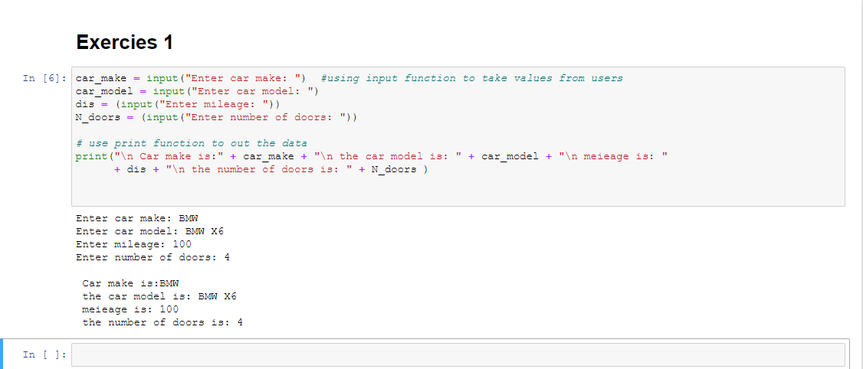

Exercise 2:

- Code:
from math import pi

# take the inputs radius
R1 = float(input("Enter radius one: ") )
R2 = float (input("Enter radius two: ") )
R3 = float (input("Enter radius three: ") )

# the area of the red-shaded
cir1 = pi* R1**2
A1 = cir1

# the area of the black-shaded
cir2 = pi * R2**2
A2 = cir2 - cir1 # area it is the difference between two circle which it is between

# the area of the blue-shaded
cir3 = pi * R3**2
A3 = cir3 - cir2 # area it is the difference between two circle which it is between

print ("The area of the red-shaded is: " + str(A1) )
print ("The area of the black-shaded is: " + str(A2) )
print ("The area of the blue-shaded is: " + str(A3) )

- Screen of the output using jupyter notebook
It is not only a straight we I have some issues like the following:
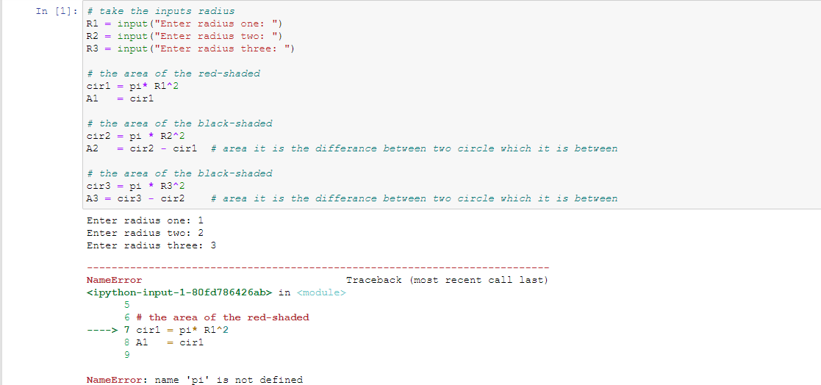

I searched for this error and found I should use a library called math to use pi

- Screen of the output after the edit
We will use R1= 1, R2=2, R3=3 to test our program

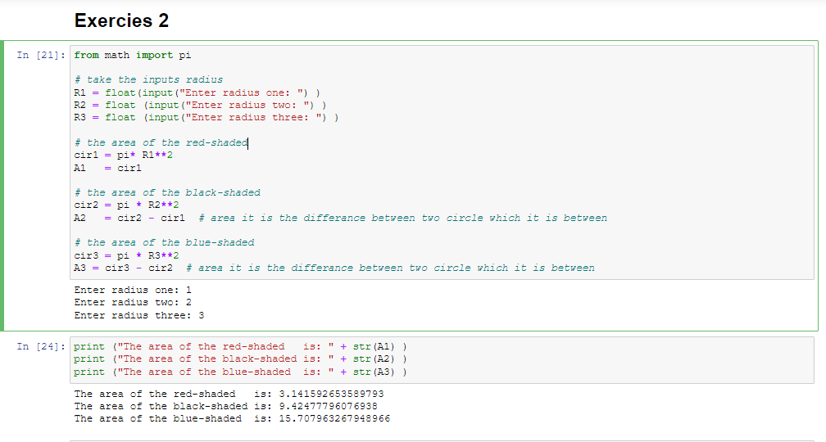

Exercise 3:

- Code:
- import pandas as pd
- lst = [ ]
- n = int(input("Enter number of elements : ")) # number of rows in our example we have 5 rows

- # for loop to go though every row
- for i in range(0, n):
- ele = [input("Enter the employee name:"), int(input("Enter employee Age:")),
- input("Enter employee Gender:"), int(input("Enter employee Salary:"))]
- lst.append(ele)

- #convert our list to dataframe type to be like the one wanted
- dataframe = pd.DataFrame(lst, columns =["Name", "Age","Gender","Salary"])
- print("Employee details entered:\n", dataframe)

- I get stuck at this: it only output the list and we need it in data frame type.
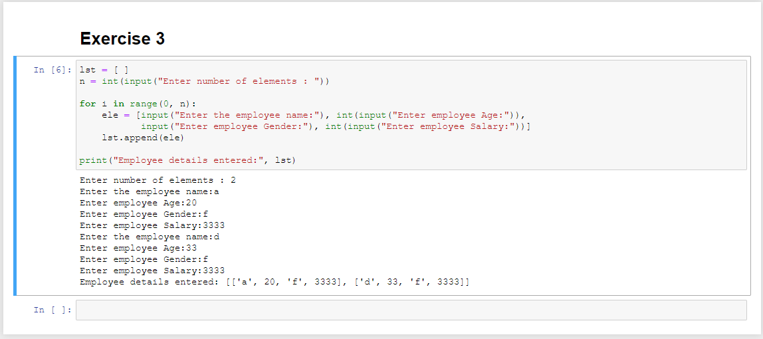
- So, I searched to convert the list to data frame and get the result that needed.

- Screen of the output using jupyter notebook

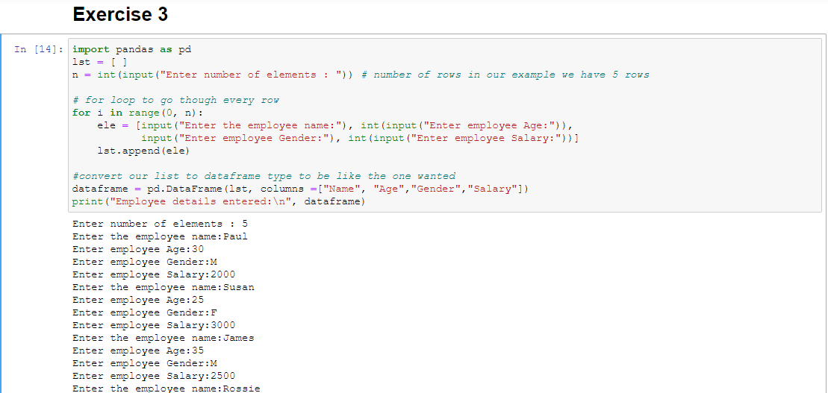

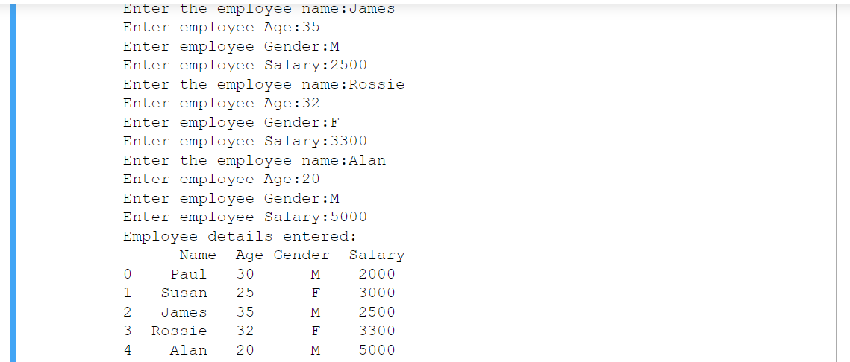

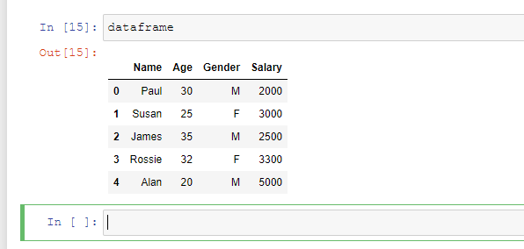

Tasks:

- the average age of males:
# select only males rows
males_age = dataframe.loc[dataframe['Gender'] == 'M', 'Age']
males_age

# take the averge of them
males_age.mean()

- Screen of the output:

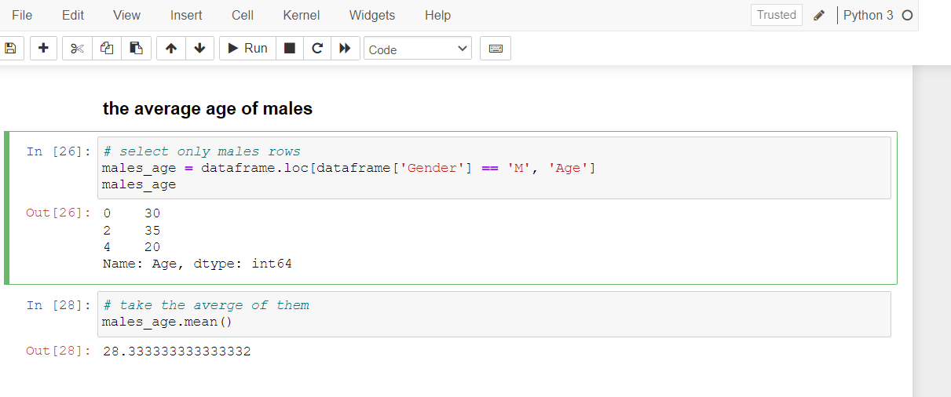

- the average age of females:
- # selec tonly females rows
- females_age = dataframe.loc[dataframe['Gender'] == 'F', 'Age']
- females_age
- # take the averge of them
- females_age.mean()

- Screen of the output:

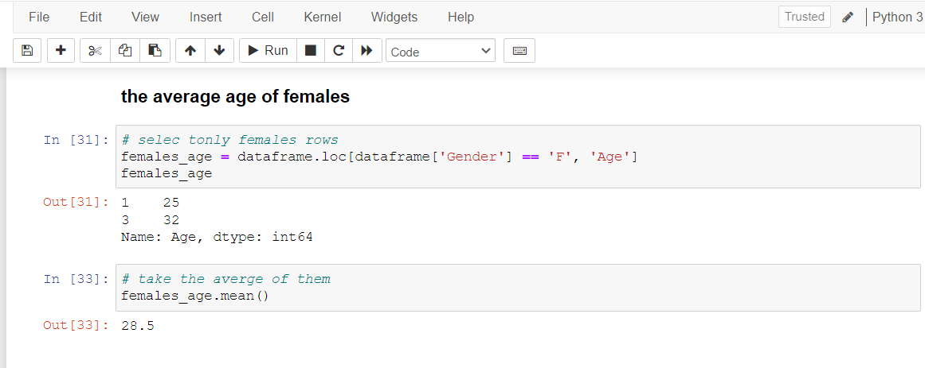

- the average salary of males:
# select only males rows
males_salary = dataframe.loc[dataframe['Gender'] == 'M', 'Salary']
males_salary

# take the averge of them
males_salary.mean()

- Screen of the output:

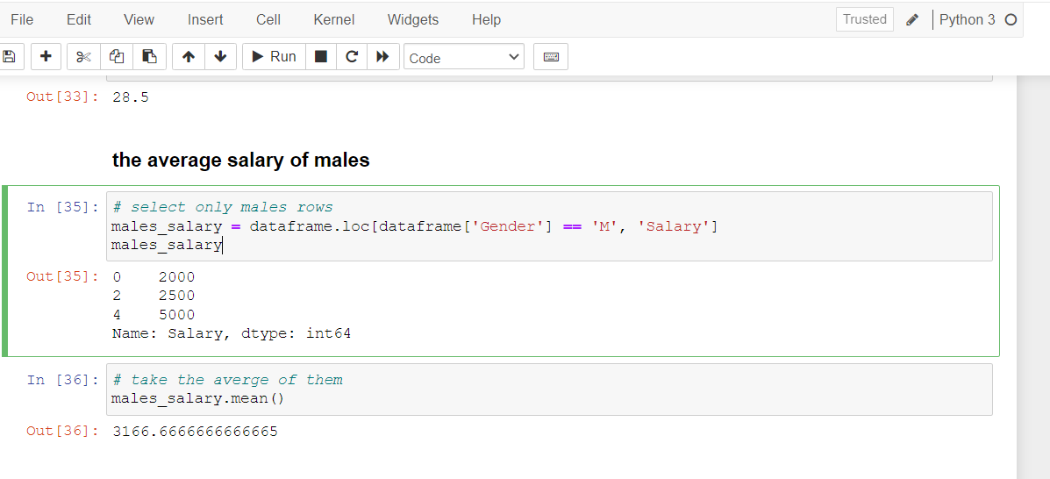

- the average salary of females:
- # selec tonly females rows
- females_salary = dataframe.loc[dataframe['Gender'] == 'F', 'Salary']
- females_ salary
- # take the averge of them
- females_salary.mean()

- Screen of the output:

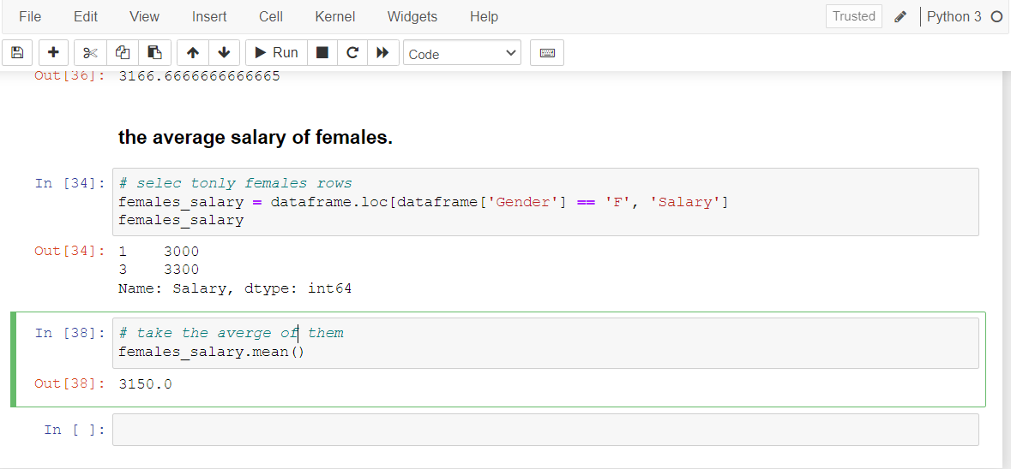

Tasks:

- Code

- import matplotlib.pyplot as plt
- import pandas as pd
- ax = plt.gca()
- dataframe.plot(kind='line',x='Name',y='Salary', color='red', ax=ax)
- plt.show()

- Screen of the output:

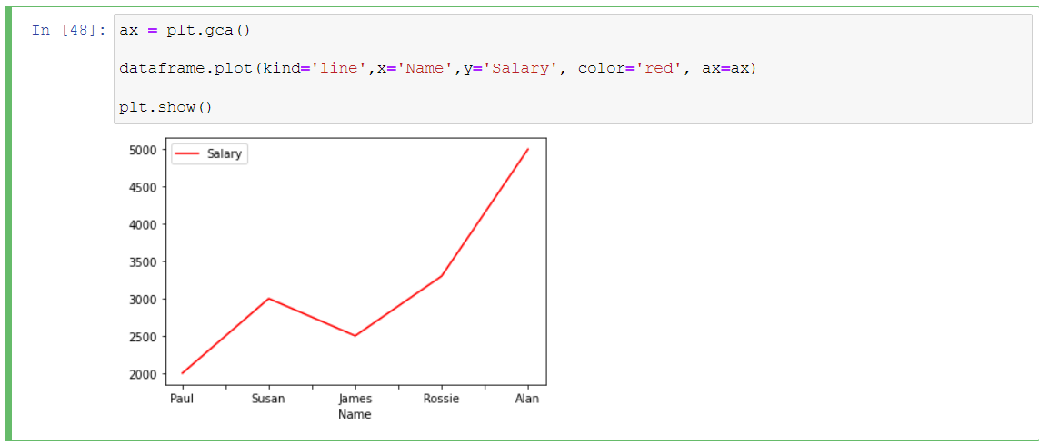

- ax = plt.gca()
- dataframe.plot(kind='line',x='Name',y='Age',ax=ax)
- plt.show()

- Screen of the output:

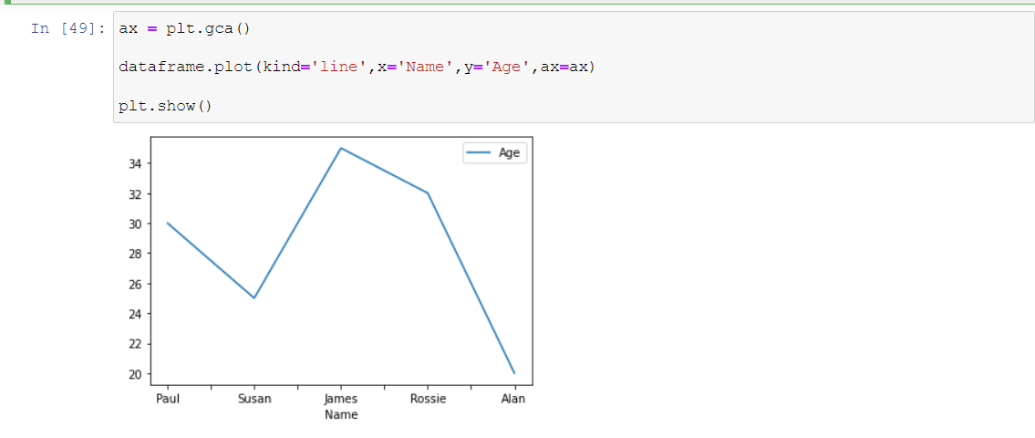
- # a simple line plot
- dataframe.plot(kind='bar',x='Name',y='Age')
- Screen of the output:
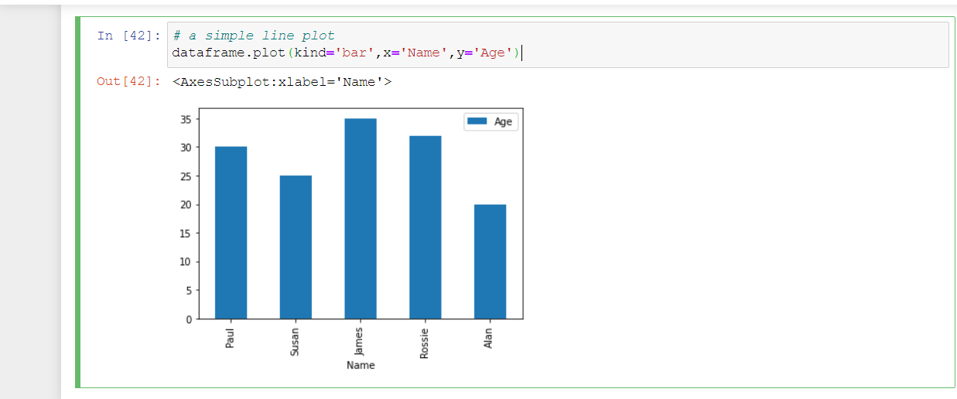
Exercise 4:

- Code:

- import random

- response = input('Spin ?')

- def trial():

- if( response == 'yes'):
- option1 = random.randint(1, 10)
- option2 = random.randint(1, 10)
- option3 = random.randint(1, 10)
- return option1,option2,option3

- [x1,x2,x3] = trial()
- print(x1,x2,x3)
- if ((x1 - x2 == 0) or (x2 - x3 == 0)):
- print('You win, your points are 10')

- elif ((x1 - x2 == 0) or (x2 - x3 == 0) or (x2 - x3 == 0))and (x1 != 5):
- print('bouns 20')

- elif (x1==5) and (x2==5) and (x3==5):
- print('jackpot of 200')

- else:
- print('You lose, your points are 0 ')

- Screen of the output using jupyter notebook

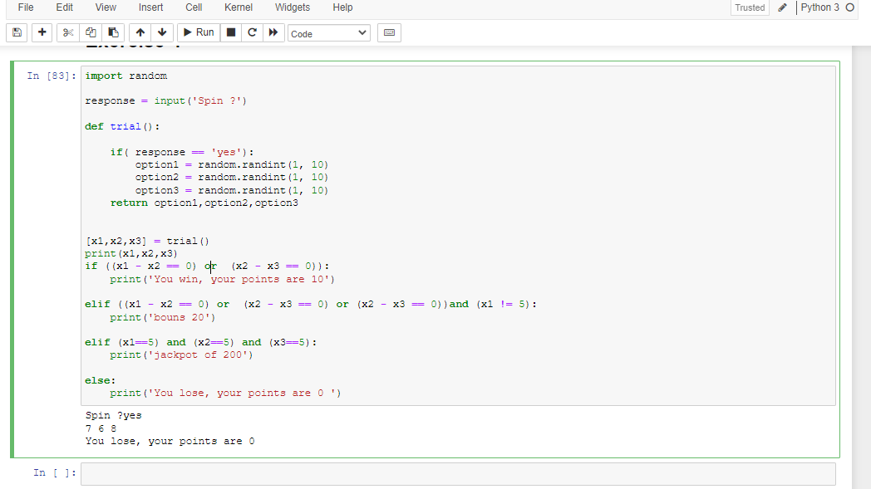

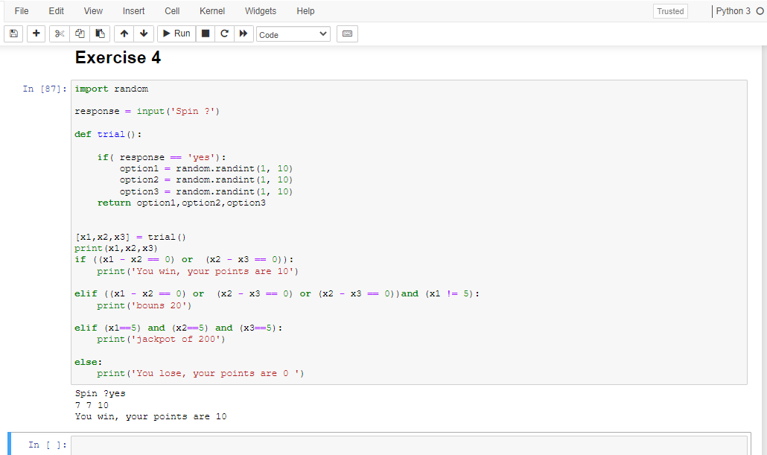
- References:

- https://www.programiz.com/python-programming/list
- https://www.datacamp.com/community/tutorials/python-list-function
- https://www.programiz.com/python-programming/user-defined-function
- https://www.geeksforgeeks.org/python-user-defined-functions/
- http://computing.outwood.com/NEA/python/programming.html
- https://stackoverflow.com/questions/37782467/error-cannot-import-name-pi

- https://www.geeksforgeeks.org/append-data-to-an-empty-pandas-dataframe/

- https://docs.python.org/3/library/random.html

- https://nostarch.com/download/Teach_Your_Kids_to_Code_sample_ch6.pdf

- https://runestone.academy/runestone/books/published/fopp/Inheritance/chapterProject.html

