UNIVERSITY OF WALES
TRINITY ST DAVI
LONDON.

Effective Team Working and Communication

Three Models of communication, Communication Skills, The Advantages and Disadvantages of Communication Technology
BSMW4002

Joseph Osayande Uhunmwangho
2030892

Lecturer: Joy Botu
4th May 2022

Table Content:
Introduction 2
Three model of Communications 4
Communication skills 5
The advantages and disadvantages of Communication Technology 6
Conclusion 7
References 8

1. INTRODUCTION.
Communication is a process of guiding a person and passing information to people to get the desired results (Beattie and Ellis, 2014). The message passed across must be, understandable, and presented to focus the attention of the person in other to have good effective communication. Communication is very important in our daily life either personal or in a corporate life-kalam time,2021.
Four types of communication are:
- Written communication- This is in various forms of expression between person to person or larger group in the society through, Emails, letters, reports, memos, and various other documents.
- Verbal communication- Passing the message through interaction, radio, Facebook, other media, etc,
- Non-verbal communication-Passing messages through the use of sign “gestures”, and body movement to notify the other person of the intended message being passed. And
- Virtual Communication – This involves the use of a chart to communicate virtual information.
The success of any organization depends on effective communication
Barriers to effective Communication are
- Physical barriers: The condition of the environment may affect the passage the flow of information to be passed.
- System design: This problem occurs as a result of the structure in place in an organization.
- Attitudinal barriers: These are problems generated by the staff within an organization,
- Individual linguistic ability. The employee's ability to understand, speak, or in written fluently. All these become barriers to effective communication.

In the past, different methods were used during the evolution of communication, such as Cave painting, smoking signals, and carrier pigeons, these were used before the advancement in communication.
The three models of communication therefore are:
- The Shannon-weaver mathematics model 1948
The model was created by an American mathematician, Name, Claud Elwood Shannon in collaboration with a Scientist, called Warren weaver. The theory was later known as Shannon Weaver's communication, and it became a foundation for communication models. It is an advanced linear model and is normally referred to as the mother of all models.
However, this model is characterized by features:
* A linear model.
* It is a one-way communication[unidirectional].
* It has a transmitter for encoding and decoding signals sent by the sender to the receiver.
* There is static interference during the telephone conversation call Noise, and
* There is no feedback.

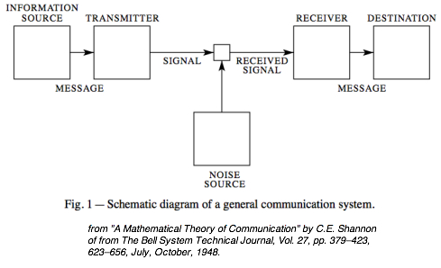
Shannon-Weaver Model of Communication Diagram
Sender (Information source) - At this stage, the message is sent through the transmitter
Encoder (Transmitter) The message is been encoded through the transmitter as a signal or binary data to the receiver

Channel - is the medium used to send a message to be passed.

Noise -The physical disturbances in the surrounding environment affect the signal quality to be delivered.

Decoder (Receiver) –This converts signals or binary data into a message or the receiver translates the message from signals.

Receiver (Destination)- Receives, decodes, and interprets the message according to the understanding of the message.

Case study
A dean of the faculty of the Engineering department in the University sends a message via phone call to his Head of the department for an urgent meeting in his office at 10.45 am On Tuesday next week about happening in the department. The Head of the department was not clear with the message received due to noise interference.

Using this case study, the below are the communication process
Head of Department: He understood the message to hold at 10.45 am on Thursday, instead of Tuesday at 10.45 am
Sender: The dean of the faculty of Engineering, and the Receiver was the Head of the department who receive the message. The message was not clearly understood by him due to noise interferences.

11. Communication Model by Berio:
It was first published in 1960 in the book called El Proceso de la Comunicaciones (The Process of Communication).
The Model has four parts[ chambers] that deal with the process of communication which is the Sender-Chamber, Message-Chamber, Channel-Chamber, and Receiver-Chamber. These are illustrated in the diagram below.
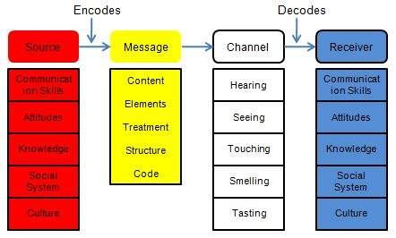
The communication process is linear, and there is no noise interference in the communication process.

In this Communication model, the Source- chamber of information and the receiver- chamber must be of the same standard of operation for effective communication to take place
Sender- The sender of the message is the source who creates and sends the message to the receiver
Message- The message is the package of information or meaning that is sent from sender to receiver
Channel- The channel is the medium used to send the message
Receiver- The receiver is the person who receives and subsequently decodes the coded message.

Case study
A certain professor lives in a house close to the city, he never associated with any of the Villagers because of his position in the society. The professor smokes a lot with his pipe and fell asleep while smoking. The pipe fell and caught fire which made him run for help to the Village and started crying while repeatedly saying “edifice is being consumed by a great conflagration”. Unfortunately, no one from the village could help because they did not understand him, causing his house to be burnt in the fire.
If the professor has used simple words like “ Fire, Fire”, the villagers would have understood him and helped. In this type of communication model, the Sender and the Receiver were not of the same level, therefore, the Message could not be understood by the Receivers,
The Sender and Receiver of the message must be of the same level to understand the message being communicated.

- Schramm's Model
The Schramm communication model started in 1954, based on the improvement of the Shannon-Weaver Communication model.
This communication model is circular rather than a linear paradigm, and the diagram below illustrates the model proposed by Schramm.
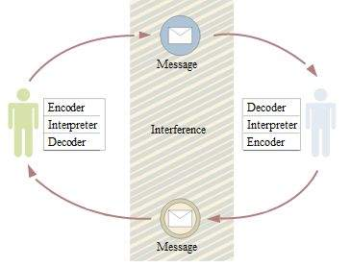
Encoding and decoding are essential factors for effective communication to take place. without these, information cannot flow between two individuals. According to the absence of the model, Coding and Decoding are the two essential processes of effective communication.
It is a 2-way communication process and the absence of these becomes incomplete
. Communication skills
Communication is the act of sharing information from one person to another person or a group of people. To perform effectively at work, and achieve organizational goals, effective communication skills are needed
Any organization irrespective of its hierarchical position needs communication skills.
Communication skills involve speaking, listening, observing, and empathizing. It also helps to understand how to communicate through phone conversations, face-to-face interactions, and digital communications like social media and email. – Harshita Khullar [2022]
The different ways of communication include - verbal (oral), nonverbal, and written communication skills.
Verbal communication: This is the process of passing information through interaction from person to person, either directly or indirectly using Radio, Facebook, and other media. With this, the receivers can understand or follow up on the information being passed.
Non-Verbal Communication – Non-verbal communication is the use of body language, gestures, eye contact, and tone of voice when the individuals are communicating with each other. Therefore, non-verbal communication is important for the success of any type of workplace, and they need to ensure they communicate well with all other members. Following the research studies, as individuals grow, they enhance their verbal, non-verbal, and written communication skills.
Effective communication:
.
Effective communication skills are necessary to mash with the rapid changes in society. As the individuals grow and get recruited into organizations; it is vital to be able to communicate well with all other members. Following research studies, as individuals grow, they enhance their verbal, non-verbal, and written communication skills.
Effective communication, therefore, requires respect, active listening, and empathy.
RESPECT: It is one of the Aspects of communication skills which means respect is reciprocal. As you respect them and they're saying, be open to people like using an individual’s name, focus an eye on them, listen when they talk, these make them feel you respect and have regard for them, they feel free to speak more with you.” A good Lecturer and his/her student”.
Active Listening skills- Is the ability for a receiver to listen attentively and respond positively[feedback], if it does, that shows the receiver understands the message or information being sent

Friendliness – Friendliness is an important aspect of communication skills; it helps to improve interaction with themselves and the society and improve their communication skills effectively

Radicality and Conciseness – These communication skills enable the senders and receivers
efficiently understand each other, they can carry out the communication process within a short possible time. Therefore, it can be stated, that clarity and conciseness are important communication skills for workplace success.
Empathy- Having the ability to understand and share the emotions of others and respond appropriately. This will make your colleagues feel they are recognized and respected.

Case Study
Ben a sales assistant in one of the retail stores in London has been off work for some days due to an illness and some family challenges he had been facing. He had called his workplace to request some days off and explained to his manager about his situation which had him hospitalized causing his absence at work. Ben eventually returned to work one 1week later after he had fully recovered thereby making Ben feel valued.
In this situation, there has been effective communication between the parties involved, from Ben informing the manager about the illness and the manager understanding him, and also showing empathy for his situation.
4. The Advantages of Communication Technology
1. The use of ICT has helped to globalize the world, united people, and do business.

2. Messages are sent faster, and instantaneous responses are received due to advancements in technology like the Telephone, smartphone, Instagram, WhatsApp, and other media. Consequently, communication has become effective and reliably use in society.

3. Communication technology has facilitated education because people can learn over the internet.
4. It increases Employment opportunities globally.

5. E-Commerce facilitates Online banking business and money transfer to any account globally.
6. Access to information is mostly through the Goggle search, through this one can assess information on Health, Education, Employment, etc.
7. It helps in the entertainment of an individual through watching videos, movies, playing music, etc.
5. Disadvantages of communication technology:

1. Bullying is a major disadvantage there are so many teens committing suicide because of being bullied.
2. Loss of job because of computerization and Automation

3. It is easier to falsify one’s qualifications.

4. People can threaten others anonymously online.

5. Technology can produce dangerous outcomes like nuclear weapons.

6. Easily to join a bad gang nearby or far away through the use of communication technology.
7. The use of the smartphone has become an addiction to some youth in the society- KAREHKA RAMEY[2012].

6. Conclusion
From the analysis of the three models of communication in this report, Schramm’s model is the most effective means of communication technology as a result of feedback. Looking at the communication skills that enhance communication efficiency and understanding the possible effective communication, we can say that effective communication is key in all areas of life.

7. References
Doyle, 2019. Communication for the workplace.
https://bohatala.com/advantages-and-disadvantages-of-communication-technology/
Hitesh Bhasin, October 18, 2021, Tagged With communication
HTTPS:// https://www.businesstopia.net/communication/berlo-model-communication.
Harshita Khullar [2022], Communication skills assessment
michellemathiasfsp.blogspot.com/2018/11/shannon-and-weavers-model-of.html
Dr. Radhika Kapor, Communication for the workplace success.
https://www.tutorialspoint.com/management_concepts/communication_models.htm.
Ramey, K. (2012). Technology and Society—Impact of Technology on Society. November 12

