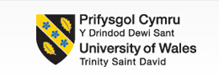

Organisation Consultancy（M6X01422）
Consultancy Project Report
- Research UNIQLO develops in the UK market

Name: Zhuoer Tan
Student ID: 1901688

Executive Summary
Uniqlo Co Ltd is a Japanese casual wear designer, manufacturer and retailer. Uniqlo currently has a large market share in the Asian market, but the development in the European market is not well organized with the same type, so Uniqlo looks forward to continued in the European market in the future Develop, improve your marketing methods, and expand more stores.

The goals of this article are:
The aim of this project is to establish a strategy to increase Uniqlo ’s market share in the UK.

Use the questionnaire to understand the most intuitive impression of the British people on Uniqlo. Through the investigation and statistical analysis of the samples, we have a more intuitive understanding of the future direction of Uniqlo in the UK.

To this end, this report analysis some internal and external factors that affect the development of the organization.
- SWOT Analysis:
S: The product quality is high, follow the low-cost high-quality marketing model to meet customer requirements.
W: The clothing design is too simple. A problem with the distribution structure has led to a backlog of products.
O: You can set your sights on the European market. Free trade is profitable.
T: In the European market, there are many companies of the same type and there is fierce competition.

- PEST Analysis:
P: The main reason for the current political factors is Brexit.
E: Influencing economic factors, such as inflation rate, exchange rate, interest rate, GDP.
S: Uniqlo can design clothes that suit the locals according to the local cultural environment and lifestyle.
T: In addition to expanding the market, innovation must also be guaranteed to be outdated.

- Potter's Five Force:
-Uniqlo has established some market awareness and brand reputation in the UK. It is difficult for new entrants to compete with Uniqlo.
-The threat of Uniqlo's potential alternatives is also small.
-The bargaining power of suppliers is very low.
-The buyer is a consumer and the bargaining power is low.
-Uniqlo is very competitive in the UK industry.

According to previous analysis:
- It can be found that the business models of Zara and H & M are very effective. Uniqlo can follow the business model developed by Zara and H & M to cope with current challenges.
- In addition, Uniqlo should establish strategic partnerships with local apparel companies and use e-commerce to attract consumers.

Table of Contents
Executive Summary 1
1.0 Introduction 1
1.2 UNIQLO History 1
2.0 Project Justification 2
2.1 Aim of the Project 2
2.2 Project Objectives 2
3.0 Research Methods 2
3.1 Primary Research Methodology- Questionnaire 2
3.2 What research was conducted and How was it conducted 3
3.3 Analysis Primary Research Results 4
3.4 Supplementary certificate of public information to the questionnaire survey 5
4.0 Environmental analysis 6
4.1 Micro-environment Analysis-SWOT Analysis 6
4.2 PEST Analysis on Uniqlo’s macro-environment in UK 8
4.3 Industry Analysis (under the framework of Porter’s five forces) 9
5.0 Findings and Discussion 12
5.1 Zara and H& M's marketing model in the UK 12
5.2 The rapid development of e-commerce platform 12
5.3 Strategic alliance with the local famous fashion brands 12
6.0 Conclusion 14
7.0 Recommendation 15
8.0 References 16
Appendix 1: SWOT Analysis 20
Appendix 2: SWOT matrix analysis 23
Appendix 3: PEST Analysis on Uniqlo’s macro-environment in UK 25
Appendix 4: Questionnaire 27
Appendix 5: Questionnaire Results 31

1.0 Introduction
With the rapid economic development, more and more companies will expand globally. Many expansion businesses have received widespread attention and become a commercial focus. The fast-growing fashion industry has come up with the enticing concept of "cutting edge designs at an affordable price" and has achieved great success in recent decades.

There are many clothing fast-selling stores in the UK and European markets, such as Zara, H&M, CAP. Uniqlo is Japan's leading clothing retail chain, which is at a profitable level in terms of sales and profits. One of the company's main qualities is to provide high-quality casual clothing at affordable prices and reasonable prices. The SPA (Private Apparel Private Retail Store) model has made it the top brand in Asia. However, compared to the rapid development of the Asian market, UNIQLO brand awareness in the UK is much lower than similar companies like Zara, H & M and others. As of 2019, UNIQLO currently has 13 stores in the UK. The ambitious expansion plan was canceled in the early 2000s, with 16 stores closed in 2003, including Manchester, Coventry and Leicester. UNIQLO opened a new store on Manchester Market Street in April 2019 (Dawson and Blakey, 2020).

1.2 Uniqlo History
Uniqlo is a Japanese casual wear designer, manufacturer and retailer. The company is a wholly owned subsidiary of Fast Retailing Co. Ltd. In November 1998, we opened UNIQLO City's first store in the fashionable Tokyo Harajuku area, and soon expanded to major cities throughout Japan. In 2001, sales and gross profit reached a new peak, with more than 500 retail stores in Japan. In 2002, the first UNIQLO store in China opened in Shanghai and four overseas stores opened in London, England. Due to overseas expansion in 2005, we opened stores in the United States, Hong Kong, and South Korea. The company aims to become the world's largest private label apparel retailer, with an annual growth rate of 20% (About UNIQLO | UNIQLO, 2020).

2.0 Project Justification
There are many express clothing stores in the UK and European markets, such as Zara, H & M, GAP. Uniqlo has made great strides in many countries and regions in recent years and has become the leading brand in Asia. However, compared to the rapid development of the Asian market in the UK, the brand awareness of Uniqlo is much lower than that of similar companies like Zara, H & M. Uniqlo currently has 13 stores in England as of 2019. Uniqlo has a much smaller market share in the UK than similar companies (Dawson and Blakey, 2020). Given the relatively large market in the UK, it is important to conduct a study and analysis on how Uniqlo can capture the UK market share.

2.1 Aim of the Project
The aim of this project is to establish a strategy to increase Uniqlo’s market share in the UK.

2.2 Project Objectives
- To analyse the current micro environment in the fast fashion industry in UK.
- To analyse the current competitors for Uniqlo in UK.
- To identify the problem of its current low market share in the UK.
- To Make recommendations to improve Uniqlo’s presence in the UK and increase their market share.

3.0 Research Methods

3.1 Primary Research Methodology- Questionnaire
The questionnaire is a research tool consisting of a series of questions, the purpose of which is to gather information from the interviewees. The questionnaire survey provides a relatively cheap, fast and effective way to obtain a lot of information from a large number of people (Saul, 2018).
The benefits of the questionnaire survey are many. First, it can save time, manpower and energy. Questionnaire survey is a structured survey method, the form of expression, the order of questions and the answers are all fixed. Secondly, the results of the questionnaire survey are easier to statistically process and analyze, and the survey samples are clearly displayed. It can also be analyzed and investigated through professional software (Juan, 2015).

However, the questionnaire survey is more difficult when designing the questionnaire. Sometimes it is difficult to understand the participant's purpose and thinking. Usually these questions are more difficult when designing the questionnaire. If there are open questions, the answers of the participants are uneven. It is difficult to collect and analyze the statistical results, and most participants are reluctant to write open questions (Juan, 2015).

3.2 What research was conducted and How was it conducted
In order to study Uniqlo's current market in the UK, we conducted a research on the understanding and suggestions of Uniqlo by the British people through google form. The questionnaire survey mainly focused on the UK's impression of Uniqlo, the frequency of purchases, and the price and style.

Due to special circumstances, the paper version of the questionnaire cannot be distributed. Therefore, this questionnaire survey is distributed online. The original plan was to issue 50 paper surveys offline and conduct simple interviews with those who filled out the survey. However, due to special circumstances, the online questionnaire was changed, so the target plan for the questionnaire was increased from 50 to 150.

The target plan was 150, and 140 were actually received, including 128 valid questionnaires. The questionnaire is divided into three modules, basic personal information, whether or not Uniqlo purchase experience, and some basic surveys of Uniqlo clothing, and comparison with similar brands (See Appendix 4). The self-selected method of probability sampling, specifically CAPI (computer-assisted personal interview), was used to present the questionnaire through a computer terminal and select the answers through the keyboard and touch screen. The statistical results are generated automatically, which reduces the labor load of the investigators.

In order to ensure the fairness of the participants, protect the privacy of the participants, and make the survey results universal, we provided a consent form before the questionnaire survey for all participants to read before filling out the questionnaire (see Appendix 4). In the statement before the questionnaire survey, the purpose of the questionnaire survey and the length of time spent were expounded. Before the questionnaire survey, an application has been submitted to the school.

3.3 Analysis Primary Research Results
The results of the questionnaire can be viewed in the chart in Appendix 5 of this report.

According to the analysis of the results of the questionnaire survey, according to the percentage of the results presented, the vast majority of people have shopping experience in Uniqlo. At the same time, there are a small number of people who do not know Uniqlo or know but have no purchase experience. Such participants directly ended the questionnaire and did not enter into detailed understanding. In addition, some people have a neutral attitude in answering some questions. The following is a detailed analysis of some specific issues.

According to the statistics of basic information, 42.28% of young people, the number of people in the two age groups of 30-49 years old and young people are almost the same. In the second survey, the number of students and full-time workers accounted for 87% of the total. Only 0.81% of people do not know Uniqlo. And 80% of people who know Uniqlo have purchase experience. The sample of this survey has certain reference, Uniqlo should continue to maintain this pricing strategy, and can launch some lower-priced products to improve customer spending power coverage.

First of all, for shopping, 77.55% will choose to shop in a physical store, and about 70% of people will go once a month. Most people spend between £10 and £50 on Uniqlo. One third of Uniqlo's clothing design and apparel prices are neutral, and one third are relatively satisfied. From this, Uniqlo has a competitive advantage in the same type of competition. Compared with Zara and H&M, 90% of Uniqlo ’s prices are acceptable, but 9% still think the price is a little expensive.
Secondly, for the same type of apparel companies, participants like Uniqlo and H & M the same degree, followed by Zara accounted for 37.76% of the overall, these three organizations are the people choose the most (Figure 1).
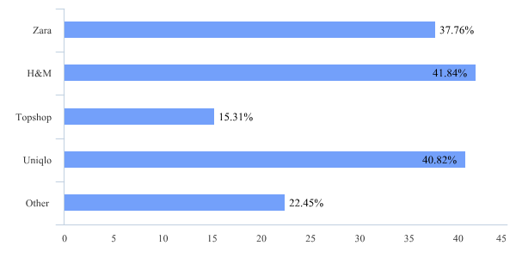
Figure 1：Daily shopping options

Finally, for future development, the vast majority of people hope that Uniqlo can improve their design. Simple and simple style is the current design direction of Uniqlo. Uniqlo on clothing design can be more youthful. In addition, choosing to open more physical stores and increase online shopping accounted for about 40% of the total (Figure 2). Currently in the UK, Uniqlo stores are mainly in large cities, and Zara and H & M have many stores in many small cities in addition to large cities, so opening more stores can make it develop faster in the future.
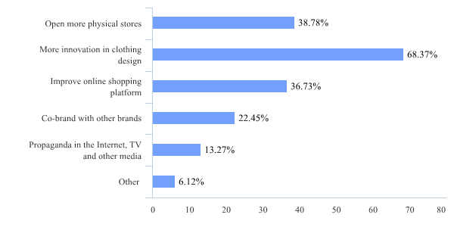
Figure 2：Statistics on Uniqlo's future expectations

3.4 Supplementary certificate of public information to the questionnaire survey
Uniqlo is a listed company. According to its public information, its pricing strategy mainly adopts the penetration pricing method. The so-called penetration pricing method mainly refers to attracting consumers with a low price, which can not only open the market quickly, but also retain consumers. Our questionnaire also reflects the conclusion that low price and high quality give them a high competitive advantage. This strategy can not only open up brand awareness, but also prevent competitors from entering the field.

Uniqlo's product positioning is similar to that of H&M and Zara. Uniqlo's products meet the needs of the public by combining the joker concept and high-quality fabric design. Our survey results also found that the customers of the above three companies have a high degree of coincidence. "Our fans often post information about new products and events on social media through videos, encouraging others to start buying Uniqlo products," Uniqlo said.

This positive published online in the young consumers of sensitive to fashion especially active ", "about the new strategy, we plan to continue in China, commonly known as" a line "the city of Beijing, Shanghai, Guangzhou and Shenzhen) open stores, and actively in the" second line "city (such as Hangzhou, Nanjing, Wuhan, , Xi 'an and Chengdu." The findings suggest that Uniqlo is right to expand outside the big cities.

4.0 Environmental analysis

4.1 Micro-environment Analysis-SWOT Analysis
SWOT analysis is a framework for analyzing a company's competitive position in its business environment. Including identifying its internal strengths and weakness, and then identifying the opportunities and threats it faces in a broad business environment (Rauch, 2007).

The main advantage of using SWOT analysis is low cost or no cost, anyone who is familiar with the organisation's business can perform SWOT analysis (Benefits and limitations of SWOT analysis, 2017). SWOT analysis helps to formulate and select strategies. Successful companies rely on their own strengths to correct their own disadvantages and prevent internal disadvantages and external threats. They also focus on the overall business environment and discover and use new opportunities faster than their competitors (SWOT Analysis-Definition, Advantages and Limitations, 2015).

SWOT analysis is not without its limitations. This may cause the organisation to treat the situation as very simple, so the organisation may ignore some key strategic connections that may occur. In addition, due to the great uncertainty in the market, it may be very subjective to divide aspects into advantages, disadvantages, opportunities and threats (Benefits and limitations of SWOT analysis, 2017).

Uniqlo is one of the leading companies in the industry, and it needs to maintain this position and use it to make strategic decisions. SWOT analysis of the organization (see Appendix 1) requires an interactive process through coordination between all departments of the company (such as finance, marketing, operations, human resources, etc.).

The reason why Uniqlo can become one of the leading in the industry, first of all, they use effective global materials, so that the quality of the products is very high. Secondly, it has always followed a low-cost, high-quality marketing model to make product design meet customer requirements and global market trends (Panagiotou, 2003). But because the Japanese are committed to simple but practical clothing, in the field of fashion penetration (for example, London, Paris and New York), this may be the main weakness in the organisational development process. Another weakness is the problem of organisational distribution structure, which makes inventory difficult to consume and eventually leads to a backlog (Panagiotou, 2003). Globalization has provided opportunities for the apparel industry to expand overseas. Uniqlo currently has a large market share in the Asian market. The company's current development direction is the European market, and free trade is considered profitable (Graham, 2008). The organisation currently has fierce competition with all other apparel companies of the same type, especially in the European market. There are already very successful organisations, and Uniqlo will be more threatened (Panagiotou, 2003).

SWOT analysis listed Uniqlo's strengths, weaknesses, opportunities and threats, but did not tell management what to do. To overcome this limitation and help formulate appropriate strategies, SWOT matrix analysis was used (see Appendix 2). The S-O strategies, which involve taking advantage of opportunities to take advantage of; S-T strategies, which involve using advantages to deal with threats; W-O strategies, which involve converting opportunities into weaknesses by taking advantage of opportunities; W-T Strategies involves overcoming weaknesses to avoid threats.

4.2 PEST Analysis on Uniqlo’s macro-environment in UK
PEST analysis (political, economic, social, and technical) is a management method by which organizations can assess the main external factors that affect their operations and thereby become more competitive in the market (PEST Analysis, 2020).

The advantage of PEST analysis is the strategic planning method to reduce business threats. After analysis and evaluation, enterprises will gain valuable advantages. These advantages contribute to the conception stage, product development, product launch, content marketing strategy, and other factors to increase the success rate (Frue, 2016).

External factors will change over time and require constant attention and review. Because external factors are based on assumptions and macroeconomic conditions, they become an obstacle to the transparency of PEST analysis and make it prone to differences. The organization may need to hire relevant R & D personnel to help the company make countermeasures and inform the government about the company. This will increase the cost of the organization, and these tasks require extensive teams and investment. This is an important limitation (Contributor, 2016).

PEST analysis makes a comprehensive assessment of Uniqlo's European market, and does a comprehensive analysis of future market share increase. For a detailed analysis, see Appendix 2.

Many political factors affect the profitability or survival of a business. Political risks range from sudden changes in the existing political system to civil war to important government decisions (Baker, 2014). In the case of a possible multinational, political factors can be taken into account which affect not only the host country, but also all the countries which involve commercial activities or trade with Uniqlo (Pestel Analysis Of Uniqlo, 2018).

Economic factors are all factors related to the economy of the country in which Uniqlo is located, such as inflation, exchange rate, interest rate, GDP and changes in the current phase of the economic cycle ( Baker, 2014). In general, these factors and their impact on aggregate demand, total investment and the business environment are likely to result in high profits for a business or very likely to suffer losses.

The social factors that influence Uniqlo directly reflect the society in which Uniqlo is located and cover the culture, beliefs, attitudes and values ​​that most people have as a community. The influence of social factors is not only important for the functioning of Uniqlo, but also for the marketing of the organization (Baker, 2014). A deep understanding of customers, their lifestyle, their level of education and their belief in a company or a social group helps to design products and marketing messages and thus to make the business prosper.

Technology can quickly eliminate the price structure and competitive landscape of the industry (Baker, 2014). Continuous innovation is therefore very important not only to maximize profits and become the market leader, but also to avoid obsolescence in the near future.

4.3 Industry Analysis (under the framework of Porter’s five forces)
Porter’s five force analysis can be used to analyze the micro environment in UK and to analyze the competitor situation.

Porter’s five forces analysis is chosen since it is a widely used model to analyze the micro environment factors. It can help the business to identify the competitive situation in the micro industry. It analyzed the micro industry from five aspects. They are the threats from new entrants, threats from potential substitutes, industry rivalry, consumer power and buyer powers.

Threats from new entrants
Threats from new entrants are small. New entrants can enter into this industry with relatively low level of investment. However, Uniqlo has occupied some markets and has accumulated some consumer basis in UK. Uniqlo has built some market awareness and brand reputation in UK. In this condition, there are some difficult for new entrant to compete with Uniqlo (Trehan & Mehta, 2014). As Uniqlo is a multinational corporation, it can gain some benefits from the economies of scales and the global operation. IT has the advantages in that it has manufacturing factories in China and some Asian countries. It can use the low labor force prices. Moreover, Uniqlo also has designers around the world. These competitive advantages caused by the large size decrease the threats from new entrants.

Threats of substitutes
There is no close substitute for the industry. Some possible substitutes include the sports wear products. However, they are not as fashionable as the products provided in the fast fashion industry (Roosens & Dens, 2019). As a result, the threats for potential substitutes are also low.

In addition, another kind of substitutes for the offline retailing services provided by Uniqlo is the online retailing service. The online retailing service tends to generate high threats as consumers prefer the online shopping due to its convenience and cost effective. Online retailing can also provide a large variety of goods for consumers to choose (Choi, 2011). Threats from this substitute is intensive.

Bargaining power of suppliers
Suppliers are of small scale and they usually provide clothes, raw materials and so on. The suppliers are not able to generate differentiation. The bargaining power of suppliers is low.

Bargaining power of buyers
Buyers are individual consumers. They purchase only small amount of products. This decreases their bargaining powers. However, the rapid development of Internet increases the information transparency (Myles, 2020). In addition, consumers can easily change to other businesses in the market, like H&M, Zara and so on. As a result, the bargaining power of buyers is increased in this condition.

Industry Rivalry Among Existing Competitors
The industry rivalry is intensive. There are many large scale and international fast fashion businesses in this industry. For example, Zara and H&M are two of the largest fast fashion retailers in the world. They are able to provide fashionable clothes at high speed and at ow prices to consumers (Shu-Fang et al, 2019). They are able to attract consumers who are in needs of fashionable clothes at low prices. They also occupy a large market share in the UK fast fashion retailers. As a result the industry rivalry is very intensive in UK.

5.0 Findings and Discussion

5.1 Zara and H& M's marketing model in the UK
Uniqlo can follow the model of Zara and H&M in terms of the operation in UK. Just as discussed before H&M and Zara have built high success in UK and they have adopted the effective business model of providing fast fashion products at low price and quick speed. They adopted effective business model, which is able to provide highly fashionable items within a short time. They can decrease the time from designing to the provision to the consumers within a short time (Usui, Kotabe & Murray, 2017).. They also use the effective technology management to collect information from stores and from the markets about the sales performances and the preferences and demands of consumers. They make quick adjustment on the clothes design and styles to be in line with the preference and demand of consumers (Kim, 2013). This can keep their clothes to be trendy and fashionable. It is important for Uniqlo to adopt effective methods to follow this model and to provide clothes that are in line with the demands of consumers and the most popular trend.

5.2 The rapid development of e-commerce platform
Just as discussed before, the threats from online substitutes are serious. Some online retailers can able to use the e-commerce platform to provide convenient online shopping services to consumers. To deal with this intensive threat from the rapid development of online retailers (Huang, Kobayashi & Isomura, 2014). Uniqlo should also develop its own e-commerce platform. Such development is conductive for Uniqlo to grasp the demands of consumers for the convenient and cost effectiveness in online shopping. Uniqlo can also provide a large variety of clothes to consumers through online stores. Moreover, Uniqlo can also save costs in the delivery of products and goods to consumers through online shopping (Shu-Fang et al, 2019. Uniqlo does not need to spend costs in the physical stores or to hire a large amount of human resources. The online platform can conveniently deal with the online payment and services process with a small amount of labor forces. In such condition, Uniqlo can use the e-commerce platform to save costs as well.

5.3 Strategic alliance with the local famous fashion brands
Anther possible strategy for Uniqlo to deal with the current intensive industry conception is to build strategic alliance with the local famous fashion brands. Uniqlo can use the popularity and famous of these highly popular brands to increase the trusts and preferences of consumers to Uniqlo’s clothes. Uniqlo can build strategic partnership with them in order to cooperate in the designing of fashionable and trendy clothes to consumers (Myles, 2020). Uniqlo can also use the local resource and local knowledge of these partners n providing high quality clothes to consumers. As a multinational retailer, Uniqlo can provide the global logistics and supply chain to them. As a result, such strategic partnership can bring mutual benefits to Uniqlo and the local famous fashion businesses. These strategies can help Uniqlo to properly deal with the intensive competition in the market.

6.0 Conclusion
In summary, this report analyzes how Uniqlo is able to deal with the intensive competition in the market. This report conducts a Porter’s five force analysis on Uniqlo to analyze the micro industry environment for Uniqlo in the fast fashion industry in UK. At the same time, the internal and external environment of the company is analyzed through PEST analysis and SWOT analysis. Based on the above analysis, it can be found that there are intensive industry rivalry in this industry and high bargaining powers from consumers. The threats from online shopping as a substitute are also intensive. Based on the above analysis, three recommendations are made. It is recommended that the business should take effective actions to follow the business model of Zara and H&M to provide fast fashion clothes to consumers. To deal with the competition in Uniqlo and to deal with the increasing demands of consumers for fashionable and attractive clothes, it is also important for Uniqlo to follow the business model adopted by Zara and H&M. In addition, Uniqlo can also use the online platforms and e-commerce to provide convenient and cost effective online shopping services to consumers. Uniqlo can also build strategic partnership with the local fashion businesses. Uniqlo can use their local resources and their reputation in UK to contribute to its own success in UK. Moreover, co-branding strategy can be adopted to strengthen the brand image and brand reputation of each other. This method can also be used to improve the favorable attitudes of consumers to the brand.

7.0 Recommendation
If Uniqlo want to develop better in the UK, it must first plan your own clothing design. Japan ’s design style is simple and simple, and it is mainly comfortable. However, if you want to occupy a certain market share in the UK, then the clothing design need to cater more to the British aesthetic. Secondly, in store expansion and online shopping, we need to follow good development, not only in large cities, but also in other small cities to open stores, improve brand awareness, attract more consumers, and develop electronic Business platform to do all after-sales services.

8.0 References
Baker, M., 2014. Marketing Strategy And Management. New York: Palgrave Macmillan.

Business.qld.gov.au. 2017. Benefits And Limitations Of SWOT Analysis | Business Queensland. [online] Available at: <https://www.business.qld.gov.au/starting-business/planning/market-customer-research/swot-analysis/benefits-limitations> [Accessed 28 April 2020].

Contributor, P., 2016. Potential Limitations Of The PEST Analysis And How To Address Them. [online] PESTLE Analysis. Available at: <https://pestleanalysis.com/limitations-of-the-pest-analysis/> [Accessed 28 April 2020].

Chiang, I., Tsai, K., Wong, R., & Wu, Y. (2018). Exploring the benefits of social media marketing on brands and communities: The case of famous brands. Xing Xiao Ping Lun, , 417-461.

Choi, E. K. (2011). THE RISE OF UNIQLO: LEADING PARADIGM CHANGE IN FASHION BUSINESS AND DISTRIBUTION IN JAPAN. Entreprises Et Histoire, (64), 85-101,3,204-205.

Dawson, H. and Blakey, A. (2020). Hundreds of excited shoppers queued for Uniqlo store opening. [online] men. Available at: https://www.manchestereveningnews.co.uk/whats-on/shopping/hundreds-excited-shoppers-queued-along-16178614 [Accessed 17 Feb. 2020].

Dyson, R. G. (2004). Strategic development and SWOT analysis at the University of Warwick. European journal of operational research, 152(3), 631-640.

Frue, K., 2016. The Advantages Of PESTLE Analysis. [online] PESTLE Analysis. Available at: <https://pestleanalysis.com/advantages-of-pestle-analysis/> [Accessed 28 April 2020].

Huang, P., Kobayashi, S., & Isomura, K. (2014). How UNIQLO evolves its value proposition and brand image: Imitation, trial and error and innovation. Strategic Direction, 30(7), 42-45.
Investopedia. 2020. PEST Analysis. [online] Available at: <https://www.investopedia.com/terms/p/pest-analysis.asp> [Accessed 27 April 2020].

Kim, B. (2013). Competitive priorities and supply chain strategy in the fashion industry. Qualitative Market Research, 16(2), 214-242. doi:http://dx.doi.org/10.1108/13522751311317602

Myles, E. L. (2020). “Cool” workings: Glamour labor and identity issues in fashion branding. Fashion Theory, 24(2), 163-180. doi:http://dx.doi.org/10.1080/1362704X.2018.1488415

Nixon, J., & Helms, M. M. (2010). Exploring SWOT analysis – where are we now?: A review of academic research from the last decade. Journal of Strategy and Management, 3(3), 215-251.

Panagiotou, G. (2003). Bringing SWOT into Focus. Business Strategy Review, 14(2), 8-10.
Pickton, D. W., & Wright, S. (1998). What's swot in the strategic analysis? Strategic Change, 7(2), 101-109.

Rauch, P. (2007). SWOT analyses and SWOT strategy formulation for forest owner cooperation in Austria. European Journal of Forest Research, 126(3), 413-420.

Roosens, B., & Dens, N. (2019). When do social alliances pay off? how the effect on corporate image depends on consumers’ prosocial attitudes. Journal of Brand Management, 26(2), 195-208.

Saul, M., 2018. Questionnaire: Definition, Examples, Design And Types | Questionpro. [online] QuestionPro. Available at: <https://www.questionpro.com/blog/what-is-a-questionnaire/> [Accessed 27 April 2020].

Survey Anyplace. 2018. 10 Advantages And Disadvantages Of Questionnaires - Survey Anyplace. [online] Available at: <https://surveyanyplace.com/questionnaire-pros-and-cons/> [Accessed 27 April 2020].

Studymode.com. 2018. Pestel Analysis Of Uniqlo Free Essays. [online] Available at: <https://www.studymode.com/subjects/pestel-analysis-of-uniqlo-page1.html> [Accessed 18 April 2020].

Shu-Fang, L., Liu, H., Jung-Hua, C., & Han-Ni, C. (2019). Analysis of a new visual marketing craze: The effect of LINE sticker features and user characteristics on download willingness and product purchase intention. Asia Pacific Management Review, 24(3), 263-277.

Trehan, G., & Mehta, D. (2014). CHANGING THE FASHION WORLD A ZARA CASE STUDY. Sansmaran Research Journal, 4(2), 39-54.

theintactone.com. 2018. Porter’S Five Forces Model. [online] Available at: <https://theintactone.com/2018/04/21/sm-u2-topic-5-porters-five-forces-model/> [Accessed 25 April 2020].

Uniqlo.com. 2020. About Uniqlo | UNIQLO. [online] Available at: <https://www.uniqlo.com/eu/en/company/> [Accessed 28 April 2020].

Usui, T., Kotabe, M., & Murray, J. Y. (2017). A dynamic process of building global supply chain competence by new ventures: The case of uniqlo. Journal of International Marketing, 25(3), 1.

Weihrich, H. (1999). Analyzing the competitive advantages and disadvantages of Germany with the TOWS Matrix-an alternative to Porter’s Model. European Business Review, 99(1), 9-22.

Weihrich, H. (1982). The TOWS matrix—A tool for situational analysis. Long Range Planning, 15(2), 54-66.

Wilson, R., Gilligan, C., & Pearson, D. (1992). Strategic Marketing Management. Butterworth-Heinemann: Oxford.

Appendix 1: SWOT Analysis
S  Strength | - Cost structure: Uniqlo implements a low-cost structure. Low production costs and low selling prices have attracted more consumers and expanded consumer groups.  - Social media: Uniqlo has a strong influence on social media, with more than millions of followers on three of the most famous social media platforms: Facebook, Twitter and Instagram. It has a high level of customer engagement on these platforms.  - Uniqlo is a brand that has been on the market for many years and its brand awareness is very high.  - Financial status: Uniqlo ’s current financial situation is good, it has continued to make profits in the past five years, and it has accumulated profit reserves that can be used for future capital expenditures.  - Product portfolio: Uniqlo has a wide range of product portfolios that can provide a wide range of products. It has unique products that many competitors cannot provide.  - Uniqlo has many intellectual property rights including trademarks and patents. These make it exclusive in the product, competitors can not copy or reverse engineer the product.
W  Weaknesses | - The Japanese are committed to simple yet practical clothes with minimalist details. But it is also the main disadvantage of its penetration into the fashion field (such as London, Paris), and its fashion elements are very limited.  - High employee turnover: Uniqlo has higher employee turnover compared to competitors. This means it has more people leaving, so as employees continue to leave and join, it spends more on training and development.  - Uniqlo currently has a low inventory distribution volume, which means it needs to rely on inventory to increase unnecessary costs.  - Market research: In the past two years, Uniqlo has never conducted market research in the markets it serves. As a result, it will make decisions based on 2 years of data, and customer needs may change over time.  - A few products have a higher market share, while most products have a lower market share. If these products suffer losses for any reason, the dependence on a few products will make Uniqlo vulnerable to external threats.  - The workload of each worker is very high, because the workers are less than the actual workload. This puts workers under psychological pressure and productivity may decrease. In recent years, with the development of company culture and politics, the morale of employees has been low.
O  Opportunities | - Internet: The number of Internet users worldwide has increased. This means Uniqlo has the opportunity to expand its online business; interact with customers by using the Internet.  - E-commerce: New trends have emerged in the e-commerce industry, and sales have also increased. This means that many people now shop online. Uniqlo can earn income by opening online stores and selling through those stores.  - Globalization: The increase in globalization has not limited Uniqlo to its own country. It can expand its business to other countries, enter these markets and take advantage of opportunities in these markets.  - Inflation: The inflation rate has been very low and is expected to remain low for the next two years. This is an opportunity for Uniqlo because its input costs will remain low in the next two years.  - Interest rate: Compared with previous years, the lower interest rate provides Uniqlo with the opportunity to carry out loan-funded expansion projects at a lower interest rate.
T  Threats | - Competitors: In the UK, there are many similar companies, such as Zara, H & M, and they now have a higher market share in the UK than Uniqlo. When there are many companies of the same type, competition intensifies. In terms of price, if Uniqlo adapts to price changes, this may lead to lower revenue and loss of market share.  - Exchange rate: The exchange rate has been fluctuating, which affects companies like Uniqlo, which sells globally while suppliers are local. The country ’s changing interest rates do not provide a stable financial and economic environment.  - Suppliers: Over the years, as the number of suppliers has decreased, suppliers ’bargaining power has improved. This means that the input cost of Uniqlo may increase.  - The increase in fuel prices increases the input cost of Uniqlo. These costs have also increased because other industries that provide inputs to the company have also suffered the effects of rising fuel prices, which has resulted in higher fees.

Appendix 2: SWOT matrix analysis
 | Strength:  1. It has a strong influence on social media.  2. It has a low-cost structure and therefore has a competitive advantage.  3. Uniqlo has a broad product portfolio and can provide various types of products.  4. Its financial condition is good, it has been profitable in the past few years, and it has a strong asset base.  5. Brands that have been on the market for many years have high brand awareness. | Weakness:  1. Most of the property that Uniqlo is using is for rent, and the rent needs to be paid.  2. Compared with competitors, the expenditure for research and development is less. The fashion elements of clothing are very limited.  3. Its employee turnover rate is high, employee motivation and job morale are low.  4. It has liquidity problems and a low quick ratio; the level of current assets is less than current liabilities. It also faces cash flow problems.
Opportunities:  1. Internet users around the world are increasing. As Internet use has increased, so has e-commerce.  2. Customers and consumers are growing globally.  3. Household income is increasing and consumer spending is also increasing. The inflation rate in the economy is expected to remain low.  4. Low interest rate, which provides investment opportunities for large projects. | S-O Strategy:  1. Increase marketing to attract consumers to spend money.  2. Use the image on social media for marketing and attract customers to visit their websites.  3. Develop environmentally friendly products at low cost through innovation, so that they can be sold at low prices.  4. Sell products at low prices by offering discounts. This will help increase sales and is feasible due to lower inflation and costs. | W-O strategy:  1. Financing property ownership through low interest rates to increase the ratio of owned property to leased property.  2. Increase salary, provide employees with incentives and benefits to reduce staff turnover and improve work morale. This is possible because of the current low cost.
Threats:  1. Low market share in Europe.  2. The exchange rate fluctuates greatly and is unstable.  3. In recent years, the price of fuel has risen, causing the cost price to increase.  4. Competition in the industry is intensifying and more and more competitors are appearing. | S-T strategy:  1. Use a strong distribution network to reach customers and compete with newcomers.  2. Use its strong financial position to invest in intellectual property. This will help to compete with the increasingly fierce market.  3. Use its innovation team to find cheaper fuel alternatives so that they can be used, thereby reducing costs. | W-T strategy:  1. Increase research and development spending so that Uniqlo can better compete with competitors.  2. Provide incentives to increase engagement or provide a better working environment to retain talent. This will ensure that employees will not leave and join competitors.

Appendix 3: PEST Analysis on Uniqlo’s macro-environment in UK
P  Political | - At present, Brexit is complete and British political development is stable. The British tax is 20%. As a low-cost fast-selling brand, it cannot maximize profits in the first few years of expansion.
E  Economic | - The UK ’s GDP has been on the rise in the past 10 years, and Uniqlo ’s future development in the UK may be very good.  - For multinational companies, the exchange rate will directly affect the company's profits. Britain has already completed the Brexit operation. At present, the exchange rate of the United Kingdom is stable. Uniqlo's expansion in the UK is profitable for investors.  - Uniqlo's price and quality characteristics are of strategic significance; Uniqlo's private-brand clothing franchise store retailer (SPA) model, which integrates low-cost but effective operating models across the company, makes people look at fashion Confident world-class clothing.
S  Social | - Design clothing in line with British aesthetics, and understand the UK, develop products and services to attract more customers and consumers.  - The UK has a large number of visitors each year and a large number of Asian students, so the UK is a good target market for Uniqlo.  - In the United Kingdom, where international brands are concentrated, this type of fast-selling clothing store will attract more general consumers, so using this, it should provide high-quality, comfortable and affordable clothing.
T  Technology | - Innovation is a top priority for the apparel retail industry. While innovating, a large amount of labor is required to ensure that production efficiency can be improved.  - According to EmpathyBroker ’s UK consumer survey (a market survey of 3,000 adult consumers in the UK), 51% of consumers said they prefer online shopping to offline shopping, so Uniqlo should optimize its website. In addition to providing a shopping platform, It also allows customers to provide feedback via email and discussion forums on the site (Cifnews.com, 2018).

Appendix 4: Questionnaire
Research UNIQLO develops in the UK market
Dear Participant:
My name is Zhuoer Tan and I am studying in the School of University of Wales Trinity Saint David.

I would like to invite you to participate in my research project. This project will research on Uniqlo's market development in the UK and aims to achieving Uniqlo's expansion in the UK

*Attached to this letter is a short questionnaire developed by UWTSD which will assess British natives' design, quality and price of clothing. I believe your opinions will be extremely helpful to me.

All questionnaires will be kept strictly confidential to the researchers involved and at NO time will individual questionnaires be released to the general public. This gives you a chance to express your views on your program a confidential and anonymous forum and still be able to make a difference. Your participation in this study is completely voluntary so you can withdraw from the questionnaire at any stage.

Our questionnaire should take about 5 minutes to complete, but there is no time constraint. There are also no right or wrong answers. Attached to this letter along with the questionnaire is instruction sheet. As this is a new project, your feedback is also important to us and we would be much obliged if you could also complete the feedback sheet along with the questionnaire. We understand that your time is at a premium but your opinions are very valuable to us.

After careful and precise analysis of the data obtained from this questionnaire, I will be happy to provide you with a copy of the findings at your request. The results of this questionnaire will hopefully enhance my understanding of Uniqlo in UK Market and will be stored on school website. The results of the research will be fed back to School.

We thank you in advance for your time and participation. If any questions do arise, feel free to contact me at 1901688@student.uwtsd.ac.uk.
1. What is your gender ?
○Female
○Male
○Prefer not to answer

2. What is your age ?
○Less than 18 years old
○18-29 years old
○30-39 years old
○40-49 years old
○More than 50 years old

3. What is your occupation?
○Student
○Full-time work
○Part-time work
○Retired
○Unemployed
○Other _________________

4. Do you know Uniqlo?
○Yes (Skip to Question 5)
○No (Please jump to the end of the questionnaire and submit the answer sheet)
○Maybe (Skip to Question 5)

5. Have you bought clothes at Uniqlo?
○Yes (Skip to Question 6)
○No (Please jump to the end of the questionnaire and submit the answer sheet)

6. Do you prefer to shop online or in a real store?
○Online
○Real store
○Other _________________

7. How often do you go to Uniqlo？
○Once a week
○Once a month
○Two to three times a month

8. How much you have spent in Uniqlo at a time?
○Less than £10
○£10 - £50
○£50 - £100
○More than £100

9. Are you satisfied with Uniqlo's clothing design and style?
○Dissatisfied | ○2 | ○3 | ○4 | ○Very satisfied

10. Do you think Uniqlo's clothing quality is good?
○Poor quality | ○2 | ○3 | ○4 | ○Very good quality

11. Do you think the price of Uniqlo is acceptable to you compared to Zara and H&M?
○Acceptable
○Slightly expensive
○Expensive

12. Do you think Uniqlo has fewer stores in the UK?
○Yes
○No
○Do not know much

13. Zara, H&M, Topshop, Uniqlo, which store do you visit most often? [Multiple choice]
□Zara
□H&M
□Topshop
□Uniqlo
□Other _________________

14. What do you expect from Uniqlo's future development? [Multiple choice]
□Open more physical stores
□More innovation in clothing design
□Improve online shopping platform
□Co-brand with other brands
□Propaganda in the Internet, TV and other media
□Other _________________

Appendix 5: Questionnaire Results
Question 1: What is your gender？*
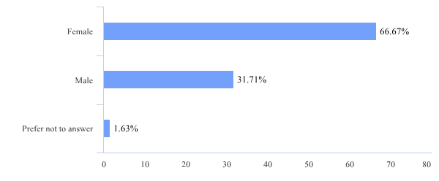
Question 2: What is your age?*
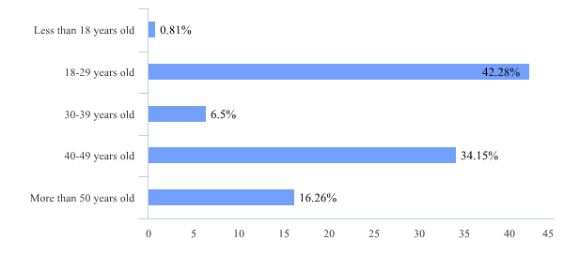
Question 3: What is your occupation?*
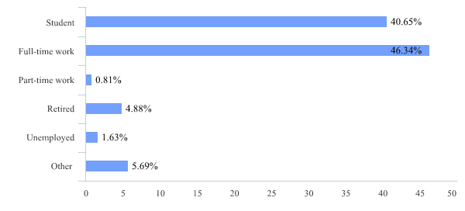
Question 4: Do you know Uniqlo?
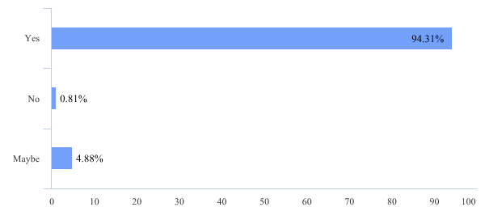

Question 5: Have you bought clothes at Uniqlo?
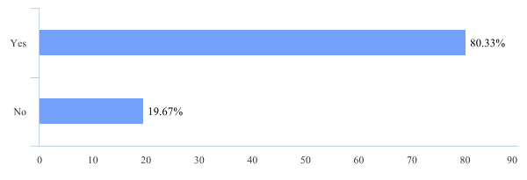

Question 6: Do you prefer to shop online or in a real store?
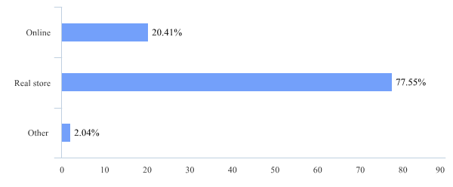

Question 7: How often do you go to Uniqlo?
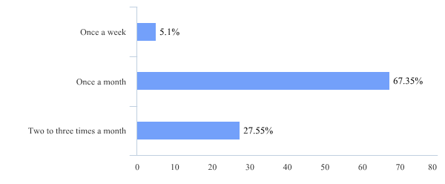

Question 8: How much you have spent in Uniqlo at a time?
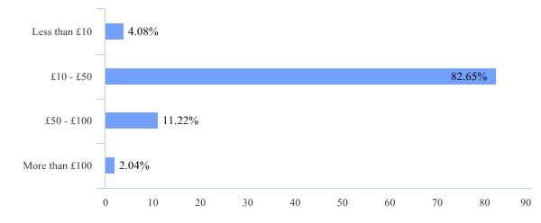

Question 9: Are you satisfied with Uniqlo's clothing design and style?
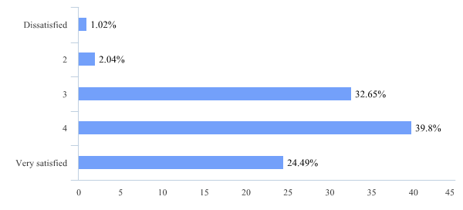

Question 10: Do you think Uniqlo's clothing quality is good?
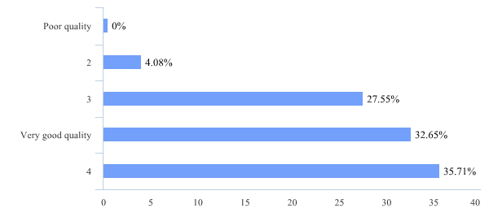
Question 11: Do you think the price of Uniqlo is acceptable to you compared to Zara and H&M?
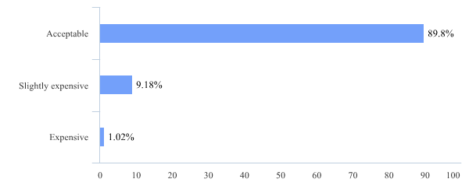

Question 12: Do you think Uniqlo has fewer stores in the UK?
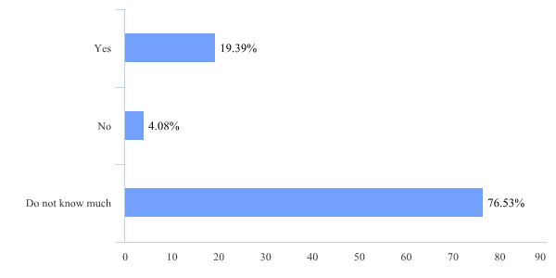

Question 13: Zara, H&M, Topshop, Uniqlo, which store do you visit most often?

Question 14: What do you expect from Uniqlo's future development?

