Appendices
Appendix 1: Electives Experience Handbook


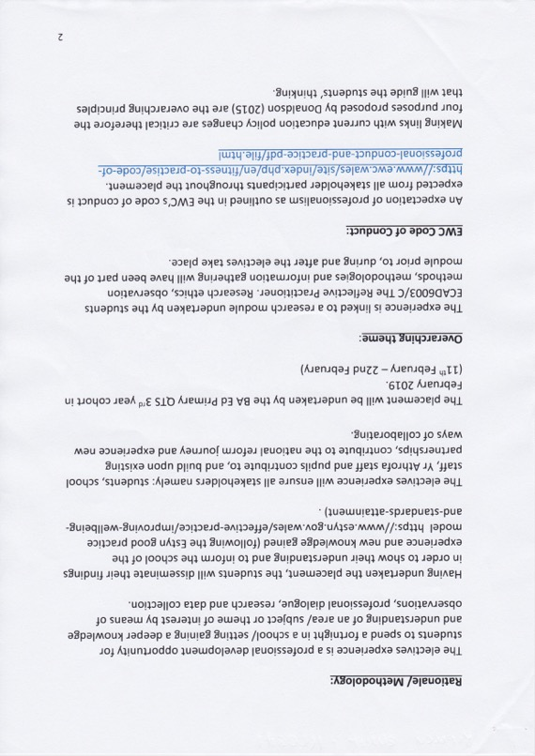

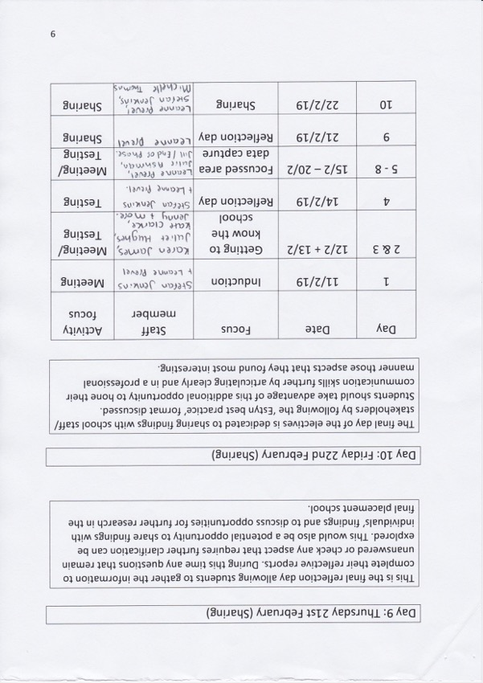

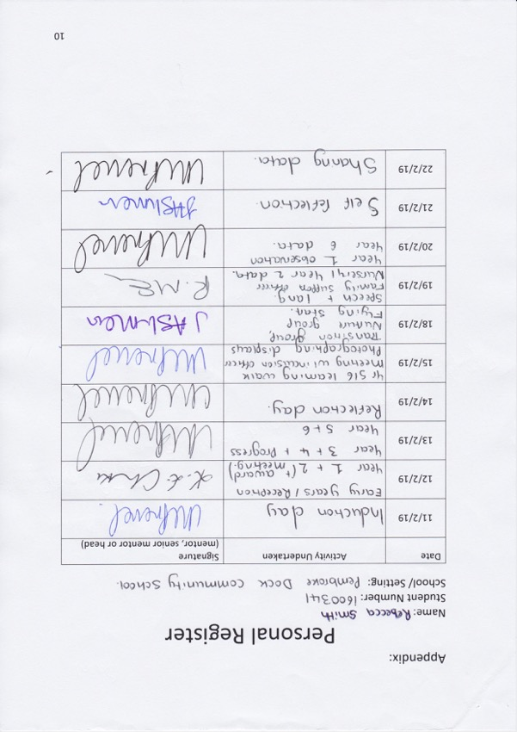



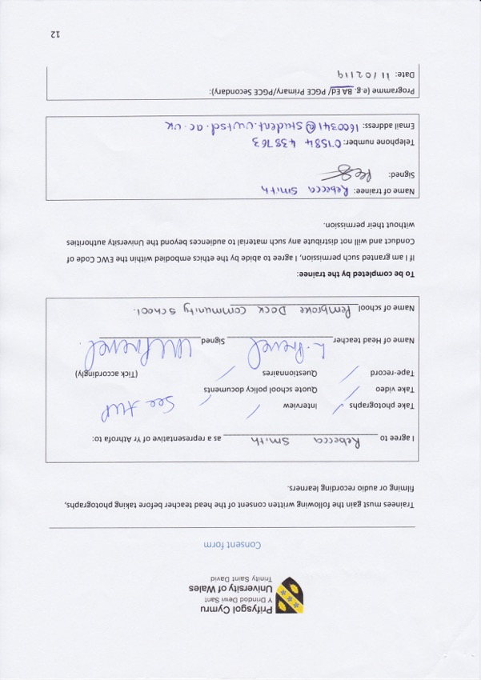

Appendix 2a: Ethics Form

APPLICATION FOR ETHICAL APPROVAL
In order for research to result in benefit and minimise risk of harm, it must be conducted ethically. A researcher may not be covered by the University’s insurance if ethical approval has not been obtained prior to commencement.
The University follows the OECD Frascati manual definition of research activity: “creative work undertaken on a systematic basis in order to increase the stock of knowledge, including knowledge of man, culture and society, and the use of this stock of knowledge to devise new applications”. As such this covers activities undertaken by members of staff, postgraduate research students, and both taught postgraduate and undergraduate students working on dissertations/projects.
The individual undertaking the research activity is known as the “principal researcher”.
Ethical approval is not required for routine audits, performance reviews, quality assurance studies, testing within normal educational requirements, and literary or artistic criticism.
Please read the notes for guidance before completing ALL sections of the form. This form must be completed and approved prior to undertaking any research activity. Please
see Checklist for details of process for different categories of application.
SECTION A: About You (Principal Researcher)
PG2 / E1 FORM
Full Name: |  |  |  | Rebecca Emma Smith
Tick all boxes which apply:
Member of staff: | ☐ |  | Student: | ✓  | Honorary research fellow: |  | ☐
Faculty/School/Centre: |  |  |  | YR ATHROFA
Campus: |  |  |  | Carmarthen
E-mail address: |  |  |  | 1600341@student.uwtsd.ac.uk
Contact Telephone Number: |  |  |  | 07584 438763
For students:
Student Number: |  | 1600341 |  | Undergraduate |  | ✓ 
Programme of Study: |  | BA Primary Education (QTS) |  | Taught Postgraduate |  | ☐
Director of Studies/Supervisor: |  | Dr Sioned V Hughes |  | Research |  | ☐
SECTION B: Approval for Research Activity
Has the research activity received approval in principle? (please check the Guidance Notes as to the appropriate approval process for different levels of research by different categories of individual) | YES | ✓  | NO | ☐
 |  |  | Date
If Yes, please indicate source of approval (and date where known): | Research Degrees Committee | ☐
 | Faculty Research Committee | ☐
 | Other (write in) Module Coordinator, ECAD6003, ITET | ✓  | 08/02/19
Approval in principle must be obtained from the relevant source prior to seeking ethical approval. July 2017 1 Ethical Approval Form v6
SECTION C: External Ethical Guidance Materials
SECTION D: External Collaborative Research Activity
Where research activity is carried out in collaboration with an external organisation
SECTION E: Details of Research Activity
PG2 / E1 FORM
Please list the core ethical guidance documents that have been referred to during the completion of this form (including any discipline-specific codes of research ethics, and also any specific ethical guidance relating to the proposed methodology). Please tick to confirm that your research proposal adheres to these codes and guidelines.
The research is within the bounds of the normal classroom and in accordance with the Athrofa guidelines for parental consent as per Athrofa letter. |  |  |  | ✓ 
The research will be conducted within BERA (British Educational Research Association) guidelines- Ethical Guidelines for Educational Research, (2018). |  |  |  | ✓ 
The research will adhere to the University research guidelines. |  |  |  | ✓ 
The research will adhere to the Education Workforce Council guidelines. |  |  |  | ✓ 
Does the research activity involve collaborators outside of the University? |  | YES |  | ☐ | NO | ✓ 
If Yes, please provide the name of the external organisation and name and contact details for the main contact person:
Institution
Contact person name
Contact person e-mail address
Does this organisation have its own ethics approval system? | YES |  | ☐ | NO |  | ✓ 
If Yes, please attach a copy of any final approval (or interim approval) from the organisation
Indicative title: | An exploration into the effects of poverty on wellbeing of primary school children. Sub questions: Exploring disadvantaged pupils’ motivations to learn and future aspirations.  Exploring the involvement of disadvantaged children in their learning. Exploring disadvantaged pupils’ engagement in rich experiences (extra- curricular activities/ visits to museums/ visits abroad). Do disadvantaged pupils show resilience and how do they deal with their wellbeing?  Do disadvantaged pupils have a lack of cognitive stimulation?
Proposed start date: | 11/02/19 |  |  | Proposed end date: |  | 29/04/19
Purpose of research activity (including aims and objectives)
Outline the purpose, aims and objectives of the research activity, including key research questions, as research as previously mentioned. Show briefly how existing research has informed the proposed activity and explain what the research activity will add and how it addresses an area of importance. (Maximum 300 words)
The research project aims to explore whether there is any correlation between poverty and wellbeing, in primary aged children. The research aims to capture the views of our current generation of practitioners and students in order to contribute to an informed dissertation regarding the true effects of poverty on wellbeing. The study will look at different elements of a disadvantaged background including: the motivations and aspirations to learn, engagement in rich experiences,
July 2017 2 Ethical Approval Form v6
PG2 / E1 FORM
levels of resilience and amount of cognitive stimulation, and how this related to the overall wellbeing of the child. These children will primarily be identified by their eligibility for Free School Meals, as it is too sensitive to use the income of families as a poverty indicator. The purpose of this study is to get in-depth data on this issue, as mental health is a rising issue in Wales and closing the attainment gap between disadvantaged pupils and their peers is a national priority, Welsh Government (2017). A research paper that has influenced the idea of this research is the Wellbeing of Future Generations (Wales) Act (2015) as it aims for a more equal and resilient Wales, currently the United Kingdom has the third highest level of inequality, OECD. The use of the Pupil Deprivation Grant will be researched, to see what opportunities children from disadvantaged backgrounds are provided in schools, Estyn has given some examples of good practice in this area. The research that I wish to undertake will provide an insight into future pedagogies and strategies that can be used in schools, in order for all children, regardless of their background, to meet the four purposes that Donaldson (2015) has suggested.
Proposed methods Provide a brief summary of all the methods that may be used in the research activity, making it clear what specific techniques may be used. If methods other than those listed in this section are deemed appropriate later, additional ethical approval for those methods will be needed. (Maximum 600 words)
Interviews – a group of children from different classes will be involved in casual interviews where they will be entitled to respond to key question. For example, what do you think of your lessons? What do you do in your spare time? Do you engage with friends outside of school? What is your favourite thing about school? How does home make you feel? Do you attend any extra-curricular clubs? Do you do any day trips with your family? The children will be in an informal setting and I will make notes of their responses. The children will not be forced into participating and no direct individual questioning will take place if the child does not wish to respond. There may also be discussions with multiagency partners. Exit: All children will be asked if they wish to take part. The children will use their emoji fans and if at any point they wish to leave the interview or withdraw the research then they are entitled to do so. I will regularly monitor the children’s wellbeing and no names will be used in my writing.
I will interview a range of teachers across the school and any specialist staff the school may have to see how they view the link between poverty and wellbeing.
Observations – I will observe different groups of children (disadvantaged and not) learning in different environments with their class teacher and this will enable me to observe good practice. I will make note of the children’s engagement and motivations during the sessions and record any information in my notebook. Exit: after the observation I will share the notes with the class teacher and each child, if asked.
Pictures – I will use photographic evidence of good practice or any classroom aspects that may influence my research, if consent is given. I will ensure that none of the children’s faces are in the pictures.
Questionnaire – depending on the response to the interviews, I may create and administer a questionnaire if I believe this will assist me to gather quality data. If a questionnaire is necessary, then participants will not be required to list their name or personal information. However, they may be asked to share their status in the school if the questionnaire is completed by both learners and staff. A cover letter will accompany the questionnaire which will explain to the participant the reason for the research questionnaire, in language that can be accessed by all. The questionnaire will be distributed by physical means only. Exit: before the participant submits their questionnaire, they have the right to retain their response. However, once their response is added to the pool there will be no way of identifying their response.
Learning walk – to support my research I may conduct a learning walk through the school to observe displays and discuss certain aspects of provision with members of staff or pupils. These learning walks may be self-directed or facilitated by a learner, group of learners or member of staff. Exit: prior to conducting the learning walk I will obtain verbal consent from a member of staff or pupil to use the information they provide in my research.
July 2017 3 Ethical Approval Form v6
PG2 / E1 FORM
Examples of pupils’ work – where I feel examples of pupils’ work would support my research, I may request samples. Exit: upon gathering samples, I will take responsibility of the work and ensure that confidentiality and security is upheld.
At no times will children’s and adults’ names be recorded.
Location of research activity
Identify all locations where research activity will take place.
The proposed study/research activity will be conducted in a large urban primary school in a deprived area and a partnership primary school (school details have yet to be released by faculty).
(this box should expand as you type)
Research activity outside of the UK
If research activity will take place overseas, you are responsible for ensuring that local ethical considerations are complied with and that the relevant permissions are sought. Specify any local guidelines (e.g. from local professional associations/learned societies/universities) that exist and whether these involve any ethical stipulations beyond those usual in the UK (provide details of any licenses or permissions required). Also specify whether there are any specific ethical issues raised by the local context in which the research activity is taking place, for example, particular cultural sensitivities or vulnerabilities of participants.
Not applicable.
(this box should expand as you type)
SECTION F: Scope of Research Activity
Will the research activity include: | YES | NO
Use of a questionnaire or similar research instrument? | ✓  | ☐
Use of interviews? | ✓  | ☐
Use of diaries? | ✓  | ☐
Participant observation with their knowledge? | ✓  | ☐
Participant observation without their knowledge? | ☐ | ✓ 
Use of video or audio recording? | ☐ | ✓ 
Access to personal or confidential information without the participants’ specific consent? | ☐ | ✓ 
Administration of any questions, test stimuli, presentation that may be experienced as physically, mentally or emotionally harmful / offensive? | ☐ | ✓ 
Performance of any acts which may cause embarrassment or affect self- esteem? | ☐ | ✓ 
Investigation of participants involved in illegal activities? | ☐ | ✓ 
Use of procedures that involve deception? | ☐ | ✓ 
Administration of any substance, agent or placebo? | ☐ | ✓ 
Working with live vertebrate animals? | ☐ | ✓ 
Other primary data collection methods, please explain in this box Learning walk – any data collected on the learning walk will be kept confidential. | ✓  | ☐
July 2017 4 Ethical Approval Form v6
PG2 / E1 FORM
Pictures – any photographic evidence will have consent and will be kept confidential.
Children’s work – any examples of work will be anonymised and will be kept confidential.
If NO to every question, then the research activity is (ethically) low risk and may be exempt from some of the following sections (please refer to Guidance Notes).
If YES to any question, then no research activity should be undertaken until full ethical approval has been obtained.
SECTION G: Intended Participants
Who are the intended participants: |  | YES | NO
Students or staff at the University? |  | ✓  | ☐
Adults (over the age of 18 and competent to give consent)? |  | ✓  | ☐
Vulnerable adults? |  | ☐ | ✓ 
Children under 18? |  | ✓  | ☐
Prisoners? |  | ☐ | ✓ 
Young offenders? |  | ☐ | ✓ 
Those who could be considered to have a particularly dependent relationship with the investigator or a gatekeeper? |  | ☐ | ✓ 
People engaged in illegal activities? |  | ☐ | ✓ 
Others (please identify): |  | ☐ | ✓ 
Participant numbers and source
Provide an estimate of the expected number of participants. How will you identify participants and how will they be recruited?
The estimate expected number of participants will be 30 children ages 3-11. However, this number may be subject to change. Additionally, head teachers, teachers, support staff and school staff will be invited to participate in the research.
I will gain consent from the head teacher, senior mentor and class mentor prior to undertaking research in my electives and professional teaching experiences class.
this box should expand as you type)
Information for participants: | YES | NO | N/A
Will you describe the main research procedures to participants in advance, so that they are informed about what to expect? | ✓  | ☐ | ☐
Will you tell participants that their participation is voluntary? | ✓  | ☐ | ☐
Will you obtain written consent for participation? | ✓  | ☐ | ☐
Will you explain to participants that refusal to participate in the research will not affect their treatment or education (if relevant)? | ✓  | ☐ | ☐
If the research is observational, will you ask participants for their consent to being observed? | ✓  | ☐ | ☐
July 2017 5 Ethical Approval Form v6
PG2 / E1 FORM
Will you tell participants that they may withdraw from the research at any time and for any reason? | ✓  | ☐ | ☐
With questionnaires, will you give participants the option of omitting questions they do not want to answer? | ✓  | ☐ | ☐
Will you tell participants that their data will be treated with full confidentiality and that, if published, it will not be identifiable as theirs? | ✓  | ☐ | ☐
Will you debrief participants at the end of their participation, in a way appropriate to the type of research undertaken? | ✓  | ☐ | ☐
If NO to any of above questions, please give an explanation
(this box should expand as you type)
Information for participants: | YES | NO | N/A
Will participants be paid? | ☐ | ✓  | ☐
Is specialist electrical or other equipment to be used with participants? | ☐ | ✓  | ☐
Are there any financial or other interests to the investigator or University arising from this study? | ☐ | ✓  | ☐
Will the research activity involve deliberately misleading participants in any way, or the partial or full concealment of the specific study aims? | ☐ | ✓  | ☐
If YES to any question, please provide full details
(this box should expand as you type)
SECTION H: Anticipated Risks
Outline any anticipated risks that may adversely affect any of the participants, the researchers and/or the University, and the steps that will be taken to address them.
If you have completed a full risk assessment (for example as required by a laboratory, or external research collaborator) you may append that to this form.
Full risk assessment completed and appended?
Yes ☐ No X
Risks to participants
For example: emotional distress, financial disclosure, physical harm, transfer of personal data, sensitive organisational information
The risk to participants is that they be involved in the research without consent. Therefore, I will ensure that all consent procedures are in place by informing the children and staff of my research. I will explain to the children and staff that they have the right to withdraw and can leave the research, or express that they do not wish any data to be used, at any time. For example, I will ask the children if I can use their answers from the interviews in my research and share my notes. I will also monitor the children’s wellbeing and stop any activity if any child is becoming upset/uncomfortable.
(this box should expand as you type)
If research activity may include sensitive, embarrassing or upsetting topics (e.g. sexual activity, drug use) or issues likely to disclose information requiring further action (e.g. criminal activity), give
July 2017 6 Ethical Approval Form v6
PG2 / E1 FORM
details of the procedures to deal with these issues, including any support/advice (e.g. helpline numbers) to be offered to participants. Note that where applicable, consent procedures should make it clear that if something potentially or actually illegal is discovered in the course of a project, it may need to be disclosed to the proper authorities
Not applicable.
(this box should expand as you type)
Risks to investigator
For example: personal safety, physical harm, emotional distress, risk of accusation of harm/impropriety, conflict of interest
The risk to the researcher is that I may be accused of unprofessional practice. I will manage the risk
by adhering to the BERA guidelines and following my plan of ethical practice.
(this box should expand as you type)
University/institutional risks
For example: adverse publicity, financial loss, data protection
There should be no risk to the University if I manage the risk to the participant and the researcher as detailed above. I will conduct the research and represent the results honestly. I will always comply with ethical, legal and professional frameworks, obligations and standards as required by the statutory and regulatory authorities, as well as with the University’s Research Integrity and Ethics Code of Practice.
There is also the risk of potential partnership disruption between the School and University. This will be minimised by adhering to the University guidelines for conducting research.
(this box should expand as you type)
Adverse outcomes
List measures put in place to limit any adverse effects or outcomes of research activity where appropriate. Include any emergency protocols.
I will manage the risk by adhering to the BERA guidelines and following my plan of ethical practice. I will always comply with ethical, legal and professional frameworks, obligations and standards as required by the statutory and regulatory authorities, as well as with the University’s Research Integrity and Ethics Code of Practice.
Loss of data – upon collection of research I will assume full responsibility for the safekeeping of the data. To ensure the participant’s response is safe it will be kept in a folder on my person until the research has been analysed and utilised at which time the data will be destroyed. If in the event that a participant’s response is lost at the fault of the author or a third party then the
individual will not be able to be identified as no personal details are listed on the data.
(this box should expand as you type)
Disclosure and Barring Service
If the research activity involves children or vulnerable adults, a Disclosure and Barring Service (DBS) certificate must be obtained before any contact with such participants. | YES | NO | N/A
Has a DBS certificate been obtained? | ✓  | ☐ | ☐
SECTION I: Feedback, Consent and Confidentiality
Feedback
What feedback will be provided to participants, how will this be done and when?
I will not be providing feedback to participants as it is not relevant for the research. If the participants request feedback from the response then I, as the author, will provide a summary of the data collected.
July 2017 7 Ethical Approval Form v6
SECTION J: Data Protection and Storage
In completing this section refer to the University’s Research Data Management Policy and the extensive resources on the University’s Research Data Management web pages (http://uwtsd.ac.uk/library/research-data-management/).
PG2 / E1 FORM
(this box should expand as you type)
Informed consent
Describe the arrangements to inform potential participants, before providing consent, of what is involved in participating. Describe the arrangements for participants to provide full consent before data collection begins. If gaining consent in this way is inappropriate, explain how consent will be obtained and recorded.
Participation consent – children I will converse with my class teacher and senior mentor and inform them of the research I will be undertaking, providing reason and rational behind the research. However, I will verbally ask children identified to participate whether they wish to participate, e.g. use traffic light fans to support the children. If they show the green face, then I know they are willing to part. If they show the red face, then I know they are not willing. This will be an individual exercise so that children are encouraged to respond honestly with their interest and wellbeing in mind. Children will also be informed that they can approach me at any time and discuss their contribution to the research project and explain whether they wish to participate.
Participation consent – teachers For the class teachers, I will ask them to sign a document if they agree to take part in my research. If they are not willing to sign this document, then I shall not use them in my research. The consent form will include a box for the participant to tick if they agree with the statements, e.g. I confirm that I have read and understood the information sheet dated 11/02/19 for the above study. I have had the opportunity to consider the information, ask questions and had these answered satisfactorily. I understand that participation is voluntary and that I am free to withdraw at any time, without giving any reason. I understand that any information given by me may be used in future report, articles or presentations by the research team. I understand that my name will not appear in any report, articles or presentations. I agree to participate in the above study.
(this box should expand as you type)
Confidentiality / Anonymity
Set out how anonymity of participants and confidentiality will be ensured in any outputs. If anonymity is not being offered, explain why this is the case.
I will ensure that no individual data (raw scores, individual identifiable performance outcomes) are made available to Schools/ Parents etc. Only non-identifiable summary/aggregate data can be provided in this way.
I will also place a statement on the consent form indicating that ‘if you decide to remain anonymous, maintaining your anonymity will be a priority and every practical precaution will be taken to disguise your identity. If you prefer anonymity, there will not be any identifying information on audiotapes and transcripts without your prior consent. All materials generated from this or any interview will remain
confidential.’
(this box should expand as you type)
YES
NO
Does the research activity involve personal data (as defined by the Data Protection Act)? “personal data” means data which relate to a living individual who can be
identified— (a) from those data, or (b) from those data and other information which is in the possession of, or is likely to come into the possession of, the data controller, and includes any expression of
☐
✓ 
July 2017 8 Ethical Approval Form v6
PG2 / E1 FORM
opinion about the individual and any indication of the intentions of the data controller or any other person in respect of the individual.
If YES, provide a description of the data and explain why this data needs to be collected:
(this box should expand as you type)
Does it involve sensitive personal data (as defined by the Data Protection Act)?  “Sensitive personal data” means personal data consisting of information as to – (a) the racial or ethnic origin of the data subject, (b) his political opinions, (c ) his religious beliefs or other beliefs of a similar nature,  (d) whether he is a member of a trade union (within the meaning of the Trade Union and Labour Relations (Consolidation) Act 1992), (e) his physical or mental health or condition, (f) his sexual life,  (g) the commission or alleged commission by him of any offence, or (h) any proceedings for any offence committed or alleged to have been committed by him, the disposal of such proceedings or the sentence of any court in such proceedings. | ☐ | ✓ 
If YES, provide a description of the data and explain why this data needs to be collected:
(this box should expand as you type)
Will the research activity involve storing personal data on one of the following: | YES | NO
Manual files (i.e. in paper form)? | ✓  | ☐
University computers? | ☐ | ✓ 
Private company computers? | ☐ | ✓ 
Home or other personal computers? | ☐ | ✓ 
Laptop computers/ CDs/ Portable disk-drives/ memory sticks? | ✓  | ☐
“Cloud” storage or websites? | ☐ | ✓ 
Other – specify: | ☐ | ✓ 
For all stored data, explain the measures in place to ensure data confidentiality, including details of password protection, encryption and anonymisation:
Confidentiality will be upheld by not requesting participants names on any piece of date collected. Data will be stored in a locked cupboard and password protected computer. Any correspondence between my tutor and myself will be through a password protected e-mail account.
(this box should expand as you type)
Will the research activity involve any of the following activities: | YES | NO
Electronic transfer of data in any form? | ☐ | ✓ 
Sharing of data with others at the University? | ☐ | ✓ 
Sharing of data with other organisations? | ☐ | ✓ 
Export of data outside the European Union or importing of data from outside the UK? | ☐ | ✓ 
Use of personal addresses, postcodes, faxes, emails or telephone numbers? | ☐ | ✓ 
Publication of data that might allow identification of individuals? | ☐ | ✓ 
July 2017 9 Ethical Approval Form v6
SECTION K: Declaration
PG2 / E1 FORM
Use of data management system? | ☐ | ✓ 
Data archiving? | ☐ | ✓ 
If YES to any question, please provide full details, explaining how this will be conducted in accordance with the Data Protection Act (and/or any international equivalent):
(this box should expand as you type)
List all who will have access to the data generated by the research activity:
The researcher, supervisor and module co-ordinator.
(this box should expand as you type)
List who will have control of, and act as custodian(s) for, data generated by the research activity:
The researcher, Rebecca Emma Smith.
(this box should expand as you type)
Give details of data storage arrangements, including where data will be stored, how long for, and in what form. Will data be archived – if so how and if not why not.
Participants that provide responses will have their data stored securely by the researcher. Once the data has been analysed by the researcher then it will be destroyed so that there is no physical trace of the data. This process will also be in accordance to the Data Protection Act (1998).
The data collection period will range from 11/02/19 until 29/04/19. Following the 29/04/19, there will no longer be a use for the data and all the data will be destroyed at this point in time.
(this box should expand as you type)
The information which I have provided is correct and complete to the best of my knowledge. I have attempted to identify any risks and issues related to the research activity and acknowledge my obligations and the rights of the participants.
In submitting this application I hereby confirm that I undertake to ensure that the above named research activity will meet the University’s Research Ethics and Integrity Code of Practice
Signature of applicant: R.E.Smith | Date: 08/02/19
For students:
Teacher / Senior Mentor / Headteacher: | Dr Sioned V Hughes
Signature: | S.V.Hughes
Date: | 09.02.19
July 2017 10 Ethical Approval Form v
Appendix 2b: Consent Form
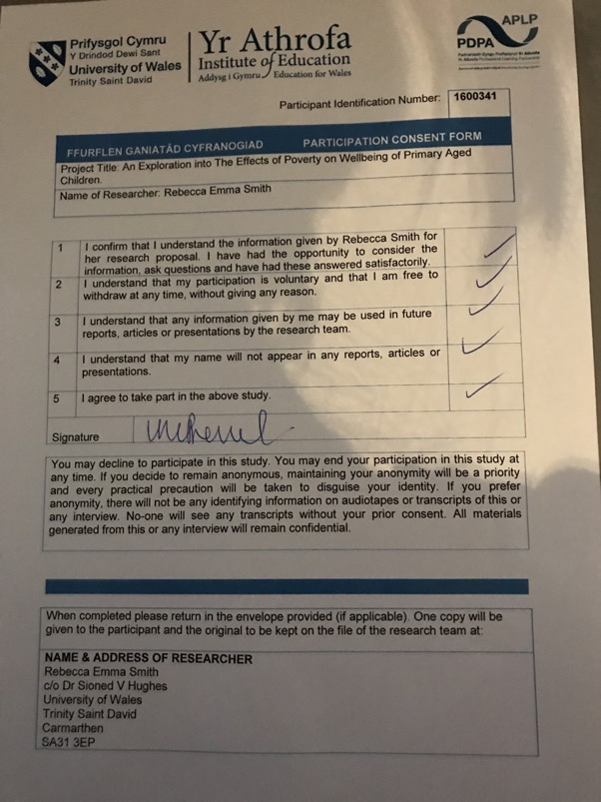

Appendix 3: Questionnaire Responses
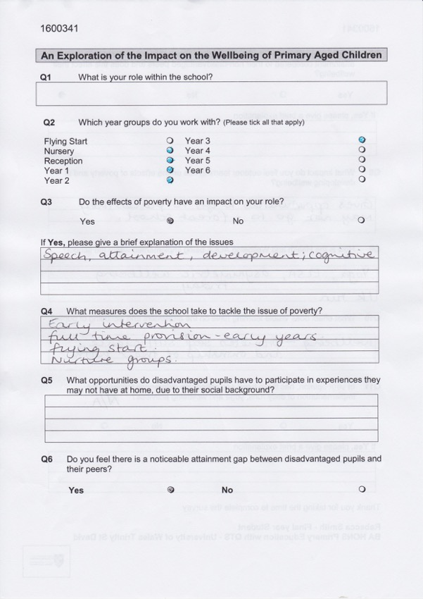

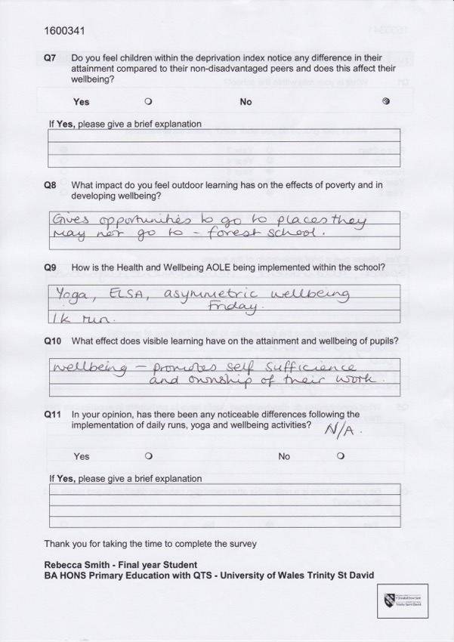

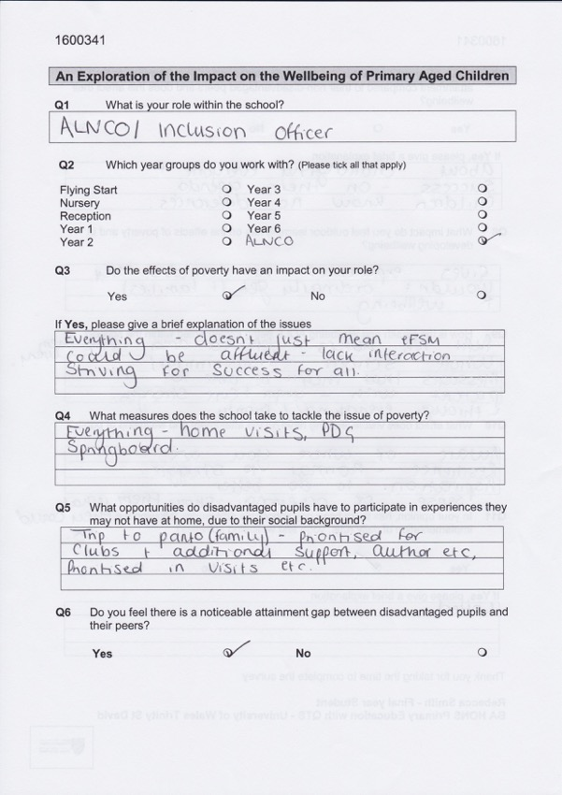

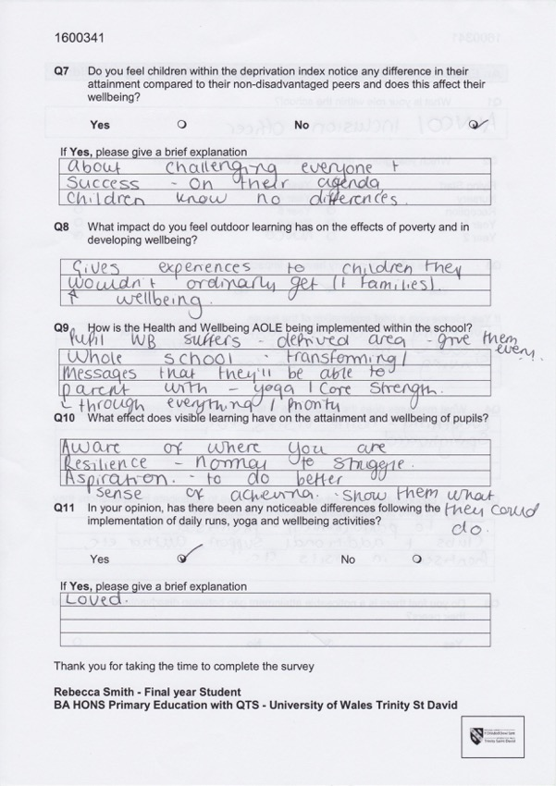
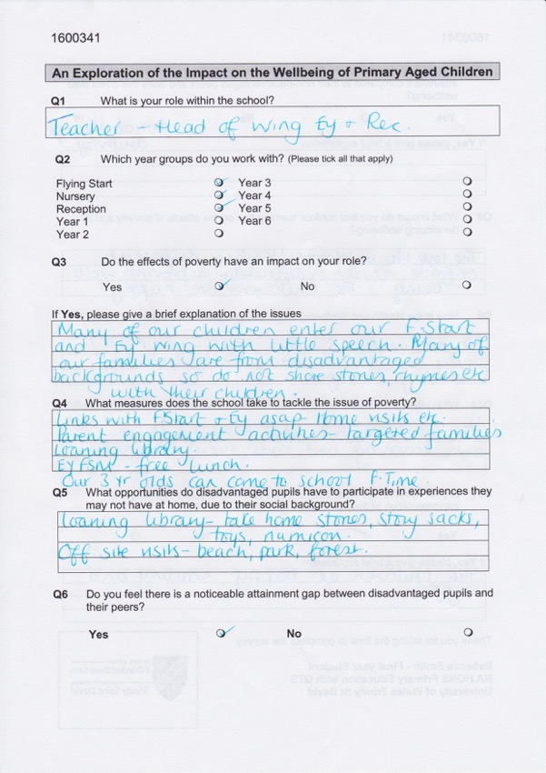

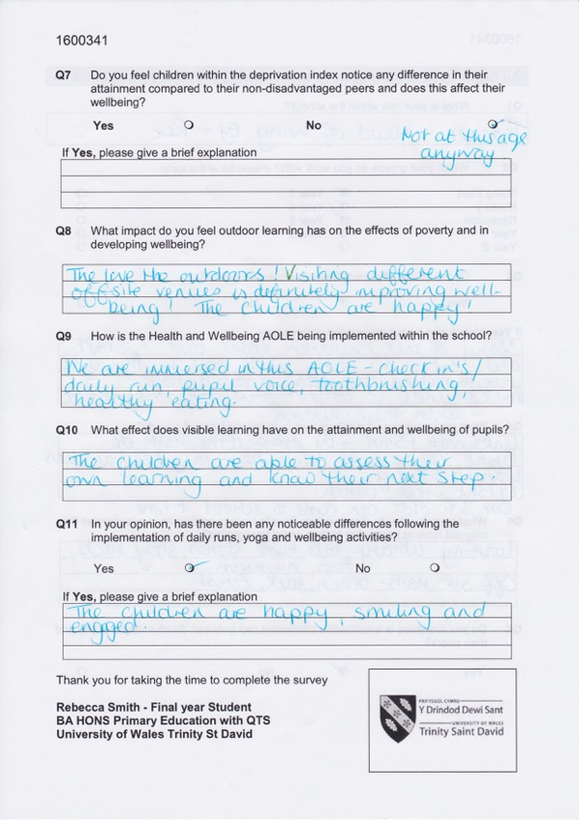

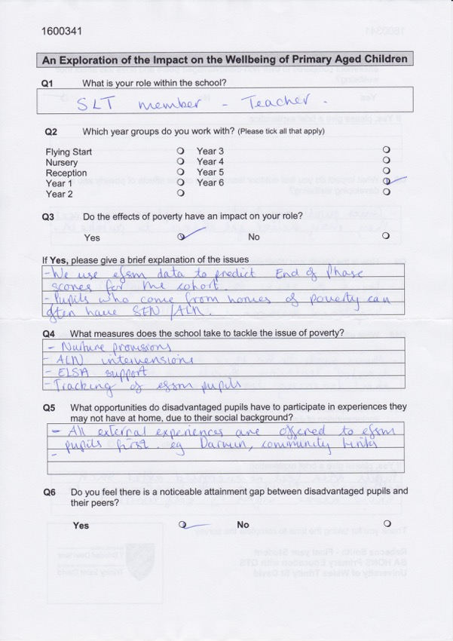

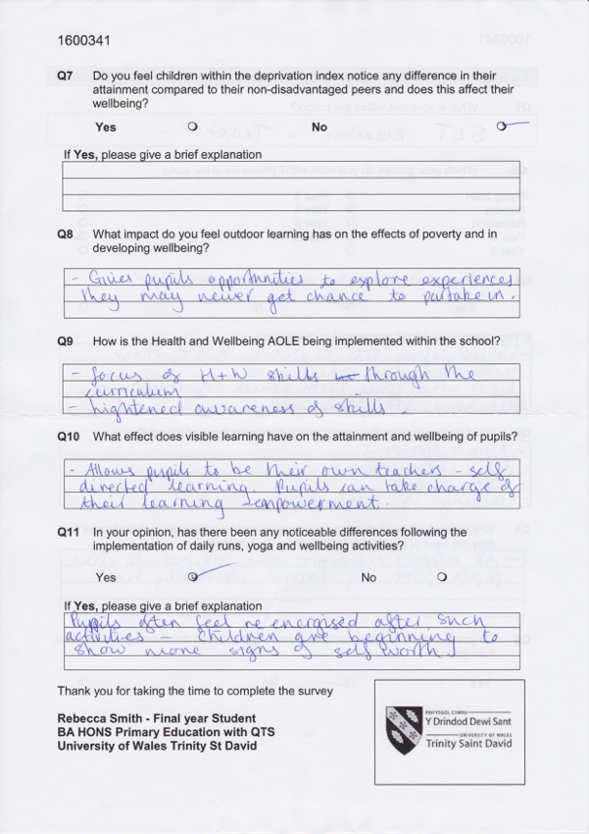

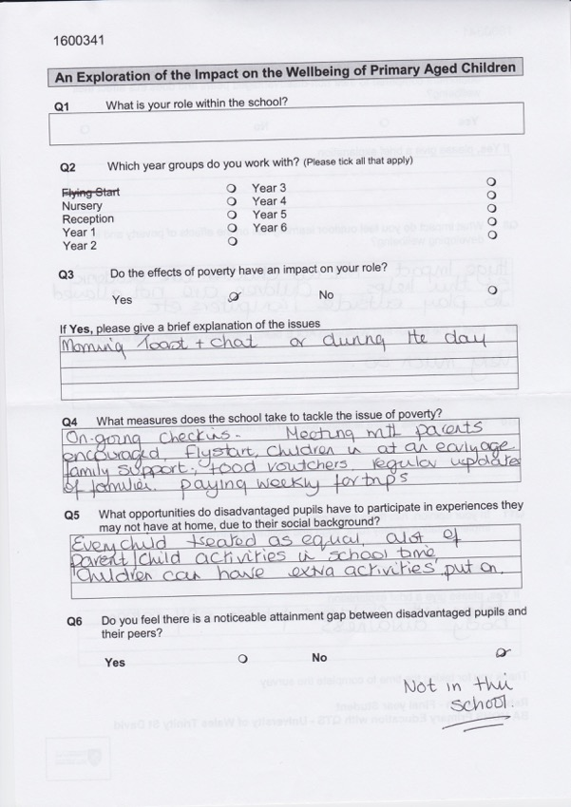

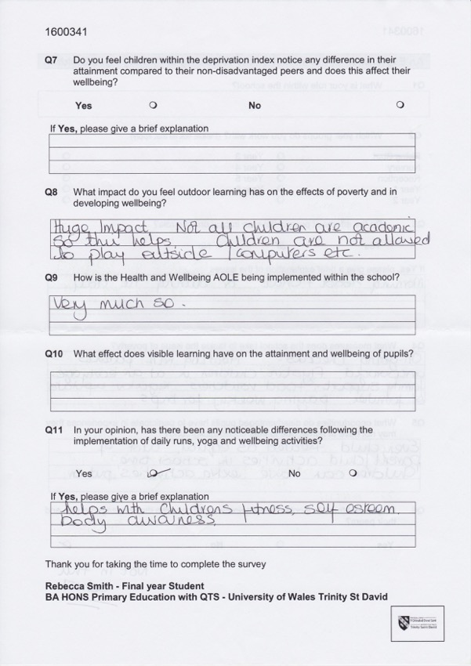

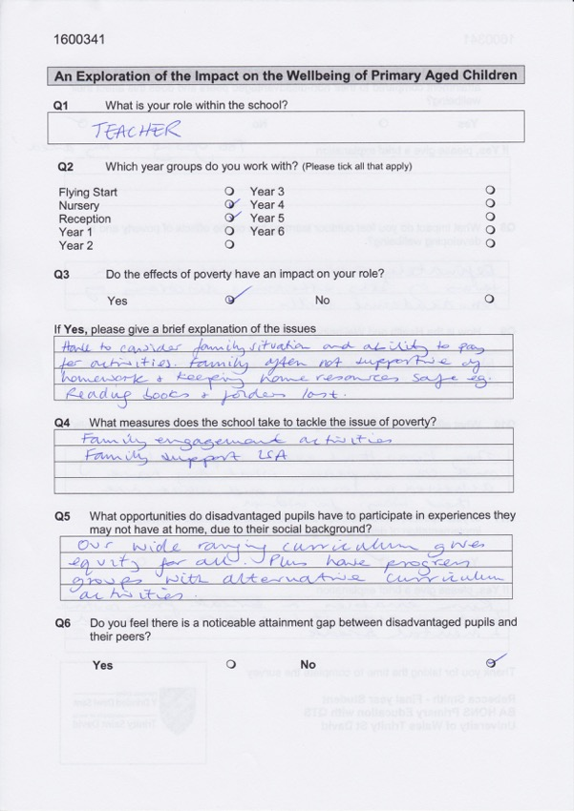

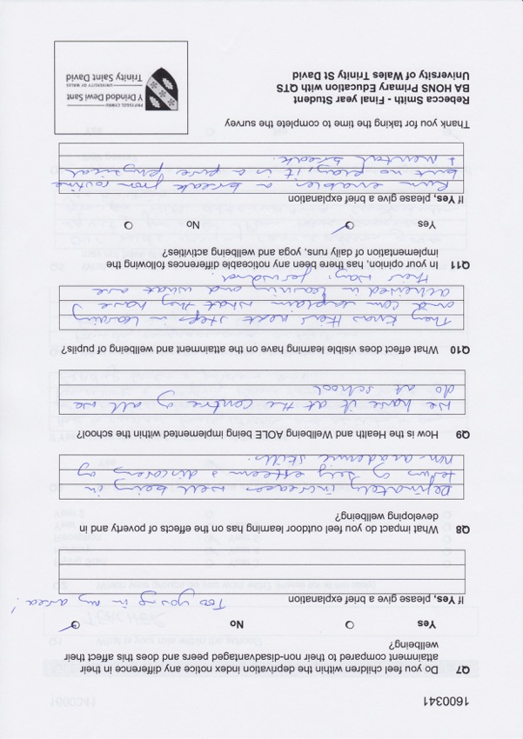

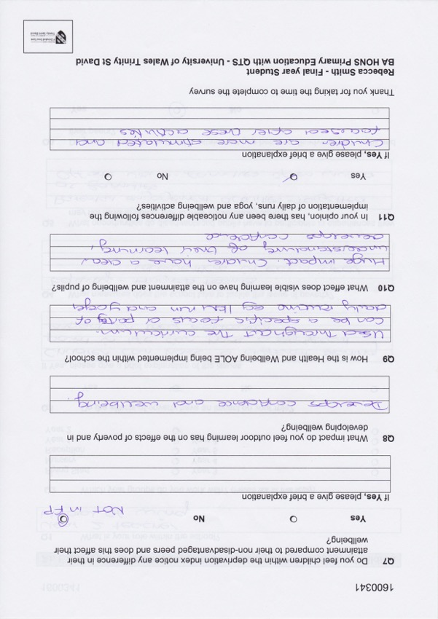

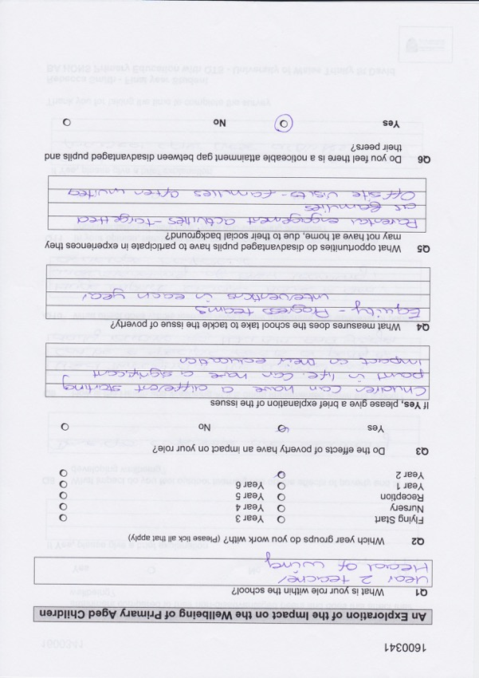

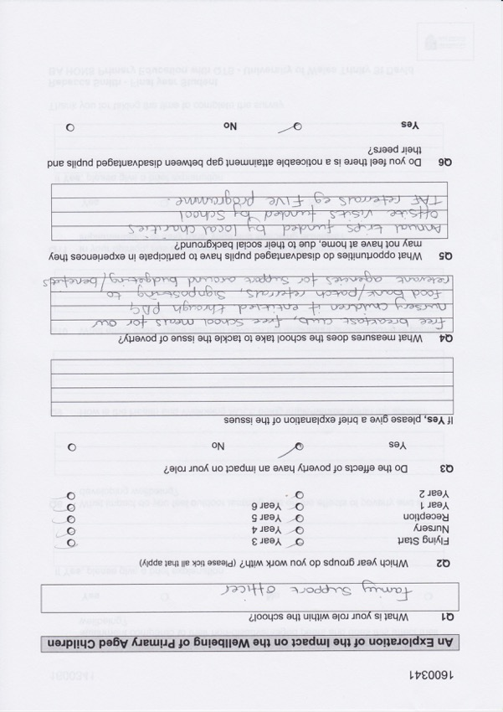

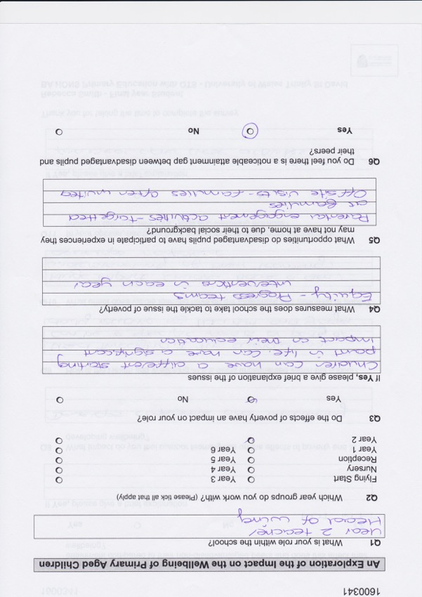

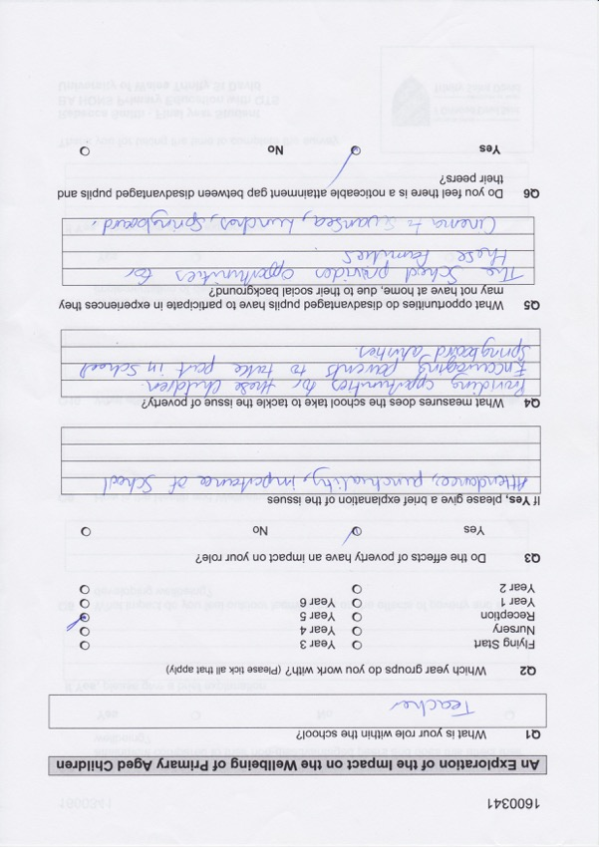

Appendix 4: Family Support Officer Interview
Notes made from a meeting with the Family Support Officer(FSO):
The main roles are: attendance, family engagement and child protection. The FSO works closely with many external agencies including Team Around the Family, who are a support service for children and families, who aim to prevent any child protection issues and also provide parenting courses. It has been found that these most positive changes are made and sustained when the families want to make positive changes themselves. The FSO also works with Child in Need, who identify the needs of the child and ensure that appropriate support is given to the families, to promote positive welfare, wellbeing and safeguarding. The main role is building relationships with the parents, which has been very effective in changing their attitude towards the school. The FSO also allocates the places for the school bus. The FSO organises the Find Out Friday’s where behaviour and speech and language specialists, nurses and doctors come to give advice to parents. The early years work with their most disengaged parents by inviting them in (2 at a time) via letter and they have a morning in class, learning what their children does and what they can do at home and they also have a school lunch. This has been effective, and it is hoped it will be rolled out to the whole school in the future. The relations with the community have significantly improved and the school do so much more for the families now, to ensure the best is in place for their child. They run events such as Mother’s Day tea and a Father’s Day breakfast, which come out of the Pupil Development Grant. All early years are entitled to FSM like the older children in the school. According to the FSO the worst memory or part of the job is seeing how upset deprived children can get at Christmas time, knowing they won’t get presents like their peers. As a result, the FSO organised getting Christmas hampers from local charities and then personally delivered them to those in need. Similarly, the FSO is able to issue PATCH vouchers for the foodbanks, which also has a café. At Christmas time, the school are donated 50 tickets for the pantomime and take families to have rich experiences they may not otherwise have. They also get gifted folly farm tickets in the summer to take some children.

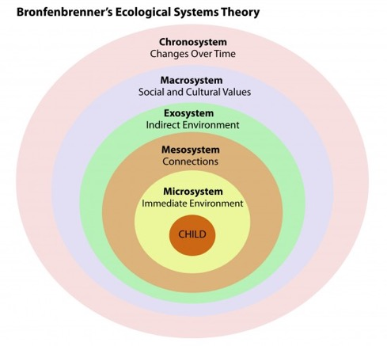
Appendix 5: Bronfenbrenner’s Ecological System (1979)
Each system has an influence of the child, and therefore an influence on their wellbeing.
This is the links between different microsystems, such as
home-school links. It is important that there is an open, supportive relationship. Schools should promote strong links with families.

This contains elements of the microsystem, for example, parents may lose their job. This will determine how external stressor will affect overall development. It is important that the school always remain positive and creates a positive community. The open relationships mean that a partnership can be created for the best interest of the child. However, parents may display negative forms of communication.

These are the cultural patterns and values experienced through a child’s life. It is important that they have the correct influences for a growth mind-set, as learning could be affected by cultural stresses, for example poverty.

This is their daily life. The type of negative stressors they are exposed to at home and at school. Not only spoken language but also body language.

This is the dimension of time. Children need consistency in their learning environment. Schools should use activities and strategies in a holistic manner and have opportunities to develop their skills.

The priority of education.

References:
Bronfenbrenner, U. (1979). The Ecology of Human Development: Experiments by Nature and Design. Cambridge, Massachusetts: Harvard University Press.
Image: Available at: https://www.psychologynoteshq.com/bronfenbrenner-ecological-theory/ (Accessed: 25th February 2019).

Appendix 6: Speech Specialist Interview
Notes made from a meeting with the Head of Speech and Language Provision:

Every child is screened in reception, year 1 and year 2, so no need is missed. There are a lot of speech problems in early years, which are affected by home life but can also be medical. They use sign along, which supports and reinforces language. ‘Sign along is a key word sign-supported communication system based on British sign language and is used in spoken word order. It uses speech, sign, body language, facial expression and voice tone to reference the link between sign and word,’ Sign along (2019). Technology and bigger families are contributors to lack of speech in children, as children aren’t stimulated at home. There are many different kinds of interventions that are used for speech and language, including turn taking games, and make learning stimulating.

References:
Sign along. (2019) Sign along the community charity. Available at: http://www.signalong.org.uk
(Accessed: 25th February 2019).

Appendix 7: Learning Walk Write Up
Notes made from a learning walk with Year 6 entitled to Free School Meals (eFSM):
The 20, 20, 20 minutes sessions are liked amongst these children as they found it less boring than sitting in a class for 60 minutes, and also found it less distracting being around less children, which they stated was good for their wellbeing.

What is your favourite part of the school?
Participant 1 (P1): break time because I can play football with my friends
Participant 2 (P2): music – on a Monday we have guitar lessons, and this means I can play for my family

What does the school do to help you?
Both: the teacher and LSA will help us with work if we are stuck, and our peers will help if we are in the VIP area.

What makes you happy?
P1: lunchtime because I can play football for younger and I prefer it when I play in teams with year 5, as its more of a challenge.
P2: basketball as it lets me get all of my energy out

What are daily check ins, and do you like them?
P1: un means happy, day means okay but somethings bothering me, and tri is sad or angry. The teachers take us somewhere quiet to ask us every day. If I am sad or angry I can go to Miss to talk through my problem and I feel much better.
P2: I like having the daily check ins, it is positive.

Do you like the family engagement activities?
Both: not really as I don’t do it.

What do the four purposes mean to you?
P1: we are always ambitious, capable learners, as we are independent and use challenges and sometimes ethical, informed citizens, when we learn about harry potter and the world.
P2: we are creative in the VIP and discovery areas as we have to solve problems and we’ve made wands for harry potter theme.

Do you do any learning at home?
P1: homework, we have learning logs on the internet, which can be interesting, but subjects can be boring, like ancient Egypt.
P2: reiterated

What do you do when you go home from school?
P1: play football and go to the skate park with my friends
P2: play basketball

What is your favourite memory from this school?
P1: flying start as I made my first friend and we are still best friends now
P2: making my best friend

What do your rights mean to you?
Both: don’t really focus on rights, and they aren’t used in class. Get a new one every week in assembly, but don’t affect classwork. When we do talk about rights, teacher talks for 30 mins and then we don’t have time to do work.

Do you like the growth mindset?
Tickled pink and green for growth – good to know strengths and weaknesses.

Appendix 8: Nurture Lead Interview
Notes made from a meeting with the Head Nurture Provision:
First thing in the morning anyone from the school can go and have breakfast and a chat if needs be. This is often when children disclose any information and parents sometimes come in for breakfast and a chat if they are stressed or worried. They talk about their night (last night) and so does miss, this is often where disclosures happen, this also acts as a check in for these children (but extended). There are a limited number of children in this group that do mainstream work but in a safe place away from big classes. Children often get through more work than they would in a classroom, as they have more time with a HLTA and less distractions. In the afternoons children do arts and crafts, cooking, board games and puzzles and at the end of the week they have the reward of soft play. This way they are learning life skills in a fun and engaging manner. However, there are rules in place and work must be done and everyone respected in order to have the rewards. They practice listening skills and often become mini detectives. They are on call at all times for children in key stage two and the aim is for children to go back to mainstream school. Their moto is to ‘look behind the behaviour’ and ‘children come first,’ as most children involved come from difficult backgrounds.
Examples of reasons children are there:
- Constantly given iPads at home, leading to lack of sleep
- Addiction to technology
- Violence at home (one child’s father died from violence)
- Interbreeding (leads to autism)
- Young mothers who don’t know who fathered their child
Wellbeing significantly improved as they form attachment to staff and have a safe space, children who wouldn’t eat their lunch before now eat it all.

The health and wellbeing AOLE is implemented here also, however as it is a smaller environment there is more emphasis and it is ongoing. They learn social and listening skills through practical activities, which will provide them with life skills. Not all children that attend the group are eFSM, but some are and often home life is a great factor in the reasons they’re there, the school is sympathetic to this. Visible learning doesn’t work here, as children cannot articulate their thoughts.

Appendix 9: Donaldson’s Four Purposes (2015)

Children should be able to ‘communicate effectively in different forms and settings’ (Donaldson, 2015, p.29)
Children should be able to ‘understand and consider the impact of their actions when making choices,’ (Donaldson, 2015, p. 30)
Children should be able to ‘express ideas and emotions through different media’ (Donaldson, 2015, p.29)
References:
Donaldson, G. (2015) Successful Futures Independent Review of Curriculum and Assessment Arrangements in Wales. Unknown: Crown copyright.
Image, Available at: http://d6vsczyu1rky0.cloudfront.net/31605_b/wp-content/uploads/2017/06/Four-Purposes-300x300.jpg (Accessed: 22/02/2019).

Children ‘are building their mental and emotional wellbeing by developing confidence, resilience and empathy,’ (Donaldson, 2015, p. 30)

Appendix 10: Year 6 Observations
Notes made from observations in Year 6:
Children are quite clear of what the four purposes are, and when asked two children stated that their favourite part of school was lunch time to see their friends who may be in different classes. However, there were differing opinions on the Very Independent People (VIP) area, some children thought ‘it was calm’ and ‘not too many people’ whilst others didn’t ‘like being independent at all’. ‘There’s a lot of people who mess around but there’s some who just get on with the work.’ One pupil was able to suggest a 5th purpose: Kind, caring students.

Appendix 11: About Me Profiles


