University of Wales Trinity Saint David
Wales Institute of Science & Art



An approach to how an engineering team would create functional and useful products.
Workshop & Practice (ACHA4011)

Ben Slade
2104137
November 2021
Table of Contents
1. Introduction 2
2. Research 3
3. Methodology 7
4. Discussion 9
5. Conclusion 11
6. Reference List 12

Introduction
This report discusses the roles required within an engineering team to create Brake discs for mountain biking applications, the relations and co-operations needed between the engineering department and supplementary departments by exploring the factors involved in creating a product. The report will also discuss the codes of conduct required within the engineering department, along with how engineers must consider the environmental impacts of their products. The aim of this research is to provide an understanding which can be used to ensure a team is working at a professional standard which will provide functional and useful products that are well thought-out and have had all aspects surrounding its creation and impact considered.

Research
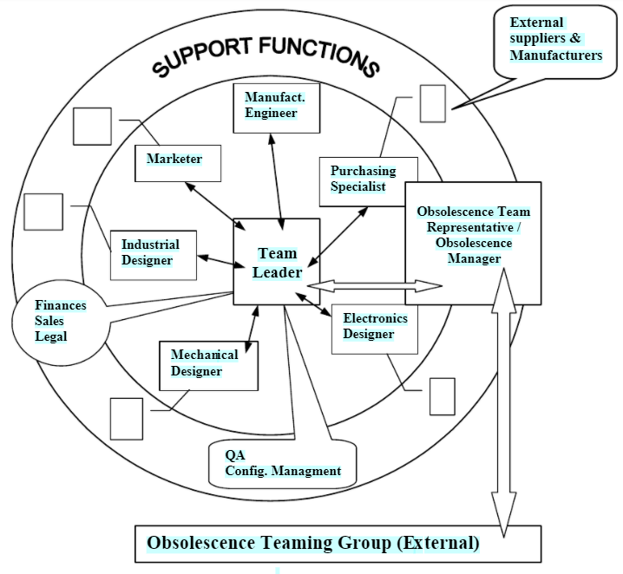
In order to create a product, a departmental structure would need to be created and put in place to make sure that all aspects of the products life cycle is thought about. An overall product leader is needed to delegate tasks to the separate departments as well as creating the concept for the product. The next step is to develop the product which for this task, a team of engineers will be needed to design early prototypes of the product. Then in the prototyping stage, another team of engineers will be needed to test the product and find out faults within the prototypes. After the product has been designed and is ready for customers, there needs to be a team to launch it and market it, and then a separate team required to manufacture and distibute it.

Figure 1 – Exemplar team structure (‌Meyer, A. & Pretorius, Leon & Pretorius, Jan-Harm. (2012)
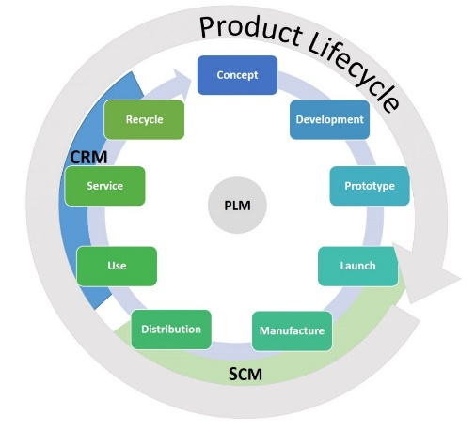

Figure 2 – Product Lifecycle (Hernando Today)

With all of the teams mentioned above in the research, for the production of a brake disc, a team structure as shown below would be needed to produce the product.
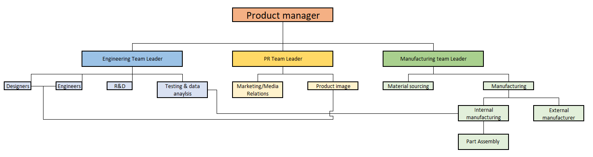
Figure 3 – Proposed team structure to create a brake disc

Engineers need to abide by professional codes of conduct while they are creating products. These codes of conduct cover how the engineer should act in regards to honesty and integrity, respect for the law and environemnt, accuracy and rigour, and leadership and communication. In their article about codes of conduct, The Engineering Council (2017) outline how an engineer should act regarding these principle as shown in the table below.

Honesty and Integrity | Respect for life, law, the environment and public good | Accuracy and rigour | Leadership and communication
Act in a reliable and trustworthy manner | Hold paramount the health and safety of others and draw attention to hazards | Always act with care | Be aware of the issues that engineering and technology raise for society, and listen to the aspirations and concerns of others
Be alert to the ways in which their work and behaviour might affect others and respect the privacy, rights and reputations of other parties and individuals | Ensure their work is lawful and justified | Perform services only in areas in which they are currently competent or under competent supervision | Promote equality, diversity and inclusion
Respect confidentiality  Declare conflicts of interest | Recognise the importance of physical and cyber security and data protection | Keep their knowledge and skills up to date | Promote public awareness and understanding of the impact and benefits of engineering achievements
Avoid deception and take steps to prevent or report corrupt practices or professional misconduct | Respect and protect personal information and intellectual property. | Assist the development of engineering knowledge and skills in others | Be objective and truthful in any statement made in their professional capacity
Reject bribery and improper influence | Protect, and where possible improve, the quality of built and natural environments | Present and review theory, evidence and interpretation honestly, accurately, objectively and without bias, while respecting reasoned alternative views | Challenge statements or policies that cause them professional concern
 | Maximise the public good and minimise both actual and potential adverse effects for their own and succeeding generations | Identify, evaluate, quantify, mitigate and manage risks not knowingly mislead or allow others to be misled
 | Take due account of the limited availability of natural resources
 | Uphold the reputation and standing of the profession

These codes of conduct ensure that all engineers work at a high standard and are trustworthy employees who will carry out their task to the best of their abilities on every task.

Methodology
Creating a product requires a team of engineers along with other departments to ensure that the final outcome is what was wanted from the customer or manager. In order to create a brake disc, the engineering department would need many types of expertise. The initial expertise required is research which will allow the engineers to gain an understanding on what the product they’re making will need to do, as well as showing the engineers other products that exist which they can get inspiration from regarding physical factors such as shape and material. From this research, engineers will also need to be able to design their product using CAD and be able to test the strength of the brake discs to make sure that they won’t fail when clamped onto by the calliper, but also to make sure that the product is durable and won’t wear down quickly from high levels of heat from the material being too soft, rendering it ineffective. They must also then be able to analyse the data gained from this testing and be able to make adaptions to their designs to overcome issues that occurred until the product is then ready for market. In an article written for the website Pinkbike (2017) about the manufacturing process of Hope Tech, a reputable bicycle parts company, the writer outlines a detailed process of how different components are designed using different techniques. Their brake discs are designed out of two parts of metal, with the parts that comes into contact with the brake pads and therefore high temperatures due to friction being manufactured by being laser cut and heat treated and the part that joins the disc to the wheel hub being CNC machined and anodized.
Outside of the engineering team, there will be other teams as part of the company that will help with the development of a product, one of those being a PR team. This team will oversee marketing the product by advertising by many means, such as at events, online advertisements, and billboards. The PR team can also have an input into the design process as there could be an iconic brand design principle such as sweeping lines that allow a customer to instantly recognise the product being from a specific brand. The relationship between designers and the marketing team is crucial to a product being what is wanted from a brand and compromises will be made from both teams.
Another team that the engineering team would need to communicate with is a manufacturing team who would manufacture the product. They could be an in-house team who create the product as part of the company who designed it, or they could be an out-sourced team who make the product by order from outside companies.

Discussion
As well as the team structure and areas of expertise, there are other considerations that need to be taken when designing and creating a product. Some of these are the risks, health and safety implications, environmental impact, ethical considerations, and industrial standards.
The first of these is risks, which can be taken in multiple ways. One of the ways to think about it being the risks this product could bring the customer and another being the risks it could bring for the company creating it. The risks for the customer can be if the customer can trust the product to do what it is intended to do. In terms of a brake disc, the customer must be certain that it will do its job in slowing down the bicycle. The way to ensure the risk of the product failing doesn’t happen would be to test the disc thoroughly in many different conditions and forces and then to convey some of this information over to the customer by stating the thresholds that the part is safe to be used within. The other way of understanding risk is the risk to the company’s reputation and capitol, as creating a product takes resources that if the product doesn’t regain back from sales can cause catastrophic problems for the company, such as loss of jobs or bankruptcy. When creating a brake disc, research must be taken to ensure that the product isn’t going to be placed into the market at the wrong side by having the pricing high or by being made at a lower quality than competitors.
The Health and Safety implications of the product must be thought about as the product can’t cause harm to the customer. For a brake disc, some of these may be that the brake must be strong enough to handle the torsion of being used, making sure that it doesn’t crumple or deform while being used. Another safety consideration should be that it can cool down and dissipate an adequate amount of the heat caused by friction when slowing down, making sure that it doesn’t cause other components to fail due to heat restraints, such as brake pads melting of brake oil boiling. Another safety consideration should be the sharpness of the rotor, as in the event of a crash the rotor could come into contact with the rider and cause harm, so a blunter edge can reduce the likelihood of harm caused by the disc.
The environmental impact of a product must also be considered as the planet is running out of resources, so making the product out of something renewable or recyclable when it can be is critical. With a brake disc, it is very difficult to make one to handle the forces and strain if it is made out of renewable resources like wood, so opting for a recyclable resource like aluminium or steel is the best way to go as they have high strength and heat conductivity properties.
Brake discs have few industrial standards to apply to it, such as the bolt pattern and size for mounting it to the wheel hub to make sure it can fit most current hubs on the market, JIS-D-9414 - 2016 and ISO-4210-4 Which govern the braking and the testing brakes of bicycles respectively.

Conclusion
In conclusion, to successfully develop a product, you would need to create a team structure which incorporates all aspects needed to create a product, like an engineering department with designers, testers and researchers and a PR department who market and sell the product, along with a manufacturing team who make the product. These teams must ensure that they’re following industrial standards to make sure the product can be sold on the international market.
This report has developed my knowledge of how a company develops a product from its conception to its sale and widened my understanding on the relationship needed between engineers and other teams such as PR to make sure the product is the best it can be.
To achieve my goals of working within the Motorsports industry as an engineer, I must undertake more research into team co-operation as well as familiarize myself with the motorsport world by taking part in more activities to gain a first-hand understanding.

Reference List
Bell, R. (2017). Inside Hope Technology: Following The Manufacturing Process - Pinkbike. [online] Pinkbike. Available at: https://www.pinkbike.com/news/inside-hope-technology-following-the-manufacturing-process.html [Accessed 25 Nov. 2021].
Document Center Inc (2014). ISO-4210-4. [online] Document-center.com. Available at: https://www.document-center.com/standards/show/ISO-4210-4 [Accessed 27 Nov. 2021].
‌Engc.org.uk. (2017). Engineering Council. [online] Available at: https://www.engc.org.uk/professional-ethics#:~:text=Engineering%20professionals%20have%20a%20duty%20to%20uphold%20the,life%2C%20law%2C%20the%20environment%20and%20public%20good%20%2B [Accessed 25 Nov. 2021].
Hernando Today. (2020). Sustainability in Product Life Cycle Management. [online] Available at: https://hernandonewstoday.com/sustainability-in-product-life-cycle-management/ [Accessed 25 Nov. 2021].
Kinetics. (2013). Disc Brake Safety Issues. [online] Available at: https://www.kinetics-online.co.uk/technical-info/disc-brake-safety-issues/ [Accessed 27 Nov. 2021].
Ly-Le, C. (2021). What does PR do exactly, and is it essential? | PRCA. [online] Prca.org.uk. Available at: https://www.prca.org.uk/What-does-PR-do-exactly-is-it-essential [Accessed 25 Nov. 2021].
Meyer, A. & Pretorius, Leon & Pretorius, Jan-Harm. (2012). A MANAGEMENT APPROACH TO COMPONENT OBSOLESCENCE IN THE MILITARY ELECTRONIC SUPPORT ENVIRONMENT. The South African Journal of Industrial Engineering. 14. 10.7166/14-2-271.
Paratey, P (2020). The only way to structure your engineering teams - Engineering Management - Medium. [online] Medium. Available at: https://medium.com/engineering-management/the-only-way-to-structure-your-engineering-teams-de8e96fbaf26 [Accessed 24 Nov. 2021].
Torres, J (2020). Team structure - Joca Torres - Medium. [online] Medium. Available at: https://jocatorres.medium.com/team-structure-42d243bc4e0 [Accessed 24 Nov. 2021].

