Lab – Understanding Ethernet Cable Standards
Topology
Addressing Table
Device | Interface | IP Address | Subnet Mask | Default Gateway
PC-A | NIC | 192.168.10.1 | 255.255.255.0 | N/A
PC-B | NIC | 192.168.10.2 | 255.255.255.0 | N/A
Objectives
Part 1: Analyze Ethernet Cabling Standards and Pinouts
Part 2: Build an Ethernet Crossover Cable
Part 3: Test an Ethernet Crossover Cable
Background / Scenario
In this lab, you will build and terminate an Ethernet crossover cable and test it by connecting two PCs together and pinging between them. You will first analyze the Telecommunications Industry Association/Electronic Industries Association (TIA/EIA) 568-A and 568-B standards and how they apply to Ethernet cables. You will then construct an Ethernet crossover cable and test it. Finally, you will use the cable you just constructed to connect two PCs together and test it by pinging between them.
Note: With autosensing capabilities available on many devices, such as the Cisco 1941 Integrated Services Router (ISR) switch, you may see straight-through cables connecting like devices.
Required Resources
- One length of cable, either Category 5 or 5e. Cable length should be 0.6 to 0.9m (2 to 3 ft.)
- 2 RJ-45 connectors
- RJ-45 crimping tool
- Wire cutter
- Wire stripper
- Ethernet cable tester (optional)
- 2 PCs (Windows 7 or 8)
- Analyze Ethernet Cabling Standards and Pinouts
The TIA/EIA has specified unshielded twisted pair (UTP) cabling standards for use in LAN cabling environments. TIA/EIA 568-A and 568-B stipulates the commercial cabling standards for LAN installations; these are the standards most commonly used in LAN cabling for organizations and they determine which color wire is used on each pin.
With a crossover cable, the second and third pairs on the RJ-45 connector at one end of the cable are reversed at the other end, which reverses the send and receive pairs. The cable pinouts are the 568-A standard on one end and the 568-B standard on the other end. Crossover cables are normally used to connect hubs to hubs or switches to switches, but they can also be used to directly connect two hosts to create a simple network.
Reflection:
Write a research report (Max word count 600) on Cat 5e and 6 Ethernet cable standards.

CAT 5e Ethernet cable standards
Category 5e (CAT 5e) is a cable which has been made to allow a simultaneous connection between two devices as long as the devices are point to point this is also known as a fully-duplex ethernet operation. This cable type also allows 1000BASE-T also known as Gigabit ethernet. The Cat 5 enhanced cable is physically the same as the Cat 5 cable however it has been made and tested to higher specifications which ensures it will outperform the Cat 5 cable however generally the twisted pairs withing these network cables tend to be the same standard. The Cat 5e cables overall performance can reach 125Mbps which is 25% more than the Cat 5e cable which only reaches speeds of around 100Mbps.This form of cable is recognized by the TIA/EIA which is a set of standards set by the telecommunications industry association or TIA for short this cable type is defined in TIA/EIA-568-A which contains the specifications for the tests to cables to have bandwidths of up to 100MHz.This cable type allows gigabit ethernet applications such as Wireless internet, Video applications, IP Phone and also supports power over ethernet. This cable provides less cross talk when compared to Cat 5 cable.

CAT 6 Ethernet cable standards
The Cat 6 cable or Category 6 is an ethernet cable standard which has been defined by TIA/EIA and this cable is used both home and business networks. This cable like the Cat 5e supports Gigabit ethernet however unlike the Cat 5e this cable is able to support 10 gigabit ethernet connections over a shorter distance generally up to 164 feet for a single cable. This ethernet cable also are made up of four pairs of copper wire and uses all of them like the Cat 5e does. The Cat 6 ethernet cable is better than the cat 5e in terms of the technical components installed instead. The issue with this cable is that its more expensive that Cat 5e. This cable like the Cat 5e and all other ethernet cables are limited to a total max recommended length of 328. This cable is fully backwards compatible with older categories of Ethernet cable. This cable is designed for very fast performance so has a very strict specification on crosstalk and system noise than older categories of these cables such as the Cat 5e. The biggest difference between Cat 6 and Cat 5e cables is the bandwidth Cat 6 Is made to be able to operate with frequencies up to 250MHz which Is a lot more than Cat5e which only has 100Mhz. Due to this both cables can give the same speeds however the Cat 6 can handle more traffic as it has a higher bandwidth. Cat 6 has considerably less cross talk and system noise than older models. Cat 6 also improves on the older Cat 5e by improving equal-level far-end crosstalk, insertion loss and there is less system noise and when transmitting at higher rates there is less errors. Cat 6 is more flexible than Cat 5e. Generally, if a business was to buy Cat 6 over Cat 5e it will cost them 10 to 20% more than Category 5 cables. If a business was to upgrade their network infrastructure now it is likely better to buy a Cat 6 cable as in the near future 10 Gbps speeds may readily available.

References
https://www.electronics-notes.com/articles/connectivity/ethernet-ieee-802-3/cables-types-pinout-cat-5-5e-6.php
http://www.webro.com/cat5e-cable-specification/
https://www.lifewire.com/cat6-ethernet-cable-standard-817553
https://www.blackbox.co.uk/gb-gb/page/43869/Resources/Technical-Resources/Black-Box-Explains/Copper-Cable/Category-5e-And-6
https://www.comms-express.com/infozone/article/cat5e-max-speed-cat5e-cable-speed/
  - Analyze diagrams and tables for the TIA/EIA 568-A standard Ethernet cable.
The following table and diagrams display the color scheme and pinouts, as well as the function of the four pairs of wires used for the 568-A standard.
Note: In LAN installations using 100Base-T (100 Mb/s), only two pairs out of the four are used.
568-A 10/100/1000Base-TX Ethernet
Pin Number | Pair Number | Wire Color | 10Base-T Signal  100Base-TX Signal | 1000Base-T Signal
1 | 2 | White/Green | Transmit | BI_DA+
2 | 2 | Green | Transmit | BI_DA-
3 | 3 | White/Orange | Receive | BI_DB+
4 | 1 | Blue | Not Used | BI_DC+
5 | 1 | White/Blue | Not Used | BI_DC-
6 | 3 | Orange | Receive | BI_DB-
7 | 4 | White/Brown | Not Used | BI_DD+
8 | 4 | Brown | Not Used | BI_DD-

The following diagrams display how the wire color and pinouts align with an RJ-45 jack for the 568-A standard.
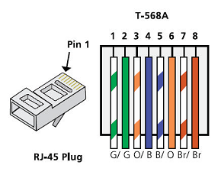
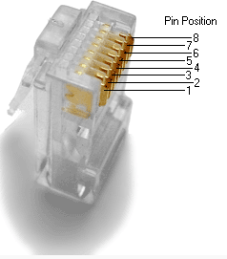
  - Analyze diagrams and tables for the TIA/EIA 568-B standard Ethernet cable.
The following table and diagram display the color scheme and pinouts for the 568-B standard.
568-B 10/100/1000-BaseTX Ethernet
Pin Number | Pair Number | Wire Color | 10Base-T Signal  100Base-TX Signal | 1000Base-T Signal
1 | 2 | White/Orange | Transmit | BI_DA+
2 | 2 | Orange | Transmit | BI_DA-
3 | 3 | White/Green | Receive | BI_DB+
4 | 1 | Blue | Not Used | BI_DC+
5 | 1 | White/Blue | Not Used | BI_DC-
6 | 3 | Green | Receive | BI_DB-
7 | 4 | White/Brown | Not Used | BI_DD+
8 | 4 | Brown | Not Used | BI_DD-
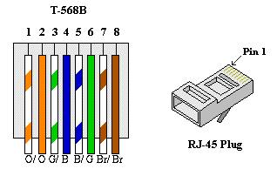

- Build an Ethernet Crossover Cable
A crossover cable has the second and third pairs on the RJ-45 connector at one end, reversed at the other end (refer to the table in Part 1, Step 2). The cable pinouts are the 568-A standard on one end and the 568-B standard on the other end. The two following diagrams illustrate this concept.
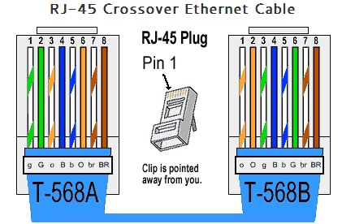
  - Build and terminate a TIA/EIA 568-A cable end.
    - Determine the cable length required. (Your instructor will let you know the cable length you should make.)
Note: If you were making a cable in a production environment, the general guideline is to add another 12 in. (30.48 cm) to the length.
    - Cut off a piece of cable to the desired length and using your wire stripper, remove 5.08 cm (2 in.) of the cable jacket from both ends.
    - Hold the four pairs of twisted cables tightly where the jacket was cut away. Reorganize the cable pairs into the order of the 568-A wiring standard. Refer to the diagrams, if necessary. Take as much care as possible to maintain the twists in the cable; this provides noise cancellation.
    - Flatten, straighten, and line up the wires using your thumb and forefinger.
    - Ensure that the cable wires are still in the correct order for the 568-A standard. Using your wire cutters, trim the four pairs in a straight line to within 1.25 to 1.9 cm (1/2 to 3/4 in.).
    - Place an RJ-45 connector on the end of your cable, with the prong on the underside pointing downward. Firmly insert the wires into the RJ-45 connector. All wires should be seen at the end of the connector in their proper positions. If the wires are not extending to the end of the connector, take the cable out, rearrange the wires as necessary, and reinsert the wires back into the RJ-45 connector.
    - If everything is correct, insert the RJ-45 connector with cable into the crimper. Crimp down hard enough to force the contacts on the RJ-45 connector through the insulation on the wires, thus completing the conducting path. See the following diagram for an example.
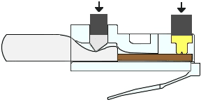
  - Build and terminate a TIA/EIA 568-B cable end.
Repeat steps 1a to 1g using the 568-B color wiring scheme for the other end.
- Test an Ethernet Crossover Cable
  - Test the cable.
Many cable testers will test for length and mapping of wires. If the cable tester has a wire map feature, it verifies which pins on one end of the cable are connected to which pins on the other end.
If your instructor has a cable tester, test the crossover cable for functionality. If it fails, check with your instructor first as to whether you should re-cable the ends and re-test.
  - Connect two PCs together via NICs using your Ethernet crossover cable.
    - Working with a lab partner, set your PC to one of the IP addresses shown in the Addressing Table (see page 1). For example, if your PC is PC-A, your IP address should be set to 192.168.10.1 with a 24-bit subnet mask. You partner’s IP address should be 192.168.10.2. The default gateway address can be left empty.
    - Using the crossover cable you made, connect the two PCs together via their NICs.
    - On the PC-A command prompt, ping the PC-B IP address.
Note: The Windows firewall may have to be temporarily disabled for pings to be successful. If the firewall is disabled, make sure you re-enable it at the conclusion of this lab.
    - Repeat the process and ping from PC-B to PC-A.
Assuming IP addressing and firewall are not issues, your pings should be successful if the cables were properly made.
Reflection
  - Which part of making cables did you find the most difficult?
The most difficult part of making cables for me was slotting the correct wires into the correct holes on the RJ45
Connector.

  - Why do you have to learn how to make a cable if you can easily buy pre-made cables?
This It is important to know this as you can customize the exact length of the cable to the desired length you need. It may also be a good as you could by a longer cable for cheaper than buying for example two different 15m cables you could buy one 30m for a cheaper price and cut it in half and make it into two to save the business money.

