Archive Project.
Darren Tierney
Level 6
25/10/23

THE PRINCIPAL’S REPORT.
AUGUST, 1940.
I, Henry Kingsley Archdall have been serving this fine institute for the second academic year at the time of writing this missive. As the 10th principle to serve the College since its foundation, the events that have sprung to fruition during my short but difficult time of service have been something I did not fully foresee. I, myself am from Balmain, Australia. I came at a time where I did not fully understand the strife that we would face in the near future, and it is a situation that the reader and I have in common. Along with the allies, both of our countries and its democracy face the terrible threat of fascist regime, both Mussolini’s Italy and Hitlers Nazi Germany pose a threat to the very foundations of the modern free world. This institute has stood for over one hundred years, and in that time, we can find much evidence of war and peace from the students of the institution over the course of little over a century. This university and institute were founded upon the core basis to provide a liberal education, deemed by our founder Thomas Burgess as a cornerstone to ensure the exemplary standard of our classically trained clergy in this evolving world.
Concerning the issues surrounding wartime, our student numbers still stand strong, we have on record that 1939 Michaelmas shows a number of 157 students taking a pass course and 39 students taking an honour course for a total amount of 196, the following Lent term, a total of 187 students, then this Trinity term that has just passed a total of 185 students. Annual examination for the Undergraduates resulted as follows: 149 candidates of which 28 passed with honours; 83 passed; 38 failed. Overall, this has been a good year. So, while not record-breaking numbers, it is nevertheless encouraging to see such a dedication to our core theological values during a time of strife such as this one. Of these students we see a strong pass grade, an excellent improvement over the previous years, these are most encouraging:

October 1939: 11/31 passes.
March 1940: 8/33 passes.
May 1940: 23/34 passes.

Our student run paper has been busy this year, led by the 3rd year representative D. G. Thomas. ‘The Lampeter Paper’ tells us of our strong standing foundation in the Lampeter society that holds renown. Permeating into the British clergy, last year 1939 they had 700 members, which then increased this year to 800 ‘Lampeter men’ out of 1500 in orders at work in Wales, England and overseas. It has to be noted that as well as the Lampeter Papers thanks for the anonymous £2,000 donor, I myself must thank their noble contribution to the finest and oldest institute of learning in the Welsh hemisphere. The challenges that we have had to face, not as a single institution, but as a country is evident with our welcomed guests of Wycliffe. At the start of the academic year we were asked to board many of the Wycliffe students of Gloucester after their local chapel was destroyed in the many air raids that descended from the lands of the fascists. This arrangement was put in place to uphold the Christian and theological morals that we hold dear, and we as an institute are glad that the students can see that our institute can be seen as a second home of sorts in this dire time of war. As a gesture of goodwill, extensive repairs have been undertaken upon their board, although this upkeep is expected, we hope this presents our devotion in a positive manner to the Wycliffe College institute and its students. In hindsight, this turn of events and the danger to the south and east will create further demand for occupation for the Wycliffe students, which we will have to board, and most likely for the better of our own College.
I also wish to personally thank the Lampeter Paper for its kind obituary at the start of the year concerning our late professor D. Walker, this loss of knowledge and life to our world will surely be missed. Walker died peacefully and was buried on July 2nd, 1939. Walker’s death has been little over a year, but we are looking to fill the position in the future. The new appointments for staff went ahead, and out of the three accepted candidates Revd. Dr. Islwyn Davies and Revds. G. O. Williams and C. Witton Davies it seems that only the former two will be joining us at this institute. C. Witton Davies withdrew his candidacy after accepting a chaplaincy at St. Michaels College in Llandaff, and we wish him good luck to his ventures in this world of uncertainty. Due to this unforeseen event, as you all know, we have already asked Revd. Dr. Davies and Revd. Williams to start this easter term.
Now we come to the general occurrences of the campus. Through the strong societies of our Lampeter men we see much resilience in our tradition, and our culture that we have been nurturing since the birth of our college. Our 17 societies that run today are a wide variety of traditions that our Lampeter men enjoy. The Clergy Friendly Society that provides for periods of incapacitation that our theologians may face during sickness, with its president being the Archbishop of Canterbury himself. The English Literary and Debating Society, with its keen culture of keeping the students minds sharp have enjoyed many of a debate this year, with such discussions as “In the opinion of this house a United States of Europe is possible’’, “This house says no,” and finishing the year with a debate concerning the topic “convention strangles progress.” An interesting debate ensued. The Welsh Society “Y Ddadleufa Gymraeg” held the local tradition strong. The student Christian Movement has been successful with their study group held every Thursday, conducted by Mr. D. R. Newte, BA. The theme of “reunion” was most compelling. The “Cymdeithas Dewi Sant” College Chapter society has had a satisfactory year, although many of the members have joined H.M. Forces, the loss has been somewhat rectified by enthusiastic newcomers. Rev. Prof A. E Morris M.A., B.D., gave an interesting paper entitled “The Sacrament of Penance” on December 7th.
The Evangelical Fellowship had yet another successful year, all the meetings have had a most satisfactory attendance and the interest shown by members points towards a bright future for the Fellowship. Our Chess Club named “Chess Notes” which ceased to exist at the College some four years ago, has now been revived. The Club meets regularly each week, and a tournament will be arranged in the near future. The “Music Societies” prospects were far from cheerful at the beginning of the year, we had as much talent at our disposal as in previous years but progress was impeded more in this Society by the outbreak of war and consequent restriction of travel than in any other of the College societies and clubs, but they still stand strong although the difficulties. The meetings of the “The Philosophical Society” were well attended throughout each session, the latest seminar was a reading of a paper by Mr. Dawson on the “Philosophy of History”.
The events of “The Dramatic Society” were heavily impeded by the threat of war, although the usual plays were cancelled due to a fear of targeting, permission was obtained to play three “One-act” plays for War Charities, the three chosen plays were “Thread o’ Scarlet” by J. J. Bell, “Russian Salad” by Philip Johnson, and “In the Cellar” by Gertrude E. Jennings. “The Swimming Club” provided the first man home in all events except the squadron race in its annual competition with Aberystwyth. The performance of Stan Meadows in the 200 yards is also worthy of note. “The Association Football Club” were fairly successful and we appreciate the effort given by the team. The “Lawn Tennis Club”, “Hockey Club”, “Harriers Club” and the “Cricket Club” saw a moderate interest throughout the year. The “Rugby Football Club” has seen a successful year with 15 matches played, 11 Won, 3 Lost, and a single match drawn. The traditional record of victory against Aberystwyth was cemented by an impressive score of 22-0.
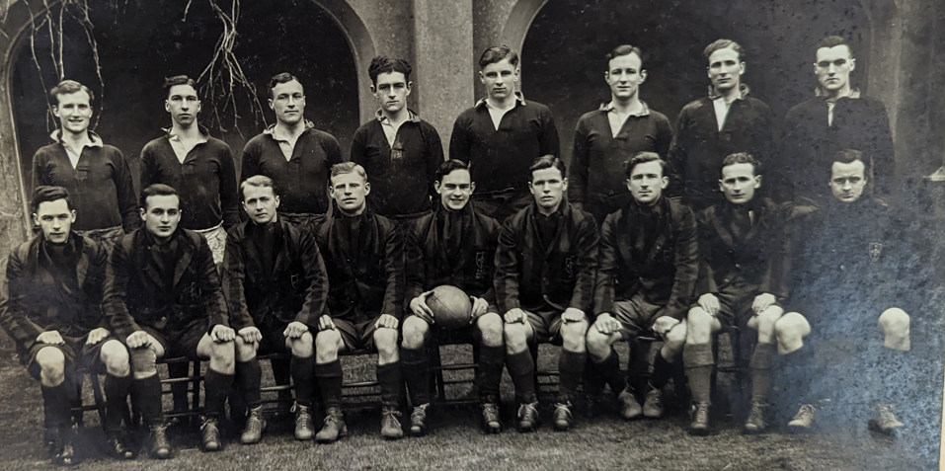
The 1939-1940 Rugby football club of St. Davids College Lampeter, with captain R. Washington Jones at the forefront, a good example of British resilience during this war.

Bibliography.

Primary Sources.

Roderic Bowen Library and Archives: University Archive, UA/A/2/2, Minutes, 1939-1953.
Roderic Bowen Library and Archives: University Archive, UA/SP/1/13, S.D.C. Magazine, 1938-1941.
Roderic Bowen Library and Archives: University Archive, UA/X/142/1, Wycliffe Star, 1939-1940.
Roderic Bowen Library and Archives: University Archive, UA/X/36, A Report on the Interior: Tenants Wycliffe Students, 1940.
Roderic Bowen Library and Archives: University Archive, UA/P/110, Image of the 1940 Rugby Football Team, 1940.

Secondary Sources.

UWTSD, History of the Lampeter Campus, UWTSD.AC.Uk, Available at: https://www.uwtsd.ac.uk/bicentenary/history-of-the-lampeter-campus/ , [Accessed on: 20/10/23]

UWTSD, History of the Lampeter Campus, UWTSD.AC.Uk, Available at: https://www.uwtsd.ac.uk/bicentenary/history-of-the-lampeter-campus/ , [Accessed on: 20/10/23]
Roderic Bowen Library and Archives: University Archive, UA/A/2/2, Minutes, 1939-1953, p. 7; RBLA, UA/A/2/2 Minutes, 1939-1953, p. 10 > Booklet [Principals Report] p. 5.
RBLA, UA/A/2/2, Minutes, 1939-1953, p. 15 > Booklet p. 3.
RBLA, UA/A/2/2, Minutes, 1939-1953, p. 15 > Booklet p. 3.
RBLA, UA/A/2/2, Minutes, 1939-1953, p. 15 > Booklet p. 3.
Roderic Bowen Library and Archives: University Archive, UA/SP/1/13, S.D.C. Magazine, 1938-1941, p. 3.
RBLA, UA/SP/1/13, S.D.C Magazine, 1938-1941, p. 23.
RBLA, UA/SP/1/13, S.D.C Magazine, 1938-1941, p. 5; RBLA, UA/A/2/2, Minutes, 1939-1953, p.10 > Booklet p. 6; RBLA, UA/A/2/2, Minutes, 1939-1953, p. 10.
RBLA, UA/A/2/2, Minutes, 1939-1953, p. 15 > Booklet p. 1.
Roderic Bowen Library and Archives: University Archive, UA/X/142/1, Wycliffe Star, 1939-1940, p. 33.
RBLA, UA/A/2/2, Minutes, 1939-1953, p. 6.
RBLA, UA/x/142/1, Wycliffe star, 1939-1940, p. 34.
Roderic Bowen Library and Archives: University Archive, UA/X/36, A Report on the Interior: Tenants Wycliffe Students, 1940.
RBLA, UA/A/2/2, Minutes, 1939-1953, p. 15 > Booklet p. 4.
RBLA, UA/A/2/2, Minutes, 1939-1953, p. 10 > Booklet p. 6; RBLA, UA/A/2/2, Minutes, 1939-1953, p. 6.
RBLA, UA/A/2/2, Minutes, 1939-1953, p. 10 > Booklet p. 1; RBLA, UA/A/2/2, Minutes, 1939-1953, p. 11.
RBLA, UA/A/2/2, Minutes, 1939-1953, p. 11.
RBLA, UA/SP/1/13, S.D.C Magazine, 1938-1941, p. 28.
RBLA, UA/SP/1/13, S.D.C Magazine, 1938-1941, p. 29.
RBLA, UA/SP/1/13, S.D.C Magazine, 1938-1941, p. 29.
RBLA, UA/SP/1/13, S.D.C Magazine, 1938-1941, pp. 30-31.
RBLA, UA/SP/1/13, S.D.C Magazine, 1938-1941, p. 31.
RBLA, UA/SP/1/13, S.D.C Magazine, 1938-1941, p. 32.
RBLA, UA/SP/1/13, S.D.C Magazine, 1938-1941, p. 32.
RBLA, UA/SP/1/13, S.D.C Magazine, 1938-1941, p. 32.
RBLA, UA/SP/1/13, S.D.C Magazine, 1938-1941, p. 33.
RBLA, UA/SP/1/13, S.D.C Magazine, 1938-1941, p. 33.
RBLA, UA/SP/1/13, S.D.C Magazine, 1938-1941, p. 34.
RBLA, UA/SP/1/13, S.D.C Magazine, 1938-1941, p. 35.
RBLA, UA/SP/1/13, S.D.C Magazine, 1938-1941, pp. 35-38.
RBLA, UA/SP/1/13, S.D.C Magazine, 1938-1941, p. 35.
Roderic Bowen Library and Archives: University Archive, UA/P/110, Image of the 1940 Rugby Football Team, 1940.

