

Assignment Title: Practical.

Module:
Cloud Computing Architecture

Module code: ACCA5025

Student: Irina Tupca (2112902)

Lecturer: Suneth Fernando

Date of submitted: 03 May 2023

Table of Contents

Introduction 3
1. The resources associated with a Virtual Machine. 4
a) Virtual hard drive. 6
b) Virtual Network. 8
c) Network Security Groups. 9
d) Web App. 10
i) Structured Query Language database. 12
2. Additional Exercise. 14
a) Connecting two VMs in the same VNET. 14
b) Installing the Nginx web server on the VM. 16
d) Creating a Network Security Group. 19
Conclusion. 21
List of References. 22

Introduction

The primary objective of this report is to present a deeper comprehension of cloud computing framework.
This will be accomplished by learning:
- How to set up and maintain a virtual computer?
- What hardware and software does a virtual machine require?
- Network security groups, virtual networks, and virtual hard drives will all be covered extensively.
- Creating a Structured Query Language database and a Web application: how to set it up.
Also, this report will show how to set up a connection between two virtual machines. The first virtual machine (VM) will have the Nginx web server set up on it.
After that, a PostgreSQL database will be made in Azure.
Two network security groups, one for the NICs of the virtual machines and one for their subnet, will also be created as part of this evaluation.
All the aforementioned objectives will be realised in Microsoft Azure, a leading provider of cloud-based services.

The resources associated with a Virtual Machine.

The Azure portal will be used to set up virtual machines and their associated components.

- The hardware and software components that make up a VM.

Microsoft Azure VM is a cloud-based virtual machine service compatible with both Windows and Linux [14].
Here is a sample of how to set up a virtual machine in Azure with Windows Server 2019. The Create Virtual Machine page can be accessed from the Virtual Machines page by clicking Create [1].

At the beginning, a new Resource Group (myRG) must be created:

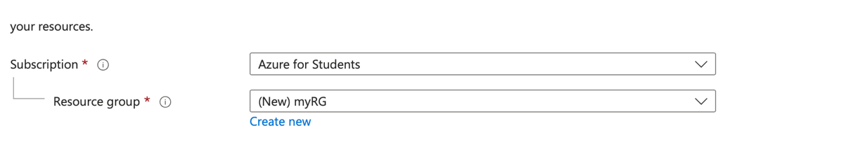

All the solution's resources, or just the ones you want to manage together, can be stored in a Resource Group.

Below the heading "Instance details",

choose Europe UK South for the Region and Windows Server 2019 Datacenter -x64 Gen 2 for the Image, and then type myVM for the Virtual machine name. All other options can be left at their default values [1].

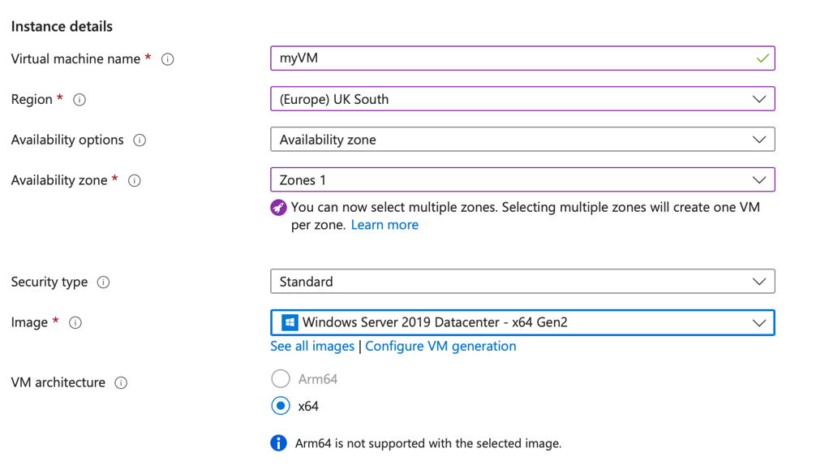

Enter your login and password under "Administrator account".

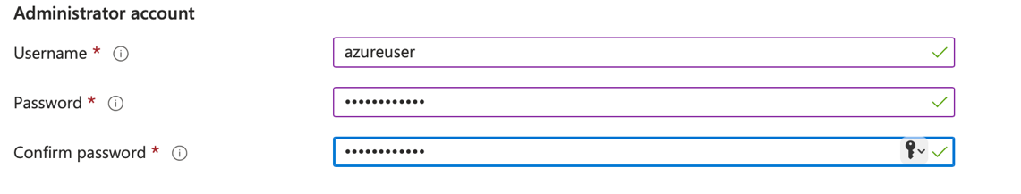

Select Allow selected ports under Inbound port rules, and then pick RDP (3389) and HTTP (80) from the drop-down [1] [2].

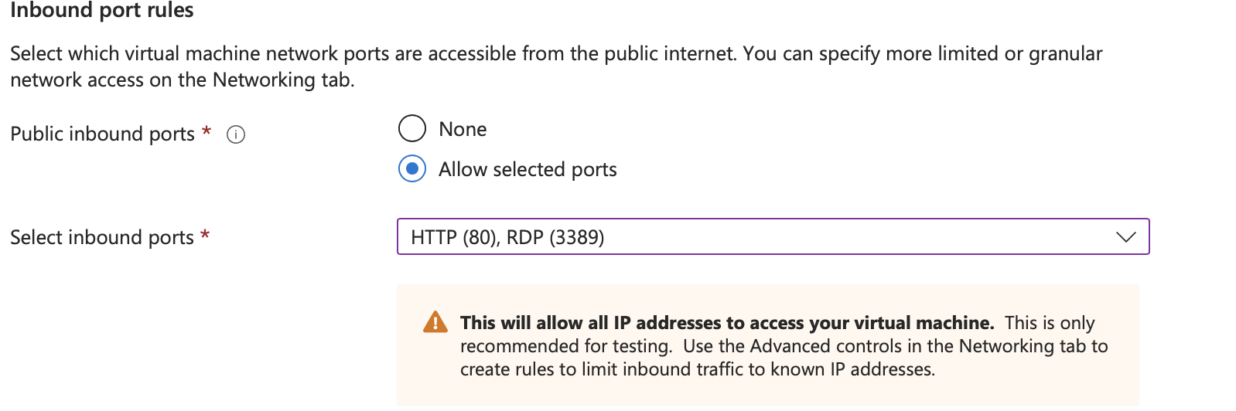

Don't change a thing default setting and hit the Review + Create button instead. Click the Create button once validation is complete.

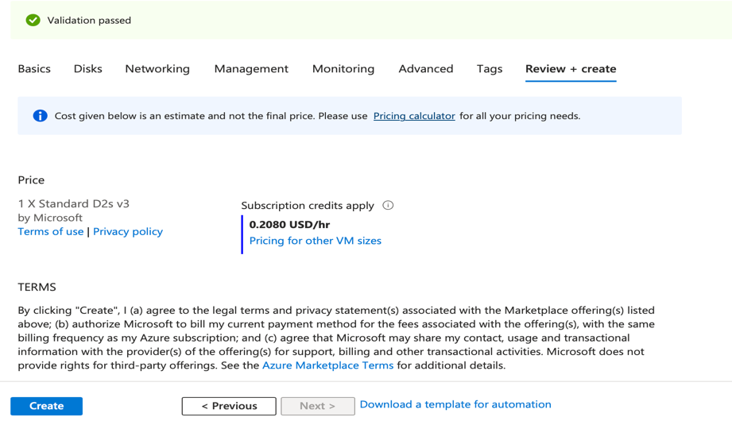

Select Go to resource once deployment is complete to access the newly created VM.

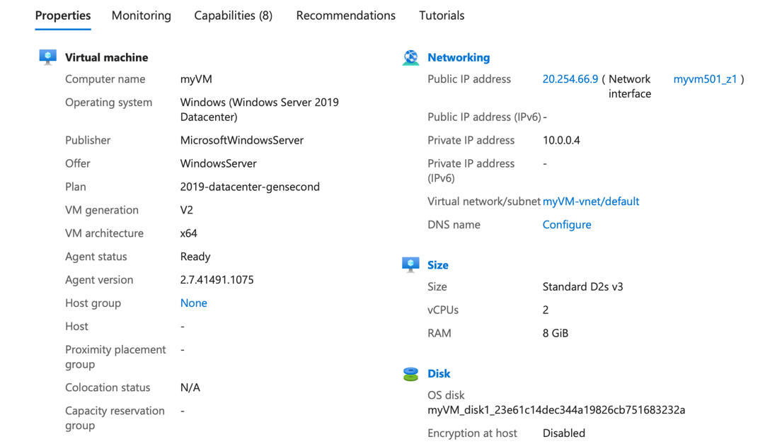

Automatically created along with the virtual machine were the corresponding virtual hard drives and virtual network [2] [3].

Virtual hard drive.

A virtual hard disk (VDH) is the virtual machine's hard disk that acts like a physical hard disk. VDH are virtual machine disk image file formats. In the following figures, you can see the VDH of the virtual machine created above. Disk type is Premium SSD LRS and disk size is 128 GB. Premium SSDs are high-performance Solid-State Drive (SSD) - based storage with the throughput and latency to handle I/O-intensive workloads [2] [3].

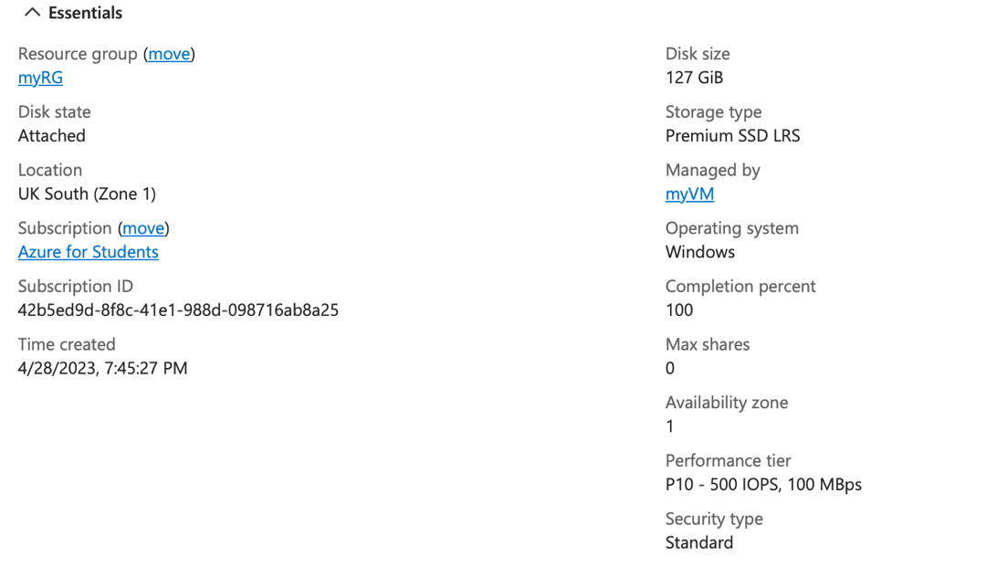

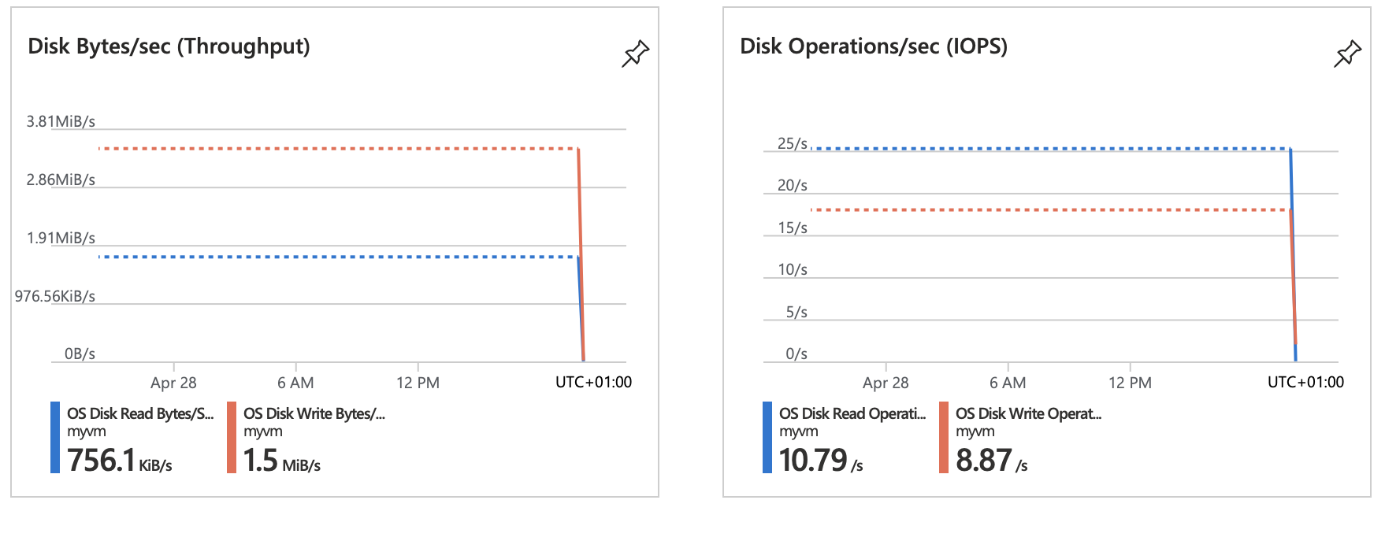

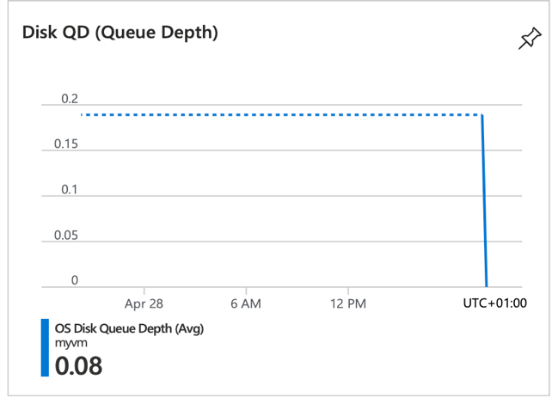

The advantage of Premium SSDs is speed and performance. Critical production applications can benefit from using Premium SSDs [3].
The features of Premium SSDs are [3]:

Base provisioned IOPS (input/output operations per second) per disk | 500
Base provisioned Throughput per disk | 100 MB/s
Max burst IOPS per disk | 3 500
Max burst Throughput per disk | 170 MB/s
Max burst duration | 30 min

The throughput, IOPS target, and latency indicated in the previous table can be expected from a premium SSD 99.9% of the time [3].

Virtual Network.

All the nodes (computers, servers, virtual machines, and data centres) in a virtual network should be connected to the Internet [2].
An Azure virtual network (VNet) is a network where virtual machines and applications run in the cloud. In the following figures, you can see the virtual network of the virtual machine created above (with public IPv4 address – 20.254.66.9 and private IPv4 address – 10.0.0.4).

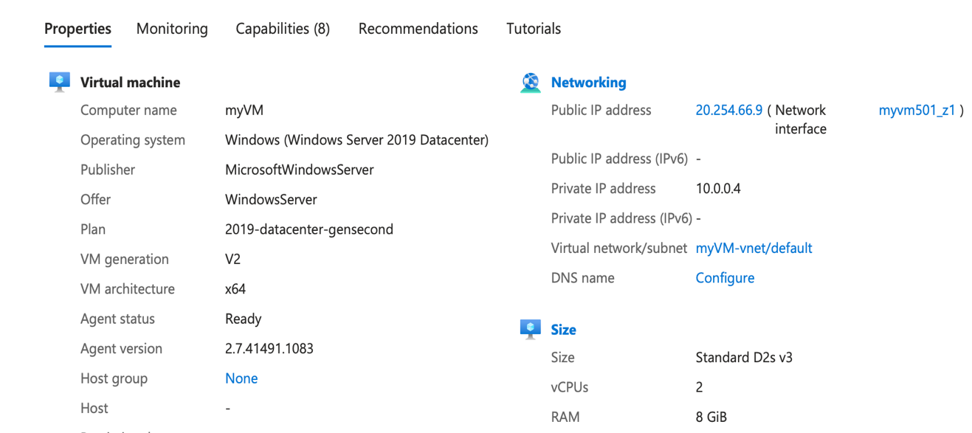

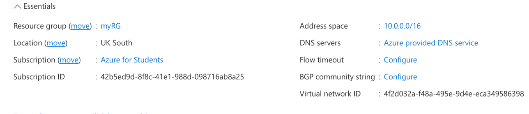

The virtual network can be divided into smaller sections called "subnets," and each subnet has its own server. Both public and private subnets exist. In this private network, instances can use the public subnet's Network Address Translation gateway to reach the Internet. Courts have direct internet connection for the public [1] [2].
A subnet that has a route in its routing table leading to an Internet gateway is in the "public" category [1] [2].
For each subnet, the virtual network automatically routes traffic and creates a routing table. The virtual network will generate a routing table and route traffic automatically for each subnet. Routing delivers data by choosing an appropriate path from source to destination. When transferring data, routing determines the most efficient path from origin to destination.
Subnets, routing, and Network security groups are the building blocks of a Virtual Network in Azure.

Network Security Groups.

Azure NSG acts as a firewall to prevent unwanted traffic from reaching the virtual machine. You can define the origin, destination, port, and protocol of a connection in a network security rule [4].
There are two types of network security group rules, default security rule and augmented security rule [12].
When a new network security group is created in Azure, the following rules are added by default:
- allows all inbound traffic inside the virtual network.
- enables communication between an Azure Load Balancer and Azure resources.
- allow all outgoing traffic inside the virtual network.
- allow all outgoing traffic to the Internet.
- blocks all incoming/outgoing traffic and is applied only after processing all other rules in the list because it has the lowest priority [4] [5].

Rules set up on an inbound firewall prevent threats including unauthorised connections, malware, and DoS assaults from entering the network [4] [5].
The rules of an outbound firewall block communications from within the network that are sent outside.
Augmented security rules that allow the user to define larger and more complex network security policies with fewer rules [4] [5].
Network Security Group of the virtual machine created above:

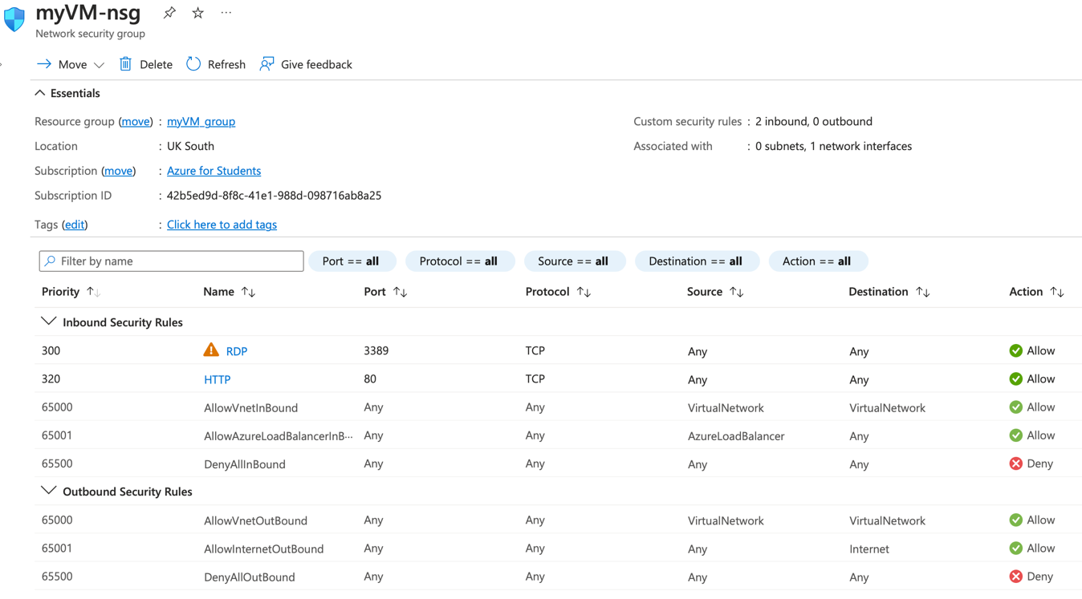

Here, two have been added Inbound security rules:
- allow remote access from all IP addresses via port 3389 (RDP). Microsoft's proprietary Remote Desktop Protocol (RDP) allows users to connect to other computers via the internet.
- allow Internet access to port 80 (HTTP). An HTTP (Hypertext Transfer Protocol) port is a communication endpoint used by the HTTP protocol to facilitate the transfer of data between a web server and a client, typically a web browser.
Azure NSG executes rules in priority order, with lower-numbered priorities processed before higher-numbered ones. The priority number must be unique for each rule in the collection. The value can be between 100 and 4096 [12] [14].

Web App.

Microsoft's Azure Web Apps provides a cloud-based platform for hosting websites. It's a PaaS that lets you release Web apps developed in various languages and using various frameworks [6].

To make a new web app, visit the App Services section of the Azure site. Complete the fields for the app's title, resource group, and service plan [7].

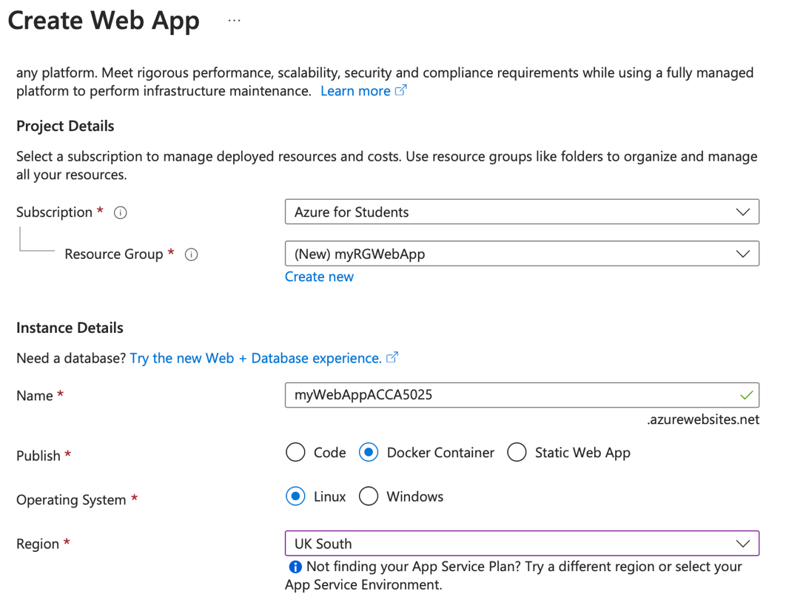

Then configure the container information.

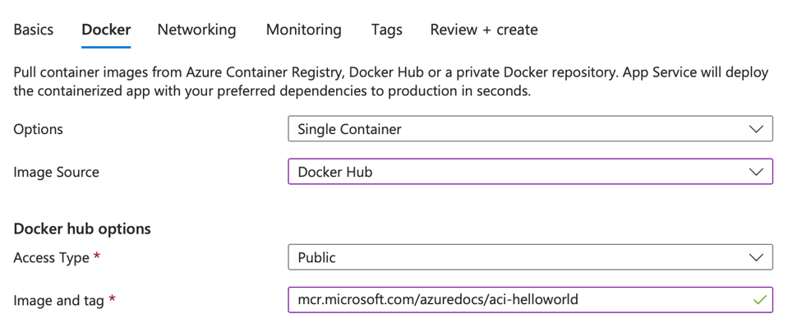

To test the newer Web App, you need to click on the URL and the Welcome to Azure Container Instances page will appear.

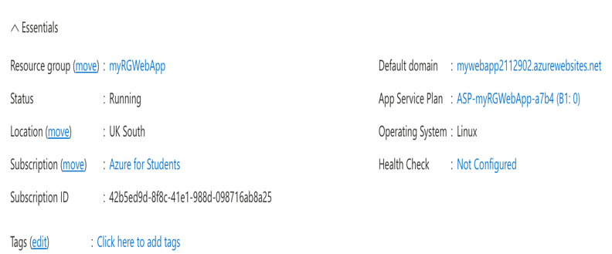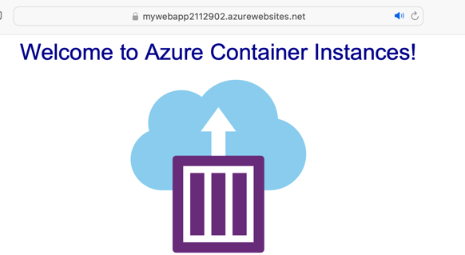

A nice feature in Azure is the ability to see the request telemetry and response telemetry data of our web application. I have created a demo traffic of the web application and respectively the telemetry is shown in the following diagrams [12].

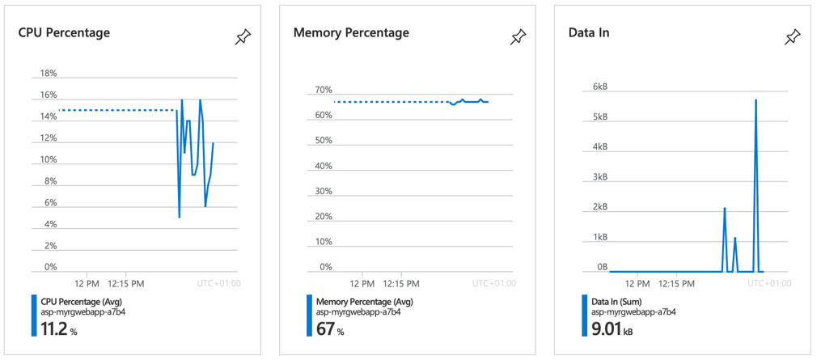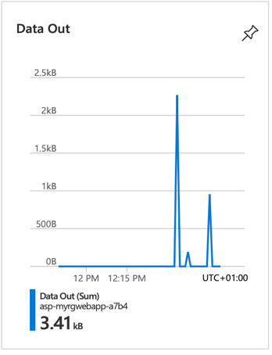

Multiple languages, including JAVA, Python, Node.js, Net, and PHP, are supported by Azure Web App [14].

Structured Query Language database.

Azure SQL Database is a cloud database that provides a fully managed environment that simplifies provisioning, patching, updating, and monitoring. Azure SQL Database allows you to build a scalable, reliable, and fast data storage layer for your Azure apps and services [8].
Go to the All Services in Azure portal to create a new SQL Database and fill in this information.

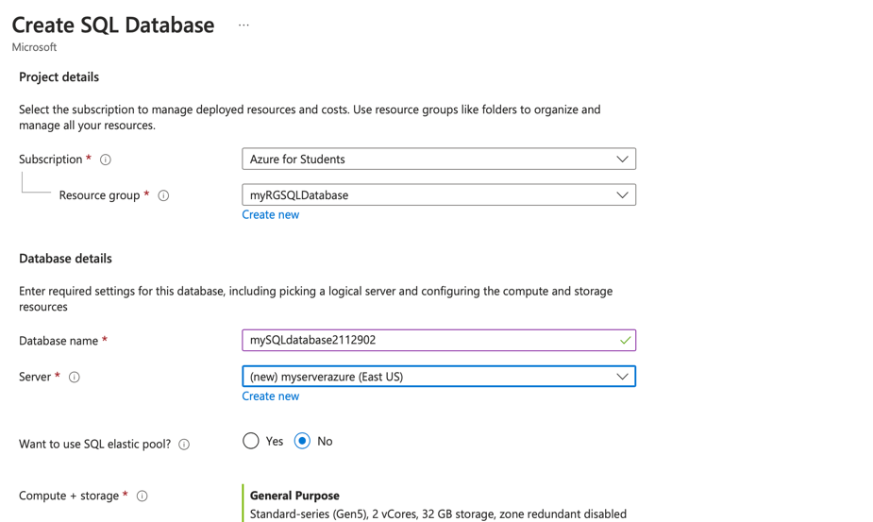
Create a new server

The next step is to add a server admin username and password when configuring a SQL server for the database. Each server in Azure must have a unique name on a global scale.

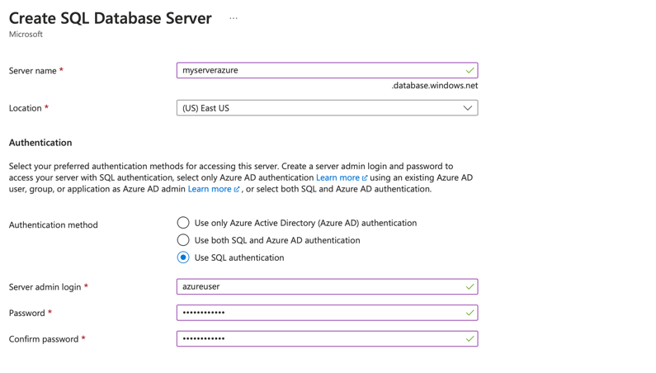

On the Network and Additional Settings tab choose the following settings:

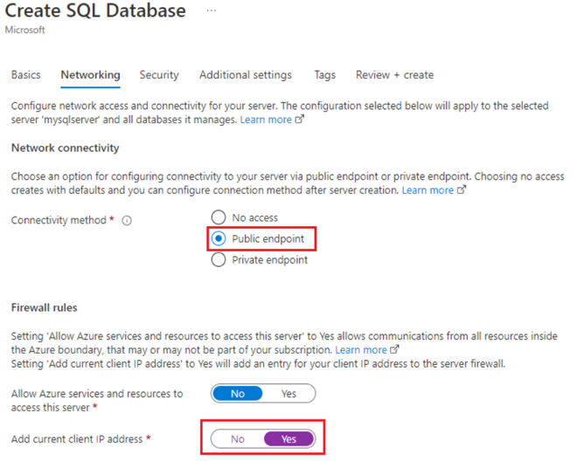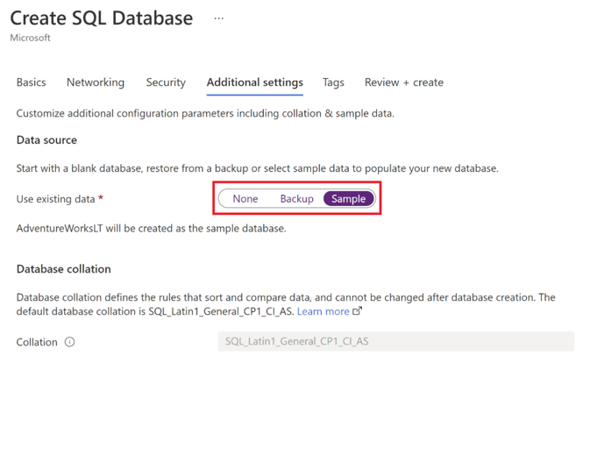

The client's current IP address has been added to the firewall rules and block access to this SQL database.
Once the database is created, select Query Editor (preview) the created SQL databases, and enter the server administrator login information to connect to the database and query the data. In the Query Editor panel, enter the following query and select Run.

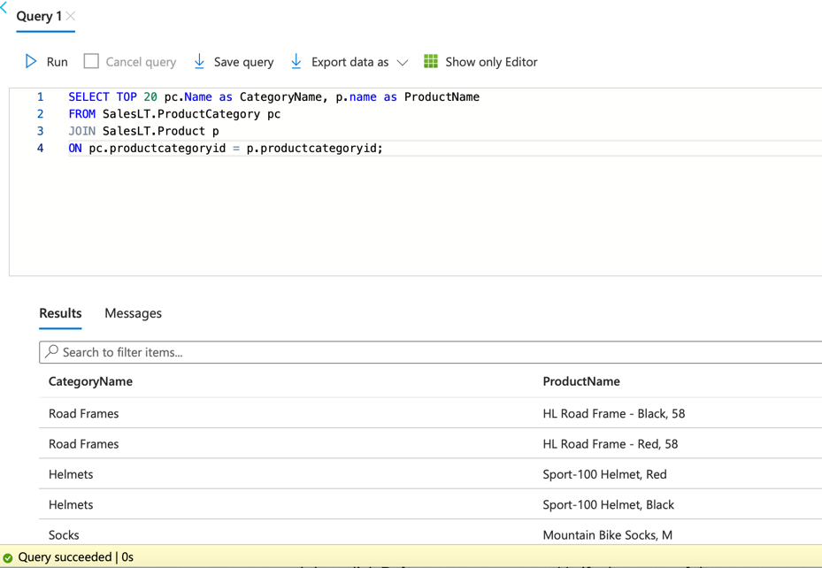

In the Results pane, you can see that the query ran successfully.
Azure SQL database enables the modern cloud application technique which has plenty of resources to support both the types of relational and non-relational data, for example, XML, graphs, and JSON [9] [13].

Additional Exercise.

Connecting two VMs in the same VNET.

In following exercise, I have created two virtual machines:
- VM1 – public IP address 172.187.168.82.
- VM2 – public IP address 172.187.168.153, which are in the same virtual network.

When creating the virtual machines and database the UK South Azure location was selected.
A Location represents the city or area of the Azure Region. Datacentres within a latency-defined boundary and linked by a regional low-latency network make up a Region. Each Azure Region has a corresponding region at the same physical location [14].

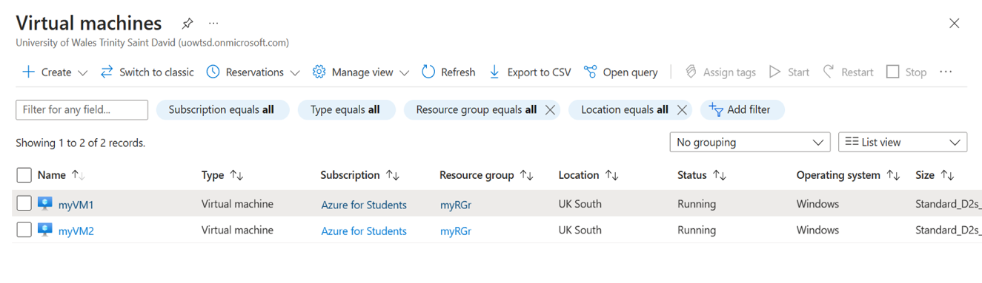

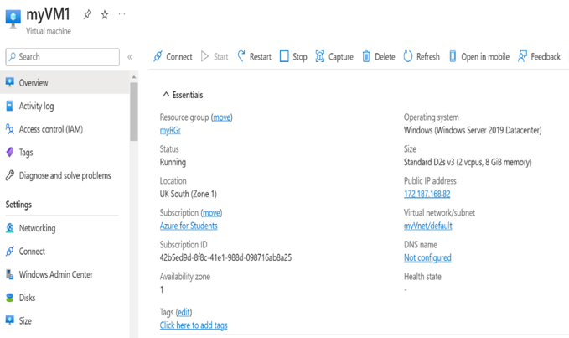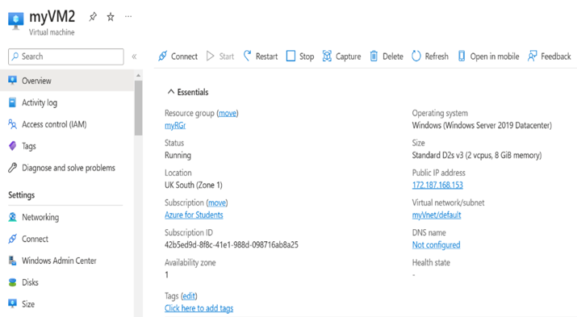

The connection to the virtual machines was made through Remote Desktop. On the Connect to Virtual Machine page, RDP was selected, then the corresponding IP address and port number were selected. In the Remote Desktop Connection window, the username and password for the virtual machine have been entered.
In Windows, RDP is blocked by the firewall. In this case, I turned off Firewall, Remote Desktop Protocol began functioning normally. In the Windows Security tab of each virtual machine, Firewall have been disabled on both the public network and the private network [12].
An organization's security policy can be enforced by a Firewall, a network security device that monitors and filters incoming and outgoing network traffic.

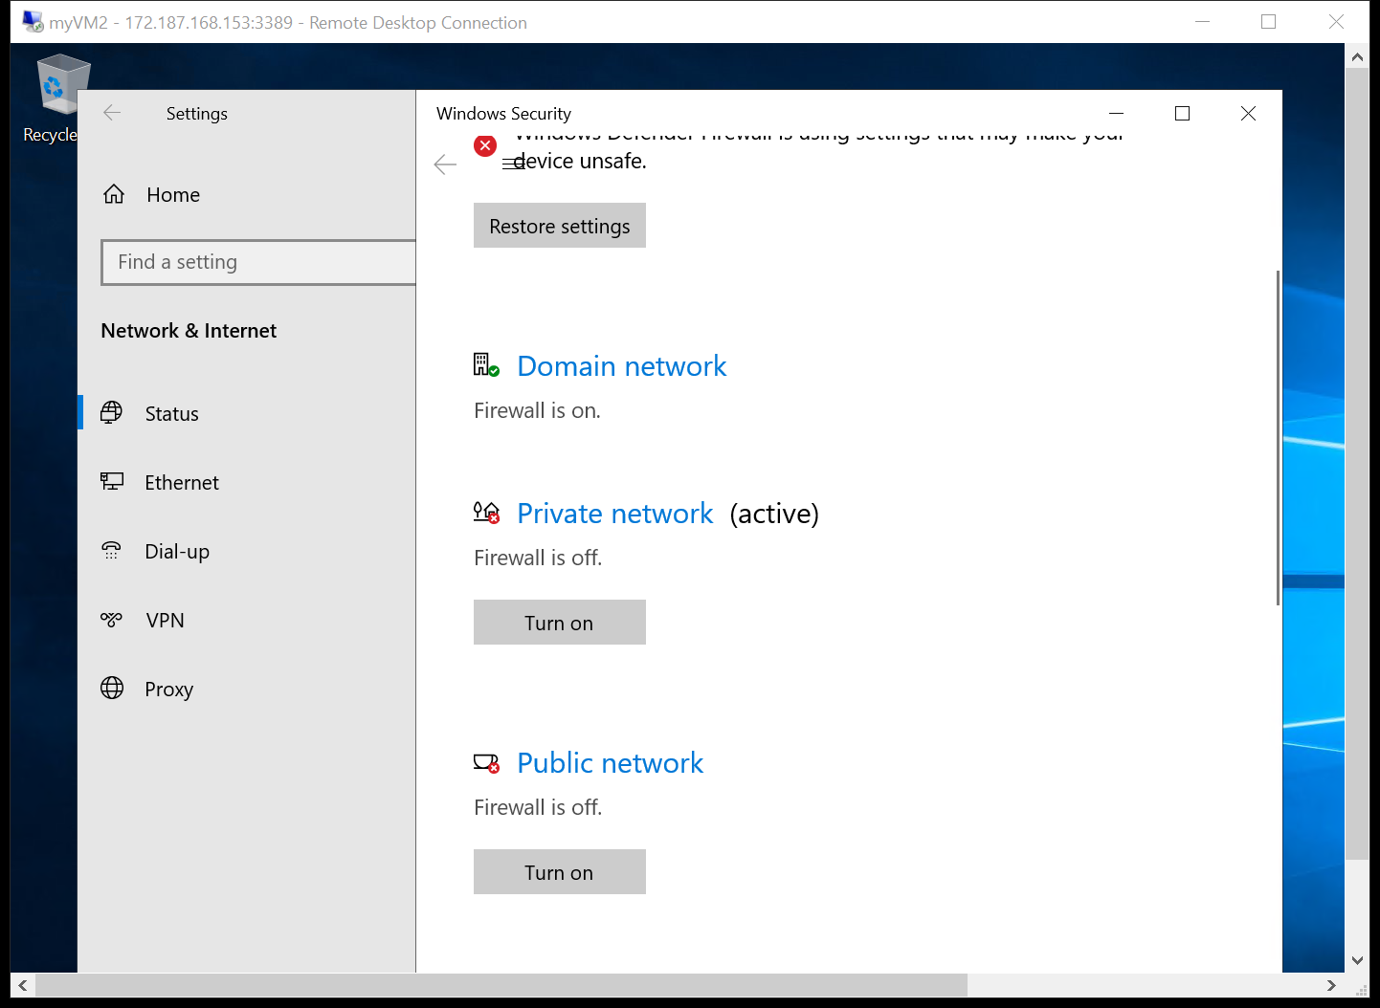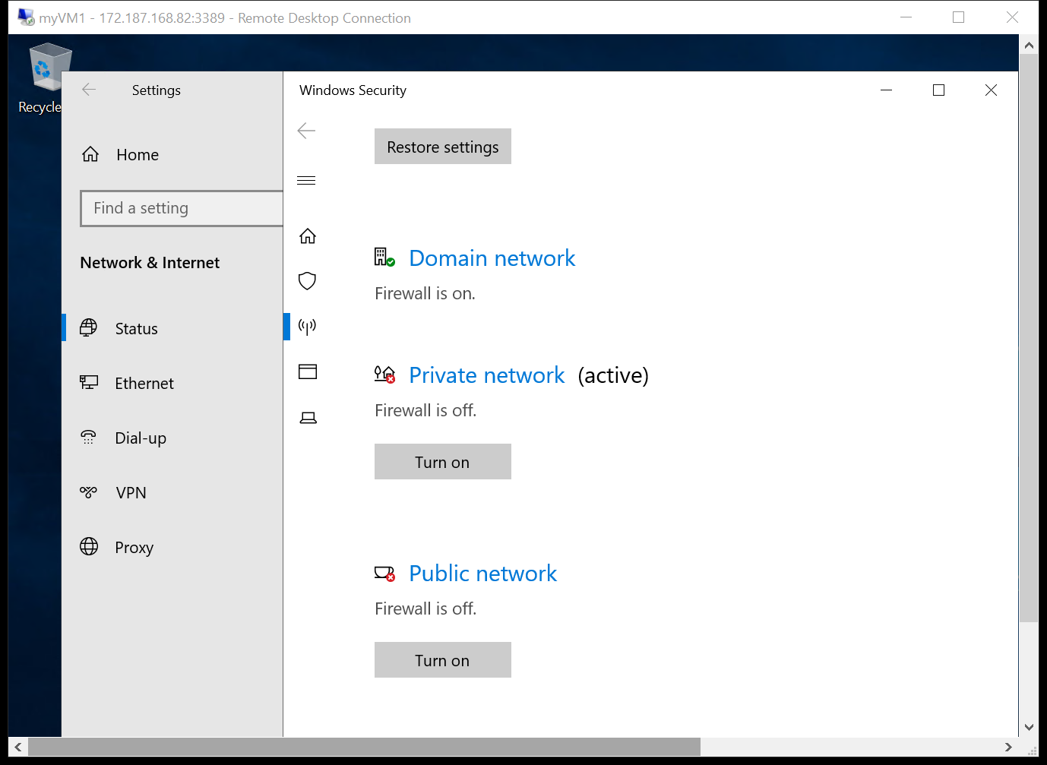

The private IP address of the virtual machines is:
- VM1 – 10.1.0.4.
- VM2 – 10.1.0.5.
In the following figures, we can see that there are connections between virtual machines.

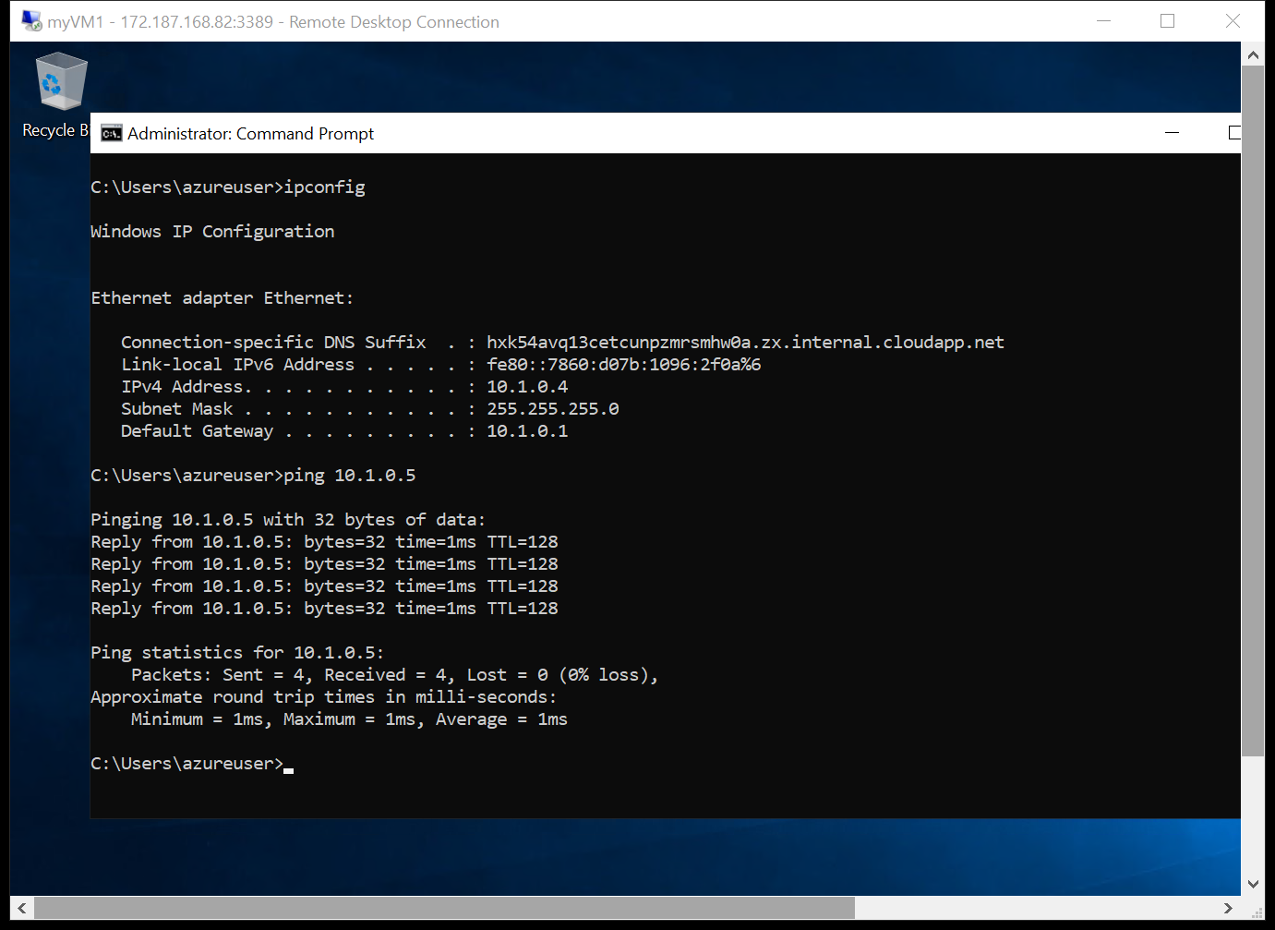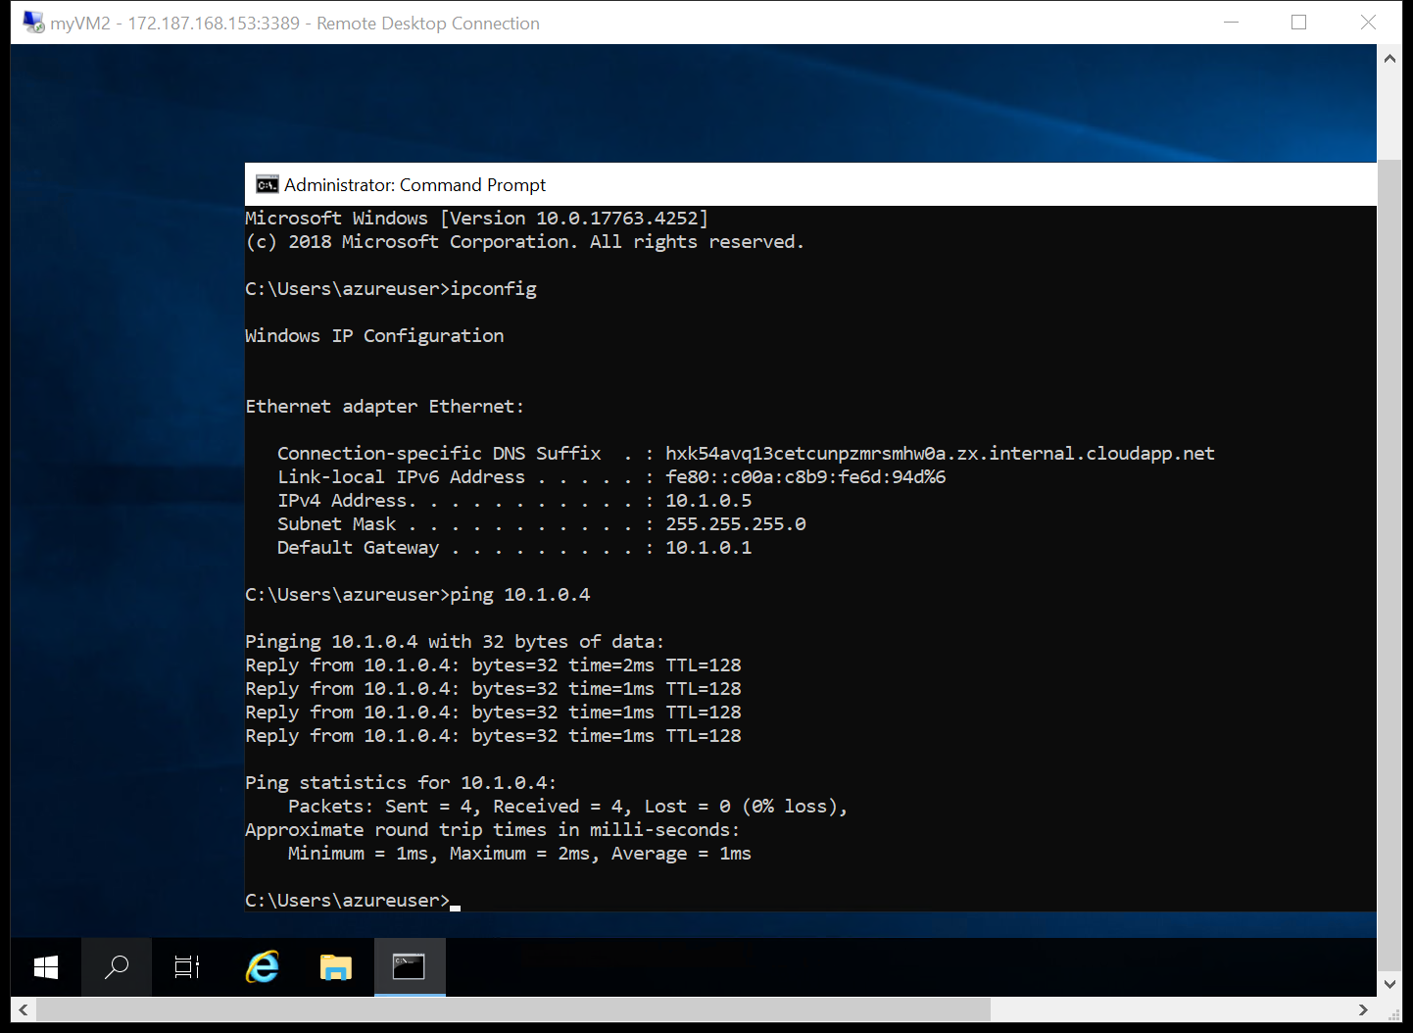

Installing the Nginx web server on the VM.

Nginx may function as a web server, load balancer, mail proxy, and HTTP cache. SaaS solution NGINX for Azure offers sophisticated traffic control and monitoring thanks to its native integration with the Azure cloud.
I set up a virtual machine running Linux. I connected to it using Bastion and entered the following commands to configure the Nginx web server.

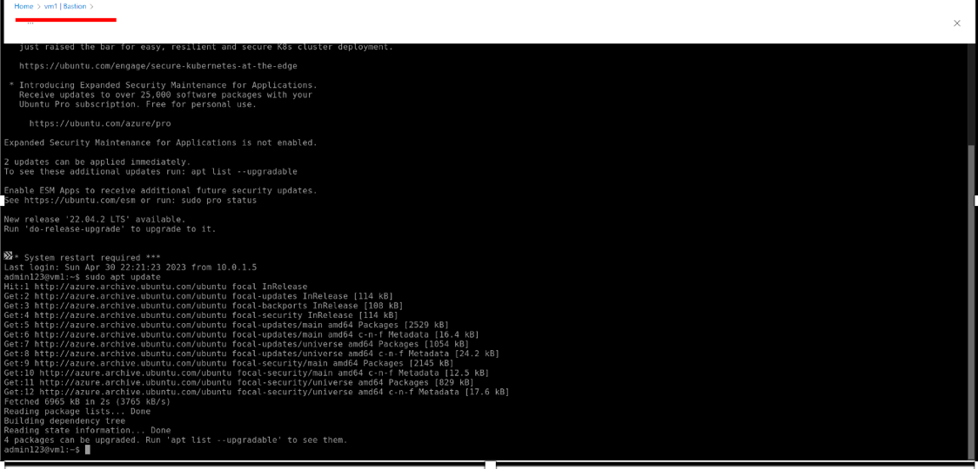

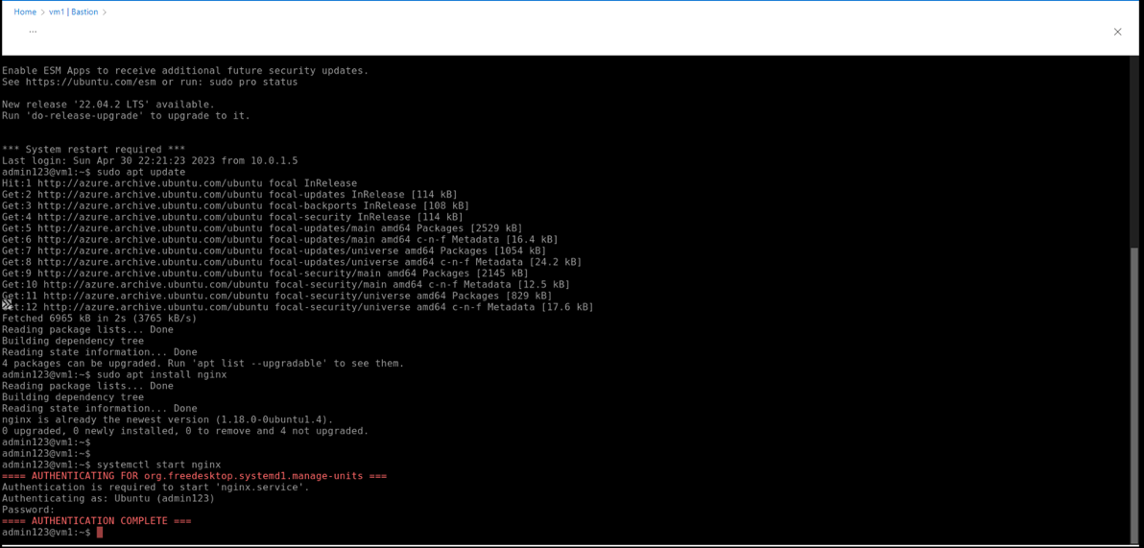

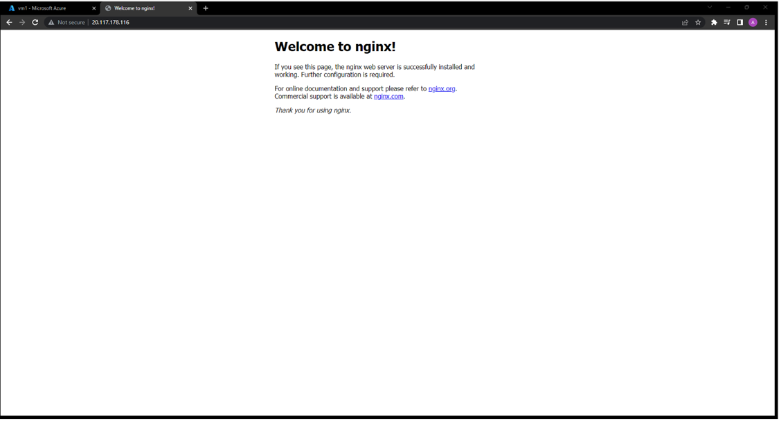

- Setting up PostgreSQL on Azure as a database.

When you need a relational database service, look no further than Azure Database for PostgreSQL [11]. It's a fully managed database-as-a-service with the performance, security, high availability, and scalability to handle mission-critical applications [11].
Then, I have created an Azure database for the PostgreSQL server. The Flexible server deployment option has been accessed, where the appropriate information has been filled in such as: Resource group name, Server name, location, admin username and password [13].
The goal of the database administration functions, and configuration settings can be fine-tuned with the help of Flexible Server, a fully managed database service [13].

Flexible servers excel at:
- Increased command and personalization in application evolution.
- The ability to pause and restart the server as well as cost-optimization settings.
- High availability across multiple zones.
- Controlled downtime for repairs [11] [13].

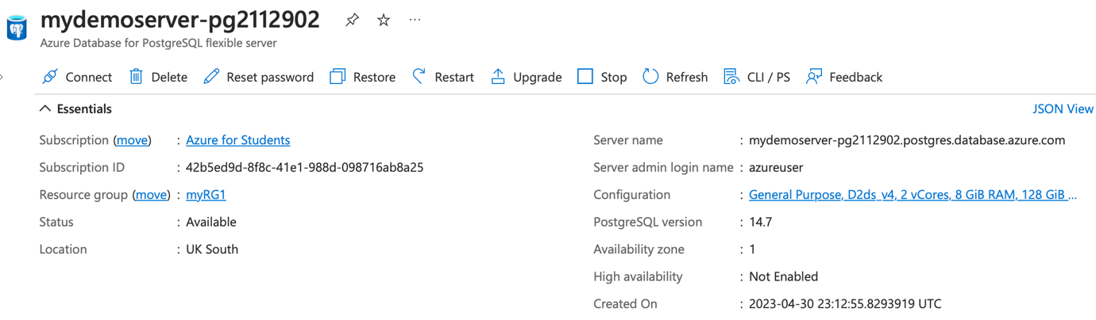

In the Network tab, private access is selected, so access to the server is limited to the virtual network. It will not be publicly exposed and remained private to vNet.

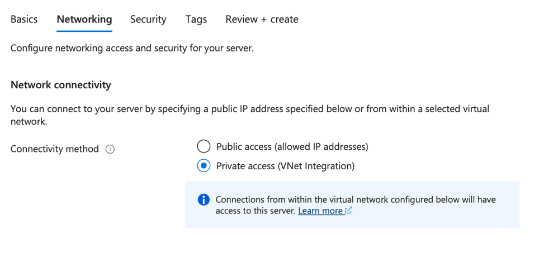
The following figure shows the connection to the PostgreSQL database using psql and the PostgreSQL version.

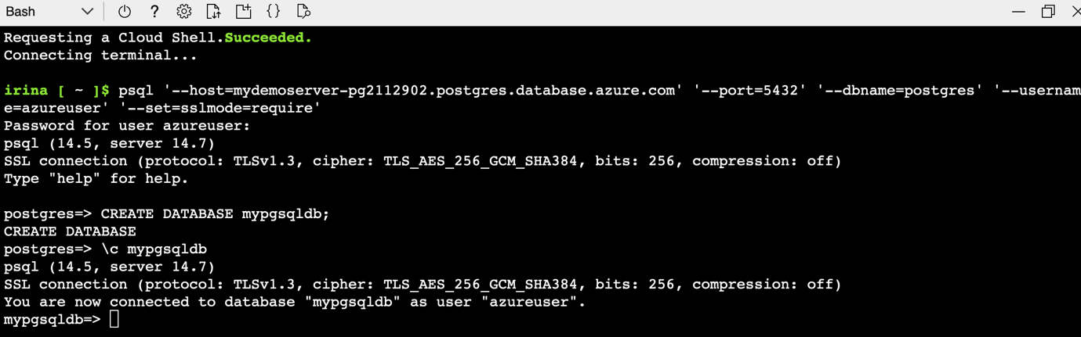

Creating a Network Security Group.

In the following figure a new network security group has been created and a set of default rules were automatically added [10].

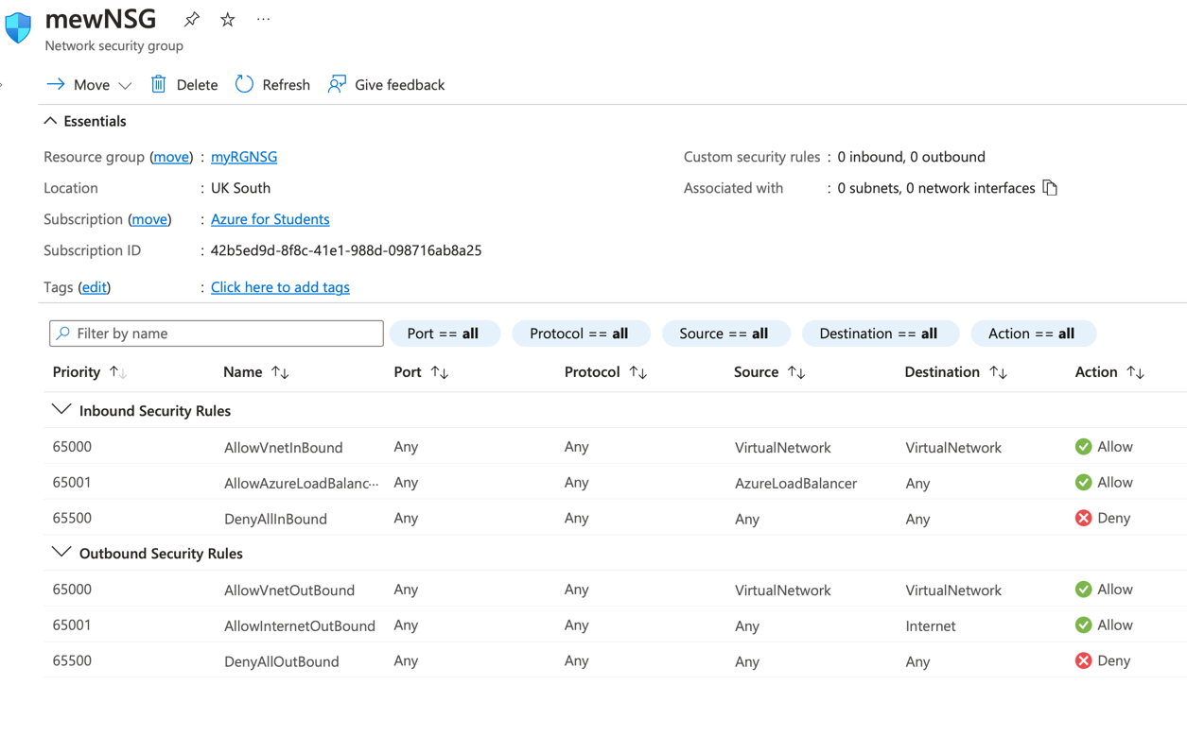

Also, some rules were added to both Inbound Security Rules and Outbound Security rules such as:
- allow SSH connection on port 22 for any client. Secure Shell is a protocol for remote server access over a network.
- allow RDP connection on port 3389 for any client.

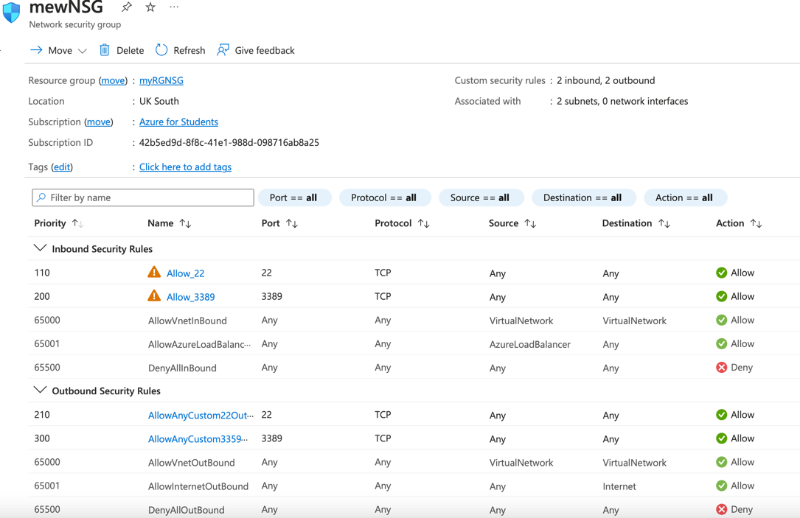

Then this NSG was associated with the virtual network of both virtual machines. Respectively, we can see Effective Security Rules for each virtual machine.

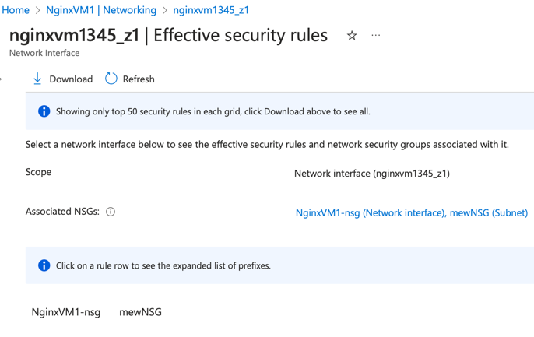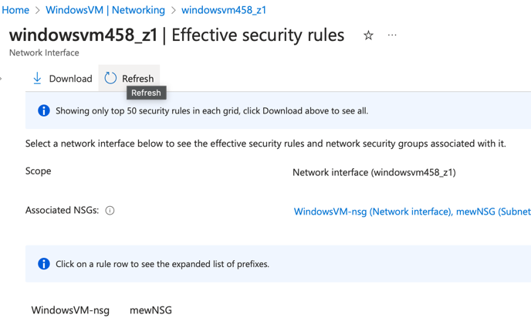

In the figures above, you can see the implementation of two Network Security Group Associations:
- Network interface card (NIC) association with a network security group whose restrictions for network access apply solely to the associated NIC.
- Subnet association with a network security group means that everything within that subnet is subject to the group's network access policies [10].

Conclusion.

My evaluation centred on testing the ability to construct, install, configure, and manage virtual machines, virtual hard discs, virtual networks, a web application, a database implemented in a structured query language, and a network security group. Microsoft Azure Portal, one of the most popular cloud-based systems, was utilised to accomplish these ends.
The topology below was used to perform the additional exercise.
Here, the most important aspects were covered and illustrated, including:
- Two virtual machines being created.
- Connecting two Virtual Machines in the same VNET (Subnet 1) over Remote Desktop Protocol.
- Setting up a virtual machine using the Nginx web server.
- Creating a PostgreSQL database.
- The first subnet will be used for the two virtual machines, while the second will be used for the database.
- Setting up a new NSG (mewNSG) and connecting it to the shared network that the two VMs use.
- Each Virtual Machine's Network Interface Card have its own NSG created.
- There is no way for anyone outside of Subnet 1 to access the PostgreSQL database.

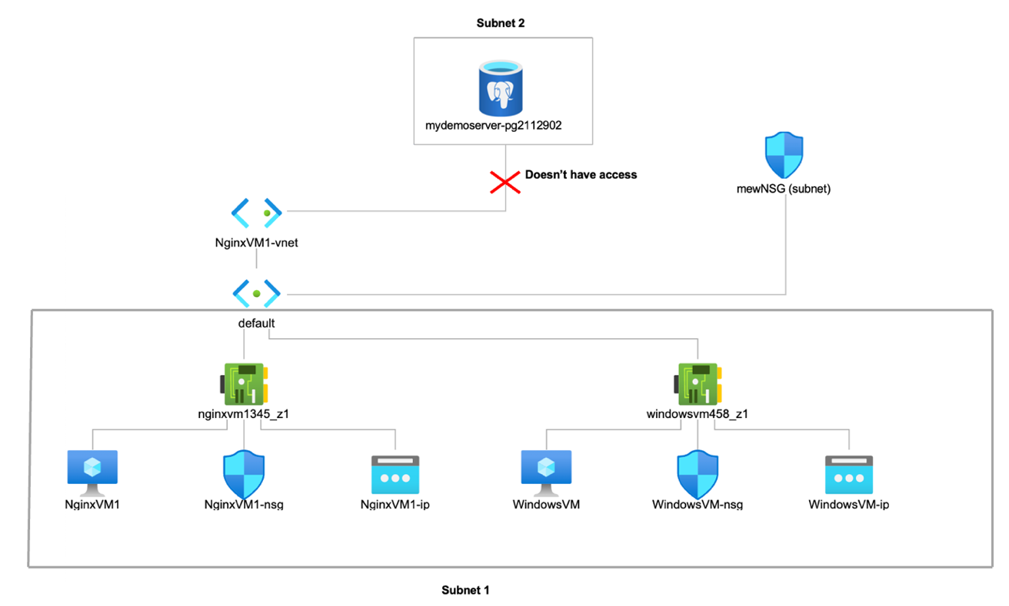

A brief overview of creating and managing resources and their features in the Azure portal was also highlighted.

List of References.

- cynthn. “Quickstart - Create a Windows vm in the Azure Portal - Azure Virtual Machines.” Learn.microsoft.com, learn.microsoft.com/en-us/azure/virtual-machines/windows/quick-create-portal.
- “Introduction to Azure Virtual Network (Vnet) || Simplilearn.” Simplilearn.com, www.simplilearn.com/tutorials/azure-tutorial/azure-virtual-network-vnet.
- roygara. “Select a Disk Type for Azure IaaS VMs - Managed Disks - Azure Virtual Machines.” Learn.microsoft.com, learn.microsoft.com/en-us/azure/virtual-machines/disks-types. Accessed 28 Apr. 2023.
- mbender-ms. “Azure Network Security Groups Overview.” Learn.microsoft.com, learn.microsoft.com/en-us/azure/virtual-network/network-security-groups-overview.
- “The Guide to Azure NSG.” CloudBolt Software, www.cloudbolt.io/azure-costs/azure-nsg/.
- cephalin. “Overview - Azure App Service.” Learn.microsoft.com, learn.microsoft.com/en-us/azure/app-service/overview.
- “What Is Azure Web App? Create an Azure Web App.” Www.dotnettricks.com, www.dotnettricks.com/learn/azure/creating-web-app-tutorial-pricing.
- WilliamDAssafMSFT. “Create a Single Database - Azure SQL Database.” Learn.microsoft.com, learn.microsoft.com/en-us/azure/azure-sql/database/single-database-create-quickstart?view=azuresql&tabs=azure-portal.
- “What Is the Azure SQL Database Service? - Azure SQL Database.” Learn.microsoft.com, 28 Sept. 2022, learn.microsoft.com/en-us/azure/azure-sql/database/sql-database-paas-overview?view=azuresql.
- “Azure Network Security Groups: How They Work & How to Create Them | Aviatrix.” Aviatrix.com, 1 Aug. 2020, aviatrix.com/learn-center/cloud-security/create-network-security-groups-in-azure/.
- sunilagarwal. “Quickstart: Create Server - Azure Portal - Azure Database for PostgreSQL - Flexible Server.” Learn.microsoft.com, learn.microsoft.com/en-us/azure/postgresql/flexible-server/quickstart-create-server-portal. Accessed 1 May 2023.
- James Boyce, "Creating and Managing Azure Resources," in Microsoft Certified Azure Fundamentals Study Guide: Exam AZ-900, Wiley, 2021, pp.157-178.
- Timothy L. Warner, "Managing Databases in Microsoft Azure," in Microsoft Azure For Dummies, Wiley, 2020, pp.185-208.
- Timothy L. Warner, "Deploying and Configuring Azure Virtual Machines," in Microsoft Azure For Dummies, Wiley, 2020, pp.87-113.

