 | Targed/Target | Yr hyn yr wyf wedi'i wneud yn yr aseiniad hwn.  What I have done in this assignment.
Targed/Target 1 | Ensure you stick to the brief of the assignment. | Made sure the assignment brief was open throughout writing to ensure I was keeping on track.
Targed/Target 2 | Proofread your assignment prior to submitting to ensure you academic writing has clarity and no ambiguity. | I read through the assignment multiple times and also sent it to a colleague to read through, taking on board any constructive comments.
Targed/Target 3 | Consider the use of Student Services to help you with point 2. | Accessed the online services to support my writing throughout the essay.

Researching the Learning: What, how and why am I teaching?

Aim, focus and purpose of the research.

During placement in PTE1 an opportunity for research was made available. This opportunity meant that an area of personal and professional interest could be identified in a deeper manner. Expressive arts were a particular interest to me, this presented an opportunity to explore this topic further. During each term the children are presented with a theme and this can be covered over several weeks, referred to as midterm planning. This term the theme was ‘Big Wide World’, from Cornerstones Curriculum (See Appendices 1). Subject coverage included Creative development: Art, Craft and Design; which meant that expressive arts could be covered within this research study. The purpose of the lesson study was to identify differences in child engagement, dependent on the choices offered to and chosen by the pupils during each task. This was decided as the main focus for the lesson study detailed below.

Research context

According to Estyn (April 2014) for my school, there is 9% additional learning needs (ALN) and most pupils appear to come from affluent families with free school meals being at 4% for the entire school, an indicator of poverty within an area (Welsh Assembly Government, 2016). My partners school was the exact opposite, according to their Estyn report (November 2017) 31% of pupils having ALN and 36% of pupils are eligible for free school meals respectively, above the Welsh average of 19%. The question arises as to whether these figures have any effect or impact on educational engagement, I was interested to explore the outcomes of presenting choices to the students.

Both myself and my partner were based in Year 2, Foundation Phase. We discussed the option of how to incorporate expressive arts it into our lesson study that would be age appropriate, resting on children’s level of choice, resulting in the following research question:

Does the level of choice impact a learner’s engagement when completing a lesson activity?

For my class this meant completing an activity, specifically discovering a Welsh landscape artist named Kyffin Williams. The element of choice could be incorporated with multiple landscapes to complete or offering a choice of medium to complete one specific landscape.

Overview of relevant literature

When exploring this further, the importance of Art for young children is paramount with multiple authors discussing the topic and citing others to support this. An article by Meiners (2005, p. 40) cites Goldberg (1998) who express that allowing the children an active role in an art experience offers opportunities to create understanding through expressing their emotions and to develop subject specific language. This is both supported and questioned by Schiller (1996, p. 75) who identifies the difficulty for teachers when trying to blend the art curriculum with play as a main priority. This is indicative for the foundation phase which describes the basis of the framework for encouraging children to be creative and imaginative, making learning more enjoyable and more effective (Welsh Assembly Government, 2010). An article by Cooper et al (2010) examined effects of providing choices. It found that when students were offered a choice, in this case with homework, they felt more competent with enhanced completion in comparison to when no choice was given. Their survey data showed that students were more motivated and interested if there was more independent choice, rather than a strict regime. Platt (2018) argues that although choice within the classroom appears to be fitting and beneficial, the reality however is dependent on subject content and the year group. She goes on to cite Dyson (2001, p.25) who states that ‘All learners are different, however, insofar as they are individuals with distinctive learning styles, needs and interests.’ This supports our research question, acknowledging that children have varied interests, however, can work within the same proximities of the topic, producing personalised work.

Choices within the classroom can possibly create an adaptable learning environment for students allowing them all to participate and flourish. Flowerday and Schraw (2003, p207) support this understanding, expressing that ‘teachers believe that allowing students to make choices within the context of instruction is an effective motivational strategy’. Agreeing on choice as our focal point of our research question we moved onto which area of learning experience (AoLE) to specifically work with. Expressive Arts allows for various techniques to be explored, including drawing, painting, puppet shows, role-playing, drama and dancing. Purswell and Stulmaker, (2015, p.104) cite Luke, (2008) who acknowledges the creative process involved in expressive arts, which encourages risk taking, and the development of a ‘deeper sense of self’, that is more authentic than instructionally manufactured. Given this insight, coupled with a student having freedom of choice within their task, brought on an intrigue as to how these two areas may complement each other when learning. Buxton et al (2014, p.195) claim that ‘research suggests that there is a lull in the developmental of expression in children’s drawings during the primary school years and that many children give up on art between the ages of 10 and 12.’ Arguing that perhaps children may lose interest in art due to the lack of individuality of the process. However, Vygotsky’s perspective of imagination and creativity, claimed the basis for creative imagination was found in the initial expression of play, identifying the link with maturity and development of rationale in youth (Ayman-Nolley, 2009). Given that every child is unique and has their own preference of subject choice, we considered what impact the amount of choice had on the student’s engagement within the task. Does more choice encourage or stifle the learning process, leading to disengagement of the activity? Cole (2012, p.73) states that it is the ‘parents and teachers that must provide rich and varied opportunities to encourage engagement’, perhaps leading to the notion that teachers are the driving force behind student engagement.

The AoLE of Expressive Arts is highly regarded for child development. Lima-Rodrigues and Santos (2016) support this, outlining a deeper connection between education and expressive arts, beyond the general learning of literacy and numeracy, but impacting the overall development of the students; promoting higher order learning. ‘Higher order thinking skills encompass both critical thinking and creative thinking’ (Conklin, 2012. p.16). Both are equally important. Jacobs (2010) identifies the importance of creativity, stating that the curriculum should develop creativity in all learners. This information only highlights the importance of children engaging in such activities. Young and Michael (2019) cite Wolpert-Gwaron (2018) and the research that was conducted by them. It highlighted that working within a classroom required so much more than motivation. They state,

A classroom that is focused just as much on engagement as it is on academic achievement not only runs smoother, but also achieves an overall goal that should function as a teacher’s target… developing people who appreciate lifelong learning. After all, enjoying school doesn’t end when our students leave our schools’ wall. The joy of learning should be a cushion that carries students into higher education and beyond (Wolpert-Gawron, 2018. P.2).

Another author who supports students having choice is A. J. Juliania. They strongly believe students should be given choice as part of their learning path. He highlights how difficult it can be to offer students choice when teachers have additional standards and expectations that interfere. Although he also states from his personal experience, when allowed to choose what he wanted to learn, he was engaged and invested in the outcome of his learning, because the experience was centred around the types of learning that he does best (Juliania, 2014). This can be adapted to all classroom, by allowing children the freedom to choose and experiment with choices, they are taking ownership of their learning, which in turn allows for personal interaction and growth.

Lesson Study Design

The methodology used for the lesson study research is a form of action research. Lesson study methodology is a Japanese model of teacher led research. A small group or pair of teachers may collaborate in a unique field that lacks evidence or requires development. The group / pair then work with any current or previous information, plan together, teach, observe, adapt and reflect. By doing this, teachers hope to impart knowledge of the study for themselves and others, improving their practice within the classroom (Teacher Development Trust, 2015).

The methods of data collection used for this lesson study were nonparticipant observation of three focus groups and reflection. My observational notes were brief for each focus groups observed, outlining the engagement and interactions, focusing on one chosen child for each group.

By observing children carefully to note their progress, involvement and enjoyment, as well as focusing on the attainment of predetermined outcomes, practitioners should be able to plan a more appropriate curriculum that supports children’s development according to individual needs (Welsh Assembly Government, 2008).

As partners we agreed upon a strategy for the lesson study. It included nonparticipant observation, interviews with prewritten questions and a 5-minute interval measurement of one child within each focus group. These are both quantitative and qualitative recordings. Qualitive data looks at multiple aspects to gain further understanding of prior information. From a qualitative perspective we agreed upon using the Leuven Scale to measure involvement during the task. The levels range from 1 to 5, as shown in the table below.

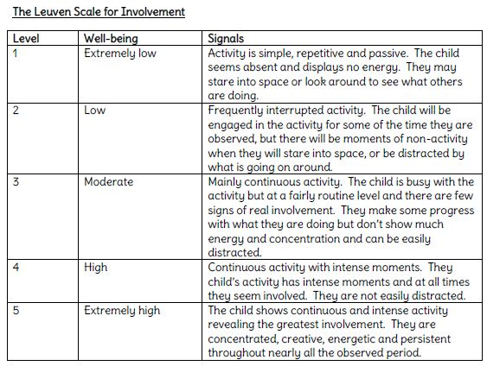

(Google, 2020)
Using the table that we created (see below) for each focus child, we monitored their engagement level every 5 minutes for a 25-minute period, observing the level that the focus child was displaying at each interval.

Tick if observed | Pupil 1 (Group 1) | Pupil 2 (Group 2) | Pupil 3 (Group 3)
5 minutes
10 minutes
15 minutes
20 minutes
25 minutes
30 minutes

Quantitative data includes aspects such as interviews. Questions can be asked to facilitate the reasoning behind the research task. It acts as a supporting factor, highlighting areas that observations may lack (Jotform, 2019). We agreed upon 6 questions to ask the children. These sets of questions were adapted for each lesson to incorporate the activity that had been chosen. Both were based around the expressive arts as previously stated; however, the activity choices differed slightly. We ensured that the questions were age appropriate for the year group that we would be working with (see questions below).

- Did you enjoy the activity?
- Did you like the character / landscape you created?
- Do you feel you worked the best you could?
- Do you think you would have worked better if you chose the character / landscape you created?
- Would you like more free choice in all your lessons?
- If you were the teacher what would you do in this lesson?

For our reflection we agreed upon Gibbs reflective cycle (1988). This model is based on six stages. Each stage allows the teacher to reflect, deeper than other models, on their practice. Canning and Reed (2010) tells us that thinking critically and creatively, aids reflective practice. Sellars (2017) supports this by citing Roberts (2009) who believes that reflective practice is deemed as crucial for maximizing learning in a professional environment.

(Google, 2020)

The model above identifies the 6 stages of the reflective cycle. Linking to our research project, we were able to identify each area specifically, expanding our prior knowledge and incorporating the newfound information; allowing for reflection of the entire process. Cambridge Assessment International Education (2020) cite Finlay, 2008, claiming that reflective practice ‘is learning through and from experience towards gaining new insight of self and practice’. This is paramount in all walks of life, however very poignant when completing teacher training to ensure you are continuously growing in your field.

Both observation sessions included 3 focus groups each. My partner had 3 middle ability groups, however we adapted this to same ability groups for the second lesson when she was to observe me. This was included in our reflection after the initial observation, allowing for small changes that we both felt would enhance the research. When discussing our group options with the class teacher, it was agreed that the 3 focus groups within my session would be of the same ability, with 5 students per group. Marks, (2016) cites Hallam et al, (2013, p.72) who tells us that ‘where structured ability-grouping is implemented, the activities undertaken in the classrooms of high, middle and low-ability pupils differ considerably. This interested me in respect of what choices might be made for which ability grouping and whether they would differ greatly also. Hallam, and Ireson (2001) also argue that ability grouping solves the problem for low attainment but note, that in practice, this is not an easy dilemma to solve. This links to the understanding of student led classroom rather than a teacher led classroom. A student led classroom allows the students to make appropriate choices, supporting themselves in their growth and development, however a teacher led classroom gives the students instructions to complete activities and actions. Student led enables children to experience activities independently encouraging initiative and creativity (Freiberg and Lamb, 2009).

Ethical Considerations

There are many ethical considerations when completing a research task within the classroom. These include areas such as confidentiality and anonymity, consent and assent, fairness and protecting the rights of the child. On completing an ethics from, prior to the research task, there were many areas that needed to be addressed. Children’s rights are paramount. BERA, (2018) highlights the importance of adhering to their underlying principles. They state that all principles should be applied with integrity to ensure that our actions are seen to be ‘ethical, justifiable and sound’. Point 50 of the report, identifies the importance of keeping any data secure, including the use of computers for storing such data.

Factors including ‘the right to withdraw’, allowing for a flexible arrangement when working with children. BERA (2018) endorses the United Nations Convention on the Rights of the Child (UNCRC), keeping the best interests of the child at the forefront of the study.

Lesson Study 1 Results and analysis

The first lesson was completed at my partners school, with me observing the activity. The learning objective of the lesson was: Draw a character and label parts of it using adjectives. Over 3 groups, the first group students were offered a chosen character of a known book to draw, the second group were allowed to choose from the mixture of animals on the front cover of a separate book, the third group were allowed to design a character or with the use of an iPad they could search for character to draw (See appendices 2).

During the lesson my partner introduced the aim of the activity, using prior learning to explain the act of labelling their character. The children had not been introduced to the term ‘adjective’ previously, this was explained by verbally modelling sentences, the children then participated in describing a part of their body.

The first group engaged well; the students were given a copy of a lion character to draw. My partner sat with the students and encouraged them by pointing out areas to possibly label. At the end of the session I spoke with the Child A who answered the above interview questions. Child A was timid and quiet in their responses, requiring a little encouragement. They were happy with their work however personally would have preferred to create a picture of an ‘LOL - Lil Outrageous Littles’, a well-known children’s toy. The Child A expressed how ‘very excited’ they were about all activities, explaining that they like doing every activity in school. When asking the final question, Child A chose a different animal that they would offer to be labelled, ‘a giraffe or an elephant’; continuing the theme of animals.

An example of the lion given to the children to draw and label.

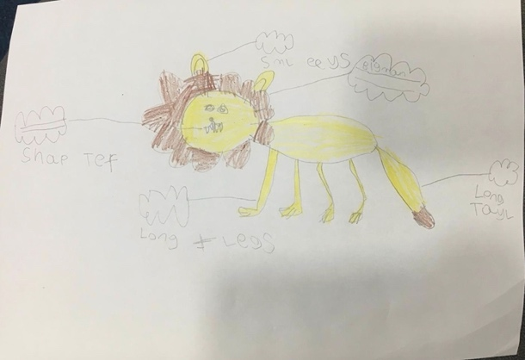

Child A’s labelled picture of a lion.

During the second session a photocopy of the book, ‘On the way home’ was given to the children to choose a character from. Again, the children engaged well during the introduction, Child B however shouted out during the session quite frequently, mumbled to themselves while completing their drawing, changed their mind after drawing one character for another requiring a new piece of paper and rushed the writing. My partner spoke calmly asking Child B to write the words again in larger bubbles that they drew for them. Child B complied and completed the descriptive words in the new bubbles. When interviewing Child B, they fidgeted on the seat, were very happy with their creation, however told me they like to draw from a boxing book (shouted out random animals initially), shouted that there should be no teachers in school so that they could always have free choice and finished off telling me that if they were the teacher they would send everyone out to play.
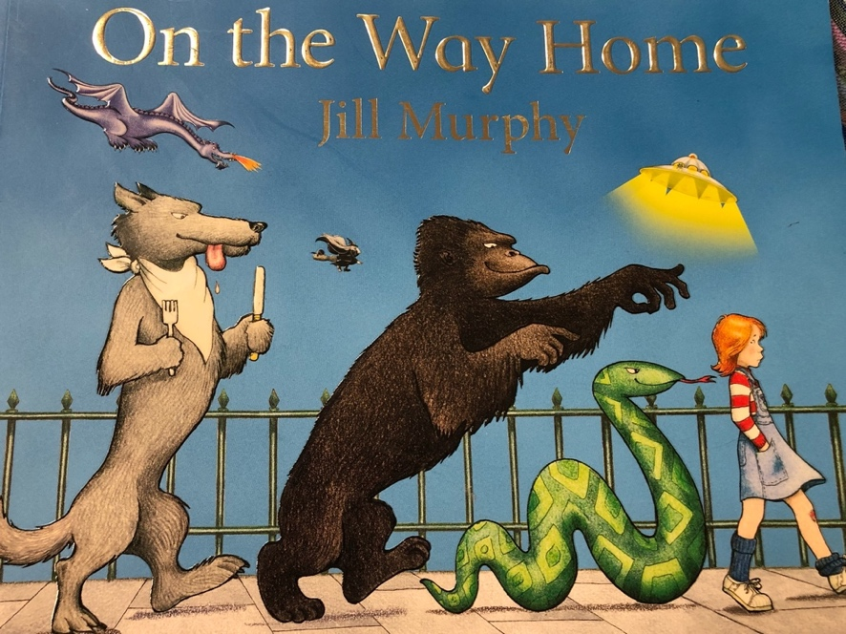

An example of the front cover to choose a character from.

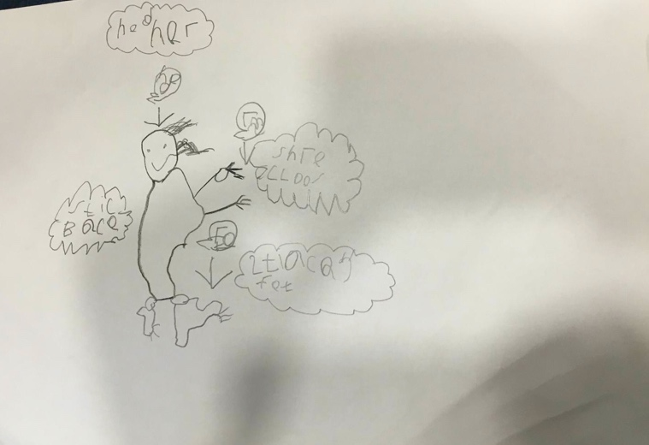

Child B’s labelled gorilla.

The third and final group were able to decide on their choice of character, either from memory or via searching on the iPad. 3 of the students chose to draw characters from memory with one child using the iPad. Child C drew their character from memory; however, the rest of the group became distracted by the iPad asking to be shown what was on the iPad. Child C continued to focus on their drawing and was not easily distracted by the other children. My partner supported the child with the iPad who became upset refusing to continue with their drawing. Child C again continued with their drawing only showing my partner their picture when finished; they were asked to add one more descriptive word to their drawing and then finally to colour it in. When interviewing Child C, they were extremely withdrawn, only nodding in response to certain questions. Question 4 was changed slightly to ask whether they felt they would work better with less choice, to which Child C nodded. They didn’t want more free choice activities because they were happy with what activities they have in the class already and would also keep this activity the same however be allowed to cut out their picture.

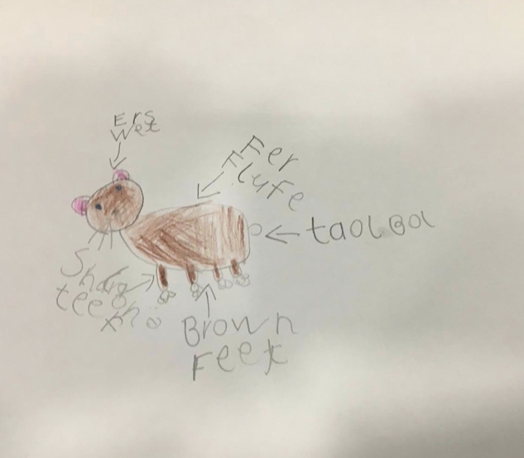
Child C’s labelled cat.

Below is a copy of the engagement observed by each pupil. Using the Leuven Scale (pictured above) I identified that Child A began at a moderate level however 15 minutes into the session they became low for involvement, picking up again towards the end. Child B had low involvement throughout most of the session, however, did briefly become moderately involved towards the end of the session. Child C was moderately involved to start, then became highly involved during the task, slowly becoming less involved towards the end of the session.

Tick if observed | Pupil 1 (Group 1) | Pupil 2 (Group 2) | Pupil 3 (Group 3)
5 minutes | 3 | 2 | 3
10 minutes | 3 | 2 | 4
15 minutes | 2 | 3 | 3
20 minutes | 3 | 3/2 | 2

From the above information myself and my partner reflected on the session. It was clear that they were very instructional during the introduction and had excellent manner and tone with the children. I did however not that to support the new concept of the adjective, modelling descriptive words on a white board may have supported their writing. On reflection we agreed upon changing the groups to 3 different abilities, rather than focusing on middle ability. For my lesson the picture would remain the same throughout but the medium used would be adapted for each group. The activity would also be introduced as a whole class approach instead of an introduction for each group individually.

Observing this lesson helped to identify how unique each child was. They each engaged differently during the task however each had their individual thoughts about what they would choose to do as the teacher. At this point I was unsure of the impact choice had on the children overall.

Lesson Study 2 Results and analysis

For my lesson the children were asked to create a copy of a landscape by the Welsh artist Kyffin Williams (See appendices 3). The introduction comprised of questioning, asking the children whether they knew what a landscape was? We discussed this and then they all watched a short film which depicted Kyffin Williams’ work. Using think, pair, share the children then identified what colours were used, what they saw in his paintings and what they thought it reminded them of. A small mind map was created showing the children’s thoughts (See below).
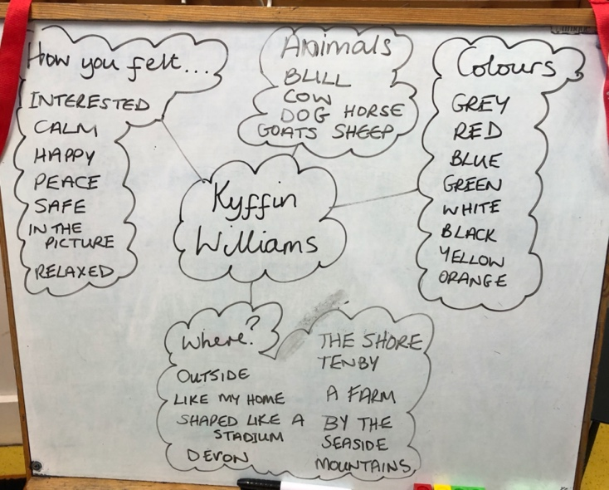
Completed mind map.

The groups were then split by ability. The first being higher ability. Group 1 was given watercolours only to complete their landscape. The children asked if they could draw the landscape prior to painting, to which I agreed. Child A was easily distracted by the other pupils initially. They briefly stopped waiting for a rubber to adjust their drawing, however when other children were chatting, they responded, continuing with the activity. Once Child A was engaged in the task, they focused and worked hard. When interviewed, they expressed that they want to be an artist when they grow up and that they would like to paint other pictures, ‘like Jesus’.
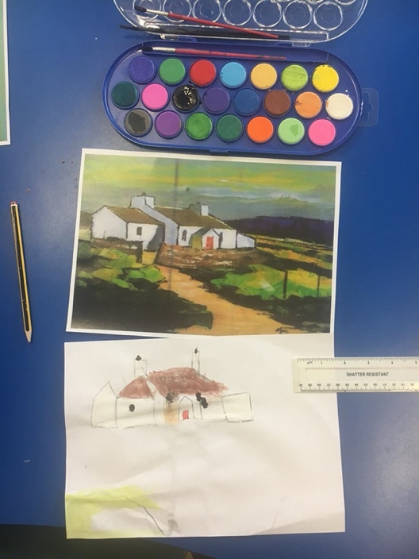
Child A’s watercolour using the landscape provided.

The middle ability group were offered the option of either watercolours of oil pastels. Child B engaged well during the activity, concentrating on the colours and staying within the lines when painting. They chose to add their own colours to the picture rather than following the colours on the example landscape, using both watercolours and oil pastels to create their picture. Child B then began colouring their hand with the oil pastel to merge the colours, however, began showing the other students that they had coloured their hand becoming distracted by this tactic towards the end of the session. When interviewed they agreed that they enjoyed the activity and were happy with what they had created because ‘I used lots of colour’. When asked if they think they would have worked better if they chose the landscape, child B responded, ‘yes because it would have been mine’. However, were unsure how they would change the lesson, stating, ‘maybe a picture with all colourful rainbows.’

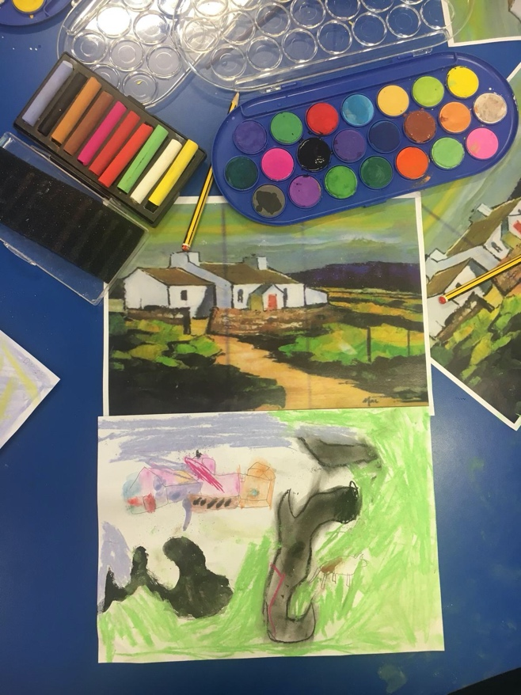

Child B’s landscape using watercolours and oil pastels.

Group 3, the lower ability group, were given the option of watercolours, oil pastels and iPads. The iPads used an application called NGA Kids (National Gallery of Art) This application allows you to upload a picture of choice allowing the children to use various interactive painting / drawing styles to create the picture. Interestingly, none of the children chose to use the iPads, instead opting to use the watercolours and oil pastels. Child C chose watercolours to complete their landscape, painting their own image, instead of copying the example provided. They were very engaged in the activity, undistracted by the conversation at the table. When interviewed, they explained how much they enjoyed painting, identifying the animal in their picture as a Scottish cow. When asked if they would have worked better if they chose the landscape, they answered, ‘I did my own one there’. Child C explained that when they are giving lots of free choice, they are unsure of what to choose, however would change the lesson to teach 10 times tables because they ‘like tens.’

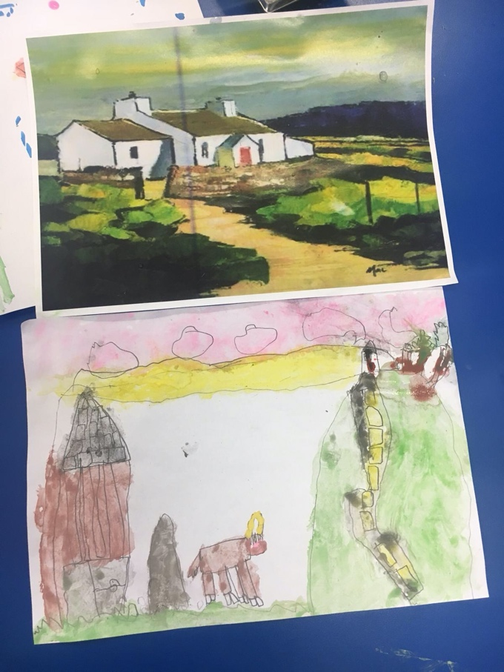

Child C’s completed landscape.

Tick if observed | Pupil 1 (Group 1) | Pupil 2 (Group 2) | Pupil 3 (Group 3)
5 minutes | 1 | 3 | 5
10 minutes | 2 | 4 | 5
15 minutes | 3 | 5 | 4
20 minutes | 3 | 5 | 4
25 minutes | 4 | 4 | 5
30 minutes | 4 | 4 | 5

Using the above information, myself and my partner again reflected on the session. Due to the introduction being led to the whole class, the above table was completed during the sessions only. We discussed the stark difference between the 2 lessons, with engagement seeming much more apparent the more choice that was offered. On reflection, I identified that the children mostly chose to use water colours, this may be due to the fact that they had not experience oil pastels previously, a prior lesson allowing them to experiment may enhance the task in the future. During the final session, children completing enhanced provision asked if they could use the iPads, creating another enhanced area to be accessed. This highlighted that although an asset to the classroom, iPads can be used independently allowing for a more in-depth focus task to be completed using varied mediums. For future lesson I would like to complete the task over a longer period, allowing for experimentation of mediums, giving the children a wider choice to complete their landscapes.

Research findings in relation to related literature and research

Interestingly the lesson study identified how unique and individual each and every student is. Some prefer choice, others not. During each lesson one child other than the focus child became quite upset, not wanting to continue with the task, both also high achievers. My partners lesson although interesting, the children were less engaged in the activity. By adapting the choice of medium rather than the choice of picture, children were able to create varying degrees of landscapes. This may have impacted their engagement.

For my class I would definitely allow for choice within the classroom. The child that engaged the most in my lesson completed their own landscape, instead of using the example. This tells us that when the choice is predominantly the students, they are more engaged and interested in their activity. Teachers are there to scaffold the learners, however this can be done in many forms. Scaffolding can simply mean introducing different choices for children to experience, not necessarily telling them directly how to complete the activity.

There are many strengths and limitations to the methods used for this lesson study. Sumeracki, (2018) says that observational methods can be beneficial allowing us to see the affects in a natural environment. However, there is a danger of the student’s behaviour changing when they know they are being observed. Also known as ‘The Hawthorn Effect.’

The Leuven scale used in this research study was originally developed by Ferre Laevers, a Belgium lecturer. The scale was used to help interpret the level of comfort and focus the children had within their classroom. According to Arnerich, (2018) Laevers believed that high levels on the involvement and well-being scales, allowed children to encounter a more focused level of learning. He also highlights that a one-off observation may not be enough to gain an understanding of the focus child and should normally only be used for children that practitioners may have concerns about and not used as a simple tick box observational method.

The final method that we used was to interview focus children from each group. Vasquez (2020) informs us that ensuring you have clarity of your purpose for the interview is essential. She also highlights the importance of asking basic questions to alleviate any anxiety within the child and ensuring the questions are age appropriate. Hofisi et al, (2014) argue that the interviewer themselves can often be the weakness due to lack of skills and often orchestrating the questions to suit their bias.

Conclusion

Overall the research study was very enjoyable, allowing for a topic of particular interest to be investigated in a more complex fashion. Working with a partner created areas of reflection as well as friction on occasion. This allowed for growth as a professional, working within an unfamiliar context and progressing through it. Liew, (2019) encourages professionals to push themselves out of their comfort zones, to continually develop themselves, freeing concealed potential. An article by Coenders and Verhoef (2018) tells us that when beginning our teaching journey, we should embrace the school environment and its support system.

The research lesson that I conducted, although an interesting topic did not divulge any background information to the students during the introduction. The online clip showed the Welsh artist, Kyffin Williams’ pictures, however it did not explain about him directly, why he painted or why we were looking at landscapes in particular. This could have been detailed more, outlining the history of Wales and why it is known for its landscapes. Linking to the midterm theme of ‘Big Wide World’, a comparative of landscapes from across the world may have been beneficial.

Although I possess experience in observation through my previous professions, interviewing children of this age was a new factor. The responses were limited and although the questions seemed appropriate prior to the study, it became apparent that they were very closed questions, not allowing the child to express their true feelings regarding the task. For future studies I would not discount interviewing as a method, however I would ensure that questions were open and more thoughtfully constructed.

During future school experiences I hope to utilise the lessons learnt from this research study, including working within a new partnership and accessing support from other professionals. Pillay, (2014) explains the importance of identifying your weaknesses is of equal importance as acknowledging your strengths. Creativity is one of my strengths, however working with a partner who may have very different perspectives, has definitely helped me grow as a professional, teaching me how to adapt my methods.

Prior knowledge of the methods for a research study should be carried out, an area that I hope to further myself in for future studies. Ensuring that all methods have been researched correctly, will hopefully allow for more concise evidence to be produced. For example, completing the Leuven scale for both well-being and involvement, rather than partially completing one area of the scale. If I were to complete this lesson again, I would like to increase the amount of time spent creating the landscapes, not limiting the children to 30-minute segments. A deeper understanding of the mediums offered should support the children in their choices and creations. I do feel that choice should be made available to children however knowing your students is equally important to ensure you are meeting their needs throughout, not only noting our strengths and weaknesses but also that of our students.

Every child is special, with unique combinations of abilities and needs that affect learning. All children deserve the opportunity to learn in ways that make the most of their strengths and help them overcome their weaknesses. (Unicef, 2001).

Recommendations

Regarding the lesson outcomes, it is obvious that more detailed research should be carried out to confirm or contest whether choice has an impact on children’s engagement within an activity. Unfortunately, although the evidence clearly recognises a difference of engagement between the two lessons, it questions the clarity of responses due to the difference in lessons offered.

The methods, although justifiable, should be completed over a longer period of time. Choice should also be offered throughout the classroom and not limited to one specific AoLE. This will support student’s growth in decision making and benefit the lessons equally. The research question comprised for this study, could easily be expanded. Due to the nature of the two settings, poverty could be recognised as a factor, as well as identifying the ability level of the students in question, allowing for differentiation to take place through personal choice.

Choice can be offered within the classroom, however as Wolpert-Gawron, (2018) identifies children should be given the chance to access choice, rather than limit their experience within the classroom and the educational environment. This links to the new curriculum for Wales 2022. Successful Futures by Professor Graham Donaldson, (2015) outlines the structure that should be delivered to all classrooms. Within all areas each child should be given the opportunity to gain four purposes, healthy, confident individuals is one purpose where choices can be made throughout their lives, identifying the importance of offering children the chance to make choices in their lesson activities. Progressing into the new curriculum should allow for future research to be completed identifying and comparing, hopefully the positive changes, the curriculum brings for students.

Reference List

Arnerich, M. (2018) ‘How to Apply The Leuven Scales In Practice Stop using wellbeing an involvement as another observation checklist’, Family.co [blog] 12 December. Available at: https://famly.co/blog/management/leuven-scales/ (Accessed: 23rd February 2020).

Ayman-Nolley, S. (2009) ‘Vygotsky’s perspective on the development of imagination and creativity’, Creativity Research Journal, 5(1), pp.77-85. Available at: https://www.tandfonline.com/doi/abs/10.1080/10400419209534424 (Accessed: 19th February 2020).

BERA. (2018) Ethical Guidelines for Educational Research (4th ed.) Available at: https://www.bera.ac.uk/publication/ethical-guidelines-for-educational-research-2018-online (Accessed: 22nd February 2020)

Buxton, S., Hallam, J.L., and Hewitt, D. (2014) ‘An Exploration of Children’s Experiences of Art in the Classroom’, International Journal of Art & Design Education, 33(2), pp.195-207. Available at: https://web-a-ebscohost-com.ezproxy.uwtsd.ac.uk/ehost/detail/detail?vid=0&sid=03ce5aa8-d5bc-442e-8e56-8b8d15b7fbfc%40sessionmgr4007&bdata=JnNpdGU9ZWhvc3QtbGl2ZQ%3d%3d#AN=102206818&db=aph. (Accessed: 19th February 2020).

Canning, N., and Reed, M. (2010) Reflective Practice in the Early Years. London: Sage.

Cambridge Assessment International Education. (2020) Getting started with reflective practice. Available at: https://www.cambridge-community.org.uk/professional-development/gswrp/index.html (Accessed: 20th February 2020).
Coenders, F., and Verhoef, N. (2018) ‘Lesson Study: professional development (PD) for beginning and experienced teachers’, Professional Development in Education, 45(2), pp.217-230. DOI: 10.1080/19415257.2018.1430050
Cole, K. (2012) ‘JOY IN THE MAKING’, in Komburstyn, C. (ed.) Young Children and the Arts: Nurturing Imagination and Creativity. United States of America: Information Age Publishing Inc.

Conklin, W. (2012) Higher Order Thinking Skills to Develop 21st Century Learners. CA: Shell Education.

Cooper, H., Patall, E.A., and Wynn, S.R. (2010) The effectiveness and relative importance of choice in the classroom. Journal of Educational Psychology. 102(4), pp. 896-915. Available at: https://doi.org/10.1037/a0019545 (Accessed: 16th February 2020).

Donaldson, G. D. (2015) Successful Futures. Available at: file:///Users/rhianbutcher/Downloads/Donaldson%20Report%20-%20Successful%20Futures%20-%20Independent%20Review%20of%20Curriculum%20and%20Assessment%20Arrangements%20in%20Wales%20(2).pdf (Accessed: 23rd February 2020).

Estyn (2017) A report on Cadoxton Community Primary. Cardiff: Available at: https://www.estyn.gov.wales/sites/www.estyn.gov.wales/files/documents/Cadoxton%20Community%20Primary.pdf (Accessed: 30th January 2020).

Estyn (2014) A report on Pendoylan C.I.W. Primary School. Available at: https://www.estyn.gov.wales/sites/www.estyn.gov.wales/files/documents/Inspection%20report%20Pendoylan%20C.I.W.%20Primary%20School%202014%20%28English%20only%29_0.pdf.pdf.pdf.pdf.pdf.pdf.pdf.pdf.pdf.pdf.pdf.pdf.pdf.pdf (Accessed: 30th January 2020).

Flowerday, T., and Schraw, G. (2003) ‘Effect of choice on cognitive and affective engagement’, The Journal of Educational Research, 96(4), pp. 207-215. Available at: https://search-proquest-com.ezproxy.uwtsd.ac.uk/docview/204313752/fulltextPDF/7A9BA32F0D1A48ACPQ/1?accountid=130472 (Accessed: 19th February 2020).

Freiberg, H. J., and Lamb, S. M. (2009) ‘Dimensions of Person-Centred Classroom Management’, Theory into Practice, 48(2), pp.99-105. DOI: 10.1080/00405840902776228.

Google. (2020) The Leuven Scale for Involvement. Available at: https://www.google.com/search?q=the+leuven+scale+for+involvement&safe=strict&rlz=1C5CHFA_enGB883GB883&sxsrf=ALeKk00owvo030-ta8p-DDiGT-Yu_vWpOg:1582281331340&source=lnms&tbm=isch&sa=X&ved=2ahUKEwjEr8GlueLnAhUYQEEAHUkbAxMQ_AUoAnoECA8QBA&biw=816&bih=720#imgrc=P4mY2k__564OAM (Accessed: 21st February 2020)

Google. (2020) Gibbs Reflective Cycle. Available at: https://www.google.com/search?safe=strict&hl=en&tbm=isch&sxsrf=ALeKk03ndy4BuiGzc4-373dLeBueHqdBvw%3A1582371150012&source=hp&biw=816&bih=720&ei=TRFRXqe6OsKfjLsP3_iEkAw&q=gibbs+reflective+cycle&oq=gibbs&gs_l=img.3.0.35i39j0j0i131j0l7.1562.2141..3568...1.0..0.62.299.5......0....1..gws-wiz-img._O3rpFRD0Kg#imgrc=SkmOqk0qNVu9kM (Accessed: 21st February 2020).
Hallam, S., and Ireson, J. (2001) Ability Grouping in Education. Sage: London.
Hofisi, C. et al. (2014) ‘Critiquing Interviewing as a Data Collection Method’, Mediterranean Journal of Social Sciences. 5(16), pp. 60-64. DOI: 10.5901/mjss.2014.v5n16p60.
Jacobs, H. H. (2010) Curriculum 21: Essential Education for a Changing World. USA: ASCD.
Jotform. (2019) Data Collection Methods. Available at: https://www.jotform.com/data-collection-methods/ (Accessed: 22nd February 2020).
Juliania, A. J. (2014) Learning by Choice, 10 Ways to Create an Engaged Learning Experience for Every Student. PA: Press Learning Publishing.
Lima-Rodrigues, L. M., and Santos, G. D. (2016) ‘EXPRESSIVE ARTS – EMBODYING INCLUSIVE TEACHERS’, Journal of Research in Special Educational Needs, 16(1), pp. 506-509. DOI: 10.1111/1471-3802.12177
Liew, J. (2019) 8 Ways to Continuously Achieve Personal Growth. Available at: https://www.lifehack.org/829885/achieve-personal-growth (Accessed: 23rd February 2020).

Marks, R. (2016) Ability-grouping in Primary Schools: Case studies and Critical Debates. Northwch: Critical Publishing.

Meiners, J. (2005) ‘IN THE BEGINNING: YOUNG CHILDREN AND ARTS EDUCATION’, International Journal of Early Childhood, 37(2), pp. 37-44. Available at: https://search-ebscohost-com.ezproxy.uwtsd.ac.uk/login.aspx?direct=true&db=eue&AN=507961716&site=ehost-live (Accessed: 9th February 2020).

Michael, C. N., Smolinski, J. A., and Young, N. D. (2019) Captivating Classrooms: Educational Strategies to Enhance Student Engagement. London: Rowman & Littlefield.

Pillay, H. (2014) Why It’s Important To Know Your Strengths And Your Weaknesses. Available at: https://leaderonomics.com/personal/why-its-important-to-know-your-strengths-and-weaknesses (Accessed: 23rd February 2020).

Platt, J (2018) ‘How far does Choice Theory Succeed, Within Classics as a Form of Differentiation in the Classroom?’, Journal of Classics Teaching, 19(37), pp. 10-16, DOI:10.1017/S2058631018000028.

Purswell, K., and Stulmaker, H. (2015) ‘Expressive arts in supervision: Choosing developmentally appropriate interventions’, International Journal of Play Therapy, 24(2), pp. 103-117. Available at: https://web-a-ebscohost-com.ezproxy.uwtsd.ac.uk/ehost/detail/detail?vid=0&sid=a4f09c04-23ab-43ee-9954-d98a453f84be%40sessionmgr4007&bdata=JnNpdGU9ZWhvc3QtbGl2ZQ%3d%3d#AN=2015-15693-005&db=pdh (Accessed: 19th February 2020).

Sellars, M. (2017) Reflective Practice for Teachers. London: Sage.

Schiller, C. (1996) Issues in Expressive Arts Curriculum for Early Childhood, An Australian Perspective. Australia: Gordon and Breach Publishers.

Sumeracki, M. (2018) Different Research Methods: Strengths and Weaknesses. Available at: https://www.learningscientists.org/blog/2018/3/8-1 (Accessed: 23rd February 2020)

Teacher Development Trust. (2015) What is Lesson Study? Available at: https://tdtrust.org/what-is-lesson-study (Accessed: 20th February 2020).

Unicef. (2001) Explore Ideas, articles, opinions, and research about teaching and learning. Available at: https://www.unicef.org/teachers/learner/paths.htm (Accessed: 23rd February 2020).

Vasquez, R. (2020) Interviewing Children. Available at: https://www.azcourts.gov/casa/Training/Training-Courses/Interviewing-Children (Accessed: 23rd February 2020).

Welsh Assembly Government (2016) How to measure a nation’s progress? National Indicators for Wales: Technical document. Available at: https://gov.wales/sites/default/files/publications/2019-06/national-indicators-for-wales-technical-document.pdf (Accessed: 23rd February 2020).

Welsh Assembly Government (2008) Observing Children. Available at: https://hwb.gov.wales/storage/74f7c7cc-d337-4fd0-9604-27b3d1a5746d/observing-children.pdf (Accessed: 20th February 2020).

Wolpert-Gawron, H. (2018) What Giving Students Choice Looks Like in the Classroom. Avaliable at: https://www.kqed.org/mindshift/52421/what-giving-students-choice-looks-like-in-the-classroom (Accessed: 23rd February 2020).

