

Data Handling and Business Intelligence

Assessment 2 (RESIT)

Lecturer: Dr. Anupam Mazumdar

Student name :DIANA VELIKOVA
Student ID:1916908

Table of Contents
Part 1 3
Part 2 7
References 16

Part 1
Excel and other types of analytical tools are used for the purpose of analysing data. There main motive is to analyse dataset so that effective decisions can be formulated. Data pre-processing can be defined as data dropping or manipulation of data before it is applied for ensuring or enhancing the performance. Data prop recessing is considered as one of the significant step of data mining process.
Calculation of Increase or decrease in Sales/Profits
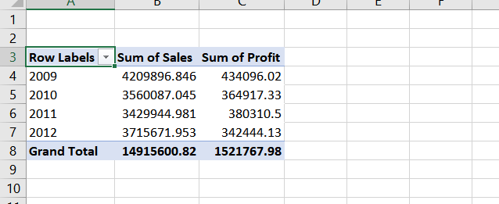

Above table shows alterations in sales and profit in four consecutive years. In 2009 sales of the store was 4209896 which has reduced to 3560087 in 2010 and 3429944.95 in 2011. Although positive alterations was seen in sales of 2012 in comparison to previous year. In 2012 sales has increased to 3715671.95 which is higher then sales of previous year.
Same trend was observed in entity’s profit. Profit of the store was highest in the year 2009 ad lowest in the year 2012. By looking at the data, it was observed that profit of entity in the year 2009 was 454096.02 and has declined to 364917.33 at the end of 2010. Several external and inner factors are responsible for decline in the profit of the store (Waskom, 2021).

Use of excel for
Pre-processing of data
Data pre-processing is defined as an process in which raw data is transformed in an type of format which is understandable by individual. It is considered as one of the essential step in data mining process as it is not possible to work with raw data.
Analysing the data
Excel is considered as one of the commonly used tools for analysing data. Raw data can be accurately analysed with the use of excel tools. Excel is capable of analysing complex data in short- period of time. Data analysis function is there in the excel which is used for the purpose of analysing data. Data validation, data analysis, forecast sheet, what-if -analysis are some of the commonly used functions of excel which can be applied for analysing data (Waskom, 2021).
Functions of MS excel
If function
IF function is used in excel for performing comparison between two values. Result of IF function can be FALSE or TRUE. FALSE indicates that test is not satisfied on the other hand, TRUE function indicates that test is satisfied. Various types of conditions can be created by using IF function. This type of function helps in determination of value which will be displayed to those who watch excel sheets. There are various other benefits of IF functions i.e., it can be applied for hiding calculation errors and adding comments to data. Logical comparison between actual value and value which is expected can be made by using IF function.
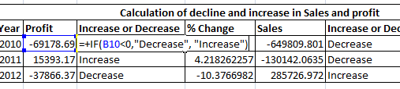
In Superstore data set, IF function is used for identifying decrease or increase in sales. Decrease in reparented by 0 and increase is defined by 1. IF function shows that in the year 2010 and 2012 there was decrease in the profit. On the other and profit of 2011 was higher then profit of 2010. Sales trends were also highlighted by using IF function in the Superstore data.
Text to column
It is considered as one of the majorly used function of excel. Data classification can be done by using Text to column function. This tool is available in Data tool group in excel. Main motive of applying this tool is to split text which is present in cell in multiple columns.
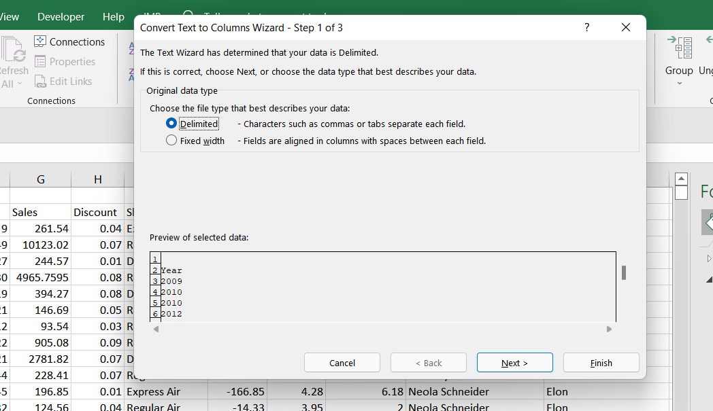
In case of Superstore data, alterations in profits and sales are required to be calculated. Now In, this case, year is not given in the specified format. It is required to be separated from date format. So, for separating year from date format Text to column function is applied. Here date is changed from DD/MM/YYYY to YYYY so that alteration in sales and profits can be calculated (Medium, 2022).
Pivot Table
It is considered as one of the critical tool for summarising data. Generally, it is not possible to analyse large set of data by using statistical or analytical tools so pivot table convert data into structured form. More the 8000 entries are there in the superstore data and it is not possible to analyse each and every entry so pivot table plays significant role in analysing these types of data. It is considered as quick tool of summarising data.
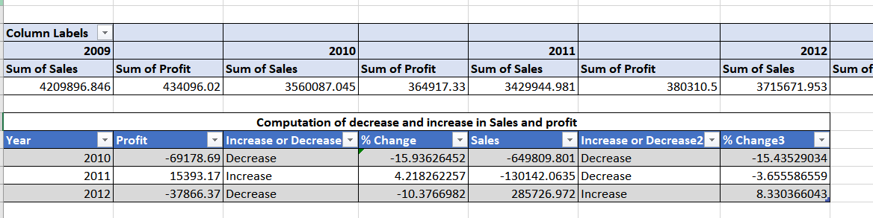
Here pivot table is used for computing total of sales and profit in the four consecutive years. Data is converted into summarised format with the use of pivot table. Also % alterations in both the sales and profit figures is also reflected through pivot table (Andrienko et al.,2020).

Visualising the data
Data mining is defined as the process of searching, collecting, extracting and analysing several types of languages and patterns. Understanding of business, data understanding, data preparation, Modelling, evaluation and Deployment are some of the common steps of data mining process. Outlier detection, regression analysis, association rules, clustering and classification are some of the common types of data mining techniques which are applied in business (Lemenkova, 2019).

Part 2
2.1 Clustering
Clustering technique is used for identification of distinct cluster’s or groups within the dataset. Similar types of groups are created in this type of statistical technique in which items having similar characteristics are shown at same place. Three types of clustering can be performed in SPSS i.e., K- means cluster, Two – Step cluster and Hierarchical cluster. Count of clusters are defined in advance so that analysis can be performed (Hahn, 2016).
Respondents which are chosen for survey are of various age groups. Classification of age groups are shown in the above chart. This chart aims at explaining % of respondents who are eating rice from age groups.
Clustering with the use of SPSS
SPSS is considered as one of the effective and useful tool for applying clustering technique. Several types of clusters can be developed by using SPSS. Clusters relies on data and there similar kinds of values which are allocated to particular clusters.
How many customers do eat rice ?

Statistics
 |  | Name | Rice
N | Valid | 100 | 100
N | Missing | 0 | 0

Frequency Table

Rice
 |  | Frequency | Percent | Valid Percent | Cumulative Percent
Valid | 0 | 40 | 40.0 | 40.0 | 40.0
Valid | 1 | 60 | 60.0 | 60.0 | 100.0
Valid | Total | 100 | 100.0 | 100.0

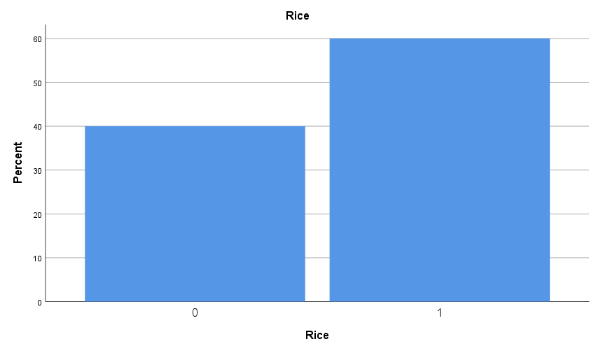

Out of 100 respondents, 40 respondent eat rice while 60 respondent does not eat rice. Ratio of respondent who eats rice in comparison to those who does not eat rice is calculated as 3:2.
Dividing customers on the basis of Gender

Rice
 |  | Frequency | Percent | Valid Percent | Cumulative Percent
Valid | 0 | 40 | 40.0 | 40.0 | 40.0
Valid | 1 | 60 | 60.0 | 60.0 | 100.0
Valid | Total | 100 | 100.0 | 100.0

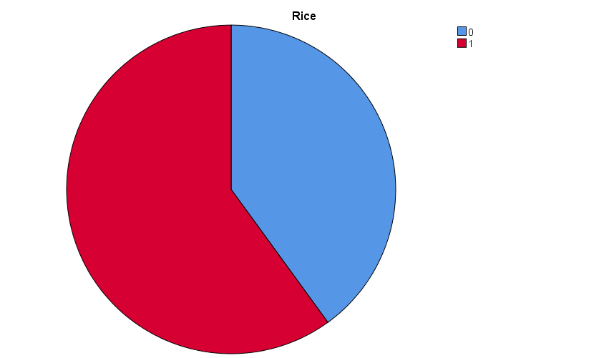

Gender
 |  | Frequency | Percent | Valid Percent | Cumulative Percent
Valid | 1 | 50 | 50.0 | 50.0 | 50.0
Valid | 2 | 50 | 50.0 | 50.0 | 100.0
Valid | Total | 100 | 100.0 | 100.0

There are total 100 respondents in which 50 are male and remaining 50 are female. Categorization is done on the basis of numeric numbers i.e., 1 and 2. 1 indicates that respondent is male and 2 indicates that respondent is female. In this case ratio of male and female is equal (Campbell et al.,2020).

Statistics (Mean , median and Mode) of data relating to the customer’s age

Statistics
 |  | Name | Age
N | Valid | 100 | 100
N | Missing | 0 | 0
Mean |  |  | 20.35
Median |  |  | 19.00
Mode |  |  | 22
Sum |  |  | 2035

Age
 |  | Frequency | Percent | Valid Percent | Cumulative Percent
Valid | 13 | 5 | 5.0 | 5.0 | 5.0
Valid | 15 | 5 | 5.0 | 5.0 | 10.0
Valid | 17 | 8 | 8.0 | 8.0 | 18.0
Valid | 18 | 13 | 13.0 | 13.0 | 31.0
Valid | 19 | 20 | 20.0 | 20.0 | 51.0
Valid | 20 | 5 | 5.0 | 5.0 | 56.0
Valid | 22 | 21 | 21.0 | 21.0 | 77.0
Valid | 23 | 1 | 1.0 | 1.0 | 78.0
Valid | 25 | 12 | 12.0 | 12.0 | 90.0
Valid | 26 | 10 | 10.0 | 10.0 | 100.0
Valid | Total | 100 | 100.0 | 100.0

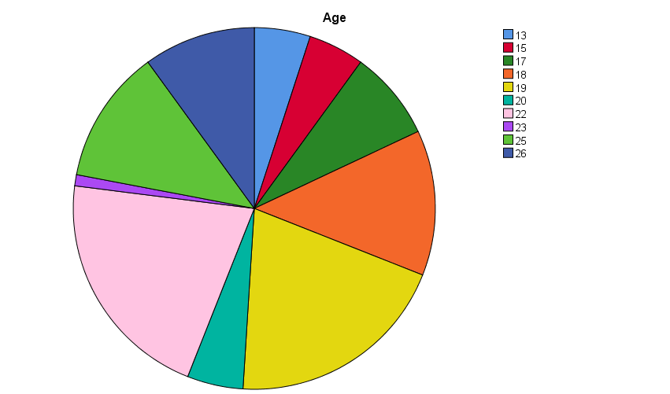

Mean, median and mode are some of the commonly used statistical techniques. Mean is defined as the average of dataset, Middle value of observation is considered as median and observation which repeats multiple time is considered as mode. These statistical functions can be computed by using descriptive statistics technique of SPSS
Age of customers ranges from 13 to 26 years. 13 being the lowest age and 26 being the highest age. After analysing it was observed that most of the customers lies in the range of 18-19 years. Mean value of smile clinic data is computed as 20.35 while its median value is calculated as 19. 22 repeats maximum number of times in the age dataset (Hahn, 2016).

K – Means clustering
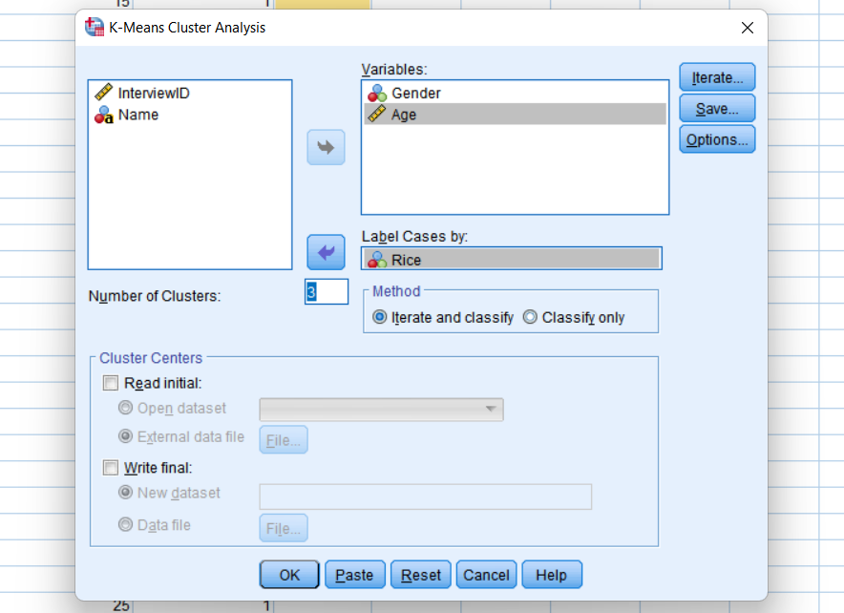

Quick Cluster

Initial Cluster Centers
 | Cluster
 | 1 | 2 | 3
Gender | 1 | 1 | 2
Age | 13 | 26 | 19

Iteration Historyª
Iteration | Change in Cluster Centers
Iteration | 1 | 2 | 3
1 | 1.118 | .892 | .792
2 | .000 | .000 | .000
a. Convergence achieved due to no or small change in cluster centers. The maximum absolute coordinate change for any center is .000. The current iteration is 2. The minimum distance between initial centers is 6.083.

Final Cluster Centers
 | Cluster
 | 1 | 2 | 3
Gender | 2 | 2 | 1
Age | 14 | 25 | 20

Number of Cases in each Cluster
Cluster | 1 | 10.000
Cluster | 2 | 23.000
Cluster | 3 | 67.000
Valid |  | 100.000
Missing |  | .000

K-means clusters
In this techniques distances and values which are closer to each other are put into same cluster. K- means clustering is popular form of clustering which is used for the purpose of analysis. Three different clusters are formed in the above cluster analysis. Cluster 3 has high values and high- level of dependency. In the 10 observations only single cluster is formed, In 23 observations 2 clusters were formed and in the 67 observations 3 clusters were formed.

Data mining techniques in the real- world
Data mining methods
Clustering
It is defined as a process of formulating a group of abstract items into classes of similar items. Cluster of data object can be considered as a single group. Clustering is mainly divided into two types i.e., soft and hard clustering (Andrienko et al.,2020). In soft clustering given output is probability likelihood of data point belongs to predefined count of clusters on the other hand, in case of hard clustering data points belongs to a single and defined cluster. Cluster analysis can be used in business for identification of consumers who have similar characteristics. For example, business may collect information related to count of customers and sales by using technique of clustering.
Classification
Data can be analysed in effective manner only if it is classified properly. It is considered as one of the common form of data mining technique. Classification technique is similar to clustering. Attributes of data are used in this technique for moving into discernable categories. For example, this technique can be used in supermarket for grouping customers according to the product type. This type of classification helps store managers to learn more about outputs and customers (Campbell et al.,2020).
Regression
Relationship between two or more then two variables can be identified by conducting regression analysis. It is considered as one of the commonly applied statistical tools in statistics. It is covered in the category of advance statistical tool. Connection between independent and dependent variables can be identified with the help of regression equation. It is also used for predicting values in statistics (Khadka, 2019).
Advantages of SPSS over EXCEL
SPSS is a kind of statistical tool which is used for analysis of data. It is developed by IBM. Although its functions are similar to Excel to excel but it can be used for performing accurate analysis of data by using advance statistical tools. Statistical tests can be accessed in SPSS in faster way in comparison to other kinds of statistical software. Various types of complex statistical tests are present in SPSS with built in features which makes users to analyse data in more effective manner. Performance and speed of SPSS is better the Excel as it is composed of advance analytical methods. Results obtained from surveys cannot be analysed by using Excel because of the limited or basic analytical features but can be analysed by using advance features of SPSS (HO, 2021).
Disadvantage of SPSS over EXCEL
SPSS can be considered as one of the effective tool for analysing data but it cannot be applied for analysing large set of data. It has limited features which are capable of analysing only limited set of data. For example, large amount of data is used in medical reports and it has not- possible for researcher to analyse these data set by using SPSS. So, in these types of cases SAP tool is preferred over SPSS. Also, cost of SPSS is high as compared to other types of statistical and analytical tools. Along with Data analytics, Excel has various other types of function which makes it compatible for severable types of users. Graphical presentation of Excel is better then SPSS and even other kinds of statistical software (Campbell et al.,2020).

References
- Andrienko, G., Andrienko, N., Drucker, S., Fekete, J.D., Fisher, D., Idreos, S., Kraska, T., Li, G., Ma, K.L., Mackinlay, J. and Oulasvirta, A., 2020, March. Big data visualization and analytics: Future research challenges and emerging applications. In BigVis 2020-3rd International Workshop on Big Data Visual Exploration and Analytics.
- Campbell, C.D., Smallwood, Z.M. and Stewart, M.I., 2020. A self-guided workshop on data handling and analysis using Microsoft Excel. https://vicephec.org/2020/wp-content/uploads/2020/08/A-Self-guided-Workshop-on-Data-Handling-and-Analysis-using-Microsoft-Excel-vVICEPHEC-2020.pdf
- Hahn, J. and Bienert, S., 2016. Methods for profitability calculation in EXCEL (VoFI). Language. http://www.rentalcal.eu/Files/Billeder/RentalCal/Publications/RentalCal_D6_3_Methods_for_profitability_calculation.pdf
- HO, J.K.K., 2021 Multidimensional data analysis with Excel pivot table (EPT-based MDA) used as a research method technique-a research. https://d1wqtxts1xzle7.cloudfront.net/56286333/Multidimensional_data_analysis_with_Excel_pivot_table_used_in_applied_business_research_v6d-with-cover-page-v2.pdf
- Khadka, B., 2019. Data analysis theory and practice: Case: Python and Excel Tools. https://www.theseus.fi/bitstream/handle/10024/335764/Khadka_Birendra.pdf?sequence=2&isAllowed=y
- Lemenkova, P., 2019. Numerical data modelling and classification in marine geology by the SPSS statistics. International Journal of Engineering Technologies IJET, 5(2), pp.90-99. https://dergipark.org.tr/en/pub/ijet/issue/45163/585830
- Mahmud, M.S., Huang, J.Z., Salloum, S., Emara, T.Z. and Sadatdiynov, K., 2020. A survey of data partitioning and sampling methods to support big data analysis. Big Data Mining and Analytics, 3(2), pp.85-101. https://ieeexplore.ieee.org/abstract/document/9007871/
- Medium, 2022. Understanding K-means Clustering in Machine Learning. [online] Available at: <https://towardsdatascience.com/understanding-k-means-clustering-in-machine-learning-6a6e67336aa1> [Accessed 7 March 2022].
- Waskom, M.L., 2021. Seaborn: statistical data visualization. Journal of Open Source Software, 6(60), p.3021.
- Wilke, C.O., 2019. Fundamentals of data visualization: a primer on making informative and compelling figures. O'Reilly Media.

