BMSW4005
Reflective Portfolio
Professional Career Development

Student Name and ID: Claudia Ilie 1816378
Lecturer Name: Olubukola Adegbite

Table of Contents
Introduction 3
Main body 4
1.1 Identify your own skills…………………………………………………………………..4
1.2 Identify the skills required for a career of your choice……………………………5 1.3Comparing relevant professional skills and behaviours to the skills………….…….6
2.1 Learning concept ………………………………………………………………………..7
2.2 Reflect on the concept…………………………………………………………………..8

Evaluate my Personal Career Action Plan 8
Gibbs Reflective Cycle 9
Appendix 11
Conclusion 15
References: 16

Introduction
During the next pages of my reflective personal report, I will try and synthetize at the best of my knowledge, four essential core skill that I consider to be representative of my personality. I will try and follow toolkits but also other people’s opinion of myself using the Johari Window and see how these matches with my own opinion of myself. The first plan of the report will follow the four chosen skills, as for the second plan of the report, I will extract strengths and weaknesses that stand out and see how a development plan can lead me into achieving my goals.
In the Reflective Portfolio I will be utilising the Gibbs model to explain, critique, show my emotions, and evaluate my work in this Reflective Portfolio (Gibbs,1988). I'm going to get into some of the jobs, assignments, and activities I completed. I'll evaluate my career growth strategy, skills audit, and internet presence. I’ll also discuss how I handled a variety of circumstances on my own or with assistance.
The important lessons I have learned will be covered along with my perspective and comprehension of them.
The career that I have chosen is being a Human Resource employee.
This portfolio also attempts to highlight my future and share my perspective in a thoughtful manner.

Main body
Consider my level of proficiency with this talent right now. How would you rate your aptitude? Like all other humans, I believe I have concentrated attention every day. As we mature, we acquire this skill in accordance with our environment and way of life. I can think of a few instances where I am typically concentrated, such as having any responsibility or when I am assisting a co-worker with some paperwork at the workplace. My friends think I'm organised, and that makes a straight connection to the talent I have picked since to be organised, as per the APPENDIX Johari window toolkit, I have selected the following talents for my job of career as human resources for this self-analysis portfolio because I believe they are the ones I have improved the most in and the ones I still need to work on, I will use a tool of self-analysis. Processing strong interpersonal, written, and collaborative skills.
Strengths: Adequate IT understanding and time management.
Weaknesses: Self-criticism, public speaking, shyness, lack of confidence.
Opportunities: Time management, career management, and IT expertise.
Threats: Having issues with others due to my limited English language proficiency and my lack of writing or communication abilities, throughout the term, learning reflection and skill performance.
IT skills for me, this is one of the skills in which I need to work the most because in this century, everyone needs to know how to use and work with IT, and a large amount of work places these days require you to have IT knowledge to qualify for the job. Also, as Belbin, (2014) stated in the theory about "Team roles," there are some roles that are different from the key roles.
Using skills to compare relevant professional skills and behaviours. To reflect on our own abilities and behaviours, we must first analyse and explore. What standards and competencies are required to work as a Human Resources (HR) professional? Some standards must be met to exercise this role, as demonstrated by the CIPD's Profession Map (2013). It is critical to be interested in your job so that you are aware of events and laws that may affect the corporation, such as the Equality Act (2010) or the General Data Protection Regulation (GDPR), being proactive throughout proposals and activities that have the potential to improve company and employee performance Another important characteristic is the ability to communicate effectively. It is also important in this role to be open-minded, creating an environment in which do not feel judged. Employees in this line of work must be capable of making capable and informed decisions while also learning and understanding information at a rapid pace.
Following on from the behaviours that an HR professional must possess, it is necessary to mention the skills that are required when working in this field. Good customer service is a necessary skill for professionals who deal with people every day, and since we will be dealing with employees and other organisations, this may necessitate some extra care. As previously stated, good communication is essential because you will be interviewing candidates and listening to people's problems daily. The role also entails overseeing all functions and staying up to date on all workplace developments.

Compare your skills with those required for the chosen career
My own skills | Skills required as a HR
Time management | Employee relations
Reading effectively | Onboarding
Seeking relevant information | Human resources information software (HRIS)
Problem-solving | Performance management
Decision Making | Teamwork and collaboration
Attention to detail | Scheduling
 | Payroll processing

As I can compare the two columns, I can say that the skills that I must improve are related more to the individuals they are it refers more when working with people.

Learning concept
According to one questionnaire I took, I learn best through auditory and visual means.
An auditory learner is a type of learner that uses instructional information that includes both sight and sound (auditory stimuli) (visual stimuli).
When learning, auditory/visual learners listen and speak aloud, comprehends, and retains what they have heard.
An auditory learns information based on how it sounds, making oral instructions simpler to grasp than written ones.
Reading aloud makes learning easier since you need to hear something to understand it.
When audio-visual learning aids like handouts, flip charts, transparencies, whiteboards, illustrations, still and motion pictures, slide shows, televisions, videos, audiotapes, records, projects, computer graphics, and multimedia are used in conjunction with the teaching process, audio-visual learning occurs.
When an instructor's vocal lecture is supported by a sequence of images or slides or a self-standing instructional exercise consisting of an instructional movie, auditory/visual learning can occur.

Reflect on the learning concept
Reflective learning entails keeping a close eye on my knowledge, skills, and performance as I learn to enhance the process and the results that follow.
If I am preparing for a test, for instance, I may practise reflective learning by assessing my understanding of each of the subjects I have covering and determining which ones I need to spend more time on as an auditory and visual learner.
It may be advantageous in a variety of ways and circumstances; this it is frequently useful to engage in reflective learning.

Evaluate my Personal Career Action Plan

- Action: Identify skill sets needed from new employment and work with recruitment agency to hire the right talent.
- Completion date: December 2024
- Responsibility: Gain the place of work

One of the first stages to bettering yourself and venturing outside of your comfort zone is to have a personal growth plan.
Both people and the human intellect are always changing.
You are not the same person you were a year ago, consider that.
Your personality, opinions, and viewpoint on the world have been further shaped by the additional knowledge, growth in several ways, and life situations you have encountered.
Try to be a better version of yourself today than you were yesterday if you want to experience personal development and progress.
Personal Strength/Personal power, which is powered by your connections, expertise, and financial standing, is the authority people perceive you to have situations.

Gibbs Reflective Cycle

(Gibbs' reflective cycle 1970)

Description
The incident that I faced few years ago was that going to a workplace to be hired as social worker. I have been hired but I faced stressful situations. What is important is that I have realized you have to be prepared in different job it is the fact that as a human being you can try as many jobs, because only trying you can learn and can assimilate as many knowledges.
Feelings
Prior to the incident occurring, I was mindful that every job that I will try during my life experience I will do my best, learn as much as I can and achieve all the duties that I had.

Evaluation
In hindsight, the experience that I had was good and had some bad elements because it was the first time for me working as a social worker. The good part is that this situation had led to an increased understanding my role it is important. Exchanging knowledge and intervening before a problem got out of hand demonstrate a lack of ability to cohesion (Rutkowsky, Gruder and Romer, 1983). I was not having any knowledge about being put at this position. As I started, I realized that this job was a little inconvenient for me. I was started to be involved and to learn more after a little bit. But in all this time, I must recognize that I had to learn from the beginning till my last day to that workplace.
Analysis
When dealing with something outside of their comfort zone, people with learning challenges may act in a negative way since they frequently struggle to adapt to new situations.
Conclusion
As a result of this experience, I am more aware of the necessity of using professionalism and assertiveness in practise and not feeling as though I cannot do something because of my position within the team or level of experience should similar circumstances occur in the future. The knowledge I learned from this event has made me more conscious of the necessity of acting in the good manner even when I am doing something new. To improve level of cohesiveness, strong working and develop connections with others.
Action Plan
Regardless of my position on team or level of experience, I want to be more proactive in dealing with different situations in the future. This includes handling a stress out service, ensuring that information is the most important and appropriate to know when you go to a work in any kind of industry. Additionally, I will consider that learning it is an all the time need and change are also. The fact that changes are necessarily to times to times and to be aware by the swaps that are sometimes done without your validation. The techniques are also required as a good result for any job with customer services.

Appendix

Appendix – Johary Window
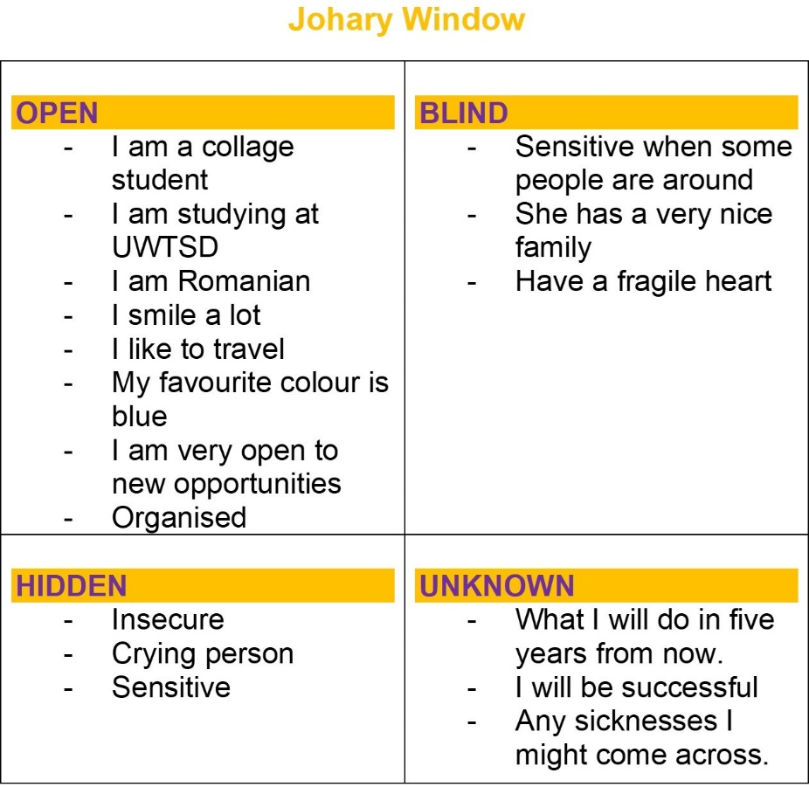

Appendix - PDP
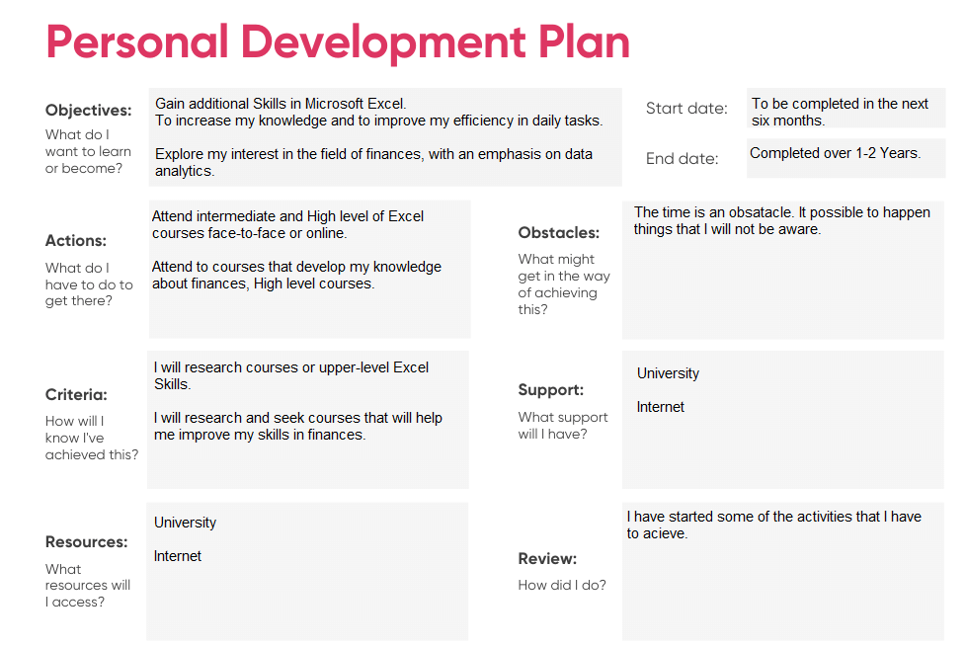

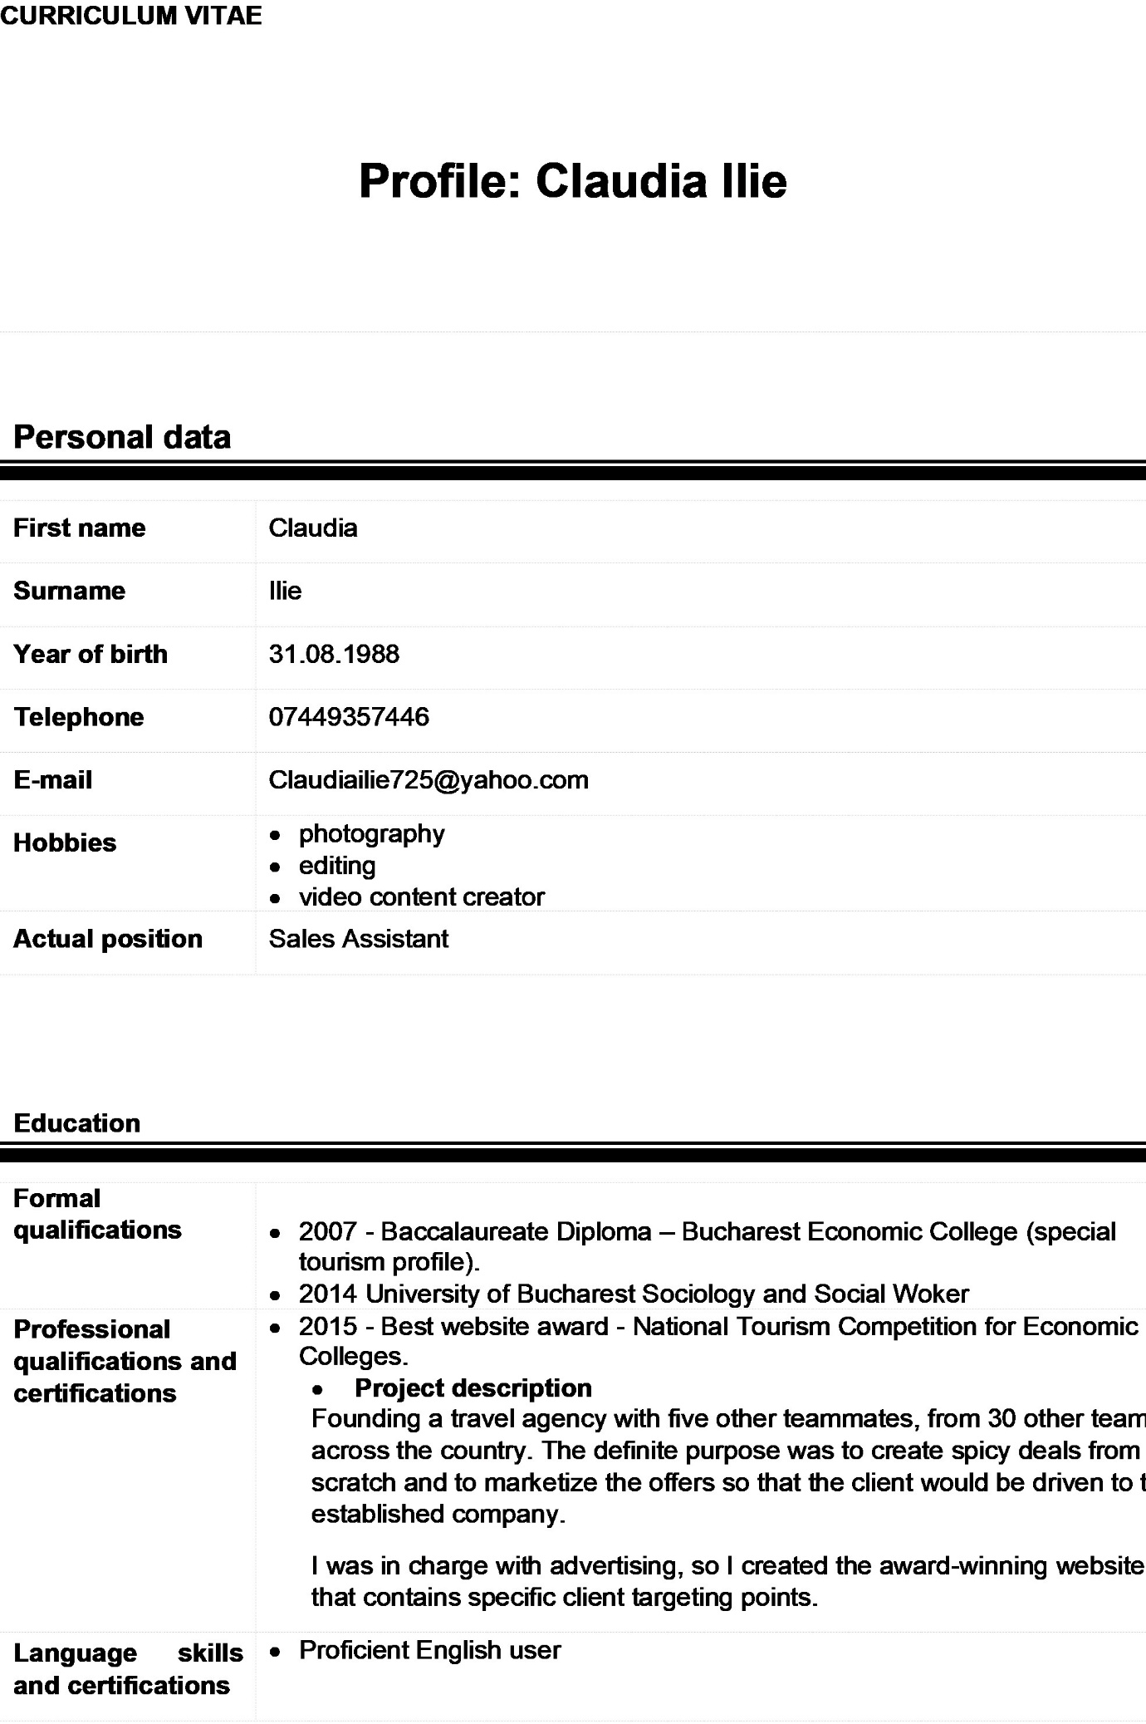
Appendix- Cover Letter
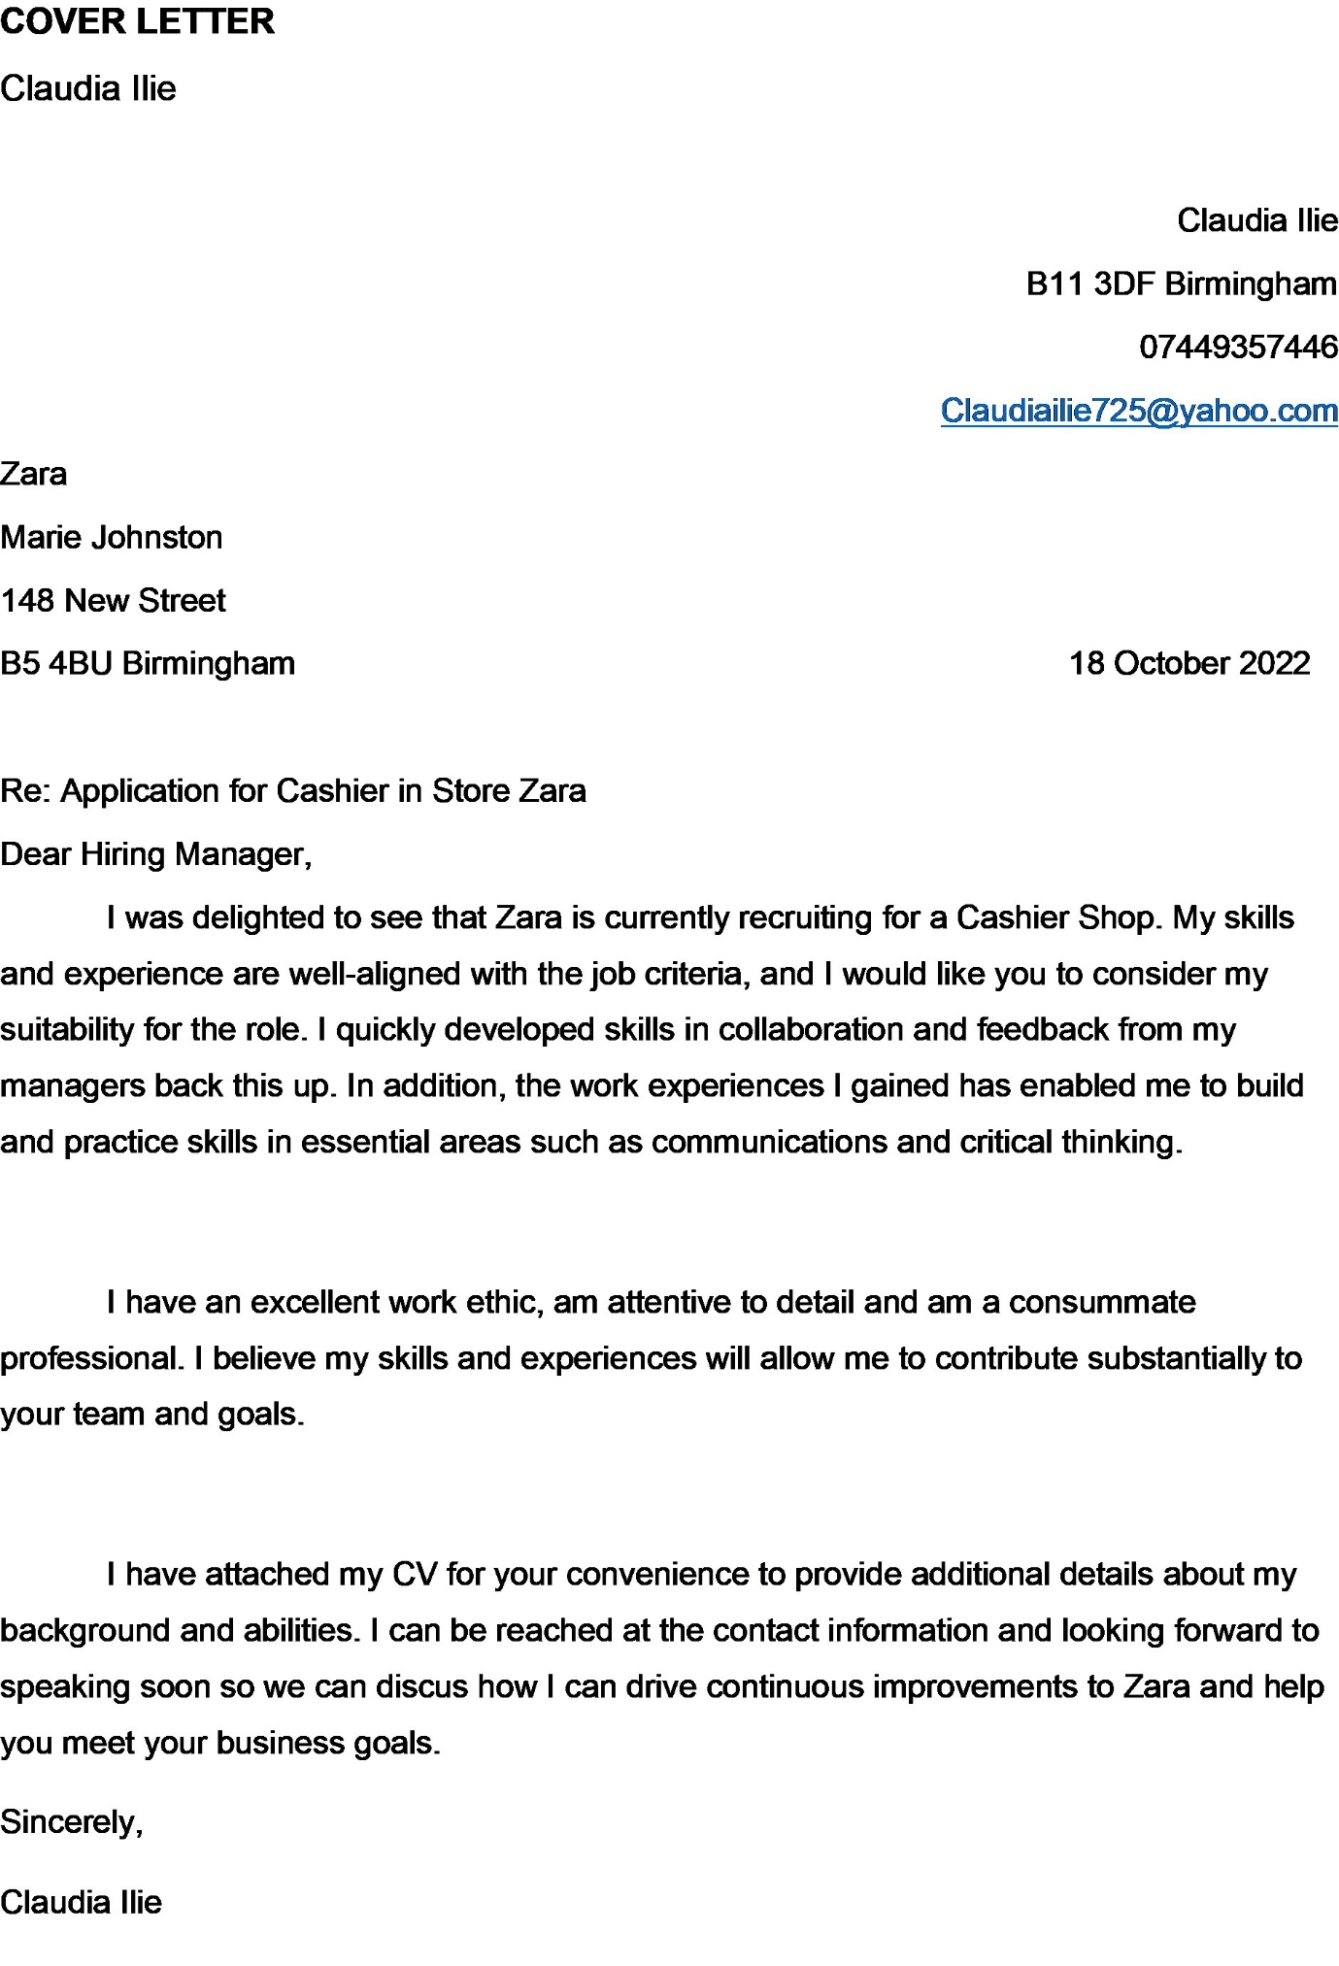

Conclusion
Undertaken a thorough personal review and reflection on the main learning concepts in the change during my process of know.
The reflection entailed a selection of the themes that had a significant impact on me as an individual within the context of the underlying study. In this regard, this reflection has concentrated on the principles of change management, the processes, and contexts of change, and, finally, I must work more at specific skills. Within these writing main theme, the reflection has analysed the main ideas that I found to be easy or difficult to learn as an individual, as well as any general emerging principles that arose within this personal research. Finally, this reflective portfolio as allowed me to adequately reflect on what I've learned.

References:
Belbin.com. 2014. Team Role Theory - Belbin Team Roles. (online) Available at: <http://www.belbin.com/rte.asp?id=8> (Accessed: November 23, 2022).
Career reflection paper - free essay example (2020) StudyDriver.com. Available at: https://studydriver.com/career-reflection/ (Accessed: November 21, 2022).
Entwistle, N.J. (no date) Styles of learning and teaching: An integrated outline of educational psychology. London: David Fulton, 1992.
Gibbs, G. (1988) Learning by doing: A Guide to Teaching and Learning Methods. Oxford: Further Education Unit, Oxford.
Gibbs' reflective cycle (1970) The University of Edinburgh. Available at: https://www.ed.ac.uk/reflection/reflectors-toolkit/reflecting-on-experience/gibbs-reflective-cycle (Accessed: November 21, 2022).
Kolb, D.A. (1984) Experiential learning: Experience as the source of learning and development. New Jersey: Prentice Hall.
Official Legal Text (2022) General Data Protection Regulation (GDPR). Available at: https://gdpr-info.eu/ (Accessed: November 23, 2022).
Participation, E. Equality act 2010, Legislation.gov.uk. Statute Law Database. Available at: https://www.legislation.gov.uk/ukpga/2010/15/contents (Accessed: November 23, 2022).
Rutkowski, G.K., Gruder, C.L. and Romer, D. (1983) “Journal of Personality and Social Psychology and Social Psychology,” Journal of Personality and Social Psychology [Preprint]. Available at: https://doi.org/10.1037/0022-3514.44.3.545.
Self-Awareness. 2013. Self-Awareness. [online] Available at: <http://www.selfawareness.org.uk/news/understanding-the-johari-window-model> [Accessed: November 23, 2022).
The 2013 profession map for HR and L&D | CIPD (no date). Available at: https://beta.cipduat.co.uk/learn/profession-map/2013-profession-map (Accessed: November 23, 2022).

