

Methods and Search Strategy Academic Poster

Student name: Manpreet Kaur
Student ID: 2246813

Module name: Independent Project
Module code: BMHP6020

The Impact of Staff Shortages on Quality of Care in UK Health and Social Care Settings
01 Introduction and Research Aim  This research methodology poster outlines the methods used to study the effects of staff shortages on the quality of care in UK health and social care settings. A methods chapter describes the way the research is being performed, its data collection, analysis and ethics. The research method in this study is a secondary research method to examine the available literature and policy documents. This study will critically analyze ways in which staff shortages can have an impact on patient care, safety, and service delivery as well as the causes and evidence-based suggestions to workforce planning and care quality (Shemtob et al., 2023; Sutton et al., 2023). | 02 Search Strategy  A search strategy in secondary research means a systematic and methodical procedure of searching and finding academic and professional sources. A systematic search strategy was applied in this research based on keywords like staff shortages, quality of care, NHS workforce and health and social care UK. Search refinement was made possible with the help of Boolean operators (AND, OR), as well as the combination of terms. This methodology helped to make the data collected narrow, pertinent, and according to the research objective (Sutton et al., 2023).
03 Searching for Information  The process of conducting the research entailed a number of procedures to make it reliable and relevant. At the start of the research, peer-reviewed journal articles were identified by using databases like Google Scholar and the university online library.  This was then accompanied by consultation of official reports by organisations like NHS Digital, NICE, WHO and UK government publications. The filters were implemented to reduce the results to the past five years to have current information (Shemtob et al., 2023).  Sources were then filtered according to their relevancy in issues related to staffing in UK health and social care. This was a systematic method that saw that only high quality and credible data was used to inform the research. | 04 Picture / Graph / Visual Aid / Statistics  Studies have shown that understaffing is associated with medical errors, low patient satisfaction, and staff burnout. The visual representations of these trends show the direct correlation between workforce deficiency and deteriorating quality of care.  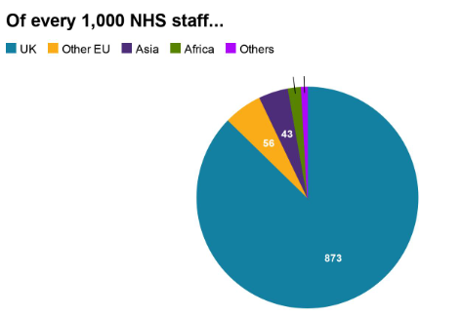  Source: BBC (2019)
05 Research Validation and Analysis
In secondary research, research validation is the process of making sure that the sources are credible, reliable, and scholarly. To ensure validity, peer-reviewed articles, official reports and reputable publications were prioritised in this study.
Nevertheless, there are such shortcomings as the possibility of bias in published data and absence of primary insights. The analysis of secondary research implies the determination of patterns and themes in the literature.
Findings were categorised by thematic analysis into major areas that included workforce issues, patient safety, and effective policy that form the foundation of the study (Milesky et al., 2025).
06 Inclusion Criteria  The sources used in the study were the ones published not more than six years ago, in the UK health and social care sector, and in full text. Articles on the peer-reviewed journals, government reports and policy documents were given priority to ensure reliability and relevancy. | 07 Exclusion Criteria  The sources that were older than six years, those that were not carried out in the UK and those that do not have full accessibility were all excluded. Also, non-academic or opinion-based sources that were not credible were not taken into account.
08 Ethical Considerations
In this research, ethical standards were followed due to proper referencing of all sources used, lack of plagiarism and proper representation of the data. There was no primary data to be collected, and there was no risk when it comes to confidentiality/consent. The university has ethical guidelines which were adhered to during the research process.

References
BBC (2019). NHS staff shortage: How many doctors and nurses come from abroad? BBC News. [online] Available at: https://www.bbc.com/news/world-48205445.
Shemtob, L., Asanati, K., Pahl, N. and Majeed, A. (2023). What needs to be done to address staffing shortages in health and social care? British Journal of General Practice, 73(728), pp.102–103.
Sutton, C., Prowse, J., McVey, L., et al. (2023). Strategic workforce planning in health and social care – an international perspective: A scoping review. Health Policy, 132(1), 104827.
Milesky, J., Rosen, M., Sharma, R., Zhang, A. and Bass, E.B. (2025). Acute care nursing staff shortages compromise patient-to-nurse ratios. NIH.

Submission Notes – Please Delete Before Submission

- The Academic Methodology Poster is worth 15% of your final grade for BMHP6020 Independent Project.
- Your poster should be no more than 2 pages in length and between 300 - 500 words approximately.
- All information should be cited using the UWTSD Harvard Referencing Guidelines from Cite them Right.
- Try not to include too much information as you will be able to explain concepts further within your main dissertation.
- Use visuals and colours to make your poster engaging to the audience.
- Ensure your poster is clear and consistent in style.
- Convey the information in an appealing way which can be understood by any audience.
- Use the headings within this guidance to ensure you include all the information for successful completion of this element.

