BA Leadership and Management year 2

Student Name: Florica-Nicoleta Tiutiu

Student Number: 1605832

Module No: BMSK6001

Module Title:Emergent Leadership skills for the workplace

Lecturer:Dr Kenny Tang

Contents
TASK 1 4
INTRODUCTION 4
DISCUSSION 4
LEADERSHIP THEORIES AND MODELS 4
RESPONSIBILITIES OF LEADERSHIP ROLE 6
EVALUATION OF PERSONAL ABILITY TO FULFILL THE KEY RESPONSIBILITY OF LEADERSHIP ROLE 7
LEADERSHIP STYLES 7
LEADERSHIP STYLES IN DIFFERENT SITUATIONS AND WITH DIFFERENT PEOPLE 9
EMOTIONAL INTELLIGENCE AND ITS APPLICATION IN A LEADERSHIP ROLE 10
IMPORTANCE OF UNDERSTANDING ONE’S OWN STRENGTHS AND LIMITATIONS 11
TECHNIQUES TO IDENTIFY CHARACTERISTICS, STRENGTHS, AND LIMITATIONS AND DISPLAYING CONFIDENCE AND SELF-ASSURANCE 11
IMPORTANCE OF SELF-DEVELOPMENT AND OPPORTUNITIES TO DEVELOP ONESELF IN THE LEADERSHIP ROLE 11
SOCIAL AWARENESS AND RELATIONSHIP MANAGEMENT 12
CONCLUSION 12
TASK 2 13
INTRODUCTION 13
DISCUSSION 13
OVERVIEW OF WHITEBREAD 13
ANALYSIS OF ANNUAL REPORT 14
VISION STATEMENT 14
MAIN STRATEGIES OF THE ORGANIZATION 16
STRATEGIC PROGRESS 17
KEY PERFORMANCE INDICATOR 17
FINANCIAL HIGHLIGHTS 19
COMPARISON BETWEEN LEADERSHIP STYLES 22
FORM OF LEADERSHIP STYLES ADOPTED BY THE COMPANY 23
COMPARISON BETWEEN THE LEADERSHIP STYLE ADOPTED BY THE CEO OF THE COMPANY AND ME 24
RECOMMENDATIONS 24
CONCLUSION 25
REFERENCES 26

TASK 1

INTRODUCTION
Organizational leadership is a very effective tool used for achieving the individual as well as organizational objective. The trait of the leadership is both acquired as well as inbuilt. The leaders of the organization influence the behavior and nature of the employees so that it can achieve the common goal together. The leader of the organization facilitates the management in motivating, encouraging and supporting the employees to help them achieve the objective and also in increasing their morale. The success of several organizations depends on the effectiveness of leaders and managers which can be seen from the JP Morgan. The company provides financial services to different institutions such as government and also small and medium companies of different countries (Kollenscher et al., 2018). With the help and support of leaders, today the company is taking several risks such as corporate social activities, cybersecurity, and others for expanding its business. The report of emergent leadership skills includes the leadership theories and practices used by JP Morgan to expand its business. The company has a strong workforce of 2, 50,000 employees who are managed by efficient leaders of the company. These employees successfully served millions of customers and clients such as government, small and medium institutions, and other corporations (Mishra, 2018).

DISCUSSION

LEADERSHIP THEORIES AND MODELS
Following are the leadership theories and models used in the JP Morgan are as follows:
Contingency theories
In this theory, the characteristics of the leaders are related to environmental factors which help them to identify the leadership style according to the situation. This theory stresses that no single method is suitable for all situations in the organization. Contingency theory is divided into several categories and among these, the theory used in the JP Morgan is Fiedler's contingency theory. This theory emphasis on the different leadership styles according to different situations (Amanchukwu et al., 2015).
Trait theory
This theory assumes that some qualities of the leaders are inbuilt traits which make him suitable for the leadership position. In the trait theory, there are some characteristics of the leaders which include physiological, social, personality task-related and demographic features of the leaders. The JP Morgan also defines some of the characteristics of the leaders which are necessary for the leaders.
Situational theories
Situational theories state that the leader's best course of action depends on the different situational variables. The situational theory is again divided into several categories and the style chosen in the JP Morgan is Hershey and Blanchard's leadership style. This leadership style divides the actions of leaders into four categories i.e. telling, selling, participating and delegating. The reason for choosing different leadership style in JP Morgan is because of the different requirement of employees (Thompson and Glasø, 2015).
Great man theory
According to this theory, the leaders are born with the right skills and traits such as intellect, confident, communication as well as social skills. This theory means that leaders are born and not made. And in addition to this, these skills are learned from the experience, decisions and different situations. These characteristics have made the leaders different from the followers and they perform their activities uniquely and creatively.
Behavioral theories
Behavioral theories mean the ability of the leaders to influence the behavior and attitude of employees. This theory considers the behavior of the leaders and not the traits and characteristics. Behavioral theories are of two types i.e. Michigan leadership theory and the second one is Ohio State leadership theory and both these theories are applied in the JP Morgan. The first theory says that there is a direct relationship between the behavior of the leaders and the performance of employees. And the second theory states that behavior or characteristics of the leaders do not bring positive results (Behrendt et al., 2017).

RESPONSIBILITIES OF LEADERSHIP ROLE
The primary responsibility of the leader is to coordinate the efforts of all employees towards achieving the organizational goal and to give the best services to its clients. Following are the key responsibilities of the leaders identified in the JP Morgan are as follows:
- Build trust
Developing trust and rapport with the employees is very difficult for the leaders because they will not work with them until they have trust in the leaders. With the help of trust, the leaders successfully find different opportunities and use them for personal and professional growth (Antonakis and Day, 2017).
- Encouraging and motivating employees
Motivated employees will contribute more than unmotivated employees and it is the roles and responsibilities of the leader to encourage the employees towards increasing their overall performance and also the profitability of the company. The leaders of JP Morgan also uses delegation to increase the morale of employees and to get the work completed on time.
- Communicating strategies to employees
The decisions are taken at the top level and in order to communicate with all employees, JP Morgan uses leaders to communicate every decision. The vision and mission statement of the company is divided into a small achievable task which is allotted to different employees. The leaders allocate the task according to the skills and knowledge of employees (Richardson, 2018).
- Finding solutions
Every problem faced by the employees is solved by the creative and innovative ideas of the leaders. Leader analyzes the problems deeply and search several options to particular problems and chooses the best one from them.

EVALUATION OF PERSONAL ABILITY TO FULFILL THE KEY RESPONSIBILITY OF LEADERSHIP ROLE
SWOT analysis is used to identify the personal ability to meet the key responsibility of leadership role and this is as follows:
Strengths
The skills which helped me to make an effective leader of JP Morgan are interpersonal, communication skills, team-building skills as well as honesty, self-confidence. These all skills helped me to create trust in employees and now they obey my orders and rules without any questions (Johnson, 2017).
Weaknesses
It is quite difficult for a leader to coordinate the efforts of all employees towards a common goal and also to make them accountable for what they are doing. Due to lack of trust and scarcity of time I was not able to complete my whole task on time. Lack of trust, delegation, and mismanagement of time are my weaknesses.
Opportunities
The biggest opportunity for me is to use my strengths in finding innovative and creative ideas for the growth and development of the organization. The innovative and creative idea will not only help the organization but it also helps the team to find the solutions to the problem.
Threats
The rapid and fast change in technology is the biggest threat for the leaders. In addition to this, any continuous change in the economic conditions of the countries increases the workload of the leaders (Blanchard, 2018).

LEADERSHIP STYLES
Leadership style means the way the leaders direct, support and motivates the employees of JP Morgan. And it is found that no one style in the organization gives positive results therefore in order to control and manage the activities of employees leaders of the JP Morgan must adopt different leadership styles. The style of the leader depends on the type and nature of employees under their control. Different leadership styles identified in JP Morgan are as follows:
- Autocratic leadership
In this style, the main focus of the leaders is to get positive final results. And also they do not give complete authority and responsibility to them. The leaders in the JP Morgan following this leadership style give a clear order and direction to employees (Yahaya and Ebrahim, 2016).
- Democratic leadership
Democratic leadership means to involve employees in the decision-making process. There are some situations where the leaders need help and suggestions from the employees and they use it at the time of making a decision. But the final decision is of the top executive and they only take this responsibility.
- Laissez-faire leadership
It is usually used at the lower level of employees where the need for a top executive is very low. The decisions where the lower level employees take the decisions are need of a helper to repair machines, fault, etc. Such small decisions are taken by lower-level employees without taking permission from top executives.
- Charismatic leadership
In this leadership style, the main aim of the leader is to influence the behavior of employees towards organizational goal. The responsibilities of the leader in this style are proper communication, motivation as well as persuade the employees to increase their overall performance (Frankel and PGCMS, 2019).
- Transformational leadership
It is the most important style found in this organization because it is found that employees are not ready to adopt the change without being influenced by their leaders. The employees are more focused, motivated and satisfied with this leadership style.
- Ethical leadership
Ethical leadership is a leadership style where the leaders show morals, values and good conduct of the employees in the organization. He sets as an example in front of other employees and expects from them that they behave in a positive and right way. The leader in the JP Morgan follows ethical approach such as the leaders do not judge the people according to words but they are fully dependent on their actions (Arnold et al., 2015).
- Supportive leadership
Supportive leadership means the leaders provide full support to employees in every step and their every activity. This type of leadership is adopted at the middle level of management where the managers have direct contact with employees. At this level, the managers build a personal and professional relationship with employees and expect from them they perform all the activities to meet their team goal.

LEADERSHIP STYLES IN DIFFERENT SITUATIONS AND WITH DIFFERENT PEOPLE
The leadership styles followed in the JP Morgan to deal with different situations and also with different people are charismatic, transformational, autocratic and supportive. The service industry is the fastest-changing industry and in order to meet those changes, leaders must support and guide the employees to meet the changing needs of each client. Supportive and charismatic leadership style means to change the style of leadership according to the requirement and need of employees. All the employees have different needs, motivation, education level, skills and knowledge and in order to meet those requirements it is essential that they change their leadership style (Iqbal et al., 2015). Autocratic leadership is required to manage and control the activities of the employees and coordinated their efforts to achieve the common goal. The organization has a total workforce of 2, 50,000 employees which belong to a different religion, culture, gender, age as well as different family background. Therefore, it can be said that a leader cannot treat each employee in the same manner. In addition to this, the situations in the organization are not the same all-time which requires changing leadership style. The leadership style depends on the type and nature of employees as well as activities because some of the activities require the attention of top executive while some can be managed at a lower level.

EMOTIONAL INTELLIGENCE AND ITS APPLICATION IN A LEADERSHIP ROLE
Emotional intelligence means the capability of the leader to understand the own as well as other’s feelings and emotions. The individual having this skill easily influence the behavior and attitude of employees. The elements included in emotional intelligence are motivation, self-regulation, social, empathy and self-awareness (Lee and Chelladurai, 2018). The applications of emotional intelligence in the leadership role are as follows:
Leading self
Self-assessment helps the leader to find out his strengths and weaknesses and also to improve it by working on it. The leader work on improving those skills and also use it in encouraging other employees.
Leading employees
Self-assessment quality is not only included in emotional intelligence but helping other members and understand their words and feelings is also a responsibility of the leader. The leaders of JP Morgan evaluate the skills and knowledge of the employees and also help them to find the opportunity for their personal growth and development.
Leading organization
An effective leader thinks not only to think about himself and teams but also about the organization. The leaders of the JP Morgan develop and maintain a long-term relationship with all stakeholders such as customers, government, employees or other partners to achieve the organizational goal effectively and efficiently (Crowne et al., 2017).

IMPORTANCE OF UNDERSTANDING ONE’S OWN STRENGTHS AND LIMITATIONS
It is essential to understand the strengths and weaknesses of different employees because of the difference in their education level, age, caste, etc. The strength and weaknesses help the leader to find present skills and the skills required for the future to increase the productivity of the employees. In order to understand their skills and weakness, the leader sets an example in front of them so that they should work on their limitations (Ratts et al., 2016).

TECHNIQUES TO IDENTIFY CHARACTERISTICS, STRENGTHS, AND LIMITATIONS AND DISPLAYING CONFIDENCE AND SELF-ASSURANCE
The methods used by the leader to identify the strengths, characteristics, and limitations are self-evaluation, assessment methods, and performance review methods. The assessment methods used in the JP Morgan are a quota system, forced distribution, forced ranking, and ratings. The 360-degree analysis tool is used to calculate the performance of employees. The ratings are given by the peer members and it is a very simple method to calculate the strengths and weaknesses which needs quick attention of the employees (Bajpai and Singh, 2019). In the self-evaluation method, the employees compare their performance with the performance of other employees and use them to improve their skills. Self-confidence and assurance increase the ability to take the risk for future growth and development.

IMPORTANCE OF SELF-DEVELOPMENT AND OPPORTUNITIES TO DEVELOP ONESELF IN THE LEADERSHIP ROLE
Self-development is a process which improves the activities, talents, skills, and behavior. In other words, it is a process of improving one's skills to be prepared for the future. It is a never-ending process and it also helps in achieving the objective because it has a direct relationship between performance and learning. Self-development also helps an individual to learn from the strengths and use them in grabbing opportunities. Self-development brings several opportunities for the leader and one is to being promoted as a leader in the organization and second is to achieve personal goals and objectives (Rubens et al., 2018).

SOCIAL AWARENESS AND RELATIONSHIP MANAGEMENT
The term social awareness is related to emotional intelligence and it is essential for the leader to not only understand his feelings but also to focus on the feelings and emotions of other people. In order to understand these terms such as social orientation, empathy, and public awareness it is essential to understand the feeling and behavior of other employees and also to develop and maintain a relationship with them (Dhanesh and Duthler, 2019).

CONCLUSION
Therefore, this report can be concluded by summarizing the term leadership. Leadership is the management practice to motivate, encourage and inspire the efforts of the employees. The leadership style is categorized into several categories such as autocratic, supportive, and transformational and many others. The report also includes the theories and models of leadership as well as personal strengths and weaknesses to deal with different people in a different situation. It also includes the concept of emotional intelligence and how it can be applied to leadership roles. Importance of self-awareness, social awareness and relationship management with other members are also included in this report.

TASK 2

INTRODUCTION
The success of the organization depends on the effective style of leadership and management. Effective leadership can be said when leaders help the organization to implement the vision of the company and also set the organization culture accordingly. The leadership means developing planning and actions for improving the operations, securing the resources as well as reducing the errors. In simple terms, effective leadership means encouraging people to work in coordination with other employees to achieve the organizational goal (Hooper and Potter, 2019). This part consists of the analysis of the Whitebread Company which is located in the UK and is one of the leading company of the hospitality industry. This report includes the practices and strategies used by the company to make customers and employees satisfied. In this report, the comparison of leadership styles of two organizations is done to analyze different styles of leadership.

DISCUSSION

OVERVIEW OF WHITEBREAD
Whitebread PLC is a multinational company and its headquarter is in England, UK. Whitebread PLC is one of the largest hospitality company in the UK. The number of employees hired by the Whitebread is more than 35,000 who gives best services to millions of customers every day. Among several brands, the two most successful brand of the company is Costa and UK Premier. The hotel and restaurants of the company create value for the stakeholders through one model which is known as Customer Heartbeat model. The model used in the Whitebread is shown below:
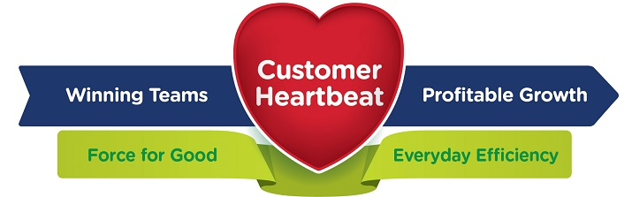
Figure 1: Customer Heartbeat Model of Whitebread
[Source: White bread, 2019]

ANALYSIS OF ANNUAL REPORT
The annual report of the Whitebread includes the strategies and practices adopted by the company to deliver a positive experience to customers and a positive environment to employees. The financial report of the company includes the facts and figures, strategies, practices, and environment of the company (Whitebread PLC, 2018).

VISION STATEMENT
The vision statement of the company is to strongly build the heartbeat of customers by bringing continuous innovation in the company. The teams of the company make every possible effort to delight customers so that they can make a long-term relationship with them and they will come again which will help it to increase the company’s profitability. The main aim of the company is to build communities for the employees so that they can work well and live well.
Two successful brands of Whitebread PLC are as follows:
The overall workforce of the company is 35,000 which are employed in more than 1200 Premier Inn hotels and restaurants. And more specifically, the hotels included in the Premier Inn are more than 785 where they give quality services for increasing the customer value. Both these brands are at the leading position and contribute to increasing the profitability of the company. The logos of both brands are represented below:


Both these two brands give quality and value to the customers and therefore becomes the favorite brand all over the world. The following chart represents the success and popularity of these brands across the world:
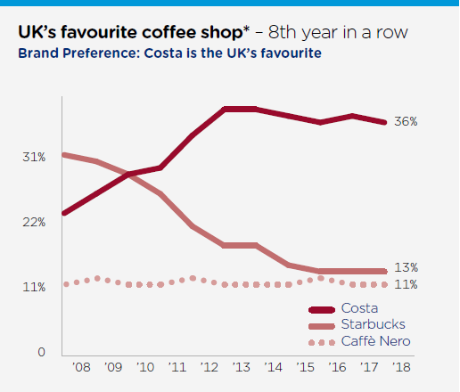

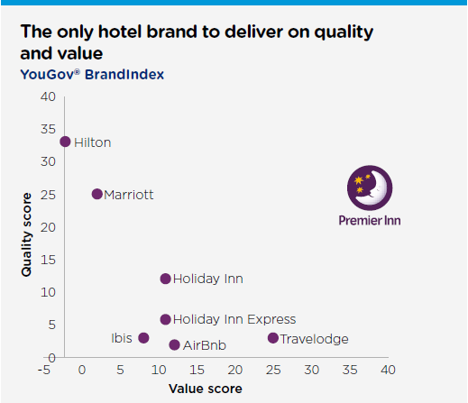

MAIN STRATEGIES OF THE ORGANIZATION
The management of the company continuously invests in the growth and development of the employees at every level so that they can deliver superior services to their customers. In order to prepare the employees ready for delivering quality services, the main focus of the management is to ensure that local managers must continuously make the effort to develop a positive environment for the employees. The strategies adopted by the management in the Whitebread are as follows:
Including employees in the communication process at the time of decision making
In recent years, the management of the company should involve the employees in the decision-making process who are closest to loyal customers and contribute to the success of the organization. Even the company is taking efforts to continue this approach and even to improve the range of the discussions at every level.
Clear and fair reward strategies to encourage all team members
The company introduces “Pay for Progression strategy” in the year 2015 in which the company pays according to their skills, knowledge and their contribution to the company. In addition to this, in the year 2018, the company gives more choices to their employees about their pension scheme where they allow their employees to decide on the saving for retirement. The company also uses online forums to reach the larges employees as possible.
The proper approach to capital management and also risk management
The Whitebread makes a deep analysis of risk and then inform all members about the decision and the reason behind the decision. The analysis of the risk allows the organization to effectively utilize the resources and create value for the customers. Corporate governance is used to facilitate the financial performance of the company which plays an important role in enhancing the financial results of the company.

STRATEGIC PROGRESS
Both the brands i.e. Premier Inn and Costa have a significant market share in the domestic market as well as international markets and it continuously finds the growth opportunities to expand its market share. The company successfully utilizes those opportunities by using proper strategies and plans. Since the last two years, Alison with his team members achieved marvelous results. In addition to this, the organization is also making efforts to find the employees with the right skills and knowledge to execute these plans with proper focus on the technology, supply chain as well as property.

KEY PERFORMANCE INDICATOR
Key performance indicator includes the number of measures which reflects that whether the activities are on track and suitable to achieve the strategic objectives and also to ensure that the needs of the stakeholders should be met within a time limit. The key performance indicator of the company is represented with the help of the following diagram:

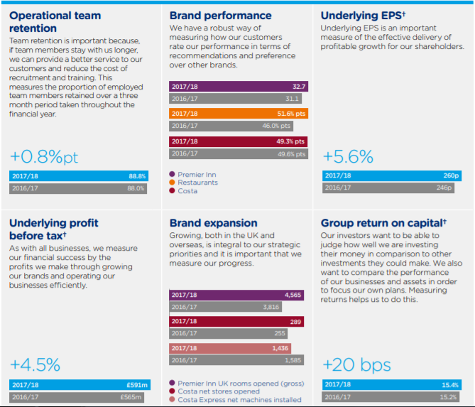
Strategies and working environment for the employees
The strategies used in the Whitebread are preparing the team members for the future, and they take the help of the local managers to create a positive environment for the employees. The strategies used by the top management to create customer value as well as improving the workplace for the employees are as follows:
To include winning team in two way communication
From the analysis, it is found those winning teams are closest to the customers as compared to other team members. Therefore, most of the people take part in a YourSay survey and further, the company is improving this situation and increase the consultation mechanism in the company. For instance, the Restaurant Forum of the company aims to build effective communication between the support center and the operations team. And in order to do this, the management of Premier Inn and Costa conduct regular meetings through conferences, leadership engagement as well as regional meetings.
Clear and transparent remuneration strategies
The management executive of the company involves employees at the time of taking the decision, and for this, the company has changed its pension scheme in April 2008 in which they give more flexibility and choice to employees to make their decision about saving for retirement. Further, in order to reach a large population, the company connects with them with the help of an online forum.
Providing people new technology and positive workplace
The management not only monitors the team but it also ensures the work conditions which allow them to flourish and work well by avoiding barriers in their work. The management also takes feedback from them which facilitate the company to more effectively target in the right investment.

FINANCIAL HIGHLIGHTS
The profitability of the company is increased from the last few years and the following figure shows the results of the previous year as well as growth. The revenue of the company has been increased by 6.1% and profit before tax has been increased by £591 million which is increased by 4.5% of the last year. This data are extracted from the annual report of the company and some of the facts and figures of the company are represented with the help of the following figure:
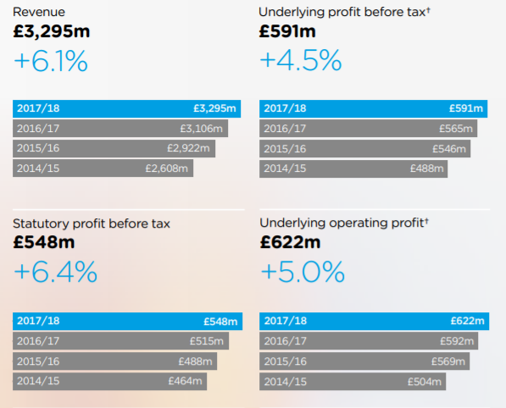
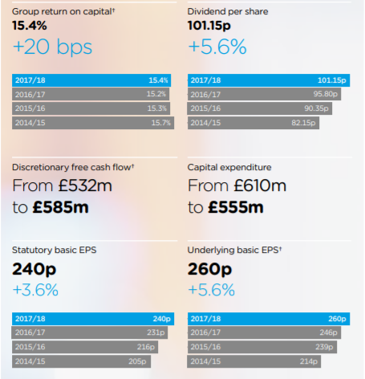
Stepping towards the vision “Customer heartbeat”
Digital revolution
The team of the Whitebread recently launched a digital revolution so that the customers will experience the exciting services of the app. As a result, the customer easily accesses the new app developed by the digital team which helps the company to increase the satisfaction level of the customers. The company also makes extensive use of social media to increase customer engagement.
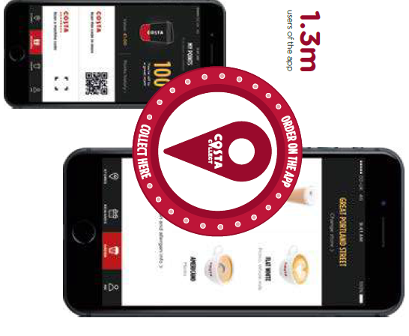

COMPARISON BETWEEN LEADERSHIP STYLES
For a company, its internal human resources mainly leaders and managers are the backbones of the organization. The success of the organization depends on their efforts and hard work. This is because the leaders influence the employees and subordinates with his communication skills and also inspire and motivates the employees towards achieving the group goal. In order to achieve these goals, the leaders maintain a strong and healthy relationship with the employees and expect that they will help the leader their goals. Also, Alison Britain who is a CEO of the Whitebread PLC uses different leadership styles to deliver quality services to its customers. Following are the difference between the leadership style adopted in the Whitebread and the leadership style adopted by me.

FORM OF LEADERSHIP STYLES ADOPTED BY THE COMPANY
From the deep analysis of the annual report, it is found that Whitebread PLC is adopting the following leadership styles:
Autocratic leadership
Autocratic style of leadership is adopted in the Whitebread PLC where the authority to takes the decision lies in the hands of top management. It is the responsibility of the top management to give orders and directions to the employees and it was expected from them that they obey and respect their decisions. The top management undertakes the risks involved in every project as well as understands the needs and skills of the employees and then develop and execute the actions accordingly (Franco and Matos, 2015).
Transformational leadership
The second leadership style adopted in the Whitebread PLC is transformational leadership. Transformational leadership helps the leaders to influence the behavior of employees according to change. The leaders of Whitebread PLC encourage, motivate and inspire the employees to change their style to achieve success. The leaders use apprenticeship, training and developing programs for the employees so that they can respond to change.
Democratic leadership
In my company, I used to prefer a democratic style of leadership. In this style, the decisions are taken by the managers but before taking any decision they discuss with employees. This is because the management feels that these decisions will be implemented on the employees and if they were taken with the consent of the employees they will give their best and put all efforts to achieve those tasks. The only disadvantage of this method is that it takes more time in the decision-making process as compared to the autocratic style of leadership (Bamiatzi et al., 2015).
Supportive leadership
The second leadership style which is used to motivate the employees is supportive leadership. It is necessary to reduce workplace stress and to maintain the work-life balance. In this leadership style, I also work with the team and help them to achieve the desired results.

COMPARISON BETWEEN THE LEADERSHIP STYLE ADOPTED BY THE CEO OF THE COMPANY AND ME
Leadership approaches used by the CEO of Whitebread PLC | Leadership approaches used by me
The main focus of Alison Brittain is to bring innovation and growth in the domestic country through achieving long-term goals. | I focus on achieving the short term goals by strengthening the skills and competencies of the employees as well.
The management style used by the company is strategic where the top management deals with capital management and risk management | The style used by me is the democratic leadership style where the employees equally involve in the decision-making process.
The company launched “Force for Good” to motivate the employees as well as giving a positive experience to team members, suppliers, and most important customers. | On the contrary to this, I used other incentive plans to motivate and improve the performance of the employees.
The Whitebread PLC uses training and apprenticeship program to train the employees and leaders of the organization. | But I prefer to recruit the employees who have the required skills so that I do not have to invest in training programs.
The company concentrates on brand leadership as well which means that it pays more attention to its products and services and develops a strong brand identity in the minds of potential customers. | But on the contrary to this, I focus on the satisfaction level of the customers and find the point of dissatisfaction and then working on it to improve the situation.

RECOMMENDATIONS
Apart from investing in the organization, it is also necessary that I should also invest in myself to improve my current skills and knowledge. In order to meet the change, I need to adopt certain new things for successfully delivering my responsibilities. The skills and knowledge which needs quick attention are as follows:
Communication skills
It is the first requirement for all position in the company. With communication skills, the managers must be capable enough to give a positive impact through their words. Communication skills play a significant role in developing and maintaining a positive relationship with employees and other colleague members (Moore et al., 2018).
Delegation
Delegation is the most important skill for a top executive for completing the work on time. Delegation skill requires analytical skills in which the managers have to analyze the skills, knowledge, and competencies of the employees and then to allocate the task accordingly.
Time management skills
Time management skills do not only require for the top executive but it is very essential at all levels. The time management skill will help in prioritizing the task, setting of goals, delegation, communication, planning as well as stress management. It is very important skills which help me to accomplish the goals on time (Owen, 2016).

CONCLUSION
This report can be concluded by focusing on the working of the CEO of the multinational company. The second task of this report includes some of the highlights from the annual report of Whitebread PLC and the management and leadership style adopted by the company. This task includes the difference between the leadership style adopted by the CEO of the Whitebread PLC and leadership style adopted by me. In addition to this, this report helps me to understand the importance of the practices used to achieve the goals and targets of the company.

REFERENCES
- Amanchukwu, R.N., Stanley, G.J. and Ololube, N.P., 2015. A review of leadership theories, principles and styles and their relevance to educational management. Management, 5(1), pp.6-14.
- Antonakis, J. and Day, D.V. eds., 2017. The nature of leadership. Sage publications.
- Arnold, K.A., Connelly, C.E., Walsh, M.M. and Martin Ginis, K.A., 2015. Leadership styles, emotion regulation, and burnout. Journal of Occupational Health Psychology, 20(4), p.481.
- Bajpai, A. and Singh, G., 2019. A Factor Analysis Methodology for Analyzing the Competencies Affecting Entrepreneurs of SMEs. Available at SSRN 3320694.
- Bamiatzi, V., Jones, S., Mitchelmore, S. and Nikolopoulos, K., 2015. The Role of Competencies in Shaping the Leadership Style of Female Entrepreneurs: The Case of North West of E England, Y Yorkshire, and North Wales. Journal of Small Business Management, 53(3), pp.627-644.
- Behrendt, P., Matz, S. and Göritz, A.S., 2017. An integrative model of leadership behavior. The leadership quarterly, 28(1), pp.229-244.
- Blanchard, K., 2018. Leading at a higher level: Blanchard on leadership and creating high performing organizations. FT Press.
- Crowne, K.A., Young, T.M., Goldman, B., Patterson, B., Krouse, A.M. and Proenca, J., 2017. Leading nurses: emotional intelligence and leadership development effectiveness. Leadership in Health Services, 30(3), pp.217-232.
- Dhanesh, G.S., and Duthler, G., 2019. Relationship management through social media influencers: Effects of followers’ awareness of paid endorsement. Public Relations Review, p.101765.
- Franco, M. and Matos, P.G., 2015. Leadership styles in SMEs: a mixed-method approach. International Entrepreneurship and Management Journal, 11(2), pp.425-451.
- Frankel, A. and PGCMS, R., 2019. What leadership styles should senior nurses develop?. Hospital, 6, p.08.
- Hooper, A. and Potter, J., 2019. The business of leadership: Adding lasting value to your organization. Routledge.
- Iqbal, N., Anwar, S. and Haider, N., 2015. Effect of leadership style on employee performance. Arabian Journal of Business and Management Review, 5(5), pp.1-6.
- Johnson, C.E., 2017. Meeting the ethical challenges of leadership: Casting light or shadow. Sage Publications.
- Kollenscher, E., Popper, M. and Ronen, B., 2018. Value-creating organizational leadership. Journal of Management & Organization, 24(1), pp.19-39.
- Lee, Y.H. and Chelladurai, P., 2018. Emotional intelligence, emotional labor, coach burnout, job satisfaction, and turnover intention in sport leadership. European Sport Management Quarterly, 18(4), pp.393-412.
- Mishra, A.S., 2018. Organizational Leadership in Changing Times. Effective Executive, 21(2), pp.5-6.
- Moore, P.M., Rivera, S., Bravo‐Soto, G.A., Olivares, C. and Lawrie, T.A., 2018. Communication skills training for healthcare professionals working with people who have cancer. Cochrane Database of Systematic Reviews, (7).
- Owen, J., 2016. Increasing time management skills to improve student-athletes' GPA.
- Ratts, M.J., Singh, A.A., Nassar‐McMillan, S., Butler, S.K. and McCullough, J.R., 2016. Multicultural and social justice counseling competencies: Guidelines for the counseling profession. Journal of Multicultural Counseling and Development, 44(1), pp.28-48.
- Richardson, J.D., 2018. Being a National Leader in Surgery: Roles, Responsibilities, and Opportunities. In Surgical Mentorship and Leadership (pp. 253-266). Springer, Cham.
- Rubens, A., Schoenfeld, G.A., Schaffer, B.S., and Leah, J.S., 2018. Self-awareness and leadership: Developing an individual strategic professional development plan in an MBA leadership course. The International Journal of Management Education, 16(1), pp.1-13.
- Thompson, G. and Glasø, L., 2015. Situational leadership theory: a test from three perspectives. Leadership & Organization Development Journal, 36(5), pp.527-544.
- White bread, 2019. About us online available at https://www.whitbread.co.uk/about-us/at-a-glance (last accessed on 10th August 2019).
- Whitebread PLC, 2018. Interactive PDF online available at NL-WHITBREAD%20ANNUAL%20REPORT.pdf (last accessed on 10th August 2019).
- Yahaya, R. and Ebrahim, F., 2016. Leadership styles and organizational commitment: a literature review. Journal of Management Development, 35(2), pp.190-216.

