Jorna Ali - 1706149

Marks and Spencer’s SWOT on their CRM
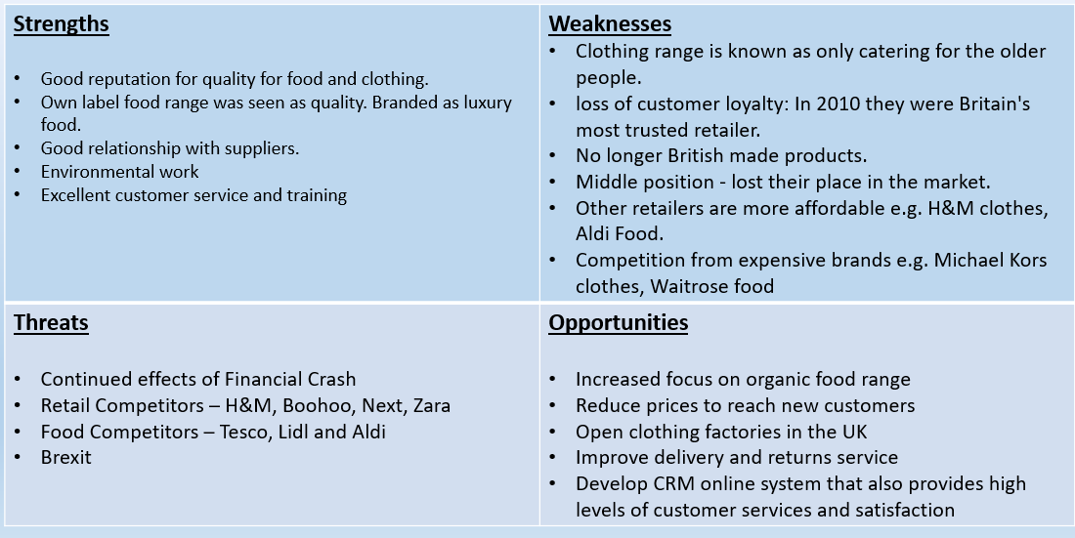

Recommendations
The first recommendation is to offer both click-and-collect and home deliver for clothing. This is to bring it in line with other brands and to compete in the online market. By 2017, around 76% of online shoppers used click and collect (Gilliland, 2017). The next is to look into the feasibility of forming British clothing factories. This is because M&S have always had a good reputation for quality for food and clothing. This is a strength but with recent changes to factory locations, it has caused a loss of trust in the brand as a quality ‘British-made’ brand. As part of this, M&S should start an advertising campaign about a return to British made clothing. M&S have always had good relationship with suppliers and have interacted with local companies. This provided jobs for local people. However, their main suppliers have moved abroad, making customers feel let down by the brand.
M&S could develop clothing range for 16-29 age group. M&S clothes are seen to be for older people, despite bringing out fashionable items and getting Holly Willoughby to promote their clothes. There is not enough to push younger people into buying M&S clothes. They need to continue engage with social media influencers but focus on reaching younger demographics. This is because more young people look towards instragrmmers as style icons, according to Dredge (2015).
The last recommendation is to improve their online services. One way they can do this is to have tool for accessorising so that customers can preview what an outfit can look, and how items can be mixed and matched to create different looks for different occasions and times of day (Laagland, 2010). Another way is to improve their online chat option as customers have to search for the option to use it, and agents are not always available (M&S, 2019).

Bibliography
Dredge, S., 2015. The social-media style icons every advertiser wants a piece of. The Guardian , 14 October, pp. https://www.theguardian.com/media/2015/oct/14/influencers-social-media-advertising-apps-instagram.
Gilliland, N., 2017. How has Click & Collect evolved, and is it still in high demand?. [Online]
Available at: https://econsultancy.com/how-has-click-collect-evolved-and-is-it-still-in-high-demand/
[Accessed 18 February 2019].
Laagland, K., 2010. The Power of Accessorising - Using Accessories to Bring an Outfit to Life. [Online]
Available at: https://ezinearticles.com/?The-Power-of-Accessorising---Using-Accessories-to-Bring-an-Outfit-to-Life&id=4902325
[Accessed 18 February 2019].
M&S, 2019. Climate Change. [Online]
Available at: https://corporate.marksandspencer.com/sustainability/business-wide/climate-change
[Accessed 4 February 2019].
M&S, 2019. Help and contact us. [Online]
Available at: https://www.marksandspencer.com/c/contact-us
[Accessed 18 February 2019].
Perrett, M., 2016. Marks & Spencer wins award for environmental impact. [Online]
Available at: https://www.foodmanufacture.co.uk/Article/2016/05/20/Marks-Spencer-wins-award-for-environmental-impact
[Accessed 4 February 2019].
Smithers, R., 2012. M&S becomes 'carbon neutral'. The Guardian , 7 June, pp. https://www.theguardian.com/environment/2012/jun/07/marks-spencer-carbon-neutral-sustainability.

