Effective Team Working and Communication

Anjaman Bashir
Dami Pokubo
BMSW 4002
2132770

Table of Contents
Abstract 3
Effective Team Working and Communication 4
Introduction 4
Main body 4
Developing effective teams 4
Tuckman's five-stage team development 5
Wheelan model of team development model 7
Dependency and Inclusion 8
Fight and interdependency 8
Structure & Trust 8
Work 9
Team roles appropriate to produce an effective team 9
What are the benefits of teamwork? 12
Barriers to effective teamwork based on the scenario 13
Conclusion 13
References 15

Abstract
The commitment of a group to reflection and constant evaluation enhances team effectiveness. To perform effectively, teams must understand their team dynamics in addition to defining success in terms of attaining specific objectives. The report focused on exploring an Amazon case study to advise Tom, the team leader on how to develop effective teams. The paper proposes two team development models which are Tuckman's five stages of team development and Whelan's four-stage model of team development. Furthermore, the report emphasizes that Tom should use the Belbin team role theory to allocate tasks in the team. From the case scenario, the barriers to an effective team are a lack of good communication channels, poor conflict resolution strategies, and a lack of strong leadership capabilities.

Effective Team Working and Communication

Introduction
Teamwork is the joint effort of a group to complete a task or realize a common goal in the cost-efficient manner possible. This concept is seen in the broader perspective of a group, which is a grouping of interdependent people cooperating to accomplish a single goal. A successful team also depends on efficient communication. One of the essential requirements for effective teamwork is the right team size. Context is essential, and team numbers may vary depending on the objective. The majority of teams vary in size beginning from 2 to 100 (Wheelan, 2009). In light of the above, this essay aims to analyse the Amazon case study and the interactions between Tom and his team and offer his advice on the possible solutions to improve teamwork collaboration. Specifically, the essay will aim to advise tom on how to develop effective teams and the team development stages, and the team roles needed to create an effective team. Furthermore, the report will advise Tom on the major benefits of teamwork and the barriers to effective team based on the case study.

Main body

Developing effective teams
A variety of activities are included in team development that is aimed at enhancing team performance. To assure self-development, constructive communication, leadership abilities, and the capacity to collaborate closely as a group to address problems, it seeks to produce the best in a given team. According to Fapohunda, (2013) a variety of elements, including organizational environment and culture, team leadership effectiveness, work engagement, the system of remuneration and rewards, and the degree of team member’s autonomy, influence teamwork's effectiveness. Furthermore, Fapohunda, (2013) identified eight crucial aspects that are helpful in the effective development of teamwork. They include; clear objectives, decision-making power, responsibility and commitment, strong leadership, learning, and employee growth, and the provision of resources, support from the organization, and rewarding the success of the group members contributed to the group success.

Tuckman's five-stage team development
There are numerous models which can be used towards developing an effective team. This is demonstrated through Tuckman’s stages of group development. Tuckman pointed out that for groups to be effective, individuals should collaborate and participate towards the shared outcomes. However, this is not a natural process; rather, it grows as the team collaborates. As a result, teams go through distinct phases of development. Tuckman’s five stages are Forming, storming, norming, performing, and adjourning. The process is depicted by the diagram below. 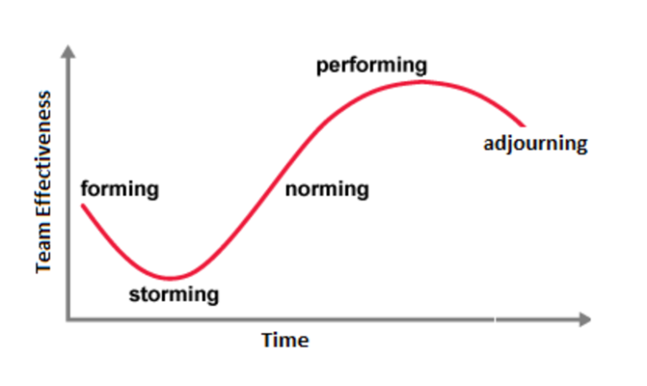
Source: ALSEVER et al, (2014).
Forming phase
It is the first stage where the team members meet for the first time. It could be said that everyone is settling in and getting acquainted with one another throughout this orientation session. Teammates are typically thrilled to be a part of the team and optimistic to learn about the work that lies ahead. Members frequently have very high standards for their team experiences. For instance, the team will provide you a question that team members commonly ask. What is expected of members to do and how they will blend in are also examples of what the team members ask. In the Amazon case, Tom must at this stage explain to the group members the objectives of the group through a well-established communication channels.
Storming stage
It is the hardest stage to get through. Conflict and members personalities start to be seen. Team performance may decline because of this period's emphasis on inefficient duties. On the team's goals or the areas of agreement, members may not always agree. Cliques or subgroups may emerge around people with strong personalities (Tuckman and Jensen, 2010). For example, Tom's group started showing flaws as members were unable to agree or solve the involved differences.
Norming phase
At this stage, the team members are able to solve the arising conflict hence making the team to be cohesive. The members are also able to follow the leader and the direction provided. When interpersonal disputes start to be resolved, a sense of coherence and oneness starts to take shape. Team performance increases at this point as member’s start cooperating and focusing on the group's goals. However, the team's harmony is fragile, and storming might start up again if disagreements arise.

Performing phase
The group is now mature, organized, and functional, with strong agreements on consent and cooperation. Individuals in the team are focused to attain the common goal of the group are committed to its objective, and the structure is sound and unambiguous. There are still differences and glitches, but they are successfully resolved in a positive way.
Adjourning phase
At this stage, the team is closed down. As the workload lowers, teammates are given other roles since the team is being brought to an end. This motivates the team to perform better in the next mission. For example, Toms team members can be awarded bonuses after successful completion of offering Amazon reliable services across Europe.

Wheelan model of team development model
Wheelan outlines how to act during the phases of team development to create effective teams. Particularly, the group's demands must be reflected based on how the leader conducts himself or herself. For example, Tom's team failed because he prioritized his needs rather than those of the team. However, the need differs in each stage.
According to Wheelan, a team's development is comparable to that of a baby. Infancy and adolescent are two examples of two phases a person goes through as they age. For human development and the gain of independence, both periods are required. A group goes through similar stages as it "matures" and gains its independence. Wheelan identifies four stages, each with distinct group dynamic characteristics and themes. Wheelan lists them as the four stages of team development: Dependency and Inclusion, Counterdependency and Figh, Trust and structure, and Work (Wheelan and Tilin, 1999).
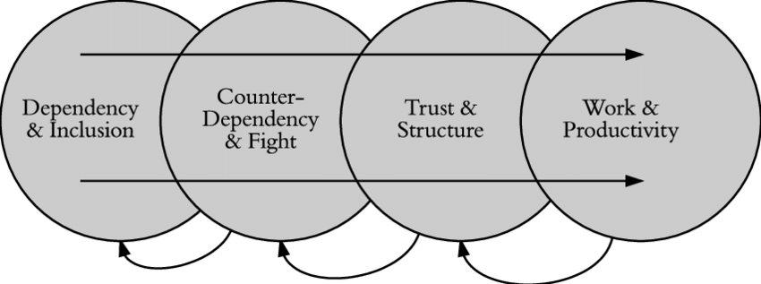
Source: Wheelan and Tilin, (1999).

Dependency and Inclusion
The first stage characteristics include team members' dependence on the official leader, worries about safety and trust, and group acceptance.

Fight and interdependency
In the second stage, team members start publicly expressing their disagreement with one another. The group's role in this situation is to draft the processes and codes of behaviour, which invariably causes conflicts. Mutual trust and an environment where members feel free to agree or disagree emerge when a group can constructively handle these disagreements. Successful completion of this phase encourages the group to communicate openly and honestly about their tasks.

Structure & Trust
The stage is distinguished by a more developed form of negotiating standards and processes.

Work
A group will enter the Work stage where optimum and effective cooperation is attained if they can complete the first three stages. Groups that function at a greater degree of group development are much more productive according to research (Wheelan and Tilin, 1999).
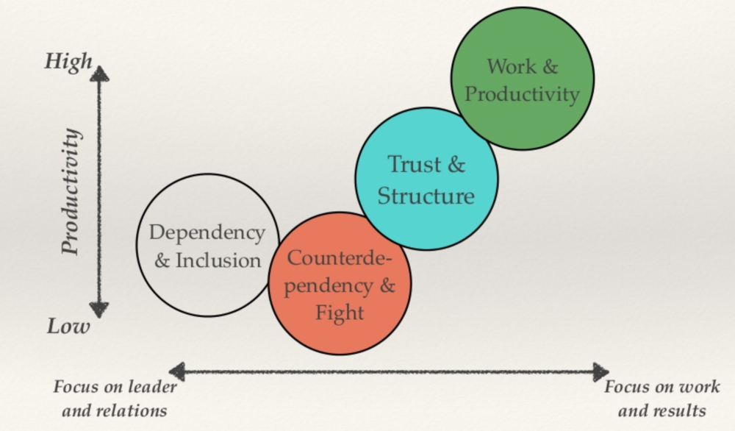
Source: Wheelan and Tilin, (1999).
Behavioural components explain the conduct observed by team members in the group, whereas psychological elements define how the group is regarded by its members. With time, team members develop a psychological image of the group and the anticipated conduct. They choose the behaviour they want to display based on this notion (Wheelan et al, 2003).

Team roles appropriate to produce an effective team
Organization and cooperation are required for teamwork. Each member should have a specialized role that plays to their abilities for teams to be effective and most productive (Bednár and Ljudvigová, 2020). Dr. Meredith Belbin established the team role theory which is grounded on behavioural characteristics. Belbin came up with nine team roles that must be present for the teamwork to be successful and attributed the team roles as "a tendency to behave, participate, and interconnect with others in a specific way" (Belbin, 2012). Action-oriented, thought-oriented, and people-oriented are the three subcategories that Belbin divides his nine team responsibilities into.
Team members that take initiative are ready to complete tasks and perform well under time constraints are action oriented. Thought-oriented employees are those who are open to new ideas and have a critical mind-set. On the other hand, individuals with better communication skills may support the entire group since they value people (Belbin, 2012).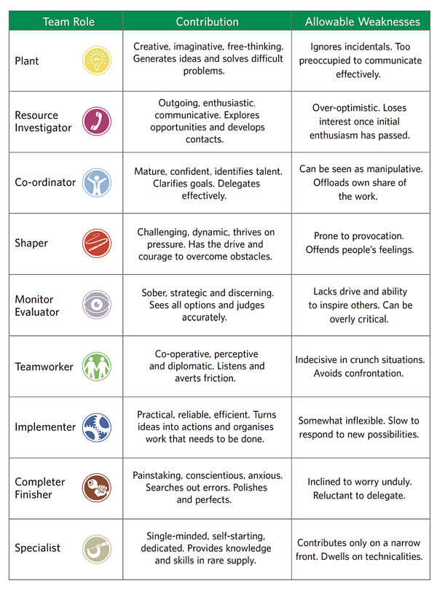
Source: Developer Experience, 2022
The nine roles kinds listed above are necessary for teams to function effectively. Belbin understood that each team member's actions affected the team's ability to succeed. According to Belbin's research, a team tends to function more effectively if each member is aware of their specific responsibilities (Senaratne and Gunawardane, 2015). Better performance results from familiarity and sharing information motivate team members to come up with useful solutions and suggestions. It lessens miscommunications and conflicts. The quality of the work is improved and mistakes are eliminated when team members are properly matched to their roles.

What are the benefits of teamwork?
According to Volkov and Volkov, (2015) firms adopt team-based structures to promote their productivity, and profitability, and increase their levels of service quality. For example, every manager and employee in an organization looks for ways to increase productivity and profitability. Furthermore, teams are highly sought to improve profitability and overall business success.
Van Knippenberg et al, (2020) pointed out that effective teams Enhanced Synergy. Teams are assembled with members from various backgrounds, expertise, and skill sets. Collectively, this diversity has the potential to produce something more than the sum of the parts.
Also, teamwork fosters Creativity in the organization. Better ideation can happen, according to Ahmed et al. (2016), in a workplace where employees frequently share their opinions, analyses, recommendations, and worries. This sparks a discussion about novel ideas and opposing opinions, which encourages continuous innovation. According to the findings by Ahmed, (2016), organizational innovation is higher the more teamwork is practiced within firms. teams space for in-depth reflection. Thus, teams inside businesses may find HRM systems to be more or less enabling or restricting. Another benefit is that teamwork engages staff members. Workers interrelate, when working together as a team.

Barriers to effective teamwork based on the scenario
Based on the given scenario, the barriers to effective teamwork include poor leadership capabilities. Tom as the team leader approaches the project poorly leading to the poor constitution of the project activities. Lack of communication is also another barrier to effective teamwork as indicated in the case study. For instance, the team lacks a proper channel to communicate with the team about the project. This implies that the project goals and objectives were not precisely understood by the team members. Also, the team lacked proper ways of dealing with conflict. This is indicated by Mihaela and Spencer who have different opinions and objectives about the team. Also, the case study indicates that most of the differences arising in the team could not be solved.

Conclusion
In conclusion, an effective team is a collection of people who are all dedicated to achieving a common objective. The ideal team makes the most of each member's unique strengths to do its finest work. While leaders must encourage and develop the collaboration abilities of their followers, team members are expected to cooperate and carry out their directives. Therefore, to develop effective teams, Tom must use the five Tuckman team development stages. Also, Whelan's team development model can be adopted to develop effective teams. Also, Tom needs to adopt Belbin's team roles theory to allocate the team members with numerous tasks based on their strengths. The barriers to effective teamwork in the case of Tom's team include poor leadership abilities, poor communication, and a lack of proper ways to solve the conflict. For teamwork to be effective, Tom needs to eradicate these barriers.

References
Ahmed, F., Shahzad, K., Aslam, H., Bajwa, S.U. and Bahoo, R., 2016. The role of collaborative culture in knowledge sharing and creativity among employees. Pakistan Journal of Commerce and Social Sciences (PJCSS), 10(2), pp.335-358.
ALSEVER, J., HEMPEL, J., Taylor III, A., 2014. 6 great teams that take care of business | Fortune [WWW Document]. Fortune. URL https://fortune.com/2014/04/10/6-great-teams-that-take-care-of-business/ (accessed 10.16.22).
Bednár, R. and Ljudvigová, I., 2020. Belbin team roles in a start-up team. In SHS Web of Conferences (Vol. 83, p. 01002). EDP Sciences.
Belbin, R.M., 2012. Team roles at work. Routledge.
Developer Experience, 2022. Team Roles Definition | Developer Experience Knowledge Base [WWW Document]. Developer Experience Knowledge Base. URL https://developerexperience.io/practices/team-roles-definition (accessed 10.16.22).
Fapohunda, T.M., 2013. Towards effective team building in the workplace. International journal of education and research, 1(4), pp.1-12.
Senaratne, S. and Gunawardane, S., 2015. Application of team role theory to construction design teams. Architectural Engineering and Design Management, 11(1), pp.1-20.
Tuckman, B.W. and Jensen, M.A.C., 1977. Stages of small-group development revisited. Group & organization studies, 2(4), pp.419-427.
Tuckman, B.W. and Jensen, M.A.C., 2010. Stages of small-group development Revisited1. Group Facilitation, (10), p.43.
van Knippenberg, D., Nishii, L.H. and Dwertmann, D.J., 2020. Synergy from diversity: Managing team diversity to enhance performance. Behavioral Science & Policy, 6(1), pp.75-92.
Volkov, A. and Volkov, M., 2015. Teamwork benefits in tertiary education: Student perceptions that lead to best practice assessment design. Education+ Training.
Wheelan, S.A. and Tilin, F., 1999. The relationship between faculty group development and school productivity. Small group research, 30(1), pp.59-81.
Wheelan, S.A., 2009. Group size, group development, and group productivity. Small group research, 40(2), pp.247-262.
Wheelan, S.A., Davidson, B. and Tilin, F., 2003. Group development across time: Reality or illusion?. Small group research, 34(2), pp.223-245.

