Subcontractors Planning and Coordination
Name: Omar aldossari
P146972
Date : 13/2/2018

Part 2: Buy or Rent Decision
The building sector in the UK has in the recent past come under increased pressure to not only enhance product quality but also to work on reducing lead times and costs. During the said period customers have shown an increasing need for efficient and eco-friendly products offering services such as electrical, cooling, and heating and air distribution which have led to new and complex building scenarios. Presently most developers encounter issues and questions relating to boundaries between subcontractors, communication, less emphasis on the testing phase and a larger number of people working at the wrong time in the same place. These subcontractor-related problems are quoted as the main cause of risk in construction projects across the globe (Arditi & Chotibhongs, 2005). They should, therefore, be reduced or eliminated in order to realize cost-effective construction projects.
For a contractor to fully satisfy her clients’ needs and have a fully efficient and tested construction product at the stated time, it is recommended that she uses the last planner system (LPS) approach to managing the subcontractor-related problems. Although the approach is primarily centered on project programming and planning, it can as well be applied in one-off project based production to bring about collaboration and teamwork in construction projects. LPS is a production tool used to enhance planning of building projects. It aims at bringing about trust among project participants in five key ways: collaborative production evaluation and planning; collective pull-based planning; production management; “make ready”; and measurement, learning and continual improvement (Mossman, 2012). Working under a conversations framework would assist ensure that processes in the planning, design, development, and implementation phases of construction projects are jointly designed and developed by all critical stakeholders. This would result in fewer quarrels, costs, and delays in the project work.
The neural network can also be used in rating subcontractors during the bidding process. Under this method, an expert charged with making decisions considers five basic elements which include management skills of the subcontractor, technical characteristics of the bid, time reduction, price reduction and the contractual reliability of a subcontractor. The neural network will then consider and suggest the appropriate subcontractor depending on past choices made by the expert. This means that previous decisions made by the expert are useful and need to be inputted into the neural network (Yoke-Lian et al., 2012).
Buy or Rent Excavators
When considering the acquisition of large equipment such as an excavator, companies need to take into considerations many factors among them the manufacturer, the prospective marginal tax rate, the renter’s cost of raising finance as well as the estimated disposal value of the asset at the project termination date. Renting is in itself a contractual arrangement in which the leasing party (lessee) would have to obtain an equipment or asset from another party (lessor) in return for a periodic payment referred to as lease rentals. The rentals may be paid monthly, quarterly or yearly depending on the negotiated terms and conditions under the contract. It may also have an option of transferring ownership of the equipment to from the lessor to the lessee upon the expiry of the contract period (Mowen et al., 2011). Buying, on the other hand, involves purchasing equipment using one’s own finances or obtaining loan finance from financial institutions to finance the equipment acquisition. In ascertaining whether renting an excavator is the better option compared to buying, contractors have to first determine the periodic cash outflows under both the options and discount them utilizing the after-tax cost of debt (Mowen et al., 2011). After that has been established, the present value of cash outflows in the two options is compared to see which one stands out against the other in terms of lower costs. The alternative with the lowest present value of cash flows is the one that has to be selected as its cost would minimize the overall cost of the contractor.
Excavator Details
The cost of a new 2016 John Deere 17G mini excavator =30,430*0.72= £21,910.00
The company would have to obtain a long-term loan of £21,910.00 at 5% per annum.
Buying an excavator would mean that the company incurs maintenance costs such as fueling, power, and security which has been estimated as £4,030.00 per year.
The firm’s tax rate is estimated to be 20% while its cost of debt is 6%. The straight line approach to depreciation is appropriate as it is allowed by UK tax laws.
Lease rentals per year for a 1.7 excavator =£250*52=£13,000.00
Analysis
Annual cash outflows of renting an excavator =£13,000.00(1-20%) = £10,400.00
Annual cash flows of buying would have several components including depreciation and interest expenses, maintenance costs borne per year, the loan amount to be repaid each year, and the tax shields related to maintenance costs. The below table condenses the computation of cash outflows under the buying option.
Period | 1 | 2 | 3
Loan Repayment | £ 8,045.54 | £ 8,045.54 | £ 8,045.54
Maintenance Costs | £ 4,030.00 | £ 4,030.00 | £ 4,030.00
Depreciation | £ 7,303.33 | £ 7,303.33 | £ 7,303.33
Interest expense | £ 1,095.00 | £ 748.00 | £ 383.00
Tax deductions | £ 12,428.33 | £ 12,081.33 | £ 11,716.33
Tax shield @20% | £ 2,485.67 | £ 2,416.27 | £ 2,343.27
Net cash flows | £ 9,589.87 | £ 9,659.27 | £ 9,732.27
PV cash flows | £ 9,150.64 | £ 18,011.58 | £ 26,603.03
Total PV | £ 53,765.25

The yearly loan repayment amount is based on the PV computation. It is computed using the excel function: PMT (5%, 3, £21,910). Depreciation is computed using the straight-line approach £21,910/3= £7,303.00
After deterring the cash outflows for the two alternatives, we have to calculate the PV of cash outflows utilizing the company’s assumed after-tax cost of debt which is 4.8% ((6 %*(1-20%))
PV of renting the excavator £10,400.00 for three years =$28,428.25 (Calculated using the excel function PV (0.048, 3, £10,400)
Present value of purchasing =£53,765.25
Conclusion
As seen in the above computations, renting has a lower present value of cash outflows of £28,428.25. it is therefore suggested that the construction company considers acquiring an excavator by way of renting. This would save the company £25,337.00 (£53,765.25- £28,428.25).

References
Arditi, D., & Chotibhongs, R. (2005). Issues in subcontracting practice. Journal of Construction Engineering and Management, 131(8), 866-876.
Mossman, A. (2012). Last Planner: collaborative conversations for predictable design & construction delivery. The Change Business Ltd.
Yoke-Lian, L., Hassim, S., Muniandy, R., & Teik-Hua, L. (2012). Review of Subcontracting Practice in Construction Industry. International Journal of Engineering and Technology, 4(4), 442.
Mowen, M. M., Hansen, D. R., & Heitger, D. L. (2011). Cornerstones of managerial accounting. Nelson Education.

Appendices
Appendix 1: Cost of a new 2016 John Deere 17G mini excavator (Conversion rate US$1= £0.72)
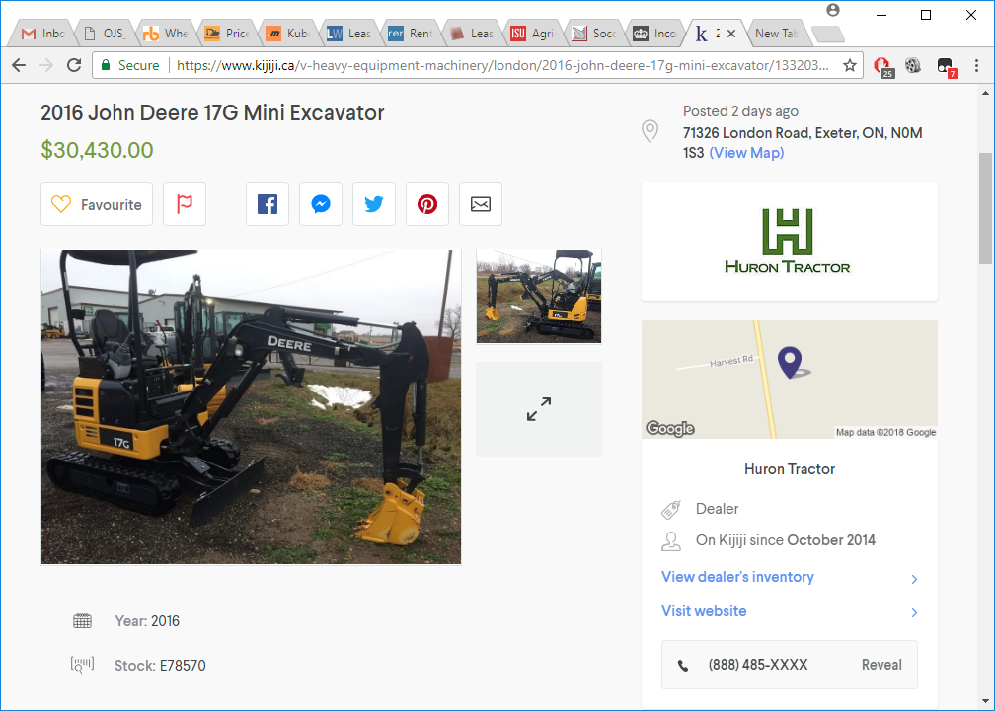
Appendix 2: Rentals for a Mini Excavator (available at http://www.1stbaseplant.co.uk/price-list.html accessed February 10, 2018)


Appendix 3: Interest Expense Calculation
Interest expense is computed in the following loan amortization schedule
Period | Beginning Balance | Total Payment | Interest | Principal | Ending Balance
0 | £ 21,910.00 | £ - | £ - | £ - | £ 21,910.00
1 | £ 21,910.00 | £ 8,045.54 | £ 1,095.50 | £ 6,950.04 | £ 14,959.96
2 | £ 14,959.96 | £ 8,045.54 | £ 748.00 | £ 7,297.54 | £ 7,662.42
3 | £ 7,662.42 | £ 7,662.42 | £ 383.12 | £ 7,279.30 | £ -

