 The Newport Ship
HPAR5007
Alexander Savage
Introduction:

In 2002, when at the city of Newport south wales, during the construction of the Arts centre at the riverfront, archaeologists were called in because of the remains of what seemed to be a wooden structure was unearthed. As the archaeologists dug down, they found that the timbers were actually part of a ship that was a lot larger than what was thought. The date of the ship could be easily dated because of the coin that was found in a part of the ship called the keel. The reason that coins are placed at the keel of the ships is because it was believed to bring good fortune. The ship was dated to the 1400s using dendrochronology taking samples of the wood but when the coin was found you could easily date this because as the coin was only minted from the dates of May 1447 to July 1447. The Dauphin of France ordered the mintage of these coins for two months. However, before all the archaeology or dating was explored, plans for the Arts centre were put on hold because of the recent discovery (Friends of the Newport ship) Save our ship campaign charity ‘SOS’). (2005)

Coin found, placed into the keel of the Newport ship

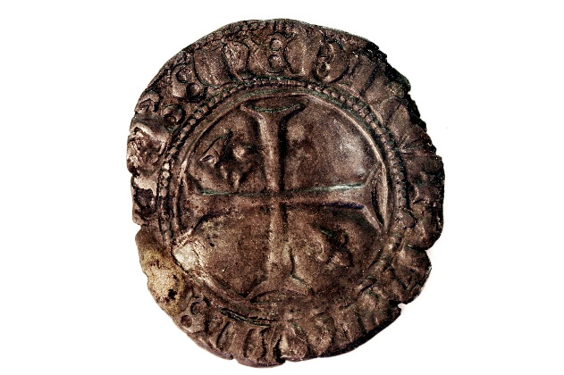
Photo taken by Friends of the Newport Ship (n.d.)

Not long after the boat was discovered by developers, the discovery of the ship in Newport was now in the public domain, and the people of Newport had campaigned to authorities to save the ship, so after months of vigorous campaigning and protesting to protect and preserve all of the ship that could be saved and excavated for reconstruction Newport council, the Welsh Assembly and other public bodies including some private investment, gave three and a half million in investment to bring the ship up to preserve it and also try to reconstruct and display (Friends of the Newport ship, 2002).

Detection of the Newport ship
In 2002 while construction was being carried out to create the new arts centre at Newport, the Glamorgan Gwent Archaeological trust (GGAT) while creating a cofferdam to keep back the water, and then pump water out and as mud was cleared away the archaeologists had found a series of a line of timbers. As the work stopped for the archaeologists to analyse what was found mud and sediment was being cleared away to expose what was to be the flattened remains of a ship even though a large potion of the ship was surrounded and protected by the cofferdam, a part of the ship was not exposed and could not be excavated. While the team where investigating the ship, what was found was that the ship itself lay on its right-hand side looking rather deformed being depressed over hundreds of years (Friends of the Newport ship finding the ship,2002).

Clearing away the mud at the Newport ship
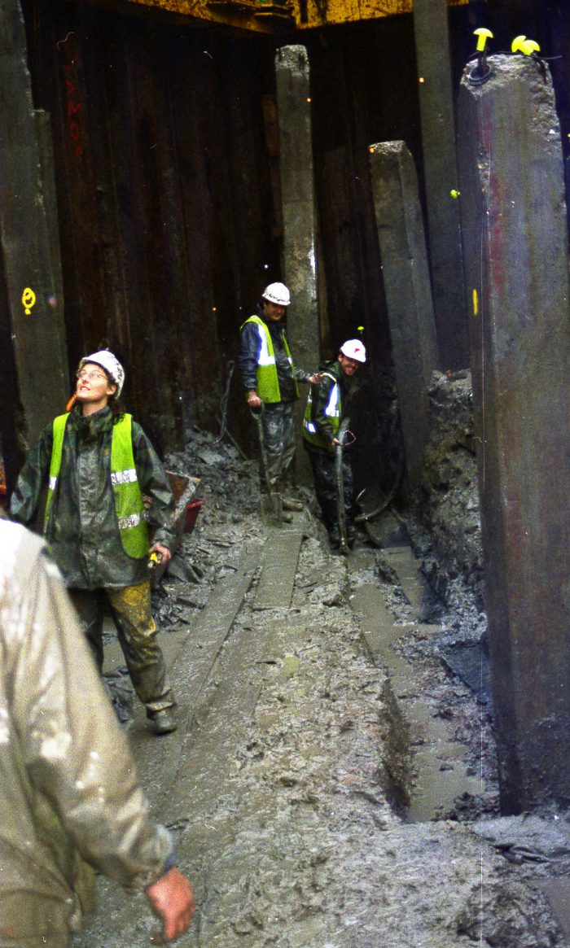
Friends of the Newport ship (2002)

This was an accidental discovery by contractors. A more active detection of the Newport ship could have been applied whether by using lidar, sonar, or laser scanning but unfortunately at the time of the discovery in 2002 some of these technologies were not available especially because the ship itself and the location where unknown.

Funding the Newport ship:
When the ship was discovered at the end of the June 2002, the council of Newport and the Government of the Welsh Assembly both acknowledged the sense of importance of the remains of the ship, after a lot of protesting members of the public, funding for the project came from the National Assembly at three and a half million pounds but also extra funding came from members of the public raising money for the excavation (Newport museums and heritage, 2016). In 2016 the lottery heritage fund in addition to the three and a half million that was given in 2002 gave to the project an additional seven hundred and ninety-nine thousand five hundred pounds to cleanse, clean and preserver the ship timber remains, this also helped the archaeologists to employ a larger team as there were only four, this turned into fifteen (Wade, 2017).

Assessment
When the Newport ship was being analysed at the hull of the ship, very many artefacts were found and specimens of environmental materials were also found and sent off for analysis. This analysis may give the archaeologist an insight into the provenance and ancestry of the ships life and who was on board at the time. When the dendrochronology of the oak wood was analysed it gave the archaeologists a country of origin which was in northern Spain and also a timeline of 1449 AD. When the Newport ship had turned onto its starboard side it sank into the water and then slowly over time was covered in clay sediment, which then helped to preserve nearly all the artefacts even the environmental, from pollen, foods and they could even tell what cargos or cargo had been carried. Like the Tankerton beach wreck, which was discovered in 2017 it also had samples that were preserved in the clay, which were also sent by Rod Bale at the laboratory at Lampeter university for analysis. (Friends of the Newport ship, excavation process, 2002).
Ariel photo of the Tankerton beach Wreck Ariel photo of the Newport Ship
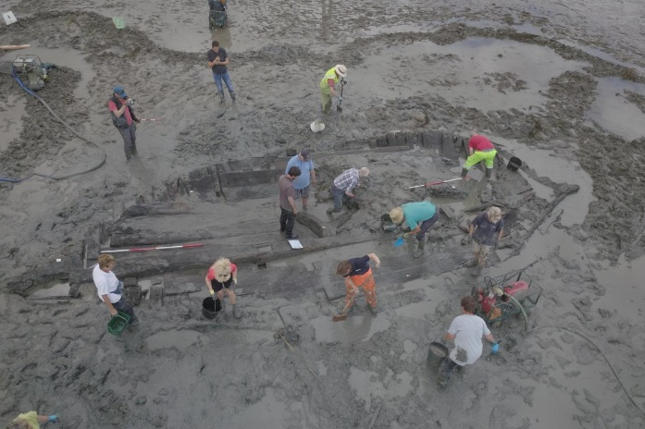
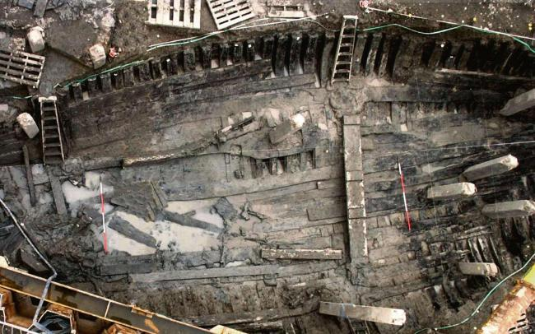
Tom Banbury (2017) Estel Farell-Roig (2016)

The main assessment techniques used were dendrochronology and analysis of other biological matter. According to Cederlund, C. (1983) p65 when a shipwreck is discovered, the general conditions of a ships timbers and overall condition of the ship remains themselves, compiling all the remains for documentation and analysis certain observational analysis should be applied some of these include trying to establish the hulls original shape, how different components of the ships remains where manufactured including all relevant information on these components dimensions may give a great indication, how the components of the ship and timbers where joined together, what type of tree was used and its provenance, any tool related marks or markings left by the ship builders themselves.

Cederlund also mentions that after gathering all the relevant ships material there are many ways then to use this to do an investigation based upon the archaeological evidence these methods that are applied in this process are based on several, comparison of other documented evidence in other discoveries written sources of evidence, iconographic any previous based theoretical studies that have been carried out, other ways to this is examining the original wreck components or structure left behind the quality of the construction itself, using architects that build ships in the present day, through archaeological investigation using a process of mathematics using calculations, the reconstruction of the ship and putting it in conditions that it would face at sea to establish its load capacity, the vessels speed while carrying cargo and without and one of the more important the ships capability’s and stability at sea, and also building a full scale replica of the ship in what would have been its original form when built Cederlund,C. (1983) p65. the same techniques may still be used today, new advancements in technology have made it a lot safer to establish what ships lie beneath the sea rivers or costal lines. Storms and bad weather maybe a factor in uncovering these great vessels for historical advancements.

Excavation
In the beginning of the excavation of the Newport ship, it became apparent to the team of archaeologists and other members of the operation that bringing up the ship in sections would be not an impossible task but a costly and time consuming and very hard to excavate, because not only because of the restraints of space to work in and around the ship but also the infiltration of concrete pillars going through the hull of the ship which then meant that the original plan to excavate, was now not an option and an alternative way of excavation would have to be thought through. Having realised the complexity of the excavation the archaeologists finally decided on an approach where by where each piece would be individually cut into small sections the very carefully lifted out by using cranes, then using tanks of water which where not salt water but fresh water to be able to preserve the timbers themselves. While the space to cut between the timbers was now very limited wooden pegs or wedges where created to widen the timbers to get able to get access for a saw to get between them to cut into small pieces (Friends of the Newport ship, excavation process,2002).
During the excavation process of cutting the timber for removal, another issue arose, which heled the project up a little, the preservation of the nails at the hull on the outer side of the ship holding the planks together where so good in their condition the archaeologists had come to realise that the modern types of saws that where being used where not strong enough to cut through and had taken longer than expected to cut through them, but there was a bonus in that respect where the iron nails holding the planking on board together where very highly damaged and corroded, breaking with ease these nails fractured and broke a lot easer that the others. As the excavation was coming to an end over a period of around several months, to finish the last part of the ship was that could be, was the recovered at the end of 2002. In 2003 the oxford institute of archaeology where called in to see if they could possibly recover the rest of the ship, but unfortunately it was to hazardous to of ahead with that plan and had to be abandoned (Friends of the Newport Ship, excavation process, 2002).
The excavation process has not changed much over the years if a ship can not be brought up in one go it has to either be raised in sections or as for the Newport ship cut into pieces with a chainsaw Marsden, P. (1997) p18 talks about the process used in the excavation of a medieval ship from Blackfriars London where the keel of the ship was being cut into sections with a chainsaw back in the 1980s so not a lot has changed in excavation process today archaeologists may be damaging artefacts or biological remains by using such an evasive process. He also states that that when amateur diving became serious for people looking for treasure not only caused damage to historical artefacts but they also used high powered explosives to break any large concretion on the sea bed floor to reveal lost loot, cannons and anything of material value killing off the site’s importance. Looting these wrecks was of tragic and in 1964 a council was formed known today as the Council for Nautical Archaeology to not only protect these very historic sites but to also see what destruction has been caused. Then in 1973 a law was passed in government called the Protection of Wrecks Act Marsden, P. (1997) p18

Photograph of the excavation of the Newport ship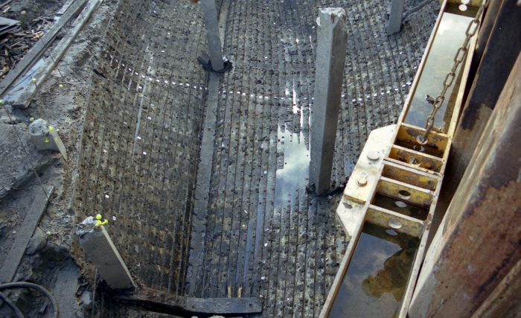
Friends of the Newport ship (2002)

Conclusion
Even though we have advanced in the field of archeologhy, with tecniques such as lidar, sonar, flying drones over to get a better understanding and perspective of what we cant see, using laser tecnology and 3d digital imaging, spending millions of pounds trying to preserve what we take out of the water and ground, you have to wounder is it really worth deconstructing such huge expensive tasks like the newport ship cutting it up into pieces possibly destroying any evidence, while using this avasive process for example chainsaws. Could it possibly be doing more damage than good as we are still at the earley stages of deconstruction conservation and preservation. Could there be other techniques that could be applied working with different organisations, who are funded on larger scales for their technologies. Working alonside the navy could be one great advantage, gaining more awareness on social media platforms raisisng money on these sites for the undertaking of such massive, time consuming, expensive tasks. It seems that using these free social media platforms doesent just make the people of that area aware but potentially the whole world, obvsiouly without given out exact locations due to treasure seekers, everyone could be aware of whats going to happen even before it does. It just seems like archeologists jump in head first without looking at all points of avenue, to be able to get funding for their projects, if they did, maybe more could be saved or just left alone and let the technology do at least 50 percent of the work leaving time and money for an excavation of an archeologgical site without having to employ so many people and outside contractors, make the people aware and use more tecnologies maybe an avenue to go down.

A drawing of the newport medevil ships timbers
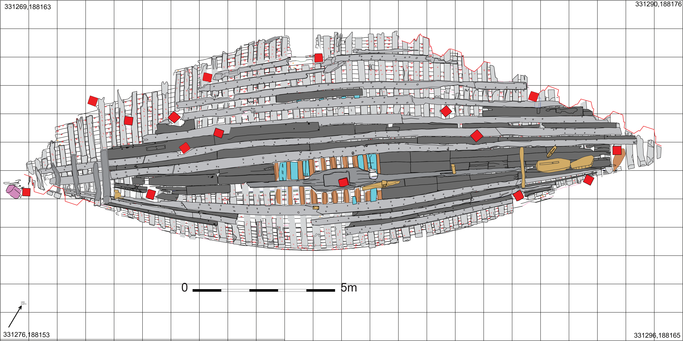
N, Nyling (2005) Jones, T. (2005)

Jones. T, (2005) Nyling. N, (2005)

Marsden, P. (1997) pp18-19 Ships and Shipwrecks

Cederlund, C. (1983) p65: The Old Wrecks of the Baltic Sea, Archaeological Recording of the Wrecks of Carvel-Built Ships, B.A.R International series 186: Oxford

Excavation of the Newport ship, friends of the Newport ship (2005) London: English Heritage
https://www.newportship.org/archaeology-conservation/excavation [Accessed 3rd march 2019]
Estel Farell-Roig (2016)
https://www.southwalesargus.co.uk/news/14670347.parts-from-newport-ship-will-go-to-york-for-treatment/ [Accessed 3rd march 2019]

Tankerton beach wreck 2017
https://www.wessexarch.co.uk/our-work/tankerton-beach-wreck [Accessed 3rd march 2019]

The future for Newport’s medieval ship martin wade 2017
https://www.southwalesargus.co.uk/news/15482549.the-future-for-newports-medieval-ship/ [Accessed 3rd march 2019]

Newport Museums and the Heritage Service, Explore Discovery Enjoy.
http://www.newport.gov.uk/heritage/Newport-Ship/Discovery.aspx [Accessed 3rd march 2019]

Friends of the Newport ship, https://www.newportship.org/archaeology-conservation/finding-the-ship [Accessed 3rd march 2019]

Friends of the Newport ship, https://www.newportship.org/archaeology-conservation/artifacts> [Accessed 3rd march 2019]

