Benjamin-David Crook
Internet Technology and Security
29th November 2020
Summary
Contents Page no.
- Introduction …………………………………………………………………………………………………………………….. 2
- Bring Your Own Device (BYOD) 2
  - Advantages of BYOD 2
  - Disadvantages of BYOD 2
  - Evaluation on BYOD 3
- Security Vulnerabilities 3
  - Spyware 3
  - Anti-Virus 3
  - Worms 3
  - Ransomware 3
  - Penetration testing 4
- Security Techniques 4
  - Mobile Device Management 4
  - Passwords 4
  - Firewalls 4
    - Filtering firewalls 4
      - Advantages 4
      - Disadvantages 4
  - Physical Security 5
- Security Policy 5
- Cisco Packet Tracer 5
  - BYOD system 5
  - Standard network system 6
  - Servers 7
  - Cloud Firewall 7
- Conclusion 7
- Bibliography 8

- Introduction
This report will be giving out appropriate and relevant suggestions on what security measures and techniques that can be used to ensure the safety of the network and important data. The author will be discussing how these different software and hardware would be able to benefit Coffe Capulus as an organisation. The author will also be discussing the benefits and drawbacks of employees using BYOD Bring Your Own Device as this is an agile technique being implemented into companies currently.
- Bring Your Own Device (BYOD)
BYOD is an agile way of working in a work environment which is a trend that is massively growing in different companies, this allows employees to use their personal devices to connect to their organizational networks and access work-related systems [1]. There are many advantages and disadvantages to using this method which the author will discuss below.
  - Advantages of BYOD
There are many advantages to using this agile way of working the author will be bullet pointing three different advantages and go on to discuss them in more detail below.
- Employee Satisfaction
This will allow the employee to use their own device and they feel more comfortable doing so which could lead them to becoming more productive and having a positive impact on their work.
- Businesses will save money
CoffeCapulus would have to provide their employees with workstations for them to be able to do any work at all this can then cost CoffeCapulus thousands which could be used in advertisement for example.
- More agile way of working
Being more agile is a modern approach to the way of working, business have implemented this into their teams and found it being very effective, if an employee wants to work in a more quite space they would be able to just pick up their laptop and more somewhere else but, if CoffeCapulus have already pre-built work stations then the employee wouldn’t have freedom to move.
  - Disadvantages of BYOD
As with everything advantage there are disadvantages. BYOD raises a number of data protection concerns and can lead to vulnerabilities in information security [2]. As mentioned by CoffeCapulus protecting its intellectual properties is extremely important to them.
- Intentionally or accidentally leaking private information
Security is the number one thing for CoffeCapulus as a business, if employees feel like one day they want to share or delete data they may be able to do this if the correct security isn’t in place.
- Outdated devices
CoffeCapulus may be using inhouse software that could be very demanding and some employees may not powerful enough devices to be able to manage these tasks, this will cause an negative impact on the employee causing them to not be able to complete the work which would effect the business as a whole.
- Device could have malware present
Some personal devices may contain malicious apps or malware that would be able to attack [3], this could have a negative impact on the security of CoffeCapulus because they would have a lot of personal information such as addresses, name and many more things an attacker would benefit from.
  - Evaluation on BYOD
BYOD is a great way to become more agile as a team or more flexible as an employee. As a team everyone could pick up their devices and go into a room and have a meeting, as an employee they can pick and choose where they work which would increase their productivity [4]. If CoffeCapulus where to implement this into their way of working they would have to implement security steps, a team that would be able to monitor what the employee is working on and if they need to download any software they would have to put a request in first in order to do so.
- Security Vulnerabilities
Security is something that should be taken seriously when handling sensitive data, due to the amount of different types of attacks there has been organizations have to completely rethink their whole security [5]. Understanding the different vulnerabilities, threats and attacks that can accrue. Below the author has listed a bunch of different malwares that could have an impact on CoffeCapulus security.

  - Spyware
Spyware is a malware software that enables an attacker to gain information about a person or organizations [6], if this is already present on a employees device an attacker would be able to see sensitive data if it is present on the employees device. This is a dangerous type of malware due to the fact the user doesn’t know this is present on their devices, research shows that 91% of surveyed people said they didn’t know this was present on their devices. [7].
  - Anti-Virus
Anti-virus software, this is a computer program used to help prevent and remove different types of malware [8] this is one of the most commonly used methods of improving security on devices. This should be implemented onto each of the employee’s devices if BYOD was pushed forward in CoffeCapulus business.
  - Worms
Worms are another type of threat that could cause issues to a business if effected by this type of malware. This spreads copies of itself from computer to computer, these can be transmitted via attachments that could be sent via emails etc [9].
  - Ransomware
Ransomware is a very well known type of malware this is where someone will take a businesses data and will hold this at ransom and threaten to either leak or delete the stolen data [10]. There is also a risk when paying the ransom because a business cannot trust if the criminal would give their data back so many articles would advise a business not to pay the ransom no matter how low the price tag may be [11].
  - Penetration testing
Penetration testing better known as pen testing or ethical hacking, this is when someone is authorized to try and penetrate a computer system or a network [12] and looking for the weaknesses in the network or system that an attacker would be able to gain sensitive data from. This will come with a full risk assessment, CoffeCapulus would be able to take this risk assessment and ensure
- Security Techniques
Security is one of the top priorities for CoffeCapulus and should be for every business that would be handling such sensitive data. Studies show that in 2017 the average data breach cost 7.35 million to businesses [13], all the time attackers are finding new ways of gaining information from businesses so keeping up to date is important.
  - Mobile Device Management Software
MDM also known as Mobile Device Management software is a type of security software that is used by a different range of IT departments, this allows the user to monitor, manage and secure employees mobile devices [14]. Mobile devices are used by mostly everyone, studies show that 96% percent of people use a mobile device this means that if an employee uses their own device they may use their mobile device to join meetings, by implementing this software CoffeeCapulus would be able to monitor their employees devices to ensure security.
  - Passwords
Having a strong password is important, this is the first line of defensive against any unauthorized access to your device or account [15] sensitive information could be stored on the employees account and if an attacker got into this account they could cause all kinds of damage. By CoffeeCapulus training their employees to ensure they have at least 8 characters long passwords as advised by uOttawa. [16].
  - Firewalls
A firewall is a network security system that monitors, and controls incoming and outgoing network traffic based on predetermined security rules [17]. Firewalls are important because it will protect the employee’s devices from being attacked over the internet by hackers [18].
    - Filtering firewalls
Packet filtering firewalls operate at the network layer of the OSI model [19]. All this does is open different ports that would be manually selected by the user with the control and it would allow all different types of traffic through the firewall. Below the author will discuss the advantages and disadvantages of using this method.
      - Advantages [20]
        - Fast and efficient for filtering headers
        - Low Cost
        - Doesn’t use up a lot of resources
      - Disadvantages [21]
        - Cannot filter what enters each port
        - No type of security
        - Vulnerable to IP spoofing

  - Physical Security
Physical protection for CoffeeCapulus is important an example being, if an employee many not be able to gain access to the sensitive data digitally they may destroy servers and different devices physically, there are different methods they would use such as starting a fire and if the data isn’t backup there is a risk of losing a load of sensitive data that would cost CoffeeCapulus a lot of money in the process.
There are many safety steps CoffeeCapulus can take such as having access control to different rooms to ensure only the correct people are allowed to enter [22], security guards to check peoples ID badges or do hall walks etc.
- Security Policy
A security policy is something that CoffeCapulus should have put in place, it is important for every business to have a security policy put in place to address the threats that BYOD would bring to the business [22]. This policy should be written by an experienced professional to display how the employees should use their devices to ensure that the security of the business is the number one priority.
- Cisco Packet Tracer
Cisco Packet Tracer is cross platform visual simulation tool that allows users to create network topologies and imitate modern networks [23]. Understanding what the main network infrastructure of a network is important, the author will display below the design of the network using Cisco packet tracer.
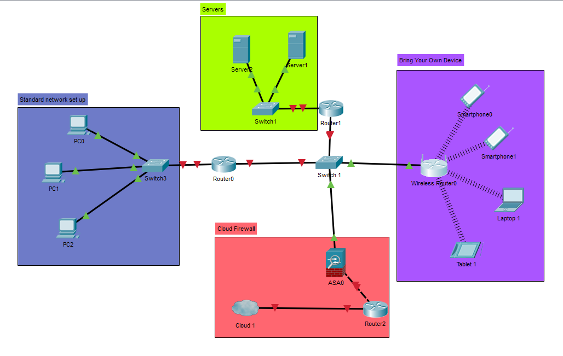
Figure 1 - Cisco Packet Tracer image displaying network
  - BYOD system
Above you can see the Network being displayed, boxes have been used around the different areas to get a better and more clear understanding of what is going on, here CoffeCapulus has examples of BYOD, different types of devices are connected via a wireless router.
Security being one of CoffeeCapulus main focuses, the network would have to have a password on the wireless router to ensure the correct users are gaining access. The author previously mentioned that strong passwords are important to prevent unauthorized access from accessing any sensitive data [24].

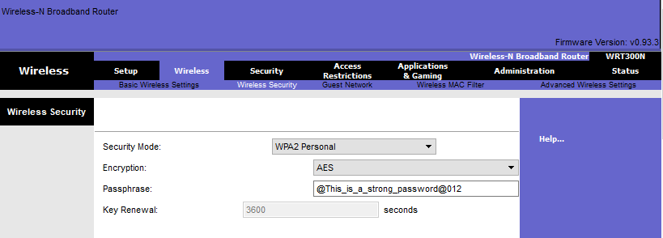
Figure 2 - Image displaying password being added to wireless router

  - Standard network system
A basic setup is used for this section of the network infrastructure, a switch is connected to the router via a copper straight-through wire, this is a twisted pair of copper wires that allow the device to connect via a LAN [25].
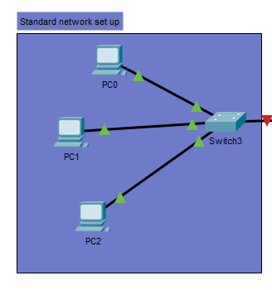
Figure 3 - Image displaying standard network setup

  - Servers
Servers are one of the most important devices in a network to keep secure, this server is important for the network security it provides, this will prevent unauthorized users from accessing sensitive data they shouldn’t [26].
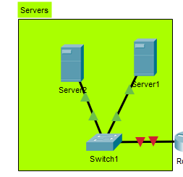
Figure 4 - Image displaying Servers setup

  - Cloud Firewall
Cloud Firewall identify and control applications, grant access through user-based policies [27], this would also help prevent any unknown threats to CoffeeCapulus this could range from the different type of threats the author discussed previously.
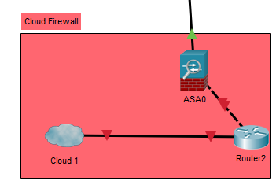
Figure 5 - Image displaying Cloud Firewall setup

- Conclusion
BYOD is a great idea if implemented correctly following the correct safety steps as the author has discussed above, moving to this more agile approach CoffeCapulus would be able to have a more productive work rate from their employees as it shows that 92% percent of people already own a smart phone which they could use to complete tasks and join meetings on [29]. Agile working and flexibility when working would result in a better work rate when employees feel more comfortable when working for long hours.

Bibliography

[1] | C. EDU, "Force Point," 29 November 2020. [Online]. Available: https://www.forcepoint.com/cyber-edu/bring-your-own-device-byod.
[2] | Nibusinessinfo, "Nibusinessinfo," 29 November 2020. [Online]. Available: https://www.nibusinessinfo.co.uk/content/bring-your-own-device-benefits-and-risks.
[3] | Nibusinessinfo, 29 November 2020. [Online]. Available: https://www.nibusinessinfo.co.uk/content/bring-your-own-device-benefits-and-risks.
[4] | W. Dessler, "Crossbrowsertesting," 29 November 2020. [Online]. Available: https://crossbrowsertesting.com/blog/development/agile-productivity-25-percent/#:~:text=Simply%20put%2C%20agile%20is%20incredibly,one%20task%20at%20a%20time.&text=Your%20short%2Dterm%20deadlines%20in,require%20prioritizing%20many%20different%20tasks..
[5] | C. Waters, 29 November 2020. [Online]. Available: https://www.networkworld.com/article/2300056/the-importance-of-wireless-security.html#:~:text=Wireless%20networks%20are%20forcing%20organizations,critical%20assets%20and%20confidential%20data.&text=Whether%20authorized%20or%20not%2C%20wireless,malicious%2.
[6] | Wikipedia, 29 November 2020. [Online]. Available: https://en.wikipedia.org/wiki/Spyware.
[7] | Wikipedia, 29 November 2020. [Online]. Available: https://en.wikipedia.org/wiki/Spyware.
[8] | Webroot, 29 November 2020. [Online]. Available: https://www.webroot.com/gb/en/resources/tips-articles/what-is-anti-virus-software.
[9] | Norton, 29 November 2020. [Online]. Available: https://us.norton.com/internetsecurity-malware-what-is-a-computer-worm.html.
[10] | Akamai, 29 November 2020. [Online]. Available: https://www.akamai.com/uk/en/products/security/enterprise-threat-protector.jsp?ef_id=CjwKCAiAiML-BRAAEiwAuWVggpsYbBZbC-7uuxbAgYWjZs8GblmOY0WnAm6ZA23MepqUcqthNwueTxoCC3YQAvD_BwE:G:s&utm_source=google&utm_medium=cpc&gclid=CjwKCAiAiML-BRAAEiwAuWVggpsYbBZbC-7.
[11] | Cyberrisk, 29 November 2020. [Online]. Available: https://www.cyberriskopportunities.com/ransomware-should-you-pay-the-ransom/#:~:text=While%20some%20people%20decide%20to,clients'%20and%20employee's%20personal%20information..
[12] | Wikipedia, 29 November 2020. [Online]. Available: https://en.wikipedia.org/wiki/Penetration_test.
[13] | Sales-i, 29 November 2020. [Online].
[14] | Continuum, "ConnectWise," 29 November 2020. [Online]. Available: https://www.continuum.net/resources/mspedia/everything-to-know-about-mobile-device-management-mdm#:~:text=Mobile%20device%20management%20(MDM)%20is,being%20used%20in%20the%20organization..
[15] | uOttawa, 29 November 2020. [Online]. Available: https://it.uottawa.ca/security/identity-authentication-theft#:~:text=Passwords%20provide%20the%20first%20line,all%20accounts%20on%20your%20computer..
[16] | uOttawa, 29 November 2020. [Online]. Available: https://it.uottawa.ca/security/identity-authentication-theft#:~:text=Passwords%20provide%20the%20first%20line,all%20accounts%20on%20your%20computer..
[17] | Wikipedia, 29 November 2020. [Online]. Available: https://en.wikipedia.org/wiki/Firewall_(computing).
[18] | Geeksonsite, 29 November 2020. [Online]. Available: https://www.geeksonsite.com/internet-security/the-importance-of-having-firewalls/#:~:text=Firewall%20is%20a%20software%20or,hackers%2C%20viruses%2C%20and%20worms.&text=For%20example%2C%20with%20the%20firewall,how%20employees%20use%20the%20network..
[19] | Sciencedirect, 29 November 2020. [Online]. Available: https://www.sciencedirect.com/topics/computer-science/packet-filtering-firewall#:~:text=Packet%2Dfiltering%20firewalls%20operate%20at,addresses%2C%20ports%2C%20or%20protocols.&text=You%20have%20to%20manually%20open,will%20flow%20through%20the%20firewall..
[20] | phoenixNAP, 29 November 2020. [Online]. Available: https://phoenixnap.com/blog/types-of-firewalls.
[21] | phoenixNAP, 29 November 2020. [Online]. Available: https://phoenixnap.com/blog/types-of-firewalls.
[22] | Wikipedia, 29 November 2020. [Online]. Available: https://en.wikipedia.org/wiki/Physical_security#:~:text=Physical%20security%20involves%20the%20use,to%20protect%20persons%20and%20property..
[23] | G. Yeagley, 29 November 2020. [Online]. Available: https://www.compassitc.com/blog/it-security-policies-and-procedures-why-you-need-them.
[24] | Wikipedia, 29 November 2020. [Online]. Available: https://en.wikipedia.org/wiki/Packet_Tracer.
[25] | namecheap, 29 November 2020. [Online]. Available: https://www.namecheap.com/support/knowledgebase/article.aspx/9517/45/what-is-a-secure-password-and-why-is-it-important-to-have-one/#:~:text=Strong%20passwords%20are%20utterly%20important,your%20electronic%20accounts%20and%20devices.&text=So%2C%20the%20mor.
[26] | Linfo, 29 November 2020. [Online]. Available: http://www.linfo.org/straight-through_cable.html#:~:text=Straight%2Dthrough%20Cable%20Definition,i.e.%2C%20arrangement%20of%20conductors).&text=Straight%2Dthrough%20cable%20is%20also%20commonly%20referred%20to%20as%20patch%20cable..
[27] | Practicallynetworked, 29 November 2020. [Online]. Available: http://www.practicallynetworked.com/support/091406servers.htm#:~:text=File%20and%20Network%20security%20%E2%80%94%20The,they%20shouldn't%20be%20viewing..
[28] | Barracuda, 29 November 2020. [Online]. Available: https://www.barracuda.com/glossary/cloud-firewall#:~:text=Cloud%20Firewall%20Benefits&text=Availability%3A%20Cloud%20firewall%20providers%20account,event%20of%20a%20site%20failure..
[29] | ThebalanceCareers, 29 November 2020. [Online]. Available: https://www.thebalancecareers.com/bring-your-own-device-byod-job-policy-4139870.

