NAME: Muhammad Ansaar Khalid
STUDENT NUMBER:2130064
MODULE: LCMB7001
LECTURER: TusharaBalendran
COURSE: Master’s in business administration
SUBMISSION DATE:09/09/2022
TITLE: Marketing Assessment 1

Contents

Introduction 4
Background 4
Communication 6
Model of Communication 6
Market of Communication 6
Promotional strategies Offline 7
Promotional strategies Online 8
Brand and Brand Equity Brand 9
Keller’s Brand Equity 10
Advantages and Disadvantages Keller’s Brand Equity 10
Customer journey 11
Customer touch points 12
Customer touch points feature 13
Customer journey map 14
Conclusion 16
References 18

Introduction
In the summer of 1976, three college dropouts created Apple Inc., a major top-technology American multinational corporation. Apple Computer, Inc. was the previous name of the business. It develops and manufactures desktop computers, electrical goods, and technology, including its well-known core products, such as the Macintosh desktop computers, MP3 players known as the iPod, iPhone cell phone technology, and its recently announced tablet series, the iPads.
Aperture is designed for industry professionals who want to modify and enhance their images; Final Cut Studio is made for those working in the expert sound and movie business; Logic Studio is made for fans of audio production; Safari is made for internet browsing; and iOS is the software platform for such smartphones.

Background
Apple Inc. was founded on April 1, 1976, by Steve Jobs, Steve Wozniak, and Ronald Wayne. Cupertino, California, is home to the organization's corporate office. On January 3, 1977, it was established. After 30 years of operating under the name Apple Computer Inc., the firm decided to drop the "computer" on January 9, 2007 (US SEC), in order to better reflect its business model in the consumer industry as well as its main concentration on the portable tech business (Markoff, n. p.).
The firm operated roughly 46,600 full-time comparable members as of September 25, 2010, as well as an estimated 2,800 full-time comparable consultants and temporary workers, based on the United States Securities and Exchange Commission, and its total global revenues were $65.23 billion (US SEC).
Because of its expansive artistic design approach and distinctive promotional strategies, Apple has earned the right to make a difference in the telecommunications equipment and digital telecommunications industries over time (Apple Store, n. p.). Particularly in the United States, the business has developed a passionate and steadfast consumer base that supports it and its reputation (Markoff, n.p.).
One of Apple Inc.'s many accomplishments is being recognized by Fortune magazine as the highest valued publicly traded corporation and also being designated the most respected corporation from 2008 to 2011 (Fisher, pp. 65-67; Colvin, 76).
E-marketing refers to the utilization of the internet to promote products and services. The development of technology in the modern world is responsible for its spread. Marketers and advertising agencies slowly adjust their brand recognition and promotional methods to keep up with this upgrading as digitization takes people under its digital influence and with the rapidly evolving developments in data and technologies.
Apple Inc. strengthens its business even more by incorporating e-marketing into its corporate marketing strategies to increase brand awareness, introduce new goods, and entice additional people to join the Apple customer community.
Apple has implemented e-marketing techniques, including the utilization of digital marketing to promote innovative goods and processes, proclaim promotional offers, and the business has established a digital Apple store that allows consumers to buy services and items without the inconvenience of going to a physical store. Although the company recently used traditional marketing tactics to promote economic force of attraction, it has established itself as a market leader in the telecommunications equipment and smart applications sectors.
According to its promotional activities, Apple Inc. has attracted a lot of attention, including the 1984 Super Bowl commercial, the 1990s Think Different campaign, and the 2000s iPod people campaign (Apple's Brand Strategy, n. p.).
The firm's marketing strategy can be clearly observed in the previous eras in the purchase of print advertisements and television advertisements, but as the new century began, Apple Inc. progressively began employing the internet as a component of its promotional activities. Apple opted to include internet activity in the "Switch" approach from 2001 by sending consumers to a webpage where Mac misconceptions were corrected. Traditional television and newspaper commercials were also part of the strategy (Apple, Google top loyalty survey, n. p.).

Communication

The Latin word for "communication" is communicare, which means "to share or to form common" (Weekley, 1967).Communication is depicted as a strategy of understanding and exchangingsignificance (Pearson and Nelson, 2000).
The connection that consolidates portion association is at the center of our communication considered. This word is supportive since it underlines thedisplay of fittingly understanding and sharing another’s viewpoint, which we are going analyze totally all through this work.

Model of Communication

As of October 2011, Apple Inc. had approximately 357 retail locations in 10 different nations (Apple Retail Store-Store List, n.p.). Additionally, the business has established an online shop where clients can purchase goods and services whenever it is most convenient for them (Apple Retail Store-Store List, n. p.). According to Poornima Gupta and Rodrigo Campos' September 2011 article (Gupta, n. p.), Apple Inc. has surpassed all other market-capitalized businesses in the globe in terms of market valuation. As of August 9, 2011, it has a market rate of $341.5 billion (Gupta, n. p.).

Market of Communication
The Apple brand is utilized as part of Apple Inc.'s marketing plan to compete in the marketplaces. Apple's Macintosh line of products, along with the associated software and operating systems, competes in the modern computing market with well-known names like IBM, Dell, and Sony Vio. In the consumer electronics industry, Apple's iPod is a competitor, with the iTunes Music Store available to meet consumers' needs for digital downloads and fun.
With the release of the iPhone in 2007 and the iPad tablet computer later that year, Apple entered the mobile smartphone and tablet marketplace. The AppsStore for iPhones and iPads, which covers publishing-related fields such as publications, ebooks, videogames, and activities, is another way that Apple has continued to grow. The firm's applications operation and iAd network put it in direct competition with Google in the marketing sector (Apple's Brand Strategy, n.p.).
Producing cutting-edge goods and services to go along with its electronic center plan has always been a part of Apple Inc.'s marketing plan throughout the past few decades (Former Wachovia, n.p.). According to the described strategy, Apple's Macintosh items act as electronic centers for several other digital items, including the iPod, iPad, personal digital assistants, smart phones, digital recorders, and recording devices, to mention just some (Internet Marketing – How, When, Where, n.p.). Apple Inc.'s strategic plan is primarily concerned with the encounters that consumers have with its goods.
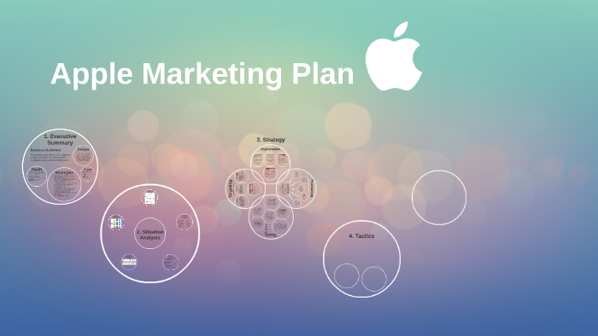

Promotional strategiesOffline
In order to effectively advertise its business, a company concentrates on the emotions and sentiments of its previous, current, and potential consumers. Its corporate identity revolves around the experience that it might offer to its potential customers. According to the World’s Most Valuable Brands, n.p., Apple's corporate reputation is centered around the idea of becoming enthusiastic, inventive, creative, and liberated, in addition to building positive optimism, goals, and ambitions.
Technologies are used by humans to gain power, which is the company's overarching idea. "The Apple corporate image also revolves around simplification and the elimination of complication from individuals' lives; the people-driven launch of new products; and being an exceptionally compassionate corporation with a genuine relationship with its

Promotional strategiesOnline
Apple's main marketing approach is to provide its consumers with privileges rather than to offer them items. Customers of Apple who are still devoted to the company have a feeling of belonging. The company's ownership and consumer loyalty, as shown by the corporation, are both extremely powerful.
In recent years, particularly during the 1990s financial downturn, the firm's solid core audience has been crucial to its growth. It has also enabled the business to retain its high prices in comparison to its rivals. Due to other IT rivals' cheap prices, Apple has managed to remain competitive thanks to its pricing approach.
Due to the small market size of the personal computer sector, suppliers frequently engage in price competition to remain productive and competitive. More significantly, PC suppliers with a lower brand image have found it difficult to compete with Dell's distribution network and production efficienciesIn recent times, polls evaluating customer satisfaction have ranked among the top five. This is partially due to Apple's reliance on customer reviews to develop and improve its devices. The company has used a variety of consumer feedback strategies for promoting market research throughout the years to pave the way toward being a worldwide tech leader. The message that "Apple appreciates your opinion on its devices" is frequently repeated to customers.
Apple has discovered that reviews are a very useful resource for comprehending its consumers. The business emails surveys to customers after they make a purchase. Customers are asked to rate their level of satisfaction and propensity to make more purchases. Because the reviews are provided as soon as a customer buys, Apple is able to get rapid, accurate responses from its clients while the transaction is still fresh in their memories.
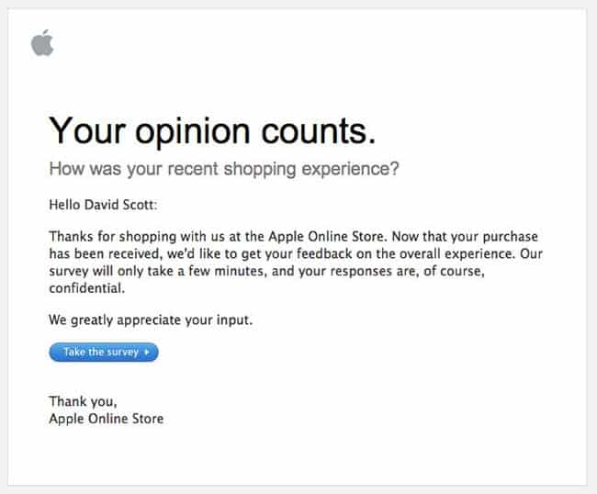

Brand and Brand Equity Brand
Its capability to provide amazing experiences to its clients using superior user interface design is the firm's primary strength and competitive edge over other businesses in the sector. Through its products like iTunes, the iPhone, and the Apple Applications marketplace, Apple has predicated its market strategies on the expertise it has claimed to exhibit.
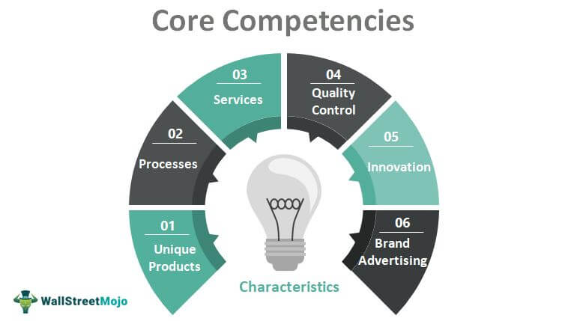

Keller’s Brand Equity

Potential clients need to be able to recognize the qualities of the Apple Company in order for Apple stores to be opened. Consumers are welcomed into a dynamic, relaxed atmosphere where they can learn about the newest developments from Apple, receive answers to their questions about the firm and its products, and get a hands-on taste of the products and offerings the company is able to provide. The major objective of the business is to offer potential customers a sneak peek of the elite society they would encounter when purchasing an apple item.

Advantages and Disadvantages Keller’s Brand Equity

Potential clients need to be able to recognize the qualities of the Apple Company in order for Apple stores to be opened. Consumers are welcomed into a dynamic, relaxed atmosphere where they can learn about the newest developments from Apple, receive answers to their questions about the firm and its products, and get a hands-on taste of the products and offerings the company is able to provide. The major objective of the business is to offer potential customers a sneak peek of the elite society they would encounter when purchasing an apple item.

Apple's production efficiencies, supply chain management, transportation, and procedures, while on the other hand, have been progressively enhanced and progressed so that they may rival those of Dell (Apple's Brand Strategy, n.p.). Even if Apple and Dell have succeeded in achieving comparable manufacturing costs, Apple's goods are more expensive due to the latter's operating system, which gives them an extra charge benefit. In Apple's situation, there is no obligation to compensate for licensing to a different firm.



Customer journey
According to its promotional activities, Apple Inc. has attracted a lot of attention, including the 1984 Super Bowl commercial, the 1990s Think Different campaign, and the 2000s iPod people campaign (Apple's Brand Strategy, n. p.).
The firm's marketing strategy can be clearly observed in the previous eras in the purchase of print advertisements and television advertisements, but as the new century began, Apple Inc. progressively began employing the internet as a component of its promotional activities. Apple opted to include internet activity in the "Switch" approach from 2001 by sending consumers to a webpage where Mac misconceptions were corrected. Traditional television and newspaper commercials were also part of the strategy (Apple, Google top loyalty survey, n. p.).

Customer touchpoints
From the I Phone to the iPod, from technology to consumer assistance programs, Apple's range of products includes a wide range of items all geared toward maximizing value for customers for the purpose of maximizing comparative benefit. This report concentrates on the research study of Apple Inc. and analyzes the significance of competitiveness, methods for gaining them, the general strategy employed by Apple, and the application, benefits, and drawbacks of these approaches.
The company's 2001 launch of the smartphone gave them an edge over their competitors. The 1984 release of the Apple Macintosh was the year that the first system with a GUI (Graphical User Interface) was introduced (Bellis, 2013). With the assistance of its inventor, Steve Jobs, the business understood that the way to succeed was to specialize in technology and offer inventions at all costs. Apple aspired to develop a user-friendly interface that would allow people to utilize technology as a profession from the very beginning, with the assistance of Wozniak (Lusted, 2012).
Apple has been growing its line of goods for some time, and now provides a larger, wider, and larger Manual of Apple Secrets with tips and techniques to make the most of your ipods, smartphones, and Apple Television (Seibold, 2008). From the beginning, Wozniak was responsible for enhancing the performance of the firm's products, while Apple took good care of the funds. Apple Inc.'s promotional tools are somewhat distinctive since, during the course of its decades-long lifespan, the company has successfully attracted devoted consumers who continue to utilize its products despite their high cost. The firm's marketing efforts have been particularly successful since they accurately represented the organization’s commitment to brand management. The Think Different project in the 1990s, the iPod People promotion in the 2000s, and the 1984 Super Bowl advertisement are just a few of Apple Inc.'s notable advertising efforts (World's Most Admired Companies, n. p.).
Apple used conventional advertising strategies in the 1980s and the beginning of the 1990s to help advertise its products. This included purchasing newspaper advertising time for print advertisements and airing television advertising. On January 22, 1984, throughout a Super Bowl advertisement interval, Apple Inc., then known as Apple Computer Inc., made the first public appearance of the Macintosh. With the introduction of newspaper and magazine ads and television advertising, this marked the start of a number of Apple's marketing initiatives.
The Switch marketing campaign, which was introduced by the firm on June 10th, 2002, showcased real people who had migrated from being used to Windows Microsoft to Mac. However, viewers and witnesses of the items were referred to a webpage in which the misinformation regarding the Mac platform was refuted. The project was pushed out via television advertisements and print ads.
While "Switch" was Apple's first significant attempt to utilize the internet in advertising their initiatives, the "Get a Mac" promotion eventually superseded it despite the failure of the "Switch" initiative. Following that, the initiatives involved the promotion of the apple company using both conventional techniques, including television advertising and print ads, and cutting-edge ones, like online marketing.

Customer touch points feature
Additionally, Apple needs to make use of industry data to develop new smartphones that have better resolution and have unique characteristics that the target audience finds to be very valuable. Utilizing industry data will enable manufacturers to incorporate unique elements into their goods that are difficult for rivals to duplicate or copy.
In order to set its goods apart from those of its rivals, the company would essentially use its technical skills and knowledge of the industry to develop extremely valuable items with unique qualities that are impossible to duplicate. They would have greater competitiveness with these qualities.
Typically, the majority of businesses in the sector creates and market comparable goods. Therefore, the differentiated product approach that emphasizes excellence and distinguishing characteristics will be crucial in drawing in the potential customers (Armstrong &Kotler, 2011).
The determination of the customer's needs and values depends on market knowledge. Data about the industry is utilized to develop items with a distinct significance, which boosts the brand's reputation (Armstrong &Kotler, 2011).

Customer journey map
Despite its humble beginnings, Apple is now regarded as one of the most profitable and significant corporations in the world and paying attention to its consumers' feedback was a major factor in how it came to be that way. And besides, neither the laptop nor even portable players for music were invented by Steve Jobs. However, Apple was capable of making these devices easier and more straightforward to use by paying attention to what people needed and anticipated from them.
One of the main factors in Apple's current success is the fact that it still tracks user feedback and makes adjustments in response to the findings. Apple's strategies for gathering consumer insights are thankfully accessible to businesses of any size, despite the fact that it is still one of the largest corporations on the globe.

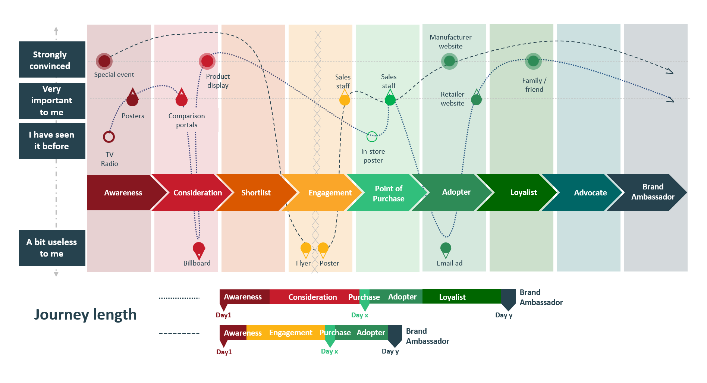
Apple is among the key leading companies nowadays because it is working to increase NPS, which is a measurement of ongoing customer experience. Apple has attained a top-tier Net Promoter Score (NPS) by utilizing four important strategies: beginning with the consumer experience, rather than the item; paying close attention to consumer attitudes; promptly ending the cycles; and engaging all Apple users in the NPS.
Consumers have a memorable time when they purchase, acquire, and use an Apple product, which delights them. When managing its whole chain of retail stores, the corporation pays special attention to the input it receives through NPS surveys. Achievement has led to greater revenue for Apple as well as a positive return on investment. The NPS project's success in drawing in all staff has also resulted in a high rate of consumer satisfaction and boosted communication and commitment.
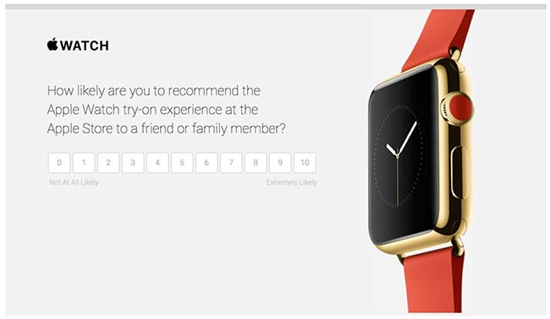

In order to understand and meet consumers' demands, businesses must establish strong connections with them (Nijssen& Ruud, 2000). An important competitive advantage for the business is its capacity to recognize client needs (Cole, 2013).
In essence, knowledge of clients' wants is derived from market data. Market data can be utilized to produce goods that consumers will consider important (Cole, 2013). In reality, businesses should use industry data to develop products that are able to compete effectively.

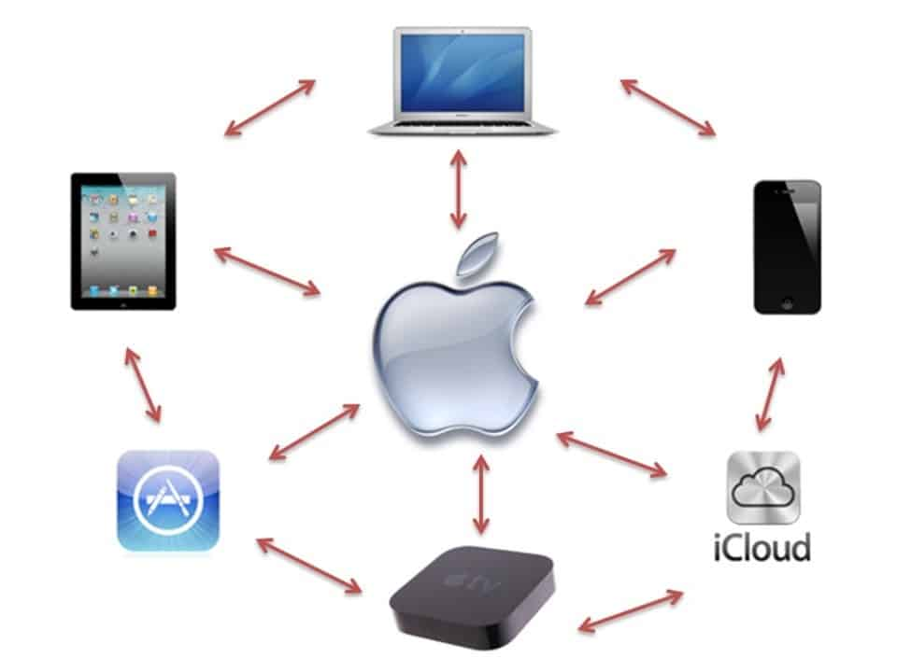

Conclusion
In order to achieve success and maintain their competitiveness in the industry, businesses employ a variety of marketing and advertising methods. Distinction continues to be a crucial tactic for achieving and maintaining a competitive edge in an industry with intense competition.
In all other terms, companies that compete in the smartphone business use a variety of techniques to differentiate their products in an attempt to expand and maintain their competitiveness. When it comes to attracting and keeping target customers, most businesses would like to enhance the value of their value propositions, but pricing distinction is also important.
Additionally, boosting brand awareness via advertisements and other marketing tactics is important for boosting the viability of businesses in the industry. As a result, the company's marketing tactics continue to play a crucial role in building and maintaining its competitiveness.
As a result, the interaction of consumers with Apple goods is the leading target used by the firm's managers to establish the business's identity. Apple Inc. concentrated its advertising methods on developing the business' reputation to be consumer-oriented.
Apple appears to be becoming an expert at quickly establishing brand commitment, and the initiatives are bearing fruit. The company has established itself as the industry leader in technological advances and customer satisfaction, and it holds a sizable customer base. Apple's primary tools, which help the company maintain a high customer base, are the Internet and maintaining quality. The company uses cutting-edge technologies that have been around for a while and doesn't let people looking for exploration down.
Effective integrated marketing communication is not defined by merely coordinating messaging (Missa, 2004). Understanding consumers and markets is a requirement for companies. Because of this knowledge, Apple has been able to remain competitive in the industry and hold onto a sizable customer base. Given that the youth of today have been introduced to technologies such as the World Wide Web and digital services offered by the Apple Company, it is a company that is anticipated to significantly boost popularity.

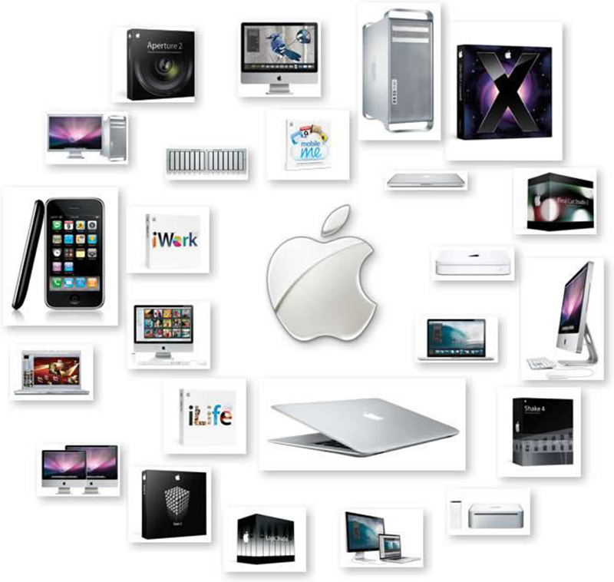

References

- Armstrong, G. &Kotler, P. (2011). Marketing: An introduction. Upper Saddle River, NJ: Prentice Hall.
- Communication is defined as the process of understanding and sharing meaning.Pearson, J., & Nelson, P.
- Cole, A. (2013). The implications of consumer behavior for marketing: A case study of social class. Munich: GRIN Verlag.
- Kerin, R. A., Hartley, S. W. &Rudelius, W. (2011). Marketing. New York, NY: McGraw-Hill Irwin.
- Kotler, P. & Keller, K. L. (2012). Marketing management. Upper Saddle River, NJ: Prentice Hall.
- Nijssen, E. & Ruud, F. (2000). Creating customer value through strategic marketing planning: a management approach. New York: Springer.
- Solomon, M. R. (2012). Consumer behavoir; Buying, having, and being. Upper Saddle River, NJ: Pearson Education.
- Colvin, Geoff. “The World’s Most Admired Companies 2009”. Fortune 159. 5 (2009): 76. Print.
- Fisher, Anne. “America’s Most Admired Companies”. Fortune 157.5 (2008): 65–67. Print. “Former Wachovia Direct Marketing Executives Launch Full Service Online Marketing and Web Design Company”. Prweb.com. PR Web., 21 March 2011. Web.
- Missa, F., (2004). Corporate communications. An International Journal, 9(4), p. 331-339.

