

Psychology in Health and Social Care

REPORT

NAME: MANPREET KAUR
STUDENT ID: 2130919
MODULE CODE: LCHS4006
LECTURER: BIANCA SANFILPPO

Table of Contents
1. Introduction 3
2. Reflect on the psychosexual theory (An in-depth discussion of the theory you focussed on in your group presentation) 3
3. A comprehensive discussion on a psychological phenomenon/framework taught under this module and its impact on your lives. 5
4. Reflection (Application of learnt perspectives in your current or future career settings) 6
5. Conclusion 7
6. References 8

1. Introduction
Health and social care must involve psychology. It explores how thoughts, attitudes, and behaviours affect physical health. Thus, professionals must understand patients' goals and behaviour to create successful medicines that improve their health. My reflective report is about my psychology-health and social care experience (Hilton and Johnston, 2023). The course taught me many psychological theories and concepts underpinning these fields.
I can also evaluate patients, advise, and implement behavioural modification programmes. This report discusses the course's main takeaways and how they have affected my health and social care practice. Discuss how I overcome course challenges to become a better practitioner. Finally, I will outline my health and social care psychology professional goals.

2. Reflect on the psychosexual theory (An in-depth discussion of the theory you focussed on in your group presentation)
The psychosexual theory proposed by Sigmund Freud is widely recognised as a highly influential and contentious theory within the field of psychology. According to Sallay et al. (2023), the aforementioned is a developmental theory that asserts the significance of human sexuality in the formation of personality and suggests that distinct stages of psychosexual development influence personality across the entire lifespan. During our group presentation, we directed our attention towards a particular theory and delved into its fundamental principles, developmental phases, and critiques. Freud posited that the human personality comprises three distinct components: the id, ego, and superego. On the other hand, Lantz and Ray (2021), said the id is a fundamental and innate aspect of an individual's personality that functions based on the pleasure principle and endeavours to promptly satisfy fundamental needs and wants. During the phallic stage of development, children tend to direct their attention towards the genitalia as the primary area of erogenous activity. Freud's discourse on the Oedipus complex and the Electra complex highlights notable instances of conduct during this developmental phase. The superego represents the ethical and moral component of an individual's personality, which is influenced by cultural and societal norms and values. As per the perception of Orenstein and Lewis (2022), the ego functions as an intermediary between the id and superego, endeavouring to achieve equilibrium amidst the divergent demands of these two components of the psyche. The psychosexual development process comprises five distinct stages, each marked by a unique emphasis on pleasure and conflict. During the oral stage, which spans from birth to 18 months, the infant's primary source of pleasure and conflict is centred on the mouth, specifically through the acts of sucking and biting. During the anal stage, which spans from 18 months to 3 years, the child's primary source of pleasure and conflict is centred around the control and elimination of faeces, with a particular focus on the anus. During the phallic stage, which occurs between the ages of three and six, the child's attention is centred on the genital region. The child's primary source of pleasure and conflict during this stage is the exploration of their own sexuality and their attraction to the parent of the opposite sex. During the latency stage, which typically spans from 6 to 12 years of age, there is a notable decrease in sexual impulses and a shift in focus towards other developmental domains. This stage is characterised by a relative sense of tranquilly. The genital stage, which encompasses puberty and beyond, signifies the resurgence of sexual impulses. During this stage, the individual's attention is directed towards sexual relationships and reproduction. In contrast, Orosa (2020), addressed that prominent critique of the psychosexual theory pertains to its prioritisation of sexuality as the primary impetus for the formation of an individual's personality. The argument put forth by critics is that the limited emphasis on personality disregards the influence of social and cultural elements, and fails to acknowledge the significance of other developmental areas such as cognitive, emotional, and social growth. Furthermore, certain concepts introduced by Freud, such as the Oedipus complex and castration anxiety, have been subject to significant criticism due to their perceived sexist and heteronormative implications. Notwithstanding these critiques, the psychosexual theory retains a significant impact and is extensively examined in psychology. The notion that early childhood experiences play a significant role in shaping later personality traits and behaviours has garnered empirical support, and subsequent theorists have subsequently adapted and modified its underlying concepts. In general, the psychosexual theory constitutes a significant contribution to the discipline of psychology, and further examination and evaluation of this theory will enhance our comprehension of human growth and conduct.
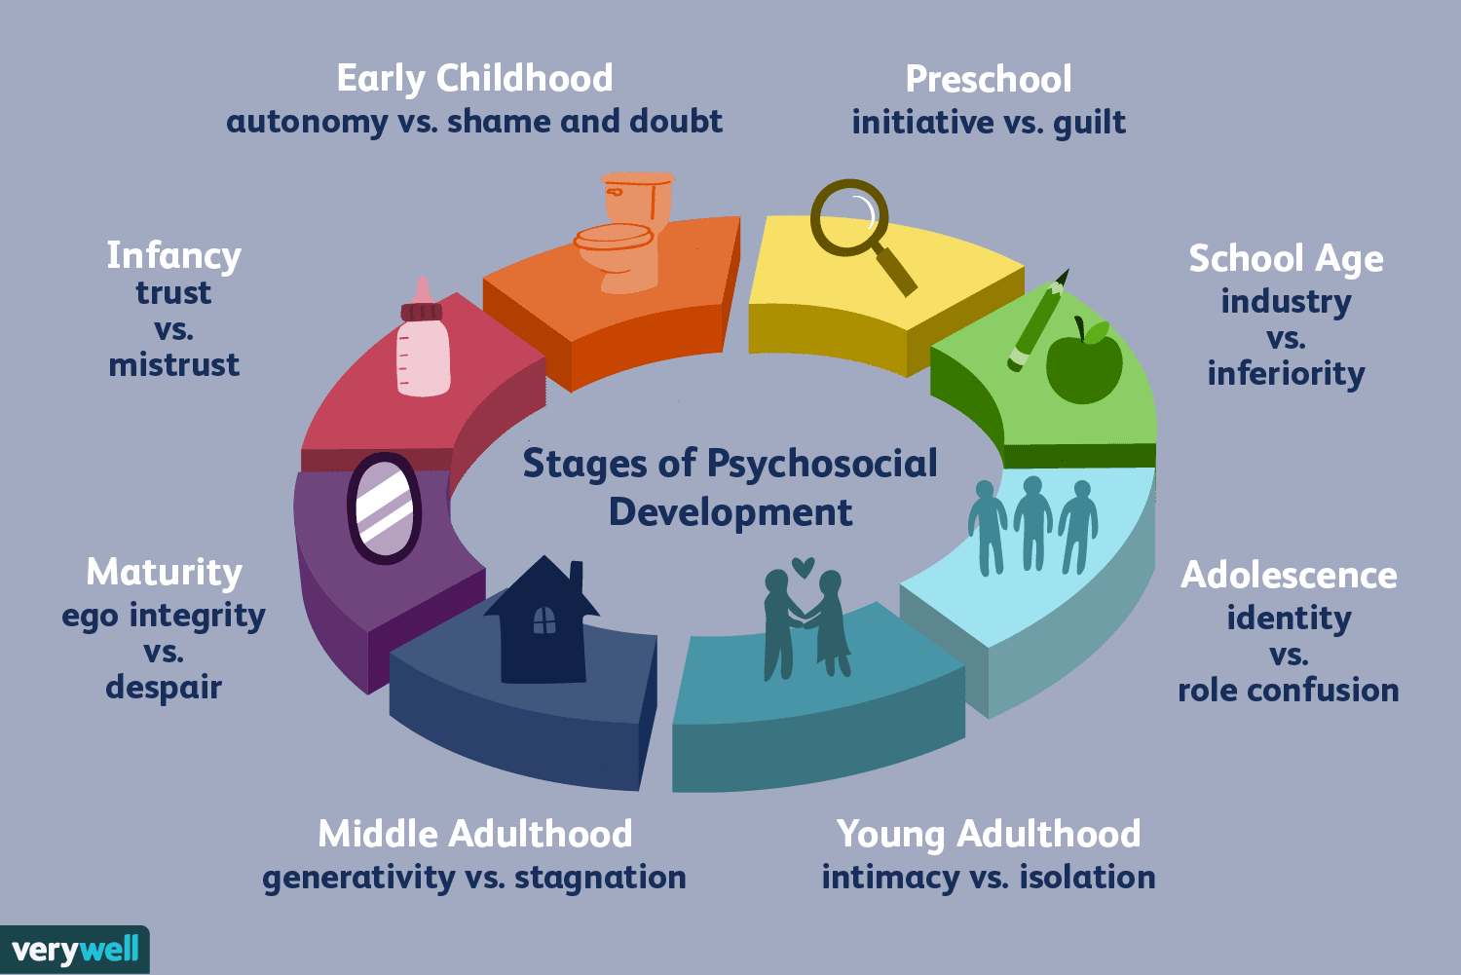
Figure 1: Stages of Psychosocial Development
(Source: Malik and Marwaha, 2019)

3. A comprehensive discussion on a psychological phenomenon/framework taught under this module and its impact on your lives.
The psychosexual theory, presented in this module, is an intriguing psychological framework that has influenced my comprehension of human behaviour and growth. The experience has facilitated a heightened understanding of the impact of early childhood experiences on an individual's personality and how unaddressed conflicts during various developmental stages can result in psychological issues in the future. Dewitte et al. (2021), claimed that the psychosexual theory posits that human personality is influenced by five distinct stages of psychosexual development, wherein each stage is marked by a unique emphasis on pleasure and conflict, as I have come to understand through my coursework. The phallic stage, which involves the emergence of children's sexual awareness and their inclination towards the parent of the opposite sex, piqued my curiosity. As per Freud's theory, this particular phase is deemed a crucial juncture in the formation of an individual's personality, and can potentially exert a long-lasting influence on their self-perception and social interactions. My own experiences fit the psychosexual idea. My early sexuality and inner agony about my attraction to a cousin or friend's parent came into memory. Despite my first confusion, these feelings may have affected my behaviour and relationships. Understanding how early childhood experiences shape personality and behaviour can help me understand and empathise with my patients, especially those with psychological issues resulting from unresolved conflicts. However, the psychosexual hypothesis has flaws, including its emphasis on sexuality as the main cause of personality development. Xia and Wang (2022), argued early childhood experiences shape personality, but cultural and environmental elements are equally important, according to the author. The psychosexual theory has greatly influenced my understanding of human conduct and growth, both personally and professionally, leading to the above conclusion. The framework's limitations are acknowledged, but the author values its contribution to understanding how early childhood experiences can shape a person's character and how unresolved issues during different developmental stages can lead to psychological issues later on.
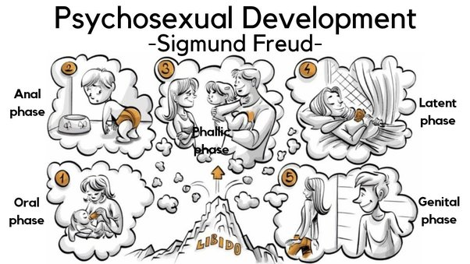
Figure 2: Psychosexual Development
(Source: Xia and Wang, 2022)

4. Reflection (Application of learnt perspectives in your current or future career settings)
The psychosexual theory may help social healthcare workers understand and help patients. This shows how understanding psychosexual development may help healthcare practitioners identify a patient's psychological distress and give appropriate treatment. The phallic stage of psychosexual development may affect future mental health. Federici et al. (2019), addressed that children grow aware of their sexuality and may feel attracted to their opposite-gender parents throughout this time. This understanding may help doctors identify individuals with unresolved conflicts from this developmental period and give appropriate treatment. Psychosexual theory may also treat sexual dysfunction and other sexual health issues. Healthcare professionals can improve patients' sexual health and well-being by understanding how early childhood experiences shape sexual orientation and sexual activity. Social healthcare workers may benefit from psychosexual theory. Theoretical ideas may help healthcare workers understand and help individuals with psychological issues from unresolved conflicts in early development. They also improve sexual health treatments.

5. Conclusion
Based on the above analysis it can be said that the psychosexual theory provides a valuable framework for comprehending how young child experiences can influence an individual's psychological development and attitudes towards sex and relationships. The theory holds significant implications across diverse domains, such as social media advancement and social healthcare, by facilitating the development of personalised and efficacious measures for individuals. Professionals in various professions may more fully comprehend and assist people in navigating the challenging psychological and social challenges that develop throughout life by putting the psychosexual theory's guiding principles to use. The psychosexual theory provides significant insights into the human experience and can assist professionals in fostering healthy development and well-being within their respective domains.

6. References
Dewitte, M., Bettocchi, C., Carvalho, J., Corona, G., Flink, I., Limoncin, E., Pascoal, P., Reisman, Y. and Van Lankveld, J. (2021). A Psychosocial Approach to Erectile Dysfunction: Position Statements from the European Society of Sexual Medicine (ESSM). Sexual Medicine, [online] 9(6), p.100434. doi:https://doi.org/10.1016/j.esxm.2021.100434.
Federici, S., Artegiani, F., Pigliautile, M., Antonelli, P., Diotallevi, D., Ritacco, I. and Maschke, R. (2019). Enhancing Psychological Sexual Health of People With Spinal Cord Injury and Their Partners in an Italian Unipolar Spinal Unit: A Pilot Data Study. Frontiers in Psychology, [online] 10. doi:https://doi.org/10.3389/fpsyg.2019.00754.
Hilton, C.E. and Johnston, L.H. (2023). Health psychology: It’s not what you do, it’s the way that you do it. Health Psychology Open, [online] 4(2), p.205510291771491. doi:https://doi.org/10.1177/2055102917714910.
Lantz, S.E. and Ray, S. (2021). Freud Developmental Theory. [online] PubMed. Available at: https://www.ncbi.nlm.nih.gov/books/NBK557526/ [Accessed 21 Apr. 2023].
Orenstein, G.A. and Lewis, L. (2022). Erikson’s stages of psychosocial development. [online] PubMed. Available at: https://www.ncbi.nlm.nih.gov/books/NBK556096/ [Accessed 21 Apr. 2023].
Orosa, F.J.E. - (2020). Understanding Psychosocial Wellbeing in the Context of Complex and Multidimensional Problems. International Journal of Environmental Research and Public Health, [online] 17(16), p.5937. doi:https://doi.org/10.3390/ijerph17165937.
Sallay, V., Martos, T., Lucza, L., Orsolya Papp-Zipernovszky and Márta Csabai (2023). Health Psychology Services for People in Disadvantaged Regions of Hungary: Experiences from the Primary Health Care Development Model Program. International Journal of Environmental Research and Public Health, [online] 20(5), pp.3900–3900. doi:https://doi.org/10.3390/ijerph20053900.
Xia, X. and Wang, X. (2022). Leisure Satisfaction, Personality, and Psychosexual Adjustment Among College Students: A Latent Profile Analysis. Frontiers in Psychology, [online] 13. doi:https://doi.org/10.3389/fpsyg.2022.895411.

