LCLM4006 Enterprise and Entrepreneurship

Mohammed Faisal
2437880
Ejike Udeogu

EXECUTIVE SUMMARY
SaveBite is a mobile application designed to reduce food waste by connecting consumers with restaurants, bakeries, cafés and supermarkets that have surplus food available at discounted prices. The business addresses two significant issues currently affecting the United Kingdom: food waste and rising living costs. Through the platform, businesses can recover value from unsold food while consumers gain access to affordable meals.
The unique selling proposition (USP) of SaveBite is its community donation feature, which allows participating businesses to donate unsold food to local charities and community organisations. This creates environmental, social and economic value while strengthening community support. Unlike competitors who don’t offer that service SaveBite will take advantage of this.
The business will operate as a Private Limited Company (Ltd) and will generate revenue through a 15% commission fee on transactions completed through the platform. SaveBite requires £20,000 in startup funding, sourced through founder investment and business angel investment. With increasing consumer awareness of sustainability and the growing demand for affordable food options, SaveBite offers a viable and socially responsible business opportunity with strong growth potential.

Contents
OVERVIEW OF THE BUSINESS IDEA 4
LEGAL FORMAT AND MANAGEMENT STRUCTURE 5
PESTAL ANALYSIS AND COMPETITION 6
MARKETING PLAN 8
FUNDING & EXPENSES 9
CONCLUSION 10

OVERVIEW OF THE BUSINESS IDEA
Entrepreneurship involves identifying opportunities and creating value through innovation (Hisrich, Peters and Shepherd, 2023). SaveBite is a mobile application developed to reduce food waste by connecting food businesses with consumers seeking affordable meals. Restaurants, cafés, bakeries and supermarkets frequently dispose of unsold food despite it remaining safe for consumption. SaveBite enables these businesses to sell unsold food at discounted prices through a simple digital platform.
Food waste remains a major challenge in the United Kingdom. According to WRAP (2024), approximately 10.7 million tonnes of food are wasted annually, creating significant environmental and economic costs. This highlights the need for innovative solutions such as SaveBite that can help reduce unnecessary waste while creating value for consumers and businesses.
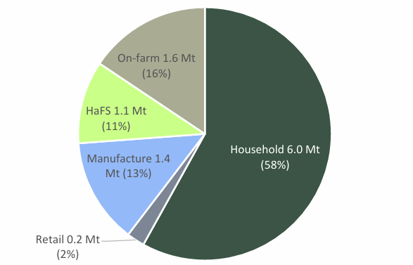

Figure 1: Food Waste in the United Kingdom (WRAP, 2024)
Food waste contributes to greenhouse gas emissions and represents a loss of valuable resources. Simultaneously, many households face financial pressures caused by rising living costs. SaveBite provides a solution to both problems by reducing waste while increasing access to affordable food.
Richter and Bokelmann (2018) argue that reducing food waste can generate both environmental and economic benefits. Consequently, businesses that implement food waste reduction strategies may improve sustainability performance while reducing financial losses associated with unsold products.
The business will offer a consumer mobile application, a retailer management dashboard, secure payment processing and a collection scheduling system. Revenue will be generated through a 15% commission fee on each transaction completed through the platform.
The Unique Selling Proposition (USP) of SaveBite is its combination of food waste reduction and community support. While competitors focus primarily on discounted food sales, SaveBite will enable participating businesses to donate unsold food to local charities through the application. This creates additional social value and strengthens relationships between businesses and local communities.

LEGAL FORMAT AND MANAGEMENT STRUCTURE
SaveBite will operate as a Private Limited Company (Ltd). Burns (2022) defines a limited company as a separate legal entity that provides limited liability protection for its shareholders. This legal structure has been selected because it protects the personal assets of owners while improving business credibility and access to investment opportunities.
A Private Limited Company is particularly suitable because the business intends to seek external investment and expand across multiple UK cities. Investors generally prefer companies with clear legal structures and limited liability arrangements.
The management structure during the startup stage will remain relatively simple.
Table 1: Management Structure

The Managing Director will oversee strategy and investor relations. The Marketing Manager will manage customer acquisition and promotional activities. The Operations Manager will maintain relationships with participating businesses and coordinate daily operations. The Freelance Developer will support platform maintenance and technological development.
This lean organisational structure allows the business to control costs during its initial growth stage

PESTAL ANALYSIS AND COMPETITION
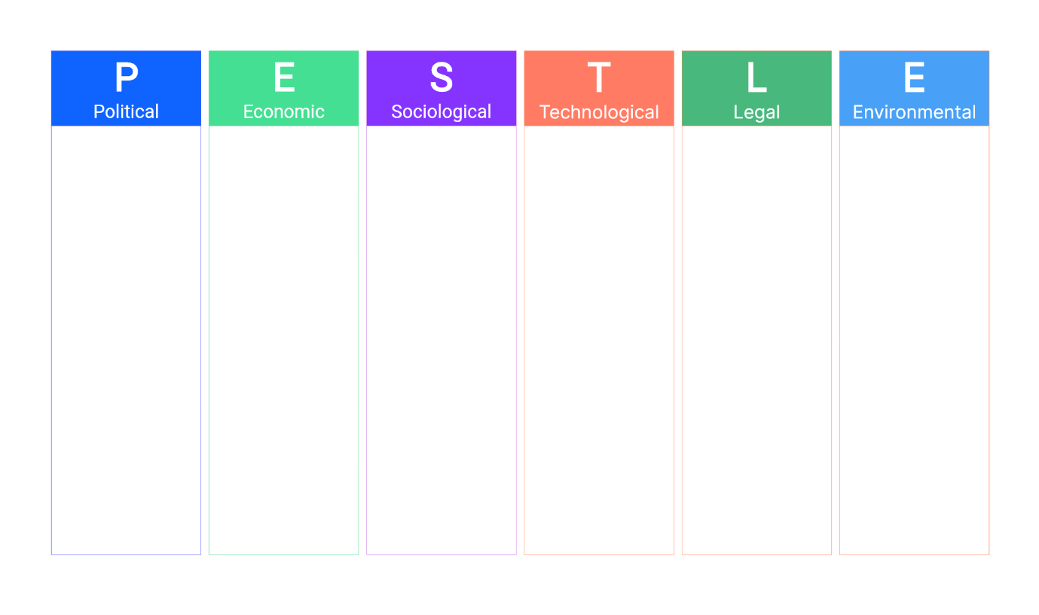
The UK Government Food Security Report (2024) highlights increasing concerns regarding food affordability and access. As household budgets continue to face pressure, consumers are becoming more interested in cost-effective food purchasing options, creating market opportunities for businesses such as SaveBite.
Environmental sustainability represents the core foundation of SaveBite. Reducing food waste helps lower greenhouse gas emissions and supports national sustainability goals. According to Richter and Bokelmann (2018), reducing food waste can create both environmental and economic benefits.
The current cost-of-living crisis has increased consumer demand for affordable products and services. SaveBite benefits from this trend because it provides discounted food options while helping businesses recover revenue from unsold inventory.
Consumers are increasingly aware of environmental sustainability issues. Research indicates that many customers actively support businesses demonstrating social responsibility (Kotler and Armstrong, 2023). This trend strengthens demand for services that reduce food waste.
The company must comply with the Food Safety Act 1990, Consumer Rights Act 2015 and UK GDPR regulations. Compliance is essential to maintain customer trust and minimise operational risks.
The widespread adoption of smartphones and mobile payment systems supports the viability of digital business models such as SaveBite. Technology allows customers to locate nearby food offers and complete transactions quickly and efficiently.
Government initiatives supporting sustainability and waste reduction create favourable conditions for SaveBite. The UK Government continues to encourage environmentally responsible business practices through sustainability policies and waste reduction strategies.

Table 2:

Competition Analysis
Too Good To Go has established itself as one of the leading food waste reduction platforms in Europe by enabling consumers to purchase surplus food from participating businesses at reduced prices (Too Good To Go, 2026). This demonstrates the growing demand for food redistribution services.

The main competitors are Too Good To Go and Olio.
Feature | SaveBite | To Good To Go | Olio
Discounted Food | YES | YES | LIMITED
Community Donation Feature | YES | NO | YES
Loyalty Rewards | YES | LIMITED | NO
Independent Business Focus | Strong | MEDIUM | MEDIUM

Olio focuses on reducing waste by encouraging the sharing of surplus food between individuals and local communities (Olio, 2026). This reflects increasing consumer interest in sustainability and community-based solutions to food waste.
Although Too Good To Go and Olio already operate within the food waste reduction market, SaveBite differentiates itself through its integrated community donation feature and customer loyalty programme. These features provide both social and commercial benefits by encouraging customer retention while supporting local communities. Consequently, SaveBite is positioned as both a sustainability-focused and socially responsible enterprise.

SaveBite will charge participating businesses a 15% commission on each completed transaction. This pricing strategy is intended to remain competitive while generating sufficient revenue to maintain and develop the platform. By comparison, Too Good To Go is reported to charge businesses a transaction fee or commission that is often estimated at around 20–30%, depending on the market and commercial agreement, in addition to annual or administrative fees. Olio does not publicly disclose a standard commission percentage and instead operates through commercial partnerships and food collection services. Therefore, SaveBite's lower commission rate may encourage small independent cafés, restaurants and bakeries to join the platform by allowing them to retain a greater proportion of their sales revenue.

MARKETING PLAN
The primary target market consists of students, young professionals, environmentally conscious consumers and cost-conscious households.
Digital marketing is particularly suitable for SaveBite because its primary target market consists of students and young professionals who regularly use social media platforms and mobile applications. Compared with traditional advertising methods, social media marketing provides a cost-effective approach for startup businesses with limited financial resources while allowing direct engagement with customers (Kotler and Armstrong, 2023).
Social media marketing will form the foundation of SaveBite's promotional strategy. Platforms such as Instagram, TikTok and Facebook will be used to share customer testimonials, sustainability statistics and promotional campaigns. This approach is cost-effective and particularly suitable because younger consumers spend significant time on these platforms (Kotler and Armstrong, 2023).
The company will also develop a professional website that provides information about the business, sustainability achievements and partnership opportunities. The mobile application will remain the primary customer interaction platform.
Influencer marketing will support brand awareness. Partnerships with sustainability influencers and local food bloggers can increase credibility and encourage adoption among target consumers.
Partnership marketing will involve collaborations with local cafés, restaurants, bakeries, universities and community organisations. These partnerships will increase both customer reach and the number of participating businesses.
To encourage customer acquisition and retention, SaveBite will introduce:
• First-order discounts
• Referral rewards
• Loyalty points
• Seasonal promotions

FUNDING & EXPENSES
Table 3: Source of fundings
Savebite requires £20,000 for startup funding:
Source | Amount
Founder Investment | £10,000
Business Angle Investment | £10,000
Total | £20,000

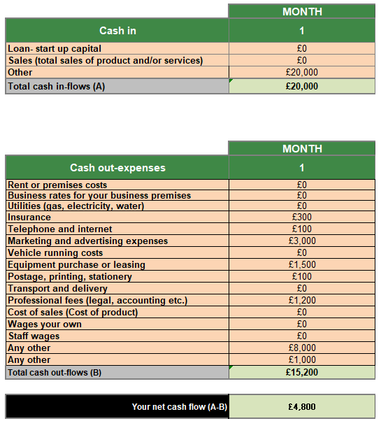

Business angel funding has been selected because investors can provide financial support as well as entrepreneurial knowledge and business networks (Hisrich, Peters and Shepherd, 2023).
Table 4: First month startup expenses
I have analysed the firsts month startup expenses:

The largest expenditure is application development because the platform is the core business asset. Marketing expenditure is also important during the launch phase to build awareness and attract both consumers and business partners.
The digital nature of SaveBite allows the business to scale efficiently without requiring substantial physical infrastructure. As the customer base grows, additional businesses can be added to the platform with relatively low operational costs, making the business attractive to investors seeking long-term growth opportunities.
The cash flow forecast demonstrates that SaveBite has sufficient startup funding to cover its initial operational expenses. During the first month, total cash inflows of £20,000 are expected from founder and business angel investment. Total cash outflows are estimated at £15,200, resulting in a positive net cash flow of £4,800. This surplus provides working capital to support future business growth and unexpected operational costs during the startup phase.

CONCLUSION
SaveBite represents an innovative entrepreneurial opportunity that combines environmental sustainability with community support. The business addresses the growing problem of food waste while helping consumers access affordable meals. Its unique community donation feature differentiates it from competitors and creates additional social value.
The combination of increasing sustainability awareness, strong smartphone adoption and demand for affordable food provides favourable market conditions. Furthermore, the scalable digital business model offers significant growth potential for investors. Therefore, SaveBite represents a viable and socially responsible business opportunity capable of delivering both financial returns and positive social impact.

REFERENCE LIST
Burns, P. (2022) Entrepreneurship and Small Business: Start-up, Growth and Maturity. 7th edn. London: Bloomsbury.
Department for Business and Trade (2024) Business Population Estimates for the UK and Regions 2024. Available at: https://www.gov.uk/government/statistics/business-population-estimates-2024
Hisrich, R.D., Peters, M.P. and Shepherd, D.A. (2023) Entrepreneurship. 12th edn. New York: McGraw-Hill Education.
Kotler, P. and Armstrong, G. (2023) Principles of Marketing. 19th edn. Harlow: Pearson Education.
Olio (2026) Our Mission. Available at: https://olioapp.com
Richter, B. and Bokelmann, W. (2018) ‘The significance of avoiding household food waste’, Sustainability, 10(3), pp. 1–18.
Too Good To Go (2026) About Us. Available at: https://www.toogoodtogo.com
UK Government (2024) United Kingdom Food Security Report 2024. Available at: https://www.gov.uk/government/statistics/united-kingdom-food-security-report-2024
WRAP (2024) Food Waste in the UK. Available at: https://www.wrap.org.uk

