Should the Death penalty be brought back to the United Kingdom
(Roger cook)

Contents page

Executive summary – 1
Introduction – 2
Main findings – 3
Conclusion – 4
Reference list – 5

Executive summary

They key information found in the report after research is that
the higher percentage do not want the death penalty returning to UK law, the public and public services want to keep the legislation that is already in place that allows defendants to have a fair trial and if found guilt to be punished by being imprisoned. A small percentage of the public and people wo work in the public services want the death penalty back for defendants who commit such crimes like, murder, rape and the killing of children. Over the last decade YouGov polls have show the decrease of people who are in favour of the death penalty. When researching the for and against it shows that when there has been a terrorist attack or a serial killer uncovered the votes for the death penalty have gone up, other than that the favour vote mostly goes to not bringing it back.

Introduction
The death penalty in Britain was abolished in 1965, and in 1973 Northern Ireland made the same decision to abolish the death penalty. The punishment for murder changed from death to life in prison. Since then there has been calls on the government to vote on the return of the death penalty for people who commit such crimes like; paedophilia, murder of children and killing of police officers. In such cases where members of parliament have had the opportunity to vote there has been a big divide in the voting in the house, even though public polls have shown that the public want the death penalty to come back into action for certain crimes it has never been passed/agreed. I am going to be looking at arguments for and against then I will be researching in depth then conclude what I have found out.

Main findings
B.ketish(2018), claims in the article that, ‘the former conservative MP, John Hayes has suggested for the government to bring back the death penalty for people who commit serious violent crimes’, the suggestion comes after the terrorist attack that happened on Westminster bridge, where Khalid Masood, the terrorist attacker, used a vehicle to mow down pedestrians on the bridge causing mayhem and death to a number of people, the suggestion for the death penalty to be reinstated in to British law has rocketed after such events, a number of politicians and members of the public are in favour of it returning, but there is also calls for it not to brought back into law, responding to John Hayes suggestion, justice minister Edward Argar, claims that, ‘he has no plans to reintroduce the death penalty’ reinforcing that government is trying to abolish the death penalty globally and that there is no substantial evidence having such penalty’s for crimes would deter people from participating in such events.

The human rights act 1998 of which become statutory legislation in the UK in order
to give every person in the UK the right to life even if they have committed malice crimes,
human rights act 1998 ‘Everyone’s right to life shall be protected by law. No one shall be deprived of his life intentionally save in the execution of a sentence of a court following his conviction of a crime for which this penalty is provided by law.’ Since the death penalty was abolished in 1965 and the human rights act came into place in 1998 there is no way that somebody found guilty of a crime in the UK can be punished with death, instead defendants get a fair trial, have the right to a public defender; if found guilty of murder or any high scale crime they will be sentenced accordingly and be imprisoned as their punishment. Although everyone has the right to life, it is not absolute. The right to life can be breached if the public authorities feel that it is necessary, the authorities have the power to use reasonable fore to, ‘lawfully arrest someone or to prevent them from escaping detention and also to stop a riot or insurrection’(citizens advice) this means the authorities have the necessary power to use the force needed and if the consequences of that is the defendant dies then the authorities cannot be held accountable for it if they have done it in good reason.

February 2014, there was a court hearing on the case of where a solider name Lee Rigby was murdered on his return back to his barracks in London, he was savagely attacked by far right supports ‘who hit him with a vehicle, got out and then, ‘butchered him to death while shouting allahu akbar’ (BBC news 2014) during the court hearing supporters of the British national party, ‘held banners calling for the death penalty to be returned’ (BBC news 2014) the result of the protesting for the capital punishment to be returned, resulting in two people from the association getting arrested, it was not just the BNP who felt this way many others did around the whole of the United Kingdom.

In the table below sourced from YouGov it shows that the public are in favour of the death penalty. Hiving harsher punishments for people who break the law is a favourable argument seen by the MPs across the country, when the poll was conducted as you can see there is a higher percentage that are in favour with capital punishment for serious crimes, such as: terrorist attacks, murder of a public service worker and the murder of adolescents. Evaluating the table below it is noticeable that most questions put to the PUBLIC are answered in favour of the death penalty but the last one, it doesn’t state what murder has been committed the public have gone to oppose the death punishment in that case, this shows that the public who undertook this poll read and understood and only voted to support the death penalty if they could see clearly that it was a cowardly crime

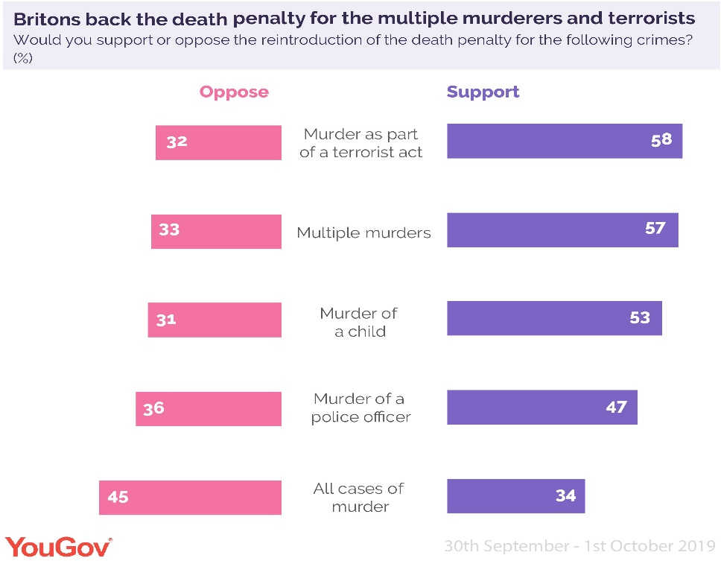

Conclusion

There have been many discussions publicly about returning the death penalty to the UK law but only when there has been some sort of disaster, weather it was a terrorist attack; hate or sexually motivated attack. The discussions have never really gone further that the newspapers, or I should say it hasn’t come to a point where the majority of the members of parliament are discussing it, its more used by a number of members of parliament to make their argument and statements stronger towards the public when there has been a disaster and they want themselves and their party to appeal to more people so they get more votes. Most members of parliament disagree with their colleagues who have them opinions, most rather a fair trial and imprisoned if found guilty. Because we are a nation the signed up to the human rights act, article two ‘right to life, stops the authorities from serving people the death penalty even if the law wasn’t unabolished.

References
B.Kentish (2018) ‘tory MP asks government to consider bringing back the death penalty’, independent, 3/11/18, available at: https://www.independent.co.uk/news/uk/politics/tory-mp-bring-back-death-penalty-john-hayes-lincolnshire-capital-punishment-a8615731.html(accessed: 17th October 2019).
B.Kentish (2018) ‘there is no evidence that capital punishment acts as a deterrent for violent crime. Furthermore, the introduction of the death penalty would bring with it the very real risk that some innocent people would die’, independent, 3/11/18, available at: https://www.independent.co.uk/news/uk/politics/tory-mp-bring-back-death-penalty-john-hayes-lincolnshire-capital-punishment-a8615731.html (accessed: 17th October 2019).
Citizens advice(2019) ‘lawfully arrest someone or to prevent them from escaping detention and also to stop a riot or insurrection’, available at: https://www.citizensadvice.org.uk/law-and-courts/civil-rights/human-rights/what-rights-are-protected-under-the-human-rights-act/your-right-to-life (Accessed: 17th October 2019).
BBC news (2014) ‘Adebolajo, 29, and Adebowale, 22, drove into Fusilier Rigby with a car before hacking him to death in Woolwich’, Available at: https://www.bbc.co.uk/news/uk-26357007 (accessed on 17th October 2019).
BBC news (2014) Supporters of the British National Party and the English Defence League gathered around makeshift gallows constructed in the street and held placards calling for the capital punishment to be restored. Available at: https://www.bbc.co.uk/news/uk-26357007 (accessed on 17th October 2019).
Human rights act, right to life 1998 C.42
Available at: https://www.legislation.gov.uk/ukpga/1998/42/schedule/1/2004-06-22
(accessed date: 16th October 2019).

