  Component One:  What are the key skills required when working in the housekeeping team? 750 words (+/- 10%)  Contribution to Overall Module Assessment: 25% | Student No: | 2209481
 | Module Title: | Operating Hotel Facilities
 | Module Code: | BMIH4006
 | Lecturer: | Kathryn Flynn
Introduction
The housekeeping department's services are significant in gaining guests' trust and making them comfortable. Cleanliness is vital in the hotel industry, and the hotel's housekeeping staff performs all these activities because no one would like to stay in a hotel with dirty lobbies, rooms and other public areas. Hotels gain positive feedback and keep their reputation intact because of the excellent services provided to the guest.
Skills required for the housekeeping department
The housekeeping department is divided into various sectors, each performing crucial roles. The executive housekeeper must possess critical skills to lead the team, assign work, make plans and supervise all the other housekeepers. Housekeepers must have good cleaning skills to provide guests with a fresh and comfortable environment as this department's primary domain. To communicate with guests properly and provide assistance with complaints, house staff must possess excellent communication and interpersonal skills. The housekeeping department is also in charge of ensuring all rooms are ready and cleaned before the arrival of guests, which requires strong organizational skills (Grobelna and Tokarz-Kocik, 2017). Housekeeping work can be very challenging at times as it requires individuals to be attentive listeners and detail oriented in ensuring all the areas of the hotel are appropriately cleaned and maintained and ready to welcome customers. A house staff must have a professional and clean appearance, which requires good sanitary practices. A good housekeeper must possess good manners and honesty towards duties and guests. In addition, housekeepers are required to perform various cleaning tasks such as mopping, sweeping and dusting. Housekeepers are required to organize rooms and conventional halls, distribute room supplies, and make restocking. Furthermore, housekeeping staff empties ashtrays and trash cans and vacuums carpets of the hotel (Ambardar and Raheja, 2017). Managing all the laundry and keeping a record of all the linens, thus following all the protocols and safety measures set up by the hotel to provide guests with a safe and fresh environment.
Applying theoretical knowledge
The housekeeping department is vital in the hotel industry as housekeepers perform various critical tasks. Without it, this industry is baseless. A housekeeping job can be very challenging and tiring at times because it requires an individual to possess a high energy level to perform all the tasks such as preparing beds, dusting, cleaning bathrooms and preparing guest rooms, as well as coordinating with another department to report improper working of any equipment (Chatterjee). The housekeeping department also reports any damage to the hotel's property. It follows all security and safety protocols to provide guests with a secure and clean environment for a pleasant experience. Therefore, the satisfaction of guests is the top priority in the reputation of any hotel and the key to success.
Importance in the hospitality industry
The Department of Housekeeping is an important sector of the hospitality industry. The housekeeping department of any sector holds the responsibility of providing a safe, fresh and clean environment to its customers. Although housekeepers are the face of the hotel industry, their duties are overlooked at times despite all the essential tasks they perform. The housekeeping department makes places hygienic, fresh and liveable (Devrim Yilmaz, 2017). A comfortable and clean environment gives guests an instant feeling of satisfaction and forms a hospitable atmosphere with consistent service from the housekeeping department.
Personal reflection
Being to various hotels in the UK., entering a clean hotel creates an instant feeling of care and comfort. Whenever we pay for a room in a hotel, we expect spotlessly clean furniture, bed and restroom. Hotels must put their maximum attention towards cleanliness if they want to succeed and gain loyal customers. I have been to a hotel once where the room was not ready as I arrived, which instantly put me in a sour mood because rooms must be prepared for guests before arrival with all the amenities. Therefore, a well-prepared, clean and fragranced room can put a smile on the face immediately.
Industry examples
The importance of the housekeeping department can be determined by taking examples from the hotel industry. From the evaluation of the worst and best hotels in the U.K., such as Premier Inn and Warner hotels, it can be stated that cleanliness was the primary factor in destroying making these hotels successful. However, from the reviews of worst-rated hotels such as Britannica and Mercure, it was identified that the housekeeping services of these hotels could be more efficient and have lowered their hygiene practices. Moreover, untidy rooms and unpleasant atmosphere played a significant role in the failure, although it is stated that these hotels have comfortable furniture (Wood, R.C., 2017)
Conclusion
Achieving a good reputation in the hotel's housekeeping department should be efficient. The Housekeeping department of any sector is responsible for providing its customers with a safe, fresh and clean environment. Therefore, the main objectives of hotels must be to provide maximum satisfaction with minimum inconvenience to the guests.
Word Count | 800

Component Two:
Contribution to Overall Module Assessment: 25%
In this scenario – You have just been promoted to team leader for a floor within the hotel. A guest complained that on their arrival, their room had not been properly cleaned. Create an action plan and answer the following questions.

Problem | Why did it happen? | What are you going to do? | How will you prevent this from happening in the future? | What measures would you introduce to improve team effectiveness?
The bed needed to be made properly and had dirty bedsheets and pillow covers on it, and the furniture needed to be more dusty as well. | The assistant housekeeper needs to supervise the housekeepers properly during laundry. | Changing the bedsheets and pillow covers immediately and cleaning furniture with agents to make them spotless is a must for keeping the reputation of the hotel intact. | Providing proper directions to the house staff to make the bed and make sure everything is in place. Make it to the notice of staff to dust furniture regularly. Hence, double-check before the arrival of the guests. | Making a proper list of chores needed to be done. Along with that, schedule regular audits.
The guest mentioned  that the carpet was not vacuumed and had several stains on it, and the room had an unpleasant odour. | The housekeeping staff did not double-check the room attentively; hence the room was not fragranced properly. | Treat all the stains with stain removers immediately and vacuum the floor to prevent dusty appearance. | Create cleaning guidelines and distribute cleaning agents to the staff and assign proper plans to check for any spills as well so that the right cleaning techniques are followed. | Plan a checklist for cleaning to ensure every part of the rooms is clean and fragranced. Double-check before guest arrival as well.
Washroom was dirty, with a bathtub having several hair strands in it, and there were no proper bath supplies. | Not restocking toiletries timely. | Bring cleaning supplies and ensure proper cleaning to prevent any grout lines and remove all the dirt and hair strands. Provide guests with proper as well as complimentary toiletries to compensate. | As can be stated that clean restrooms can create a very good impression, so make sure all the trash cans are empty, and all the products are restocked before guest arrival. Double-check after housekeepers has performed their duty. | Provide necessary training to the housekeeping staff to communicate cleaning expectations and do a final check.
Towels and curtains do not look fresh and appear unwashed and messy. | Forgetting to look for quality and appearance before guests arrive. | Ensure that the curtains are cleaned every three months and towels are soaked and then cleaned with good quality detergent to have a clean and fluffy appearance. | Check every piece of laundry, such as tablecloths, bedsheets, and towels, before keeping it in the rooms. Look for any stains on it as well. | Investing is an excellent quality cleaning product which makes cleaning easy and efficient. Prepare a proper housekeeping cart.
The room has poor air quality, and no air purifying system was present. It can cause allergic reactions. | Poor maintenance of ventilation by housekeeping staff, so the quality of air deteriorated. | Set air purifiers to eliminate any pollutants so the guest is prevented from any kind of allergic reactions and thus has a delightful experience. | Design a proper plan for checking the air quality of all the rooms as well as other areas to provide a safe environment. Hang posters for house staff to remind them and communicate expectations of the hotel. | Designed protocols to check for any contaminants and make plans to improve services. Set a meeting to discuss cleaning patterns.

Component Three:
Contribution to Overall Module Assessment: 50%
Your task is to create and prepare a presentation following the detailed scenario provided below.

As the floor housekeeping manager and given the recent guest complaints, you need to put together a basic training presentation for your colleagues within the housekeeping team to get the best out of them, ensure that brand standard is being achieved and that Health and Safety procedures are also being followed.

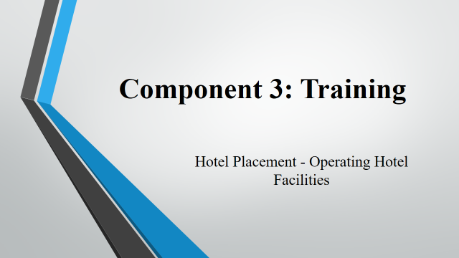

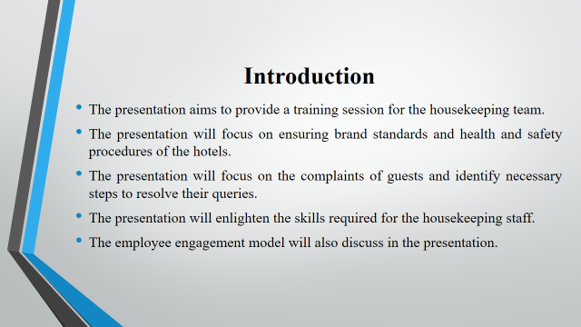

Training Notes: In the presentation, the main discussion revolves around the training session provided to the housekeeping team in order to make them efficient. The main agenda of the training session is to make staff aware of the complaints of guests and teach them what to do to serve guests and make them satisfied with the services.
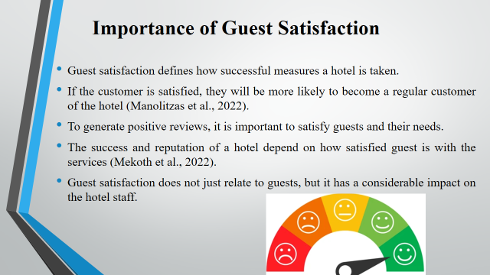

Training Notes: Guest satisfaction is an important part of the hotel as it determines the position of the hotel in the market (Manolitzas et al., 2022). Guest satisfaction leads towards a great level of retention and a strong brand reputation. To minimise the complaints of guests, it is important to focus on guest satisfaction.
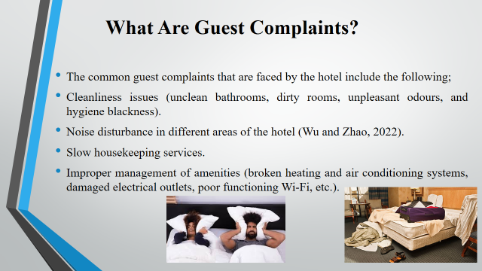

Training Notes: The complaints of guests vary from individual experience and situations (Wu and Zhao, 2022). It is important for the management of the hotel to offer proper services to the guests, like clean rooms and all the necessary items like bath kits, warm and cooked food, proper Wi-Fi and other electrical device facilities. All the mentioned things directly relate to either satisfaction or dissatisfaction of guests.
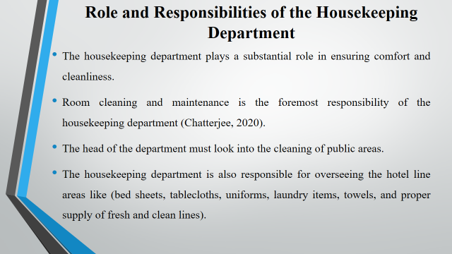

Training Notes: The entire guest satisfaction depends on the efficiency of the housekeeping department (Chatterjee, 2020). It is important for the staff to ensure room cleaning and public area cleaning. Moreover, laundry and line management handling is also the primary responsibility of the housekeeping department.
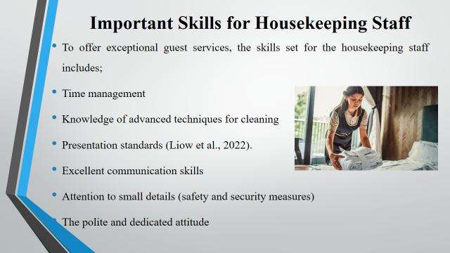

Training Notes: In order to satisfy customers and enhance their loyalty, it is important for housekeeping staff to learn advanced techniques and methods of cleaning. It is also crucial to improve communication and presentation skills (Liow et al., 2022). Moreover, staff members must have trained specifically about the safety and security measures of the hotel.

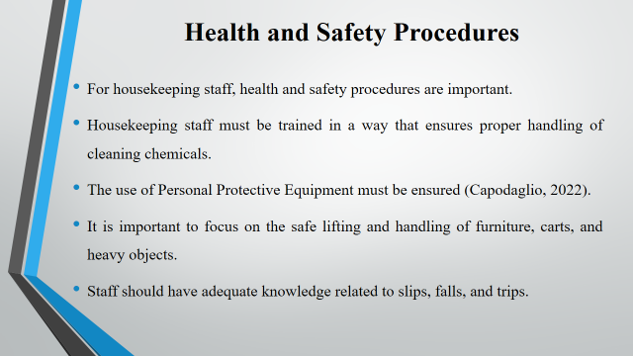

Training Notes: Staff should have a strong knowledge of personal safety and security. In hotels, policies and standards must need to follow by housekeeping staff (Capodaglio, 2022). It is the responsibility of every associated member of the hotel to ensure that health and safety guidelines are followed in the hotel.
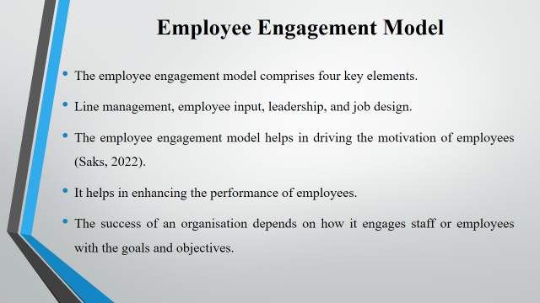

Training Notes: The employee engagement model helps in increasing the productivity and performance of employees (Saks, 2022). To engage employees for the long term and reduce turnover rate, it is important for hotels to engage employees efficiently.
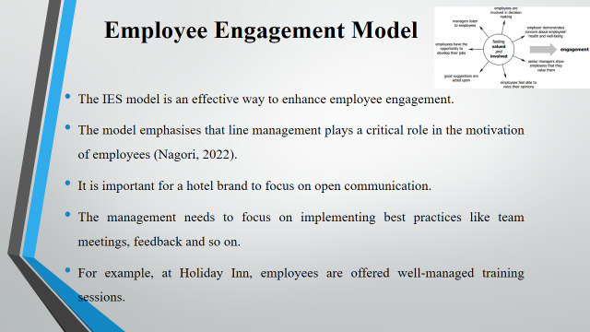

Training Notes: The use of the employee engagement model helps hotel management to engage the workforce for the long term (Nagori, 2022). It is important for hotel management to offer personal and professional benefits to the employees and reduce the turnover rate and improve the success of the hotel.
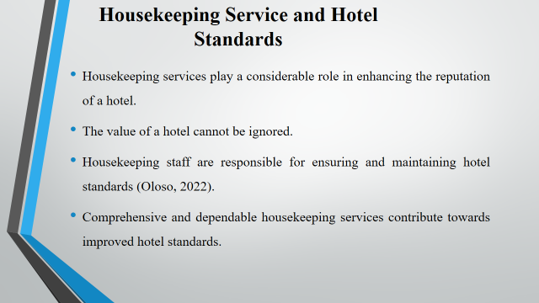

Training Notes: Hotel standards are considered important (Oloso, 2022). It is impossible to ignore the importance of standards while talking about housekeeping services and the importance of guest satisfaction.
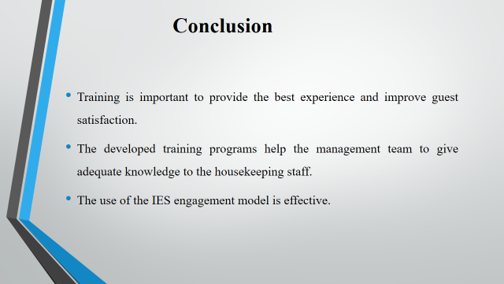

Training Notes: The presentation mainly focused on the identification of guest complaints and their importance in relation to housekeeping services. The IES model of employee engagement has been discussed.

References
Ambardar, A. and Raheja, K., 2017. Occupational Safety and Health of Hotel Housekeeping Employees: A Comparative Study. International Journal of Hospitality & Tourism Systems, 10(2).
Bhattarai, S.P. and Ojha, S.K., 2022, February. Accountability on Guest Perceptions of Hotel Employees for Sustainable Tourism. In 25TH INTERNATIONAL CONFERENCE ON IT APPLICATIONS AND MANAGEMENT (p. 205).
Capodaglio, E.M., 2022. Participatory ergonomics for the reduction of musculoskeletal exposure of maintenance workers. International Journal of Occupational Safety and Ergonomics, 28(1), pp.376-386.
Chatterjee, P., 2020. Role of Housekeeping Cleaning Equipment and Agent in the World of Hospitality Industry.
Chatterjee, P., Role of Housekeeping Cleaning Equipment and Agent in the world of Hospitality Industry.
Devrim Yilmaz, Ö., 2017. An undervalued department or a terra incognita? Hotel housekeeping from the perspectives of executive housekeepers and room attendants. Tourism: An International Interdisciplinary Journal, 65(4), pp.450-461.
Grobelna, A. and Tokarz-Kocik, A., 2017. Relationships between job characteristics and organizational commitment: The example of hotel housekeeping employees. Economic and Social Development: Book of Proceedings, pp.491-500.
Liow, M.H.L., Lee, L.C., Tan, N.C.K., Tan, H.K., Chow, W., Wee, G.L.E., Wong, S.H., Paramasivam, J., Tan, K. and Ling, M.L., 2022. Personal protective equipment training for non-healthcare workers in the Covid-19 pandemic: Effectiveness of an evidence-based skills training framework. Infection, Disease & Health, 27(1), pp.38-48.
Manolitzas, P., Glaveli, N., Palamas, S., Talias, M. and Grigoroudis, E., 2022. Hotel guests’ demanding level and importance of attribute satisfaction ratings: An application of multiple criteria Satisfaction Analysis on TripAdvisor’s hotel guests ratings. Current Issues in Tourism, 25(8), pp.1203-1208.
Mekoth, N., Thomson, A.R. and Unnithan, A., 2022. The mediating role of satisfaction on the relationship between professionalism and employee continuity in the hospitality industry. Journal of Quality Assurance in Hospitality & Tourism, pp.1-27.
Nagori, R., 2022. Improving Employee Engagement in Small and Medium Enterprises. In Small Business Management and Control of the Uncertain External Environment. Emerald Publishing Limited.
Oloso, S.E., 2022. The Impact Of Housekeeping Service Qualities On Guests Satisfaction In Oyo State Hotels. Journal of Research in Hospitality and Tourism Management, 4.
Saks, A.M., 2022. Caring human resources management and employee engagement. Human Resource Management Review, 32(3), p.100835.
Wood, R.C., 2017. Housekeeping and related accommodation services. In Hotel Accommodation Management (pp. 70-82). Routledge.
Wu, J. and Zhao, N., 2022. What consumer complaints should hoteliers prioritize? Analysis of online reviews under different market segments. Journal of Hospitality Marketing & Management, pp.1-28.

