Appendices

Appendix A

Observer: Ross Chislett

Context of lesson: Reception Maths – Ordinal Numbers

Tick if observed | Disruption 1 | Disruption 2 | Disruption 3 | Disruption 4 | Disruption 5 | Disruption 6
Level of disruption 1-4 | 3 | 4 | 4 | 3 | 3 | 3
Non-verbal method used by teacher? | Clapping | Clapping | Hand up | Hand up | Clapping | Hand up
Time for whole class to settle | 9 seconds | 6 seconds | 16 seconds | 13 seconds | 4 seconds | 9 seconds

- Low – 2-3 individuals talking to each other when the teacher is talking
- Fairly Low – 3-10 individuals talking to each other when the teacher is talking
- Fairly High – 10-20 individuals talking to each other when the teacher is talking
- High – More than 20 individuals talking to each other when the teacher is talking

Pupil engagement after non-verbal behaviour management strategy

 | Pupil 1 | Pupil 2 | Pupil 3
Disruption 1 | 3 | 5 | 4
Disruption 2 | 2 | 5 | 4
Disruption 3 | 2 | 5 | 3
Disruption 4 | 2 | 5 | 3
Disruption 5 | 3 | 5 | 4
Disruption 6 | 3 | 5 | 4

- Extremely Low
The child hardly shows any activity:
- no concentration: staring, daydreaming;
- an absent, passive attitude;
- no goal-oriented activity, aimless actions, not producing anything;
- no signs of exploration and interest;
- not taking anything in, no mental activity

- Low
The child shows some degree of activity, but which is often interrupted:
- limited concentration: looks away during the activity, fiddles, dreams;
- is easily distracted;
- action only leads to limited results.

- Moderate
The child is busy the whole time, but without real concentration:
- routine actions, attention is superficial; • is not absorbed in the activity, activities are short lived;
- limited motivation, no real dedication, does not feel challenged;
- the child does not gain deep-level experiences;
- does not use his/her capabilities to full extent;
- the activity does not address the child’s imagination.

- High
There are clear signs of involvement, but these are not always present to their full extent:
- the child is engaged in the activity without interruption;
- most of the time there is real concentration, but during some brief moments the attention is more superficial; the child feels challenged, there is a certain degree of motivation;
- the child’s capabilities and its imagination to a certain extent are addressed in the activity.

- Extremely High
During the episode of observation, the child is continuously engaged in the activity and completely absorbed in it:
- is absolutely focussed, concentrated without interruption;
- is highly motivated, feels strongly appealed by the activity, perseveres;
- even strong stimuli cannot distract him/her;
- is alert, has attention for details, shows precision;
- its mental activity and experience are intense;
- the child constantly addresses all its capabilities: imagination and mental capacity are in top gear;
- obviously enjoys being engrossed in the activity.

Pupil well-being after non-verbal behaviour management strategy

 | Pupil 1 | Pupil 2 | Pupil 3
Disruption 1 | 2 | 5 | 4
Disruption 2 | 2 | 5 | 5
Disruption 3 | 2 | 5 | 4
Disruption 4 | 2 | 5 | 3
Disruption 5 | 2 | 5 | 5
Disruption 6 | 3 | 5 | 4

- Extremely Low
The child clearly shows signals of discomfort:
- whines, sobs, cries, screams;
- looks dejected, sad or frightened, is in panic;
- is angry or furious;
- shows signs feet, wriggles, throws objects, hurts others;
- sucks its thumb, rubs its eyes;
- doesn’t respond to the environment, avoids contact, withdraws;
- hurts him/herself, bangs its head, throws him/herself on the floor.

- Low
The posture, facial expression and actions indicate that the child does not feel at ease. However, the signals are less explicit than under level 1 or the sense of discomfort is not expressed the whole time.

- Moderate
The child has a neutral posture. Facial expression and posture show little or no emotion. There are no signals indicating sadness or pleasure, com- fort or discomfort.

- High
The child shows obvious signs of satisfaction (as listed under level 5). However, these signals are not constantly present with the same intensity.

- Extremely High
During the observation episode, the child enjoys, in fact it feels great:
- it looks happy and cheerful, smiles, beams, cries out of fun;
- is spontaneous, expressive and is really him/herself;
- talks to itself, plays with sounds, hums sings;
- is relaxed, does not show any signs of stress or tension;
- is open and accessible to the environment;
- is lively, full of energy, radiates;
- expresses self-confidence and self-assurance.

Appendix B

Pupil 1 Interview

- How did the teacher regain your attention in the lesson today?

She claps her hands and puts her hand up

- How did you feel when the teacher was clapping to regain your attention? (only ask if learner recognises this method in question 1)

The learner gave a thumbs up

- How did you feel when the teacher put their hand in the air to regain your attention? (only ask if learner recognises this method in question 1)

The learner gave a thumbs up

- Which way of getting your attention did you find easier to understand?

Hand up

- Which way of getting your attention did you like most?

Hand up

- Which way of getting your attention did you think the class settled down better to?

Clapping

Pupil 2 Interview

- How did the teacher regain your attention in the lesson today?

She claps and she puts her hand up

- How did you feel when the teacher was clapping to regain your attention? (only ask if learner recognises this method in question 1)

Thumbs in a neutral position

- How did you feel when the teacher put their hand in the air to regain your attention? (only ask if learner recognises this method in question 1)

Thumbs up

- Which way of getting your attention did you find easier to understand?

Clapping

- Which way of getting your attention did you like most?

Clapping

- Which way of getting your attention did you think the class settled down better to?

Clapping

Pupil 3 Interview

- How did the teacher regain your attention in the lesson today?

Clapping and her hand up

- How did you feel when the teacher was clapping to regain your attention? (only ask if learner recognises this method in question 1)

Thumbs up

- How did you feel when the teacher put their hand in the air to regain your attention? (only ask if learner recognises this method in question 1)

Thumbs up

- Which way of getting your attention did you find easier to understand?

Clapping

- Which way of getting your attention did you like most?

Hands up

- Which way of getting your attention did you think the class settled down better to?

Clapping

Appendix C

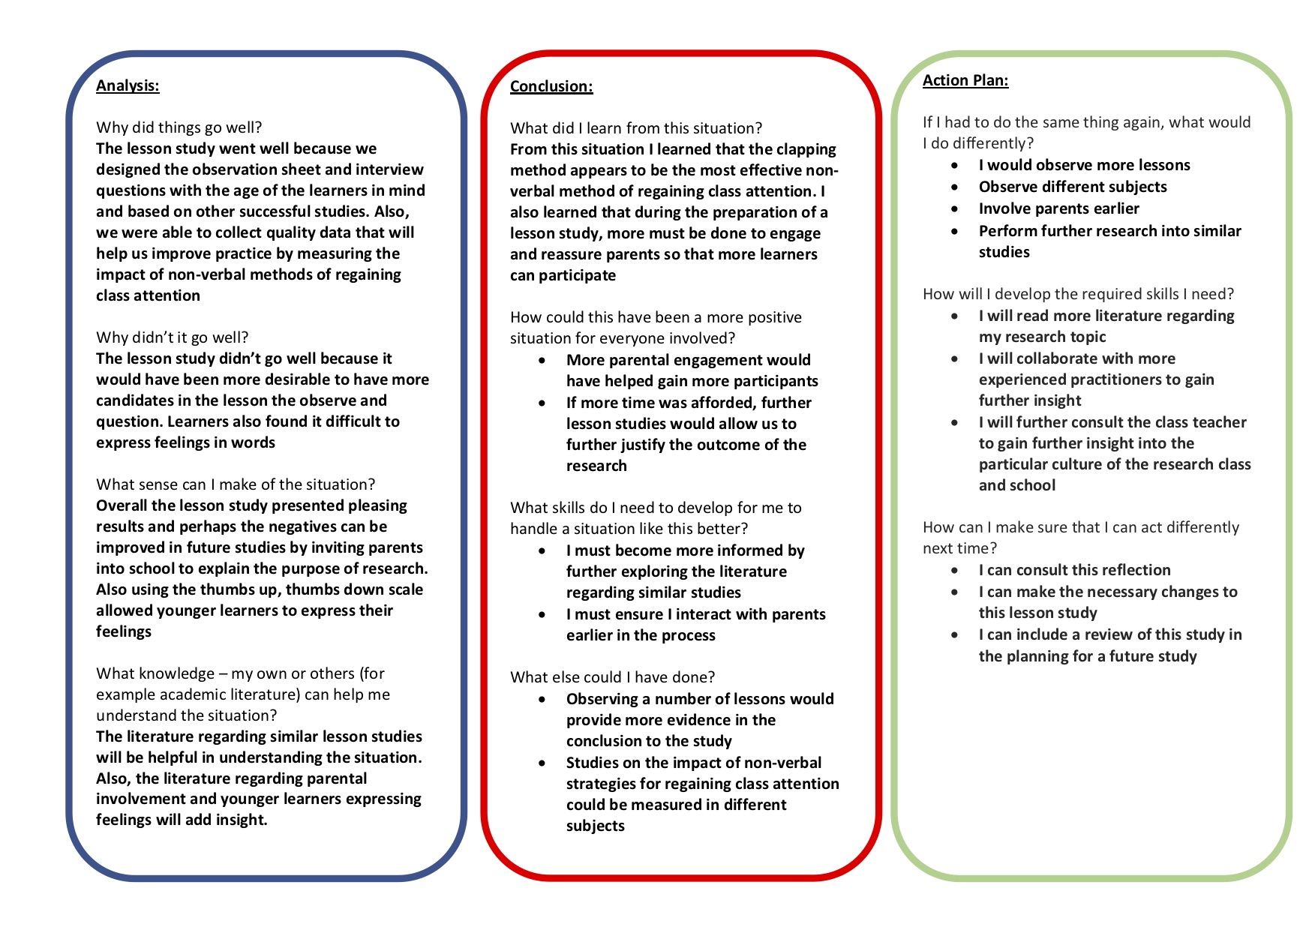
Appendix D

Lesson Plan Phase 1

Lesson Plan – Step 1 Cynllun Gwers – Cam 1

Student-teacher | Paige Cherrington | Class: | Dosbath 2
AoLE or Subject | Maths and Numeracy | Date: | W/C 6.2.19
Lesson Focus: | To use ordinal numbers
Meaningful links to Curriculum | WM 2- Algebra uses symbol systems to express the structures of relationships between numbers, quantities and relations.
Meaningful links to:  Cross Curricular Responsibilities | R.N2 read and write numbers to at least 10. AOL: recite numbers up to 20, forwards and backwards, and from different starting points
Personal Targets (Linked to QTS and identifed in weekly review)
- Provide additional resources to support scaffolding the learning
- Expand on pupil comments to deepen the learning process
- Ensure lesson plans are completed on the correct AoLE template

Learning Objectives (focus on Learning- use accessible vocabulary):
The pupils will learn to:

To use ordinal numbers in a practical and authentic way.

Success Criteria (clearly linked to each Learning Objective and related to the process and/or product of learning) | Assessment of Pupils’ Learning  Evidence  (What have the learners to say/write/do/produce – to demonstrate learning)
I can use 1st, 2nd, 3rd  I can write numbers to 10  IDP target MB. I can share with others/I can take turns with a friend. | - Carry out practical tasks to identify ordinal numbers  - Be able to say who came 1st, 2nd and 3rd and put them in order  - Practice number formation

Time | Activities/Methodology/Key Concepts  (Teacher’s Role – including key teaching points, differentiation strategies and key questions) | Pupil Tasks  (Pupils’ role –including differentiation, engagement in formative assessment and homework) | Resources  (Including Health and Safety requirement)
Opening phase (with links to prior learning) | Children to join the conga line! Count who is first, second, third. Practise counting on and back to 10. Conga line to walk up the numberline dragon on the playground and count up to 20 and back. | Pupils to take part in activities and promted where necessary. | Dragon numberline (FP yard)
Teaching & Core Learning | Class to take part in mixed ability group races. These can include bike races, running races or races to write their name 10 x etc (pupil voice ideas for what kind of races they would like to take part in) Adults to use questioning to prompt discussion of ordinal places. Who was first? What comes after first? Who was second? Allow the children to take part in a few different races so that they can familiarise themselves with the language of ordinal numbers and embed these in their learning. | Mixed ability groups: Pupils to work co-operatively to find the correct results to each race. Some pupils can use a clipboard to record their results, other pupils can record the race on an ipad or cheer on the other children. All children to participate in deciding who should be awarded each placing  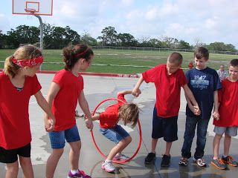 | Clipboards  Ipad  Pencils  Award stickers/medals
Plenary | Pass the hoop! Class split into 2 or 3 teams. They must get the hoop from one end of their line to the other while holding hands. Who can do it 1st? | Work as a team to complete task the quickest. Able to identfiy who came 1st and 2nd. | Hoops

Lesson Plan – Phase 1
Evaluation of the Learning Experience
(include references to QTS)

Evaluation of Pupil Learning

Evidence of Learning (including attitude to learning over time)) | Who – evaluate individuals within a group setting. Ensuring that all pupils are focused on the task and demonstrate understanding.  How – evaluate through observing the activities being carried out and pupils engaging in the task. Have a conversation with pupils about what they have found out so far. Use questioning throughout session to ensure learning is embedded. Assist those who are seen to require addition support.  What – collaborating in a group focusing and contributing to the task. Entails communicating with the teacher and their peers in order to demonstrate understanding of the lesson. Independent learning, active learning.  Why – identify that pupils can acknowledge 1st, 2nd and 3rd in order to demonstrate this in different situations.
Next Steps for Progress | Pupils to carry out additional acitvities that relate to real-life scenarios. Demonstrate understanding by putting their peers in order of who came 1st, 2nd, 3rd etc.

Reflective Analysis of Teaching and Strategies For Development – including justification/rationale for pedagogical choices

Evidence of my Effective Practice | Majority of the pupils were able to show understanding of 1st, 2nd and 3rd quite quickly. Pupils were engaged in the actviities and could reflect on their prior knowledge in order to assist their learning.
Areas for my Development  Personal Targets for Progress | Ensure that all pupils have an equal chance to learn. That more able pupils are not ‘taking over’ the questionning process while in mix ability groups.

Appendix E

Observer: Paige Cherrington

Context of lesson: Year 3 Literacy – Writing a poem about France

Tick if observed | Disruption 1 | Disruption 2 | Disruption 3 | Disruption 4 | Disruption 5 | Disruption 6
Level of disruption 1-4 | 3 | 2 | 2 | 2 | 2 | 3
Non-verbal method used by teacher? | Clapping | Clapping | Hand up | Clapping | Hand up | Hand up
Time for whole class to settle | 4 seconds | 8 seconds | 15 seconds | 8 seconds | 7 seconds | 4 seconds

- Low – 2-3 individuals talking to each other when the teacher is talking
- Fairly Low – 3-10 individuals talking to each other when the teacher is talking
- Fairly High – 10-20 individuals talking to each other when the teacher is talking
- High – More than 20 individuals talking to each other when the teacher is talking

Pupil engagement after non-verbal behaviour management strategy

 | Pupil 1 | Pupil 2 | Pupil 3
Disruption 1 | 3 | 4 | 2
Disruption 2 | 1 | 1 | 5
Disruption 3 | 2 | 1 | 5
Disruption 4 | 4 | 1 | 4
Disruption 5 | 5 | 2 | 1
Disruption 6 | 5 | 3 | 3

- Extremely Low
The child hardly shows any activity:
- no concentration: staring, daydreaming;
- an absent, passive attitude;
- no goal-oriented activity, aimless actions, not producing anything;
- no signs of exploration and interest;
- not taking anything in, no mental activity

- Low
The child shows some degree of activity, but which is often interrupted:
- limited concentration: looks away during the activity, fiddles, dreams;
- is easily distracted;
- action only leads to limited results.

- Moderate
The child is busy the whole time, but without real concentration:
- routine actions, attention is superficial; • is not absorbed in the activity, activities are short lived;
- limited motivation, no real dedication, does not feel challenged;
- the child does not gain deep-level experiences;
- does not use his/her capabilities to full extent;
- the activity does not address the child’s imagination.

- High
There are clear signs of involvement, but these are not always present to their full extent:
- the child is engaged in the activity without interruption;
- most of the time there is real concentration, but during some brief moments the attention is more superficial; the child feels challenged, there is a certain degree of motivation;
- the child’s capabilities and its imagination to a certain extent are addressed in the activity.

- Extremely High
During the episode of observation, the child is continuously engaged in the activity and completely absorbed in it:
- is absolutely focussed, concentrated without interruption;
- is highly motivated, feels strongly appealed by the activity, perseveres;
- even strong stimuli cannot distract him/her;
- is alert, has attention for details, shows precision;
- its mental activity and experience are intense;
- the child constantly addresses all its capabilities: imagination and mental capacity are in top gear;
- obviously enjoys being engrossed in the activity.

Pupil well-being after non-verbal behaviour management strategy

 | Pupil 1 | Pupil 2 | Pupil 3
Disruption 1 | 4 | 5 | 3
Disruption 2 | 3 | 1 | 4
Disruption 3 | 3 | 1 | 4
Disruption 4 | 5 | 1 | 1
Disruption 5 | 5 | 1 | 2
Disruption 6 | 5 | 3 | 2

- Extremely Low
The child clearly shows signals of discomfort:
- whines, sobs, cries, screams;
- looks dejected, sad or frightened, is in panic;
- is angry or furious;
- shows signs feet, wriggles, throws objects, hurts others;
- sucks its thumb, rubs its eyes;
- doesn’t respond to the environment, avoids contact, withdraws;
- hurts him/herself, bangs its head, throws him/herself on the floor.

- Low
The posture, facial expression and actions indicate that the child does not feel at ease. However, the signals are less explicit than under level 1 or the sense of discomfort is not expressed the whole time.

- Moderate
The child has a neutral posture. Facial expression and posture show little or no emotion. There are no signals indicating sadness or pleasure, com- fort or discomfort.

- High
The child shows obvious signs of satisfaction (as listed under level 5). However, these signals are not constantly present with the same intensity.

- Extremely High
During the observation episode, the child enjoys, in fact it feels great:
- it looks happy and cheerful, smiles, beams, cries out of fun;
- is spontaneous, expressive and is really him/herself;
- talks to itself, plays with sounds, hums sings;
- is relaxed, does not show any signs of stress or tension;
- is open and accessible to the environment;
- is lively, full of energy, radiates;
- expresses self-confidence and self-assurance.

Appendix F

Pupil 1 Interview

- How did the teacher regain your attention in the lesson today?

Raises hands, actions to follow. Claps with hand

- How did you feel when the teacher was clapping to regain your attention? (only ask if learner recognises this method in question 1)

Everyone not paying attention, be able to concentrate

- How did you feel when the teacher put their hand in the air to regain your attention? (only ask if learner recognises this method in question 1)

Not listening, sad

- Which way of getting your attention did you find easier to understand?

Hand up, Silly with claps

- Which way of getting your attention did you like most?

Hand aches with hand up, clapping

- Which way of getting your attention did you think the class settled down better to?

Hands up

Pupil 2 Interview

- How did the teacher regain your attention in the lesson today?

Clapping

- How did you feel when the teacher was clapping to regain your attention? (only ask if learner recognises this method in question 1)

Need listening, sleepy – tiring to clap

- How did you feel when the teacher put their hand in the air to regain your attention? (only ask if learner recognises this method in question 1)

Did not recognise this

- Which way of getting your attention did you find easier to understand?

Yes

- Which way of getting your attention did you like most?

Like it

- Which way of getting your attention did you think the class settled down better to?

Go quiet with clapping

Pupil 3 Interview

- How did the teacher regain your attention in the lesson today?

Claps his hands

- How did you feel when the teacher was clapping to regain your attention? (only ask if learner recognises this method in question 1)

Happy, don’t know

- How did you feel when the teacher put their hand in the air to regain your attention? (only ask if learner recognises this method in question 1)

Didn’t recognise

- Which way of getting your attention did you find easier to understand?

Claps

- Which way of getting your attention did you like most?

Claps

- Which way of getting your attention did you think the class settled down better to?

Claps sometimes

Appendix G

Lesson Plan Phase 1

Lesson Plan – Step 1

Student-teacher | Ross Chislett | Class: | Year 3
AoLE or Subject | LLC | Date: | 04/02/2020
Lesson Focus: | Write a poem about a trip to France
Meaningful links to Curriculum | I can listen to and remember poetry, drama and prose and can adapt them creatively
Meaningful links to:  Cross Curricular Responsibilities | Literacy - I can use vocabulary related to the topic or subject.  Wider Skills – Creative skills
Personal Targets (Linked to QTS and identified in weekly review)

Managing the learning environment – Make sure all learners are on task
Pedagogy – Ensure I meet the needs of individual learners when planning lessons

Learning Objectives (focus on Learning- use accessible vocabulary):
The pupils will learn to:
Use their plans to write a poem about a trip to France including various types of figurative language

Success Criteria (clearly linked to each Learning Objective and related to the process and/or product of learning) | Assessment of Pupils’ Learning  Evidence  (What have the learners to say/write/do/produce – to demonstrate learning)
- I can use my plan to write a poem  - I can include figurative language | - Learners must use ideas from their plan to create their poem  - Learners must include the figurative language that we have covered (alliteration, simile and rhyme)

Time | Activities/Methodology/Key Concepts  (Teacher’s Role – including key teaching points, differentiation strategies and key questions) | Pupil Tasks  (Pupils’ role –including differentiation, engagement in formative assessment and homework) | Resources  (Including Health and Safety requirement)
Opening phase (with links to prior learning) | - I will ask learners to recap findings from their research in previous lesson  - I will write ideas on the whiteboard  - I will recap what alliteration, simile and rhyme mean | - Learners to participate in questioning
Teaching & Core Learning | - Teaching assistant and I to work with 1 group each while the other 2 groups work in provision areas  - The groups will then swap in the next lesson | - Learners to write a poem including ideas from their plan  - MAT – to write 8 lines including alliteration, simile and rhyme  - Main 1 – to write 6 lines including alliteration and rhyme  - Main 2 – to write 4 lines including rhyme  - Support – to write 2 lines including rhyme | - Plans from previous lesson  - Workbooks
Plenary | - Discuss what alliteration, simile and rhyme mean  - Discuss how learners created their poems  - Discuss how useful learners found their plans | - Learners to participate in discussion

Lesson Plan – Phase 1
Evaluation of the Learning Experience
(include references to QTS)

Evaluation of Pupil Learning

Evidence of Learning (including attitude to learning over time)) | - Learners were able to write poems to different standards based on ability  - Learners included different figurative language
Next Steps for Progress | - Learners must use a larger variety of figurative language

Reflective Analysis of Teaching and Strategies for Development – including justification/rationale for pedagogical choices

Evidence of my Effective Practice | - I ensured all learners were on task by using a variety of classroom management strategies  - The differentiation in the lesson provided challenge to all learners  - I provided extra support for IDP learners
Areas for my Development  Personal Targets for Progress | - Further work was needed in the intro to ensure learners had grasped exactly how to use figurative language  - I will use further questioning to ensure all learners understand the task

Appendix H



