Student Name: Sarah Davies
Student Number: 0650551
Programme of Study: Surface Pattern & Textiles
Module: ADDA6006 Independent Project
Tutor Name: Georgia McKie

Word count: 3299

Project Proposal
Patterning the Year: Using the Almanac to Explore the Cyclical Relationship between Nature, Folklore and Design

Table of Contents
Introduction 4
Working Practices | Who I am | Artist Inspiration 6
Context | Narrative | Theme 10
Materiality |Methodology |Process 12
Critical Perspectives on Contemporary Design Practice 15
What does this body of work need to do for me? 20
How will I ensure success? 20
Bibliography 21

List of Figures

Fig. 1 Davies, S. ‘Illustrated Guidebooks’. (2025). [image] Personal collection.

Fig. 2 Davies, S. ‘The Almanac. A Seasonal Guide to 2025’. (2025). [image] Personal collection.

Fig. 3 Burton, F.W. ‘Hellelil and Hildebrand, the Meeting on the Turret Stairs’. (1864). [image] Available at: https://www.nationalgallery.ie/art-and-artists/highlights-collection/hellelil-and-hildebrand-meeting-turret-stairs-frederic (Accessed: 5th November 2025).

Fig. 4 Morris, W. ‘Wild Tulip & Vine’. (1884). [image] Available at:
https://www.wmorrisandco.com/uk/wild-tulip-vine-wallpaper-rose-linen-48112-217579/ (Accessed: 6th November 2025)

Fig. 5 Ingalls-Gunn, L. ‘Autumnal Interiors’. (2025). [image] Available at:
https://decortoadore.net/2025/11/friday-favorites-wander.html (Accessed: 18th November 2025)

Fig. 6 Davies, S. ‘Devoré on Velvet’. (2024). [photograph] Personal collection

Fig. 7 Hunter, A. ‘The Pennines’. (2025). [image] Available at: http://www.andreahunterfocusonfelt.co.uk/prints.html (Accessed: 16th November 2025)

Fig. 8 Mahon, M. ‘Traditional Wood-block Printing’. (2023). [photograph] Available at: https://www.instagram.com/p/Czii8yxCvGq/?img_index=4&igsh=MTEybDMwZXg4Yjh4eA== (Accessed: 16th November 2025)

Fig. 9 Lipkin, Z. ‘Falling Leaves’. (2016). [image] Available at: https://www.anytexture.com/2016/12/falling-leaves-art-quilt/ (Accessed: 2nd December 2025)

Introduction

Nature captured my imagination long before I realised it could be part of my design practice. Growing up in a secluded rural area surrounded by fields, woodlands and rivers, I would study illustrated books of plants, insects and birds, fascinated by what they could do and what they might symbolise. Every time I encountered them in real life, I (with my mum’s help when I was very young) made a note of the date beside their pictures, creating my own personal record of the seasons (Fig. 1).

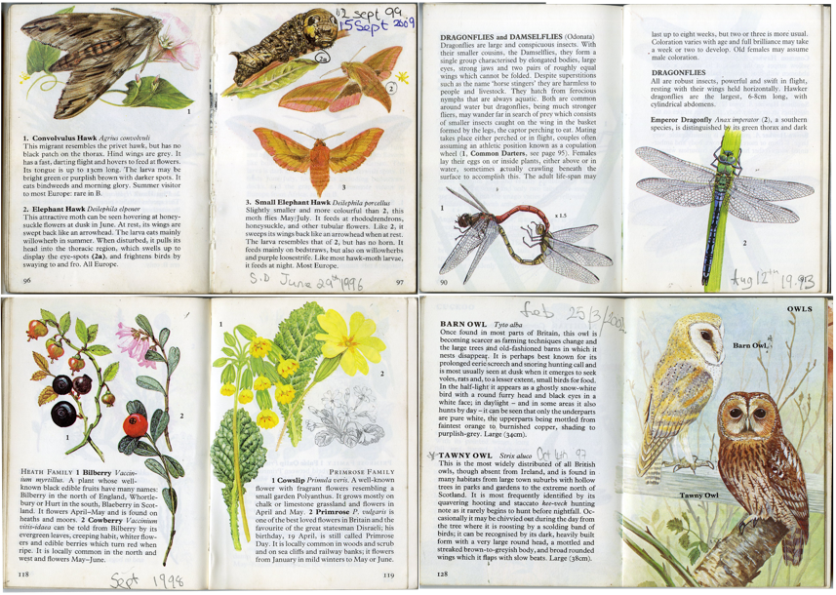

Fig. 1 Illustrated guidebooks

The landscape could be wild and unpredictable, yet it also felt like a companion and a source of curiosity, with its cyclical patterns and rhythms. That early sense of connection now shapes my work as a designer, where I explore how we experience and reimagine nature through patterns and materials.
This relationship forms the foundation of my project, which uses the almanac as a conceptual framework. I view the almanac as a kind of ‘nature’s bible’. Traditionally, almanacs were created as practical guides for rural and agricultural life, offering weather predictions, planting dates, lunar cycles and folk wisdom to help communities live in tune with the seasons. Although its role in daily life has evolved, the almanac is still published today, and it continues to uphold its tradition of providing seasonal knowledge and folklore (Fig.2).
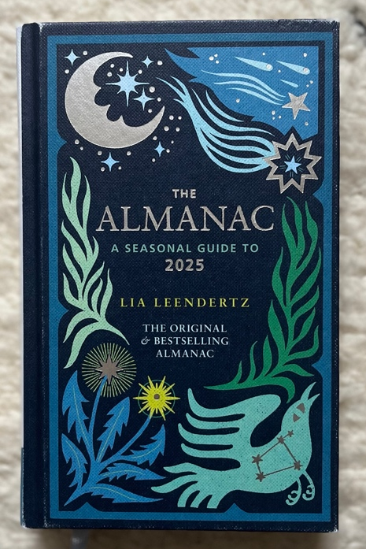

Fig. 2 The Almanac (2025).

While folklore plays a role in my work, reflecting how plants, animals and weather were once instilled with human meaning, my focus will also extend beyond myth and into the patterns of nature itself. From this perspective, I aim to explore how these natural patterns resonate with us on a psychological level; why humans are instinctively drawn to nature-based motifs, and why such imagery remains a dominant theme within design.
Through these concepts, the almanac becomes a dialogue between natural observation and creative interpretation, with its cyclical rhythms guiding my exploration of how time, repetition, and seasonal change can shape contemporary design.

Working Practices | Who I am | Artist Inspiration
As a designer, my goal is to create work that is both visually appealing and evocative. I have a natural affinity for detail, particularly in older designs, such as those from the Victorian period; a time where emphasis on detail was fundamental, and beauty, functionality, and longevity held equal importance. For instance, the Albion letterpress in the university's printmaking department demonstrates how even machinery from that era was crafted with both purpose and aesthetic consideration. In my practice, I pay close attention to detail and find that drawing and illustrating by hand is a meditative process. The act of creating feels therapeutic; however, I frequently think in terms of patterns, scale, and repetition, as if the designer and artist within me are engaged in a quiet battle.
I often find myself wondering if I am trapped in nostalgia. Nostalgia has significantly influenced designers, leading to patterns that reconnect people with familiar memories, traditions and stories. A key example is Welsh designer Laura Ashley, whose work drew heavily on romanticised Victorian textiles and domestic craft. Rather than defining herself as a trendsetter, Ashley described her designs as having “evolved from necessity,” emerging from her fascination with traditional patchwork and the heritage of women’s making (BBC Wales, 1977). When she discovered that the delicate florals and stripes she had admired in museum collections were no longer produced, she began printing her own fabrics and reviving historical styles for a modern audience. This approach demonstrates how nostalgia can become a creative strategy, allowing designers to re-interpret the past in ways that feel comforting, familiar, and emotionally resonant (Nicholls-Lee, 2025). Interestingly, psychologists describe nostalgia as not only longing for a different time, but as a form of ‘mental time travel’; a return to meaningful, emotionally charged memories. Rather than being a passive or melancholy feeling, nostalgia is rooted in specific remembered experiences and is often described as a ‘wistful affection’ for moments that shaped us (Stephan et al., 2012). This might explain why much of my work revisits the past, where every design becomes a way to relive those memories in the present. I strive to create a scene within my work that captures a particular moment or atmosphere, aiming to evoke emotion or stir recognition in the observer. My intention is to create a sense of familiarity and form connections, rather than just serving as decoration.
I take inspiration from Pre-Raphaelite artists such as John William Waterhouse and Frederick William Burton, whose romantic imaginations of the past capture both beauty and emotion through their compositions and colours. This sentiment can be seen in Burton’s The Meeting on the Turret Stairs (Fig. 3), which conveys love and tragedy through small gestures and subtle expressions.
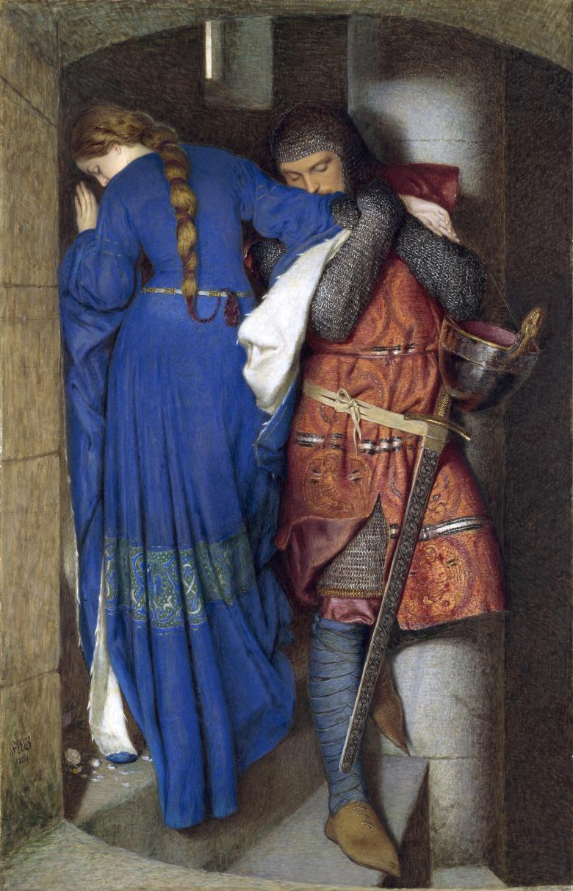

Fig 3. The Meeting on the Turret Stairs (1864)

The paintings of the Pre-Raphaelites represent reimagined interpretations of history that continue to influence our perception of medieval times. Elizabeth Prettejohn (2000) suggests, “The Pre-Raphaelites did not so much recreate the Middle Ages as invent them — crafting a vision of a purer, more poetic world untouched by modernity” (p.12). Their nostalgia can be seen as an act of resistance towards the industrial age; an effort to hold onto beauty, sincerity and craftsmanship in an increasingly mechanised world. Tim Barringer (1998) interprets this response as “an idealised retreat into a purer, more authentic vision of art and life” (p.45), a sentiment that resonates with my own work.
The Pre-Raphaelites conveyed their romantic ideals through painting and storytelling, while William Morris aimed to apply those same principles to daily life. His philosophy that we should "have nothing in our houses that we do not know to be useful or believe to be beautiful" (Morris, 1880), remains one of the most influential ideas in design history. His patterns, often inspired by nature, reflect the cyclical qualities of the natural world (Fig. 4). Vines, leaves, and flowers repeat endlessly in rhythmic symmetry, showcasing his belief that natural forms are the purest source of design inspiration (Naylor, 1989).
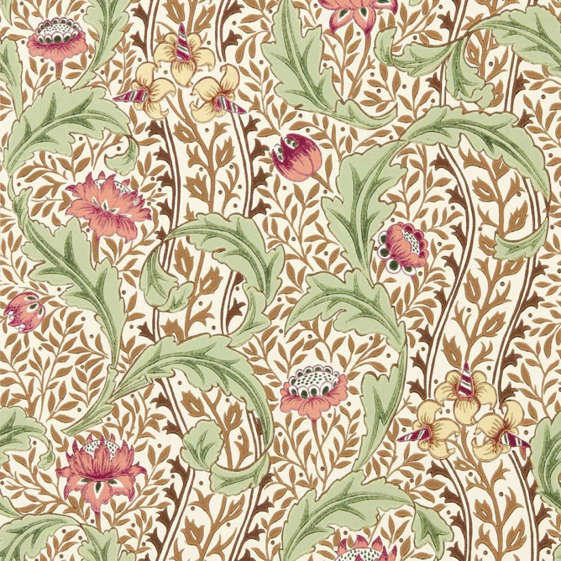

Fig. 4 Wild Tulip & Vine (1884)

Morris’s ideas continue to influence contemporary design, particularly among those who value sustainability, material honesty and emotional connection to the handmade (Naylor, 1989). His belief in the connection between art and life, and the importance of beauty in everyday things, feels especially relevant in a world increasingly defined by digital production and disposability. Brands such as House of Hackney reinterpret Morris’s principles for a modern audience, merging traditional craftsmanship with modern technology and bold, nature-inspired patterns. As a certified B Corporation, the brand continues Morris’s legacy by combining heritage-inspired designs with sustainable production methods (House of Hackney, 2025). Their collections demonstrate how traditional ideals can evolve to meet modern-day values, acting as inspiration and affirmation for my own exploration of nature, folklore and design.

Context | Narrative | Theme
The cultural emphasis on nature within our homes highlights the deep connection we have with the natural world; a concept that is far from new. From ancient cave paintings to modern wallpapers, humans have consistently incorporated natural forms into decorative elements and design. This reflects our desire for balance, belonging, and continuity in an increasingly disconnected world. Psychologists describe this phenomenon as biophilia, which refers to our innate affinity for nature that fulfils our emotional and psychological needs (Wilson, 1984). Surrounding ourselves with organic shapes, floral motifs, and natural colours can create a sense of familiarity and calm, helping us feel grounded in our environments. For many people, these designs are more than just decorative; they are restorative, offering us a way to reconnect with the beauty and abundance of nature.
Beyond motifs and patterns, our connection to nature often extends to how we alter our surroundings seasonally. Subtle changes in colours, textures and materials that reflect the landscape’s own transformations. These changes are often marked by seasonal traditions and acts of celebration, reinforcing our transition and renewal within the home (Fig. 5).
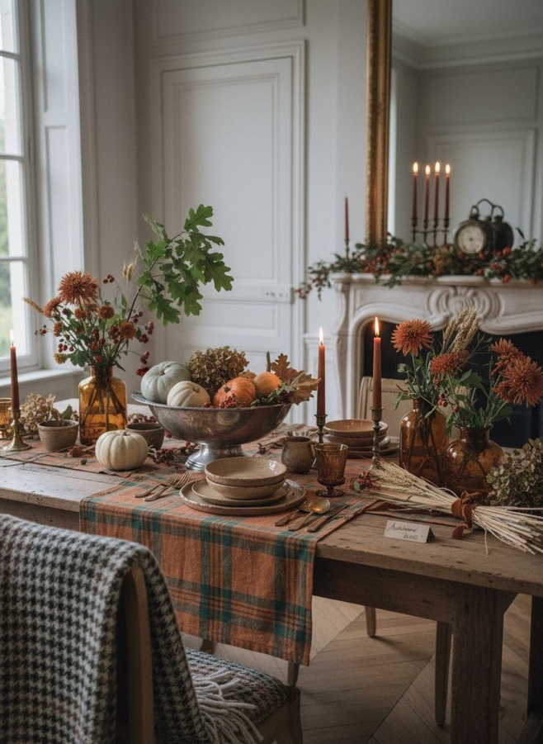

Fig. 5 Autumnal interiors

The way we respond to seasonal change may reflect more than aesthetic preference; it can support our natural cycles and rhythms. Exposure to changing light, colour and pattern has been shown to influence our circadian rhythm and emotional stability, helping align our inner rhythms with those of the natural world (Foster and Lockley, 2018). Therefore, adapting interior design in accordance with the seasons may provide subtle psychological benefits, reflecting the body's natural responses to the cycles of nature. Psychologist Kelly Watkins (2023) suggests that recognising seasonal changes can provide emotional balance and a sense of continuity, which helps us connect with the passage of time and transitions. This highlights how patterns and rhythms within the home can not only enhance aesthetic enjoyment but also promote psychological well-being.
The use of folklore in my project reflects how traditional almanacs blend practical seasonal knowledge with story and symbolism to interpret transitions in nature. In The Almanac: A Seasonal Guide, ‘A Song for September’ refers to the Celtic sun god Lugh and Brân the sparrow as symbolic figures representing the shift from late summer to the coming of winter, showing how folklore has helped people understand seasonal change through narrative rather than fixed dates (Leendertz, 2024, p. 211). I am inspired by the idea of exploring how the changing of the seasons carries emotional and symbolic significance, rather than just depicting these stories literally. By incorporating folklore in an almanac style, my work evolves into more than just a visual record of seasonal changes; it becomes part of a larger narrative.

Materiality |Methodology |Process
The concepts surrounding our emotional and psychological connection to seasonal changes have become central to my design practice. This understanding guides my exploration of how textiles and pattern design can reflect the changing rhythms of nature throughout the year. My collection will form a textile almanac; a tactile record of seasonal change that translates observations into patterns, textures, and colours. My aim is to create pieces that will subtly transition from one season to the next, incorporating motifs of plants, fruits, flowers, and animals that evolve throughout the year. Although each design will represent a specific point within the seasonal cycle, my intention is for them to be interchangeable while remaining visually cohesive, forming one unified collection. The colour palette will follow natural tonal shifts, moving gradually between the four seasons. Materiality will play an important role in my designs. For spring and summer, I will use lighter, sheer fabrics, such as cotton and linen. In contrast, I will use heavier textures such as wool and velvet to evoke warmth and comfort for autumn and winter. My process will combine hand-drawn and digital methods, starting with simple pencil sketches and translating these into more refined images using watercolour, gouache, charcoal and coloured pencils to capture natural variation in form and tone. These will be developed through digital fabric printing, digital embroidery, cyanotype, and the selective use of screen printing. While screen printing can produce striking results, it offers less control over detail and outcome than the processes I naturally gravitate towards. Since many of my designs originate as watercolour paintings, the tonal variations and nuances often become lost when translated into a screen-printed format. Therefore, I will use this process sparingly but intentionally, choosing the right moment where its qualities genuinely enhance my work. An example of this can be seen in my use of devoré on velvet for my hero piece created for the Monki live brief (Fig. 6).
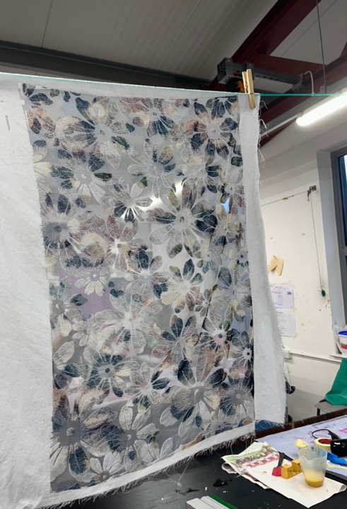
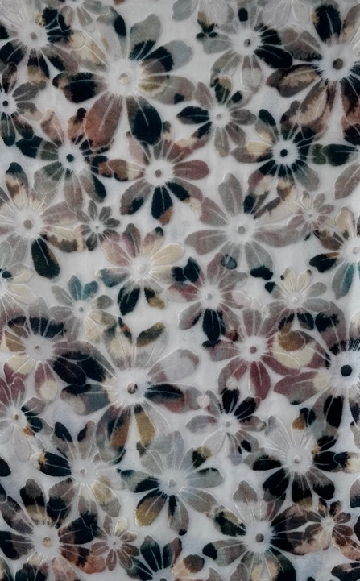

Fig. 6 Devoré on velvet

I will also explore the process of needle felting, a technique that involves poking layers of wool with barbed needles to tangle and compress the fibres. Felt artist Andrea Hunter demonstrates how wool and felt can be built up, shaped, and compressed to create expressive images (Hunter, 2025). Hunter’s artwork sits between drawing and textiles, using the wool to create soft lines, blended tones, and landscape-like textures (Fig. 7).
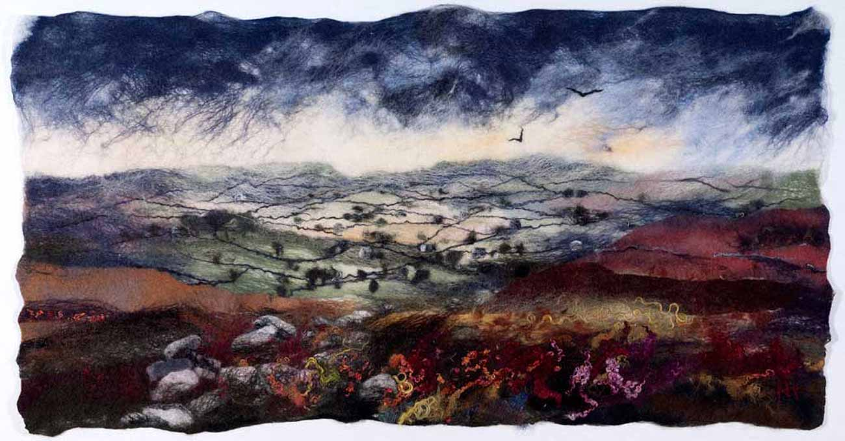

Fig.7 The Pennines

I am particularly drawn to her approach because it illustrates how felting can capture atmosphere and seasonal changes in a tactile way, something that I intend to incorporate into my own project. By using the industrial needle-felting machine, I will use simplified shapes of my imagery cut from wool, and repeatedly pass the layers through the machine. The agitation from this process creates softened, partially obscured forms that become increasingly ambiguous as they lose definition. This technique produces richly tactile pieces, but I also intended for it to reflect the current ambiguity of the seasons, which are becoming progressively harder to define due to climate change.

Critical Perspectives on Contemporary Design Practice
As a designer, I believe that everyone should have access to beautiful and meaningful designs, but this should not come at the expense of environmental damage and overconsumption. I advocate for a slower, more intentional approach to interiors that encourages people to make selective, lasting choices rather than following short-lived trends. While transitioning towards sustainability can be a slow process, investing in natural materials and timeless pieces supports both physical and emotional well-being. In my own home, I use wooden flooring, wool rugs, and natural fabrics such as cotton and linen to create a calm and harmonious space. While this perspective can be challenging within an industry driven by fast interiors and consumer demand, I will endeavour to balance my creative ambitions with my commitment to longevity, quality and environmental responsibility.
A contemporary designer whose values align strongly with my own is Molly Mahon. Her practice centres on traditional block printing, collaborating with skilled craftspeople in India, where every motif is printed by hand using carved wooden blocks (Fig. 8).
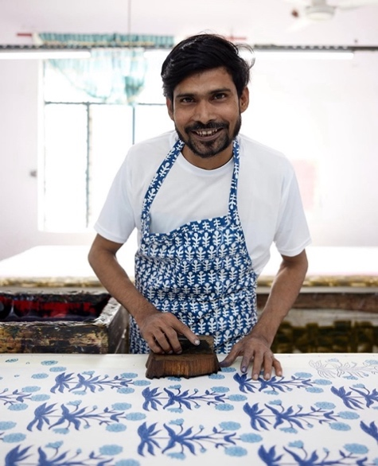

Fig. 8 Traditional wood-block printing

Mahon actively supports the makers she works with and pays above-average wages (Mahon, 2025). Her designs are heavily inspired by the natural world, featuring simple florals, leaves, and organic shapes. Her use of natural fibres, water-based inks and small-batch production offers a conscientious alternative to fast interiors, demonstrating how craft-led textiles can bring beauty and longevity into the home with minimal compromise to the environment.
While brands like Molly Mahon are genuinely committed to sustainable and ethical production, it is important to acknowledge the rise of greenwashing within the industry. Many companies portray themselves as environmentally conscious through the use of selective language and vague claims, without making significant changes to their materials or manufacturing processes (Delmas and Burbano, 2011). This can create a false sense of responsibility for consumers and raises ethical questions about authenticity and transparency for designers. Therefore, it is essential to understand the difference between genuine sustainability and performative marketing, especially in a field where nature-inspired designs are commonly used but do not always align with environmentally responsible practices.
It is also important to recognise that achieving complete sustainability within textile and interior production is extremely challenging. Many processes, such as dyeing, printing or fabric finishing, require chemicals, water or energy that cannot be fully eliminated without compromising the quality, longevity, or design of the product. A clear example of this is fire-retardant finishing, which is a requirement in the UK for upholstered domestic furniture (Fire Safety Advice Centre, 2024). These treatments involve chemical processes that are difficult to avoid; however, they play an essential role in ensuring safety in the home. As Fletcher and Grose (2012) argue, sustainability in textiles is less about achieving perfection and more about finding a balance between competing values. Even if a process cannot be entirely low-impact, clear communication is more important than presenting a misleading ‘green’ image. This means openly acknowledging where certain finishes are necessary, being honest about environmental limitations, and sharing information on waste, resource use or unavoidable chemical treatments.
This challenge is something I face within my own practice. One of the techniques I am most drawn to is devorè, yet it requires a fabric that contains both cellulose and synthetic fibres for the chemical process to work. This creates a conflict between my design preferences and my intention to work solely with natural fabrics. A natural alternative, such as cotton–silk velvet, would achieve the effect without synthetics, but it is significantly more expensive and realistically outside the budgets of myself and most consumers. This raises questions about accessibility, sustainability and compromise: should a technique be abandoned because it is not fully ethical, or is it more responsible to use it sparingly, transparently, and with clear justification? These considerations will form part of my research process, as they directly influence which designs can be produced and which will remain conceptual due to material limitations, allowing me to find a balance between creative ambition and environmental responsibility.
However, sustainability goes beyond just choosing the ‘right’ fabrics. It is also about how materials are used, valued and cared for. Taking care of what we already own, repairing textiles when possible, and investing in durable pieces are all important aspects of sustainable practice. In this context, sustainability is less about strict rules and more about a considered approach to materials. It involves making informed choices, being transparent about our limitations, and creating designs that people will want to keep, use, and care for over the years.
It is important to hold myself to the same standard of transparency that I expect from other brands, so I plan to keep a record of my own waste throughout the making process. This will include fabric, excess printing pastes and dyes, wastewater from dyeing, paper waste, gloves, and other small materials that get used and discarded. The wastage will be recorded by weight, alongside photographs, and documented at the end of my research journal. Through this process, I hope to gain a clear understanding of the environmental impact of each method, which will enable me to make more informed decisions as the project progresses.
An artist whose work aligns with my intention to document waste is Zwia Lipkin, who transforms discarded materials, particularly home-decor textiles, into layered collages (Fig. 9).
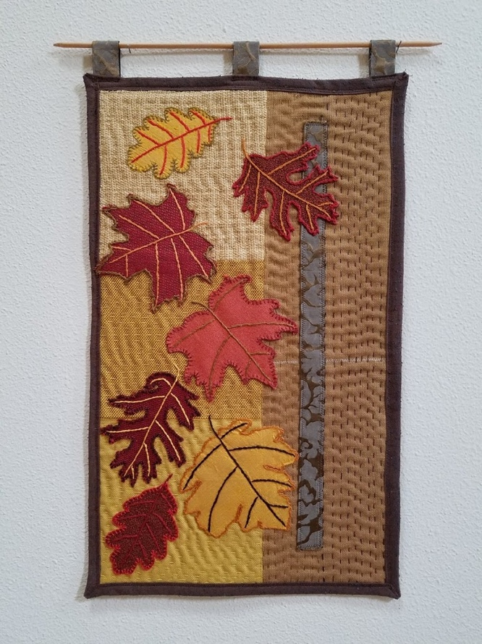

Fig. 9 Falling Leaves (2016)

By reworking fabrics that would typically be discarded, Lipkin challenges assumptions about value and demonstrates how waste can possess both visual and narrative potential. Her practice highlights the importance of noticing what is left behind in a making process, rather than overlooking it (Lipkin, 2021). This supports my decision to record my own material waste throughout the project, using it as a means to reflect on process, impact and the realities of working with textiles.

What does this body of work need to do for me?
This project aims to create a cohesive collection that reflects the changing seasons without encouraging unnecessary consumption. Each design will be interchangeable and complementary, forming a single collection that can be used year-round. As the seasons in the United Kingdom become less distinct, with berries ripening earlier and flowers blooming later, my pieces will mirror this natural overlap. By using natural fibres and a carefully considered colour palette, the collection will transition smoothly from one season to the next, supporting a slower and more thoughtful approach to decorating.
While I will prioritise the use of natural fabrics, not every process can be entirely environmentally low-impact, as certain chemical dyes are necessary to achieve the depth and durability of colour. I aim to be transparent about these choices and to explain where limitations arise, rather than portraying the collection as fully sustainable.
My goal is to be as sustainable as possible with the time, resources and techniques available, while remaining true to the folklore component, and the almanac-inspired narrative at the heart of the project.

How will I ensure success?

To ensure success next semester, I intend to work in a more structured and consistent way, using planning tools and realistic time management to maintain a steady workload. My working rhythm can fluctuate, with periods of intense hyperfocus followed by slower starts, which is a pattern I am learning to manage more effectively. Going into my third year, I have adapted my approach by breaking tasks into phases, setting realistic goals, and taking necessary breaks to maintain a healthier and more sustainable workload. Beyond university, success will rely on continuing to build my portfolio, strengthening my industry connections, and developing confidence in promoting my work. My goal is to establish myself as a designer whose practice is informed by research, craft, and sustainability, enabling me to attract suitable clients and establish a professional presence.

Bibliography

Barringer, T. (1998) Reading the Pre-Raphaelites. New Haven: Yale University Press.

BBC Wales (1977) Laura Ashley interviewed on Kane on Friday [online] available at: https://www.facebook.com/BBCArchive/videos/604587441236347/?rdid=xUVRV5khSZdp9vBG [accessed: 02.12.2025]

Delmas, M.A. and Burbano, V.C. (2011) ‘The drivers of greenwashing’, California Management Review, 54(1), pp. 64–87.

Fire Safety Advice Centre (2024) Furniture and Furnishings (Fire Safety) Regulations 1988, 1989 and 1993. [online] Available at: https://www.firesafe.org.uk/furniture-and-furnishings-fire-safety-regulations-19881989-and-1993/ (Accessed: 16th November. 2025).

Fletcher, K. and Grose, L. (2012) Fashion & Sustainability: Design for Change. London: Laurence King.

Foster, R. and Lockley, S. (2018) Circadian Rhythms: A Very Short Introduction. Oxford: Oxford University Press.
House of Hackney. (2025) Our Story. [online] Available at: https://www.houseofhackney.com/pages/our-story (Accessed: 6th November. 2025).

Hunter, A. (2025) Focus on Felt. [online] Available at: http://www.andreahunterfocusonfelt.co.uk/ (Accessed: 16th November).

Leendertz, L. (2024) The Almanac: A Seasonal Guide to 2025. London. Octopus Publishing Group Ltd.

Lipkin, Z. (2021) Zwia Lipkin: Textile and Mixed-Media Artist. [online] Available at: https://www.zwialipkin.com (Accessed: 2nd December 2025).

Molly Mahon. (2025) About Us. [online] Available at: https://mollymahon.com/pages/about-us-1 (Accessed: 16th November 2025).

Naylor, G. (1989) William Morris by Himself: Designs and Writings. London: Little, Brown and Company.

Nicholls-Lee, D. (2025) ‘Gentle, gracious living’: Laura Ashley and how the ‘prairie homemaker’ lifestyle took hold. BBC Culture. [online] Available at: https://www.bbc.co.uk/culture/article/20250904-laura-ashley-and-how-homestead-chic-was-born-in-wales (Accessed: 2nd December. 2025).

Prettejohn, E. (2000) The Art of the Pre-Raphaelites. London: Tate Publishing.

Stephan, E., Sedikides, C. and Wildschut, T. (2012) ‘Mental travel into the past: Differentiating recollections of nostalgic, ordinary, and positive events’, European Journal of Social Psychology, 42(3), pp. 290–298.

Watkins, K. (2023) ‘Noticing Seasonal Changes: A Psychologist’s Perspective on Transition and Well-being.’ Kelly Watkins Psychology Blog. [online] Available at: https://kellywatkins.co.uk/noticing-seasonal-changes-a-psychologists-perspective-on-transition-and-well-being/ (Accessed: 8th November 2025).

Wilson, E.O. (1984) Biophilia. Cambridge, MA: Harvard University Press.

