

Name – Jay-Ryan Weaver

Student Number – P151948

Course – HND Quantity Surveying (Year 2)

Module – Work Based Project (ACBA5009)

Assignment Title – Learning Contract

Submission Date – 14th November 2019
Company Name and Address – Morganstone Ltd, Llanelli Gate, Llanelli SA14 8LQ
Contact Name and Number – Kelvin Rees (Managing Surveyor) 01554 779126
Project Detail – The role of the main contractor’s Quantity Surveyor, specifically looking at financial reporting and the decisions made by senior management based on the report’s data. This will be done whilst being the QS on the following projects:

Project A – Lon Brynawel
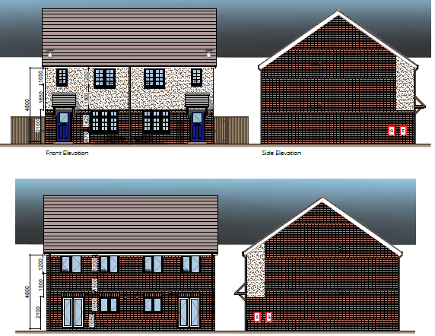
A social housing package deal, consisting of 16nr 3 bedroom semi-detached properties for Pobl Group. This project is based in Llansamlet, Swansea and is programmed to be handed over in April 2020.
Client – Pobl Group
Client’s Agent – ER Brown
Architect – Morganstone Ltd

Project B – College Road
A package deal of an apartment block consisting of 27nr units with large communal areas, surrounded by 6nr bungalows for Linc Cymru. These properties will be handed over in February 2020 and has been designed as retirement properties for over 55 year olds.
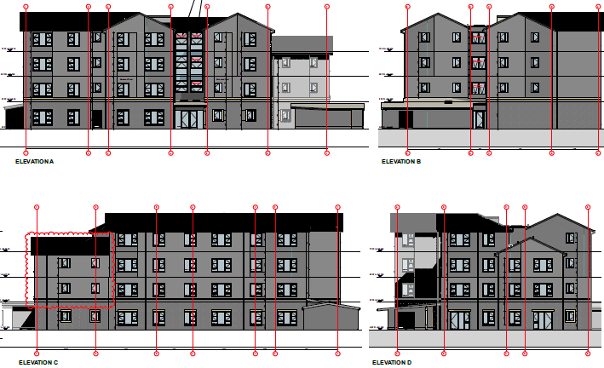
Client - Linc Cymru
Client’s Agent – Strongs
Architect – Quattro

Index
- Introduction
- Learning Contract

- Introduction
A learning contract is an independent study where the student will initially agree with their lecturer clear objectives which they want learn or gain more knowledge in a particular area. This learning contract is to be done whilst in work, or a placement, and will give the student an ownership of their own learning with a view of then reflecting on what they have learnt after setting clear goals and objectives.
The benefits of a learning contract is that it uses the students maximum motivation to learn as they have chosen the objectives themselves and it encourages the students to work independently, gaining valuable experience required for their job in the present or future time. On the other hand, a learning contract may not be the best type of learning for some students and they may struggle, therefore requiring more time from their lecture, in which it is meant to minimise the time required for a lecturer. Also, in this case, if the student is not already working as part of the construction industry, as they are a full-time student it is challenging for them to gain a placement and the company to share as much information with them for their contract as the company may deem this information to be private and may not be willing to share this information to individuals who are not their employees.
For a learning contract to be successful, the student is to initially submit a learning contract indicating objectives they want to learn (as mentioned earlier in this report) and then record a weekly record schedule detailing what they have been working on or what they have learnt, all of which should relate to their objectives. Finally, the student is to then meeting with their lecturer regularly to review what they have learnt and discuss the progress they have made, raising any queries they may have.
2.0 Learning Contract
During this learning contract, I will be working full-time with my current employer, Morganstone Ltd, a Llanelli based Construction Company. Where I will be performing my current role as an Assistant Quantity Surveyor and will be looking to broaden my understanding of the importance of my role on the company, and the decisions effected with the information I produce to senior management. As such, I will be aiming to improve my knowledge on the 3 main points detailed below:

- The importance of the CVR/Cost Report
- The significance of an accurate cash flow forecast
- The decisions made by senior management following financial reporting has been presented
This will be done by working on two live residential projects as the project’s Quantity Surveyor. The projects I will be working on will be a 33 unit retirement apartment block (and bungalows) and the other will be a 16 semi-detached properties for another local authority. Whilst working on these projects, I will be asking senior management such as the Managing Surveyor and Construction Director questions regarding the objectives I want to improve on. For my final objective, objective 3, I will be speaking with the Managing Director to get his response to some questions that I will be thinking about throughout the period of this project. Also, I will be using documents such as Microsoft Excel and Word to analyse and record my findings. These databases will also be used in my everyday work tasks such as updating and presenting the CVR Report in project meetings, with the site team.
The target date for my final reflective journal will be 30th April 2020, but I will be aiming to complete the three objectives by the following dates:
- Objective 1 – CVR Report importance 19th February 2020
- Objective 2 – Cash flow forecast importance 9th March 2020
- Objective 3 – Decisions made by financial data 30th March 2020
Once I have finished the period required for the learning contract, I will submit a reflective journal of the process. Included in the reflective journal will be a written document, describing if I learnt the objectives I have mentioned and providing evidence showing this. This evidence will detail what I have learnt about the three objectives and will show examples of this throughout the document, which will then be submitted to my mentor to provide feedback, confirming if I have achieved the three objectives initially set out or not.

