Name:_ Olcay Sivas________________________________

Student Number: 2331962________________________
__________________________________________________________

WORKSHEET 1 – TESTING (Using Variables)

- Original code:
[Copy and paste your original code from Moodle into this box. Do not change it.]
#define _CRT_SECURE_NO_WARNINGS
#include <stdio.h>
#include <string.h>
#include<math.h>
void main()
{
char surn[20], nati[10];
int age, i, j, length;
float workh;

printf("Please enter your surname : ");
scanf("%s", &surn);

length = strlen(surn);

while (length <= 2)
{
printf("Length of surname is too short please enter a valid surname including at least 3 characters: ");
scanf("%d", surn);
}
if (length > 10)
{
printf("Waow long surname!\n");
}

printf("Please enter your National Insurance Number : ");
scanf("%s", nati);

length = strlen(nati);
//printf("%d", length);
while (length != 9)
{
printf("National Insurance Number must be 9 characters long, please try again: ");
scanf("%s", nati);
}

printf("Your age: ");
scanf("%d", &age);

while (age <= 0 || age >= 99)
{
printf("Invalid attempt, please enter an age between 1-89:\n ");
scanf("%d", &age);

}
if (age >= 0 || age <= 89)
{
printf("Your age is %d \n", age);
}

printf("How many hours do you work per week : ");
scanf("%f", &workh);

while (workh <= 0 || workh >= 168)
{
printf("Invalid number please enter a number between 1-168: ");
scanf("%f", &workh);
}
if (workh <= 30)
{
printf("You're a part time worker.");
}
else
{
printf("You're a full time worker.");
}

}

- Code Testing

For each test below, run your code and enter the values provided. Present a screenshot of the programme running. Did the programme behave correctly or did it do something unexpected, and if so, why?

Surname:
- Enter JONES
- Leave blank
- Enter A
- Enter 123

National Insurance Number:
- Enter PE534121B
- Leave blank
- Enter AB11223344556677 (ie too long for National Insurance number format)

Age
- Enter 34
- Enter 150
- Enter -4
- Enter a letter

Number of working hours per week:
- Enter 37.5
- Enter 105
- Enter 0
- Enter -2

Fill in a box for each test above. You should present 15 separate boxes, 1 for each test. (Note: the two boxes are provided as a template)

Test:
Surname i. Enter JONES

Screenshot(s) of output: 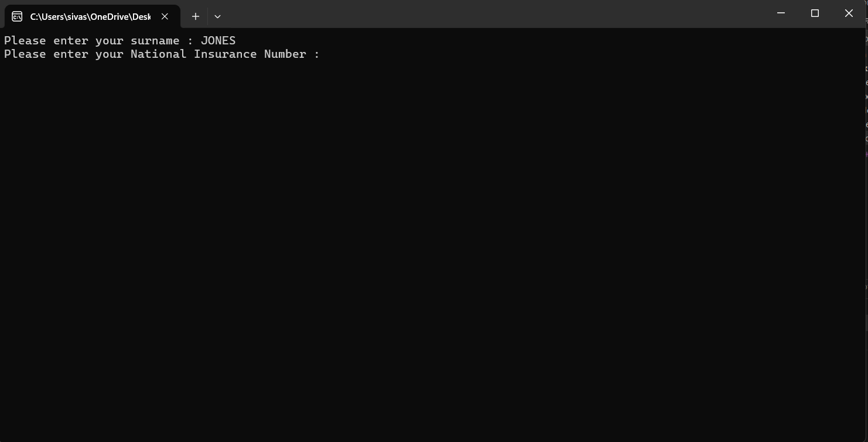

Result: Did the programme behave as expected ie syntactically and logically correct?
Yes, the “JONES” surname was accepted as a valid surname by the program and it has moved on to the next question.

Test:
Surname ii Leave blank

Screenshot(s) of output: 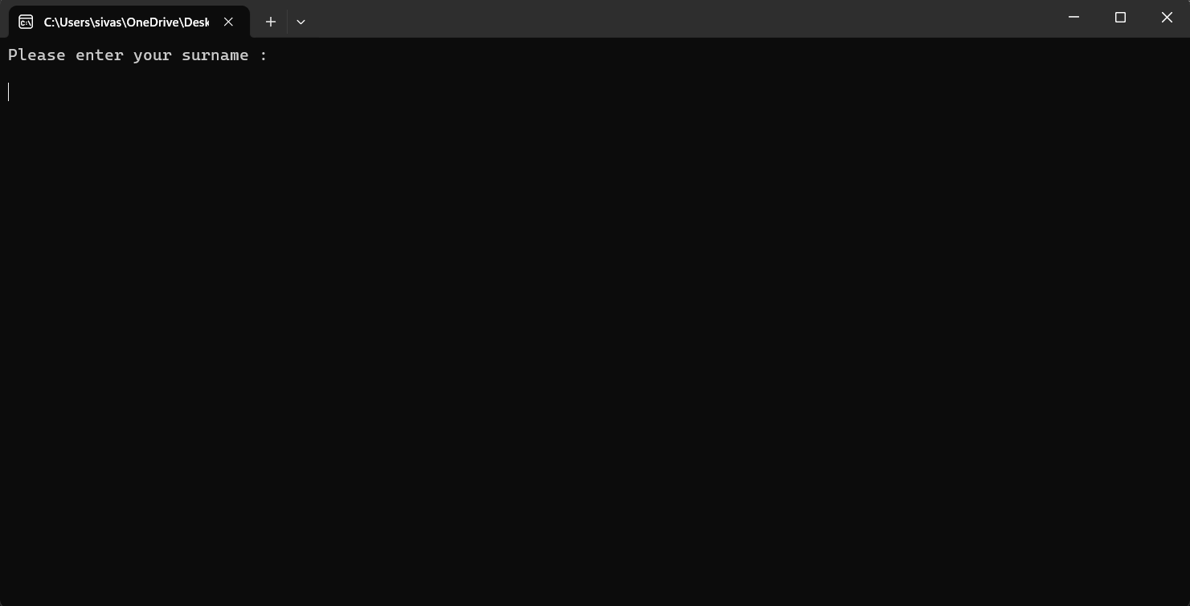

Result: Did the programme behave as expected ie syntactically and logically correct?
No, the enter key hasn’t been recognised as an input by the program and was interpreted as a space between lines. The next question hasn’t been started and the and next character is still waiting.

Continue the rest of the tests below. (Copy and paste a box for each one)

- Test: Surname iii Enter A

Screenshot(s) of output: 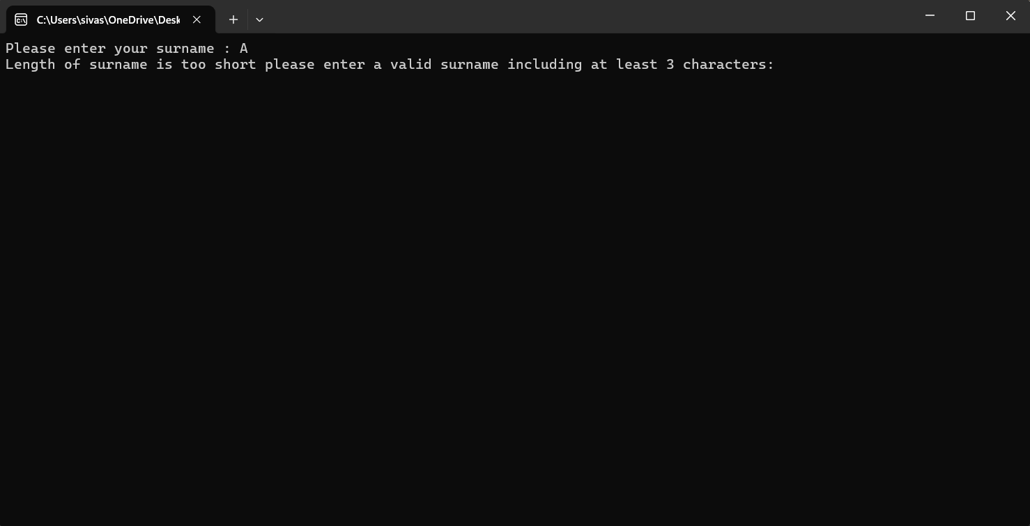

Result: Did the programme behave as expected ie syntactically and logically correct?
Yes, the only one character was recognised as too short for a surname by the program and the user was asked to put a valid input.

- Test: Surname iv Enter 123

Screenshot(s) of output: 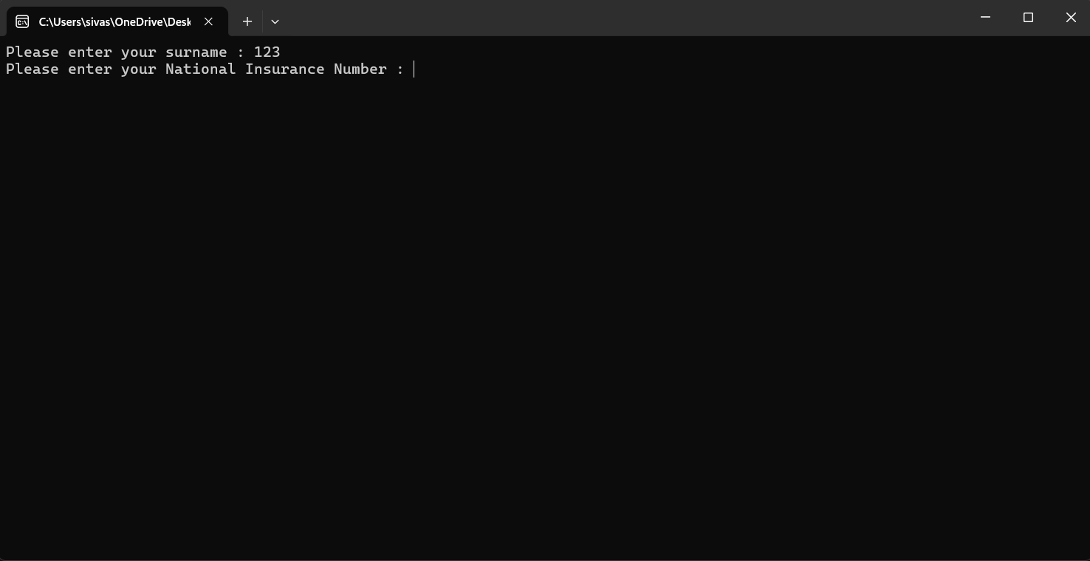

Result: Did the programme behave as expected ie syntactically and logically correct?
No, the 123 answer been accepted as a valid surname by the program because only the length of it was checked. The content of the surname wasn't able to be checked by the program as content of surname shouldn’t have included numbers or special characters.

Test: NIN i Enter PE534121B

Screenshot(s) of output: 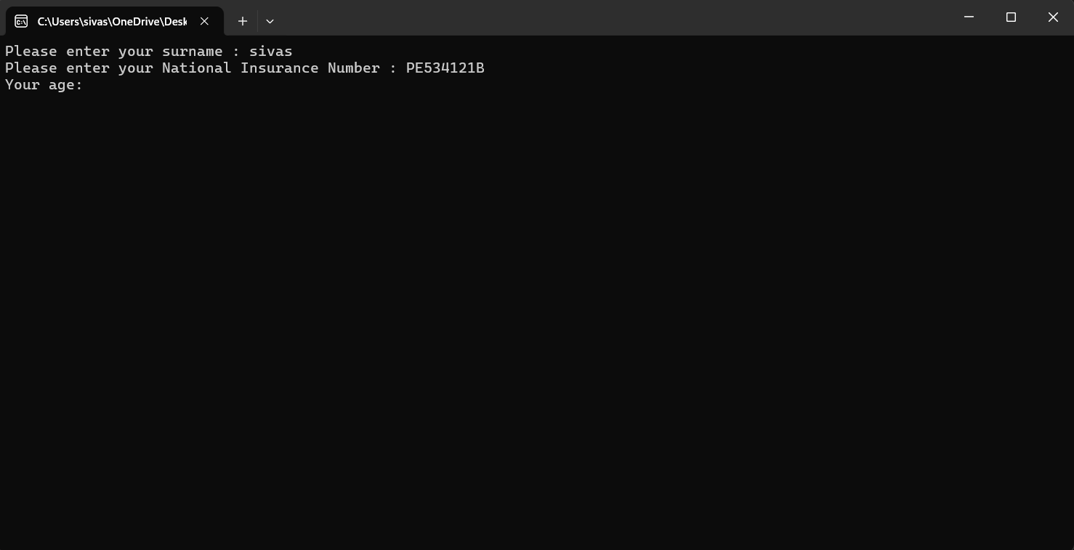

Result: Did the programme behave as expected ie syntactically and logically correct?
Yes, the PE534121B has been accepted as a valid 9 character long National Insurance Number by the program.

- Test: NIN ii Leave blank

Screenshot(s) of output: 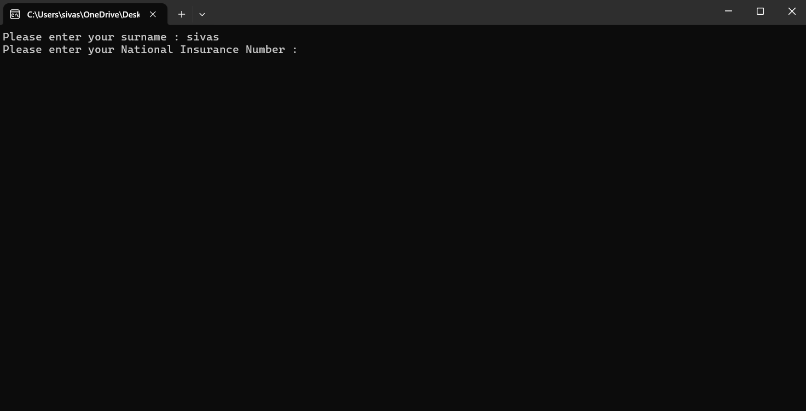

Result: Did the programme behave as expected ie syntactically and logically correct?
No, same as the surname issue, the enter key hasn’t been checked as an input by program. It’s been treated as a space between lines and the next question hasn’t been able to being moved into.

Test: NIN iii Enter AB11223344556677

Screenshot(s) of output: 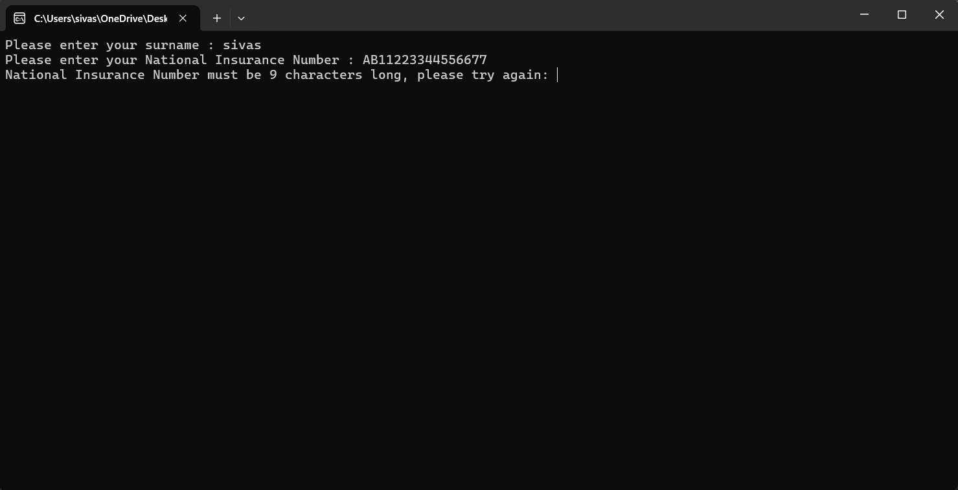

Result: Did the programme behave as expected ie syntactically and logically correct?
Yes, different than 9 character long input been rejected by the program correctly and user been re asked to put a valid input.

Test: AGE i Enter 34

Screenshot(s) of output: 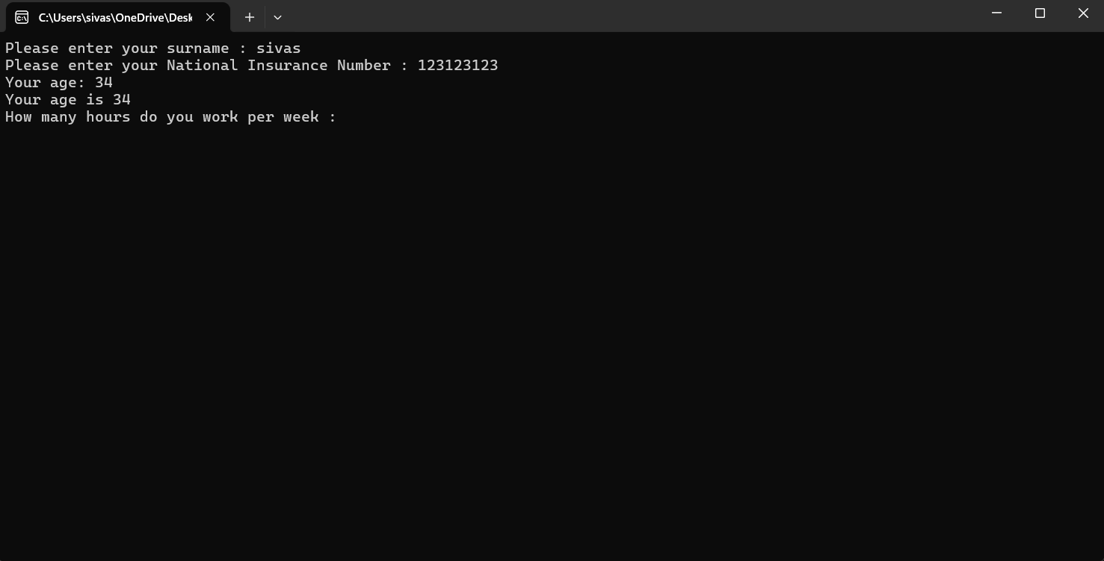

Result: Did the programme behave as expected ie syntactically and logically correct?
Yes, the age 34 been accepted as a valid age by program without any issue.

- Test: AGE ii Enter 150

Screenshot(s) of output: 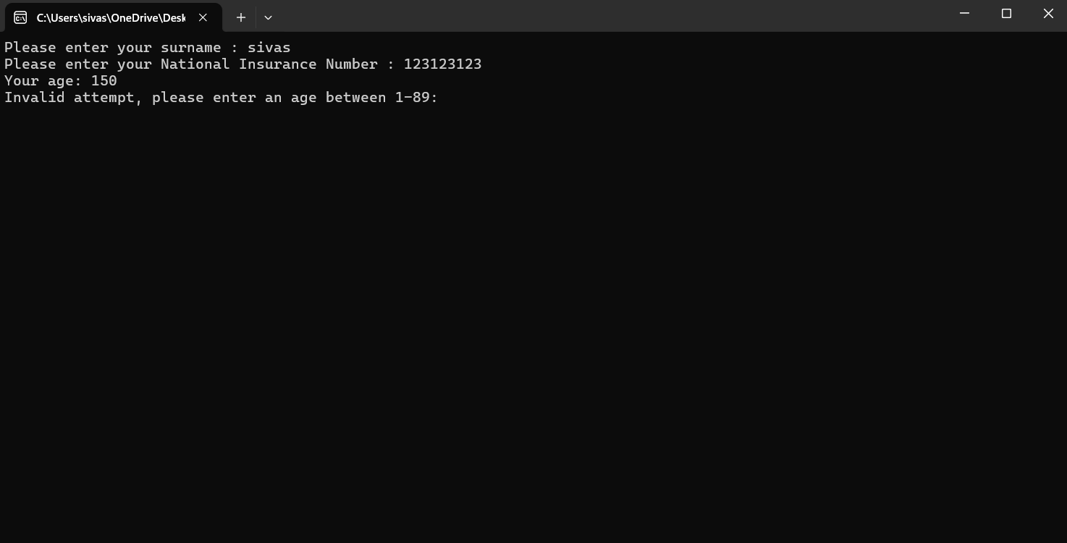

Result: Did the programme behave as expected ie syntactically and logically correct?
Yes, the age 150 hasn’t been accepted by the program as 89 been accepted as maximum age gap for working and the user was asked to re answer the question.

- Test: AGE iii Enter -4

Screenshot(s) of output: 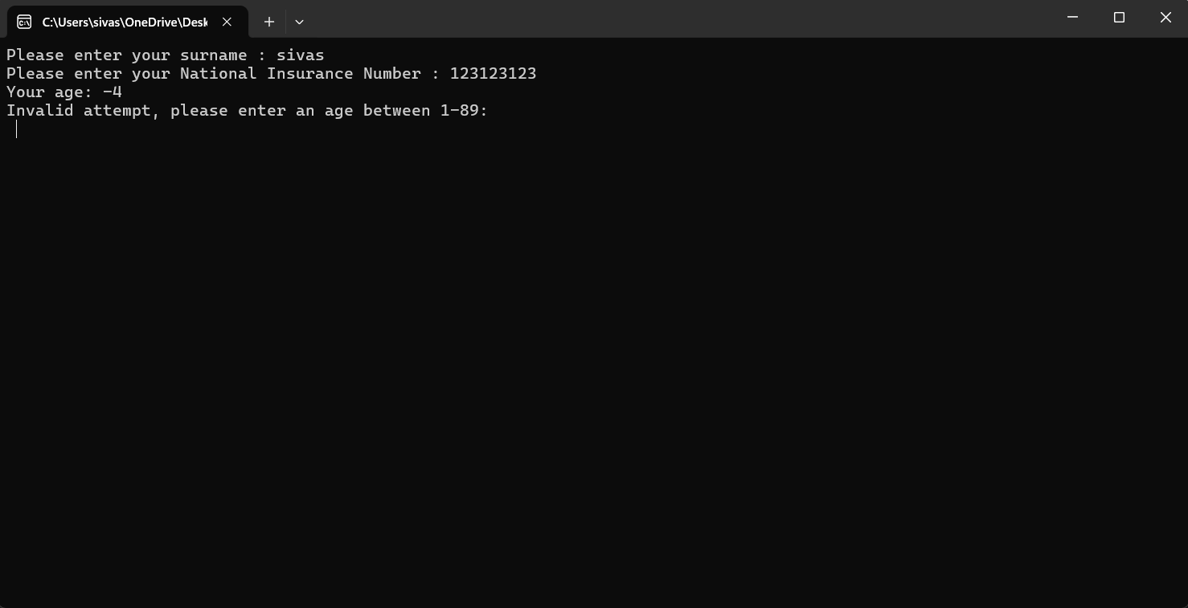

Result: Did the programme behave as expected ie syntactically and logically correct?
Yes, the age of -4 correctly been rejected by the program as an invalid input and user been asked to put a valid input.

- Test: AGE iv Enter a letter

Screenshot(s) of output: 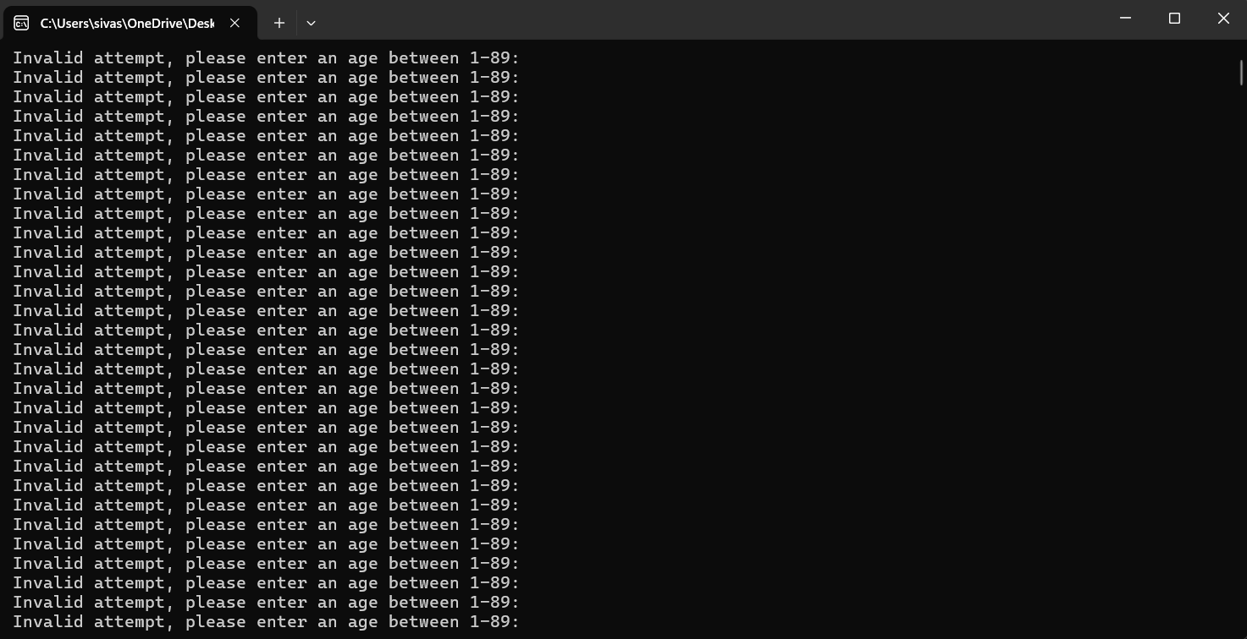

Result: Did the programme behave as expected ie syntactically and logically correct?
No, the infinite loop has been gone into by the program and reading a letter been failed by scanf so it has been tried to be read infinitely.

- Test: WORK i Enter 37.5

Screenshot(s) of output: 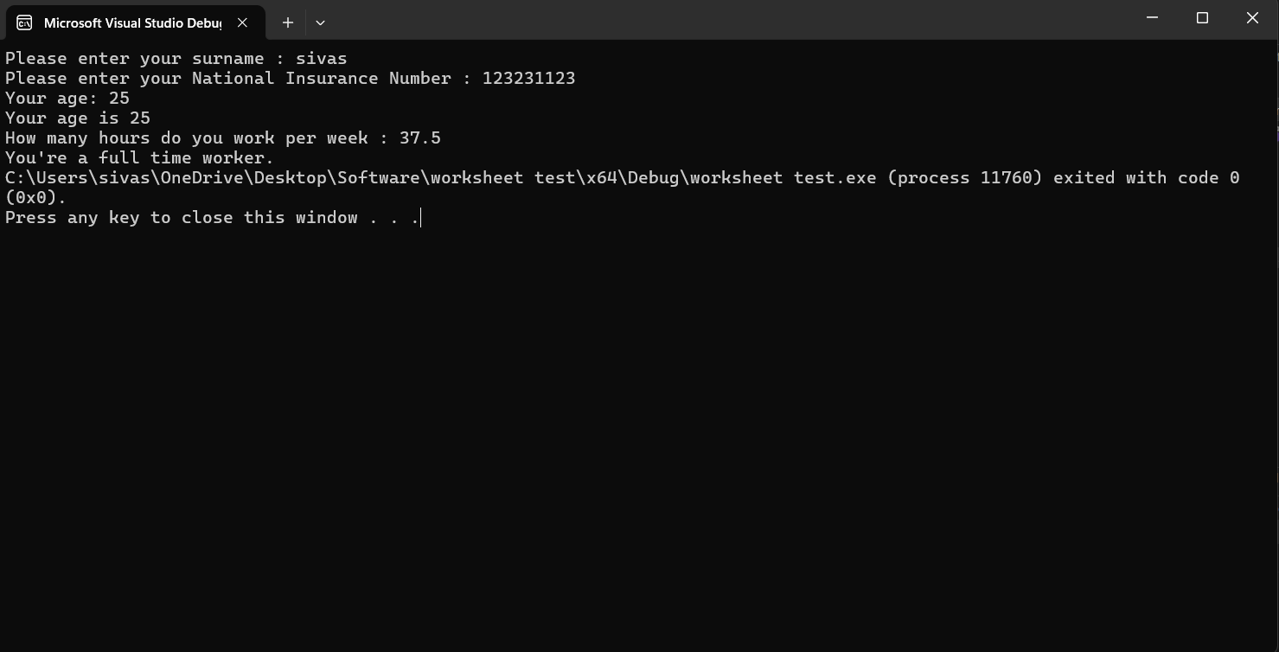

Result: Did the programme behave as expected ie syntactically and logically correct?
Yes, the age of float 37.5 was accepted as valid working hours by the program without issue.

- Test: WORK ii Enter 105

Screenshot(s) of output: 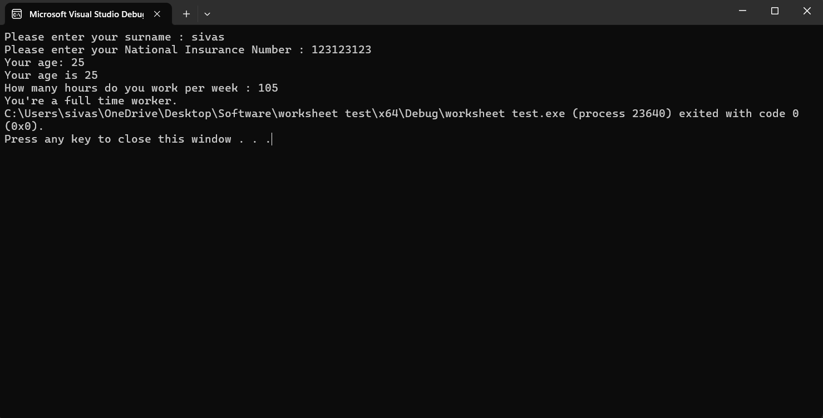

Result: Did the programme behave as expected ie syntactically and logically correct?
Yes, the 105 hours been accepted as valid working hours by the program.
No, the 105 hours shouldn’t have been accepted due to maximum working hours in UK been set to 48 a week.

- Test: WORK iii Enter 0

Screenshot(s) of output: 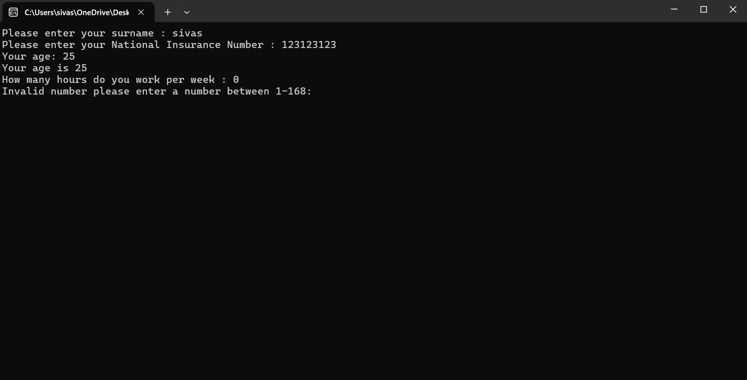

Result: Did the programme behave as expected ie syntactically and logically correct?
Yes, the 0 hours working time was rejected by the program as 0 has been accepted invalid in the code provided.

- Test: WORK iv Enter -2

Screenshot(s) of output: 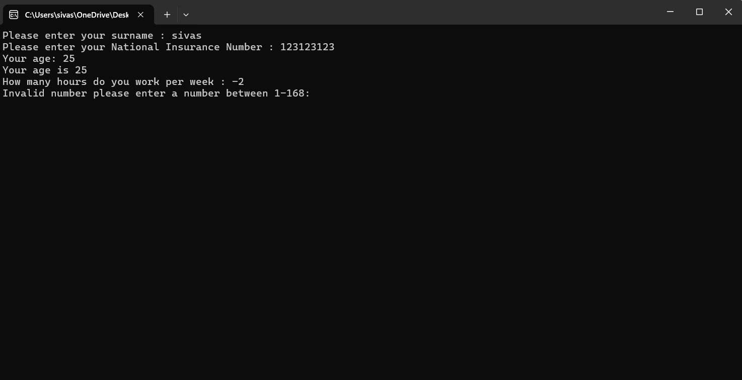

Result: Did the programme behave as expected ie syntactically and logically correct?
Yes, -2 hours been rejected by the program as negative numbers been accepted invalid in the code provided.

- Consider the results of the above tests and revisit your code in order to solve the problems. (Note: you may not be able to solve all of them, but solve as many as you can.)

Paste your revised code here:

#define _CRT_SECURE_NO_WARNINGS
#include <stdio.h>
#include <string.h>
#include <math.h>

void main()
{
char surn[20], nati[20];
int age, valid, length;
float workh;

valid = 0;
while (valid == 0)
{
printf("Please enter your Surname: ");
scanf("%s", &surn);
length = strlen(surn);

if (length < 2)
{
printf("Length of surname is too short please enter a valid surname including at least 3 characters.\n");
}
else
{
valid = 1;
for (int i = 0; i < length; i++)
{
if ((surn[i] < 'A' || surn[i] > 'Z') && (surn[i] < 'a' || surn[i] > 'z'))
{
valid = 0;
}
}

if (valid == 0)
{
printf("Error: Surname can't contain numbers or symbols. Please try again.\n");
}
}
}

if (length > 10)
{
printf("Waow long surname!\n");
}

valid = 0;
while (valid == 0)
{
printf("Please enter your National Insurance Number (e.g. PE253412B): ");
scanf("%s", nati);
length = strlen(nati);

if (length != 9)
{
printf("National Insurance Number must be 9 characters long, please try again.\n");
}
else
{
valid = 1;

if ((nati[0] < 'A' || nati[0] > 'Z') && (nati[0] < 'a' || nati[0] > 'z'))
{
valid = 0;
}

if ((nati[1] < 'A' || nati[1] > 'Z') && (nati[1] < 'a' || nati[1] > 'z'))
{
valid = 0;
}

for (int i = 2; i <= 7; i++)
{
if (nati[i] < '0' || nati[i] > '9')
{
valid = 0;
}
}

if ((nati[8] < 'A' || nati[8] > 'Z') && (nati[8] < 'a' || nati[8] > 'z'))
{
valid = 0;
}

if (valid == 0)
{
printf("Error: Invalid Format. NIN must start with 2 letters, followed by 6 numbers, and end with 1 letter.\n");
}
}
}

valid = 0;
while (valid == 0)
{
printf("Your age: ");
if (scanf("%d", &age) == 0)
{
scanf("%s", &surn);
printf("Invalid attempt, please enter a number.\n");
}
else
{
if (age < 16 || age > 110)
{
printf("Invalid attempt, please enter an age between 16-110.\n");
}
else
{
valid = 1;
}
}
}
printf("Your age is %d \n", age);

valid = 0;
while (valid == 0)
{
printf("How many hours do you work per week : ");
if (scanf("%f", &workh) == 0)
{
scanf("%s", &surn);
printf("Invalid number please enter a number.\n");
}
else
{
if (workh <= 0 || workh > 48)
{
printf("Invalid number please enter a number between 1-48.\n");
}
else
{
valid = 1;
}
}
}

if (workh <= 30)
{
printf("You're a part time worker.\n");
}
else
{
printf("You're a full time worker.\n");
}

printf("\n------------------------------------------------\n");
printf("EMPLOYEE DETAILS CONFIRMATION\n");
printf("------------------------------------------------\n");
printf("Surname: %s\n", surn);
printf("NI Number: %s\n", nati);
printf("Age: %d\n", age);
printf("Weekly Hours: %.2f\n", workh);
printf("------------------------------------------------\n");
}

