A simple token based distributed network
Distributed Intelligence Systems
(ACDA5018)
Electrical and Electronic Engineering

Ayoob Mohammed Azhar (2400571)

CONTENTS

Introduction page 2

Background research page 3

System design page 4 - 5

Development page 6 - 11

Analysis page 12 - 14

Conclusion page 15

References page 16 - 17

Introduction
The purpose of this report is to design and implement a project that demonstrates a simple token based distribution network to control the lights on a single corner of a vehicle using Proteus software. Additionally, the project will also be attempted on a breadboard. This will be done by developing a microcontroller-based system that uses a master device to coordinate communication with a slave to control the required outputs.

Background research
Point-to-point is a communication protocol in which there is a direct communication link between two devices (a single master and a single slave device), and every data delivered by one device is destined for and received by a single other device. The advantages of this are simplicity, high reliability and easy troubleshooting as there are no devices in between that share the network. However, disadvantages include poor scalability when many devices need to communicate, and the need for separate wiring for each connection. [1]
UART (Universal Asynchronous Receiver Transmitter) is a good example, as it uses two lines, TX (for transmitting data) and RX (for receiving data), between two devices to exchange data asynchronously (without a shared clock). In automotive applications, UART is usually used for communication between OBD (on-board diagnostic) systems and external diagnostic tools, aiding maintenance, and to interface with peripherals such as display modules and infotainment systems [2][3].
Point-to-multipoint is a communication protocol in which a single device (master device) coordinates multiple other devices (slave devices) over a shared medium to communicate with them [4]. Its advantages include reduced wiring for multiple devices connected to the network, easy scalability for systems with one controller and many endpoints, and cost efficiency. However, disadvantages include data collision when multiple devices try sending data simultaneously on a shared channel, increased complexity of the system, and the master device becoming a single point of failure (if the master fails, all slaves lose communication).
One example is SPI (Serial Peripheral Interface), as it uses shared MISO (Master In Slave Out), MOSI (Master Out Slave In), and SCK (Serial Clock) lines with individual slave select signals to communicate with multiple slaves synchronously (using a shared clock generated by the master device). SPI in automotive applications is usually used in ECUs to allow quick communication between a microcontroller and its peripheral ICs, for example, a microcontroller that reads data from a temperature sensor and stores it in an EEPROM [5].
Multi-master is a communication protocol that allows communication between multiple masters and slaves by connecting multiple devices to a single bus or network. Its advantages include fault tolerance, if one master fails, another master device is there to communicate, high flexibility that allows multiple devices to initiate communication whenever needed, and the efficient use of a single bus for multiple devices. However, disadvantages include high complexity, the likelihood of data inconsistency, and extremely challenging conflict resolution due to the possibility of simultaneous writes on several devices. [6]
An example of this is I2C (Inter-Integrated Circuit), which uses two lines, SDA (serial data line) and SCL (serial clock line), allowing multiple masters and slaves to share the same two-wire bus for data transfer. Master devices use arbitration for bus access, while slaves respond to unique addresses. CAN (Controller Area Network) bus topology is significantly used in automotive applications for real-time communication between multiple ECUs, such as engine, brakes, and transmission, prioritising critical safety messages first [2][7].

System design
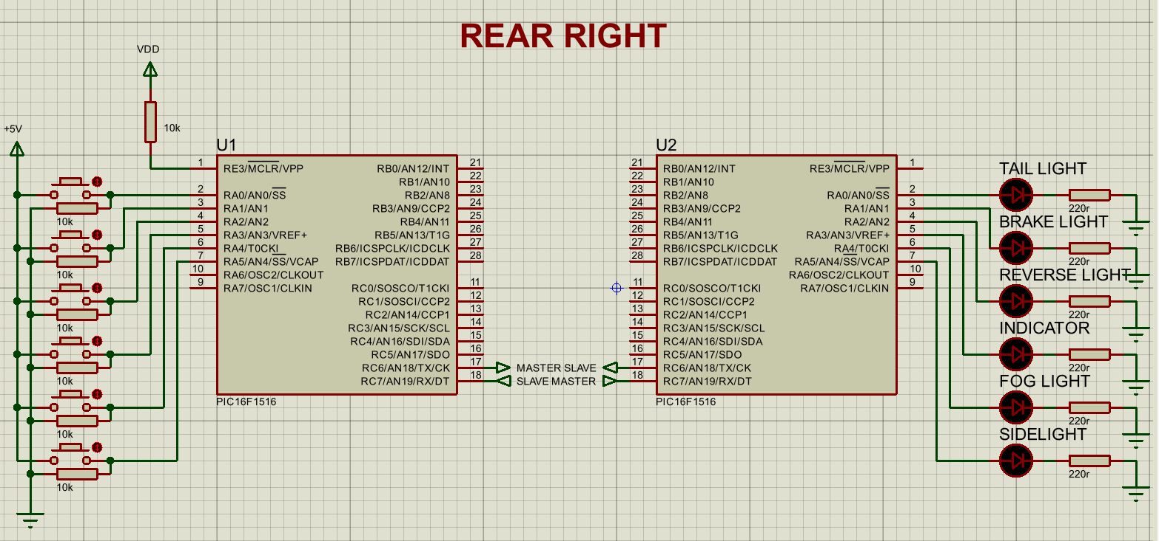
For this project, the rear right side of a car in the UK will be demonstrated as the distributed network for a single corner vehicle lighting system.
Figure 1: Proteus circuit design
Figure 1 shows the circuit design in Proteus. The PIC16F1516 master device receives button inputs, generates tokens internally, and sends these tokens via UART (transmitted over RS-232) to the PIC16F1516 slave device. The slave device then interprets these token commands and drives the outputs.
As shown in Figure 1, button inputs are connected to port A of the master through pull-down resistors, making this circuit an active-high. When a button is pressed, the input reads HIGH, and when it is released, the input reads LOW. The 10k resistors prevent floating inputs and ensure a stable, reliable signal is read. A 10k pull-up resistor is connected to the MCLR pin to prevent accidental resets and keep the PIC running smoothly. Communication is achieved through both the PIC microcontroller’s TX (transmit) and RX (receive) pins. Token commands are sent from the master’s TX pin (pin C6) and received by the slave's RX pin (pin C7).
The LED lights are connected to port A of the slave to represent the vehicle’s rear lighting output, along with 220 ohm resistors connected to each of them to ensure current is limited for safe operation, and are driven by the token command the slave receives. The lighting system includes: three red colour LEDs to represent the taillight, brake light, and sidelight, 2 white colour LEDs to represent the reverse light and fog light, and an amber colour LED to represent the indicator, which are the rear lights found in UK cars [8]. The indicator light should flash between 60 and 120 times per minute according to UK regulations [9]. In the system design here, 120 flash/minute is chosen. One full flash cycle is: 1 min = 60000ms, 60000ms/120 = 500ms, which means 250ms ON time plus 250ms OFF time for the LED.
In this system, the point-to-point communication protocol, UART, was chosen for its simplicity and reliability. It uses only two wires, TX and RX, for communication, where the master sends commands, and the slave responds directly, unlike I2C, which uses 2 wires but needs pull-up resistors and addressing, or SPI, which is more complex because it uses four wires and needs a slave select.
When considering the PIC microcontroller, the PIC16F1516 (28-pin package) was chosen because it met the system design requirements for this project. Importantly, it has an EUSART module that provides built-in UART support for RS232 communication [10]. It sufficiently provides 25 programmable I/O pins for all the necessary button inputs (using 6 pins of the master PIC) and LED outputs (using 6 pins of the slave PIC), with spare pins for future expansion, such as for an LCD for light status updates. Additionally, it has I2C capability for potential system design upgrades, such as adding additional slaves for different other lighting outputs [10]. The same type of PIC was chosen for both microcontrollers because it makes it easy for program development, debugging and maintenance. This avoids PIC-specific coding problems and makes it easy to add more features or PIC microcontrollers later.

Development
Pseudocode
The system logic is described in the pseudocode below, showing how each device should operate before developing the final C programs.
Master device:
Start
Main loop
Repeat forever
Read the input value from port A
Send the port A value through UART as a byte
End repeat
End
Slave device:
Define an unsigned integer variable to store the byte
Start
Main loop
Repeat forever
If a byte is in the UART receive buffer
Read the byte and store it in the variable
Update the port A LED output using the byte value stored in the variable
End if
If the byte value stored in the variable is = 0x08
Turn the LED connected to pin A3 ON
Wait 250ms
Turn the LED connected to pin A3 OFF
Wait 250ms
End if
End repeat
End

Code listings
The code listings in Figures 2 and 3 below show the final implementation of the master and slave programs reflecting the system logic developed during the pseudocode stage.
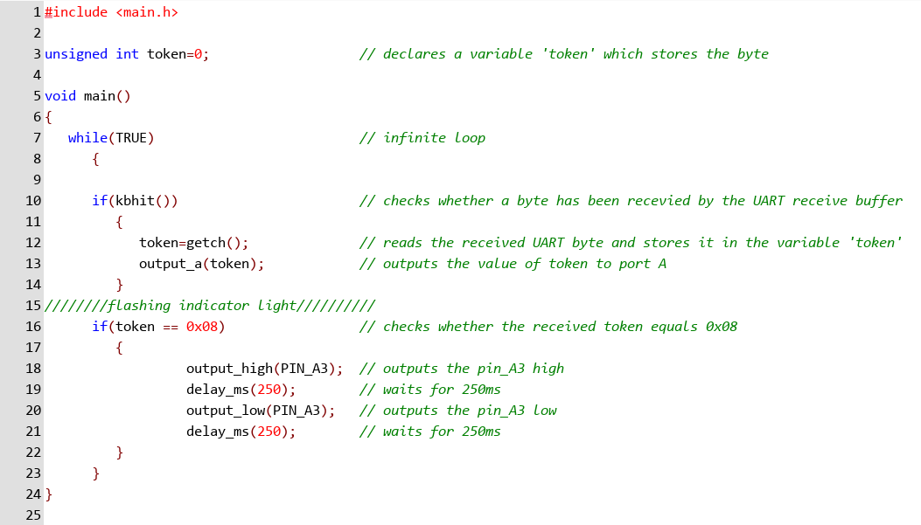
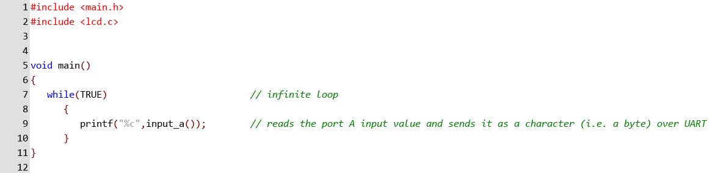
Figure 3: Screenshot of slave PIC code
Figure 2: Screenshot of master PIC code

Proteus simulation results
The simulation screenshots shown in Figures 4 to 9 illustrate the system's functionality, showing the behaviour of each output when the button input is held down. Note: the indicator ‘flashing’ cannot be seen in Figure 7; however, this, in addition to the overall functionality, can be confirmed in the attached project files (provided with this report).

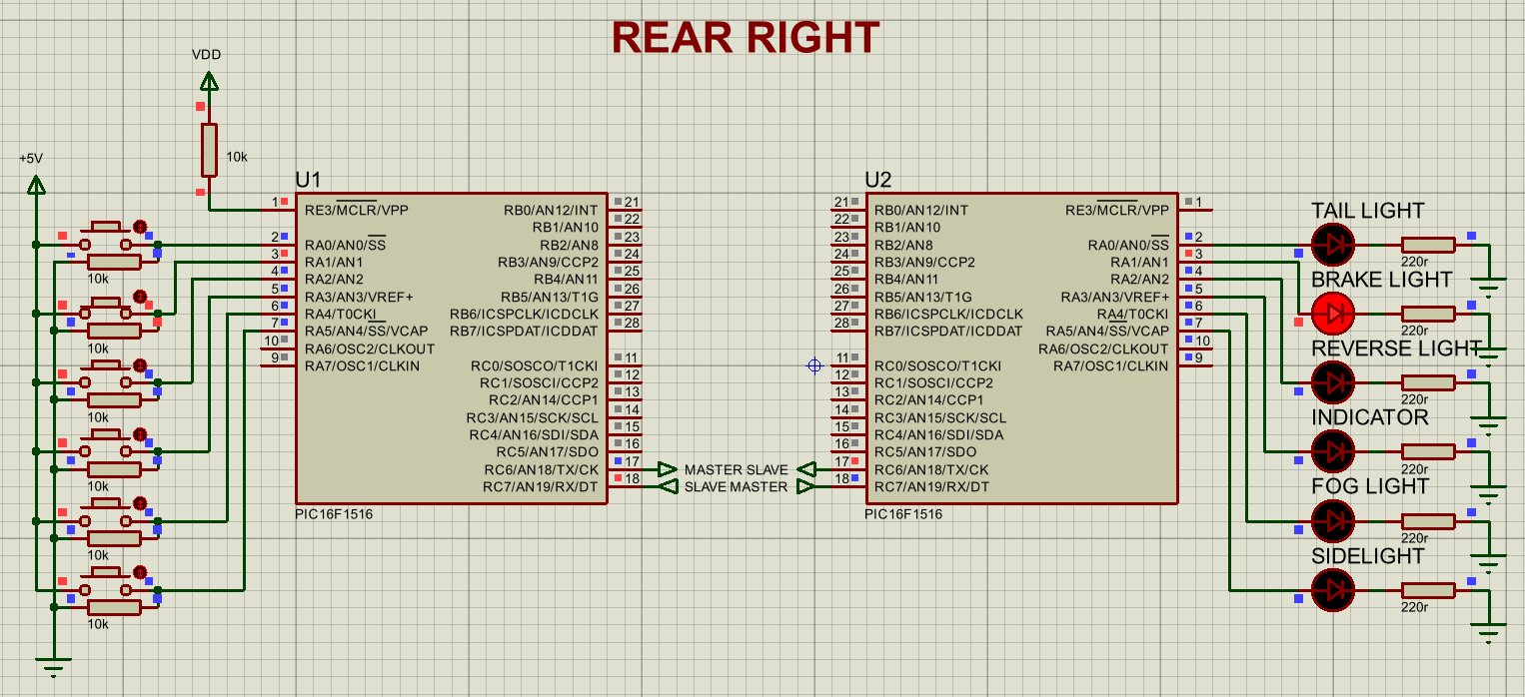
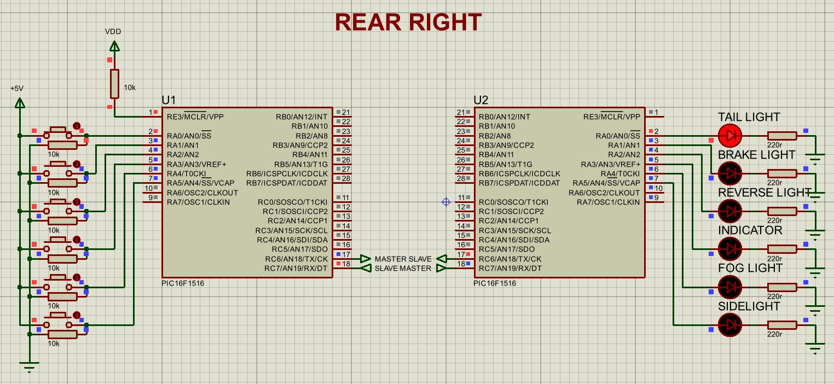
Figure 5: Brake light output
Figure 4: Tail light output

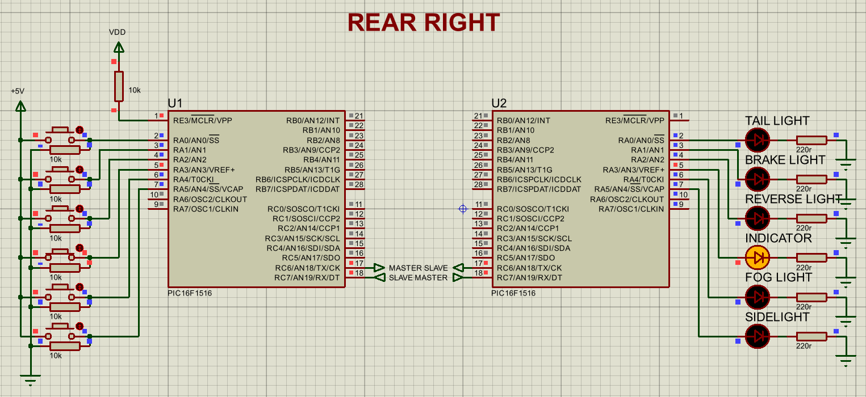
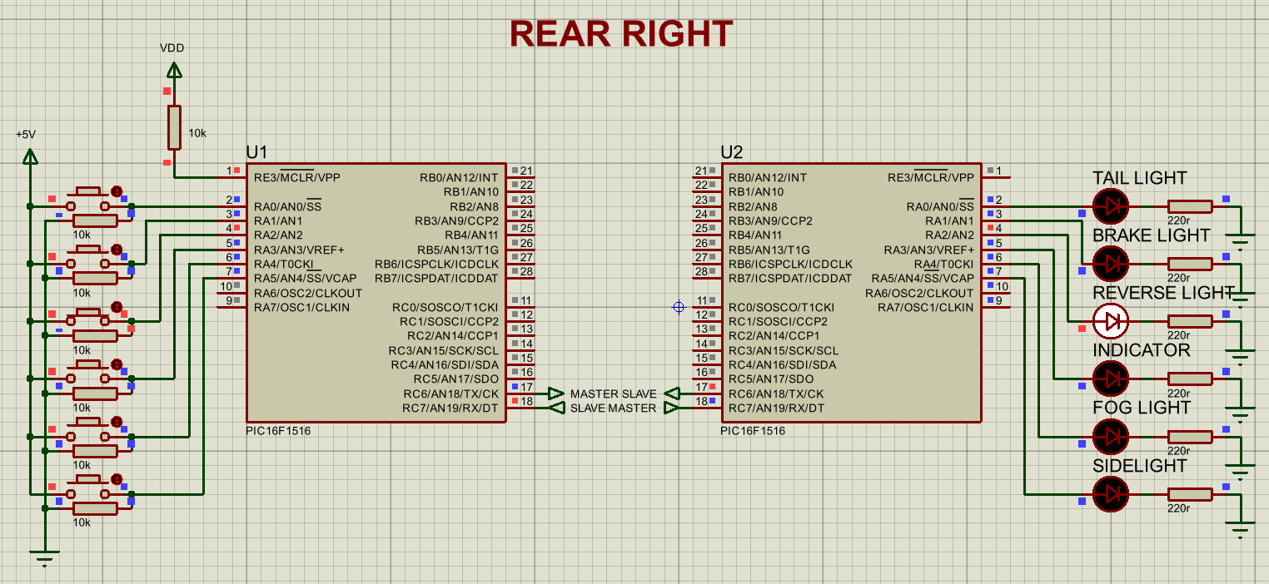
Figure 7: Indicator output
Figure 6: Reverse light output

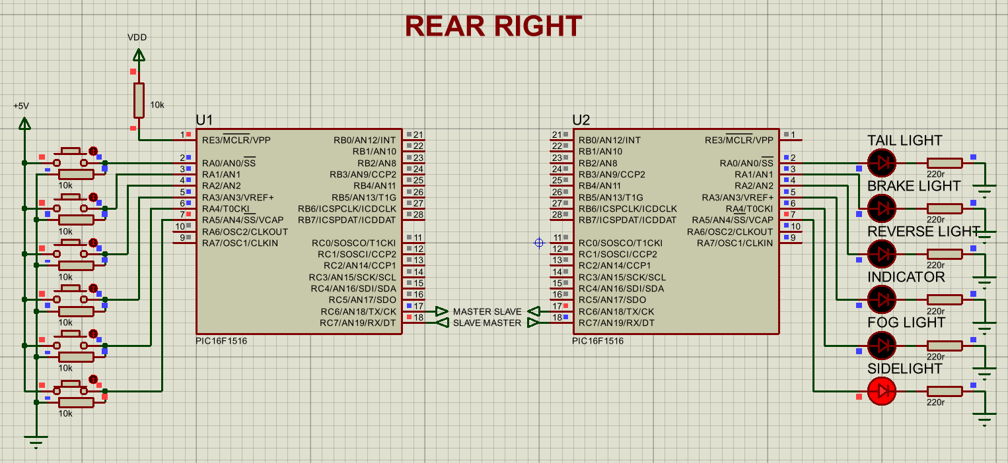
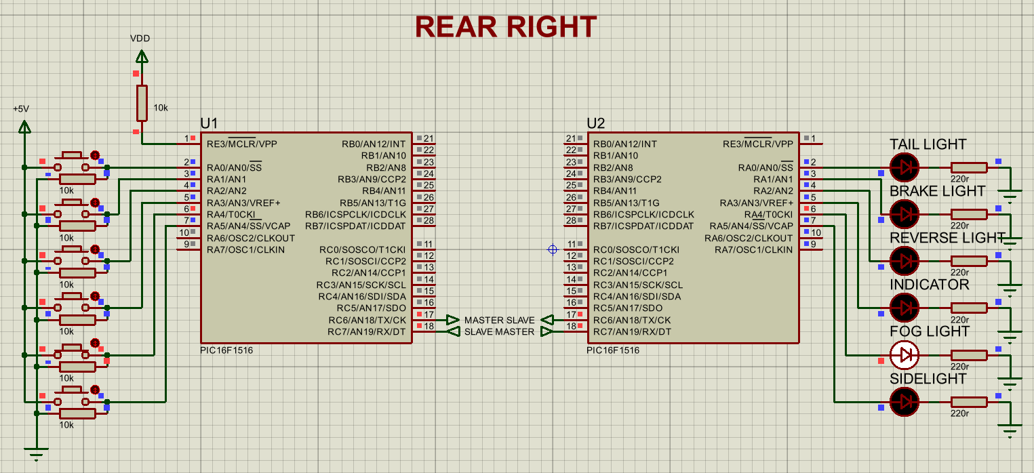
Figure 9: Sidelight output
Figure 8: Fog light output

Breadboard layout
Figure 10 shows the project attempted on a breadboard. This was done to validate the component layout and wiring for the project. Note that a full practical implementation (the programmed PICs and real-world simulation) is not demonstrated here.
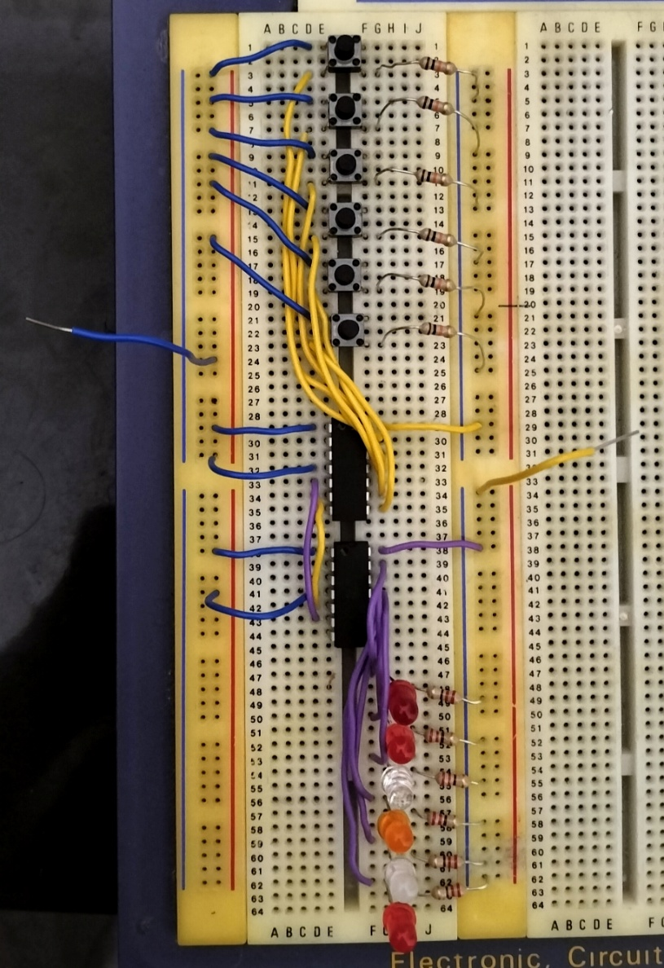
To power
To ground
Figure 10: Breadboard layout

Analysis
Program operation
The UART communication between the microcontrollers here is configured in the header file main.h using the following line of code: #use rs232 (baud=9600,parity=N,xmit=PIN_C6, rcv=PIN_C7,bits=8,stream=PORT1, FORCE_SW), which is the serial communication link used by both the microcontrollers. This sets the baud rate, transmit and receive pins, and frame rate required for the transmission and reception of the byte.
The master device operates within a loop that goes on forever, and continuously reads the 8-bit status of port A using input_a(). The program then transmits the value as a complete token, i.e. a single byte, over the UART connection to the slave device’s receive pin through the following line of code, printf("%c",input_a()). Each byte it sends corresponds to the light output command for that moment.
The slave device also operates within a loop that goes on forever, and it uses if(kbhit()) to check if any new byte has arrived in the UART receive buffer. If a byte is waiting, it returns 1 (TRUE), which calls getch(); if no byte is waiting, it returns 0 (FALSE ).
When a byte is available in the UART receive buffer, getch() reads it from there and stores it in the variable ‘token’, which is what happens in the following line of code, token=getch(). The received value is then directly written to port A using output_a(token), which switches ON the corresponding light output. This shows how the master device's input state directly correlates to which lights are ON at the slave.
The token value 0x08 specifically selects bit 3 of the master’s port A, i.e., pin A3, corresponding to the indicator light output on pin A3 of the slave. The slave then checks whether this token is received using if(token == 0x08). When it does receive, the slave drives pin A3 high and low with a 250 ms delay between each transition, according to these lines of code, output_high(PIN_A3), delay_ms(250), output_low(PIN_A3), delay_ms(250); producing a complete flash cycle of 500 ms.
Limitations and improvements
One of the limitations here is that the slave device assumes every token it receives is valid. So, if a byte is corrupted by UART timing errors or electrical noise, interference, which can occur in a vehicle environment, it will still be written to port A and could switch ON the wrong light without any warning. This poses a safety risk in a vehicle for critical light outputs, such as the indicators or brake lights that need to work reliably. As a result, there is no way for the program to verify if the data received is correct or whether communication has failed. Another limitation is that the flashing routine uses delays in the main loop, which stops the slave device from executing any instructions during the indicator’s flash cycle. An implementation to improve the system would be to configure a parity bit for detecting errors, a watchdog timer to reset the system if communication fails, and a timer interrupt routine for flashing, so that the slave device can continue to receive and process tokens during the indicator flashing.

Operational flowchart
Figure 11 shows the flowchart split into two lanes: the master PIC on the left and the slave PIC on the right, to show the two PIC devices running independently and simultaneously, rather than a linear program. The dashed arrow visually shows the communication link from the master PIC to the slave PIC.
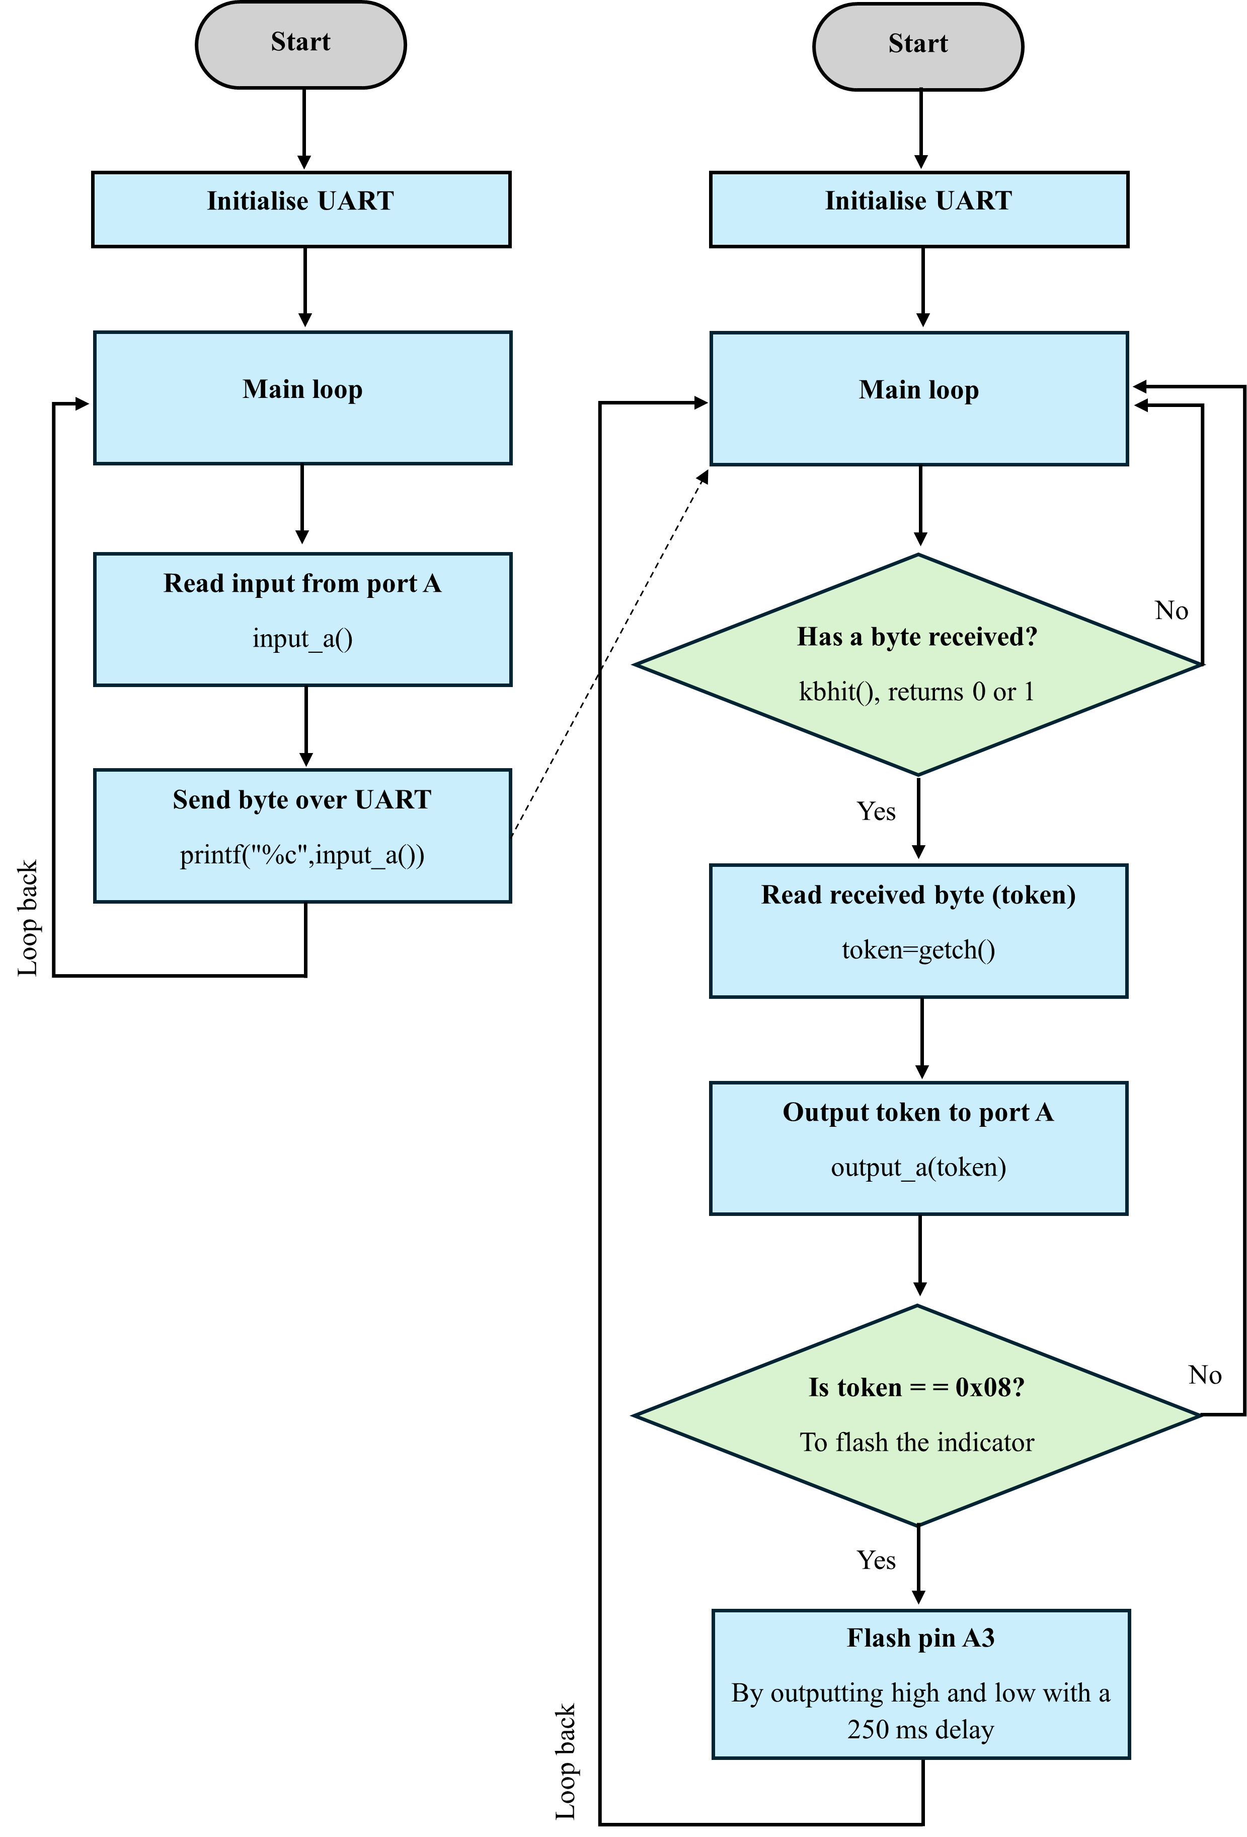

Figure 11: Operational flowchart

Quality management systems and continuous improvements
Quality Management Systems (QMS) are needed here, as the project here is related to an automotive application. The vehicle lighting system is there to comply with legal regulations and ensure the safety of drivers. Any faulty light output action, such as the indicator light not flashing or the brake light not turning on, can lead to potential car accidents.
The internationally recognised standard for QMS is ISO 9001, developed by the International Organisation for Standardisation (ISO) [11]. It applies to any organisation that wants to meet consumer satisfaction, improve performance and show its commitment to quality [11]. IATF 16949 is an automotive industry specific QMS standard that builds on ISO 9001, developed by the International Automotive Task Force (IATF) [12]. Manufacturers and suppliers in the automotive industry adhere to this standard to ensure high quality, reliable assembly processes, parts, and components, and to prevent defective products [12]. Additionally, ISO 26262 is a standard for functional safety of electrical and electronic systems to prevent hazards caused by the malfunctioning behaviour of these systems, including their interactions [13].
When considering the specific application here, the vehicle lighting system would be covered by these standards in a manufacturing environment where a programming error could have an impact on the driver’s visibility and road safety. Thus, a QMS approach here would require each token value to be clearly assigned to a specific output need. For example, the requirement that the token value 0x08 activates the indicator light at a certain flash rate according to the regulation should be carefully assessed against the written specification, and the results should be recorded rather than assuming it to be correct just because the observed simulation appears to work.
Continuous improvement can be implemented in this project by following the Plan-Do-Check-Act (PDCA) method, which is a requirement under the ISO 9001. The plan phase here would involve all decisions made before implementing the system, such as which PICs will be used, what communication method will be used, and what outputs are required. The do phase would involve the actual development of the system, i.e., programming, design, and simulation of the circuit implemented in Proteus. The check phase would involve testing and evaluating what was designed against what was planned, and finding out the limitations. The act phase would involve making improvements to the system based on what the check phase found, and putting them into a revised design version. [11]

Conclusion
In conclusion, this report demonstrated the successful completion of a simple token based distributed network in Proteus (the method as stated in the brief) by the implementation of a rear corner vehicle lighting application using the UART communication protocol. The lights all functioned as required, where the red light turned on for the taillight, brake light and sidelight, the white light turned on for the reverse light and fog light, and the amber light flashed for the indicator.
However, when looking back at the challenges, the originally planned and designed PIC in Proteus simulation was unavailable in the lab, so a different PIC was used for the breadboard assembly and due to time constraints, design and simulation couldn’t be done.
Future recommendations include checking available PICs in the lab before starting the project design, adding an LCD for light updates, simulating the project on a breadboard and seeing if it works as expected in the Proteus simulation.

References
[1] “Point-to-Point Communication in Distributed Systems,” GeeksforGeeks, 23 July 2025. [Online]. Available: https://www.geeksforgeeks.org/system-design/point-to-point-communication-in-distributed-systems/. [Accessed 24 April 2026].
[2] S.-A. Drăgușin, N. Bizon, R.-M. Teodorescu, D. Toma, R.-N. Boștinaru, and G. Anghel, “Communication Protocols in Embedded Systems for Automotive Applications: Comparative Analysis and Implementation Through Virtual Instruments,” 2025 17th International Conference on Electronics, Computers and Artificial Intelligence (ECAI), pp. 1–8, Jun. 2025, doi: https://doi.org/10.1109/ecai65401.2025.11095564.
‌[3] “What is UART (Universal Asynchronous Receiver-Transmitter)? How Does It Work? Automotive Applications,” BESTAS, 23 September 2024. [Online]. Available: https://www.bestas.com.tr/en/blog/vehicle-components-guide/what-is-uart-protocol-how-does-it-work-automotive-application. [Accessed 24 April 2026].
[4] “Point-to-multipoint communication,” NordVPN, [Online]. Available: https://nordvpn.com/cybersecurity/glossary/point-to-multipoint-communication/. [Accessed 24 April 2026].
[5] “The SPI bus in the automotive sector,” eVision Webshop, [Online]. Available: https://evision-webshop.eu/blog/the-spi-bus-in-the-automotive-sector. [Accessed 24 April 2026].
[6] “What is MultiDrop Network Topology in Computer Network?,” TutorialsPoint, [Online]. Available: https://www.tutorialspoint.com/article/what-is-multidrop-network-topology-in-computer-network. [Accessed 24 April 2026].
[7] “CAN protocol (Controller Area Network) Explained,” Automotive vehicle testing, [Online]. Available: https://automotivevehicletesting.com/in-vehicle-networks/can-bus-protocol/. [Accessed 24 April 2026].
[8] “Car lights explained: When to use the different types of lights on your car,” Motability Scheme, 19 February 2025. [Online]. Available: https://news.motability.co.uk/everyday-tips/car-lights-explained-when-to-use-the-different-types-of-lights-on-your-car/. [Accessed 24 April 2026].
[9] “MOT inspection manual: cars and passenger vehicles,” GOV.UK, 1 April 2026. [Online]. Available: https://www.gov.uk/guidance/mot-inspection-manual-for-private-passenger-and-light-commercial-vehicles/4-lamps-reflectors-and-electrical-equipment. [Accessed 24 April 2026].
[10] “PIC16(L)F1516/7/8/9 Data Sheet,” Microchip Technology, [Online]. Available: https://ww1.microchip.com/downloads/en/DeviceDoc/40001452F.pdf. [Accessed 24 April 2026].
[11] “ISO 9001:2015,” ISO - International Organization for Standardization, 2021. [Online]. Available: https://www.iso.org/standard/62085.html. [Accessed 24 April 2026].
[12] “What are the differences between ISO 9001 and IATF 16949?,” DNV - Global, [Online]. Available: https://www.dnv.com/assurance/articles/the-differences-between-iso-9001-and-iatf-16949/. [Accessed 03 May 2026].
[13] “ISO 26262-1:2018,” ISO - International Organization for Standardization, 2018. [Online]. Available: https://www.iso.org/standard/68383.html. [Accessed 03 May 2026].

