DANIEL LUPU
Student Nr:1915933
Marketing Fundamentals A1
TESCO
Tushara Balendran

Table of Contents
INTRODUCTION 3
MAIN BODY 3
CONCLUSION 8
REFERENCES 9

INTRODUCTION
Blog marketing refers to the process that helps to advertise a business, website, brand or service through the medium of blogs (Rosnizam and Alajmi, 2020). Tesco is a Retail firm having headquartered in London, UK. Company was founded by Jack Cohen in year 1919 in Hackney, London. First store was opened in Barnet in 1931. The Report will outline a series of blog posts to communicate with target customers.

MAIN BODY
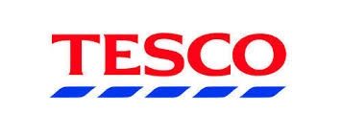
Product strategy -
Tesco is currently offering a wide range of products and services under different product lines. It includes financial services, electronics, clothing, food, cosmetics etc. At present, firm owns 1600 product lines across Tesco Finest and Tesco Value range. Tesco is planning to offer Vegan sweet dishes from year 2021 and it aims to increase the sales of new products by 30 % till year 2023 (Guvenc, 2019). The new products that firm will offer include Chocolate Orange Sundae, Cherry and Chocolate Dessert, Passion fruit Panna Cotta etc. Firm will target young children and middle-income group people so that, they can easily purchase the products of the company. Further, it will also use its existing strategy for targeting customers such as based on the interest of people towards quality of items, price etc.

It will also help customers to maintain and improve their health and well-being. Tesco is currently using experiential positioning strategy to position the brand image on the minds of target customers. For positioning the image of new products that firm will offer, it is considering multi-segment positioning strategy to position variety of items under the product line of Vegan sweet dishes. This will assist firm in targeting various markets with the help of a unique marketing strategy.

Pricing strategy –
Currently, Tesco is using cost leadership pricing strategy to offer a wide range of goods to the consumers that assist firm to maintain low price of the products without compromising with the level of quality. Major limitation is that, this strategy technology may pressurize the position of company with the competitors offering new items or having less costly manufacturing processes. Firm is planning to implement a new pricing strategy that is “The Big Price Drop “to increase the market share of the company. This strategy will help management to promote the strategy of market penetration. Firm is focusing on reliable and clear savings to provide various benefits to the customers (Erdmann and Ponzoa, 2020).
The change in pricing strategy is the response towards aggressive pricing competition and high cost of living. The strategy will help households to purchase in new products with minimum expenditure. This pricing strategy will help Tesco to compete with other companies such as Asda etc. Under this strategy, firm will reduce the prices by at least 30 %. The initial price for Vegan sweet dishes will be £ 3.5. The price is lower as compared with the rate at which other firms are offering their products in the market.

Place strategy –
Firstly, the firm will launch the new products in 3968 stores which are owned by firm in UK. Currently, company is offering the existing products like groceries and merchandise through this retail stores .Management has planned that, after the consumers accept the products Tesco will offer these items in Thailand. Company is planning to open additional 750 c-stores and it will move its focus from cash and carriers to small box. Place strategy will assist customers to purchase the products easily and conveniently. It will also help Tesco to increase the existing level of sales and profit (Dost and Libai, 2019).
Moreover, there is a possibility that Tesco might trial its Finest stores to carry only premium private label. At the same time, management is also focusing on other strategies to grab the new opportunities for growth and development. Furthermore, firm will use channel 3 for distribution of the new products to ultimate target consumers. Under this strategy, Tesco will directly sell the goods to the buyers. This will also help firm in minimizing the expenses on distribution.
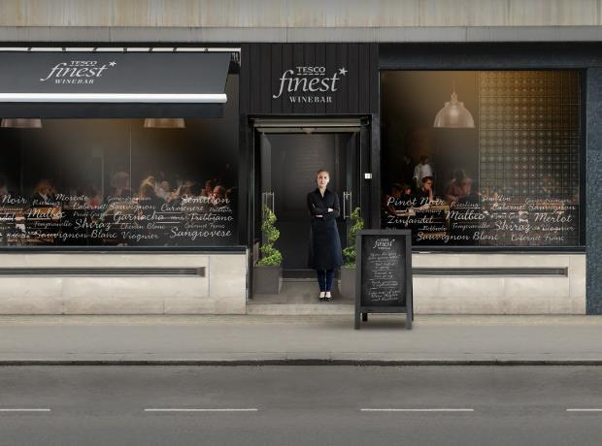

Process strategy –
Tesco has entered into a new agreement with a retailer in Vietnam to offer private label ranges in different market segments. Furthermore, it has entered into partnership with Takeoff, a robotics specialist that will help top management of Tesco to implement a mini DC’s in the warehouses of retail stores. This will help firm to improve the speed of order processing through online channels and helps to improve the efficiency of the process for delivering Vegan sweet dishes to target consumers. This unique capability of micro-fulfillment depends upon automation. The firm is expecting that the new system will help to improve the existing level of the performance for online delivery of food items. It will also assist Tesco to boost the performance of in-store logistics. Firm remain careful with its capex and carefully determining the return on investment of the technology that company is using in its stores (Lahtinen, Dietrich and Rundle-Thiele, 2020).
One of the major reasons behind company investing in this strategy is that, company has attained profitability in the sector of ecommerce apparently following the shedding of the direct operation of Tesco in year 2018. It means that online is currently a better place for firm to move forward and grow as a major element of a wider Omni-channel strategy. The investment of funds by Tesco will help to promote efficiency and back-end alertness.

Promotion strategy –
Previously firm is using traditional marketing tools for promoting the sales of the products. With an increase in the importance of digital marketing, Tesco is scheduling to shift the investment in ads from tactics of traditional marketing to digital marketing tools. It means that, firm will spent nearly 30 % of the revenue from marketing on digital marketing channels (Woohyoung, Hyun and Hwang, 2020). This will allow Tesco to get in touch with highly targeted individuals that traditional marketing methods have failed to provide. Tesco has developed a latest campaign in which firm has asked target consumers to actively participate in the campaign of new Food Love Stories.
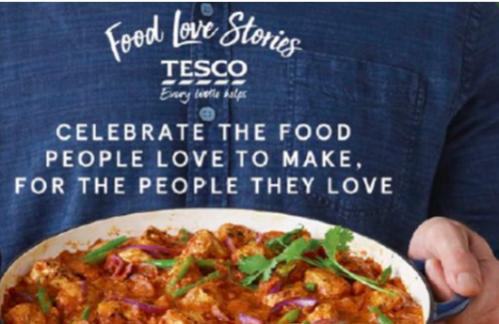

Customization is an essential part of the new world of marketing. Tesco sees a huge requirement of focusing on the individual experience and the marketing department has come up with various unique marketing ideas. Firm will focus on delivering deep discounts on birthdays to printed campaigns that will be directly provided to the customers to the door. Tesco will provide details regarding new products through What’s App, snap chat etc. Tesco will also offer Order & Collect Service to the consumers as a part of the campaign. This service will be available to the customers till march 2021 (Hammett, 2020).

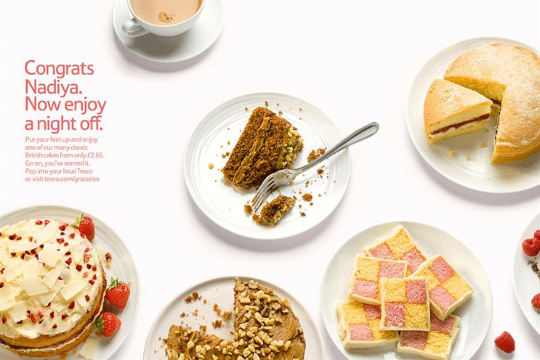

Physical evidence strategy –
All the stores of Tesco are clean and attractive. They are easy to navigate with all the items well categorized and they can be easily found out by the consumers. The colors, logos, labels and equipments are some of the physical evidence that is used by the firm as evidence to the customers. Furthermore, the website of company will help in providing necessary information related with the new products that firm will offer to target customers. Website visits will be as orderly and efficient as in-person buying by the customers at Tesco’s physical retail stores. The category page of the firm will help buyers to add products to their carts and they can also maintain a track of purchases on the right side of the screen (Revoredo-Giha, 2015).
In January, Tesco will remove the material from its tinned multipack goods. It will also offer the consumers multi buy deals under which they will be able to buy various individual tins at the similar rate as the erstwhile multipack. Moreover, Tesco has planned to remove non recyclable and unnecessary plastic from Tesco and consumers will still get advantage from the same great value price of multipack.

People strategy –
The sales force of the company plays a major role in achieving the success. Tesco is currently using various programs such as Save As You Earn, Colleague Privilege card and Buy As You Earn that helps to promote the loyalty of the employees of the company. Tesco will make efforts to recruit employees belonging to different backgrounds. This will help business in promoting diversity and inclusion (Costa-Font and Revoredo-Giha, 2016).
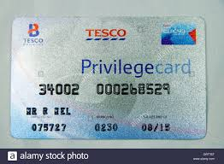

Moreover, management will offer various promotional opportunities to the workforce. This will motivate them to make efforts to attain the goal and objectives of the firm. Furthermore, Tesco will conduct training and development programs for the employees to bring an improvement in the existing level of skills and abilities of the workers. Training will also be given to employees who will perform operations in new stores in Thailand. Training will assist existing employees to learn new language and become familiar with the culture of the country. The programs will also assist existing and new staff members to assume leadership roles at different job positions (McKenzie and Watts, 2020).



CONCLUSION
The above assignment concludes that, marketing mix plays a major role in offering new product or service of the company to target customers. It helps firm in executing, developing and planning the strategies for marketing of the goods or services. It helps business to avoid unnecessary costs.

REFERENCES
Costa-Font, M. and Revoredo-Giha, C., 2016. Introduction of new food and drink products in the UK: is there a trend towards more sustainability? (No. 358-2016-18342).
Derya Guvenc. 2019. Tesco reveals its strategic vision beyond 202. [Online] Available On < https://www.kantarretailiq.com/Conversation/ConversationDetails.aspx?id=1520792 > [Accessed On 5 December]
Dost, F., and Libai, B., 2019. Seeding as part of the marketing mix: word-of-mouth program interactions for fast-moving consumer goods. Journal of Marketing, 83(2), pp.62-81.
Ellen Hammett. 2020. Tesco asks customers to take part in new Food Love Stories campaign. [Online] Available On <https://www.marketingweek.com/tesco-food-love-stories-coronavirus/> [Accessed On 5 December]
Erdmann, A. and Ponzoa, J.M., 2020. Digital inbound marketing: Measuring the economic performance of grocery e-commerce in Europe and the USA. Technological forecasting and social change, 162, p.120373.
Lahtinen, V., Dietrich, T. and Rundle-Thiele, S., 2020. Long live the marketing mix. Testing the effectiveness of the commercial marketing mix in a social marketing context. Journal of Social Marketing.
McKenzie, J.S. and Watts, D., 2020. Food ideals, food rules and the subjective construction of a healthy diet. Food and Foodways, pp.1-21.
Revoredo-Giha, C., 2015. Introduction of new food and drink products in the UK: is there a trend towards more sustainability? (No. 716-2016-48670).
Rosnizam, M.R.A.B., and Alajmi, A.M., 2020. Market Opportunities and Challenges: A Case Study of Tesco. Journal of the community development in Asia, 3(2), pp.18-27.
Woohyoung, K., Hyun, K. and Hwang, J., 2020. Transnational Corporation’s Failure in China: Focus on Tesco. Sustainability, 12(17), p.7170.

