

Assessment 1 – Reading Task Template
Upload your photo of your A3 in-class notes here:
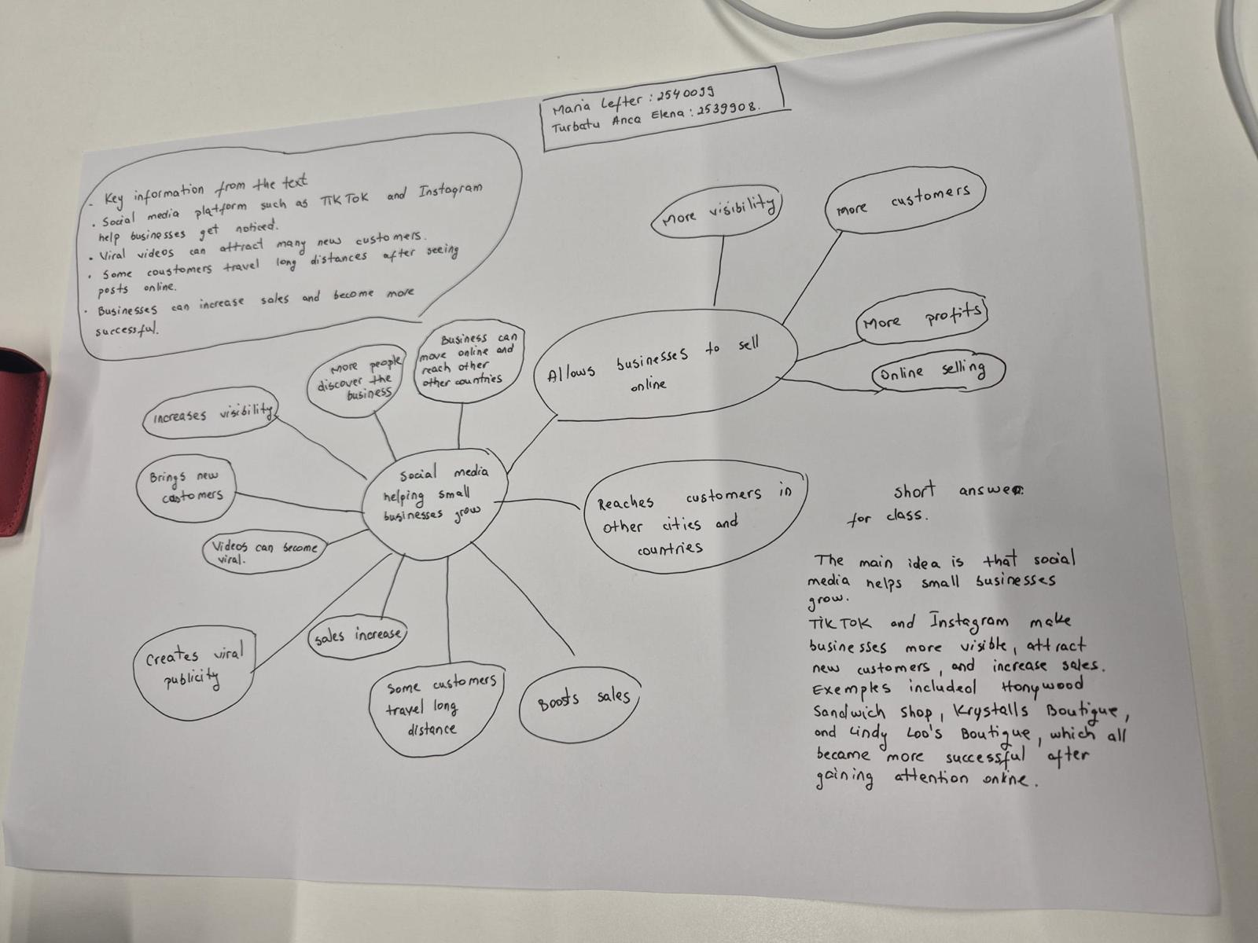

1. Answer these questions using the sentence starters below
a. What is the main idea of the text?
The main idea is that social media platforms like TikTok and Instagram can help small businesses become successful by attracting many new customers.
b. What are two key points?
One key point is that viral videos can bring customers from long distances to local businesses.
Another key point is that businesses can grow quickly by creating authentic and interesting content on social media.
c. What part of the text did you find most important? Why?
The most important part is the example of Honywood Sandwich Shop, where people travelled several hours just to try a chicken burger after seeing it on TikTok. I think this is the best example because it clearly shows how powerful social media can be for a small business.
d. Was anything unclear or difficult to understand?
I was not sure about how some businesses became viral so quickly because the article does not explain exactly how the social media algorithms work.
e. How did your group help you understand the text better?
My group helped me by discussing the different business examples and explaining parts of the article that I did not understand at first.
2. One sentence reflection
Question: What did you find challenging about this task?
The hardest part was identifying the most important information because the article included several different business stories.

