ACCA 4017 SOFTWARE DEVELOPMENT RESIT DAN DRIU 2026379 A 1
Lists
A list in python is a mutable type that is made up of a collection of ordered objects. The objects contained in a list do not have to be of the same type and may include other lists(nested sublists) (Van Rossum, 2007).
Accessing the List Elements
You can access the values of lists separated by commas using indices and slicing with square brackets.
List1 = [“Oracle”,”Google”,”Tesla”,”Microsoft”,”IBM”]
Print(list1[0:4])

Updating list objects
Because lists in Python are a mutable type, you can update a single or multiple elements using the assignment operator. You can also add new items on the list using the append() method as shown below.
List1 = [“Oracle”,”Google”,”Tesla”,”Microsoft”,”IBM”]
Print(list1[0:4])
List1.append(“PANDA”)
Print(“New list1:”, list1)

Deleting List Objects
There are two ways to delete items from a list in python. If you know the exact items to delete, you can use the del statement but if you don’t know you can use the remove() method as shown below:
List1 = [“Oracle”,”Google”,”Tesla”,”Microsoft”,”IBM”]
Print(list1[0:4])
Del list1[3]
List1.remove(“Tesla”)
Print(“New list1:”,list1)

Variables
In object-oriented programming a variable is a space in computer memory that is reserved for storing values of a specified type. When you declare a variable in your Python script, you are essentially asking the interpreter to allocate computer memory for the type of data expected and you assign that memory location a name (Nikula et al, 2007). This name is what we call a variable name and it may be assigned any of the following live data types supported by python:
- Numbers
- Strings
- Lists
- Tuples
- Dictionary
The interpreter decides which data will be stored in the reserved memory based on the data type declaration. It is therefore important to specify the type of data the variable will store so that the interpreter can allocate sufficient memory space.
Declaring a variable
You declare a variable in python by assigning a variable name a value. Unlike other high-level programming languages, with python you do not need to explicitly declare a memory space reservation, it happens automatically when a value is assigned to the variable using the assignment operator (Nikula et al, 2007).
Dictionaries
Like lists, dictionaries are a mutable data type whose objects can easily be deleted, updated and added at runtime and they can also contain different types of data (including lists). The difference between the two is that dictionaries contain items not in any order, unlike lists whose items are ordered. This means that the items on a dictionary are accessed using keys and not their positions.
A dictionary in python is an associative array or hash in which each value is mapped to(associated with) a key.
A 2
User-defined Functions
A function is defined using the keyword def and assigning it a name. its syntax takes the following format:
def function_name(arguments):
“””docstring”””
Statement(s)
The keyword def marks the beginning of the function header followed by the function name, a unique identifier that must follow the standard rules of writing identifiers in Python. The arguments section in parentheses is where the optional values or parameters are passed to the function. Note that the end of the function header is marked by a colon(:).
The optional documentation string (docstring) describes what the function does. The statements that make up the body of the function are entered below the docstring and must be identified at the same level, typically one tab or four spaces.
The return statement at the very end of the function exits the function back to the last position from where it was called. Note that return may contain an expression or expressions that get evaluated and a value returned
User-defined functions allow programmers to create their own procedures and routines that the computer can follow; it is the basic building block of any program and also very important for modularity and code reuse since a programmer could create a user-defined function which does a specific process and simply call it.
Calling a Function
Once you define a function, you can call it from the Python prompt, program or another function by simply typing its name with appropriate parameters.
Function Arguments
If the function is run without the argument it expects the interpreter will return an error
By default, function arguments are required and they must be passed to the function in the correct positional order
def user_details(age,sex):
print(“User is”, age, “years old”, sex)
return
user_details(21,”male”)

Exercise 1
Steps
Declare each of the given variables
Using the input prompt in python prompt the user to enter the values
Print out the values t display them on the screen
The output is as shown below:
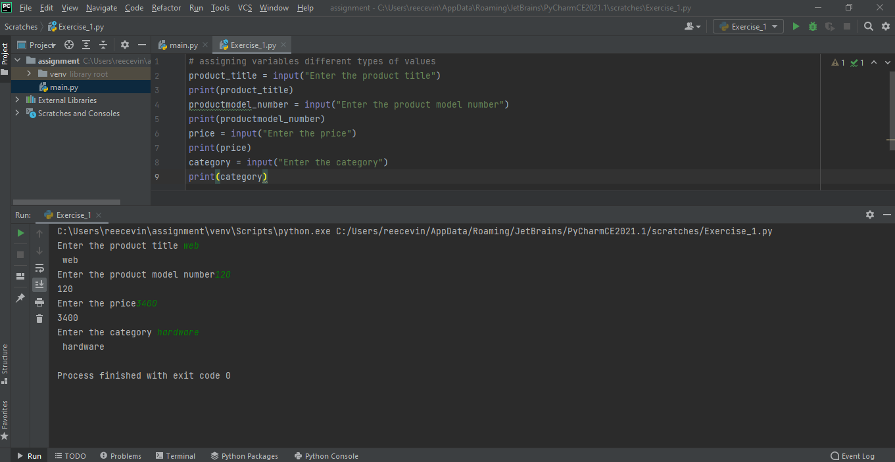

Exercise 2
Steps
Using a class Area with a def __init__ function make use of user defined functions to find the areas of each of the given rectangles within the main rectangle
The output is as shown below:
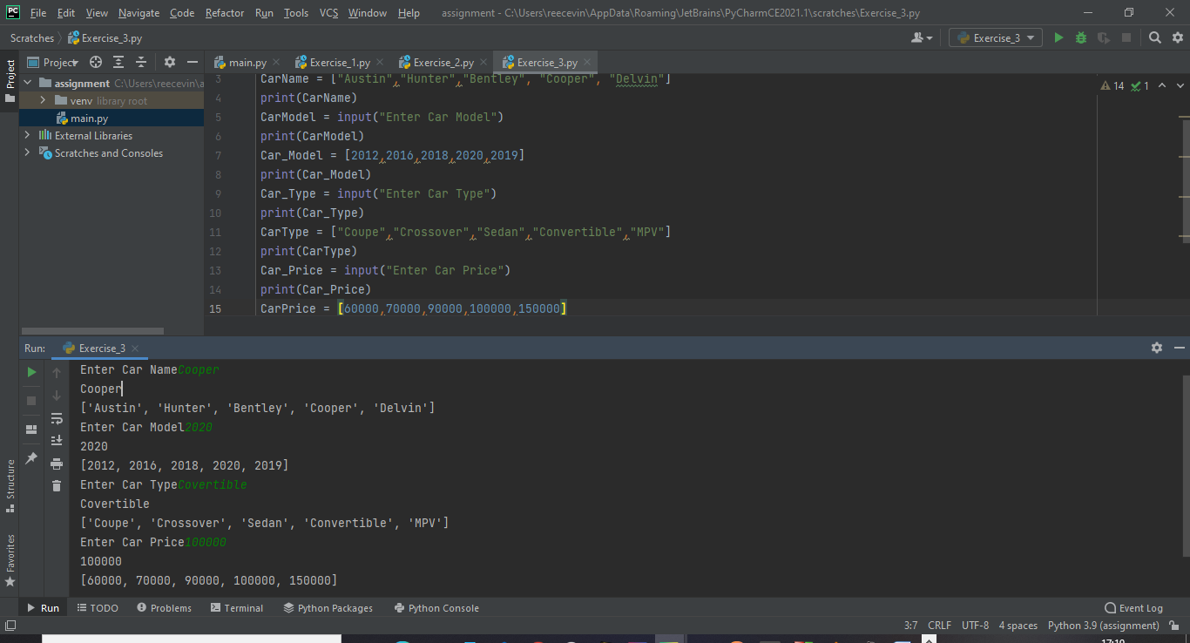

Exercise 3
Steps
Declare the variables
Using the input prompt, prompt the user to enter the values of the given variables
Print to display the output on the screen
The output is as shown below:

Task a and b
Steps
a)
Import the Pandas Library in Pycharm
Create a Data frame Using Arrays
Create a Pandas Data frame
Print the data frame to display the data

b)
Import matplotlib library in Pycharm
Perform all the computations given
Draw the pie chart graph
The output is as shown below:
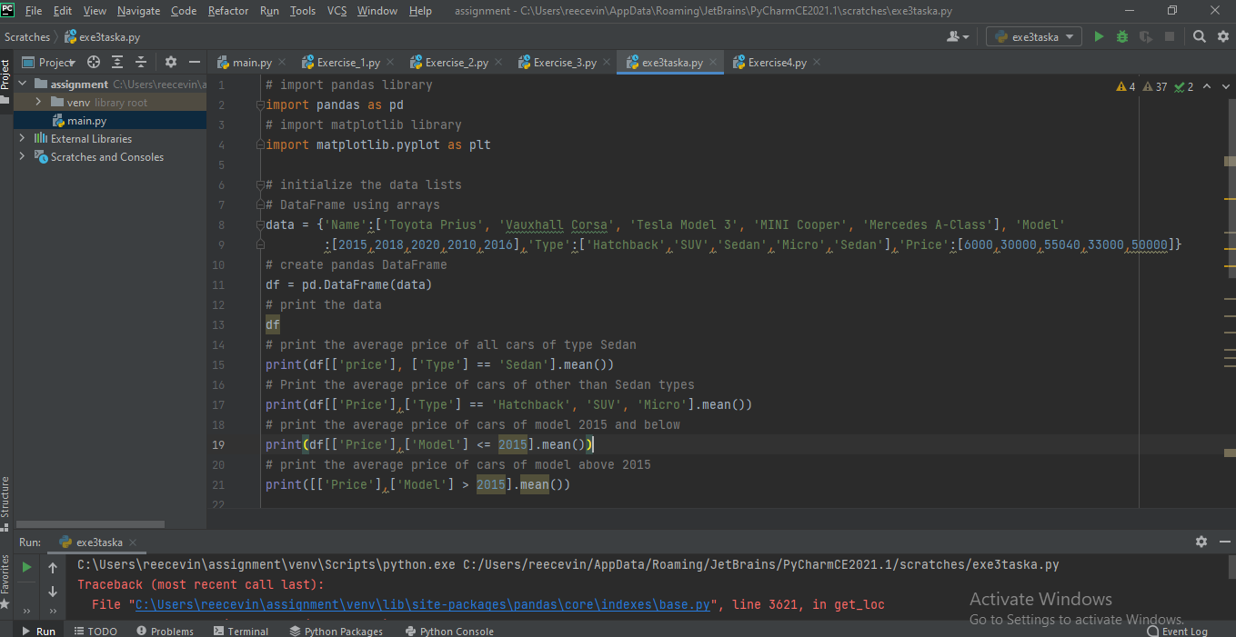

Exercise_4
Steps
Import random library in Pycharm
Using the user defined function :
Get the range integer numbers in which the random number occurs
Increment the integer number by 1 if count is < 3
Using the input prompt request user to Spin if user_act equals to True
Print the final score and display it on the screen
If user_act equals to false Quit the game
The output is as shown below:
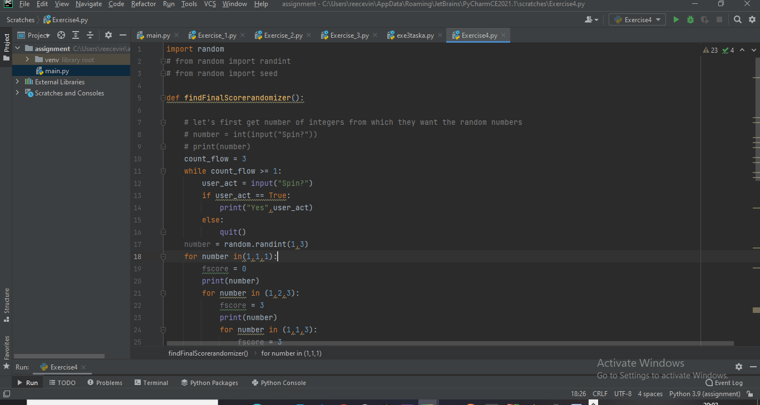

References
Nikula, U., Sajaniemi, J., Tedre, M. and Wray, S., 2007. Python and roles of variables in introductory programming: experiences from three educational institutions. Journal of Information Technology Education: Research, 6(1), pp.199-214.
Van Rossum, G., 2007, June. Python Programming language. In USENIX annual technical conference (Vol. 41, No. 1, pp. 1-36).

