

Executive Summary
This research project aims to investigate the impact of Customer Relationship Management (CRM) systems on the sales performance of small-to-medium-sized Business-to-Business (B2B) companies from Cardiff. As the B2B sector, especially within SMEs, is an underexplored domain, this study focuses on filling the existing gap in the literature (Zhang, Watson IV & Palmatier, 2016).
Adopting an inductive, quantitative research approach, the study explores various aspects of the CRM-sales performance relationship, such as the impact of CRM system implementation on sales cycle duration, the role of CRM systems in facilitating cross-selling and up-selling, and the influence of CRM systems on customer retention and its subsequent impact on sales (Trainor et al., 2014).
Data collection comprises primary and secondary methods. Primary data is gathred through an online questionnaire involving stakeholders (Lecturers and students) acting as owners of B2B SMEs from Cardiff. This survey focuses on the implications of CRM system usage on sales performance (Saunders, Lewis, & Thornhill, 2012). The secondary method involves an extensive review of related literature, aiming to identify trends and gaps within the current resarch sphere (Creswell & Creswell, 2018).
The preliminary analysis reveals a positive correlation between comprehensive CRM system usage and improved sales performance, echoing earlier research findings in the field (Raman, Wittmann, & Rauseo, 2006). Initial findings reinforce the pivotal role of CRM systems in enhancing sales performance in small-to-medium B2B enterprises, indicating beneficial outcomes in terms of sales volume, sales cycle duration, customer retention, and sales forecasting accuracy (Verhoef & Leeflang, 2009).
In conclusion, this research contributes to the ongoing discourse on the intersection of CRM systems and sales performance, particularly within small-to-medium B2B enterprises from Cardiff. The findings offer valuable insights for thes businesses, potentially guiding the adoption and utilisation of CRM systems to enhance sales performance (Bendoly & Cotteleer, 2008).

Contents
Executive Summary................................................................................................................................2
Terms Of Reference................................................................................................................................4 Procedure ...............................................................................................................................................4 Task 1 – Formulation of Research Question ..........................................................................................5 Task 2 – Primary & Secondary Research Techniques.............................................................................8 Task 3 – Video Presentation of Idea .......................................................................................................9 Task 4 – Analysis Poster........................................................................................................................10 Reference List........................................................................................................................................11

Terms Of Reference
This research study aims to explore and analyse the impact of Customer Relationship Management (CRM) systems on sales performance in small-to-medium-sized B2B enterprises from Cardiff, the capital of Wales. The research is primarily quantitative, using an inductive approach to derive patterns and draw conclusions from the data collected. The focus of this research aligns with the necessity to understand the broader applications of CRM systems and thir implications for sales performance.
The research questions that drive this project are:
- What impact does the implementation and use of CRM systems have on sales performance in small-to-medium-sized B2B companies from Cardiff?
- What specific aspects of sales performance are most significantly influenced by CRM system utilisation?
Procedure
1. Research Design: A quantitative, inductive research design is chosen to conduct the study. This approach involves collecting numerical data to discover patterns and form a general understanding of the relationship between CRM systems and sales performance.
2. Data Collection: Primary data will be collected through an online questionnaire by stakeholders (Lecturers and students) imagining themselves as ownes of B2B SMEs. The questionnaire will explore various aspects of CRM implementation and usage and its impact on sales performance. Secondary data will be gathered through a comprehensive review of existing literature related to the study's focus.
3. Data Analysis: Collected data will be analysed quantitatively, using statistical techniques to discover patterns and derive insights about the influence of CRM systems on sales performance.
4. Video Elevator Pitch: A 3-minute video elevator pitch will be created to present the research area and its significance to identified stakeholders. This pitch will concisely communicate the research's aim, methodlogy, and potential value. Stakeholder (Lecturers and Students) feedback will be sought to refine the research focus and design.
5. Presentation of Findings: Initial findings will be presented through a conference poster, outlining the preliminary results and key conclusions drawn from the research.
The procedure follows standard academic research methods to ensure the research findings' reliability, validity, and generalisability. The research aims to contribute valuable insights and knowledge to B2B sales performance and the role of CRM systems.
Task 1 – Formulation of Research Question
A research study is a systematic investigation designed to gain new knowledge or understanding or to test theories in a particular field of inquiry. It involves collecting, interpreting, and analysing data to answer a specific question or explore a hypothesis (Bryman, 2016).
Conducting a research study includes defining a research question or problem, reviewing existing literature, deciding on a research methodology, collecting and analysing data, and presenting the findings clearly and structured (Creswell & Creswell, 2017).
To define the problem, we will apply the 4W. The 4W is a standard tool used in various fields, including business, communication, and research, to help define and structure a project or investigation. The 4W's stand for 'What,' 'Who,' 'Where,' and 'Why.' They are guiding questions that help clarify a study's focus or project (Flick, 2018).
For our research, we will explore the impact of Customer Relationship Management (CRM) systems on sales performance in the small-to-medium-sized business-to-business (B2B) from Cardiff, the capital of Wales (What). Since CRM systems have increasingly become integral in sales management, assessing their impact is essential to enhance business operations and strategies further (Zeng et al., 2010).
The main parties involved in this exploration are the SMEs operating in the B2B sector, their sales teams, and their customers who interact through CRM systems (Who). The problem manifests within the operational context of these SMEs implementing CRM systems (Where).
The research question will be: Impact of Customer Relationship Management Systems on Sales Performance in Small-to-Medium-Sized B2B Companies: A Quantitative Investigation?
The research question covers a well-travelled area, namely the influence of CRM systems on sales performance. However, the study uniquely focuses on SMEs in the B2B sector, a subgroup often overlooked in favour of larger corporations or the B2C (business-to-consumer) sector. Such a focus allows for a deeper understanding of how SMEs in the B2B sector can benefit from CRM systems, filling an essential gap in the existing literature (Why) (Trainor et al., 2014).
As for the chosen quantitative approach, there are several reasons behind this decision. Firstly, the topic inherently lends itself to numerical analysis as sales performance can be measured in quantitative terms such as revenue, conversion rate, sales cycle length, and customer retention rate. Similarly, CRM system usage can be quantified (Creswell & Creswell, 2017).

Secondly, quantitative methods allow for more objective comparisons and correlations, helping to address questions about the extent of the CRM system's impact on various aspects of sales performance. Lastly, findings from quantitative research are replicable and can be generalised to a larger population, which aligns to provide actionable insights to the broader SME B2B sector (Creswell & Creswell, 2017).

The chosen Research Approach
Deductive, inductive, and abductive are three primary methods of reasoning that guide the research approach in various studies.
Deductive Approach: This method starts with a theory or a hypothesis, which is then tested against empirical evidence. The researcher begins with an abstract idea or theory and then seeks concrete evidence to validate or invalidate it. It is essentially a top-down approach (Bryman, 2016).
Inductive Approach: This method is the reverse of the deductive approach. It starts with observations or data and aims to develop a theory based on the observed patterns. The researcher begins with factual data and attempts to conceptualise or theorise from it. It is essentially a bottom-up approach (Bryman, 2016).
Abductive Approach: This method combines elements of both deductive and inductive reasoning. The researcher may start with an observation, formulate a theory, and refine the theory based on further observations. It is a back-and-forth process between theory and observations (Timmermans & Tavory, 2012).
For the proposed research on the "Impact of Customer Relationship Management Systems on Sales Performance in Small-to-Medium-Sized B2B Companies," we are opting for the inductive approach. The objective guides the choice of this approach to explore the relationship between CRM systems and sales performance and, from the findings, develop or contribute to the theoretical understanding of this relationship in the context of SMEs in the B2B sector.

Data Collection Method
In conducting research, data collection is a crucial step. There are two fundamental types of data collection methods: primary and secondary.
Primary Data Collection: Primary data collection refers to gathering original data directly from the source. This type of data is collected first-hand for the specific purpose of the study. Primary data is often gathered through surveys, interviews, experiments, or direct observations, and it is generally more accurate and reliable as it is specifically collected to answer the research question (Creswell, 2013; Saunders et al., 2018).
Secondary Data Collection: This is the data already collected and processed by someone else. It could be books, databases, official records, reports, or previously conducted studies. This data type is time and cost-effective but may not align with the research purpose (Saunders et al., 2018; Smith, 2011).

Sampling Method & Sample Size
Our research will employ a convenience sampling method, segmenting small-to-medium B2B companies by industry and selecting based on availability and willingness to participate. This ensures representation across sectors. Sample size will depend on accessible companies and resource availability, but aims for the maximum possible for greater accuracy and generalisability. This approach aligns with our quantitative research, enabling robust analysis of the CRM systems' impact on sales performance (Bryman, 2016; Cohen et al., 2007).

Task 2 – Primary & Secondary Research Techniques
Our research employs an inductive approach and revolves around the impact of Customer Relationship Management (CRM) systems on sales performance within small-to-medium-sized B2B companies from Cardiff. As for primary research, we have adopted a questionnaire method, which directly collects data from respondents who are considered hypothetical company owners (Lecturers and Students). This method allows us to gather first-hand, quantitative data o their experiences with CRM systems about sales performance.
The online questionnaire: https://forms.office.com/e/hz7i7XfNLw
The answers: http://bitly.ws/HLuw
For secondary research, we conduct a literature review, examining available academic literature on our subject. Many studies suggest that CRM systems significantly influence sales performance (e.g., Ahearne et al., 2007; Rapp et al., 2010). Ahearne et al. (2007) found that sales representatives fully utilised CRM capabilities and positively impacted sales performance. Moreover, Rapp et al. (2010) indicated that effective CRM utilisation improves the salesperson-customer relationship, increasing sales.
However, fewer studies focus on the specific context of small-to-medium-sized B2B companies (Nagwan et al., 2020). Therefore, our research aims o contribute to filling this gap in the literature by conducting a quantitative investigation on the topic.
https://www.sciencedirect.com/science/article/abs/pii/S016781160700047X - Why sales reps should welcome information technology: measuring the impact of CRM-based IT on sales effectiveness
https://www.sciencedirect.com/science/article/abs/pii/S0148296309002896 - Examining the complementary role of customer orientation and CRM technology
https://www.researchgate.net/publication/348232618_Competitive_Advantage_Achievement_through_Customer_Relationship_Management_Dimensions - Competitive Advantage Achievement through Customer Relationship Management Dimensions

Task 3 – Video Presentation of Idea
Work in progress.
“For video: Engaging with storytelling to try and portray why we are choosing our research approach. What value do we intend to add with this research, and how can we present that in an engaging storytelling, manner to try and persuade your stakeholders to invest in what your idea is?
It’s about storytelling; with your video, you’re producing and telling the research story. Why is it going to add value? Why you chose that direction?”

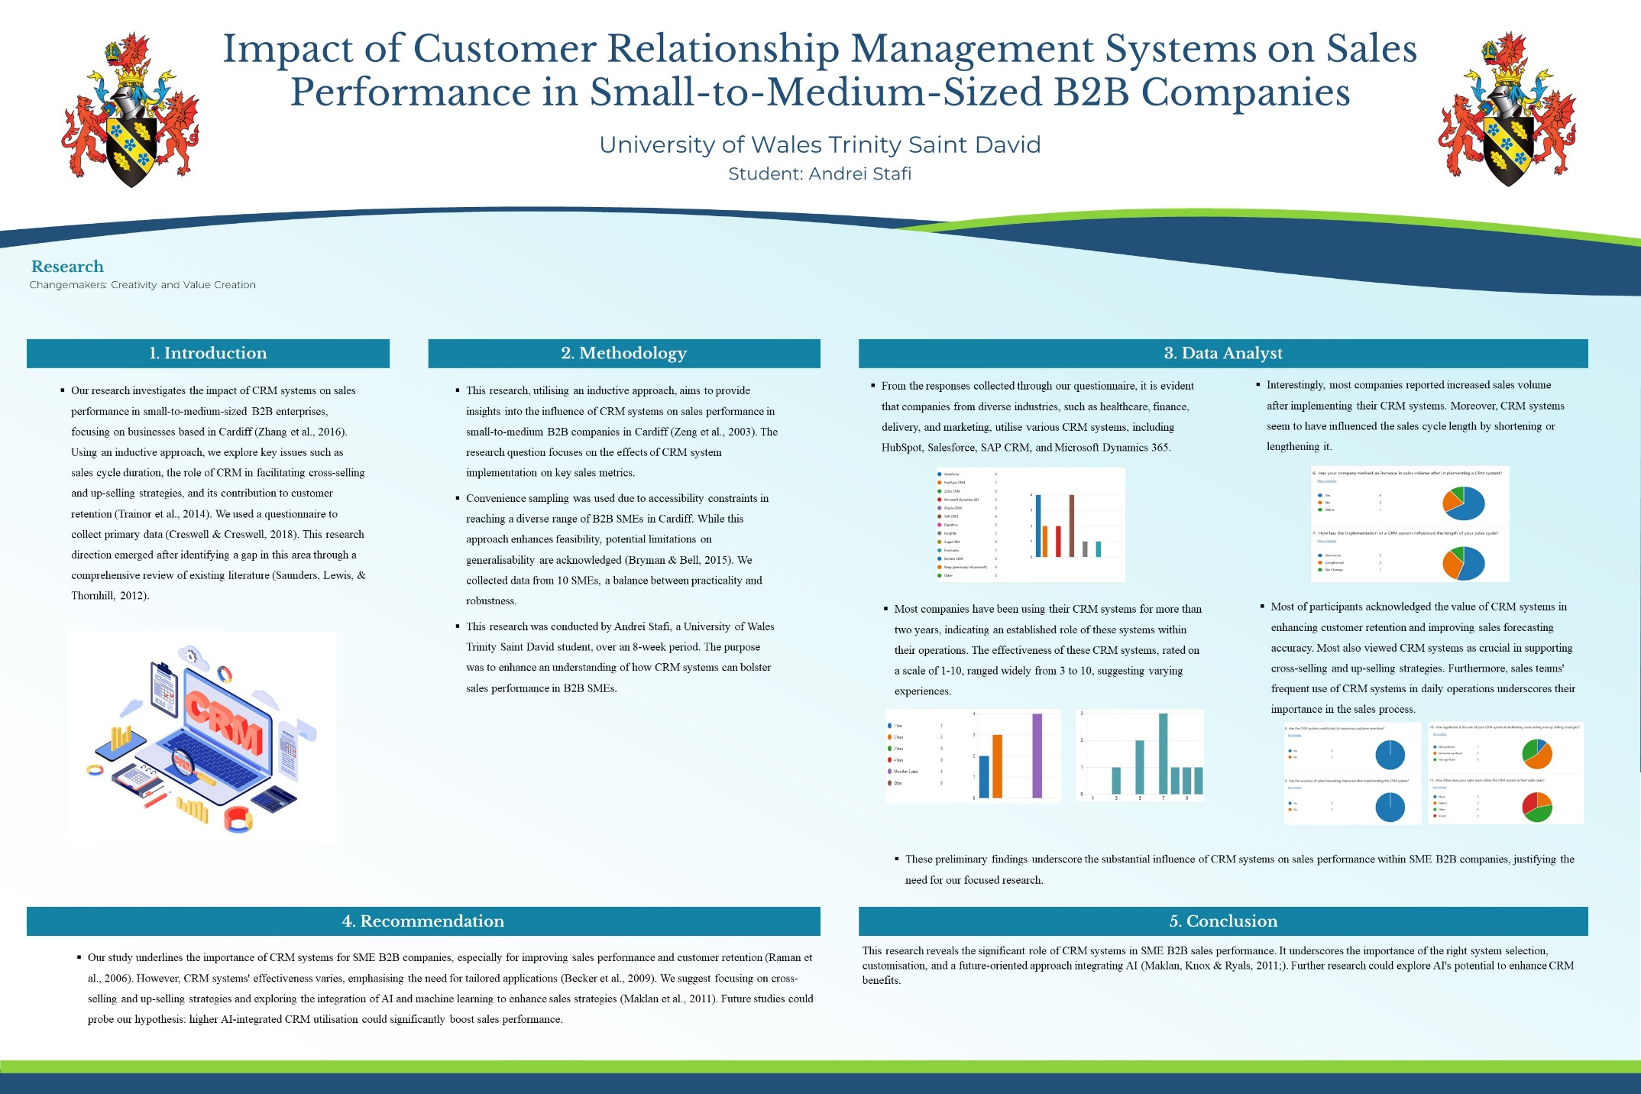
Task 4 – Analysis Poster

Reference List
Ahearne, M., Hughes, D. E., & Schillewaert, N. (2007). Why sales reps should welcome information technology: measuring the impact of CRM-based IT on sales effectiveness. International Journal of Research in Marketing, 24(4), 336–349.
Becker, J. U., Greve, G., & Albers, S. (2009). The impact of technological and organisational implementation of CRM on customer acquisition, maintenance, and retention. International Journal of Research in Marketing, 26(3), 207-215.
Bendoly, E., & Cotteleer, M. (2008). Understanding sales performance through visualisation of CRM data. Journal of Interactive Marketing, 22(4), 30-45.
Bryman, A. (2016). Social research methods. 5th ed. Oxford: Oxford University Press.
Bryman, A., & Bell, E. (2015). Business research methods. Oxford university press.
Cohen, L., Manion, L., & Morrison, K. (2007). Research methods in education. 6th ed. New York: Routledge.
Creswell, J. W., & Creswell, J. D. (2017). Research design: Qualitative, quantitative, and mixed methods approaches. 5th ed. Los Angeles: SAGE Publications.
Creswell, J. W., & Creswell, J. D. (2018). Research design: Qualitative, quantitative, and mixed methods approaches. Sage publications.
Flick, U. (2018). An Introduction to Qualitative Research. 6th ed. London: SAGE Publications.
Maklan, S., Knox, S., & Ryals, L. (2011). Using real-time customer intelligence for CRM. Journal of Database Marketing & Customer Strategy Management, 18(2), 129-146.
Nagwan, Alqershi, Ismail, Abdussalaam, Abu Al-Rejal, Hussein, & Salahudin, Shahrul. (2020). Competitive Advantage Achievement through Customer Relationship Management Dimensions. Journal of Distribution Science, 18, 61-67. 10.15722/jds.18.11.202011.61.
Raman, P., Wittmann, C. M., & Rauseo, N. A. (2006). Leveraging CRM for sales: The role of organizational capabilities in successful CRM implementation. Journal of Personal Selling & Sales Management, 26(1), 39-53.
Saunders, M., Lewis, P., & Thornhill, A. (2012). Research methods for business students. Pearson.
Smith, K. (2011). 'Secondary Data Analysis: An Important Tool for Addressing Developmental Questions.' Journal of Cognition and Development, 12(4), 377-386.

Timmermans, S., & Tavory, I. (2012). 'Theory Construction in Qualitative Research: From Grounded Theory to Abductive Analysis.' Sociological Theory, 30(3), 167-186.
Trainor, K. J., Rapp, A., Beitelspacher, L. S., & Schillewaert, N. (2014). Integrating information technology and marketing: An examination of the drivers and outcomes of e-Marketing capability. Industrial Marketing Management, 43(1), 15-24.
Verhoef, P. C., & Leeflang, P. S. (2009). Understanding the marketing department's influence within the firm. Journal of Marketing, 73(2), 14-37.
Watson IV, G. F., Palmatier, R. W., & Dant, R. P. (2016). Dynamic relationship marketing. Journal of Marketing, 80(5), 53-75.
Zeng, R., Wen, H.J., & Yen, D.C. (2010). 'Customer relationship management (CRM) in business-to-business (B2B) e-commerce.' Information Systems Frontiers, 12(2), 201-212.
Zhang, J., Watson IV, G. F., Palmatier, R. W., & Dant, R. P. (2016). Dynamic relationship marketing. Journal of Marketing, 80(5), 53-75.

