ANSWER ANY 4 QUESTIONS

Question 1 [25 Marks]
- For the circuit shown in fig:1 below,
- Calculate the total circuit resistance ( R_{T} ). [3 marks]
- Calculate the supply current ( I_{s}) [2 marks]
- Calculate the total power dissipated. [2 marks]
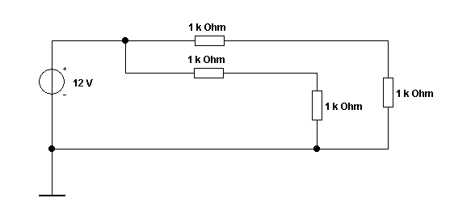
Fig:1
Answer:
- $R_{T}=\frac{\left(1k+1k\right)×\left(1k+1k\right)}{\left(1k+1k\right)+\left(1k+1k\right)}=1k$ [3 marks]
- $I_{s}=\frac{V}{R}=\frac{12}{1k}=12 mA$ [2 marks]
- $P=I^{2}R={\left(12×{10}^{-3}\right)}^{2}×1000=0.144 W$ [2 marks]

- An indicator light requires a $330Ω$ resistor to limit current. The voltage across the current limiting resistor is 3V. What is current flowing through the resistor? Also, calculate how the current change if a $200Ω$ resistor is used instead? [4 Marks]
Answer:
Given, Voltage = 3V
Resistor = $330Ω$
Current flowing through the resistor = $\frac{V}{R}=\frac{3}{330}=0.0091A$ [2 Marks]
When the resistor is $270Ω$, Current =$\frac{V}{R}=\frac{3}{270}=0.0111A$ [2 Marks]
- An oscilloscope display shows the below voltage waveform. The oscilloscope settings are shown in the box next to the waveform.
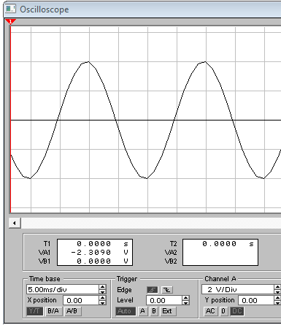
Oscilloscope settings:
2V/div
10ms/div

Fig:2
- Estimate the period of the waveform. [1 mark]
- From the estimated period, determine its frequency. [2 marks]
- Determine its peak-peak amplitude [2 marks]
- Determine the r.m.s. value of the waveform. [2 marks]
Answer:
- Estimate the period of the waveform.
$Period=4 div ×10 ms=40 ms$ [1 mark]
- From the estimated period, determine its frequency.
$f=\frac{1}{t}$
$f= \frac{1}{40 ms}=25 Hz$ [2 marks]
- Determine its peak-peak amplitude
$V_{pk-pk}=4 div ×2 V=8 V$ [2 marks]
- Determine the r.m.s. value of the waveform.
$V_{RMS}=\frac{V_{pk}}{\sqrt{2}}=\frac{4}{\sqrt{2}}=2.828 V$ [2 marks]
- Design an equivalent circuit with a single current source, for the circuit shown in fig.3, [3 Marks]
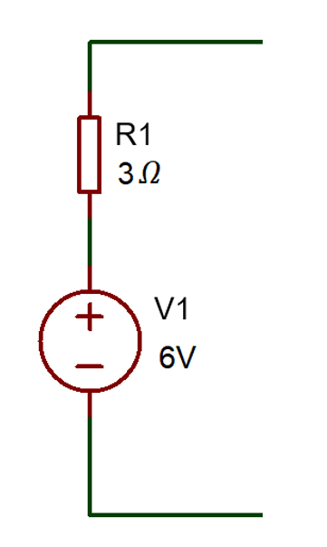
Fig: 3
Answer:
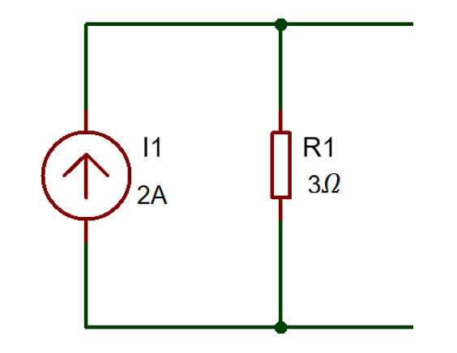
[2 Marks]
$I=\frac{V_{1}}{R_{1}}=\frac{6}{3}=2A$ [1 Mark]
- Differentiate Step- up Transformer and Step-Down Transformer (minimum of two differences) [4 Marks]
Answer:
Sl. No | Step-up Transformer | Step-down Transformer
1 | Input voltage is lower than the output voltage | Input voltage is higher than the output voltage
2 | Number of Secondary winding is higher than the primary winding | Number of Secondary winding is less than the primary winding
3 | 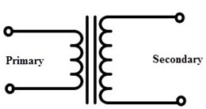 | 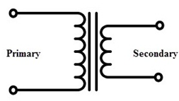
[Each difference two marks, Maximum of 4 marks]

Question 2 [25 Marks]
- For the circuit shown in Fig. 4, calculate:
  - The total resistance. [3 Marks]
  - The total current if the battery voltage was 12V [2 Marks]
  - The total power dissipated by the circuit [2 Marks]
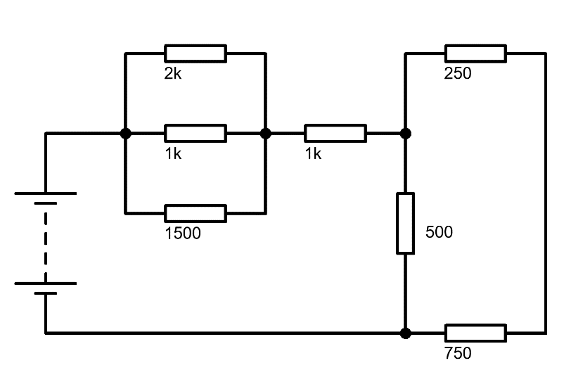
Fig: 4
Answer:

$R_{T}=R_{A}+R_{B}+R_{C}$
$R_{A}=\frac{1}{\frac{1}{2k}+\frac{1}{1k}+\frac{1}{1500}}=461.538 Ω$ [1 mark]

$R_{B}=1 kΩ$

$R_{C}=\frac{1}{\frac{1}{500}+\frac{1}{250+750}}=333.333 Ω$ [1 mark]

$R_{T}=461.538+1k+333.333=1794.871 Ω$ [1 mark]

- $I=\frac{V}{R}=\frac{12}{1794.871}=6.686 mA$ [2 marks]

- $P=V×I=12 V×6.686 mA=80.237 mW$ [2 marks]

- Three resistors ($R_{A} R_{B} and R_{c})$are connected in series to a 250V Voltage Source. Where, $R_{c}=50Ω, V_{B}=80V and$Total current = 2A. Calculate the following
- Voltage across $R_{A}$ [2 Marks]
- Voltage across $R_{C}$ [2 Marks]
- Resistance value of $R_{A}$ and $R_{B}$ [4 Marks]
Answer:
- Voltage across $R_{A}$
$V=V_{A}+V_{B}+V_{C}$
$250=V_{A}+80+100$
$V_{A}=250-180=70V$ [2 marks]
- Voltage across $R_{C}$
$V_{C}=I×R_{c}=2×50=100V$ [2 Marks]
- Resistance value of $R_{A}$ and $R_{B}$
$R_{B}=\frac{V_{B}}{I}=\frac{80}{2}=40Ω$ [2 Marks]
$R_{A}=\frac{V_{A}}{I}=\frac{70}{2}=35Ω$ [2 Marks]
- Explain the following terms:
- Resistance [2 Marks]
- Reactance [2 Marks]
- Impedance [2 Marks]
Answer:
- Resistance
Opposition to flow of current. Unit is Ohm - DC circuit property [2 Marks]
- Impedance
Opposition to change of flow of current. Unit is Ohm- AC circuit property [2 Marks]
- Reactance
Vector sum of resistance and reactance – Describes total opposition to current – AC and DC circuit property. [2 Marks]
- List any four types of Transistors. [4 marks]
Answer:
- BJT (Bipolar Junction Transistor) – NPN
- BJT (Bipolar Junction Transistor) – PNP
- N-Channel JFET (Junction Field Effect Transistor)
- P-Channel JFET (Junction Field Effect Transistor)
- N-Channel MOSFET (Metal Oxide Semiconductor Field Effect Transistor)
- P-Channel MOSFET (Metal Oxide Semiconductor Field Effect Transistor)
[1 mark each, Maximum of 4 Marks]
Question 3 [25 Marks]
- A certain power supply requires 25W of input power and produces an output power of 20W. Calculate its efficiency in percentage and the total power loss? [4 Marks]
Answer:
$Efficiency=\frac{P_{OUT}}{P_{IN}}=\frac{20}{25}=0.8$ [1 Mark]
$\%Efficiency=80\%$ [1 Mark]
$P_{Loss}=P_{IN}-P_{OUT}=25-20=5W$ [2 Marks]
- Determine the voltage across each resistor in the circuit shown in fig.5. [4 Marks]
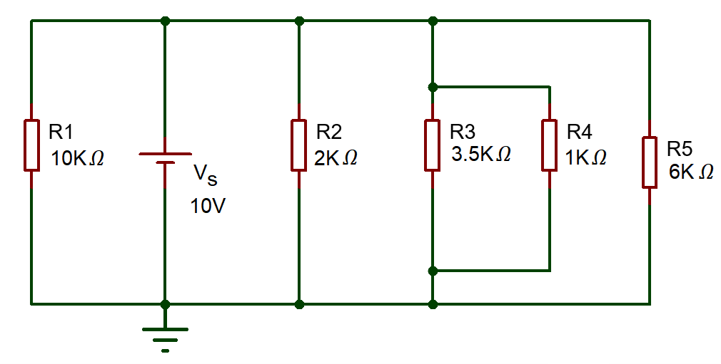
Fig.5
Answer:
As all the resistors are in parallel, the Voltage across the resistor is the same.
$V_{1}=V_{2}=V_{3}=V_{4}=V_{5}=10V$ [4 Marks]
- Determine the current across each resistor in the circuit shown in fig.6, using mesh analysis (Kirchhoff’s Voltage Law) [17 Marks]
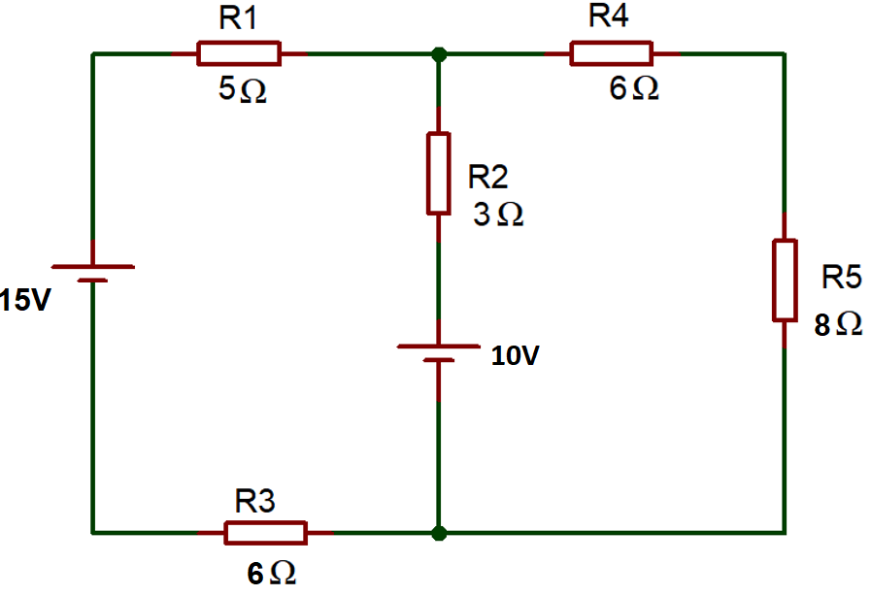
Fig.6
Answer:
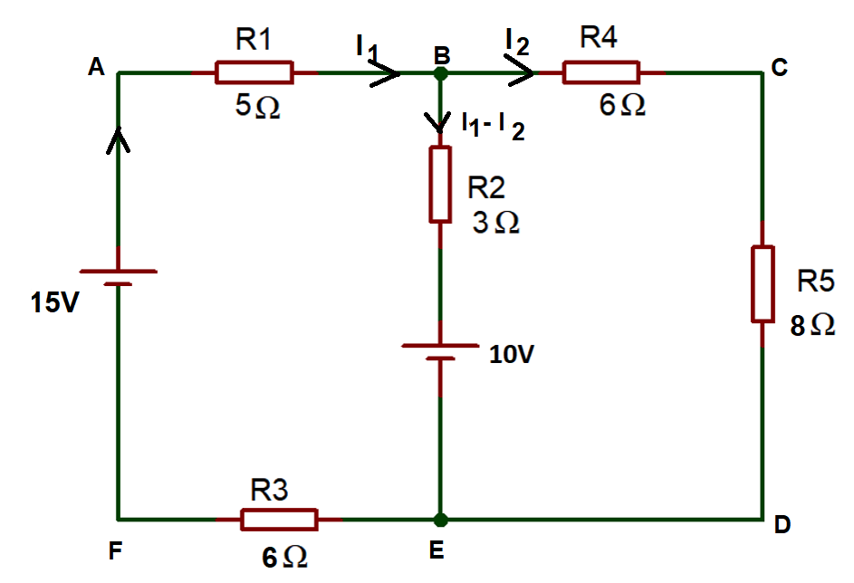

[1 Mark]
Apply KVL in ABEFA
$-5I_{1}-3\left(I_{1}-I_{2}\right)-10-6I_{1}+15=0$ [3 Marks]
$-14I_{1}+3I_{2}=-5$ …………(1) [2 Marks]
Apply KVL in BCDEB
$-6I_{2}-8I_{2}+10+3\left(I_{1}-I_{2}\right)=0$ [3 Marks]
$+3I_{1}-17I_{2}=-10$ …………(2) [2 Marks]
Simplifying Equation (1) and (2)
$I_{2}=0.677A$ [2 Marks]
Substitute, $I_{2}$ in equation (1)
$-14I_{1}+3\left(0.677\right)=-5$
$I_{1}=\frac{7.031}{14}$=0.5022A [2 Marks]
Current across branch BE
$I_{1}-I_{2}=0.5022-0.677=-0.1678A$ [1 Mark]
Current Across $R_{1}and R_{3}=I_{1}=0.5022A$

Current Across $R_{2}=I_{1}-I_{2}=-0.1678A$
Current Across $R_{4} R_{5}=I_{2}=0.677A$ [1 Mark]
Question 4 [25 Marks]
- The alternating current is given by $i=40 sin314t$. Determine the following
- Maximum Value of current [1 Mark]
- RMS Value of Current [2 Marks]
- Frequency [2 Marks]
Answer:
- Maximum Value of current
From the given equation, $V_{m}=40V$ [1 Mark]
- RMS Value of Current
$V_{RMS}=\frac{V_{m}}{\sqrt{2}}=\frac{40}{\sqrt{2}}$ [1 Mark]
$V_{RMS}=28.284V$ [1 Mark]
- Frequency
From the equation, $ω=314$
We know that, $ω=2πf$
$314=2πf$ [1 Mark]
$f=\frac{314}{2π}$=50Hz [1 Mark]
- What is the use of the circuit shown in fig.7? Describe the functions of each stage of the circuit with the necessary diagrams. [12 marks]
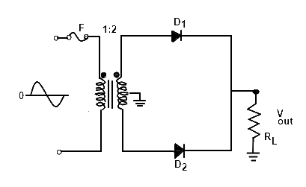
Fig.7
Answer:
- Step down transformer reduces the voltage
- Diode converts AC to pulsating DC.
- During the Positive half cycle, the region A become Positive and region B becomes Negative. So, the diode D1 will be forward biased and the diode D2 will be reverse biased. So the current passes from the secondary, then to the diode D1 and then to the load.
- During the negative half cycle, the region B becomes positive and region A becomes negative. So, the diode D2 will be forward biased and the diode D1 will be reverse biased. So the current passes through the secondary, then to the diode D2 and then to the load.
- Thus, the circuit is active for both the positive and the negative cycles. [6 marks]
Diode D1 (ON) and D2 (OFF)
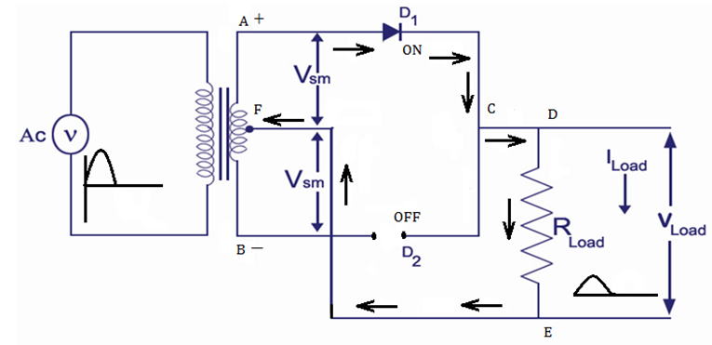
Diode D1 (OFF) and D2 (ON)
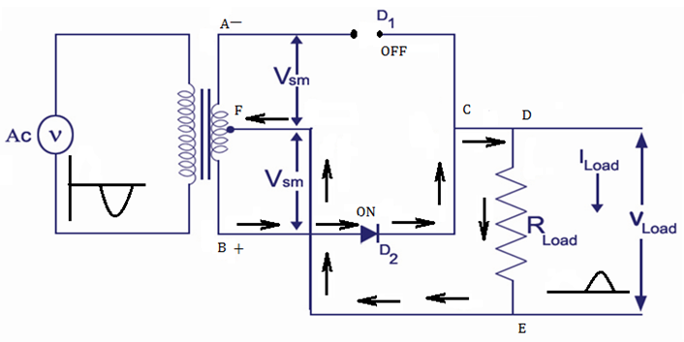 [4 marks]
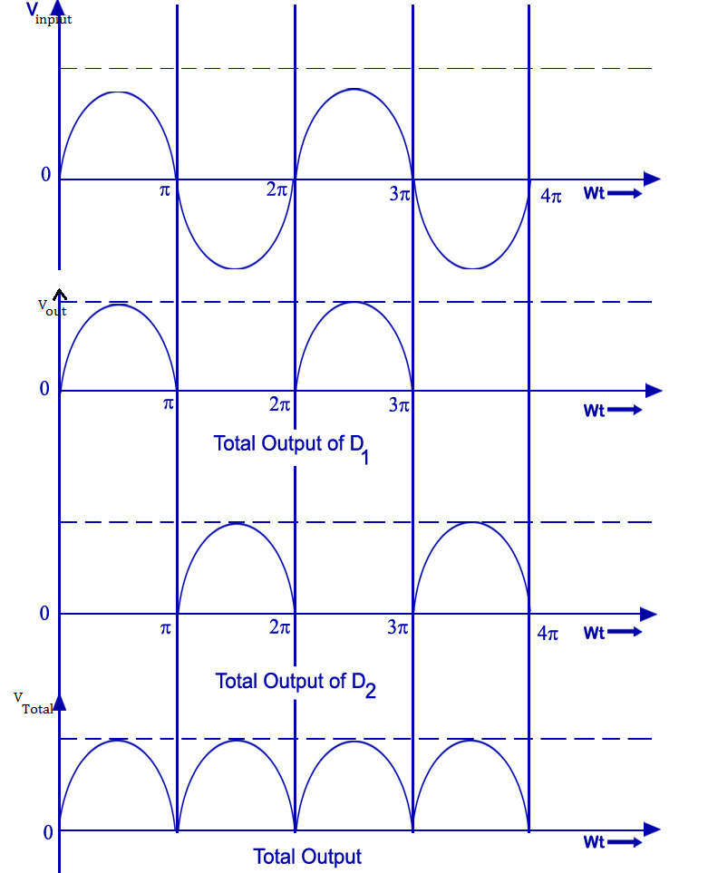
[2 marks]
- For the circuit shown in fig 8:
- Calculate the total impedance [2 Marks]
- Calculate the circuit current and phase angle [3 Marks]
- Calculate the voltage drop across the resistor [1 Mark]
- Calculate the voltage drop across the inductor [1 Mark]
- Calculate the voltage drop across the capacitor [1 Mark]
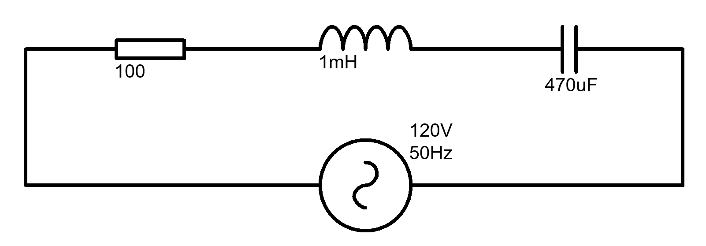
Fig.8
Answer:
- $X_{L}=2πfL=2×π×50×1 mH=0.3142 Ω$
$$X_{C}=\frac{1}{2πfC}=\frac{1}{2×π×50×470 μF}=6.773 Ω$$

$\left|Z\right|=\sqrt{R^{2}+{\left(X_{L}-X_{C}\right)}^{2}}=\sqrt{{100}^{2}+{\left(0.3142-6.773\right)}^{2}}=100.208 Ω$ [2 Marks]

$I=\frac{V}{Z}=\frac{120}{100.208}=1.198 A$ [1 Mark]
$φ=\tan^{-1}{\frac{X_{T}}{R}}=\tan^{-1}{\frac{\left(0.3142-6.773\right)}{100}=}-3.695°$ [2 Marks]
- $V_{R}=I×R=1.198×100=119.8 V$ [1 Mark]
- $V_{L}=I×X_{L}=1.198×0.3142=0.376 V$ [1 Mark]
- $V_{C}=I×X_{C}=1.198×6.773=8.114 V$ [1 Mark]

Question 5 [25 Marks]
- Describe the construction and working of PN Junction diode with the aid of necessary diagrams. [10 Marks]
Answer:
A junction formed between a sample of P type semiconductor and N type semiconductor is known as PN junction (or) Junction diode. [1 mark]
It has two electrodes
- P region named as Anode
- N region Named as Cathode [1 mark]

[1 mark]
When no supply is given to the PN junction diode.
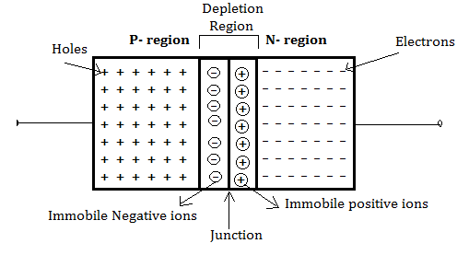 [1 mark]
- At the junction, electrons in N-type semiconductor moves towards holes in P-type region and Holes in P-type region moves towards the electrons in the N- type region.
- Electrons from N region diffuse to P region, recombine with holes and form negative charge immobile ions, near the junction of P region.
- Similarly, Holes from P region diffuse to N region, recombine with electrons and from positive charge immobile ions, near the junction of N side.
- These immobile ions forms a barrier at the junction, which is known as Depletion region or Space charge region.
- After certain period of time, the negative charge ions in the P-region and the Positive charge ions in the N-region prevents further charges moving from one region to another. [4 marks]
Voltage can be applied in PN junction diode in two ways to control the width of the depletion region. They are
- Forward biasing
- Reverse Biasing
When an external voltage is applied to the PN junction in such a way that its cancels the potential barrier and permits the current flow, it is called Biasing [2 marks]
- A 10 V Battery has an internal Resistance of 10Ω, Calculate the power dissipated by various load resistances given in the below table and complete the table. [10 Marks]
Load Resistance (Ω) | Load power (W)
5
10
15
20
25
- Plot a graph of the load Power against the load resistance,. [5 Marks]
Answer:
Load Resistance (Ω) | Load power (W)
5 | 2.22
10 | 2.50
15 | 2.40
20 | 2.22
25 | 2.04
[Each 2 Marks, Maximum of 10 Marks]
Graph:

[5 Marks]

Diwedd/End

