

Managing Health, Safety and Welfare in Construction
Lecturer: Dr Deborah Hughes
Module Code: ACBA4003
Rhydian Jones 1910142

Contents

- Construction Phase Plan

- Method Statement

- Risk Assessments

- CDM Regulations and Duty Holders

Introduction
This document will present many tasks that are required before, during and after a construction project. University of Trinity St David’s have had plans approved by the local authority to build a two storey detached domestic building with a loft room. The project itself will initially start on the 6th May 2020 and the intended time duration for this project will be 33 weeks ending on Wednesday 23rd December 2020. I am to provide a detailed Construction Phase Plan for all major activities that relate to this project from start through to the finish. A specific Method Statement will be produced for three major activities that will be identified on site.
Construction Phase Plan (CPP)
Company name: Jones Homes
Principal Contractor: Rhydian Jones (Jones Homes)
07769985478
Architect Information:
Mr Shane Jones
Jones&Halford Architect and design
Unit 1
Swansea bay Industrial Estate
Mumbles
SA4 5HR
07765518767
What is the Job:
Build a Single, Two Storey detached domestic building with a loft room. Located in SA1 (see plans below CPP) Direct access off highway.
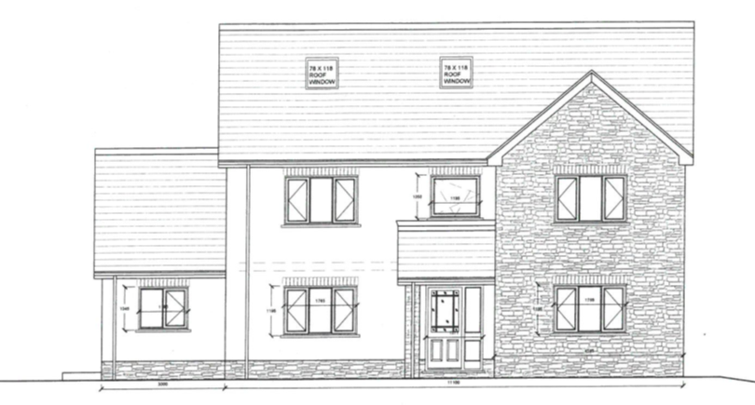
Proposed NW Elevation

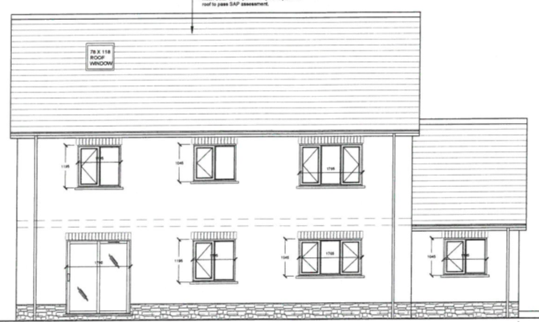
Proposed SW Elevation

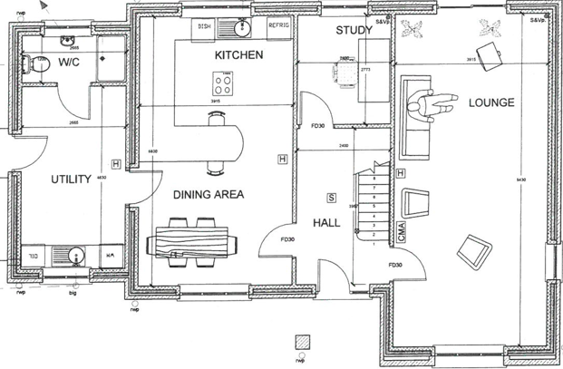
Proposed Ground Floor Plan
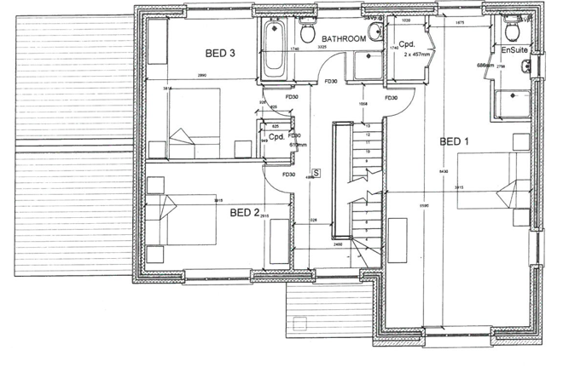
Proposed First Floor Plan

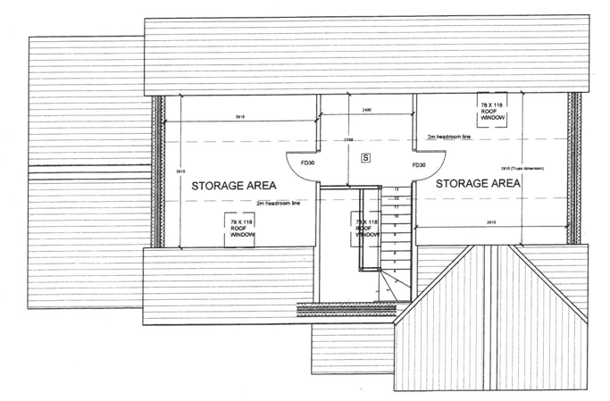
Proposed 2nd Floor Plan

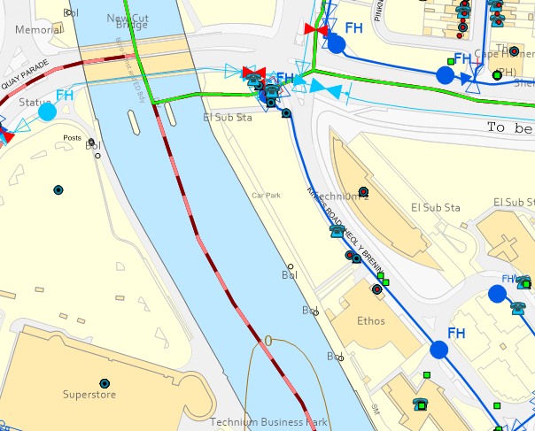
This is the location of where the dwelling will be built.

Further Details about the job:
Concrete strip to a depth of 1m with standard cavity wall.
Natural sandstone porch pillars
Beam and block ground floor
Light oak wood effect uPVC with sealed double-glazing units.
Trussed roof rafters at 40% pitch and natural slate covering and closed eaves.

Start Date: 06/05/2020
End Date: 18/12/2020
Contractors on Site: Contractors on site will primarily be Jones Homes. All subcontractors will have to be given a site inductions by the contract manager and present their CSCS card. All Health and Safety practices will be highlighted throughout the induction. Once site induction has been given and the visitor, contractor are happy and understood their site induction they will sign a document to acknowledge this.
Supervising Staff contact list:
Jones Homes | Project Manager | Rhydian Jones | 07769985478
Jones Homes | Contracts Administrator | Angharad Allinson | 07787845896
Jones Homes | Contracts Manager | Daniel Evans | 07895485968
Jones Homes | Construction Manager | Aled Tommason | 07895635254
Jones Homes | Site Foreman | Jonathan Lloyd | 07415454447

Welfare facilities: In line with (CDM 2015) welfare facilities will be provided in the far right hand side of the site. There will be cold running drinking water, washing facilities along with warm water, changing facilities and a place to rest. All welfare facilities must be kept clean at all times and hygiene levels are paramount. They will be put on hard standing surfaces and the position of the welfare facilities will not interfere with the health and safety of site operatives.
Personal Protective Equipment: All employees must comply with the site safety rules that are on the entrance of the site. It’s mandatory to wear a Hard Hat, Safety goggles, and long sleeve high visibility vest that comply with EN471 and safety boots. When working in a confined space with poor ventilations a dusk mask must be worn at all times.
All personnel have a responsibility to maintain their PPE. If their PPE is in a poor state and requires replacing employees need to contact site foreman who will replace their PPE.
Emergency and First Aid: In an event of an accident on site it must be documented in the Accident site book. Depending on the severity of the problem escalation will be required. For all emergencies call 999. All relevant information is logged on the accident site book. Nearest hospital for accident and emergency is Morriston. Address is: Heol Maes Egwlys, Morriston, Cwmrhydyceirw, Swansea, SA6 6NL.
In an event of a fire, the fire assembly point is located next to the welfare facilities. Once everyone is accounted for the site manager will take a register on who is on site and make sur everyone is accounted for. All employees must drop tools and immediately go to the fire assembly point under the first instruction.
Site Foreman Mr Jonathan Lloyd has certificate in First Aid at work.
Manual Handling:
Manual Handling Operations Regulations 1992 must be adhered too.
PUWER
Provision and Use of Work Equipment Regulations 1998. All work equipment depending on risk levels will be inspected by a competed person. High risk equipment must comply with the PUWER regulations and meet all the requirements from 5th Decemeber 1998.
LOLER: The Lifting Operations and Lifting Equipment Regulations 1998. All lifting equipment will be inspected each week and when environment changes that could have an adverse effect on the lifting equipment. It should be recorded in the site safety book. All tags colour coded and representation of this will be documented in a file.
Site Communication: Every morning prior to starting the day’s work the contracts manager will give a daily brief. In his brief will any updates to the project in hand, weather conditions followed by Q&A. This ensures everyone is aware of their responsibilities for that particular day on site.
No foreign speaking operatives are employed by Jones Homes at present therefore all operatives can read, speak and communicate effectively in English.
Access and Egress: Access to the working area will be via the entry point from King Road. Care must be taken when entering site and leaving site as the access point is directly onto the main road.

Method Statement .1
Task – Install roof trusses
Employee requirements –
- CSCS Card
- Slinger Signaller
- Fully trained and competent Banksman
- Crane driver will be third party operative
Tools/Plant needed –
- Crane mounted lorry
- Lifting equipment (certified and tested)
- Hand tools
- 4” galvanized nails

Installation of the roof trusses:
- The roof trusses are stacked up in a pile on the hard standing stone near the welfare unit. Slinger Signaller will attach the load. Once attached will signal to the banksman on the scaffolding that the load is ready to be lifted.
- Once the crane has lifted the truss up to roof level the banksman will liaise with the crane operative to slowly lower the truss into position.
- Two carpenters will be guiding the truss down on the wall plates ready to nail into place.
- Once nailed into place the lifting equipment will be released and sent back down to pick up the next roof truss.
- Ensure all trusses are nailed 400mm apart from one another and doubled up for any openings such as Velux windows.
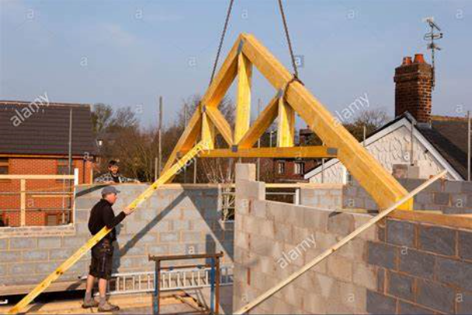
(crane lifting roof trusses - Bing, 2020)

Method Statement .2
Task – Excavate trench for utilities (Water)
Employee Requirements –
- CSCS Card
- 1.5t digger ticket
Tools/Plant needed
- 1.5t digger
- Pecker
- Road saw
- 16” bucket
- Laser level
- Half round headed shovel
- Measuring tape
- Cat + Genny

Excavating Trench –
- Barrier area off to ensure no further operatives are in the exclusion zone.
- Mark out with spray where the trench will be going exactly. Once this is done run over the whole area with a Cat & Genny to ensure there no buried services. Once this is done carry out inspection on the road saw.
- If happy use the road saw and cut down the through the concrete. Operative in machine can then begin and peck away the concrete. Once all the concrete has been pecked away change the pecker for the 16” bucket.
- Begin digging down to the level of 750mm. The second ground worker must always keep a close eye on the excavation in case you come across buried services that weren’t picked up on the Cat & Genny.
- Once the required depth has been made lay the 32mm blue MDPE pipe in the trench ready for inspection.
Method Statement .3
Task – Prepare area and fill trenches for foundations
Employee requirements –
- CSCS Cards
- Operative with tickets to operate dump truck and 6t Digger
- Fully trained operative to use pump on cement lorry
- Fully competent Carpenter
Tools/Plant needed
- Basic carpentry hand tools such as Claw hammer, Level, Jack saw
- Dump Truck
- 6t Digger
- Shovel
- Cement Lorry and pump

Preparing and filling trench with concrete –
- Once area is marked out ensure no personnel enters zone of dump truck and digger
- Once dug out to the required depth of 1m 18mm plywood shuttering must be installed and braced

- All soil from the dump truck must be put in the designated area
- Once all operatives have left the trench, start pumping the cement into the trenches and once in place start removing the shuttering before the cement goes hard
- Level off all concrete to ensure its flat.
Risk Assessment
Here below are the Risk assessments that are in order of the method statements:
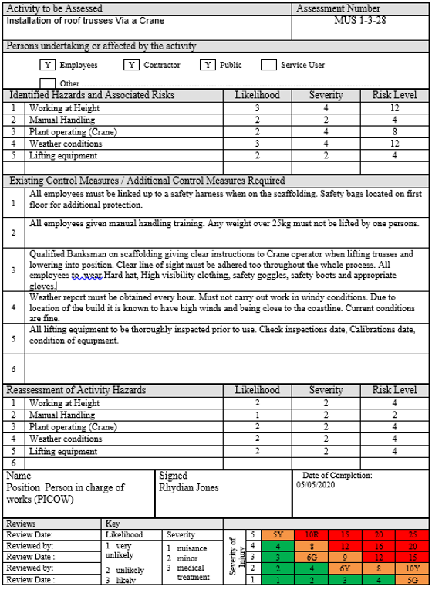
Risk Assessment 2
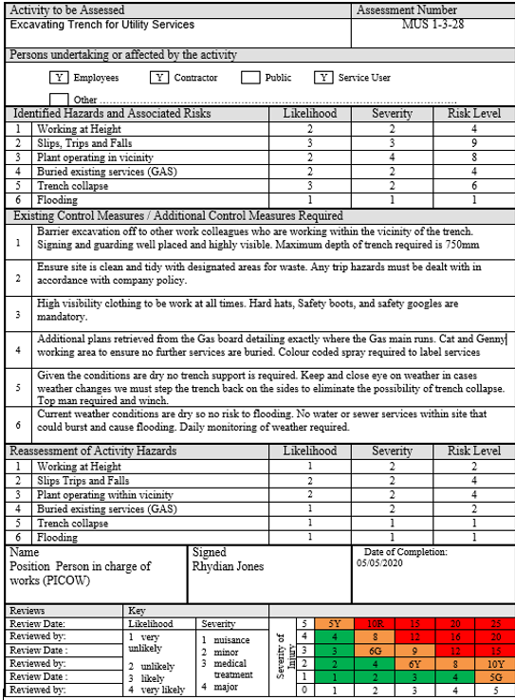

Risk Assessment 3

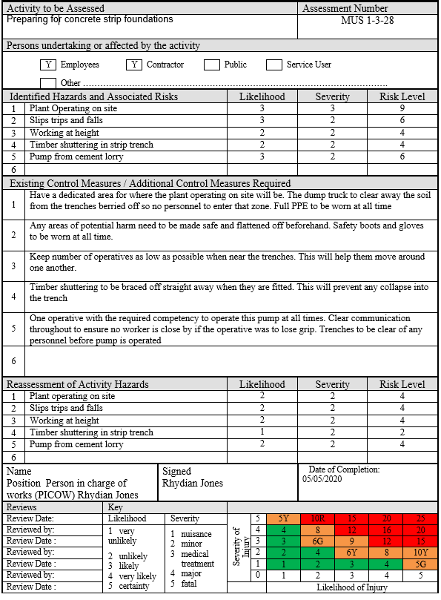

CDM Regulations
Many CDM duty holders play a part in the construction industry. They can range from commercial clients, domestic clients, designers, principal designers, principal contractors, contractors and workers on the project.
Below is a holistic diagram showing the functions of a duty holder and the different project stages.
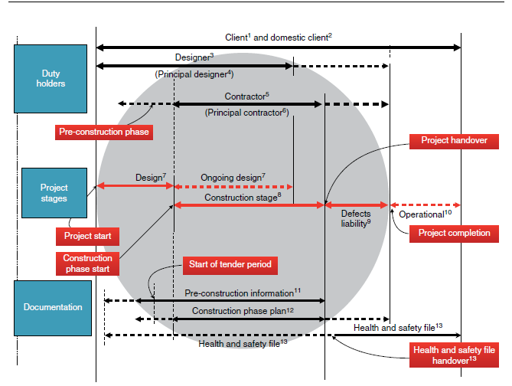
(UWTSD Moodle 2019/20: Log in to the site, 2020)
Through doing this project it is evident that the one of the most relevant Health and Safety legislations that have come in many of my risk assessment is the Working at Height Regulations 2005.
As Jones Homes is the principal contractor it’s their aim to ensure they are managing risks to the best of their ability by identifying them early and using general principles of prevention. From here it’s their duty to appoint the correct organisations at the right time.
To manage this they must make sure that all organisations have the correct information, instruction, training and supervision that is required to carry out any of their jobs. The principal contractor must appoint an individual to provide site inductions and ensure workers are consulted and engaged at all times.
Workers on site become responsible duty holders and play a big part in health and safety. It is paramount that they look after their Health and Safety as well as the Health and Safety of others who work in close proximity to them. Working at Heights is one of the most important regulations to be had as there could be catastrophic consequences if this wasn’t to be adhered.

References
Hse.gov.uk. 2020. [online] Available at: <https://www.hse.gov.uk/pubns/priced/l153.pdf> [Accessed 5 May 2020].
Legislation.gov.uk. 2020. The Lifting Operations And Lifting Equipment Regulations 1998. [online] Available at: <http://www.legislation.gov.uk/uksi/1998/2307/contents/made> [Accessed 5 May 2020].
Bing.com. 2020. Crane Lifting Roof Trusses - Bing. [online] Available at: <https://www.bing.com/images/search?view=detailV2&id=CE189E8BDFB9E99E3621C30AEBFA45F868A1CA00&thid=OIP.fVgdOWYNaQ3ah99h4Q7HbwHaFc&mediaurl=http%3A%2F%2Fc8.alamy.com%2Fcomp%2FDD9Y81%2Fself-building-house-constructing-roof-lifting-first-trusses-with-crane-DD9Y81.jpg&exph=956&expw=1300&q=crane+lifting+roof+trusses&selectedindex=17&adlt=strict&ajaxhist=0&vt=0> [Accessed 5 May 2020].
Moodle.uwtsd.ac.uk. 2020. UWTSD Moodle 2019/20: Log In To The Site. [online] Available at: <https://moodle.uwtsd.ac.uk/pluginfile.php/338365/mod_resource/content/0/CDM%20Regulations%202015.pdf> [Accessed 5 May 2020].

