

Assessment 1 – Reading Task Template
PART 1: Upload your photo of your A3 in-class notes here:
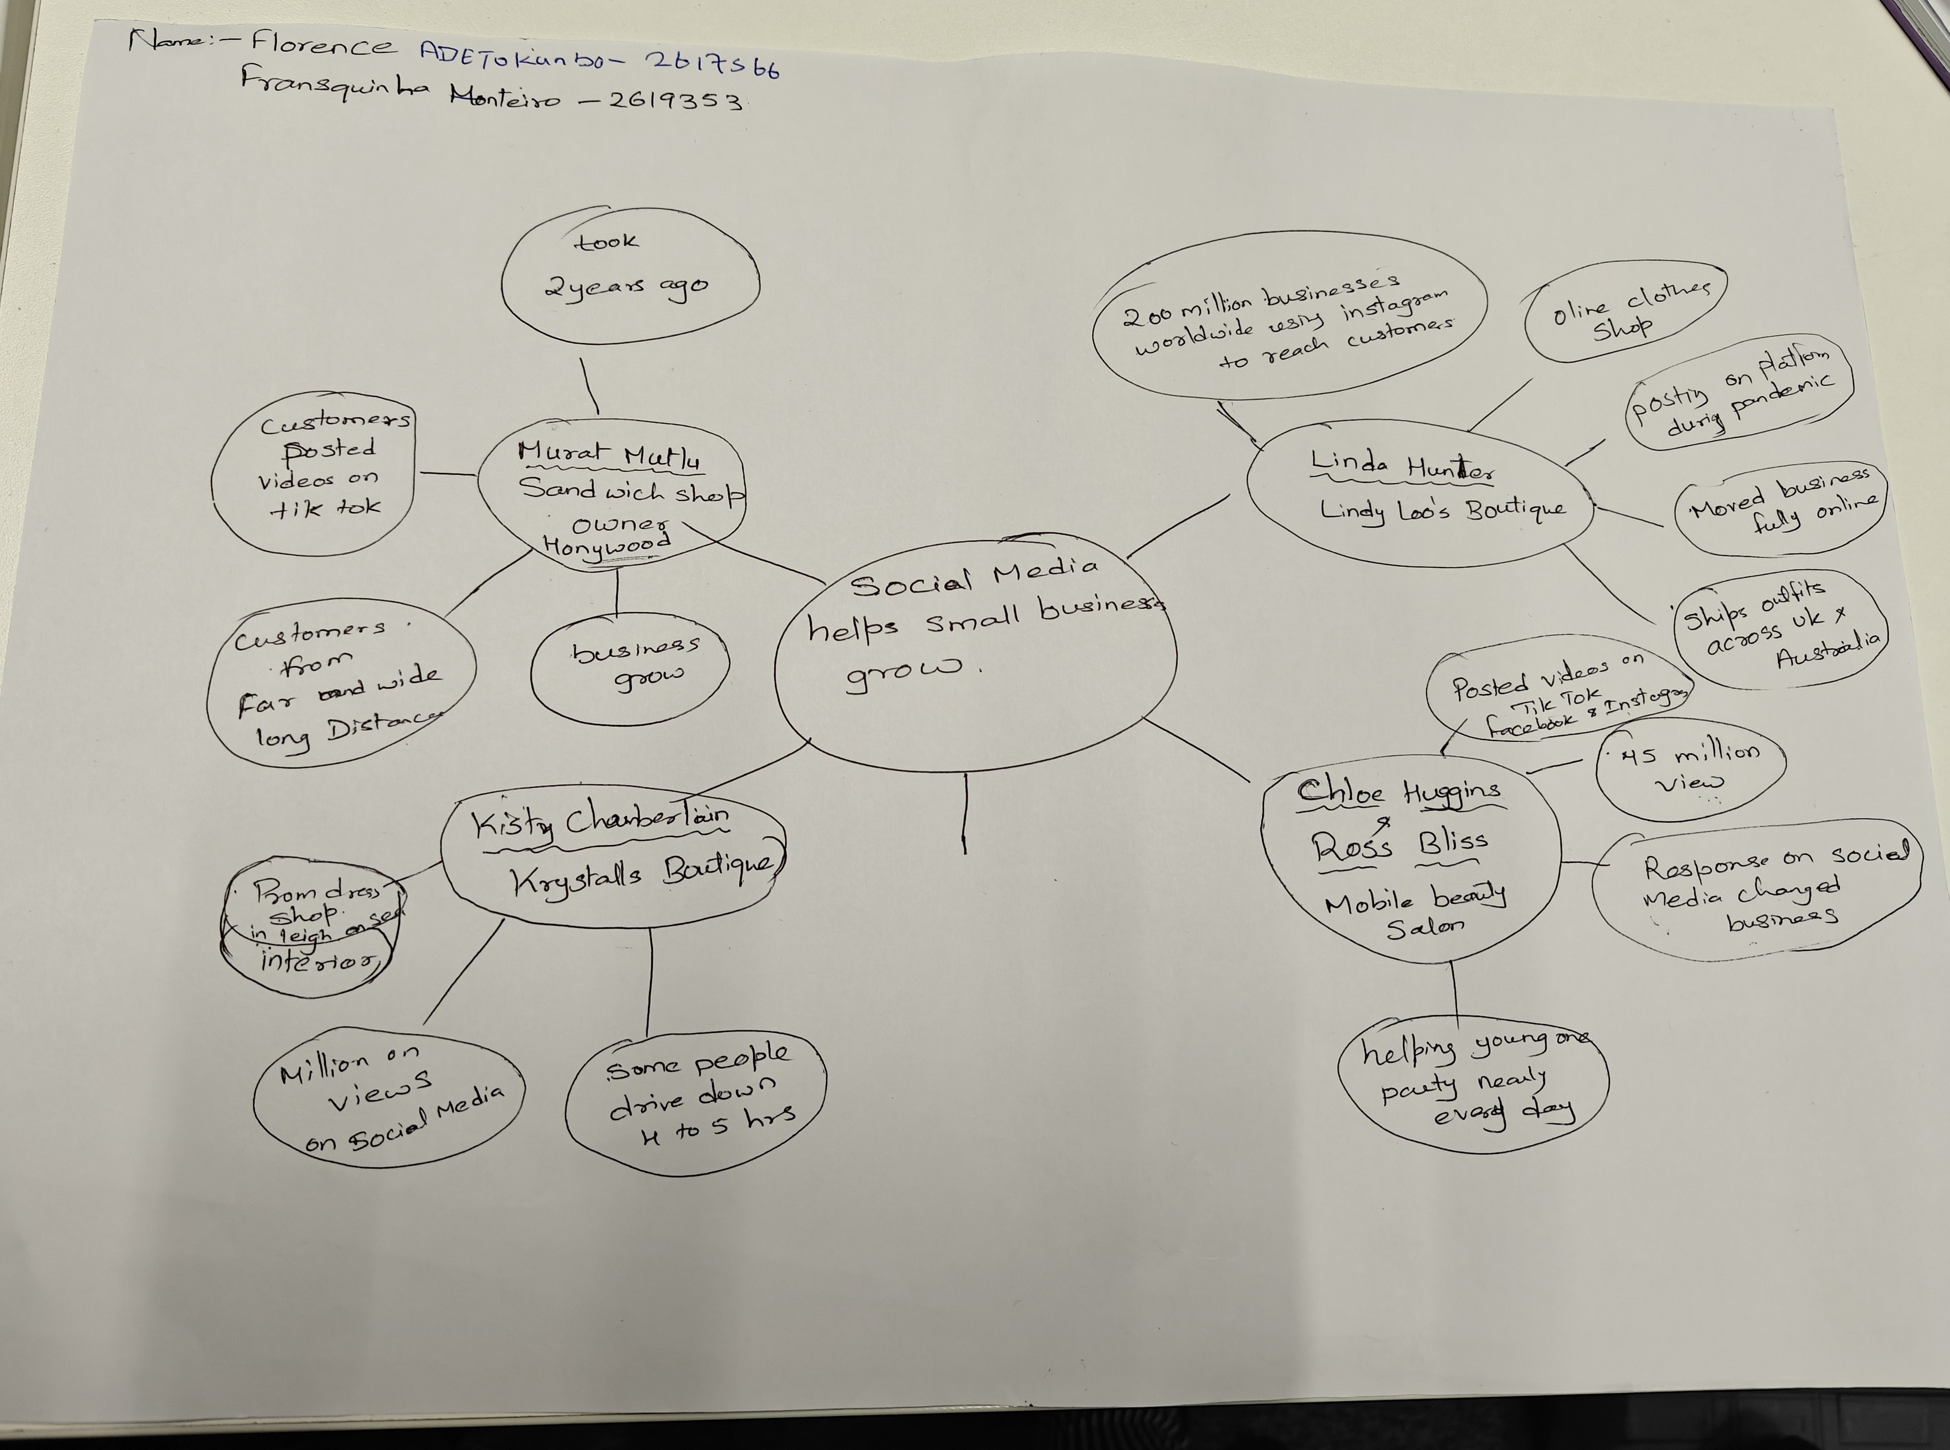

PART 2:
- Answer every question below in 1-3 full sentences.
- Use your own words. Do not use generative AI to answer these questions.
- Include a specific detail from the text when asked.
REMINDER
- The main idea is the overall message of the whole text.
- A key point helps to explain the main idea.
- A specific detail or example from the text shows that the key point is true.

- What is the main idea of the whole text?

Ans: - The main idea of the whole text is a social media. Social media helps small local businesses become highly successful by posting videos online. And these online likes turn into real – world customers.

- What is one key point that supports the main idea, and which specific example from the text shows this?
Ans: - There are different key points in the whole text, but one key point is going viral brings in customers from very far away. For example, Honywood Sandwich Shop had customers who travels three hours just for a burger after trending online.

- What is a different key point that supports the main idea, and which specific example from the text shows this?
Ans: - The other key point from the text is the Apps on the phone. This Apps help tiny side projects or market stalls grow into full-time global companies. Example will be Lindy Loo’s Boutique; it went fully online and now ships their clothes as far as Australia.

- Which part of the text do you think is most important, and why?
Ans: - The most important part in the text is the big numbers like the 1.5 million UK business using Tik Tok. This is important because it shows that social media is helping millions of small shops everywhere, not just a few lucky ones.

Reflection:
- What did you find difficult in this task (including in-class components), and why was it difficult?
Ans: - In this task I found difficulty in keeping track of all the different business owners and their separate stories. It was hard to write short answers because the article had so many interesting details about different businesses. I found it difficult to summarize the information without making my sentences too long.

- What helped you with this difficulty, and how did it help you?
Ans: - Grouping the business together by how they used video skits to find success. And focusing on just one clear example for each point helped me stay on track. This made it easier to keep my answers very simple.

