
BMSW4008
Digital Skills for Personal and Professional Growth
Student Name: Vasile Baciu
Student ID:1815810

Table of Contents
TASK 1 3
Introduction 3
About me 3
Professional Experience 4
Personal Life 4
Desired Job Role 5
Conclusion 6
TASK 2 7
Introduction 7
The Importance of Storytelling in Brand-Building 7
Example: How Storytelling Connects an Audience to the Brand 8
Conclusion 8
TASK 3 10
Questionnaire analysis 10
References 16

TASK 1

Introduction
Hey there! I am excited to begin a new level in my painting life. I have a strong beyond-driving HGV Class 1 truck and a robust love for sports activities and journeys. This component referred to as "About Me" tells you about my one-of-a-kind transportation-related events and desires. From locating my way on the roads to picturing business solutions that work easily, I am driven by a preference to be great and maintain getting higher. Come with me as I communicate about my activity course, non-public hobbies, and goals as I paint to make a difference as a Transport.

About me
I am a pretty prompt person who simply wants to be efficient and do a fantastic job, in particular on the subject of transportation and delivery management. When I first started my job, I drove Heavy Things Vehicles (HGV) Class 1. That's where I learned a way to get around complex transportation networks and ensure that matters were added accurately and on time. Over time, I've turned out to be a clever thinker who is right at finding the nice approaches, carrying the maximum weight, and following the guidelines.
Strengths: Being able to quickly adapt to new conditions is one of my major abilities. Even when there are sudden site visitor delays or problems with logistics, I stay calm and innovative, coming up with new ways to solve issues and meet dreams. Also, due to the fact I pay close attention to details and attempt for accuracy, I can whole tasks efficaciously and reliably, winning the trust and happiness of each customer and coworker. Furthermore, my amazing speaking skills encourage productive teamwork and make it simpler for human beings from distinctive backgrounds to work together.
Weakness: However, like everybody else, I realise that I even have matters I ought to do higher. A weakness of mine is that I frequently decide on my work too harshly, which can cause me to question my very own abilities. This want for perfection drives me to keep going for the high quality, however, I'm additionally privy to how critical it is miles to keep good stability and celebrate my successes along the way. I'm also working on getting higher at delegating obligations so that I can use my crew participants' strengths greater successfully and supply them more freedom to deal with more duties on their very own.
Overall, I am committed to persevering to study and grow as a person and to the use of my strengths to get through difficult situations and enhance my talents as a transportation employee.

Professional Experience
When it involves my profession, I have quite a little knowledge in shipping and operations, more often than not strolling Heavy Goods Vehicles (HGV) Class 1. I started as an HGV Class 1 driver and have regularly elevated my skills and duties in the discipline. Driving for a long time has taught me loads about a way to get around on distinct sorts of landscapes and carry matters appropriately and on time.
During my career, I have shown that I even have deep expertise in transport operations and concepts, such as planning routes, making exceptional use of loads, and following regulations and rules. With this ability, I'm capable of often meeting and beating overall performance goals even placing safety and pace first. Additionally, I even have developed robust problem-solving capabilities, capable of quickly addressing troubles like road jams, awful climate, and unexpected troubles to make certain transports cross smoothly.
In addition to using, I even have worked together with dispatchers, storage workers, and different partners to enhance the overall performance of operations and make approaches run extra smoothly. Being in a position to speak clearly and work collectively with humans from special fields has helped create awesome work surroundings and acquire accurate outcomes.
As I pass up my career, I'm excited to use my huge range of labour revel to search for jobs in transportation management. I'm certain that my in-depth understanding of transportation plans and my years of experience driving make me a useful device which can assist an organisation to prevail and inspire new ideas inside the field.

Personal Life
Not associated with my work, I have a busy and thrilling personal life. Sports have usually been an essential part of my existence. Not simplest do they keep me in shape, but they also assist me in making buddies and paintings as a group. I get joy and satisfaction from staying busy and competitive, whether it's gambling soccer with friends or going to the gym for training sessions.
Another issue I love that feeds my sense of excitement and interest in the world is travelling. Discovering new locations, interacting with unique cultures, and attempting new foods are all matters I value very much. Every journey I take, whether or not it's hiking through beautiful scenery or interacting with locals and getting to know about their traditions, broadens my view and offers me reports a good way to ultimate a lifetime.
Finding stability among my love of sports activities and travel offers me a threat to relax and get thoughts outdoors of labour. Whether I'm trekking through difficult terrain or cheering for my preferred crew at a sport, this stuff not only makes me experience higher, but in addition, it teaches me to be strong and bendy, which I use in each part of my existence.

Desired Job Role
As a Transport Manager, it's my job to make certain that every one of an organisation's transport activities run easily and efficiently. To make sure that matters and offerings circulate smoothly from which they begin to where they emerge, the character in this complex process desires to be proper at strategic planning, logistics, and being a pacesetter.
Creating and implementing powerful delivery plans that are consistent with the business enterprise's goals and funds is one of the predominant obligations of a Transport Manager. This way searching at organisational facts, guessing how much demand there will be, and locating ways to make things more efficient and keep cash. I would also have to negotiate contracts with delivery agencies to make sure they had proper phrases and service level agreements that met realistic needs.
As an MD within the transportation department, I might also need a set of drivers, dispatchers, and operations managers. It would be my task to provide them with advice, support, and route to make certain they did their quality paintings and followed safety rules. To coordinate transportation activities and hold the supply chain community going for walks easily, it is also essential to communicate and paint together with inner companions like warehouse managers and buying teams.
In the give up, my task as a Transport Manager is to make transportation operations run more easily, improve productivity, and make sure customers are satisfied via the use of strategic making plans, operational excellence, and initiatives for ongoing increase.

Conclusion
Finally, operating in the delivery enterprise has given me a variety of understanding, talents, and a strong choice to always do my high quality. With a sturdy background in HGV Class 1 riding and a sturdy preference to do nicely as a Transport Manager, I am prepared to make a large distinction in enhancing transportation operations and boosting the success of the organisation. I'm prepared to take at the problems and probabilities that lie beforehand way to strategic making plans, management, and willpower to usually get better. I desire to help the transport region circulate forward and provide you with new thoughts.

TASK 2

Introduction
Crafting and promoting a brand via tales is a strong method that goes beyond easy advertising; it's the key to connecting with human beings on a deeper stage. Crafting tales that connect to people on a human level is one way for manufacturers to awaken feelings, build agree with, and stand out in a crowded market. In this text, we will check out the importance of storytelling in emblem promotion by looking at what it's so far, how it works, and an example of this.

The Importance of Storytelling in Brand-Building
Building a logo via storytelling is very powerful because it consists of creating tales that display what an emblem stands for and what it desires to achieve. Traditional advertising and marketing techniques only speak approximately the features or perks of a product. Storytelling, then again, tells an interesting tale that connects with humans on a deeper stage (Hofman-Kohlmeyer, 2017).
In its middle, tales offer a brand persona, sincerity, and the experience of having the ability to narrate to people. Stories stand out as a way to get human beings' interest and make a connection in the modern crowded marketplace, where human beings are constantly being overloaded with ads. Brands can depart an extended effect and build a devoted following through telling memories that make humans feel something and get them involved.
Also, manufacturers can set themselves aside from the competition by sharing stories. Brands can make a unique personality that sets them apart in the thoughts of customers by telling unique delivery testimonies, displaying middle values, or promoting customer reviews. This is a vital manner to set your brand apart if you want to construct a logo accepted as true with long-term relationships with those who percentage your values and perspectives (Kingsnorth, 2022).
In the give-up, manufacturers can use testimonies to connect with their audience, get them fascinated, and build ties with them. Brands can create a unique emblem to revel in and construct logo loyalty that goes past single purchases by telling stories which can be interesting and connect with customers. In the modern competitive marketplace, in which humans search for sincerity which means inside the brands they purchase, storytelling has turned out to be an essential way to construct a robust and long-lasting brand effect (Adesanya, 2016).

Example: How Storytelling Connects an Audience to the Brand
Patagonia is a remarkable instance of how tales can trade how a logo is promoted. The enterprise changed into started through Yvon Chouinard, an avid outdoorsman and environmentalist. Its tale is set extra than simply promoting products; it is also about journey, ecology, and social obligation.
The “Worn Wear” advert, which tells the tales behind properly-cherished Patagonia garments, is at the heart of Patagonia's messaging. Patagonia wants its clients to be a part of a shared story of exploring and connecting with nature by displaying the reminiscences, adventures, and reviews that go along with each piece of apparel. This method now not only makes the brand appear extra actual, but it also enables its viewers to sense like they're part of a group (Cooley-Broughton, 2020).
Patagonia's determination to protect the surroundings and use honest labour strategies also moves a chord with the people it wants to promote. The emblem shares its perspectives and values through testimonies, connecting with troubles which can be important to its customers. Patagonia has made a sturdy emotional hyperlink with its target market through combating social justice and surroundings. This has helped the emblem present itself as one that stands for something aside from earning money.
Patagonia's technique for telling testimonies is likewise based on being open and actual. Customers agree with and believe in the organisation extra due to the fact it's miles willing to speak about the problems with sustainability and the complexity of its supply chain. Patagonia suggests to its clients that it cares about honesty and transparency by way of letting them into its world via films and behind-the-scenes material. Patagonia's testimonies are ultimately a strong way for the agency to connect to its target market in a significant manner. The logo tells a story that hits people strongly on an emotional stage by using common themes like pleasure, purpose, and caring for the surroundings (Michel, et.al., 2019).

Conclusion
Storytelling is an essential part of selling an emblem as it facilitates humans to connect with it beneficially. It goes beyond selling products to move human beings to movement and bring about the exchange. Brands like Patagonia display how effective its miles are by displaying how stories can improve man or woman, set you aside in the marketplace, and construct agencies of dependable customers.

TASK 3

Questionnaire analysis

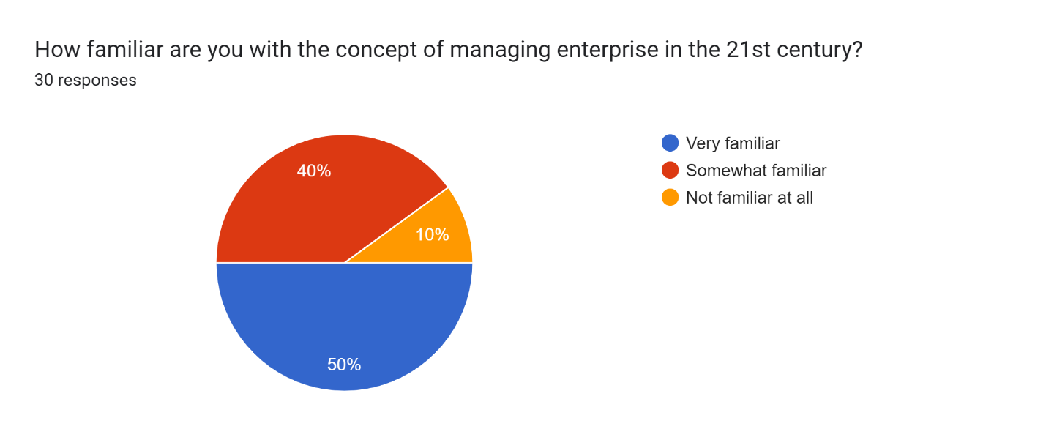
50% very familiar, 40% somewhat familiar, and 10% not familiar—indicating a high level of awareness about 21st-century enterprise management.

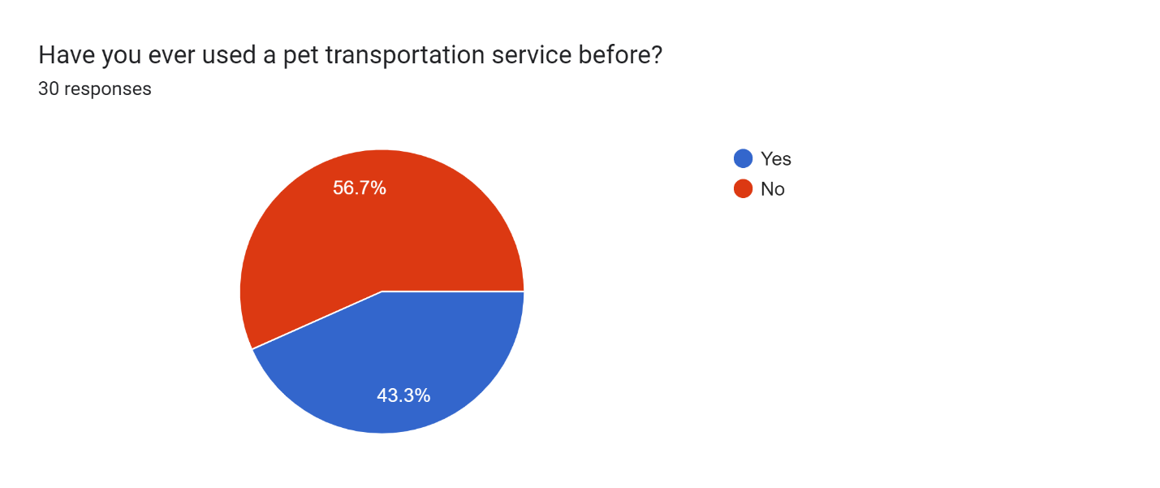
About 56.7% of those who answered have used a pet travel service before, which shows that they are already familiar with the market. This shows that a big part of the target group might want and be interested in these kinds of services.

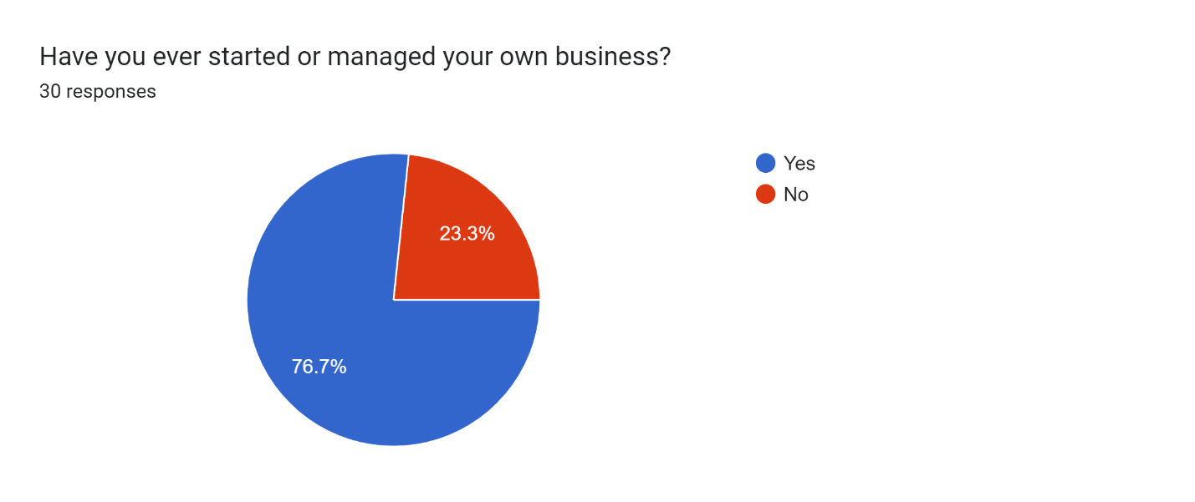
76.7% have started or managed their own business, indicating a significant entrepreneurial experience among the surveyed population.

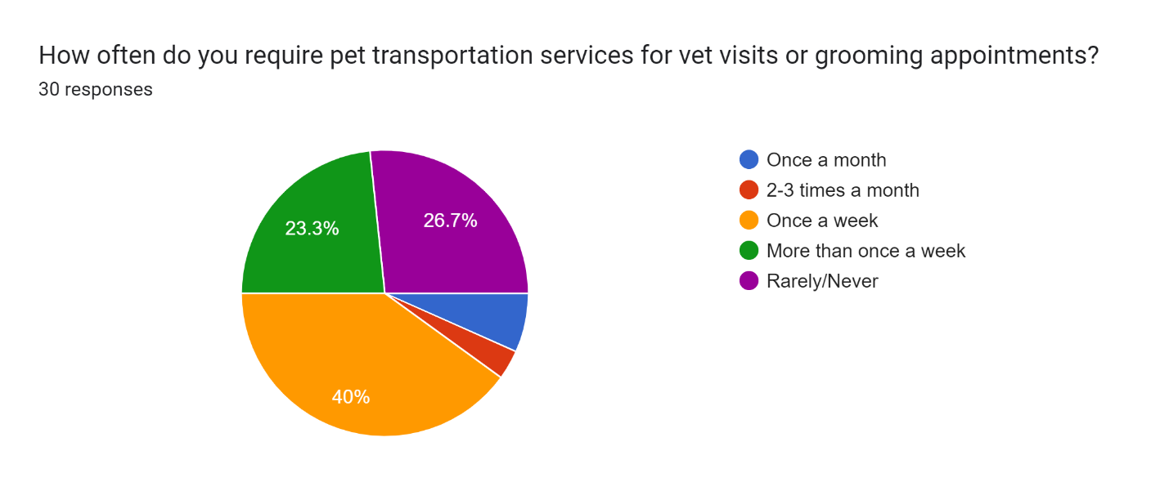
A massive chew of res ponders 40% want puppy transportation offerings at least as soon as every week, which means that they continually need to get their pets to the vet or groomer. Also, 23.3% need these services greater than once a week, which shows that a big part of the target group wishes them greater often. However 26.7% rarely or never need those styles of offerings, which can mean a marketplace group with decreased calls for or different transportation options (Kavin, 2016).

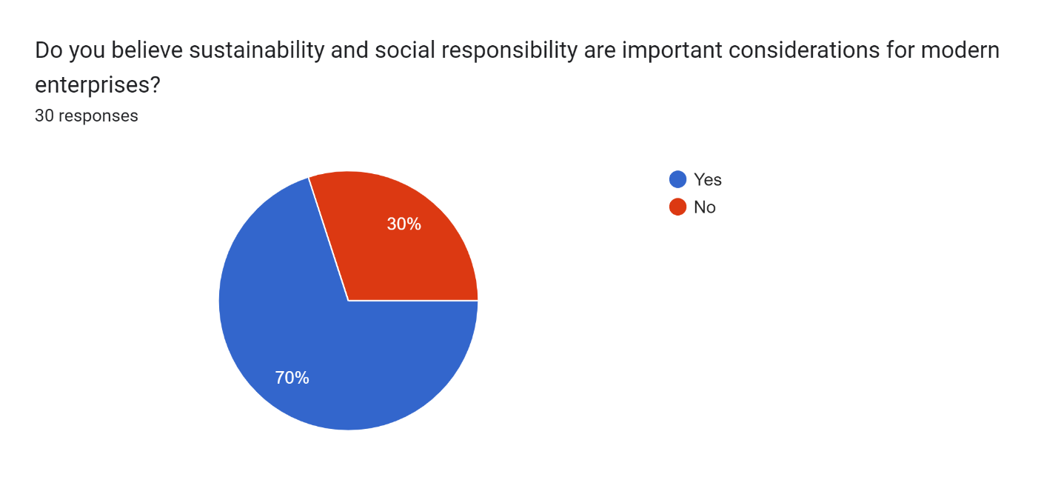
70% prioritise sustainability and social responsibility, indicating a strong emphasis on ethical practices among modern enterprises.

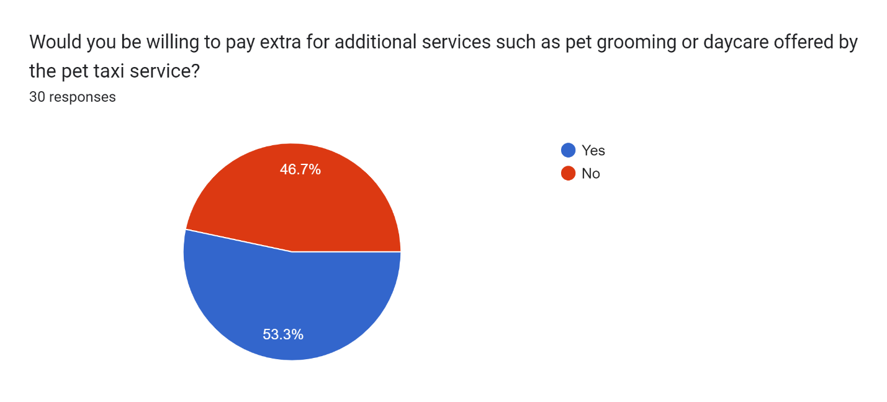
About 53.3% of folks that replied are geared up to pay extra for extra services that the puppy cab provider gives, which includes cleansing or babysitting for pets. This shows that lots of humans are willing to put money into extra functions that might assist the provider make more money (Kraus, et.al., 2019). But 46.7% aren't inclined to pay more, because of these fee tactics and what kind of one-of-a-kind companies of the target marketplace value those more offerings need to be cautiously concept through (KACHOLIA, 2021).
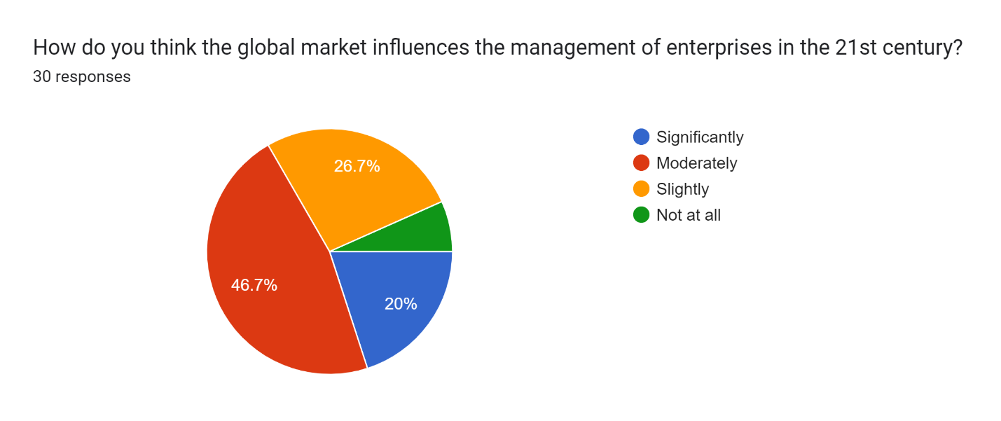
The solutions display that human beings have unique thoughts approximately how the worldwide market influences enterprise control. 20% think it has a large impact, whilst 46.7% assume it has a modest impact. Also, 26.7% think it has a small effect, and 7.7% assume it has no impact at all. These consequences point to a greater complicated manner of thinking about how international markets and company management are related. Globalisation, overseas exchange, and adjustments within the marketplace are likely to affect both method alternatives and realistic techniques (Meseguer-Sánchez, et.al., 2021). Overall, the records indicate that human beings are aware of the worldwide market's significance, though it has one-of-a-kind stages of importance in coping with organisations within the twenty-first century.
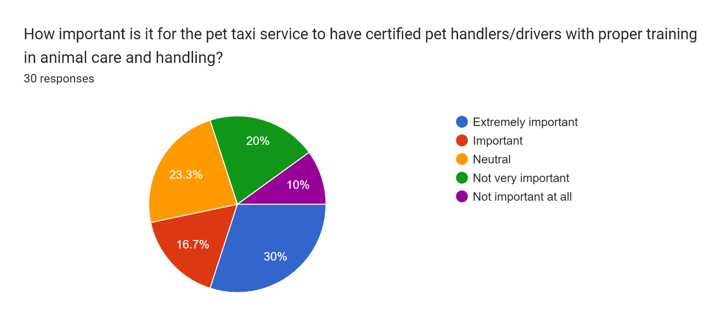
About 30% of individuals who answered suppose the pet cab provider must have trained pet employees and drivers who know the way to care for and treat animals properly. This indicates that there is a high demand for experts with the talents and know-how to make certain that pets are secure and healthy during travel. But 16.7% suppose it's important, and 23.3 are not positive, which indicates that human beings have distinct levels of cost for this option. Notably, 30% of people don't suppose it's critical at all or not very crucial at all. This shows that a few human beings in the market may care greater approximately different matters than the abilities of the provider companies when making a desire (Wala-Bruin, 2023).
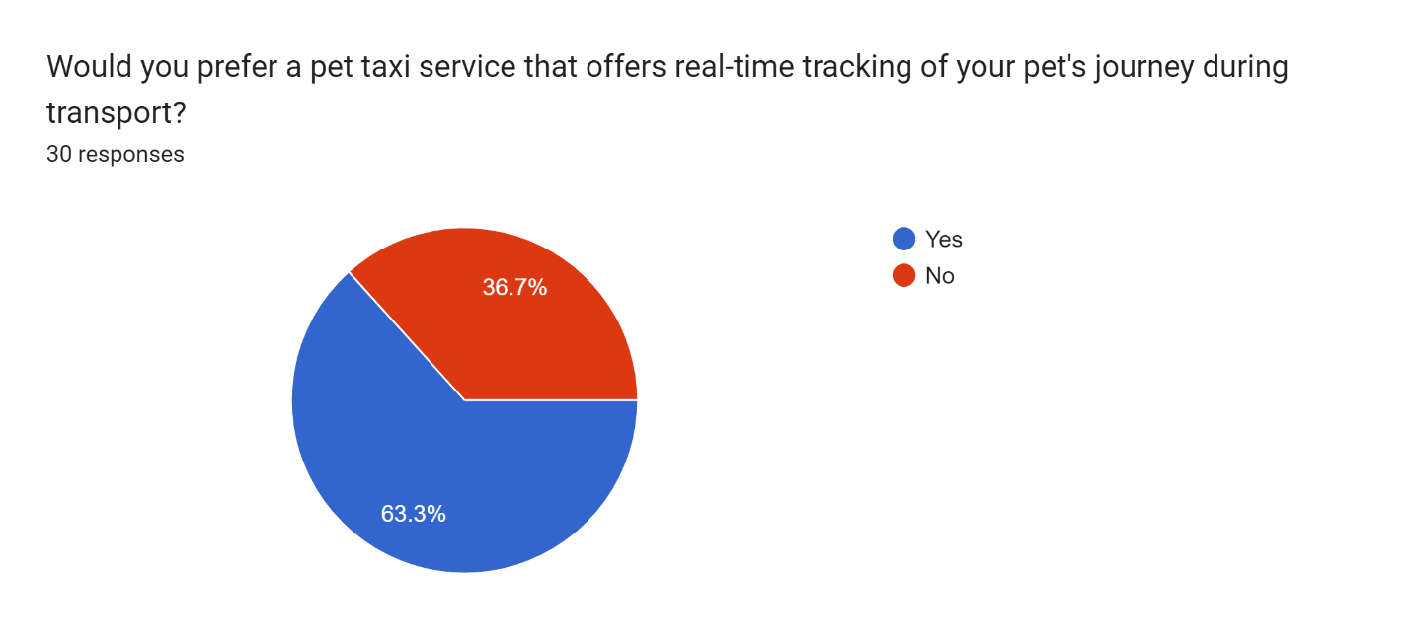
About 63.3% of those who answered want a pet cab service with real-time tracking, which shows a strong desire for information and peace of mind about their pet's safety and whereabouts during transport.
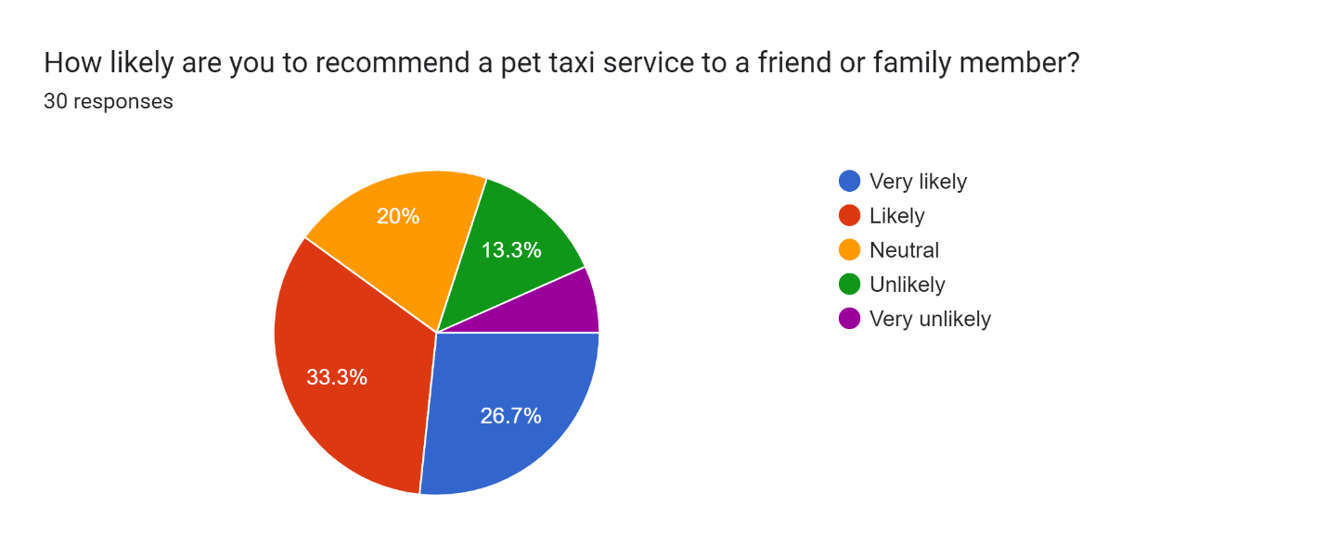
About 60% of those who answered are likely or very likely to tell a friend or family member about a pet car service. This means that the service could benefit from good word-of-mouth and customer support.

References
Adesanya, A.O., (2016). Understanding The Rules That Govern Economic Life: A Study Of “Business On The Streets” In Lagos (Doctoral dissertation, University of Leicester).
Cooley-Broughton, N., (2020). Leveraging Social Storytelling to Foster Consumer Brand Engagement (Doctoral dissertation, Oklahoma State University).
Hofman-Kohlmeyer, M., (2017). The role of storytelling in building a brand. Humanitas University's Research Papers Management, 18(3), pp.131-145.
KACHOLIA, M.V., (2021). BUSINESS PLAN ON INTEGRATED DIGITAL PLATFORM FOR PET CARE SERVICE-THE PAW LABS (Doctoral dissertation, Thammasat University).
Kavin, K., (2016). The Dog Merchants: Inside the Big Business of Breeders, Pet Stores, and Rescuers. Simon and Schuster.
Kingsnorth, S., (2022). Digital marketing strategy: an integrated approach to online marketing. Kogan Page Publishers.
Kraus, S., Palmer, C., Kailer, N., Kallinger, F.L. and Spitzer, J., (2019). Digital entrepreneurship: A research agenda on new business models for the twenty-first century. International Journal of Entrepreneurial Behavior & Research, 25(2), pp.353-375.
Meseguer-Sánchez, V., Gálvez-Sánchez, F.J., López-Martínez, G. and Molina-Moreno, V., (2021). Corporate social responsibility and sustainability. A bibliometric analysis of their interrelations. Sustainability, 13(4), p.1636.
Michel, G.M., Feori, M., Damhorst, M.L., Lee, Y.A. and Niehm, L.S., (2019). Stories we wear: Promoting sustainability practices with the case of Patagonia. Family and Consumer Sciences Research Journal, 48(2), pp.165-180.
Wala-Bruin, K., (2023). Pet transportation by air: a study of customer experiences and expectations using AVIH services.

