

ASSIGNMENT PART ONE
SKILLS FOR PROFESSIONAL PRACTISE (ACBA4027)

HNC / HND / BSc Quantity Surveying
Lecturer – Hannah Williams

Bibek Khatri
Student Id – 2503477

Table of Contents

Introduction 3
Ethical problem 3
Options and Consequences 3
Ethical Thinking 4
Rules and Responsibilities 4
Your Decision 5
Conclusion 6
References 6

Introduction
There is always an issue about ethical dilemma in construction industry regarding corruption, unfair labour practise. An ethical problem or issue is when people or companies face a situation where they must choose between doing what is right or fair and what is wrong or unfair. Ethics is important to ensure fairness and prevent future harm. In the construction industry, this often means issues like bribery, unsafe working conditions, unfair contracts, or harming the environment. (The Constructor,2023).
This assignment will explore about the specific scenario, during the construction of hospital Concrete being used does not meet specific strength requirement and project manager must deal the situation professionally and ethically. The situation itself is a problem.

Ethical problem
The scenario given is the compromised concrete mix, Midway through the project, an engineer reports that the concrete supplier has been providing a mix that does not meet the specified strength requirements. The difference is small but could affect in the long-term durability. The project manager is under intense pressure to meet a strict completion deadline if not completed on time will end up with heavy financial penalties, and public criticism. Supplier is arguing that the concrete still meets the required standard and quietly offering discount on future deliveries if you agree to let the issue go.
Everyone from the supplier to the public are involved (Project manager, Supplier, Engineer, Construction worker, public users, Regulator authorities, Client and more) but the biggest responsibility lies with the person who is managing the contract which is project manager so it is P.M. responsibility to ensure the quality of material, safety of worker, public and durability of structure. (HSE,2015)
All the parties from Supplier to Public/User will be affected positively or negatively, depending on the project manager decision.

Options and Consequences
Numerous companies involved with construction industry have a long history of business practices that is unethical (CIOB,2022). There will always have some options even the situation is under intense pressure. In this case project manager will have the following options,
- Ignore the problem and accept the supplier offers
- Stop and report issue
If Project manager ignores the problem, it might be winning situation for now, project will be completed in time, company will get discount and there will be no penalties and criticism. Everything is happening knowingly which is completely unethical if some serious issues arise in the future, which is high in probability and company must face legal issues or heavy penalties.
If project manager stops the work and report issues the project might be delayed, might have to face some minor penalties and some criticism as well, but Project will be safe and sound. There will be no future legal issues, and this is ethical choice.

Ethical Thinking
I will abide with rules and regulations. It’s not about what I think or about the benefit to the company. It’s about what is right and what is wrong so I will follow the rules even if it delays the work or company get penalised.
Ethical principles include honesty, fairness, justice and accountability. This guideline will help making choices that are legally applicable. Ethical practises promote trust and respect among clients and partners. It also safeguards reputation and long-term business. Choosing this option eventually put you in good position at the end. So being ethically honest and abiding with the law is the key for long term success, achieving trust from stakeholder, and building good relationship with client.

Rules and Responsibilities
The royal institution of chartered surveyor (RICS) updated its rules of conduct in 2021 effective from February 2022. They explain a clear ethical framework for all professional members and client. Project manager must comply with the following rules and regulation in accordance with safety, ethical choices and leadership.
- Safety: A project manager must ensure health and safety regulations are followed on site, protecting workers and public.
- Honesty: When presenting progress, costs, risks, the project manager must be transparent and avoid hiding problems.
- Ethical choices: Project manager should be fair with procurement process, utilise local resources and respect environmental standards even under pressure.
- Leadership: Project managers should set the example for professionalism, ensuring the team works responsibly and ethically. (RICS,2021)
While undertaking any construction works all the professional member must follow the code of conduct to ensure the safety and sustainability of project and environment.
Anyone who manages work or directly employs or engages construction workers is a contractor like project manager. Their main duty is to plan, manage and monitor the work under their control in a way that ensures the health and safety of anyone including public. (HSE,2015)

Your Decision
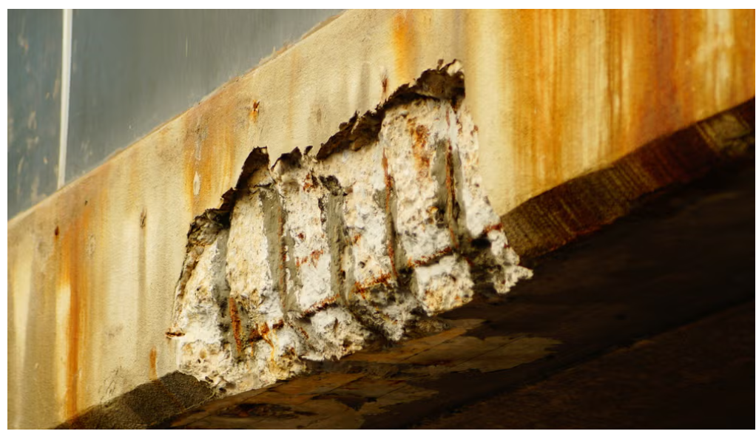
(Silverwood, J. 2023)
Multiple hospital in the U.K. has been forced to partially close because concrete used in constructing them Reinforced autoclaved aerated concrete (RAAC) has already reached their lifespan of around 30 years as shown in above picture. Concrete plays a vital role in construction, as we can see in above picture even if concrete is not compromised it will lose its strength with time, if concrete is compromised it will decrease the life span of concrete significantly and will put people’s life in danger. (Silverwood, J. 2023)
I would reject the compromise concrete mix and refuse the suppliers offer. I would stop the work investigate and inform client and regulatory authorities for further investigation. Further I will ask supplier for the proper concrete which meet the requirements or switch the supplier and I will work with stakeholders to minimize delay while ensuring safety and request for extension of project if needed.
As it is hospital lots of people’s life’s will be in danger if compromised, I will always make sure safety comes first, as I am from professional background my duty and ethics is to follow building codes. Accepting the offer like discount is a bribery which will ruin the company’s trust and eventually end up my career as well.

Conclusion
The situation given here is ethical dilemma in construction where Project manager face construction deadline pressure, financial pressure, safety, honesty and professionalism. The concrete mix does not meet the required strength, which could harm the structural durability. Project managers reject compromised concrete mix and stand up with the public safety, professional value and long-term trust, which really seems to be ethical and legal as well. This hospital will stand strong not just for today for the longer period.
Ethical thinking is basically moral principles to all the decisions and action you make. These principles help you guide making choices that are legally safe and sound.

References
CIOB (2022). Ethical Standards | CIOB. [online] www.ciob.org. Available at: https://www.ciob.org/industry/policy-research/policy-positions/ethical-standards. (Accessed 17/11/2025)

Health and Safety Executive (HSE) (2015) Construction (Design and Management) Regulations 2015: Guidance on Regulations. Available at: https://www.hse.gov.uk/construction/cdm/2015/index.htm (Accessed: 26 November 2025).

RICS (2021). Rules of Conduct. [online] RICS. Available at: https://www.rics.org/content/dam/ricsglobal/documents/standards/2021_roc_en.pdf. (Accessed 17/11/2025)

Silverwood, J. (2023). Faulty concrete forces evacuation planning at hospitals across the UK. [online] Hospital Management. Available at: https://www.hospitalmanagement.net/features/faulty-concrete-forces-evacuation-planning-at-hospitals-across-the-uk/ [Accessed 28 Nov. 2025].

The Constructor. (2023). Legal and Ethical Issues in the Construction Industry. [online] Available at: https://theconstructor.org/practical-guide/safety-practical-guide/legal-and-ethical-issues-in-the-construction-industry/571064/. (Accessed 17/11/2025)

