BMIH4002 Food & Beverage Operations
Assignment 2

Student Name: Maria Andrei
Student ID:2243878
Lecturer’s: Antoinette Milne
Word count:609

Part 1: Restaurant Concept


Trinity Hotel in Manchester is established with the aim of giving people experience of different food items of different parts of the world in one place. People will be able to experience different types of cuisine like Italian, Chinese, Japanese, Mexican, and so on.
In order to attract young people with lots of energy to visit and experience new food, trinity Hotel offers different types of food items such as, Mashed Potato, Chicken Breast Couscous Salad, Capsicum, Apricot, Chicken Schnitzel Burger Bacon, and Parmigiana Crumbed Chicken.
The hotel also offers different foods for health-conscious people such as Vegetarian Nachos Corn Chips, Jalapeños, Corn Salsa (V/VG), Corn Salsa, Corn Chips. One of the most popular and favourite items of this hotel to everyone is Mozzarella Chips and Coleslaw.
The hotel also announces different types of offers at a very low cost in different times so that everyone can enjoy the food of the hotel and experience its specialty at certain point of time. For instance, at present, the hotel offers Steak Frites, Burger Special, Schnitzel Special at a reasonable rate where the target customers for the organisation are mostly young people who are students or who do not have enough money to spend for foods.
The organisation also has wide variety of drinks to offer to different people and this helps the hotel to get people of all classes anytime of the Year. Elderton Chardonnay Eden Valley, Catalina Sounds Sauvignon Blanc Marlborough, Vinaceous Crafted By Hand Rose Margaret River are the most popular drinks at this moment those give organisation excellent recognition for offering wide ranges of drinks of different categories for the people of different classes of the society.
The hotel also offers non-alcoholic drinks like Jalapeño, Lime & Agave, Espresso Martini Ketel One, Cosmopolitan Ketel One as the motto of the hotel is to attract people of all types of the society towards its foods and get popularity and stability in the industry which will definitely help the hotel to be one of the best in London.
On the occasion of New Year, Thames Festival, London Literature Festival, Winter Wonderland, Notting Hill Carnival, Christmas Festival, New Year and so on the hotel offers different types of food items to their customers and also tries to give something unique at lower price so that everyone can enjoy precious festival moment of the year with their family and friends regardless of the differences in capability to have those foods.

Part 2: Menu Design
Greetings!
Menu
Specials
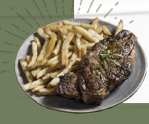
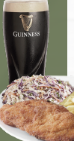
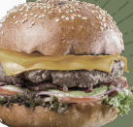

Steak Frites (£15.00), Burger Special (£20.00), Schnitzel Special, Tacos
WITH CHIPS & SLAW + ALL DAY GUINNESS PINT SPECIAL (£15.00)
Salads & Bowls
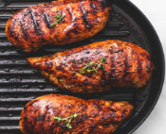
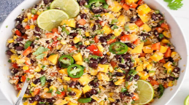
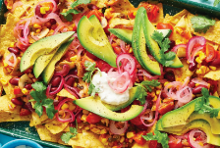

Vegetarian Nachos Corn Chips, Sour Cream, Guacamole, Jalapeños, Corn Salsa (V/VG), Risotto ai Funghi (£22.00), Trinity Bowl Black Rice, Quinoa, Brown Rice, Corn Salsa, Corn Chips (VG/GF/DF) (£25.00)
Add On: Grilled Chicken, Haloumi (£6.00)
Mains
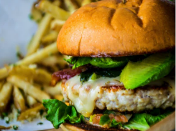
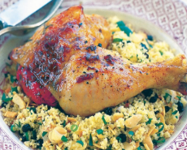
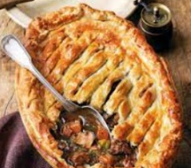

Beef & Guinness Pot Pie Puff Pastry, Mashed Potato, Crushed Peas (£28.00), Chicken Breast Couscous Salad, Capsicum, Apricot, Shallot, Coriander, Vinaigrette (£28.00), Chicken Schnitzel Burger Bacon, Avocado, Cheese, Coleslaw, Chips, Aioli (£25.00), Parmigiana Crumbed Chicken, Ham, Napolitana, Mozzarella Chips, Coleslaw, Coq au Vin (£28.00)
Drinks
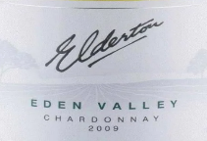
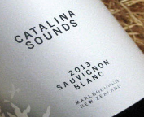
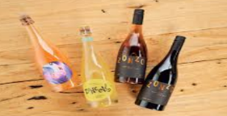

Elderton Chardonnay Eden Valley, SA (£50.00), Catalina Sounds Sauvignon Blanc Marlborough, NZ (£60.00), Vinaceous Crafted By Hand Rose Margaret River, WA (£70.00), Zonzo Cabernet Sauvignon Yarra Valley, VIC (£165.00)
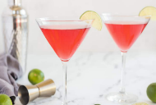
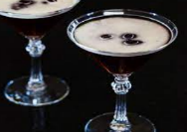
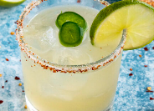
Cocktails

Spicy Margarita Jose Cuervo Silver, Jalapeño, Lime & Agave (£20.00), Espresso Martini Ketel One, Kahlua, Little Drippa Coffee & Sugar (£20.00), Cosmopolitan Ketel One, Triple Sec, Cranberry, Lime & Sugar (£20.00)

(All prices inclusion of 20% VAT)

