Module Title: Cultural Awareness

Student Name: Syed Jahangir bakth
Student ID: 2026520
Lecturer: Rodrigo Aguilera.

Table of Contents
Introduction 3
Intercultural Competence 4
Cultural Understanding 4
Cultural in the Global Marketplace 5
Cultural Variation from Country to Country 5
Hospitality Industry in The UK 6
Hospitality Industry in The UAE 6
Do's and Don'ts in Hotel Management 7
Conclusion 8
References 9

Introduction
A hotel is a matter of recreation for the clients. Clients use the service of a hotel for both professional and tourism purposes. This report is focused on determining the measures to be followed by the hotel staff to ensure a moderate service within the hotel. At the same time, some activities will be categorised so that the do’s and don’ts’ for the hotel staff can be determined.

Intercultural Competence
People in a workplace have to ensure that they are following professional manners. Intercultural competence is the ability of a person, which helps to identify the ways through which an individual can interact with people from different cultures (Cooper, He and Levin, 2011). Individuals from different backgrounds and countries are more likely to interact with each other in today's more globalized world, and intercultural competency can be a useful advantage (Samovar, Porter and McDaniel, 2012).
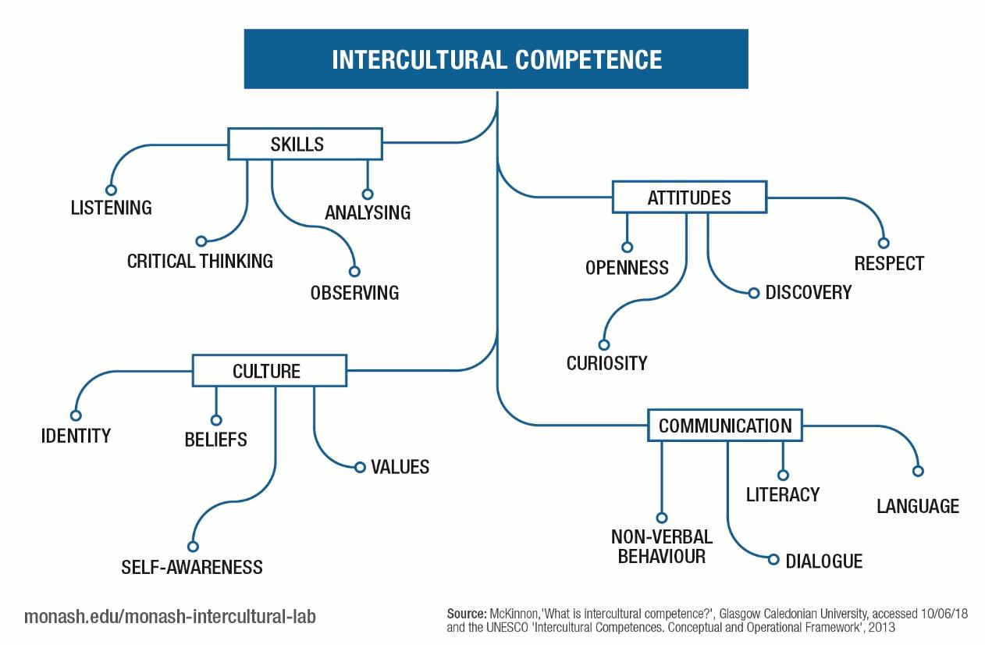
Some elements fall under the umbrella of intercultural competence. The first one is global competence. The second quality is the qualities learned from the graduate level. Employability skills also play a vital role in determining intercultural competence (Moodian, 2009). Globalization is central to all of these principles, and graduates must be prepared to participate and act worldwide to succeed in today's world.

Figure-1: Intercultural Competence Diagram (Leung, Ang and Tan, 2014)

Cultural Understanding
Building bridges across cultural divides and learning to love and appreciate others who are different from us are all made possible by cultivating a knowledge of one's own culture (Llama, 2021). Individuals should have a fundamental understanding of their own culture. In the hotel industry, managers that can appreciate their employees' culture, values, and attitude variations can gain some advantages (Oktadiana and Djauhar, 2011). The hospitality industry demands a wide range of talents and characteristics from its employees to remain competitive in an ever-evolving market. Those in the hospitality business provide a service to their customers, which is an intangible product.
Developing cultural awareness has received so much attention that the most important factor has been overlooked: our sense of cultural identity. The first step in becoming culturally conscious is to recognize and accept one's cultural heritage (Oktadiana and Djauhar, 2011).

Cultural in the Global Marketplace
Cultural awareness is important. Because lack of cultural awareness may lead to loss. Because, to run a successful organisation, it is necessary to focus on the workforce. If any organisation fails to focus on the workforce, it will lose potential outcomes.
Because of new technology, organisations can no longer depend on their home market to meet operational requirements. To combat this new challenge, local businesses may explore expanding into other markets. (Wenzel, 2019) Cultural values and traditions influence customers' purchasing habits in a specific market. There will almost certainly be difficulties when an American corporation enters a foreign market like Saudi Arabia and tries to apply policies and concepts that are popular in the United States. Increasing a company's global market share requires an in-depth knowledge of cultural differences.

Cultural Variation from Country to Country
The world has different cultural practices followed by the variable region, and they have some significant differences from country to country. Due to globalization and modern technology, some behaviours are practised the same way worldwide. In this section, two of the country are analyzed based on their cultural behaviour.
Knowledge, skills, and attitudes are the three basic characteristics of intercultural competence that all need to describe one's cultural attitude (Ehlion, 2021).
Knowledge: Knowledge necessitates cultural self-awareness and cultural-specific insights in addition to understanding global challenges.
Skills: The ability to observe the world from a different perspective and to listen patiently when necessary is a skill.
Attitudes: Respect, curiosity, and receptivity towards different cultures are attitudes.

Hospitality Industry in The UK
The hospitality industry is diversified because of the many factors that contribute to it, such as new technologies, new owners, different levels of service, different types of recreational amenities, and an eye toward the future. Conventional guest services are available at a variety of hotels. The hotel now has internet, a gym, a pool, a sauna, a Jacuzzi, nightclubs, shops, hair and beauty salons, laundry, parking, conference and meeting rooms, etc. Ownership and classification of the hotel rating system vary as well (Hassanien and Losekoot, 2017).
The motel has a restaurant on site. Each sort of hotel has its own set of amenities. One or more restaurants can be found in a hotel. The restaurant provides a la carte, buffet, bar, catering, and room service in addition to its regular menu. Restaurants are now common in most hotels. In this sense, hotel dining is essential.

Hospitality Industry in The UAE
Dubai's hotel business is well-established. The facts support this. Due to its world-class infrastructure, transportation, and hospitality, the UAE is well-known for hosting events (sporting events, trade fairs, business meetings, etc.). For many years, this has been a lure for tourists worldwide (Hassanien and Losekoot, 2017). This can be done with a world-class hotel sector in the United Arab Emirates.
Observing current tourism development projects and the construction of tourist attractions in the United Arab Emirates, particularly in Dubai, will help you better understand the hospitality industry in the country. The Burj Al Arab Hotel in Dubai opened in 2009 and has a seven-star rating, and Palm Spring Island are only two examples of this type of hotel.

Do's and Don'ts in Hotel Management
Do's | Don'ts
Listening to the guest sincerely | Not compromising with the standard
Ensuring brand value through professional behaviour | Not making a mess with the mix of cultures.
Keeping the place clean and comfortable (Sichta, 2018) | Not serving food without testing the quality.
Maintaining the highest possible quality of standard | Not ignoring the staff-related issues.

Conclusion
Strategy is developed at the corporate, functional, and business levels. Porter identified three generic strategies for generating a competitive advantage at the enterprise level: cost leadership, differentiation, and concentration. Seniors are a valuable resource for the hospitality and travel industries. In contrast to some younger professionals who need to improve their English or manners, post-retirement employees are typically conscientious, well-spoken, and courteous to guests.

References
Cooper, J., He, Y. and Levin, B., 2011. Developing critical cultural competence. Thousand Oaks, Calif.: Corwin Press.
Ehlion, 2021. Intercultural Competence - Definition, Skills, Model | EHLION. EHLION.
Hassanien, A. and Losekoot, E., 2017. The application of facilities management expertise to the hotel renovation process. Facilities, 20(7/8), pp.230-238.
Leung, K., Ang, S. and Tan, M.L. (2014), 'Intercultural Competence', Annual Review of Organisational Psychology and Organisational Behaviour, 1:4889-519.
Llama, E., 2021. Importance Of Cultural Awareness In The Workplace: How To Become More Culturally Aware.
Moodian, M., 2009. Contemporary leadership and intercultural competence. 1st ed. Los Angeles: Sage.
Oktadiana, H. and Djauhar, R., 2011. The Importance of Understanding Cultural Awareness for Managers in the Hospitality Industry (in Indonesia). Binus Business Review, 2(1), p.230.
Samovar, L., Porter, R. and McDaniel, E., 2012. Intercultural communication. 3rd ed. Boston, Mass.: Wadsworth Cengage Learning.
Sichta, J., 2018. 10 dos and don'ts for managing hotel food-and-beverage. hotelmanagement.net.
Wenzel, J., 2019. The Importance of Intercultural Competence in Modern Times. 3rd ed. Fresenius University of Applied Sciences Hamburg, p.21.

