2x2 within-subjects design
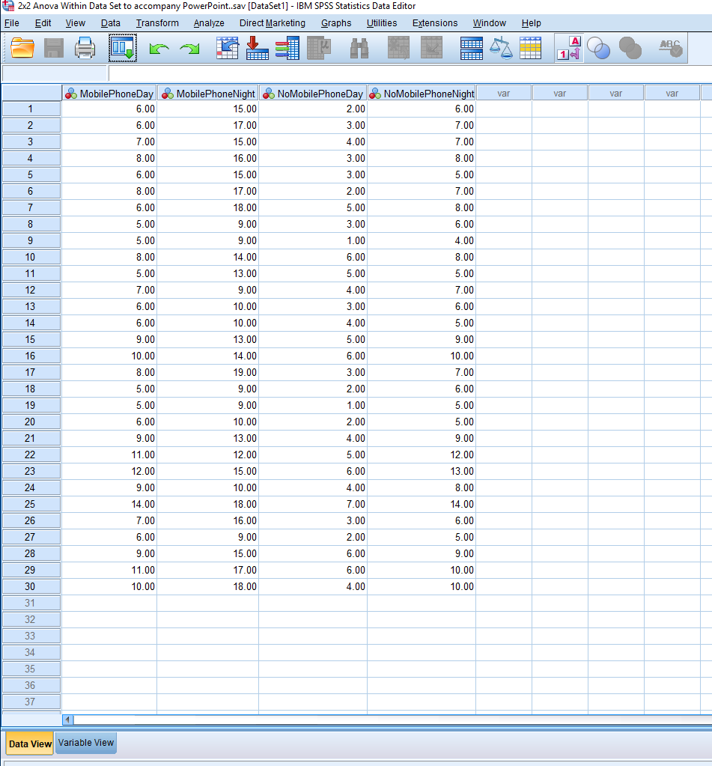

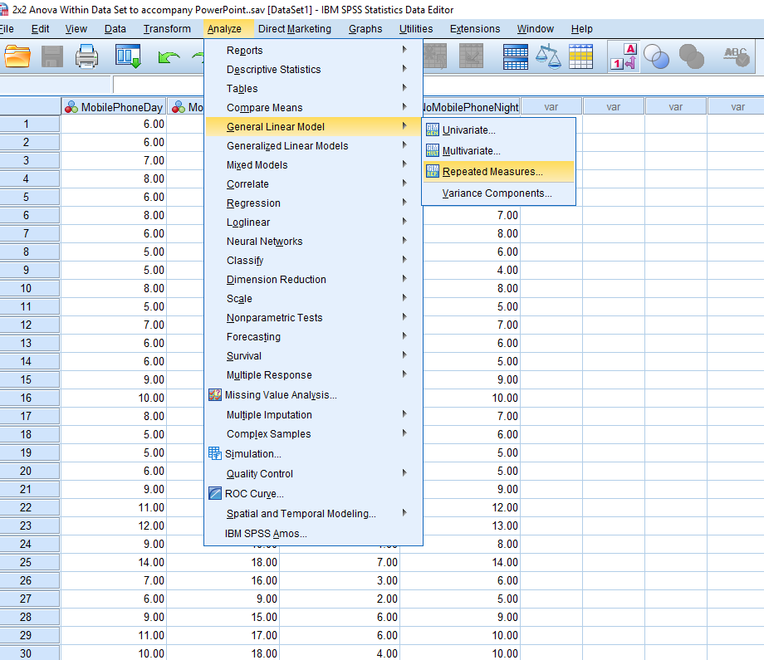

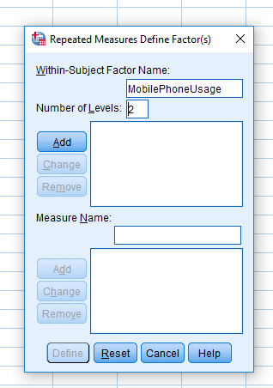

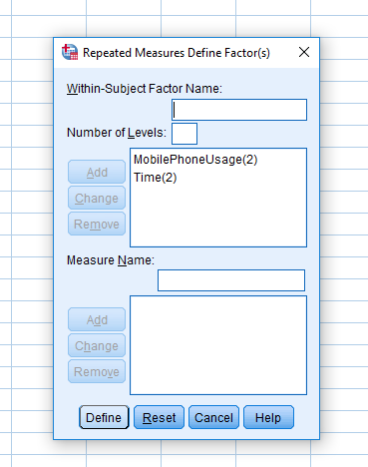
Insert MobilePhoneUsage in the factor box. Insert 2 in the levels box (you have 2 levels/conditions). Press add.
Insert Time in the factor box. Insert 2 in the levels box (you have 2 levels/conditions). Press add.
Then press define.

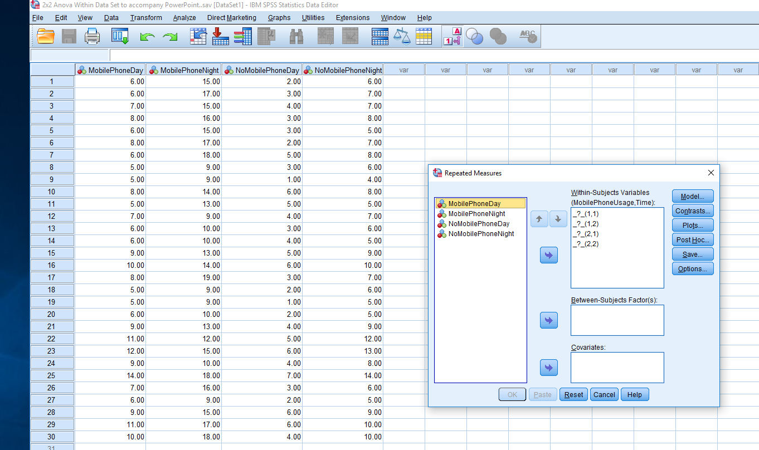
Move the conditions into the correct places in the right-hand box. Make sure that you match each condition to the appropriate number.
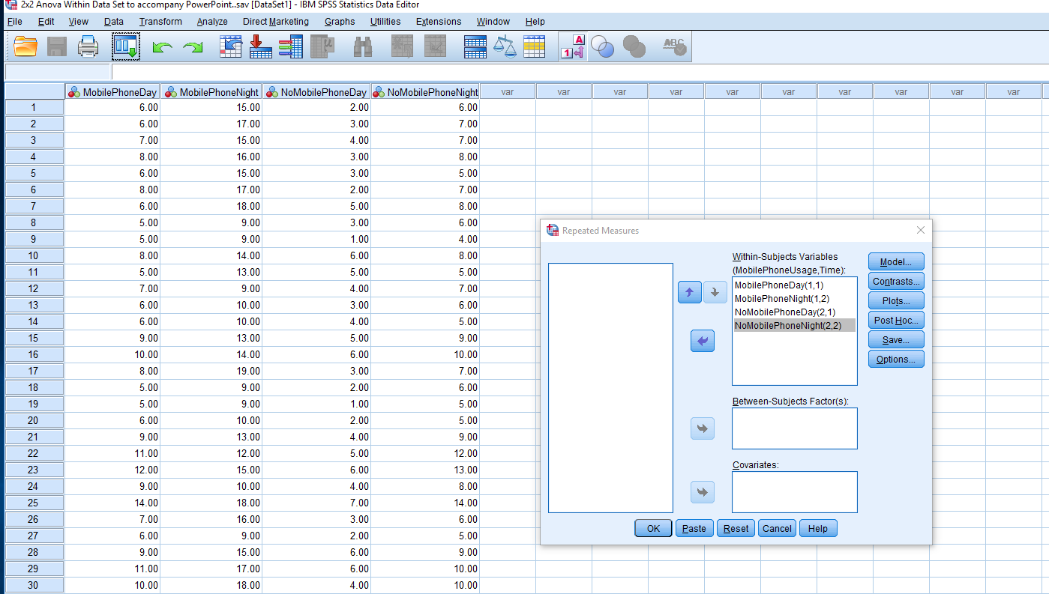

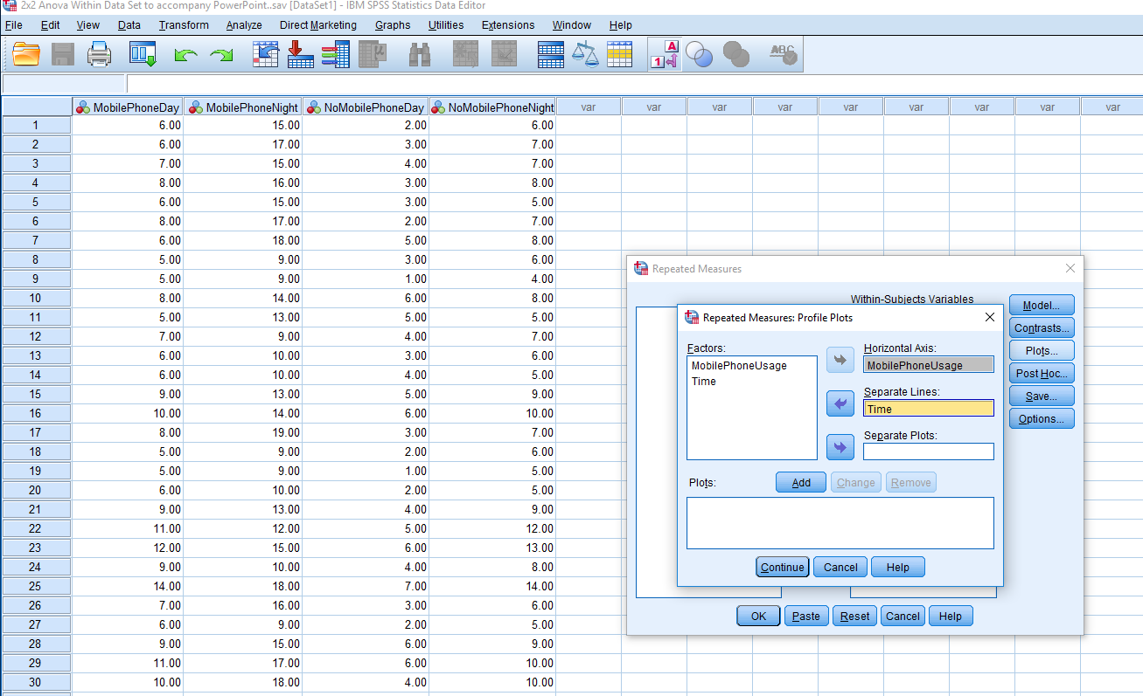
Press plots – move each variable to the horizontal and separate line (doesn’t matter which). Press ADD then CONTINUE.

Press options. Select descriptive stats, estimates of effects size, observed power

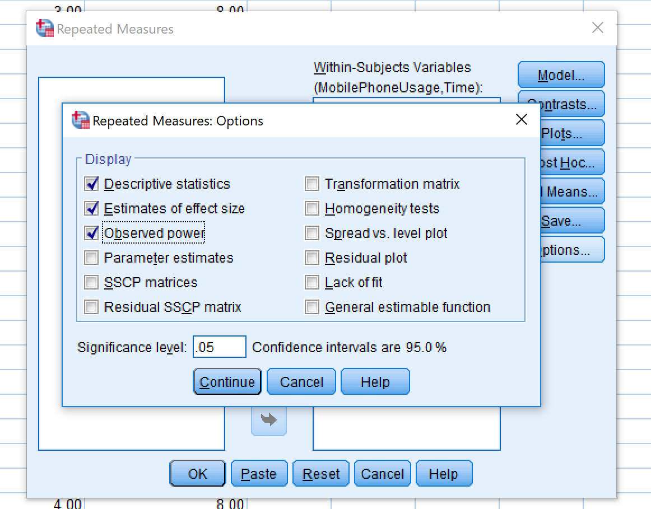
Select Continue and then select EM Means.

Move all factors to the display means box on the right (using the Arrow), tick compare main effects and select Bonferroni in the Confidence interval adjustment.
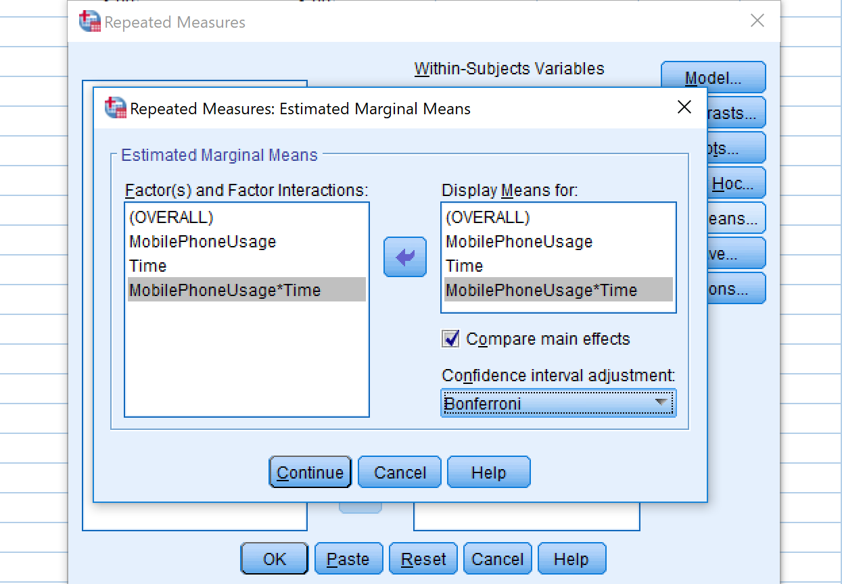
Press CONTINUE. Then OK.

