Assignment Title: Global Business Management
Student ID: 2113969

Table of Contents
Introduction 3
Overview of Higher Education Sector 4
PESTLE Analysis of University of Wales Trinity Saint David 5
Political factors 5
Economic factors 6
Sociocultural factors 7
Technological factors 8
Legal factors 9
Environmental factors 10
Porter’s Five Forces analysis of University of Wales Trinity Saint David 11
New Entrant Threats 11
Suppliers' Bargaining Power 11
Buyers' Bargaining Power 11
Substitute threats 11
Competition in the existing Industry 12
Conclusion 13
References 14

Introduction
The focus of the project is on the major business environmental elements affecting higher education and how they affect the University of Wales Trinity Saint David. The University of Wales Trinity Saint David is situated at UK. Here are two parts of analyzation. In the first part PESTLE Analysis of the University will be discussed and in the second part, Porter’s Five Forces analysis will be discussed.

Overview of Higher Education Sector
Higher education is comprised of many different aspects, including but not limited to the following: teaching, research, rigorously applied labor (such as at medical and dentistry schools), and public welfare. For the purposes of this conversation, the terms "higher education" and "postgraduate studies" will be used interchangeably (theconversation.com, 2022). Higher education is the next level of education that one must complete after secondary school. Higher education encompasses not just the undergraduate but also the graduate levels of study at educational institutions like colleges and universities.
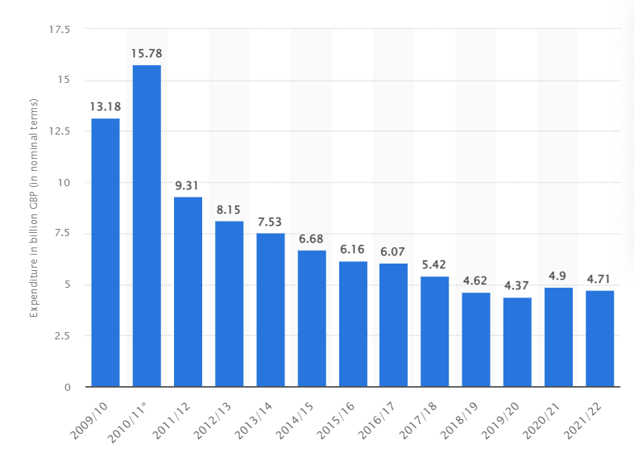
Figure: UK government funding for higher education, (theconversation.com, 2022)
The graph makes it apparent that the UK government is cutting back on its support for higher education on a daily basis. According to the graph, the UK government funded higher education with 13.18 billion GBP in 2009 and 2010, and 15.78 billion GBP the following year. From then on, from 2011 through 2020, lower education spending dropped. The following year, higher education funding recovered a little bit, but in the fiscal years 2021 and 2022, the decline is still present. The fact that higher education spending is going down is encouraging for a nation like the United Kingdom. The quality of education is also improving concurrently.

PESTLE Analysis of University of Wales Trinity Saint David

Political factors
In the United Kingdom, almost all higher education institutions get money from the government in one way or another. The government is able to partially subsidize the cost of education for the last student because of this widespread support. Though, there is much dispute about how much public money should be spent on education, especially higher education. The UK government has been steadily cutting education financing, which could lead to severe problems for institutions in the future (TURAN et al., 2022). Policy changes could jeopardize state financing for higher education, including research funds. The University of Wales Trinity Saint David's funds may be cut if overall funding declines (UWTSD). Funding for the University of Wales Trinity Saint David could be affected by rising taxes. Remember that the UK is a global center for higher education. International students make up 20% of UK higher education and 40% of postgraduate students. The UK higher education sector's strength may potentially be its weakness. Political unrest could reduce the number of overseas students in the UK, but its influence on the sector is unclear. If enrollment drops too low, some schools may have to close. Brexit's impact on EU students studying in the UK will be intriguing to monitor.
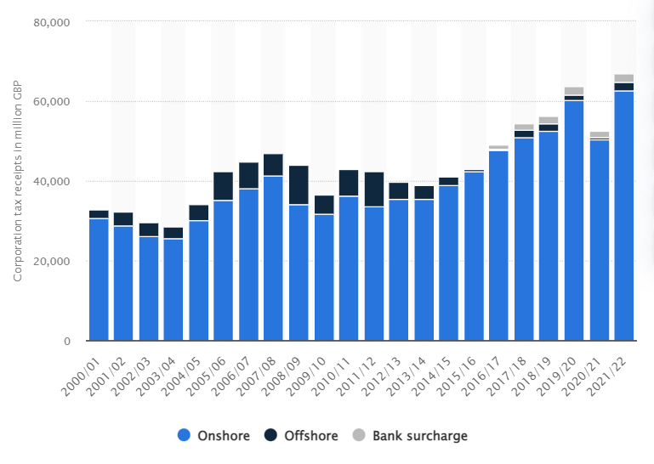
Figure: Revenues from corporate taxes in the UK from 2000 to 2022, (TURAN et al., 2022)

Economic factors
The UK's higher education system is once again impacted by a number of economic reasons. Many people in the United Kingdom, especially in England, are forced to take on substantial amounts of student debt in order to pay for their studies. This is starting to cause worry because many graduates have a significant financial setback when they start their careers. In actuality, the appeal of pursuing higher education is diminished by the reality that an increasing number of graduates are merely unable to repay their loans. But compared to the US, student loan debt in the UK is not nearly as bad. However, the UK currently doesn't have the most robust job market when compared to other important educational hubs like the United States or Australia (Vartiak et al., 2022). Of course, the ultimate goal of additional education for many people is to obtain a job with a respectable pay after graduating from college. These students may wonder why they would pick to study in the UK when they could study elsewhere and have greater job prospects. The investment of the University of Wales Trinity Saint David in sustainable initiatives may suffer if the economy weakens. Prior government policy changes lowered public support while allowing universities to collect higher fees for tuition.
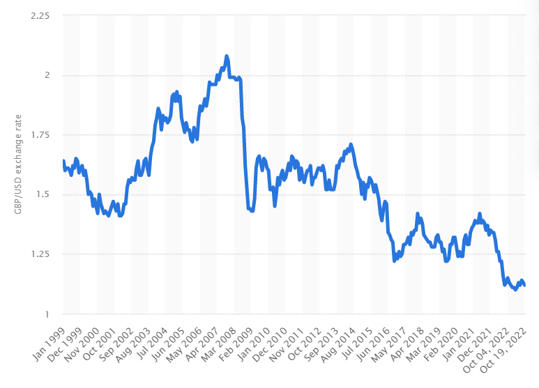
Figure: UK exchange rate, (Vartiak et al., 2022)

Sociocultural factors
The issue of student loan debt has been discussed from a purely financial standpoint. But from a societal standpoint, student loan debt is also a significant subject of conversation. Today's students are quite tolerant of heavy debt loads. It's possible that new students will see student debt negatively as the economic issues related to unaffordable debts begin to emerge (HIREMATH & C, 2021). If so, the number of students enrolling in English universities might be drastically reduced. For many years, a college degree has been a requirement for people who want to prosper in the modern world. But as times change, many people think that the value of higher education is eroding. If a result, as more high school graduates enter the workforce right away, we can see a decreasing number of pupils. Many entrance positions' work requirements are changing to prioritize relevant experience over a higher school degree as a result of this transition. If uncovered, a lack of commitment to sustainable development could harm the reputation of the University of Wales Trinity Saint David. The public has higher expectations of businesses that practice environmental responsibility. Exposure risk if not ecologically conscious.
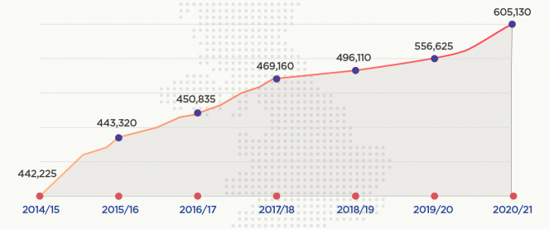
Figure: Number of international students in the UK, (HIREMATH & C, 2021)

Technological factors
Online learning materials are continually improving. It is simple to imagine a period in the future where there would be a wealth of educational resources available online, perhaps even for no cost. We recently discussed how recent high school graduates may choose to pursue professions immediately rather than immediately enrolling in college. It's also conceivable that high school graduates decide against continuing their education in favor of online learning, which would have a big negative influence on the traditional higher education market in the UK. Technology's effects extend beyond higher education. On the contrary, we can improve education in a number of ways thanks to current technology. Even though university lectures are usually available online now, technology is ever evolving. Technologies like virtual reality (VR) and artificial intelligence (AI) could change how we learn in higher education. A rise in energy use may result from the increased integration of technology across the university's campus. High technological expenses and protracted payback times may make it more difficult to embrace new technologies (SALTAMARSKI, 2021). If financial incentives for technology are decreased, such as through the termination of the Feed in Tariff program, the University of Wales Trinity Saint David may have a harder time reaching its carbon reduction objectives.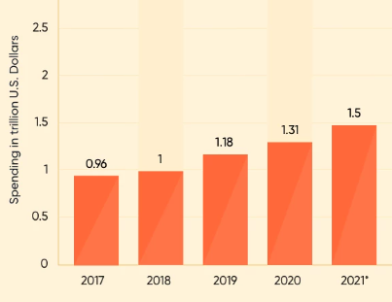
Figure: Expenditure for digitalization in the UK, (SALTAMARSKI, 2021)

Legal factors
A legal factor is a consequence of changes to the regulatory environment and can affect the whole economy, a specific industry, or even a single company within a given sector. Among these, but not primarily, are laws covering employment and consumer rights, operational licenses and permissions, and IP protection (Tumaku et al., 2020). Regulations can either be a headwind or a tailwind for operators. A tailwind would be strict regulation in a particular area, like food production, which may operate as a protective moat for established firms and construct additional obstacles to entrance. A headwind would be rising capital requirements for financial institutions. The University of Wales Trinity Saint David's environmental laws may change as a result of the UK exiting the EU, and regulations may be loosened or tightened. Non-compliance with legal standards may result from a lack of awareness, comprehension, and responsibility. It may be challenging to prove the requirement for compliance if regulatory organizations don't enforce their rules.

Environmental factors
Environmental considerations came as a natural addition to the basic PEST structure as the corporate sector began to realize that changes to our physical surroundings can offer material threats and opportunities for firms. A few ecological factors are the CO2 footprint, the effects of global warming, all-encompassing physical and transitional threats, an increase in the frequency of catastrophic weather events, and ecological stewardship (Pestel Analysis, 2022). The environmental aspects that are often found in an ESG (Environmental, Social, and Governance) analysis will significantly overlap with those in a PESTEL analysis. In fact, it's widely accepted that movements like CSR (Corporate Social Responsibility) and ESG, which are becoming more and more popular, are to blame for the inclusion of environmental issues in the PESTEL framework. The University of Wales Trinity Saint David's activities could be disrupted by climate change and energy use. Flood risk could potentially rise as a result. In addition to increasing resource demand, climate change is detrimental to the University of Wales Trinity Saint David.
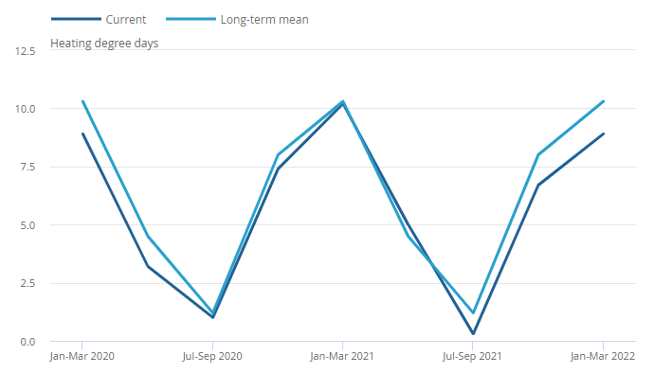
Figure: The average number of heating degree days in UK, (Pestel Analysis, 2022)

Porter’s Five Forces analysis of University of Wales Trinity Saint David

New Entrant Threats
New competitors in the publishing and book industry are able to invent new solutions, innovate, and apply pressure simply on the University of Wales Trinity Saint David by adopting a lower pricing approach, saving expenses, and delivering new value propositions to customers (INDRARATHNE et al., 2020). The University of Wales Trinity Saint David needs to overcome all of these challenges and set up robust barriers in order to preserve its position as an industry leader. University of Wales Trinity Saint David has the ability to reduce the dangers that are offered by new competitors by increasing its capacity and investing in research and development.

Suppliers' Bargaining Power
The majority of organizations operating in the printing and book publishing industry procure their raw materials from a wide array of sources. The market margins that Educational Corporation Limited is able to attain may be constrained by the presence of suppliers in monopoly positions (Mahat, 2019). Strong service providers take advantage of their position in the bargaining process to put pressure on book publishers to accept higher charges. An increase in the negotiation strength of the supplier almost always has the consequence of diminishing the profitability of Publication - Books.

Buyers' Bargaining Power
It's possible that either the parents or the pupils are overly demanding. They want to get the best things for the least amount of money possible while yet doing as much shopping as possible. This had an effect on the higher education industry's ability to generate profits over the long run (Nurlansa & Jati, 2017). In the market for higher education, students have more bargaining power than other customers due to the fact that their demographic represents a more affluent and less numerous consumer base.

Substitute threats

Threats originate from alternatives that could be used in place of a company's products or services. Companies that produce goods or offer services for which there are no direct substitutes will be able to boost prices and negotiate favorable terms (Abinsay, 2020). When close substitutes are easily accessible, customers will have the option of choosing not to buy a company's goods, which could weaken a company's position in the market. University of Wales Trinity Saint David can lower the dangers of replacement institutions by putting the needs of the students ahead of its own financial goals.

Competition in the existing Industry
The main driver is the sheer number and power of market competitors. The market would lose its allure if there are so many competitors offering comparable products and services. As there are more rival businesses offering more similar products and services, a corporation's strength diminishes. Customers and suppliers will turn to a competitor if they can offer a better deal or lower prices (Burra & Ushadevi, 2022). On the other hand, a company has more negotiating power and can raise prices when there is minimal competition, which will increase sales and profits. By developing a sustainable differentiator, expanding its scale to compete better, and other strategies, University of Wales Trinity Saint David is able to handle competition in the contemporary industry and working with rivals to expand the market rather than focusing on competing for a narrow market.
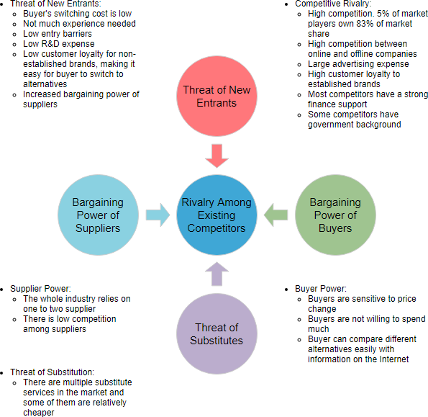
Figure 1Porter’s Five Forces analysis, (Burra & Ushadevi, 2022)

Conclusion
Higher education is a word used to describe a program of study that extends beyond high school and results in the awarding of a degree, diploma, or certificate. Studies in a technical or professional school, a college or university, or both are included in this description. Here are two analysis parts. The PESTLE analysis of the university was covered in the first section, and Porter's Five Forces analysis was covered in the second.

References
Abinsay, M. (2020) “Porter’s five forces analysis of the organic farming in Laguna province,” International Journal of Academe and Industry Research, 1(2), pp. 20–46. Available at: https://doi.org/10.53378/345652.
Burra, N.J. and Ushadevi, K.N. (2022) “Porter’s five forces analysis of Zanzibar’s seaweed industry,” Asian Journal of Agricultural Extension, Economics &amp; Sociology, pp. 185–196. Available at: https://doi.org/10.9734/ajaees/2022/v40i111700.
Helena Gillespie Professor of Learning and Teaching in Higher Education and Academic Director of Inclusive Education (2022) Higher education funding shake-up: What it means for students and universities, The Conversation. Available at: https://theconversation.com/higher-education-funding-shake-up-what-it-means-for-students-and-universities-177778 (Accessed: October 24, 2022).
HIREMATH, S.U.V.A.R.N.A. and C, D.R.P.R.A.S.H.A.N.T.H.A. (2021) “Pestle analysis of organized retailing in India.” Available at: https://doi.org/10.31124/advance.16653532.
INDRARATHNE, P.K.G., RANADEWA, K.A.T.O. and SHANIKA, V.G. (2020) “Impact of competitive forces to the contractors in Sri Lanka: An industry analysis using Porter’s five forces,” Conference Proceedings - FARU 2020 [Preprint]. Available at: https://doi.org/10.31705/faru.2020.21.
Industry research: Pestel Analysis (no date) LibGuides. Available at: https://libguides.libraries.wsu.edu/c.php?g=294263&amp;p=4358409 (Accessed: October 24, 2022).
Mahat, M. (2019) “The competitive forces that shape Australian Medical Education,” International Journal of Educational Management, 33(5), pp. 1082–1093. Available at: https://doi.org/10.1108/ijem-01-2018-0015.
Nurlansa, O. and Jati, H. (2017) “Analysis porter’s five forces model on Airbnb,” Elinvo (Electronics, Informatics, and Vocational Education), 1(2), pp. 84–96. Available at: https://doi.org/10.21831/elinvo.v1i2.12457.
SALTAMARSKI, D. (2021) “Wine sector analyzed through pestle analysis as a part of the strategic management,” Journal of Sustainable Development, 12(27), pp. 75–86. Available at: https://doi.org/10.54442/jsd211227075s.
Tumaku, J. and Ren, J. (2020) “Ghanaian perspective of franchise contract in Africa, a pestle analysis,” Journal of Economics, Business and Management, 8(3), pp. 192–199. Available at: https://doi.org/10.18178/joebm.2020.8.3.636.
TURAN, B.İ., AKMAN, M. and TURAN, F. (2022) “SWOT/pestle analysis of the Bodrum Yacht Building Industry,” Gemi ve Deniz Teknolojisi [Preprint]. Available at: https://doi.org/10.54926/gdt.1074404.
Vartiak, L., Jaseckova, G. and Capkova, E. (2022) “Student activation in the education process: The Pestle Analysis Creation,” EDULEARN Proceedings [Preprint]. Available at: https://doi.org/10.21125/edulearn.2022.0986.

