The Right if the Child to be Heard.
The definition of Participation: - It is important that everybody has a clear and shared understanding of what is meant by participation and its place in everyday activities with children and young people.
Participation is about providing choices and opportunities for children and young people to have an input into decisions that affect their lives. It is about talking, listening to and hearing children and young people and encouraging and supporting them to contribute. Then we must act on these views and ideas whilst being open and honest and realistic with them on the levels of involvement that they can have.
Embedding Participation.
To develop a culture of participation in an organisation. It is essential that departments, Service managers and staff who provide a service to children and young people understand what participation is and the importance of involving children and young people in decisions.
In order for participation to be effective in any service, it requires commitment from senior managers and staff at all levels. It is a statutory requirement under the Wellbeing and future generations act 2015 (Welsh Government, 2015) that all local authorities adopt the National Participation Standards for Children and Young People (Children in Wales, 2019).
International Context.
United Nations Convention on the Rights of the Child (United Nations, 1989 Convention on the Rights of the Child).
- The most widely-ratified human rights treaty.
- Grants a comprehensive set of rights.
- Was adopted by the United Nations General Assembly on the 20th of November 1989.
- It is for all children and young people under the age of 18.
- Consists of 54 articles.
- The UK Government ratified the UNCRC on the 16th December 1991.
Article 12 of the UNCRC:
“shall assure to the child who is capable of forming his or her own views freely in all matters affecting the child, the views of the child being given due weight in accordance with the age and maturity of the child.” (Lundy, 2007).
National Context:
- In 2004 the Welsh Government adopted the UNCRC.
- For children and young people between the ages of 0-25.
- The School Councils (Wales) Regulations 2005, put a legal responsibility on all schools in Wales.
- All publicly funded primary, secondary and special schools in Wales are required to by law have a school council.
- Formal educational settings are encouraged to develop and embed holistic and inclusive models of pupil participation.
- The children’s and families measure (Wales) 2010 places a duty on local authorities.
- Local Authorities must promote and facilitate participation by children and young people
- Wales has their Rights of young person’s measure (2011).
- There is a duty upon the Welsh Minister to have due regard to the rights in the UNCRC.
- The Wellbeing of Future generations (Wales) Act 2015
Local Context
To embed a culture of participation across the County, by positively engaging with children and young people and ensuring that children and young people know how to be involved in the decisions that affect their lives and futures.
In Practice.
Developing and implementing a county wide strategy. Adopting a Children’s Rights Promise, by providing help support and training. Working with national organisations for further ideas and support on how to succeed in this field. Providing opportunities for the young people to become involved. Also aid the implementation of participation through the organisation.
Force Field Analysis.
Forces for change.
- Encourage organisations and services to complete Self Evaluations of current practice.
- Identify and challenge the barriers preventing progress.
- Drive improvements in schools, organisations and services
- Measure and improve the quality of the process of children and young people's participation and identifying gaps in practice.
Forces Resisting Change
- Organisations completing evaluations as a token gesture.
- Some are unable to see the value of a young person’s perspective, especially if they have been through the justice system.
- They then will have lost their rights.
Proposed Change and the difference it would make!
- Improving young people’s life skills and confidence
- Improve the quality of life in their communities
- Improves attendance, attainment and behaviour
- Changing how young people are perceived
- Can lead to better decisions
- Promote working with others and working together
But… who is benefiting? Are services really giving opportunities for all children and young people to participate meaningfully?
Roger Hart a Sociologist wrote a book called Children's Participation: The Theory and Practice of Involving Young Citizens in Community Development and Environmental Care for UNICEF in 1997. The "Ladder of Children's Participation," also called the "Ladder of Youth Participation," is one of many significant tools from the book. (Malone et al., 2010)
- Manipulation – This occurs when adults use the younger generation to support certain causes in the pretence that this was inspired by them.
- Decoration – This occurs when youngsters are used in the aid of bolstering a cause indirectly, but in this instance the adults don’t pretend that it has been inspired by the youngsters.
- Tokenism – Is what happens when youngsters appear to have been given a voice, but in reality have had very little if anything to do with the work, basically all for appearance.
- Assigned but informed - This happens when youngsters are given a role and are told why they are participating.
- Consulted and informed – This occurs when youngsters give of their opinions on work carried out by adults. They are informed how their participation will be used and the decisions then made by the adults.
- Adult-initiated, shared decisions with young people – This happens when projects for example are initiated by the adults and the decision making process is shared by the youngsters and adults
- Young people-initiated and directed - This happens youngsters initiate the project and the adults only have a supporting role.
- Young people-initiated, shared decisions with adults - This occurs when the project is initiated by youngsters and the decisions are shared. This empowers the youngsters and gives them valuable life skills with the expertise of adults.

National Standards.
- Endorsed and adopted by the Welsh Assembly Government in 2006
- Means for assessing and measuring participatory practice
- ensuring participation happens in meaningful and effective ways
- Statutory requirement (under the Well Being of Future Generations Act 2015) Local Authorities must adopt them

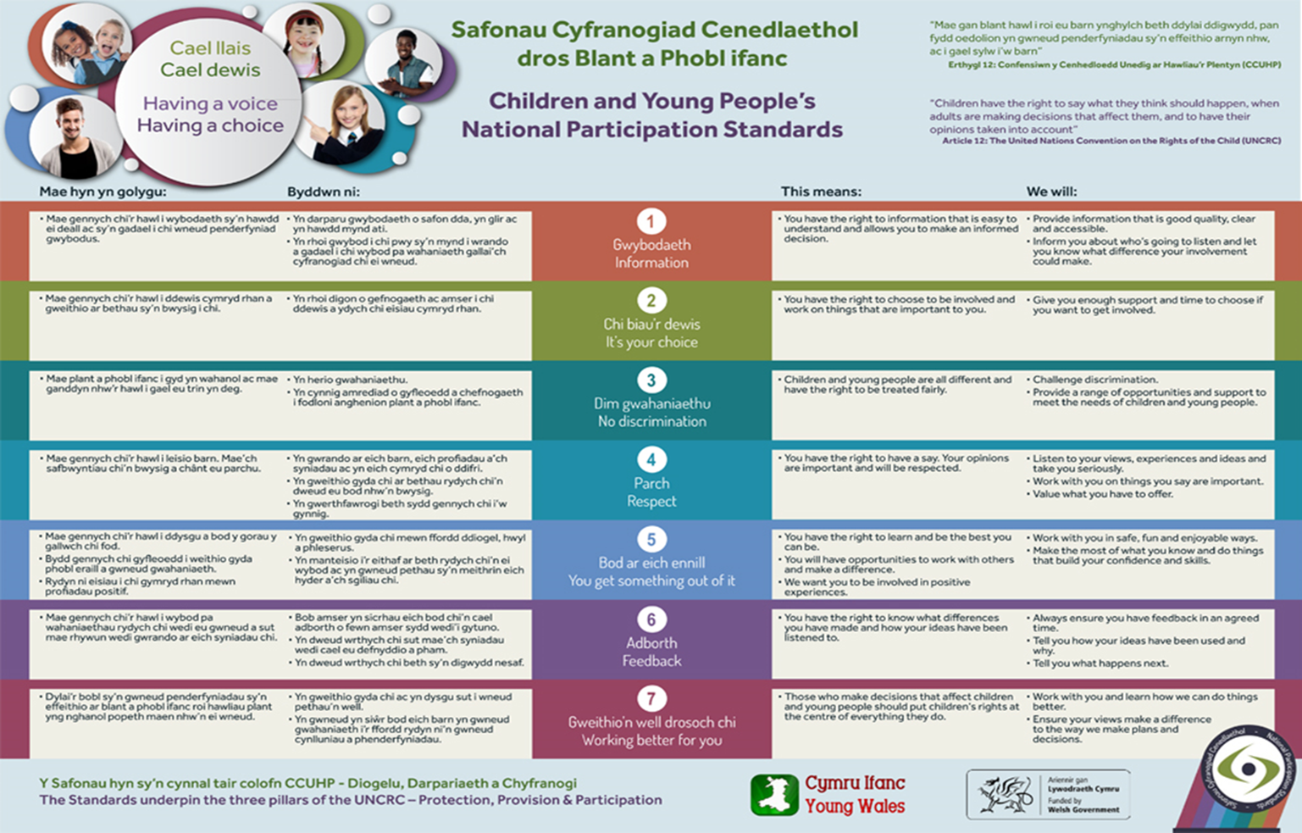
To Conclude.
Participation as has been discussed in this presentation is about providing choices and opportunities for children and young people to have an input into decisions that affect their lives.
To develop a culture of participation in an organisation. It is essential that departments, service managers and staff who provide a service to children and young people understand what participation is and the importance of involving children and young people in decisions.
It seems to be a very difficult concept for some, the need to consult a young person’s opinions a token gesture or a tick box exercise.
Children and young people also need to be themselves to some extent and not as some may feel dragged into adult making decisions before they are adults.
This is an ongoing debate which will carry on for years to come, but organisations have to adopt the participation practice as a matter of legislation.

Reference List.
Children in Wales (2019) Retrieved 29 March 2019 from http://www.childreninwales.org.uk/our-work/participation/participation-standards/
Kanyal, M. (2014) Children’s Rights 0-8: Promoting participation in education and care, London: Routledge.
Lundy, L., 2007. ‘Voice’is not enough: conceptualising Article 12 of the United Nations Convention on the Rights of the Child. British educational research journal, 33(6), pp.927-942.
Malone, K. and Hartung, C., 2010. Challenges of participatory practice with children. A handbook of children and young people’s participation: Perspectives from theory and practice, pp.24-38.
Rights of Children and Young Persons (Wales) Measure 2011 Retrieved 29 March 2019 from http://www.assembly.wales/en/bus-home
Unicef, 1989. Convention on the Rights of the Child.
www.edingburgh.gov.uk
Welsh Government, 2015. Well-being of future generations (Wales) act 2015.

